Supporting information for
Massively Parallel Microbubble Nano-Assembly
Hyungmok Joh¹, Shaw-long Hsueh², Zhichao Ma^{3,4} Bin Lian¹, Peer Fischer^{3, 5, 6}, and Donglei Emma Fan^{1,7*}
¹Materials Science and Engineering Program, Texas Materials Institute, The University of Texas at Austin ² Chandra Family Department of Electrical and Computer Engineering, The University of Texas at Austin
³Max Planck Institute for Intelligent Systems, Heisenbergstr. 3, Stuttgart 70569, Germany
⁴Current address: School of Biomedical Engineering and Institute of Medical Robotics, Shanghai Jiao Tong University, China
⁵ Institute for Molecular Systems Engineering and Advanced Materials, Heidelberg University, INF 255, 69120 Heidelberg, Germany
⁶ Max Planck Institute for Medical Research, Jahnstrasse 29, 69120 Heidelberg, Germany
⁷ Walker Department of Mechanical Engineering, University of Texas at Austin, Austin, TX 78712, USA

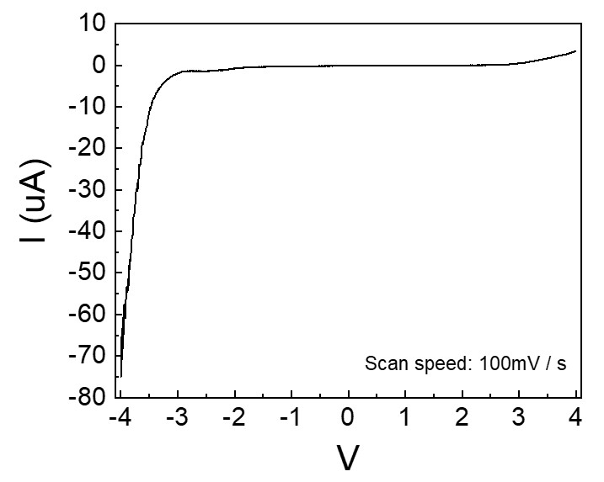
Figure S1. Voltage sweep from +4 V to -4 V of the α-Si:H sample used in this work.

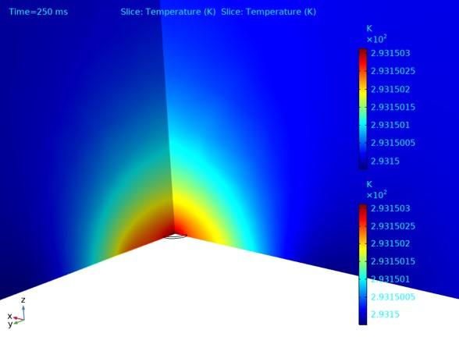
Figure S2. Simulation results of heat generated by a focused 532 nm laser with an intensity of 100 mW/cm².
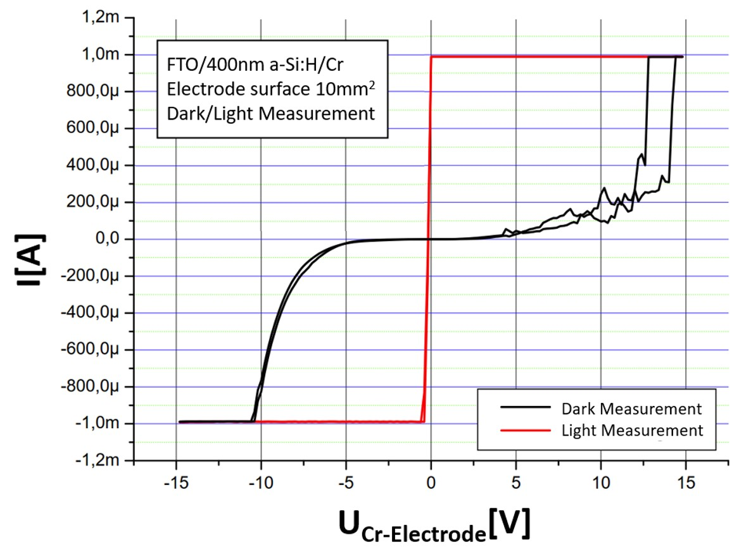
Figure S3. Photocurrent measurement results of an α-Si:H sample.

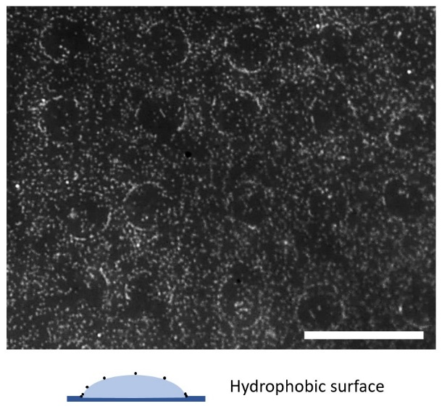
Figure S4. Coffee ring patterns form when the surface is hydrophobic. Image has been enhanced by adjusting the contrast / brightness / sharpness to show more clearly the deposited particles. Scale bar: 50 μm.
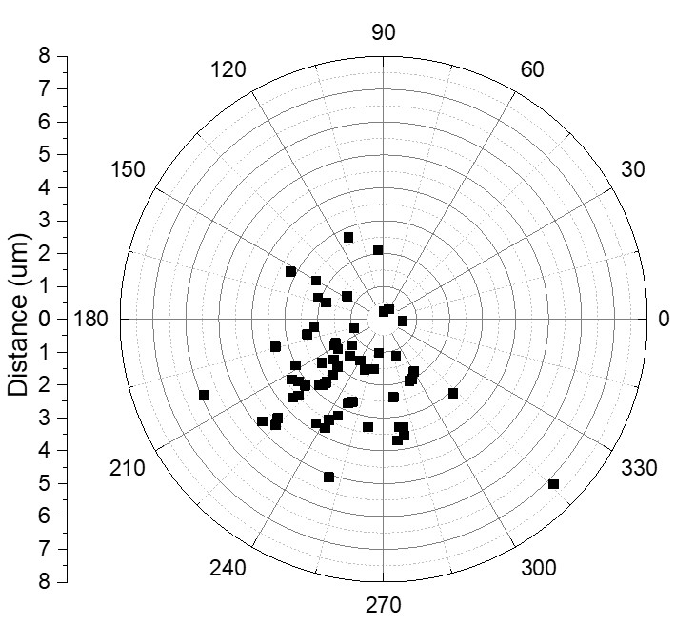
Figure S5. The center of the bubble position is within 2.45 ± 1.08 μm relative to the center of the laser spot.

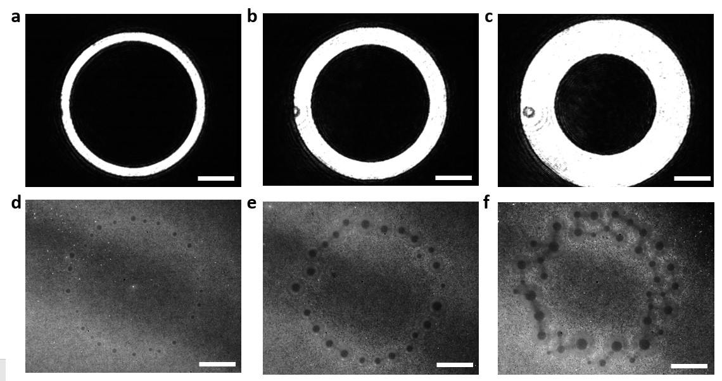
Figure S6. Laser patterns used for line thickness vs bubble pattern determination: a) 8 μm, b) 16 μm and c) 32 μm, and their corresponding bubble patterns. d-f) Scale bars: 50 μm.

Figure S7. Bubble-assisted large-scale assembling of ordered arrays of nanospheres (total length: 2.56mm). Scale bar: 100 μm.

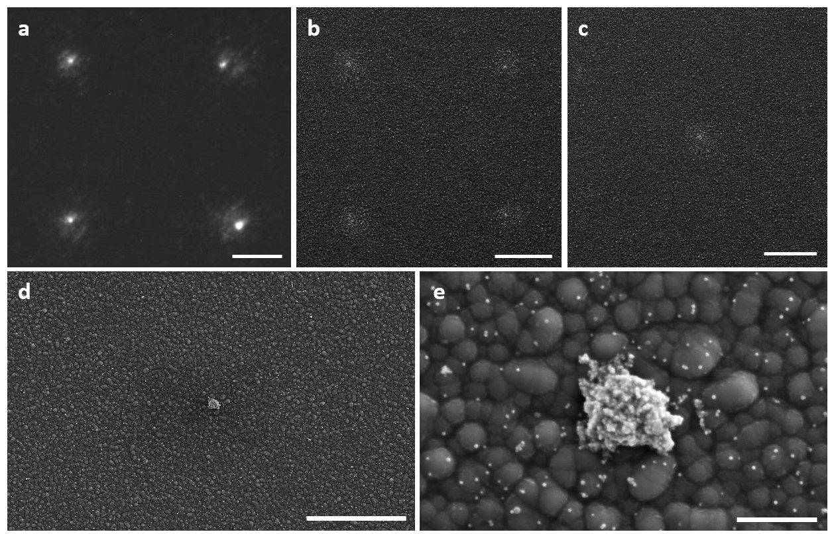Figure S8. a) Fluorescent and b-c) SEM images of 2 x 2 PS sphere deposits on a negatively charged surface. Scale bars: 25 μm. d-e) SEM of a single Ag nanoparticle assembly on positively charged surface. Scale bars: 10 μm, 1 μm.

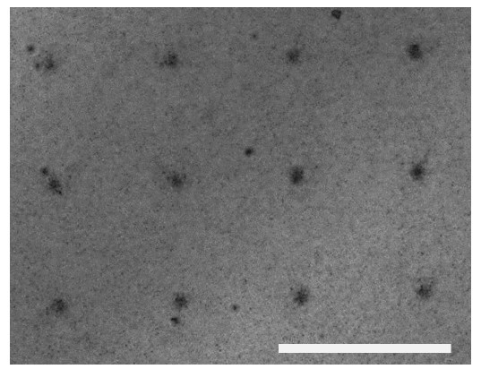
Figure S9. Optical image of simultaneously deposited Ag nanoparticles in a 3x4 array. Scale bar: 100 μm.

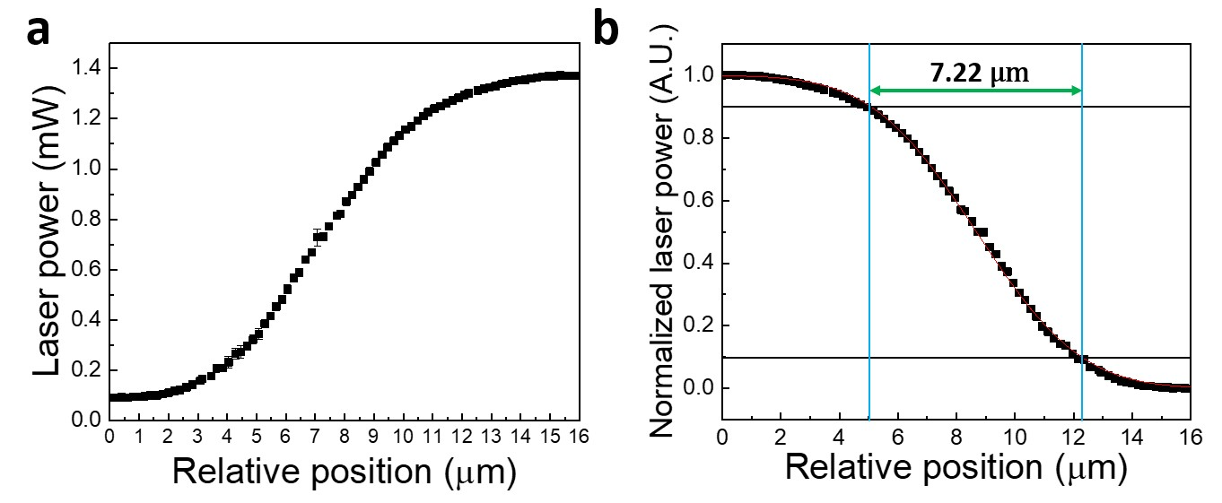
Figure S10. a) Original and b) normalized laser power vs relative position used for laser beam width determination with the 10/90 knife edge method.

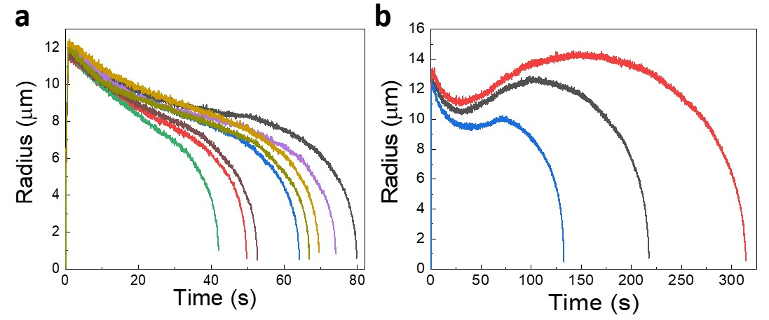
Figure S11. Analysis of bubble radius over time during bubble generation and collapse. a) While most of the bubbles shrank similarly over time, b) some bubbles showed a secondary expansion phase before shrinking again.
aa
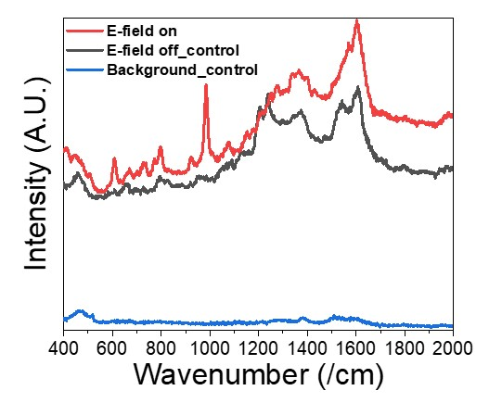
Figure S12. Surface Enhanced Raman Spectroscopy results taken at the background (blue line), on the silver aggregate without DEP attraction of E-coli (black line), and with DEP attraction of E-coli (red line).

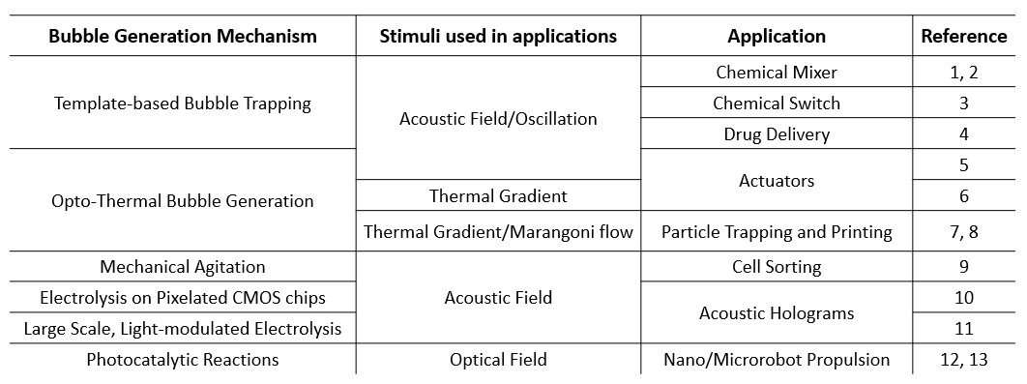
Table S1. State-of-the-art bubble-based technologies.¹⁻¹³

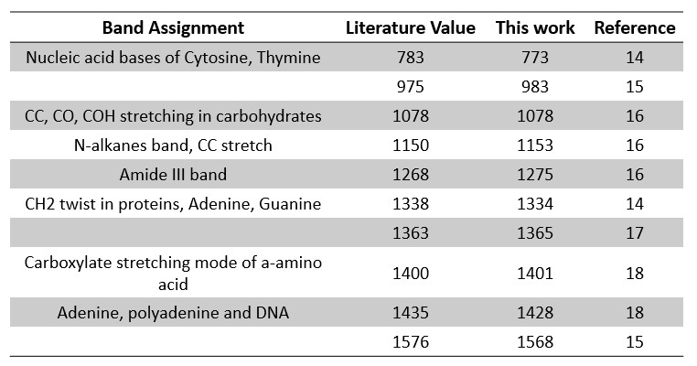
Table S2. Peak assignment of E-coli SERS measurement and its comparison with other works.^{14–18}

Note 1: Heating and simulation and laser heating
While many works utilize heat-induced thermophoretic and accompanying Marangoni flows to attract and trap particles onto the surface,^{8,19,20} the heat generation in our method in contrast, is minimal. Due to the low intensity, heating due to laser absorption is very small at the surface of the Si and the ohmic heating in our experiments is similarly minimal. Simulations (Figure S2) and calculations result in a heat increase of less than <<1 K for each source, due to the high photoconductivity of our substrate and the low laser intensity requirement to generate a bubble. Here, we provide the parameters relevant for ohmic heating and laser heating simulations:²¹

Description | Expression | Reference
Thermal conductivity of a-Si | 1.3 x 10⁻¹¹(T-900)³ + 1.3 x 10⁻⁹(T-900)² + 10⁻⁶(T-900) + 10⁻² [W/cm∙K] | ²²
Specific heat of a-Si | 0.171 T / 1865 K + 0.952 [J/g∙K] | ²²
Density of a-Si | 2260 [kg/m³] | ²²
Reflectivity of solid a-Si | 0.58 | ²²
Absorption coefficient of a-Si | 5.02 x 10³exp(T/430) [/cm] | ²²

The temperature increase due to the absorption of light in the a-Si layer was simulated using COMSOL Multiphysics and further details are provided in the main text of the manuscript.

Note 2: Effect of H₂O₂ and CTAC
We explore how various additives and surfactants such as H₂O₂ and cetyltrimethylammonium chloride (CTAC) and a thin Pt catalyst layer on the counter electrode may affect the minimum laser intensity. Under normal conditions (a 0.5 M Na₂SO₄ solution with a -5 V DC bias superimposed on a 12 V_{pp} AC E-field with a frequency of 1.5 kHz), the average minimum laser intensity is 390.151 ± 17.477 mW/cm². With the addition of H₂O₂, this number falls to 288.384 ± 36.120 mW/cm², which represents a 26% drop in the required laser intensity. Despite having a slightly higher surface tension than water with a value of 80.4 mN/m, which would prohibit bubble formation, H₂O₂ decreases the required laser intensity due to two factors: 1) H₂O₂ has an acid dissociation constant (pKa) of 11.6, meaning that it is slightly acidic in nature; releasing H⁺ ions into the solution which is the basis of the hydrogen bubbles generated by the E-field. 2) H₂O₂ has been reported as an effective hole scavenger and can prevent hole-electron recombination during illumination.^{23,24} Indeed, as can be seen in equation (1), the increase of recombination lifetime leads to an increase of the photocurrent of amorphous silicon, leading to smaller minimum intensity values.
CTAC, on the other hand, acts as a surfactant that reduces the surface tension of water at the liquid-gas interface, which can facilitate bubble growth. It has been reported that the addition CTAC can reduce the surface tension down to 36.1 mN/m, compared to the surface tension of plain water of 71.78 mN/m.²⁵ For our experiments, we use a concentration of 1250 mg/L to ensure the highest decrease of surface tension. Indeed, as can be seen in Figure 2f, the addition of CTAC has shown to greatly decrease the required laser intensity down to 219.741 ± 51.093 mW/cm².
Note 3: Considerations on the formation of single vs multiple bubbles
A single larger bubble possesses a smaller surface area compared to multiple smaller bubbles that contain the same overall volume of gas, and hence minimization of the overall surface energy favors the formation of a single bubble. Hydrophobic or partially hydrophobic nanoparticles are known to attach themselves to gas bubbles and can in turn stabilize the bubbles. Smaller bubbles possess a larger curvature and are most probably not as well covered by nanoparticles, such that these smaller bubbles fuse to form larger, more stable ‘single’ bubbles. The exact mechanism of formation and hence the resulting size) is likely to be a complex process that is an interplay between the stabilizing effect of the nanoparticles, surface tension effects, as well as pressure-volume work and entropy considerations. A full exploration of all of the relevant parameters is beyond the scope of this work.

Note 4: Shrinkage of the H₂ bubbles
The shrinkage and collapse of the bubbles are the result of competition between the outward H₂ diffusion pressure and the inward pressure of the surrounding liquid at the gas-liquid interface. Most of the bubbles show a similar trend, with an initial slow shrinking speed likely due to dynamic interactions with supersaturated hydrogen at the bubble surface vicinity, which is followed by a rapid collapse (Figure S11a). Here, most of the bubbles eventually shrank and collapsed under ~80 s. However, some of the bubbles exhibited a secondary expansion phase even after the E-field and laser pattern is turned off (Figure S11b). This additional growth of the bubbles increases the bubble lifetime, taking the total time to shrink and collapse as from ~ 125 s to over 300 s. Similar bubble growth has been found in bubbles in supersaturated water at the vicinity of an electrode.²⁶

Note 5: Consideration of the surface state and particle density
The versatile bubble-patterning technique is applied for capturing and assembling colloidal nanoparticles. For this purpose, it is crucial to control the surface state of the substate, as well as the shape and size of microbubbles.
1) On a native α-Si:H surface, a hydrogen bubble maximizes its contact and adapts to a truncated sphere due to the hydrophobic nature of both the hydrogen gas and the α-Si:H.^{11,27} As a result, the particles deposit into a coffee ring structure (Figure S4). We, therefore, tune the α-Si:H substrate to be hydrophilic to obtain single-spot particle deposition via a spherical, single-contact microbubbles.
2) When the particle density inside the solution is low, or no particles are inside the solution, multiple, instead of single, bubbles form under light spots (Figure 4a, inset, Video S5),¹¹ which is not suitable for precisely positioning nanoparticles. The single-bubble formation in a nanoparticle colloid suspension (Video S5), in contrast to multi-bubbles made without nanocolloids, could be attributed to a total energy reduction driven by surface-area minimization as discussed in Note 3.
Note 6: Gas-diffusion controlled process of microbubble growth
While a slope of 0.5 is often assumed for ideal diffusion-controlled growth,^{28,29} variations from the diffusion-controlled growth model may exist due to the following factors: 1) The research in references^{28,29} used solutions such as sulfuric acid in water, which exhibits a higher hydrogen ion concentration for hydrogen bubble growth compared to that in D.I. water used in our study. 3) The model assumes that the bubble is far away from any solid wall since the surface roughness may alter the bubble growth.³⁰ While, we grew bubbles next to a substrate. 4) Last, we usually grew bubbles in a closely spaced array. It has been reported that the presence of close-by bubbles decreases a bubble’s growth.³¹ The reported power factor of a second bubble generated next to an already existing bubble is 0.44, which exactly agrees with that we observed in experiments.
Note 7: Deposition of hybrid Ag – E-coli assemblies
Ag– E-coli hybrid assemblies were obtained by depositing Ag nanoparticle assemblies using microbubbles as described in the text, followed by the deposition of E. coli cells. In between, the solution is exchanged. Specifically, we first deposited Ag clusters using a Ag particle solution. After the Ag nanoparticle deposition, the original Ag nanoparticle solution was removed by gently applying and removing fresh DI water to the surface 10 times. Then, the sample was dried, and an E. coli solution was dispersed in the contained, followed by the bubble assembly.

Note 8: Measurement of E-coli metabolites using SERS
Three SERS measurements are made with two measurements for control: 1) away from the silver nanoparticle deposits, where the silver nanoparticle density is low and not concentrated enough to generate ‘hot spots’ (Figure S12, blue line). 2) At a silver nanoparticle deposit, but without any AC field to attract E-coli, leading to the generation of ‘hot spots’ but without any detection of E-coli (Figure S12, black line). 3) At a silver nanoparticle deposit with the AC field on, leading to the generation of ‘hot spots’ with E-coli at the vicinity of the deposit (Figure S12, red line). First, as expected, the SERS signals are low from the silicon surface alone, compared to when the measurement is taken at the silver nanoparticle assembly. The SERS measurement from the silver nanoparticle assembly in the absence of the E-field, shows stronger signals, but characteristic peaks associated with E-coli were not observed. Last, when the E-field is turned on, multiple peaks are seen, indicating the attraction of E-coli by the DEP force. The plots are displayed in Figure 6d after a baseline correction. The peak positions are assigned after comparing the results with multiple references, which are summarized in SI Table 2.

Materials
200 nm fluorescent PS spheres used for particle deposition were purchased from Thermofisher Scientific. The carboxylate-terminated spheres have a surface charge of 0.3699 meq/g (technical data sheet). Sodium sulfate (anhydrous) and hydrogen peroxide (30%) were purchased from Fisher Chemical. Non-Functionalized silver nanoparticles (citrate capped, 40 nm) were purchased from NNCrystal US Corporation and washed with DI-water via centrifugation 3x and concentrated 4x before use. E-coli (K12 strain) were purchased from Carolina Biological Supply Company. The measured cell density of after washing 3x with DI water turned out to be 4.77 x 10⁷ cells / mL. Polydimethylsiloxane (Sylgard 184 silicone elastomer kit) was purchased from Dow Corning Corporation. Cetyltrimethylammonium chloride (25 wt. % in H2O) and Poly(diallyldimethylammonium chloride) (average Mw 200,000-350,000, 20 wt. % in H2O) was purchased from Sigma Aldrich. All reagents were used without further purification. FTO (Fluorine-doped Tin Oxide) glass (0.7 mm thickness and 13 – 15 Ohm/Sq sheet resistance), purchased from MSE Supplies (Product TEC 15), was used as the counter electrode. Sapphire glass–FTO glass–Hydrogen-terminated silicon substrates were fabricated at the University of Stuttgart.
Equipment
The experiments are carried out on an inverted microscope (Olympus IX 70) equipped with a 532 nm laser (DJ532-40, Thorlabs) and a digital light projecting device (DLP, Model DLi4130 .7”VIS XGA, Digital Light Innovations). Scanning electron microscopy (Model Quanta 650, FEI, Model Apreo 2 SEM, Thermo Fisher Scientific) was used for the characterization of deposited particles. A function generator (Model 33250A, Agilent), coupled with a custom-made amplification circuit was used to create AC/DC fields with the desired electric field intensity. A reactive ion etcher (Model RIE-1C, Samco) or UVO-cleaner (Model 30, Jelight) was used to clean the surface of the silicon sample and etch the deposited PS spheres. The etcher was also used to etch away part of the silicon so that the FTO glass underneath could be exposed for electric connections. An e-beam and sputtering system (Model PVD75, Kurt J. Lesker Company) was used to deposit a thin film of Pt on top of a FTO-glass counter electrode substrate to test the effects on bubble generation. A 532 nm wavelength laser (Model Sapphire, Coherent) was used for the characterization of minimum laser intensity, and another 532 nm wavelength laser (DJ532-40, Thorlabs), coupled with a digital light projector (Model DLi4130 .7”VIS XGA, Digital Light Innovations) was used for light pattern projection.

References:
1. Bertin, N. et al. Bubble-based acoustic micropropulsors: active surfaces and mixers. Lab Chip 17, 1515–1528 (2017).
2. Conde, A. J., Keraite, I., Ongaro, A. E. & Kersaudy-Kerhoas, M. Versatile hybrid acoustic micromixer with demonstration of circulating cell-free DNA extraction from sub-ml plasma samples. Lab Chip 20, 741–748 (2020).
3. Ahmed, D. et al. Acoustofluidic chemical waveform generator and switch. Anal. Chem. 86, 11803–11810 (2014).
4. Jeong, J., Jang, D., Kim, D., Lee, D. & Chung, S. K. Acoustic bubble-based drug manipulation: Carrying, releasing and penetrating for targeted drug delivery using an electromagnetically actuated microrobot. Sensors Actuators, A Phys. 306, 111973 (2020).
5. Xie, Y. et al. Probing Cell Deformability via Acoustically Actuated Bubbles. Small 12, 902–910 (2016).
6. Hu, W., Fan, Q. & Ohta, A. T. An opto-thermocapillary cell micromanipulator. Lab Chip 13, 2285–2291 (2013).
7. Zhao, C. et al. Theory and experiment on particle trapping and manipulation via optothermally generated bubbles. Lab Chip 14, 384–391 (2014).
8. Lin, L. et al. Bubble-Pen Lithography. Nano Lett. 16, 701–708 (2016).
9. Meng, L. et al. Microbubble enhanced acoustic tweezers for size-independent cell sorting. Appl. Phys. Lett. 116, (2020).
10. Ma, Z. et al. Spatial ultrasound modulation by digitally controlling microbubble arrays. Nat. Commun. 11, 4537 (2020).
11. Ma, Z., Joh, H., Fan, D. E. & Fischer, P. Dynamic Ultrasound Projector Controlled by Light. Adv. Sci. 9, 2104401 (2022).
12. Moo, J. G. S., Presolski, S. & Pumera, M. Photochromic Spatiotemporal Control of Bubble-Propelled Micromotors by a Spiropyran Molecular Switch. ACS Nano 10, 3543–3552 (2016).
13. Li, Y. et al. Light-controlled bubble propulsion of amorphous TiO2/Au Janus micromotors. RSC Adv. 6, 10697–10703 (2016).
14. Xie, C. et al. Identification of single bacterial cells in aqueous solution using confocal laser tweezers Raman spectroscopy. Anal. Chem. 77, 4390–4397 (2005).
15. Witkowska, E., Niciński, K., Korsak, D., Szymborski, T. & Kamińska, A. Sources of variability in SERS spectra of bacteria: comprehensive analysis of interactions between selected bacteria and plasmonic nanostructures. Anal. Bioanal. Chem. 411, 2001–2017 (2019).
16. Jarvis, R. M., Brooker, A. & Goodacre, R. Surface-enhanced Raman spectroscopy for bacterial discrimination utilizing a scanning electron microscope with a Raman spectroscopy interface. Anal. Chem. 76, 5198–5202 (2004).
17. Premasiri, W. R. et al. The biochemical origins of the surface-enhanced Raman spectra of bacteria: a metabolomics profiling by SERS. Anal. Bioanal. Chem. 408, 4631–4647 (2016).
18. Efrima, S. & Zeiri, L. Understanding SERS of bacteria. J. Raman Spectrosc. 40, 277–288 (2009).
19. Gargiulo, J., Cerrota, S., Cortés, E., Violi, I. L. & Stefani, F. D. Connecting Metallic Nanoparticles by Optical Printing. Nano Lett. 16, 1224–1229 (2016).
20. Armon, N. et al. Continuous Nanoparticle Assembly by a Modulated Photo-Induced Microbubble for Fabrication of Micrometric Conductive Patterns. ACS Appl. Mater. Interfaces 9, 44214–44221 (2017).
21. Förster, J. & Vogt, H. Excimer Laser-Annealing of Amorphous Silicon Layers. 109, 47057 (2010).
22. Jellison, G. E. & Modine, F. A. Optical absorption of silicon between 1.6 and 4.7 eV at elevated temperatures. Appl. Phys. Lett. 41, 180–182 (1982).
23. Dotan, H., Sivula, K., Gr, M. & Warren, S. C. Probing the photoelectrochemical properties of hematite ( a -Fe 2 O 3 ) electrodes using hydrogen peroxide as a hole scavenger. Energy Environ. Sci. 4, 958–964 (2011).
24. Sreedhar, A. et al. Highly supportive hydrogen peroxide as a hole scavenger to improve the visible light water splitting activity of fl ake-like Co-doped ZnO thin fi lms. Sol. Energy 191, 151–160 (2019).
25. Chen, G. et al. Preparation and surface activity study of amino acid surfactants. Comptes rendus - Chim. 22, 277–282 (2019).
26. Chandran, P., Bakshi, S. & Chatterjee, D. Study on the characteristics of hydrogen bubble formation and its transport during electrolysis of water. Chem. Eng. Sci. 138, 99–109 (2015).
27. Sakuma, G., Fukunaka, Y. & Matsushima, H. Nucleation and growth of electrolytic gas bubbles under microgravity. Int. J. Hydrogen Energy 39, 7638–7645 (2014).
28. Westerheide, D. E. & Westwater, J. W. Isothermal growth of hydrogen bubbles during electrolysis. AIChE J. 7, 357–362 (1961).
29. Higuera, F. J. A model of the growth of hydrogen bubbles in the electrolysis of water. J. Fluid Mech. 927, A33 (2021).
30. Aoki, K. J. Frequency-dependence of electric double layer capacitance without Faradaic reactions. JEAC 779, 117–125 (2016).
31. Choi, H., Li, C. & Peterson, G. P. Dynamic Processes of Nanobubbles: Growth, Collapse, and Coalescence. J. Heat Transfer 143, 1–23 (2021).

