Supplementary Materials for

Stress drives polymer phase separation and microplastic release

Corresponding authors: Dunzhu Li, lidu@tcd.ie; Liwen Xiao, liwen.xiao@tcd.ie; Jing Jing Wang, jjwang@tcd.ie; John J. Boland, jboland@tcd.ie

This PDF file includes:

Supplementary Note 1
Supplementary Figs. 1 to 7
References

Supplementary Note 1 The analysis of spectra and microplastic quantity

Using the same system setting and HQI index (Method in the main text), the spectra of separated droplets (the surface droplets were transferred to an aluminium foil to avoid spectral interference from the bulk PP sheet), plastic sheets and products were obtained and compared with standard plastic spectra.
The full range (250-3500 cm⁻¹, Fig. S3) HQI of separated droplets compared to the parent semicrystalline PP and standard amorphous PP wax (Goodfellow) was 0.97 and 0.98, respectively. The high HQI values confirm the a-PP nature of the separated droplets. Notably, Raman spectra in Fig. 1C clearly showed that the droplets perfectly matched that of standard amorphous PP wax, with a hit quality index (HQI) of 0.93 at low wavenumber range (800-1500 cm⁻¹, Fig. 1C). Interestingly, there were clear differences between PP droplets and the parent PP cantilever beam at low wavenumber (800-1500 cm⁻¹), with a substantial difference at 810 and 840 cm⁻¹ associated with the crystallinity degree of PP. Additionally, PP droplets have no peak at 1168 cm⁻¹ associated with the crystalline C-C backbone vibration ^{1,2} (Fig. 1C). Those differences gave rise to a poor match between PP droplets and the parent PP cantilever, with an HQI of only 0.75. Similar difference was observed in FTIR spectra (Fig. S4). FTIR is a complementary tool that can further confirm the amorphous nature of the droplets. Different from Raman spectroscopy, FTIR is more sensitive at the peaks of 997 and 973 cm⁻¹, which are primarily associated with the rocking of crystalline C-C backbone and the stretching of CH₃, respectively ³⁻⁵. The crystallinity degree of PP is proportional to the ratio between the peak intensity of 997 and 973 cm⁻¹ ^{4,5}. Clearly, the intensity of 997 cm⁻¹ is negligible, which closely matched the spectrum of standard amorphous PP. Evidently, most of these droplets are a-PP that has been squeezed out from the bulk PP sheet.

To quantify MP levels, four representative spots (2 spots in the middle area and 2 close to the edge of filter membrane, with total analysed area of 1.5 mm²) were analysed, as detailed in previous studies ^{6,7}. After Raman testing, the total MP number on the filter was obtained based on the ratio between tested area and the whole area of filter membrane (227 mm²). Finally, the released MPs number from unit area of a plastic sheet or PP bottle (particles/cm²) was determined based on the total captured MPs and the area of the plastic exposed to water.

a

b

c

Supplementary Fig. 1. Surface stress drives amorphous polypropylene separation from semicrystalline polypropylene sheets at different temperatures and time durations. (a) AFM height image of compressive side 5 mm from the clamped end after 7 hrs of 85 °C oven heat. (b) AFM height image of compressive side 0.5 mm from the clamped end after 120 hrs of 60 °C oven heat. PP sheets in Figs. A and B were compressed using cantilever PP-1 in Table S1. (c) AFM height image of compressive side 0.1 mm from clamped end after 40 days of 35 °C oven heat, compressed using a shorten cantilever PP-2 in Table. S1.

Supplementary Fig. 2. Full Raman spectra of bulk PP sheet, surface droplets from bulk PP sheet and standard amorphous PP wax, respectively. During Raman detection, the bulk standard samples of PP sheet and PP wax were detected directly. To avoid interference from the parent PP sheet the sticky gel-like droplets were transferred to an aluminium foil and their Raman spectrum recorded (see Supplementary Note 2).

Supplementary Fig. 3. FTIR spectra of bulk PP sheet, surface droplets from bulk PP sheet and standard amorphous PP wax, respectively. Similar to Raman detection, the sticky gel-like droplets were transferred to an aluminium foil to facilitate detection.

a

b

Supplementary Fig. 4. In-situ test of the influence of ethanol exposure on droplets. (a) Droplets formed on standard PP sheet surface after 2 hrs of 95 °C oven heat in the shape of cantilever with setting 1 in Table S1. (b) The same location after 5 hrs of ethanol soaking. Slight changes were observed, which confirmed that these droplets contain very low levels of organic additives that are ethanol soluble.

Supplementary Fig. 5. Arrhenius plots of Eq 2 at compressive surface stresses of -5 and -26 MPa respectively. Data extracted from 3 temperatures (78 °C, 85 °C and 95 °C) in Fig 2C. The slope of linear fitting at each stress can be used to calculate flow activation energy.

Supplementary Fig. 6. The correlation between 1/T and Ln (Viscosity) of amorphous PP in previous publication. Data were extracted from the publication of ⁸. The flow activation energy (E_{f}) can be obtained multiply the slope by gas constant (R, 0.00831434 kJ/mol K), which is 159.0 kJ/mol.

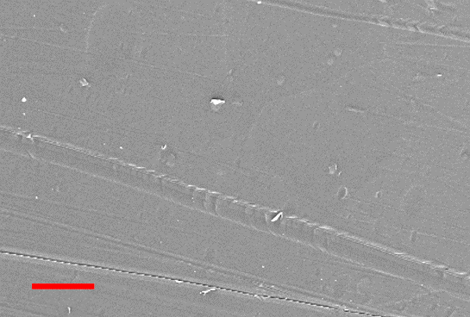
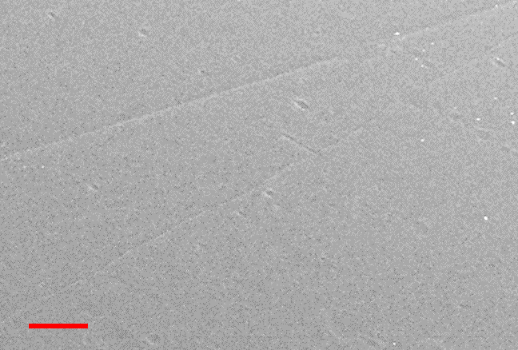
a
b

Supplementary Fig. 7. (a) and (b), SEM images of the inner surface of bottle’s body before and after exposure to 95 °C water, respectively. The red scale bar in both figs is 5 µm.

References

1 Nielsen, A. S., Batchelder, D. & Pyrz, R. Estimation of crystallinity of isotactic polypropylene using Raman spectroscopy. Polymer 43, 2671-2676 (2002).
2 Gopanna, A., Mandapati, R. N., Thomas, S. P., Rajan, K. & Chavali, M. Fourier transform infrared spectroscopy (FTIR), Raman spectroscopy and wide-angle X-ray scattering (WAXS) of polypropylene (PP)/cyclic olefin copolymer (COC) blends for qualitative and quantitative analysis. Polymer Bulletin 76, 4259-4274 (2019).
3 McDonald, M. & Ward, I. The assignment of the infra-red absorption bands and the measurement of tacticity in polypropylene. Polymer 2, 341-355 (1961).
4 Longo, C., Savaris, M., Zeni, M., Brandalise, R. N. & Grisa, A. M. C. Degradation study of polypropylene (PP) and bioriented polypropylene (BOPP) in the environment. Materials Research 14, 442-448 (2011).
5 Paukkeri, R. & Lehtinen, A. Thermal behaviour of polypropylene fractions: 1. Influence of tacticity and molecular weight on crystallization and melting behaviour. Polymer 34, 4075-4082 (1993).
6 Oßmann, B. E. et al. Small-sized microplastics and pigmented particles in bottled mineral water. Water research 141, 307-316 (2018).
7 Imhof, H. K. et al. Pigments and plastic in limnetic ecosystems: A qualitative and quantitative study on microparticles of different size classes. Water research 98, 64-74 (2016).
8 Plazek, D. L. & Plazek, D. J. Viscoelastic behavior of atactic polypropylene. Macromolecules 16, 1469-1475 (1983).

