Organic waste product composting process and parameters

Table 1-SI Synthesis of organic waste products composting process in LTFE2

Compost | Year | Department number | Waste input | Refining | Fermentation |  | Maturation
 |  |  |  | mm | Process | Duration | Process | Duration
GWS | 1998 | 44 | Green wastes of wood chips + sewage sludge | 20 | Swaths sheltered | 3 months | sheltered | 2 months
GWS | 2000 | 44 | Green wastes of wood chips + sewage sludge | 20 | outside | 1 month | outside | 1 month
GWS | 2002  2004 | 68 | Green wastes of wood chips + sewage sludge (Colmar) + grounded pallets | 20 | Forced aeration under shelter | 6 weeks | outside | 3 months
GWS | 2006 | 68 |  | 40
GWS | 2007 |  |  |  |  | 4 weeks | outside | 4 months
GWS | 2009 |  |  |  |  |  |  | 3 months
GWS | 2011  2013  2015 | 68 | Green wastes of wood chips + sewage sludge (Belfort) + grounded pallets | 20
BIOW | 1998 | 95 | Fermentable fraction of municipal waste + Green wastes | 20 | SILODA sheltered | 1 month | Sous sheltered | 2 months
BIOW | 2000 | 59 | Fermentable fraction of municipal waste + Green wastes | 20 | Forced ventilation under canvas | 26 days | Swaths outside | 4 months
BIOW | 2002  2004  2006 | 54 | Fermentable fraction of municipal waste + Green wastes | 25 | Slow composting (turned) | 3 months | Swaths outside | 3 months
BIOW | 2007 | 56 | Fermentable fraction of municipal waste + Green wastes | 15 | Accelerated fermentation in composting tunnels | 5 weeks | sheltered (including 2 weeks of forced ventilation) | 6 months
BIOW | 2009 |  |  |  |  |  |  | 3 months
BIOW | 2011  2013  2015 |  |  |  |  |  | sheltered (including 2 weeks of forced suction) | 3 months
MSW | 1998  2000  2002  2004 | 38 | Residual municipal wastesª | 10-12 | SILODA sheltered | 22 days | sheltered | 5 days
MSW | 2006  2007 | 22 | Residual municipal wastesª | 30 | BRS 3j | Swaths  1 month
MSW | 2009 | 76 | Mixed | 12.5 | Forced ventilation (not turned) | 1 months | outside | 5 days
MSW | 2011 | 45 | Mixed | 40
MSW | 2013  2015 | 72 | Residual municipal wastesª | 6 | Forced ventilation (n+ 1 turning) | 3 weeks | sheltered | 3 weeks
FYM | 1998  2000  2002  2004  2006  2007  2009  2011  2013  2015 | 78 | Dairy cattle manure from the Grignon experimental farm
ª Residual municipal wastes: the waste remaining after sorting the recyclable waste (used paper, plastic packaging, metal packaging, beverage containers, biodegradable waste, glass and textiles)
Table 2-SI Synthesis of organic waste products composting process in LTFE3

Compost | Year | Department number | Waste input | Refining | Fermentation |  | Maturation
 |  |  |  | mm | Process | Duration | Process | Duration
SLU | 2001  2003  2005  2007  2009  2011  2013 | 68 | Urban sewage sludge activated by prolonged aeration and died by centrifugation
DVB | 2001 | 68 | Urban sewage sludge + Bark, green waste, wood chips | 25 | Forced ventilation (not turned) | 6 weeks | sheltered | 2 months
DVB | 2003  2005 | 68 | Urban sewage sludge + green waste, wood chips, grounded pallets
DVB | 2007 | 68 | Urban sewage sludge + green waste, wood chips, maize cobs | 17.5 | Forced ventilation (not turned) | 4-5 weeks | sheltered | 2 months
DVB | 2009 | 68 | Urban sewage sludge + green waste, maize cobs
DVB | 2011 | 68 | Urban sewage sludge + green waste
DVB | 2013 | 68 | Urban sewage sludge (Colmar) + green waste, maize cobs, screening rejects | 20
BIOW | 2001 | 68 | Fermentable fraction of municipal waste + Green wastes | 12 | Turning with worm screw + forced ventilation | 15-20 days | sheltered | 3 months
BIOW | 2003  2005 | 54 | Fermentable fraction of municipal waste + Green wastes | 25 | Outside swaths + turning | 3 months | outside | 3 months
BIOW | 2007 | 54 | Fermentable fraction of municipal waste + Green wastes | 20
BIOW | 2009  2011  2013 | 56 | Fermentable fraction of municipal waste + Green wastes | 15 | Accelerated fermentation in composting tunnels | 1 month | sheltered (including 1 weeks of forced suction) | 3 months
FYM | 2001  2003  2005 | 88 | Dairy cattle farmyard manure
FYM | 2007  2009 | 88
FYM | 2011  2013 | 68
FYMC | 2001  2003  2005 | 88 | Dairy cattle farmyard manure |  | Outside swaths + turning | 2 months
FYMC | 2007  2009 | 88
FYMC | 2011  2013 | 68

Crops successions in LTFE2 and LTFE3

Crops succession in LTFE2
1999 | 2000 | 2001 | 2002 | 2003 | 2004 | 2005 | 2006 | 2007
maize | wheat | maize | wheat | maize | wheat | maize | wheat | barley

2008 | 2009 | 2010 | 2011 | 2012 | 2013 | 2014 | 2015
maize | wheat | maize | wheat | maize | wheat | maize | barley

Crops succession in LTFE3
2001 | 2002 | 2003 | 2004 | 2005 | 2006 | 2007
maize | wheat | maize | barley | maize | wheat | sugar beet

2008 | 2009 | 2010 | 2011 | 2012 | 2013 | 2014
barley | maize | wheat | sugar beet | barley | maize | wheat

Dynamic of SIP and SOP with years of experimentation

Fig. 1-SI Evolution of stocks over years of soil inorganic P (SIP) in the ploughed layer as affected by P fertilization treatments in the three studied LTFE. Values are means ± std. err. (n=4). Lines are linear regressions and grey areas are confidence interval (95%) of the linear regressions. Linear regressions equations are presented in supplementary information. CON: no P input; MWS: municipal solid waste compost; FYM: farmyard manure; FYMC: FYM compost; SLU: dehydrated urban sewage sludge; GWS: compost of green waste and SLU; BIOW: biowaste compost; TSP: triple superphosphate. Subscript values in treatments abbreviations are the average annual rate of P application, in kg P ha⁻¹ yr⁻¹. Linear regressions equations are presented in Table 3-SI.

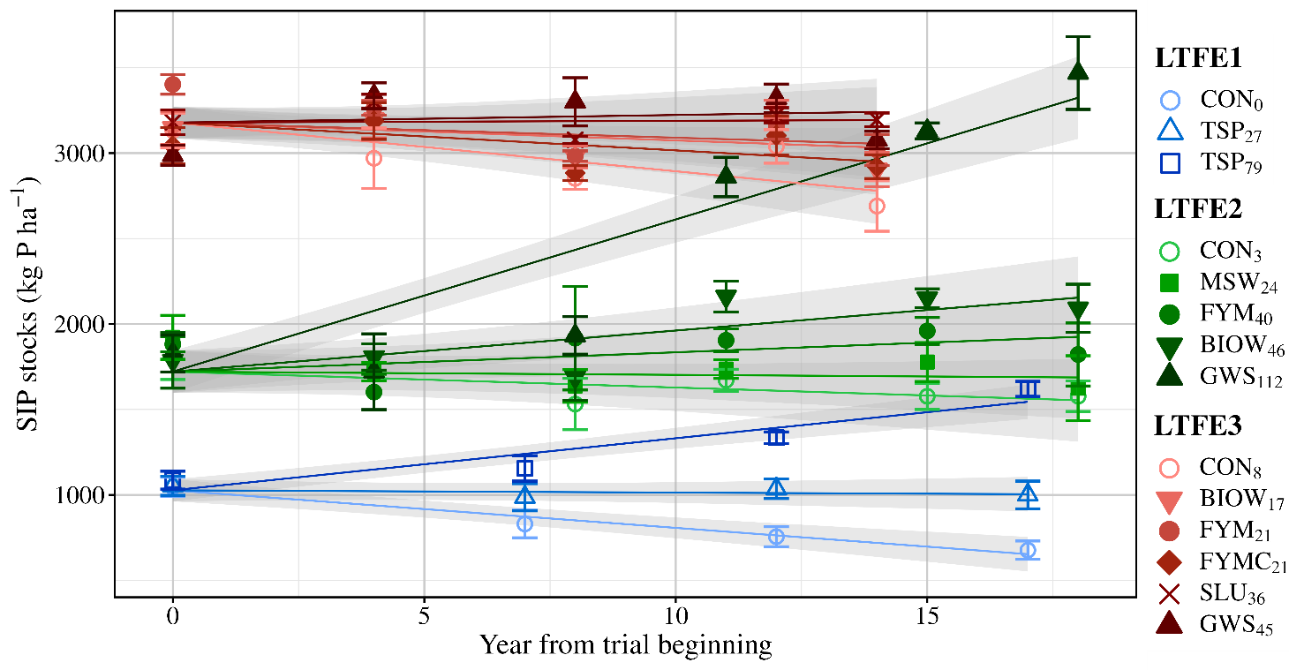

Table 3-SI Linear regression of soil inorganic P (SIP) stock in relation to years of experiment as affected by P fertilization rates of the three LTFE, as presented in Fig. 1-SI. CON: no P input; MWS: municipal solid waste compost; FYM: farmyard manure; FYMC: FYM compost; SLU: dehydrated urban sewage sludge; GWS: compost of green waste and SLU; BIOW: biowaste compost; TSP: triple superphosphate. Subscript values in treatment abbreviations are the average annual rate of P application, in kg P ha⁻¹ yr⁻¹.

Treatments | Regressions equations | Slope P-value | Regression statistics
LTFE1
CON₀ | -22.0 ± 3.3 × Yr + 1027 | 0.0002 | R² = 0.96; n = 12
TSP₂₇ | -1.3 ±3.3 × Yr + 1027 | 0.70 | R² = 0.96; n = 12
TSP₇₉ | 30.5 ±3.3 × Yr + 1027 | <0.0001 | R² = 0.96; n = 12
LTFE2
CON₃ | -9.3 ± 7.7 × Yr + 1721 | 0.24 | R² = 0.88; n = 30
MSW₂₄ | -1.9 ± 7.8 × Yr + 1721 | 0.81 | R² = 0.88; n = 30
FYM₄₀ | 11.3 ± 7.8 × Yr + 1721 | 0.16 | R² = 0.88; n = 30
BIOW₄₆ | 24.0 ± 7.8 × Yr + 1721 | 0.005 | R² = 0.88; n = 30
GWS₁₁₂ | 89.1 ± 7.8 × Yr + 1721 | <0.0001 | R² = 0.88; n = 30
LTFE3
CON₀ | -28.5 ± 7.8 × Yr + 3179 | 0.001 | R² = 0.47; n = 30
BIOW₁₇ | -10.4 ± 7.8 × Yr + 3179 | 0.19 | R² = 0.47; n = 30
FYM₂₁ | -8.8 ± 7.8 × Yr + 3179 | 0.27 | R² = 0.47; n = 30
FYMC₂₁ | -16.3 ± 7.8 × Yr + 3179 | 0.05 | R² = 0.47; n = 30
SLU₃₆ | 1.0 ± 7.8 × Yr + 3179 | 0.89 | R² = 0.47; n = 30
GWS₄₅ | 4.5 ± 7.8 × Yr + 3179 | 0.57 | R² = 0.47; n = 30

Fig. 2-SI Stocks of soil organic P (SOP) in the ploughed layer in relation to years of experiment as affected by P fertilization treatments of the three studied LTFE. Values are means ± std. err. (n=4). Lines are linear regressions. Grey areas are linear regression confidence interval at 95%. CON: control with no P input; MWS: municipal solid waste compost; FYM farmyard manure; FYMC: FYM compost, GWS: compost of green waste and SLU; SLU: dehydrated sewage sludge; BIOW: biowaste compost; TSP: triple superphosphate. Subscript values in treatments abbreviations are the average annual rate of P application, in kg P ha⁻¹ yr⁻¹.

LTFE1: SOP = -0.04 ± 0.94 × Yr + 452 ± 10 (P-value = 0.97; R² = 0.00; n = 12)
LTFE2: SOP = 8.3 ± 2.0 × Yr + 553 ± 21 (P-value = 0.0002; R² = 0.34; n = 35)
LTFE 3: SOP = 7.9 ± 3.1 × Yr + 1146 ± 29 (P-value = 0.015; R² = 0.16; n = 36)

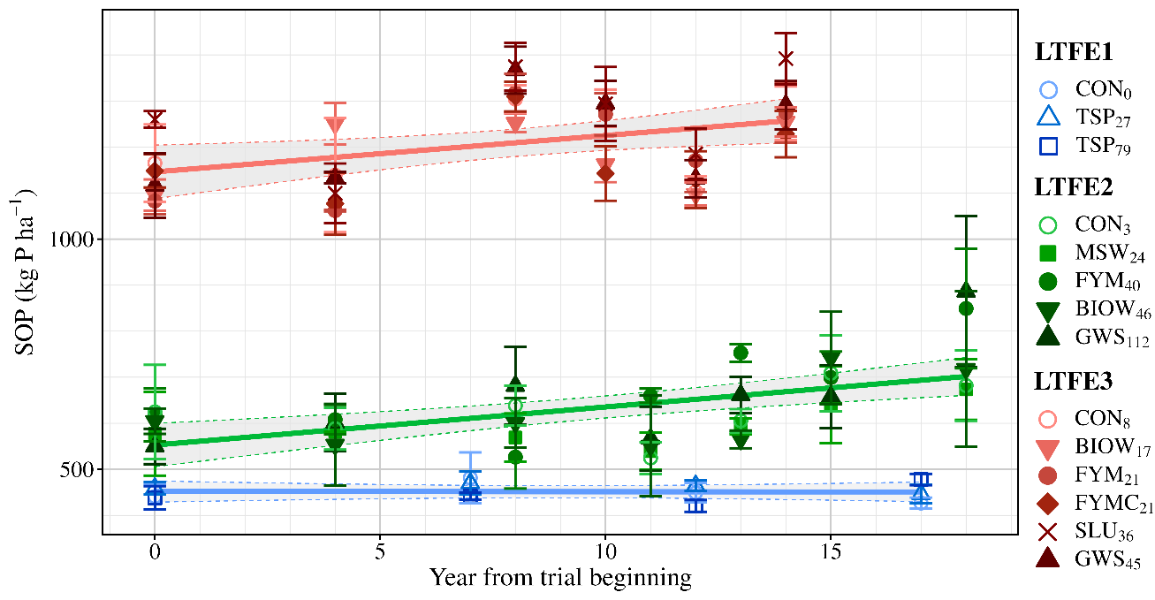

Total, incorporated, and released P in aboveground, belowground, grain residues, and total P in OWP of the three LTFE

Table 4-SI Amount of P in crop residues (kg P ha⁻¹ yr⁻¹) and its partition between P incorporated to SOP and phosphate ions released in soil solution during the post-harvest (<1 yr) decomposition at the LTFE1. Values are means ± std. err. (n = 18). Different lower case letters (a, b, c) indicate significant differences among treatments (α = 0.05). CON: no P input; TSP: triple superphosphate. Subscript values in treatment abbreviations are the average annual rate of P application, in kg P ha⁻¹ yr⁻¹.

P fluxes (kg P ha⁻¹ yr⁻¹) | CON₀ | TSP₂₇ | TSP₇₉ | P-Value
Phosphate ions released to soil solution by residues decomposition
aboveground residues | 5.3 ± 0.2 b | 6.6 ± 0.3 ab | 8.3 ± 0.6 a | 0.01
belowground residues | 4.6 ± 0.2 b | 5.3 ± 0.3 ab | 5.8 ± 0.4 a | 0.04
harvest losses | 0.4 ± 0.1 | 0.5 ± 0.1 | 0.5 ± 0.1 | 0.11
Sum | 10.4 ± 0.4 b | 12.4 ± 0.7 ab | 14.6 ± 1.0 a | 0.02
P incorporated to SOP
aboveground residues | 0.9 ± 0.1 b | 1.1 ± 0.1 ab | 1.4 ± 0.1 a | 0.01
belowground residues | 0.9 ± 0.1 b | 1.1 ± 0.1 ab | 1.2 ± 0.1 a | 0.04
harvest losses | 0.29 ± 0.01 | 0.33 ± 0.02 | 0.34 ± 0.02 | 0.11
Sum | 2.1 ± 0.1 b | 2.5 ± 0.1 ab | 2.9 ± 0.2 a | 0.02
Sum of the two above P fluxes
aboveground residues | 6.2 ± 0.2 b | 7.6 ± 0.4 ab | 9.7 ± 0.7 a | 0.01
belowground residues | 5.6 ± 0.2 b | 6.4 ± 0.3 ab | 7.0 ± 0.4 a | 0.04
harvest losses | 0.7 ± 0.1 | 0.8 ± 0.1 | 0.8 ± 0.1 | 0.11
Sum | 12.5 ± 0.4 b | 14.9 ± 0.8 ab | 17.5 ± 1.2 a | 0.02

Table 5-SI Amount of P applied as OWP and crop residues (kg P ha⁻¹ yr⁻¹) and its partition between P incorporated to SOP and phosphate ions released in soil solution during the post-harvest (<1 yr) decomposition at LTFE2. Values are means ± std. err. (n = 17). Different lower case letters (a, b, c) indicate significant differences among treatments (α = 0.05). CON: no P input; MSW: municipal solid waste compost; FYM: farmyard manure; GWS: compost of green waste and urban sewage sludge; BIOW: bio-waste compost. Subscript values in treatment abbreviations are the average annual rate of P application, in kg P ha⁻¹ yr⁻¹.

P fluxes (kg P ha⁻¹ yr⁻¹) | CON₃ | MSW₂₄ | FYM₄₀ | BIOW₄₆ | GWS₁₁₂ | P-value
Phosphate ions released to soil solution by residues decomposition
aboveground residues | 2.5 ± 0.5 | 2.9 ± 0.6 | 3.3 ± 0.7 | 3.1 ± 0.7 | 3.4 ± 0.7 | 0.38
belowground residues | 5.1 ± 5.1 | 5.9 ± 0.6 | 6.4 ± 0.7 | 6.1 ± 0.6 | 6.4 ± 0.7 | 0.07
harvest losses | 0.4 ± 0.1 | 0.5 ± 0.1 | 0.5 ± 0.1 | 0.5 ± 0.1 | 0.5 ± 0.1 | 0.06
OWP |  | 22 ± 5 b | 25 ± 6 b | 42 ± 10 b | 94 ± 22 a | <0.0001
Sum | 8 ± 1 c | 31 ± 5 bc | 35 ± 6 b | 52 ± 10 b | 104 ± 22 a | <0.0001
P incorporated to SOP
aboveground residues | 0.51 ± 0.07 b | 0.61 ± 0.08 ab | 0.71 ± 0.09 ab | 0.64 ± 0.09 ab | 0.72 ± 0.0.9 a | 0.04
belowground residues | 2.4 ± 0.4 | 2.8 ± 0.5 | 3.0 ± 0.6 | 2.9 ± 0.5 | 3.0 ± 0.6 | 0.45
harvest losses | 0.18 ± 0.02 | 0.20 ± 0.02 | 0.22 ± 0.02 | 0.21 ± 0.02 | 0.21 ± 0.02 | 0.17
OWP |  | 1.7 ± 0.4 b | 13.8 ± 3.3 a | 3.2 ± 0.8 b | 17.8 ± 4.3 a | <0.0001
Sum | 3.1 ± 0.4 b | 5.3 ± 0.8 b | 17.8 ± 3.6 a | 6.9 ± 1.2 b | 21.8 ± 4.7 a | <0.0001
Sum of the two above P fluxes
aboveground residues | 3.0 ± 0.6 | 3.5 ± 0.7 | 4.0 ± 0.8 | 3.7 ± 0.7 | 4.1 ± 0.8 | 0.30
belowground residues | 7.5 ± 0.9 | 8.7 ± 1.1 | 9.5 ± 1.2 | 9.0 ± 1.1 | 9.5 ± 1.3 | 0.16
harvest losses | 0.62 ± 0.05 b | 0.70 ± 0.05 ab | 0.75 ± 0.05 a | 0.72 ± 0.05 ab | 0.73 ± 0.05 ab | 0.02
OWP |  | 23 ± 6 b | 39 ± 9 b | 45 ± 11 b | 111 ± 27 a | <0.0001
Sum | 11 ± 1 c | 36 ± 6 bc | 53 ± 9 b | 59 ± 11 b | 126 ± 27 a | <0.0001

Table 6-SI Amount of P applied as crop residues (kg P ha⁻¹ yr⁻¹) and its partition between P incorporated to SOP and phosphate ions released in soil solution during the post-harvest (<1 yr) decomposition at the LTFE3. Values are means ± std. err. (n = 14). Different lower case letters (a, b, c) indicate significant differences among treatments (α = 0.05). CON: no P input; FYM: farmyard manure; FYMC: FYM compost; GWS: compost of green waste and SLU, SLU: dehydrated urban sewage sludge, BIOW: bio-waste compost. Subscript values in treatment abbreviations are the average annual rate of P application, in kg P ha⁻¹ yr⁻¹.

P fluxes (kg P ha⁻¹ yr⁻¹) | CON₈ | BIOW₁₇ | FYM₂₁ | FYMC₂₁ | SLU₃₆ | GWS₄₅ | P-value
Phosphate ions released to soil solution by residues decomposition
aboveground residues | 2.0 ± 0.5 | 2.2 ± 0.5 | 2.5 ± 0.6 | 2.4 ± 0.6 | 2.4 ± 0.6 | 2.4 ± 0.6 | 0.79
belowground residues | 4.9 ± 0.7 | 4.9 ± 0.7 | 5.1 ± 0.8 | 5.2 ± 0.8 | 5.0 ± 0.7 | 5.0 ± 0.7 | 0.99
harvest losses | 0.4 ± 0.1 | 0.4 ± 0.1 | 0.4 ± 0.1 | 0.4 ± 0.1 | 0.4 ± 0.1 | 0.4 ± 0.1 | 0.99
OWP |  | 16 ± 5 b | 14 ± 4 b | 16 ± 5 b | 34 ± 10 a | 37 ± 11 a | <0.0001
Sum | 7 ± 1 c | 23 ± 5 b | 22 ± 4 bc | 24 ± 5 b | 41 ± 10 a | 45 ± 11 a | <0.0001
P incorporated to SOP
aboveground residues | 1.1 ± 0.5 | 1.2 ± 0.5 | 1.4 ± 0.6 | 1.3 ± 0.6 | 1.4 ± 0.6 | 1.3 ± 0.6 | 0.96
belowground residues | 2.3 ± 0.5 | 2.3 ± 0.5 | 2.4 ± 0.5 | 2.5 ± 0.5 | 2.3 ± 0.5 | 2.4 ± 0.5 | 0.99
harvest losses | 0.17 ± 0.03 | 0.17 ± 0.03 | 0.18 ± 0.03 | 0.18 ± 0.03 | 0.17 ± 0.03 | 0.17 ± 0.03 | 0.99
OWP |  | 1.2 ± 0.3 c | 7.6 ± 2.3 a | 5.4 ± 1.6 ab | 2.8 ± 0.8 bc | 7.1 ± 2.1 a | <0.0001
Sum | 3.6 ± 0.5 c | 4.9 ± 0.5 c | 11.6 ± 2.3 a | 9.4 ± 1.6 ab | 6.8 ± 0.9 bc | 11.0 ± 2.1 a | <0.0001
Sum of the two above P fluxes
aboveground residues | 3.1 ± 0.7 | 3.4 ± 0.7 | 4.0 ± 0.9 | 3.7 ± 0.8 | 3.8 ± 0.9 | 3.7 ± 0.8 | 0.70
belowground residues | 7.2 ± 1.2 | 7.2 ± 1.2 | 7.6 ± 1.2 | 7.7 ± 1.3 | 7.3 ± 1.2 | 7.4 ± 1.2 | 0.99
harvest losses | 0.6 ± 0.1 | 0.6 ± 0.1 | 0.6 ± 0.1 | 0.6 ± 0.1 | 0.6 ± 0.1 | 0.6 ± 0.1 | 0.99
OWP |  | 17 ± 5 c | 21 ± 7 bc | 21 ± 6 bc | 36 ± 11 ab | 45 ± 13 a | 0.003
Sum | 11 ± 1 d | 28 ± 5 cd | 33 ± 7 bc | 33 ± 6 bc | 48 ± 11 ab | 56 ± 13 a | <0.0001

Fig. 3-SI Annual amount of P in aboveground, belowground and grains residues in relation to years of experiment, as affected by P fertilization treatments for the three studied LTFE. Values are means ± std. err. (n=4). CON: no P applied; MWS: municipal solid waste compost; FYM: farmyard manure; FYMC: FYM compost; GWS: green waste and SLU compost; SLU: dehydrated urban sewage sludge; BIOW: biowaste compost, TSP: triple superphosphate. Subscript values in treatments abbreviations are the average annual rate of P application, in kg P ha⁻¹ yr⁻¹.
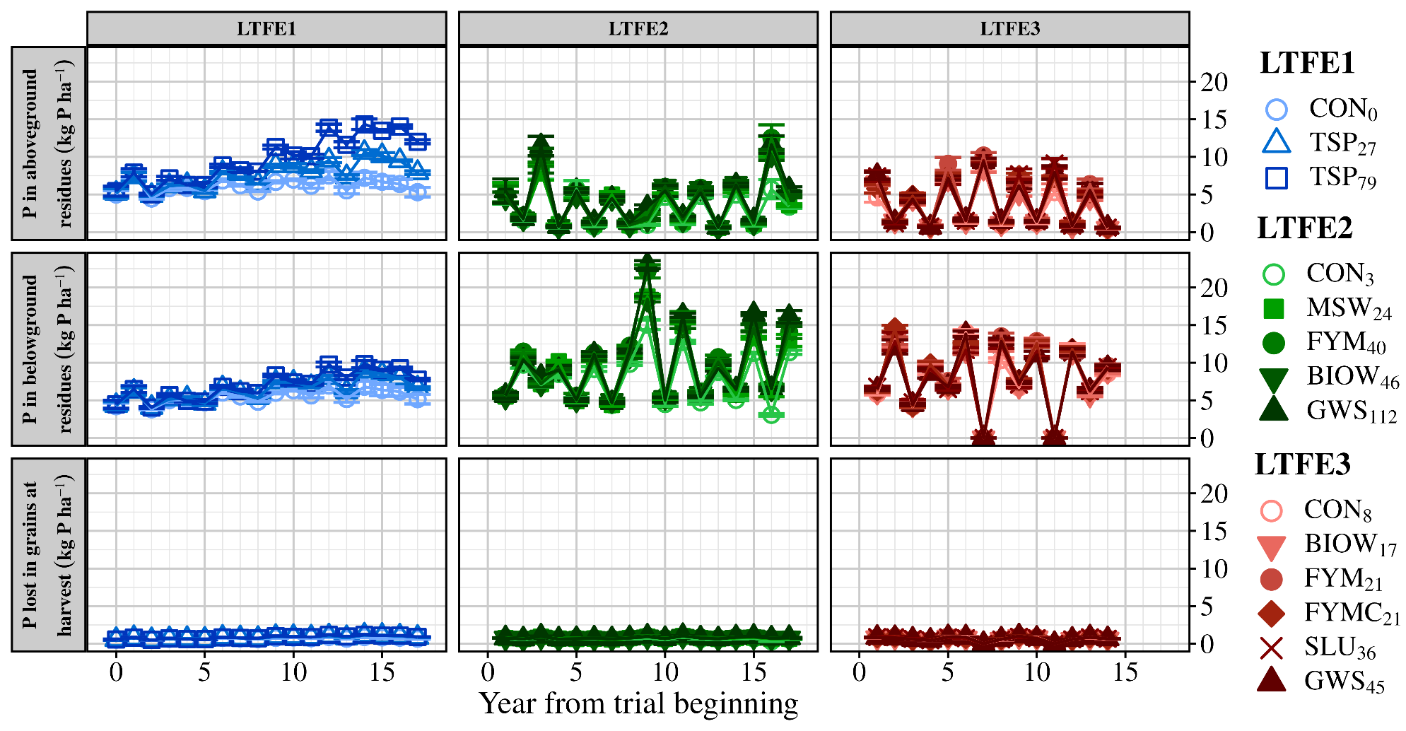

Fig. 4-SI Cumulated P applied as OWP and triple superphosphate (TSP) for all years and treatments in the three LTFE. Organic P input through OWP is also specified. Values are means (n=4). CON: no P input; MWS: municipal solid waste compost; FYM: farmyard manure; FYMC: FYM compost; SLU: dehydrated urban sewage sludge; GWS: compost of green waste and SLU; BIOW: bio-waste compost, TSP: triple superphosphate. Subscript values in treatments abbreviations are the average annual rate of P application, in kg P ha⁻¹ yr⁻¹.
