SUPPLEMENTARY METHODS

Postoperative monitoring
Animals were checked twice daily through post-operative day three and daily thereafter. Food and water intake, weight, and overall health were assessed. If mice required more supervision due to clinical symptoms suggestive of AL, including reluctance to move, unkempt coat, discharge from eyes/nose, lack of balance, stumbling, stiff gait, and abdominal swelling, monitoring was increased as needed.

DNA extraction and sequencing
DNA was extracted from individual fecal pellets (approximately 0.1 g) for microbiome analyses using the DNeasy PowerSoil Pro kit. Amplification of the V4 hypervariable region of the 16S rRNA gene was done by the University of Minnesota Genomics center using the 515F/806R primer set followed by paired-end sequencing on the Illumina MiSeq platform (300bp).^{1,2} Fecal samples were amplified for 25 cycles, while serum and tissue samples were amplified for 30 cycles due to low biomass. Sterile water controls were included on each plate. Sequence data were deposited in the NCBI SRA under accession number SRP408098.

16S rRNA Amplicon Processing and Analysis
Mothur software (v.1.41.1) was used for the processing of sequence data and its analysis.³ Sequences were cut to 170 nucleotides (nt), paired-end joined with fastq-join⁴ and cut for quality with an average quality score of 35 over a 50-nt window, homopolymers ≤ 6 nt, no ambiguous bases, and ≤ 2-nt differences from primer sequences. Alignment of high-quality sequences was performed using SILVA database (v.138.1).⁵ Any chimeras identified were removed using UCHIME v.4.2.409.⁶ Binning of operational taxonomic units (OTUs) was done at 99% similarity using the furthest-neighbor algorithm and Ribosomal Database Project (RDP v.18) was used for taxonomic assignments.⁷ With regards to statistical comparisons, rarefication of samples was done to 5,000 reads (feces) or 9,350 (serum and tissue) per sample, which yielded a median Good’s coverage estimate of 98.8% [IQR 98.6 – 99.0%] among all samples.
While negatives for fecal samples did not produce amplicons, contamination was noted in blanks run among the tissue and serum samples. To account for this, samples were normalized to 9,350 reads to remove all negatives that produced sequence reads. Presumably all samples with read numbers greater than this value had sufficient biomass to reflect unbiased sequencing results.
SourceTracker
To determine similarity between fecal, serum, and tissue samples, the Bayesian algorithm SourceTracker2 was used with default parameters in a Python 3.6 environment.⁸ This program takes an OTU table as input and identifies the percent of a community in user-defined sink samples (i.e., serum and tissue samples) that were attributable to user-defined source categories (i.e., fecal samples).
RNAseq analysis
For mice transcript abundance data, we used the ‘biomaRt’ R package (version 2.37.4) to only keep data for protein-coding genes.⁹ Genes with low frequency in the dataset were filtered out leaving genes that were expressed in at least half of the samples. The DESeq2 package (version 1.28.1) was used to perform differential gene expression in R.¹⁰ ‘NoAL’ was set as reference level to compare with ‘AL’. Further, the ‘gage’ (Generally Applicable Gene-set Enrichment for Pathway Analysis) package (version 2.40.1) was used in R to identify the enriched functional pathways with transcript abundance data.¹¹ The R package enables the association of pathways categorized in Kyoto Encyclopedia of Genes and Genomes (KEGG) with the given gene set. To visualize activated and suppressed pathways, enrichment analysis was performed using gseGO function of clusterProfiler (version 4.0),¹² along with DOSE (version 2.3.5), and org.Mm.eg.db (version 3.17.0) in R and subsequently presented on dotplots using R package Enrichplot (version 1.2.0). The significantly different OTUs and gene transcripts between AL and no AL of each treatment group (i.e., SD SBP, SD Water, WD SBP and WD Water) were identified. Further, canonical correlation analysis (CCA) was used via PMA package (version 1.2.1) in R to model the relationship between the differentially abundant OTUs and differentially expressed mice genes.^{13,14} CCA is a dimensional reduction technique that evaluates the association of two sets of variables (vectors) measured from the same sample. Differential analysis for screening significant OTUs and transcript abundances was performed using the Wald test. Statistical P-values for multiple tests were adjusted using the Benjamini-Hochberg correction procedure. All statistical analyses were conducted using R (version 4.3.4).

Supplementary Table 1. Nutrition details of standard and western diets.
Macronutrients | Standard Diet (2018) | Western Diet (TD.88137)
Protein (% weight) | 18.4 | 17.3
Fat (% weight) | 6.0 | 21.2
Carbohydrate (% weight) | 44.2 | 48.5
Fiber (% weight) | 14.7 | 5.0
Energy density (Kcal/g) | 3.1 | 4.5
Protein (% Kcal) | 24.0 | 15.2
Fat (% Kcal) | 18.0 | 42.0
Carbohydrate (% Kcal) | 58.0 | 42.7

Supplementary Table 2. Survival contingency table: no significant differences in survival to necropsy on POD7 between groups by Fisher’s exact test.
 | Survived (n) | Died (n) | P-value
SD MBP | 17 | 1 | 1.00
SD OA | 18 | 0 | 1.00
SD SBP | 18 | 0 | 1.00
SD Water | 18 | 0 | 1.00
WD MBP | 17 | 1 | 1.00
WD OA | 17 | 1 | 1.00
WD SBP | 17 | 1 | 1.00
WD Water | 18 | 0 | 1.00

Supplementary Table 3. Summary of samples and alpha diversity among different sample types evaluated. Median and interquartile range is shown.
Median | n | ASVs Observed | Coverage | Shannon | Chao1
Fecal | 549 | 155, [137 - 172] B* | 98.8, [98.6 – 99.0] B | 3.11, [2.90 - 3.26] B | 271, [228 - 321] B
Serum | 4 | 54, [51 - 57] C | 99.9, [99.9 – 1.00] A | 3.63, [3.54 - 3.71] A | 61, [60 - 63] C
Tissue | 32 | 237, [205 - 271] A | 98.9, [98.8 – 99.2] C | 3.24, [3.03 - 3.44] A | 489, [377 - 561] A
P-value |  | < 0.0001 | 0.0001 | < 0.0001 | < 0.0001
*ABC: Groups sharing the same letter in a column did not differ significantly by Dunn’s post-hoc test with Bonferroni correction for multiple comparisons (adjusted α = 0.017). Letters progress in descending order.
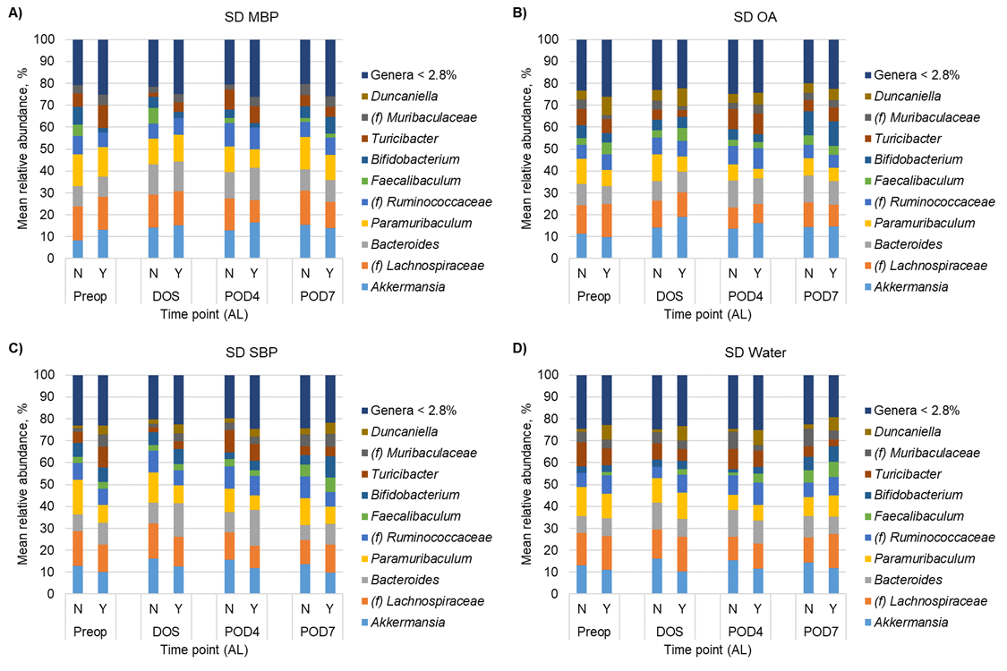

Supplementary Figure 1. Distribution of predominant genera among all samples for SD-fed mice. For clarity, the top 10 predominant genera are shown and the less abundant genera were consolidated. Each genus consolidated had a mean relative abundance <2.8% of normalized sequence reads. (f) Indicates the taxon could not be classified to greater resolution than family.
Supplementary Figure 2. Concentrations of fecal short-chain fatty acids. A-C) butyrate, propionate, and acetate in SD mice; D-F) butyrate, propionate, and acetate in WD mice. Tukey’s post-hoc P-values for multiple pairwise comparisons by ANOVA are shown.
Supplementary Figure 3. Concentrations of fecal IgA measured on POD7. Tukey’s post-hoc P-values for multiple pairwise comparisons by ANOVA (F = 15.9, P < 0.0001) are shown.

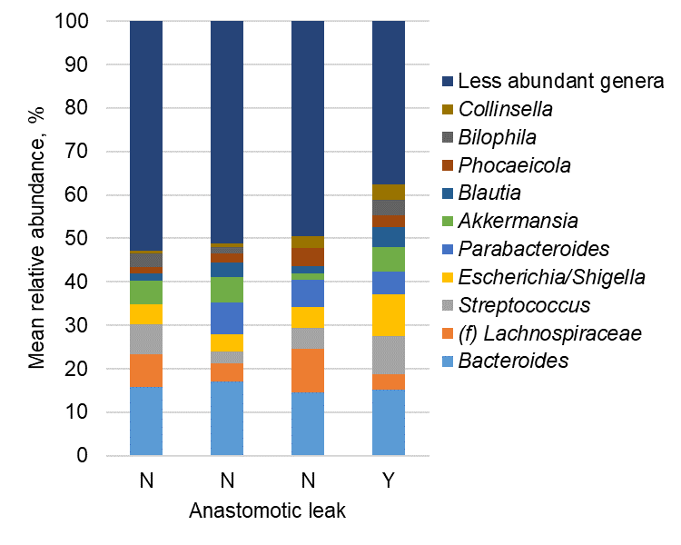
Supplementary Figure 4. Distribution of predominant genera among serum samples included in the analysis. For clarity, the top 10 predominant genera are shown and the less abundant genera were consolidated. (f) Indicates the taxon could not be classified to greater resolution than family.
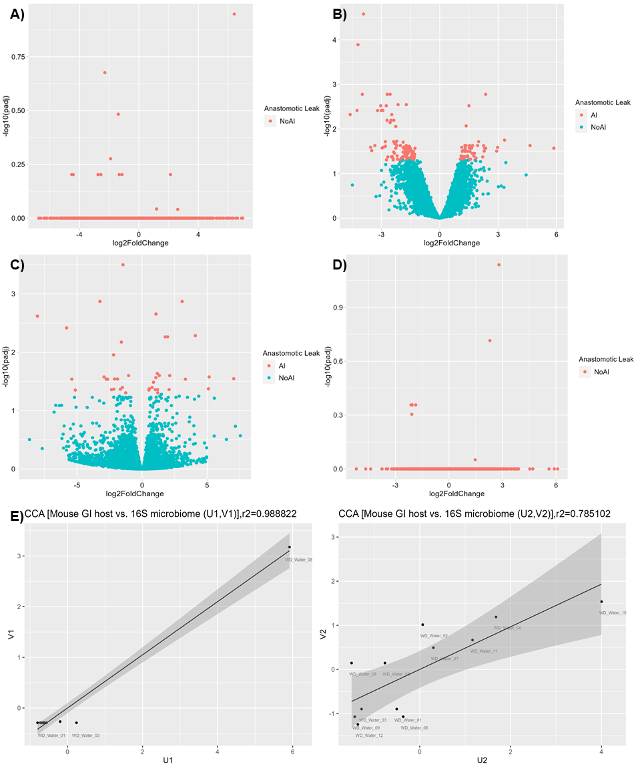
Supplementary Figure 5. Differentially abundant features in RNAseq data. A-B) Volcano plots showing significantly differential features in SD water (A) and SBP (B) treatments; C-D) Volcano plots showing significantly differential features in WD water (C) and SBP (D) treatments. E) Scatter plots for first and second canonical variates with fecal microbiome and mouse gene features for the WD water treatment group. Black dots represent samples (n=12). U₁ represents bacterial OTUs and V₁ represents mouse gene transcripts in the first canonical variate pairs. 98.8% of the variation in U₁ is explained by the variation in V₁. U₂ represents bacterial OTUs and V₂ represents mouse genes in second canonical variate pairs. 78.5% of the variation in U₂ is explained by the variation in V₂. The solid black line and gray zone represent the linear regression line and 95% confidence interval, respectively

SUPPLEMENTARY REFERENCES
1. Caporaso, J.G., Lauber, C.L., Walters, W.A., Berg-Lyons, D., Huntley, J., Fierer, N., Owens, S.M., Betley, J., Fraser, L., Bauer, M., et al. (2012). Ultra-high-throughput microbial community analysis on the Illumina HiSeq and MiSeq platforms. ISME J 6, 1621-1624. 10.1038/ismej.2012.8.
2. Gohl, D.M., Vangay, P., Garbe, J., MacLean, A., Hauge, A., Becker, A., Gould, T.J., Clayton, J.B., Johnson, T.J., Hunter, R., et al. (2016). Systematic improvement of amplicon marker gene methods for increased accuracy in microbiome studies. Nat Biotechnol 34, 942-949. 10.1038/nbt.3601.
3. Schloss, P.D., Westcott, S.L., Ryabin, T., Hall, J.R., Hartmann, M., Hollister, E.B., Lesniewski, R.A., Oakley, B.B., Parks, D.H., Robinson, C.J., et al. (2009). Introducing mothur: open-source, platform-independent, community-supported software for describing and comparing microbial communities. Appl Environ Microbiol 75, 7537-7541. 10.1128/AEM.01541-09.
4. Aronesty, E. (2013). Comparison of sequencing utility programs. The Open Bioinformatics Journal 7, 1-8.
5. Pruesse, E., Quast, C., Knittel, K., Fuchs, B.M., Ludwig, W., Peplies, J., and Glockner, F.O. (2007). SILVA: a comprehensive online resource for quality checked and aligned ribosomal RNA sequence data compatible with ARB. Nucleic Acids Res 35, 7188-7196. 10.1093/nar/gkm864.
6. Edgar, R.C., Haas, B.J., Clemente, J.C., Quince, C., and Knight, R. (2011). UCHIME improves sensitivity and speed of chimera detection. Bioinformatics 27, 2194-2200. 10.1093/bioinformatics/btr381.
7. Cole, J.R., Wang, Q., Cardenas, E., Fish, J., Chai, B., Farris, R.J., Kulam-Syed-Mohideen, A.S., McGarrell, D.M., Marsh, T., Garrity, G.M., and Tiedje, J.M. (2009). The Ribosomal Database Project: improved alignments and new tools for rRNA analysis. Nucleic Acids Res 37, D141-145. 10.1093/nar/gkn879.
8. Knights, D., Kuczynski, J., Charlson, E.S., Zaneveld, J., Mozer, M.C., Collman, R.G., Bushman, F.D., Knight, R., and Kelley, S.T. (2011). Bayesian community-wide culture-independent microbial source tracking. Nat Methods 8, 761-763. 10.1038/nmeth.1650.
9. Durinck, S., Spellman, P.T., Birney, E., and Huber, W. (2009). Mapping identifiers for the integration of genomic datasets with the R/Bioconductor package biomaRt. Nat Protoc 4, 1184-1191. 10.1038/nprot.2009.97.
10. Love, M.I., Huber, W., and Anders, S. (2014). Moderated estimation of fold change and dispersion for RNA-seq data with DESeq2. Genome Biol 15, 550. 10.1186/s13059-014-0550-8.
11. Luo, W., Friedman, M.S., Shedden, K., Hankenson, K.D., and Woolf, P.J. (2009). GAGE: generally applicable gene set enrichment for pathway analysis. BMC Bioinformatics 10, 161. 10.1186/1471-2105-10-161.
12. Wu, T., Hu, E., Xu, S., Chen, M., Guo, P., Dai, Z., Feng, T., Zhou, L., Tang, W., Zhan, L., et al. (2021). clusterProfiler 4.0: A universal enrichment tool for interpreting omics data. Innovation (Camb) 2, 100141. 10.1016/j.xinn.2021.100141.
13. Mai, Q., and Zhang, X. (2019). An iterative penalized least squares approach to sparse canonical correlation analysis. Biometrics 75, 734-744. 10.1111/biom.13043.
14. Witten, D.M., Tibshirani, R., and Hastie, T. (2009). A penalized matrix decomposition, with applications to sparse principal components and canonical correlation analysis. Biostatistics 10, 515-534. 10.1093/biostatistics/kxp008.

