Appendix S1: dry season rainfall (DSR)
Daily rainfall data (CHIRPS v2.0) were used to calculate the dry season rainfall as in Liebmann et al. (2012). We first calculated the per-pixel long-term (i.e., 1997-2016) daily average and the annual mean daily average (both in mm/day) for each day of the year. The difference between these two quantities was later summed to obtain a cumulative daily rainfall anomaly. The day that minimizes this anomaly (d_{min}) marks the start of the climatological water season (i.e., the annual mean daily average exceeds the long-term daily average) whereas the maximum defines the end (d_{max}). We then calculated another daily cumulative rainfall anomaly, yet this time as the difference between the daily rainfall and the long-term daily average, and in the range d_{min} − 50 to d_{max} + 50. The day with minimum value marks the onset of the wet season whereas the day with maximum value defines the end. Once the wet season was defined in every year, we could therefore retrieve the dry season and ultimately the DSR. In Sahel grasslands, for instance, the DSR in 2006 is calculated starting from the end of the wet season in 2005, while for Southeast African subtropical grasslands this is calculated within the year (Figure S1). Liebmann et al. (2012) approach was shown to be problematic in regions with two wet seasons per year (Dunning, Black, and Allan 2016). However, the four bioregions investigated here have one annual wet season only.
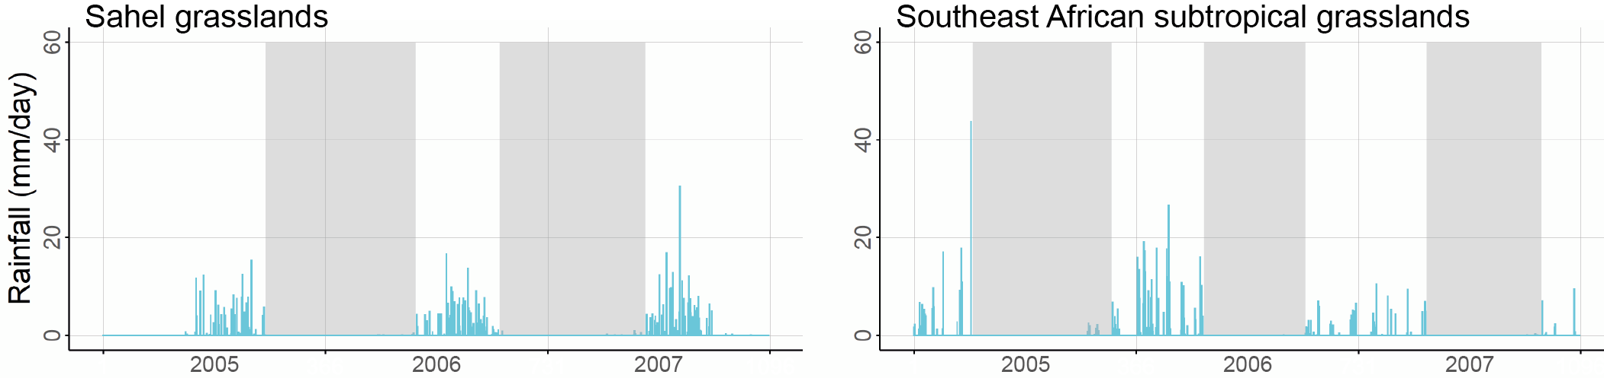
Figure S1 Sample examples of the dry season (grey-shaded areas) during 2005-2007 for a random pixel in Sahel grasslands (dry season across two years) and Southeast African subtropical grasslands (dry season within the year).

Dunning, Caroline M, Emily C L Black, and Richard P Allan. 2016. ‘The Onset and Cessation of Seasonal Rainfall over Africa’. Journal of Geophysical Research 121: 11405–24. https://doi.org/10.1002/2016JD025428.
Liebmann, Brant, Ileana Bladé, George N Kiladis, Leila M V Carvalho, Gabriel B Senay, Dave Allured, Stephanie Leroux, and Chris Funk. 2012. ‘Seasonality of African Precipitation from 1996 to 2009’. Journal of Climate 25: 4304–22. https://doi.org/10.1175/JCLI-D-11-00157.1.
Appendix S2: the 37 SEM causal structures
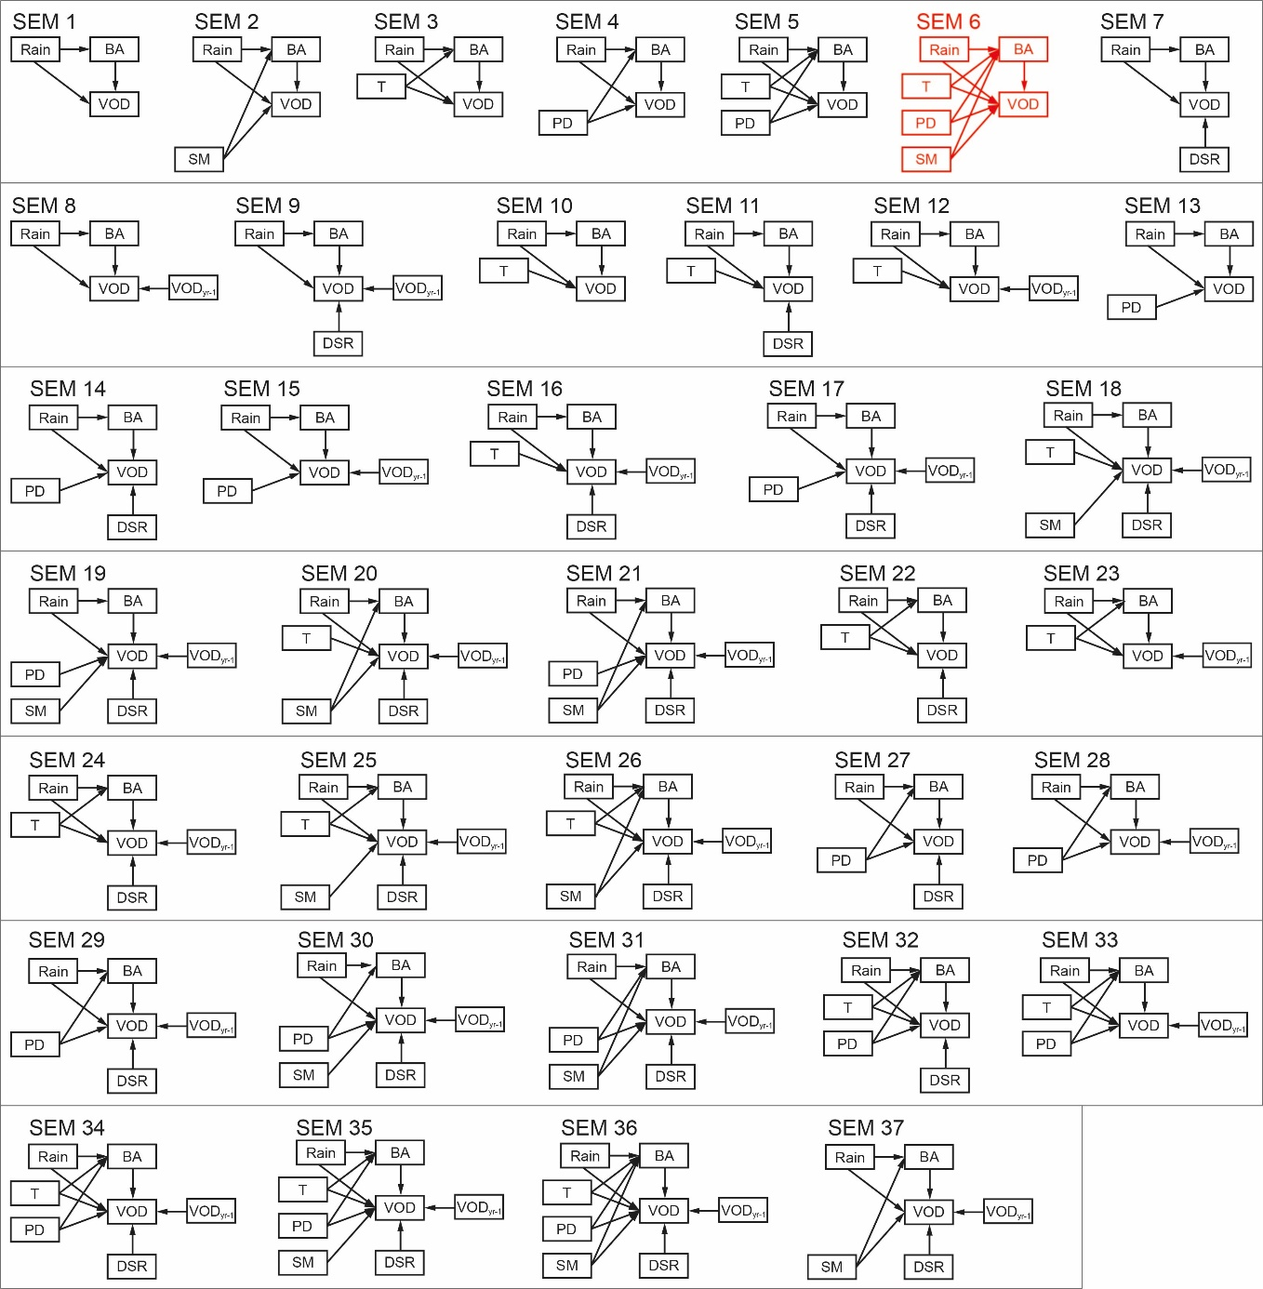
Figure S2 The full list of the 37 SEM causal structures tested each year and each bioregion. The initial hypothesis is highlighted in red. The figure is not showing the 37 SEM structures as per increasing complexity. Acronyms: vegetation optical depth (VOD), burned area (BA), annual rainfall (Rain), temperature (T), dry season rainfall (DSR), population density (PD), soil moisture (SM), previous year VOD (VOD_{yr-1}).
Appendix S3: collinearity between annual rainfall and rainfall metrics
Annual rainfall was significantly collinear (Pearson’s r > 0.774, p < 0.001) with rainfall metrics accumulated over 6, 12, 18, and 24 months before the start of the fire season during 1997-2016 (Appendix S3: Figure S1). For this reason, only annual rainfall was included as a
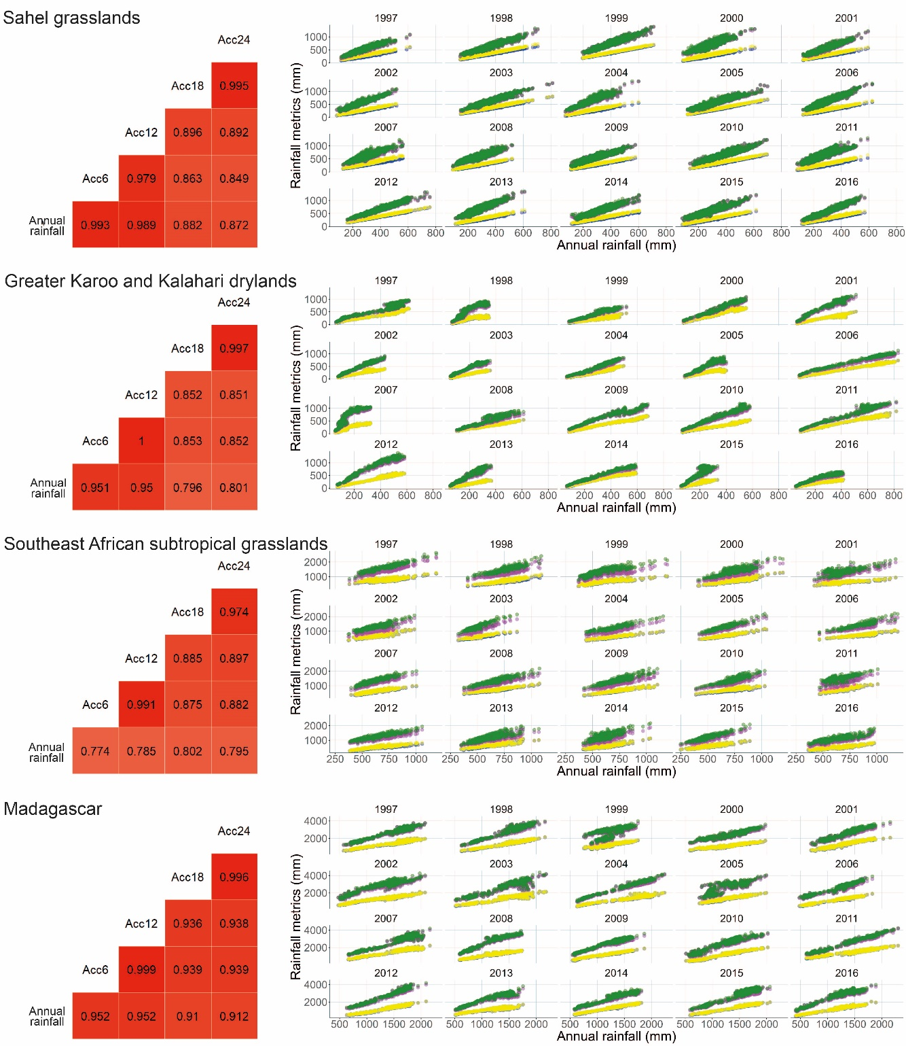
Appendix S3: Figure S1 Collinearity (Pearson’s r > 0.774, p < 0.001) between annual rainfall and rainfall accumulated over 6 (Acc6), 12 (Acc12), 18 (Acc18), and 24 (Acc24) months before the fire season across 1997-2016. Darkest red indicates highest correlations (left). We also plotted scatterplots (right) between annual rainfall and Acc6 (blue), Acc12 (yellow), Acc18 (purple), and Acc24 (green) to facilitate both the assessment of linearity and the influence of any potential outliers.
predictor variable in the 37 SEMs. Note that in the four bioregions, the fire season largely corresponded with the dry season (Appendix S3: Figure S2) (Abdi et al. 2022).
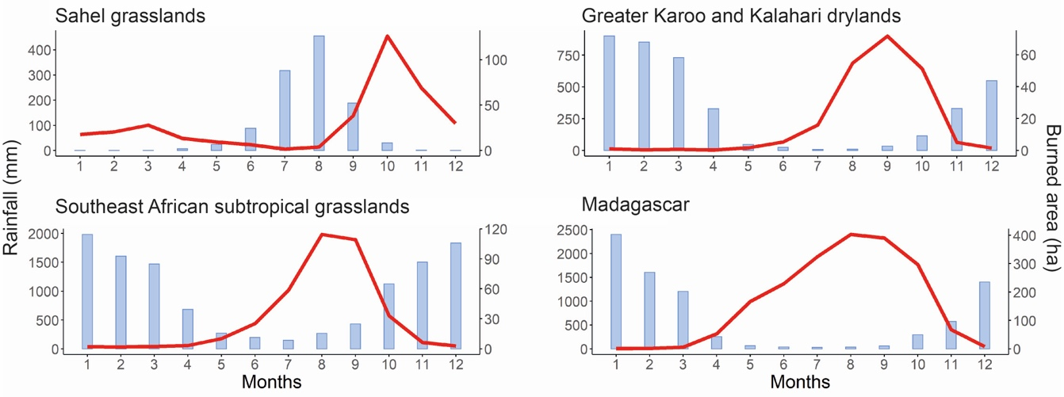
Appendix S3: Figure S2 The timing of the fire season (red line) in relation to rainfall patterns (light blue bars) in the four bioregions. The fire season and dry season largely overlapped. To calculate the rainfall accumulated over 6, 12, 18, and 24 months before the onset of the dry season, we started to accumulate rainfall from the day before the start of the dry season (see Appendix S1) each year. The figure shows monthly burned area (ha) and monthly rainfall (mm) averaged during 1997-2016.

Abdi, Abdulhakim M, Martin Brandt, Christin Abel, and Rasmus Fensholt. 2022. “Review Article Satellite Remote Sensing of Savannas: Current Status and Emerging Opportunities.” Journal of Remote Sensing, 2022:2022. https://doi.org/DOI: 10.34133/2022/9835284.
Appendix S4: spatial autocorrelation (SAC)
SAC is identified by clusters of relatively large residuals of the same sign, correlograms decreasing from a certain level of SAC, and statistically significant (p < 0.001) Moran’s I. As these conditions were observed in preliminary model runs, we embedded SEMs with spatial autoregressive error models (R package ‘spatialreg’; Bivand, Piras et al. 2022) (Figure S4).
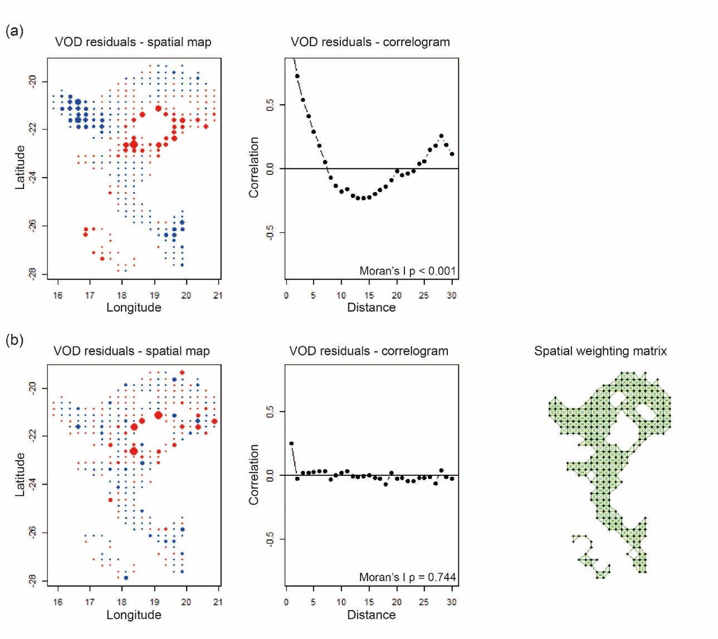
Figure S4 SAC in an SEM not embedding (a) and embedding (b) errorsarlm models. In (b) we also plotted the spatial weighting matrix (R package ‘spdep’; Bivand, Altman, et al. 2022) used by errorsarlm models to handle SAC (d1 = 0 km and d2 = 39 km). For brevity, we only show one example (i.e., SEM20 for 1997 in Greater Karoo and Kalahari drylands). Residuals in the maps are positive (blue) and negative (red). The figure was produced following Dormann et al. (2007).

Bivand, Roger, Micah Altman, Luc Anselin, Renato Assunção, Olaf Berke, Guillaume Blanchet, Marilia Carvalho, et al. 2022. “Package ‘Spdep.’” CRAN.
Bivand, Roger, Gianfranco Piras, Luc Anselin, Andrew Bernat, Eric Blankmeyer, Yongwan Chun, Virgilio Gómez-Rubio, et al. 2022. “Package ‘Spatialreg.’” CRAN.
Dormann, Carsten F, Jana M McPherson, Miguel B Araújo, Roger Bivand, Janine Bolliger, Gudrun Carl, Richard G Davies, et al. 2007. “Methods to Account for Spatial Autocorrelation in the Analysis of Species Distributional Data: A Review.” Ecography 30: 609–28. https://doi.org/10.1111/j.2007.0906-7590.05171.x.
Appendix S5: full result for final SEMs
Appendix S5 shows two tables for each bioregion:
- a table reporting the list of final SEMs, Fisher’s C, Fisher’s C p-value, Chi-squared, Chi-squared p-value, degrees of freedom, ΔAIC, Nagelkerke r², and standardised path regression coefficients (β) each year
- a table reporting the mean, 95% confidence interval, standard deviation, and coefficient of variation of standardised path regression coefficients (β) for each year
Appendix S5: Table S1 Final SEMs, Fisher’s C (F’s C), Fisher’s C p-value (F's C p), Chi-squared (χ²), Chi-squared p-value (χ² p), degrees of freedom (DF) for both the Fisher’s C and Chi-squared statistics, ΔAIC, Nagelkerke r² (Nag. r²), and standardised path regression coefficients (β) each year in Sahel Grasslands. Blue-shaded cells indicate statistical significance (p < 0.05). Maximum number of final SEMs: 10 (2004 and 2014). Minimum number of final SEMs: 1 (1998, 2008, 2015). Average: 5.3 final SEMs per year.
Appendix S5: Table S1 cont.
Appendix S5: Table S2 Mean, 95% confidence interval (CI upper/lower limit), standard deviation (SD), and coefficient of variation (CV) of standardised regression coefficients (β) for each path in Sahel grasslands. No CI and SD for years with one final SEM only. Similarly, there are no CI and SD when either no or only one β is available in a year. Further, SD is zero when β does not change within a year. Green-shaded cells are the overall mean values that were used to scale the arrows of the diagrams in Figure 4a, while the 1997-2016 graphs of Figure 4a were produced using the mean, CI upper limit, and CI lower limit values.
Appendix S5: Table S2 cont.
Appendix S5: Table S3 Final SEMs, Fisher’s C (F’s C), Fisher’s C p-value (F's C p), Chi-squared (χ²), Chi-squared p-value (χ² p), degrees of freedom (DF) for both the Fisher’s C and Chi-squared statistics, ΔAIC, Nagelkerke r² (Nag. r²), and standardised path regression coefficients (β) each year in Greater Karoo and Kalahari drylands. Saturated SEMs have no degrees of freedom and Fisher’s C statistic (2012). Blue-shaded cells indicate statistical significance (p < 0.05). Maximum number of final SEMs: 11 (2009). Minimum number of final SEMs: 1 (1999, 2012). Average: 5.7 final SEMs per year.
Appendix S5: Table S3 cont.
Appendix S5: Table S4 Mean, 95% confidence interval (CI upper/lower limit), standard deviation (SD), and coefficient of variation (CV) of standardised regression coefficients (β) for each path in Greater Karoo and Kalahari. No CI and SD for years with one final SEM only. Similarly, there are no CI and SD when either no or only one β is available in a year. Further, SD is zero when β does not change within a year. Green-shaded cells are the overall mean values that were used to scale the arrows of the diagrams in Figure 4b, while the 1997-2016 graphs of Figure 4b were produced using the mean, CI upper limit, and CI lower limit values.
Appendix S5: Table S4 cont.
Appendix S5: Table S5 Final SEMs, Fisher’s C (F’s C), Fisher’s C p-value (F's C p), Chi-squared (χ²), Chi-squared p-value (χ² p), degrees of freedom (DF) for both the Fisher’s C and Chi-squared statistics, ΔAIC, Nagelkerke r² (Nag. r²), and standardised path regression coefficients (β) each year in Southeast African subtropical grasslands. Saturated SEMs have no degrees of freedom and Fisher’s C statistic (2000, 2014, 2015). Blue-shaded cells indicate statistical significance (p < 0.05). Maximum number of final SEMs: 11 (2005). Minimum number of final SEMs: 1 (1999, 2014). Average: 4.7 final SEMs per year.
Appendix S5: Table S5 cont.
Appendix S5: Table S6 Mean, 95% confidence interval (CI upper/lower limit), standard deviation (SD), and coefficient of variation (CV) of standardised regression coefficients (β) for each path in Southeast African subtropical grasslands. No CI and SD for years with one final SEM only. Similarly, there are no CI and SD when either no or only one β is available in a year. Further, SD is zero when β does not change within a year. Green-shaded cells are the overall mean values that were used to scale the arrows of the diagrams in Figure 4c, while the 1997-2016 graphs of Figure 4c were produced using the mean, CI upper limit, and CI lower limit values.
Appendix S5: Table S6 cont.
Appendix S5: Table S7 Final SEMs, Fisher’s C (F’s C), Fisher’s C p-value (F's C p), Chi-squared (χ²), Chi-squared p-value (χ² p), degrees of freedom (DF) for both the Fisher’s C and Chi-squared statistics, ΔAIC, Nagelkerke r² (Nag. r²), and standardised path regression coefficients (β) each year in Madagascar. Blue-shaded cells indicate statistical significance (p < 0.05). Maximum number of final SEMs: 4 (2008). Minimum number of final SEMs: 1 (2003, 2004, 2011). Average: 2.4 final SEMs per year.
Appendix S5: Table S8 Mean, 95% confidence interval (CI upper/lower limit), standard deviation (SD), and coefficient of variation (CV) of standardised regression coefficients (β) for each path in Madagascar. No CI and SD for years with one final SEM only. Similarly, there are no CI and SD when either no or only one β is available in a year. Further, SD is zero when β does not change within a year. Green-shaded cells are the overall mean values that were used to scale the arrows of the diagrams in Figure 4d, while the 1997-2016 graphs of Figure 4d were produced using the mean, CI upper limit, and CI lower limit values.
Appendix S5: Table S8 cont.
Appendix S6: model evaluation
Final SEMs were selected via satisfactory Fisher’s C, χ², and ΔAIC values. In addition, to verify whether final SEMs fitted the data well, we checked the distribution of the VOD residuals and plotted VOD residuals against fitted values, each variable included and not included in the model, latitude and longitude, and time, as suggested in Zuur and Ieno (2016). VOD residuals were normally distributed, and no trend was observed in both the residuals vs. fitted values and residuals vs. variables plots in all bioregions, as recommended. Note that in the residuals vs. variables plot, we scaled the VOD residuals to allow for comparability. Further, for brevity, we only showed the residuals vs. variables plots for the most likely SEM at the beginning (1997) and the end (2016) of the time series of our analysis for each bioregion. Figures are as follows: Sahel grasslands is Appendix S6: Figure S1; Greater Karoo and Kalahari drylands is Appendix S6: Figure S2; Southeast African subtropical grasslands is Appendix S6: Figure S3; Madagascar is Appendix S6: Figure S4.
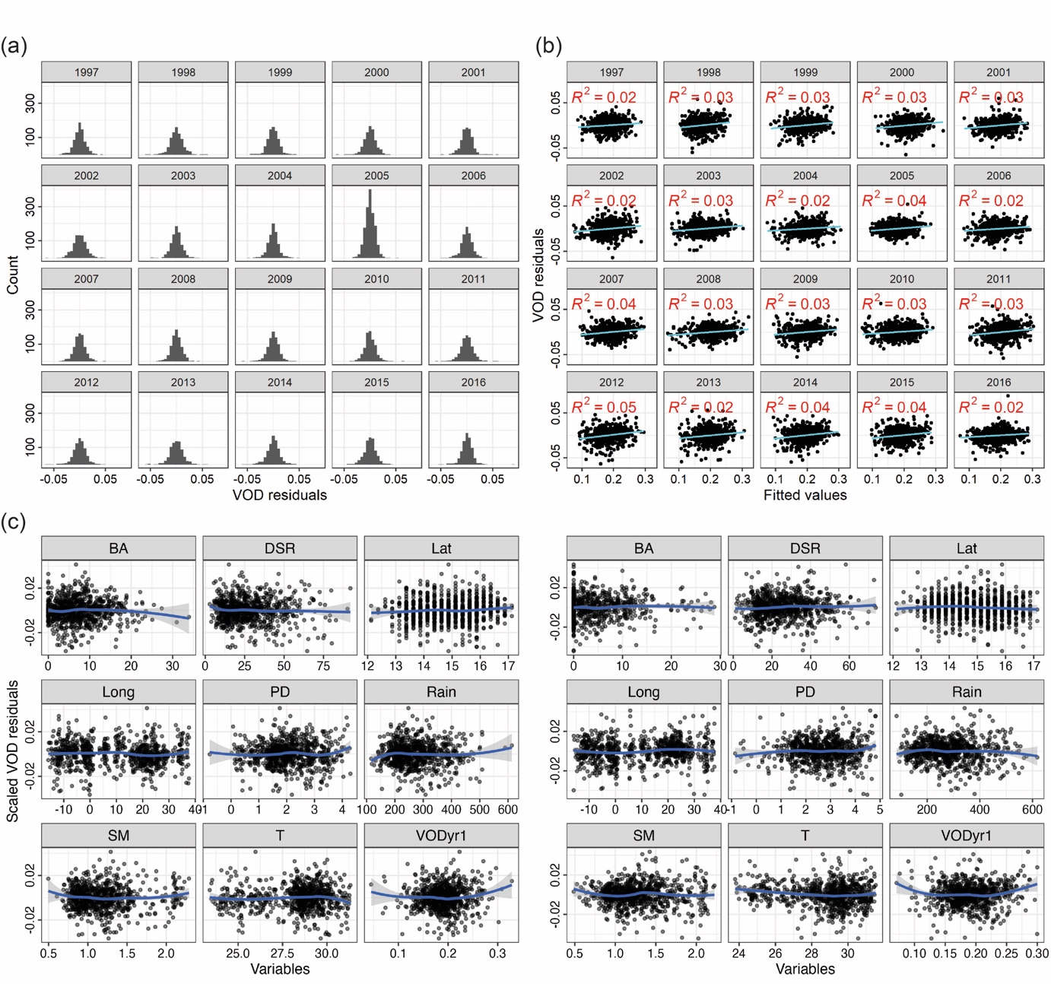
Appendix S6: Figure S1 Distribution of the VOD residuals (a), VOD residuals vs. fitted values (b), and scaled VOD residuals vs. variables (c) in 1997 (left) and 2016 (right) for Sahel grasslands. Variables are burned area (BA), dry season rainfall (DSR), latitude (Lat), longitude (Long), population density (PD), annual rainfall (Rain), soil moisture (SM), temperature (T) and previous year VOD (VOD_{yr-1}).
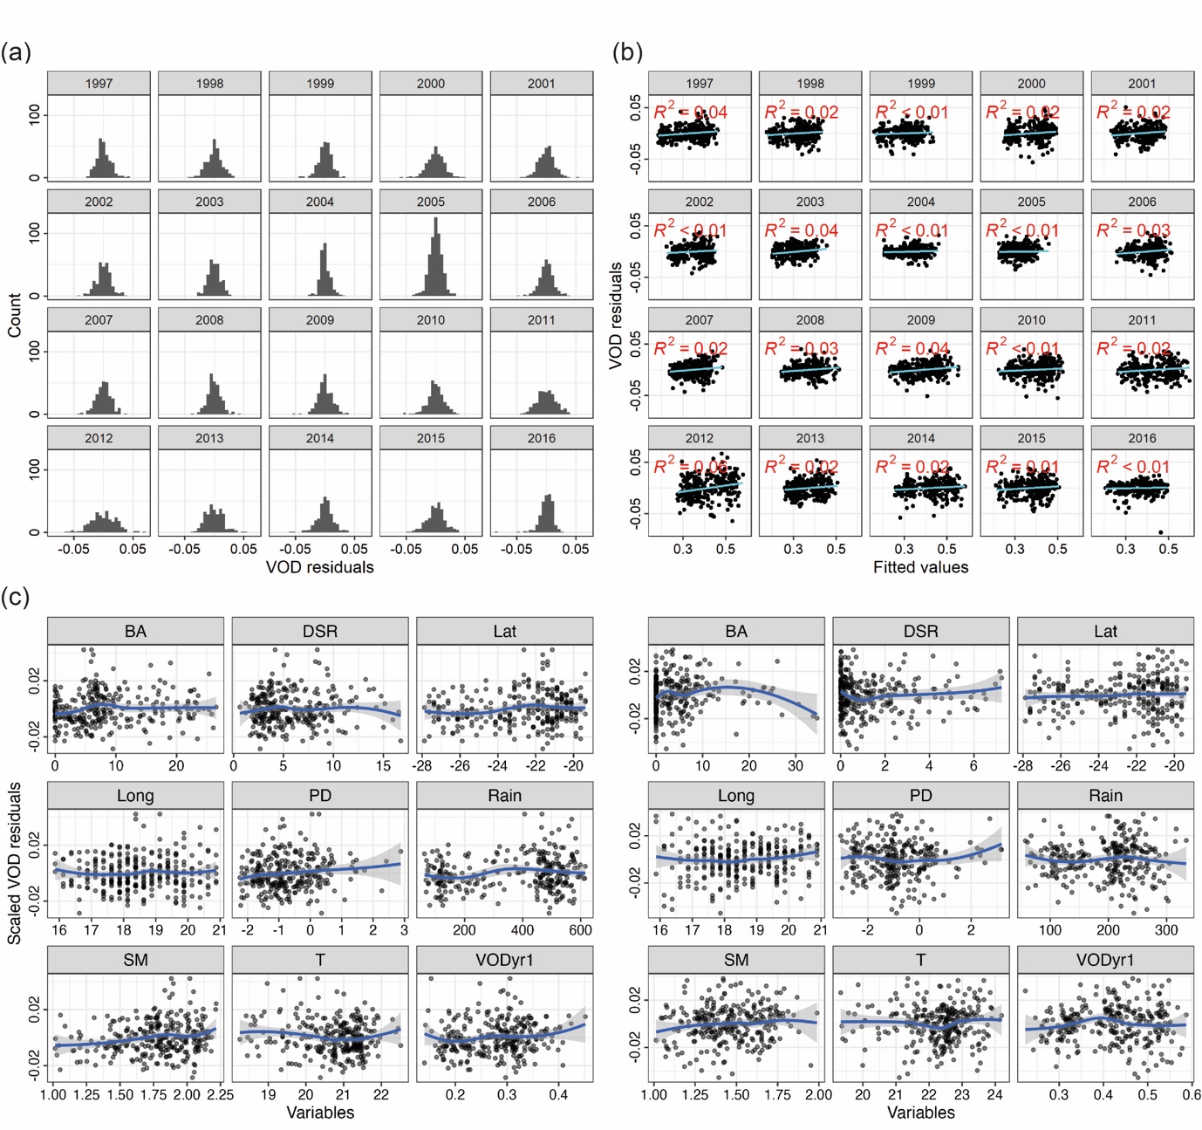
Appendix S6: Figure S2 Distribution of the VOD residuals (a), VOD residuals vs. fitted values (b), and scaled VOD residuals vs. variables (c) in 1997 (left) and 2016 (right) for Greater Karoo and Kalahari drylands. Variables are burned area (BA), dry season rainfall (DSR), latitude (Lat), longitude (Long), population density (PD), annual rainfall (Rain), soil moisture (SM), temperature (T) and previous year VOD (VOD_{yr-1}).
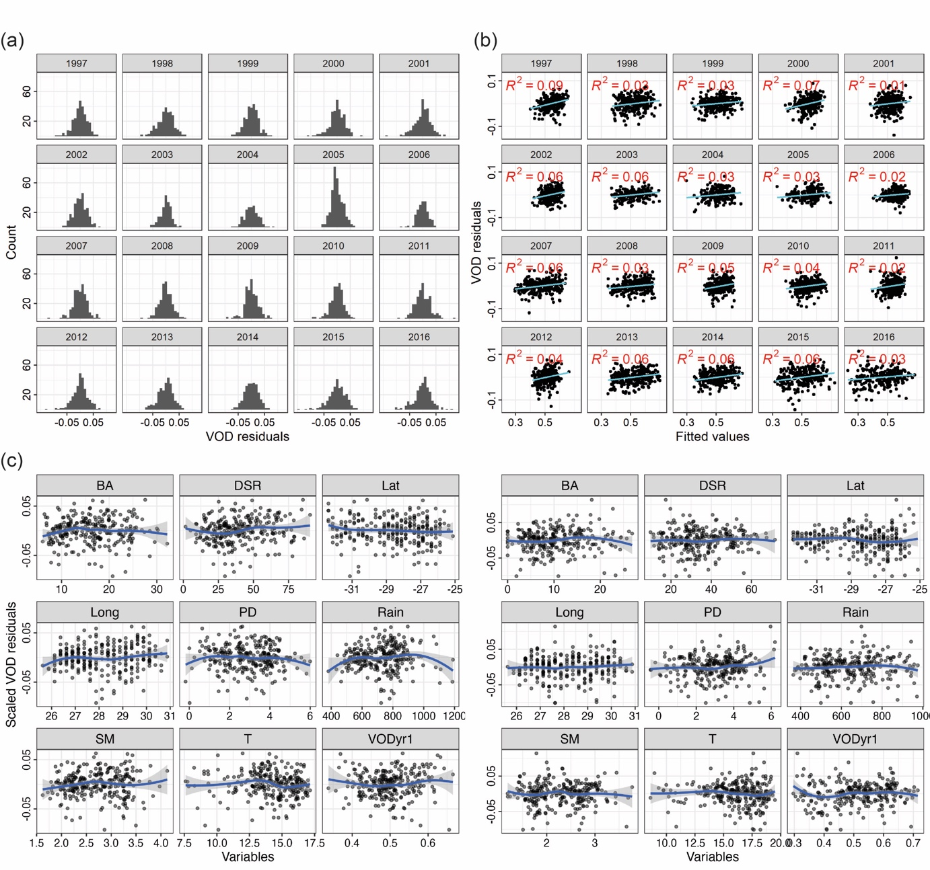
Appendix S6: Figure S3 Distribution of the VOD residuals (a), VOD residuals vs. fitted values (b), and scaled VOD residuals vs. variables (c) in 1997 (left) and 2016 (right) for Southeast African subtropical grasslands. Variables are burned area (BA), dry season rainfall (DSR), latitude (Lat), longitude (Long), population density (PD), annual rainfall (Rain), soil moisture (SM), temperature (T) and previous year VOD (VOD_{yr-1}).
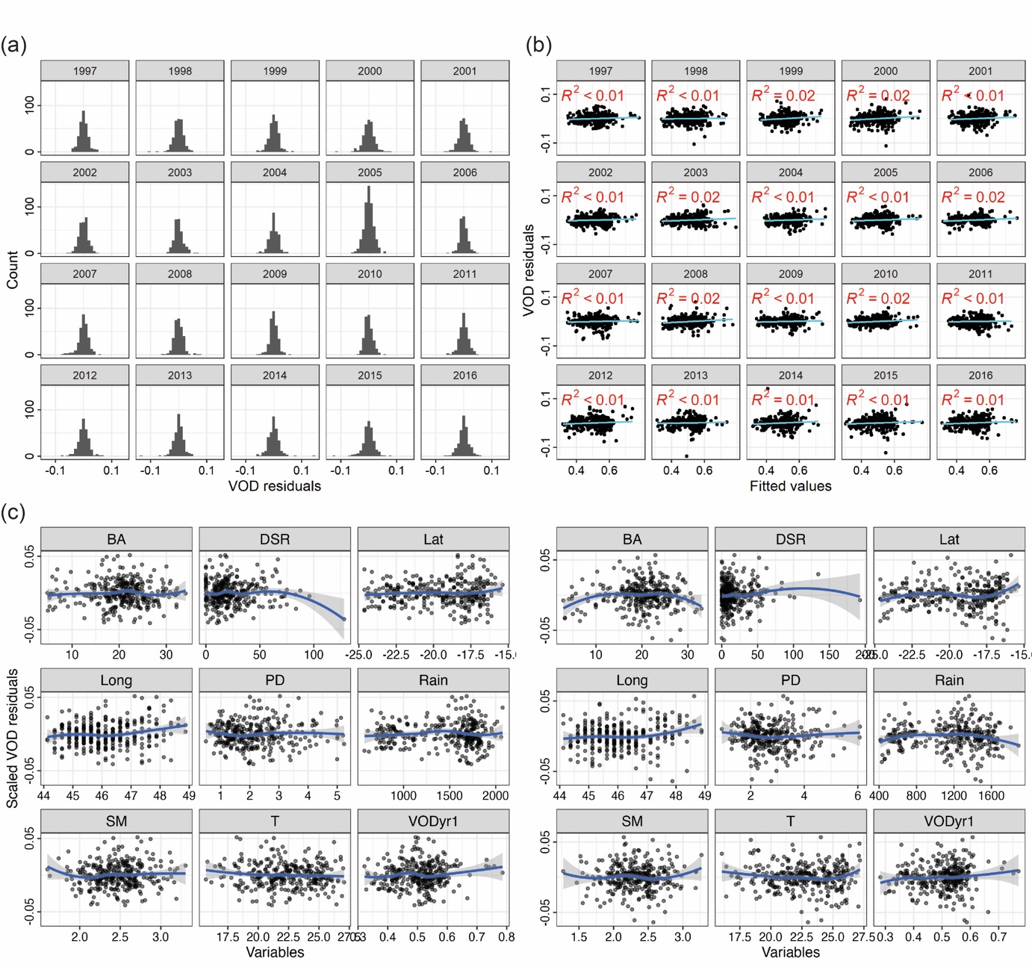
Appendix S6: Figure S4 Distribution of the VOD residuals (a), VOD residuals vs. fitted values (b), and scaled VOD residuals vs. variables (c) in 1997 (left) and 2016 (right) for Madagascar. Variables are burned area (BA), dry season rainfall (DSR), latitude (Lat), longitude (Long), population density (PD), annual rainfall (Rain), soil moisture (SM), temperature (T) and previous year VOD (VOD_{yr-1}).

Zuur, Alain F, and Elena N Ieno. 2016. “A Protocol for Conducting and Presenting Results of Regression-Type Analyses.” Methods in Ecology and Evolution 7: 636–45. https://doi.org/10.1111/2041-210X.12577.
Appendix S7: preprocessing
All data were resampled to the common spatial resolution of 25 km × 25 km (i.e., the coarser among our data) at which the VOD data are available, using both the aggregate and resample function from the R package ‘terra’ (Hijmans et al. 2023). The discrete ESA CCI land cover map was resampled with a majority resample approach, in which we decided to include only the 25 km × 25 km pixels where at least 50% of the cell was classified as classes 110 (mosaic herbaceous cover > 50% and tree and shrub < 50%) and/or 130 (grassland) (Eigenbrod et al. 2020). We then explored the data following Zuur, Ieno, and Elphick (2010), as follows. Some 130 outlier pixels (i.e., zeros) per bioregion were removed from the soil moisture data because of the storage failure that occurred onboard the European Remote Sensing satellite 2 (ERS-2) during 2003-2006 (Dorigo et al. 2017). A few other outliers (up to ca. 5 per bioregion) were removed based on boxplots and Cleveland dotplots (e.g., population density data, as some densely populated areas were unavoidably reintroduced due to the resampling to a coarser resolution). Collinearity between rainfall and soil moisture was observed only in Greater Karoo and Kalahari drylands in 1997, 2000, 2001, 2006, 2010, and 2014, as indicated by Pearson’s r > 0.7 (Dormann et al. 2013). Prior to fitting models in these years, we removed soil moisture and used only rainfall as a water availability predictor. Normally distributed data remained untransformed (i.e., VOD, rainfall, temperature, and soil moisture), while burned area (cubic root), population density (logarithmic), and dry season rainfall (square root) were transformed before the analysis. In Sahel grasslands and Greater Karoo and Kalahari drylands, burned area could not be normalised despite the transformation given the high number of pixels with low burned area values. For consistency, we still applied the cubic root transformation to preserve changes in the functional shape of the relationship between variables and make the results comparable across bioregions.

Dorigo, Wouter, Wolfgang Wagner, Clement Albergel, Franziska Albrecht, Gianpaolo Balsamo, Luca Brocca, Daniel Chung, et al. 2017. “ESA CCI Soil Moisture for Improved Earth System Understanding: State-of-the Art and Future Directions.” Remote Sensing of Environment 203: 185–215. https://doi.org/10.1016/j.rse.2017.07.001.
Dormann, Carsten F, Jane Elith, Sven Bacher, Carsten Buchmann, Gudrun Carl, Gabriel Carré, Jaime García R Marquéz, et al. 2013. “Collinearity: A Review of Methods to Deal with It and a Simulation Study Evaluating Their Performance.” Ecography 36: 27–46. https://doi.org/10.1111/j.1600-0587.2012.07348.x.
Eigenbrod, Felix, Michael Beckmann, Sebastian Dunnett, Laura Graham, Robert A Holland, Patrick Meyfroidt, Ralf Seppelt, et al. 2020. “Identifying Agricultural Frontiers for Modeling Global Cropland Expansion.” One Earth 3: 504–14. https://doi.org/10.1016/j.oneear.2020.09.006.
Hijmans, Robert J, Roger Bivand, Edzer Pebesma, and Michael D Sumner. 2023. “Package ‘Terra.’” CRAN.
Zuur, Alain F, Elena N Ieno, and Chris S Elphick. 2010. “A Protocol for Data Exploration to Avoid Common Statistical Problems.” Methods in Ecology and Evolution 1: 3–14. https://doi.org/10.1111/j.2041-210x.2009.00001.x.
Appendix S8: overall trend analysis
Appendix S8 shows trends in vegetation optical depth (VOD), burned area (BA), annual rainfall (Rain), temperature (T), and population density (PD) during 1997-2016 in each bioregion. In addition, to facilitate a better overview of the spatiotemporal sub-bioregional relationships between environmental and anthropogenic variables within the bioregions, we plotted k-means cluster per-pixels trends. The k-means cluster method arranges the data into k groups for which the sum of squares from points to the allocated cluster centres is minimized (Hartigan and Wong 1979). Given the spatial extent of our bioregions, we deemed it reasonable to use three clusters (i.e., k = 3). The k-means clusters are calculated with the kmeans in-built function within the R environment (R Core Team 2021). Figures are as follows: Sahel grasslands is Appendix S8: Figure S1; Greater Karoo and Kalahari drylands is Appendix S8: Figure S2; Southeast African subtropical grasslands is Appendix S8: Figure S3; Madagascar is Appendix S8: Figure S4.

Hartigan, John A, and Anthony M Wong. 1979. ‘Algorithm AS 136: A K-Means Clustering Algorithm’. Applied Statistics 28: 100. https://doi.org/10.2307/2346830.
R Core Team (2021). R: A language and environment for statistical computing. R Foundation for Statistical Computing, Vienna, Austria. URL https://www.R-project.org/.
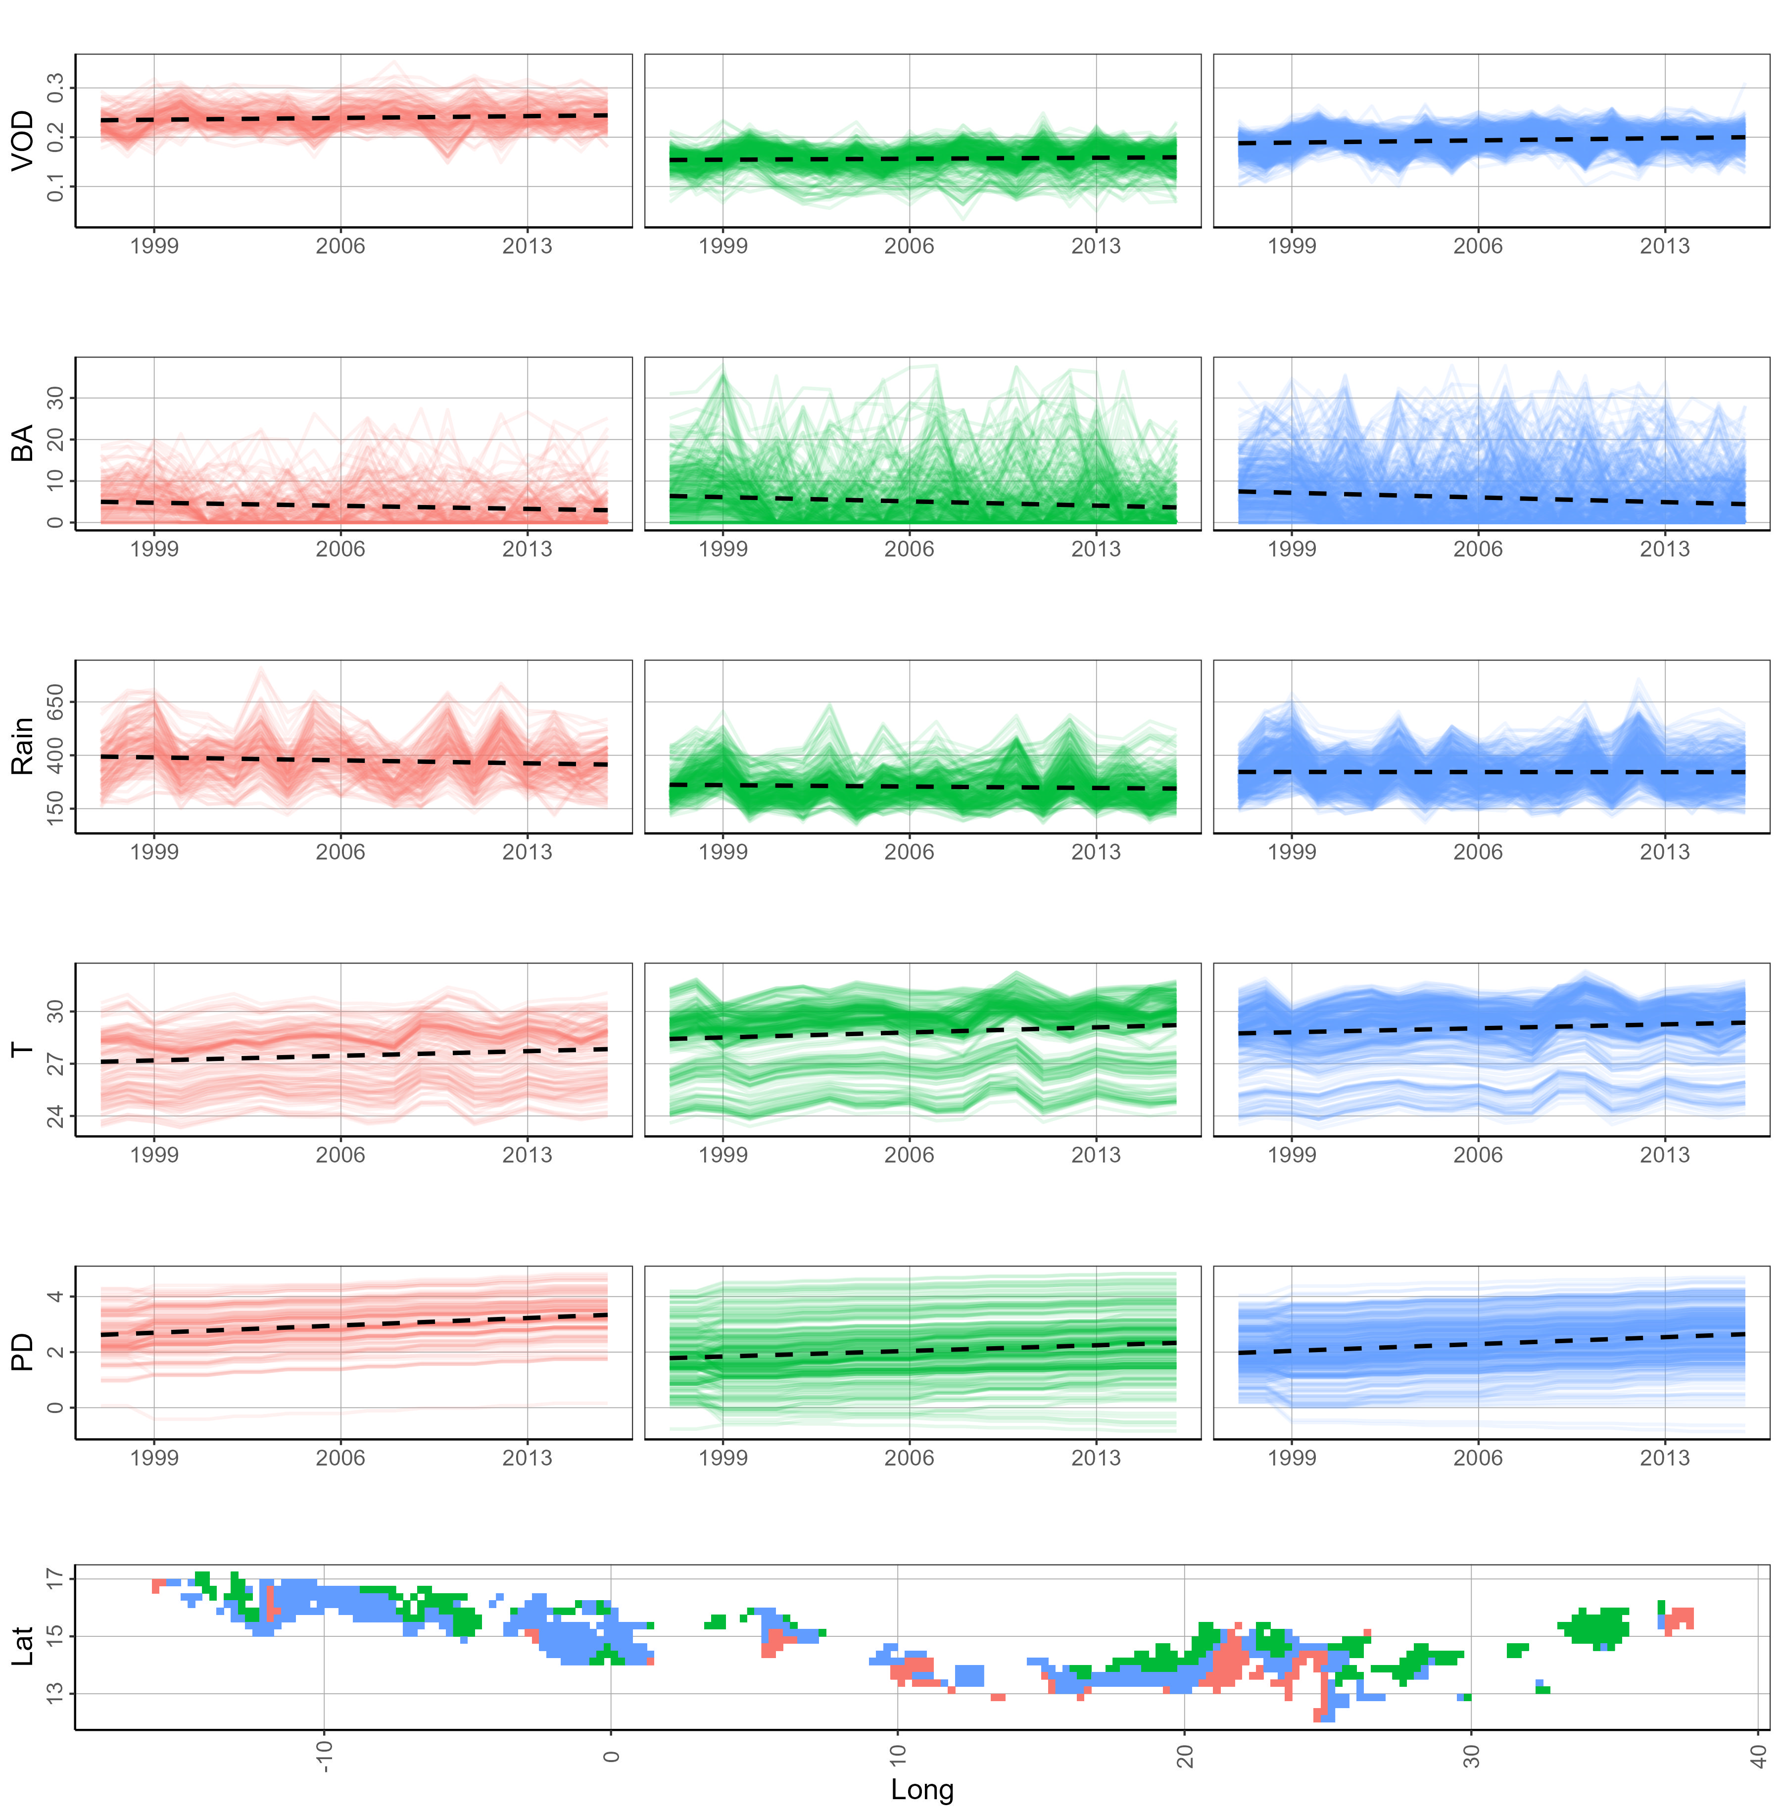
Appendix S8: Figure S1 Sahel grasslands. Overall trends (slope of the regression) during 1997-2016: VOD = 0.0005 VOD unit yr⁻¹ (F(1, 15577) = 93.65, p < 0.001), BA = -0.1463 ha^{1/3} yr⁻¹ (F(1, 15577) = 260.9, p < 0.001), Rain = -0.6438 mm yr⁻² (F(1, 15577) = 21.14, p < 0.001), T = 0.0363 °C yr⁻¹ (F(1, 15577) = 216.2, p < 0.001), PD = 0.0338 log (p km⁻²) yr⁻¹ (F(1, 15577) = 640, p < 0.001) (DSR, SM, and VOD_{yr-1} not shown). Changes in VOD and burned area were overall negligible. Precipitation (negative) and temperature (positive) showed opposite trends. We observed higher population values in the southern part of the Sahel (i.e., greener, wetter, and less warm areas) (pink shading).
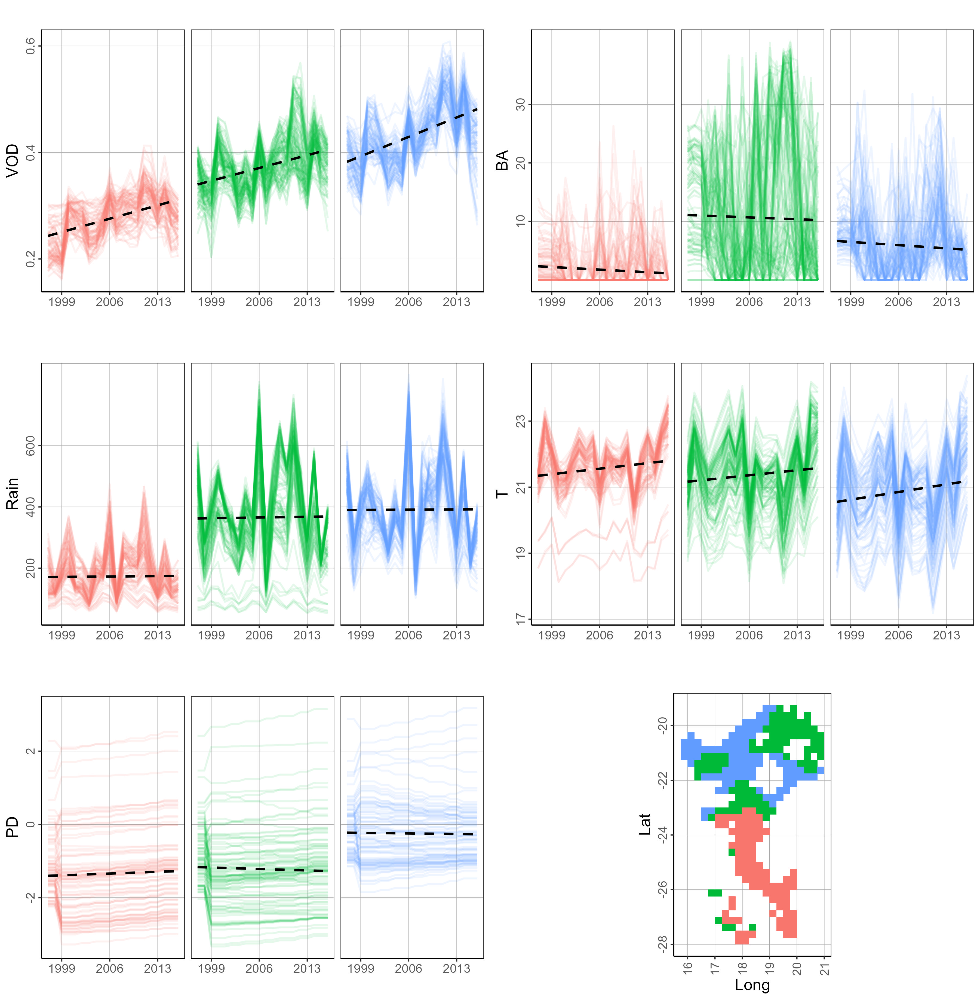
Appendix S8: Figure S2 Greater Karoo and Kalahari drylands. Overall trends (slope of the regression) during 1997-2016: VOD = 0.0041 VOD unit yr⁻¹ (F(1, 5700) = 527.5, p < 0.001), BA = 0.0605 ha^{1/3} yr⁻¹ (F(1, 5700) = 9.854, p = 0.0017), Rain = 0.1712 mm yr⁻² (F(1, 5700) = 0.2216, p = 0.6379), T = 0.0257 °C yr⁻¹ (F(1, 5700) = 105.8, p < 0.001), PD = -0.0017 log (p km⁻²) yr⁻¹ (F(1, 5700) = 0.3955, p = 0.5295) (DSR, SM, and VOD_{yr-1} not shown). VOD showed a clear increase throughout the whole bioregion during 1997-2016. Despite the overall trends (i.e., non-significant in rainfall and significant in temperature) the magnitude of the VOD-Rain standardised path regression coefficient (β = 0.139 [-0.111, 0.366]) was considerably higher than the VOD-Temp one (β = -0.063 [-0.240, -0.002]) (see Figure 4b and Appendix S5: Table S4). This imbalance between rainfall and temperature might have triggered woody encroachment in this bioregion. Drier, warmer, less vegetated, less intense fire, and less populated areas occured in the southern part towards the Kalahari Desert (pink shading).
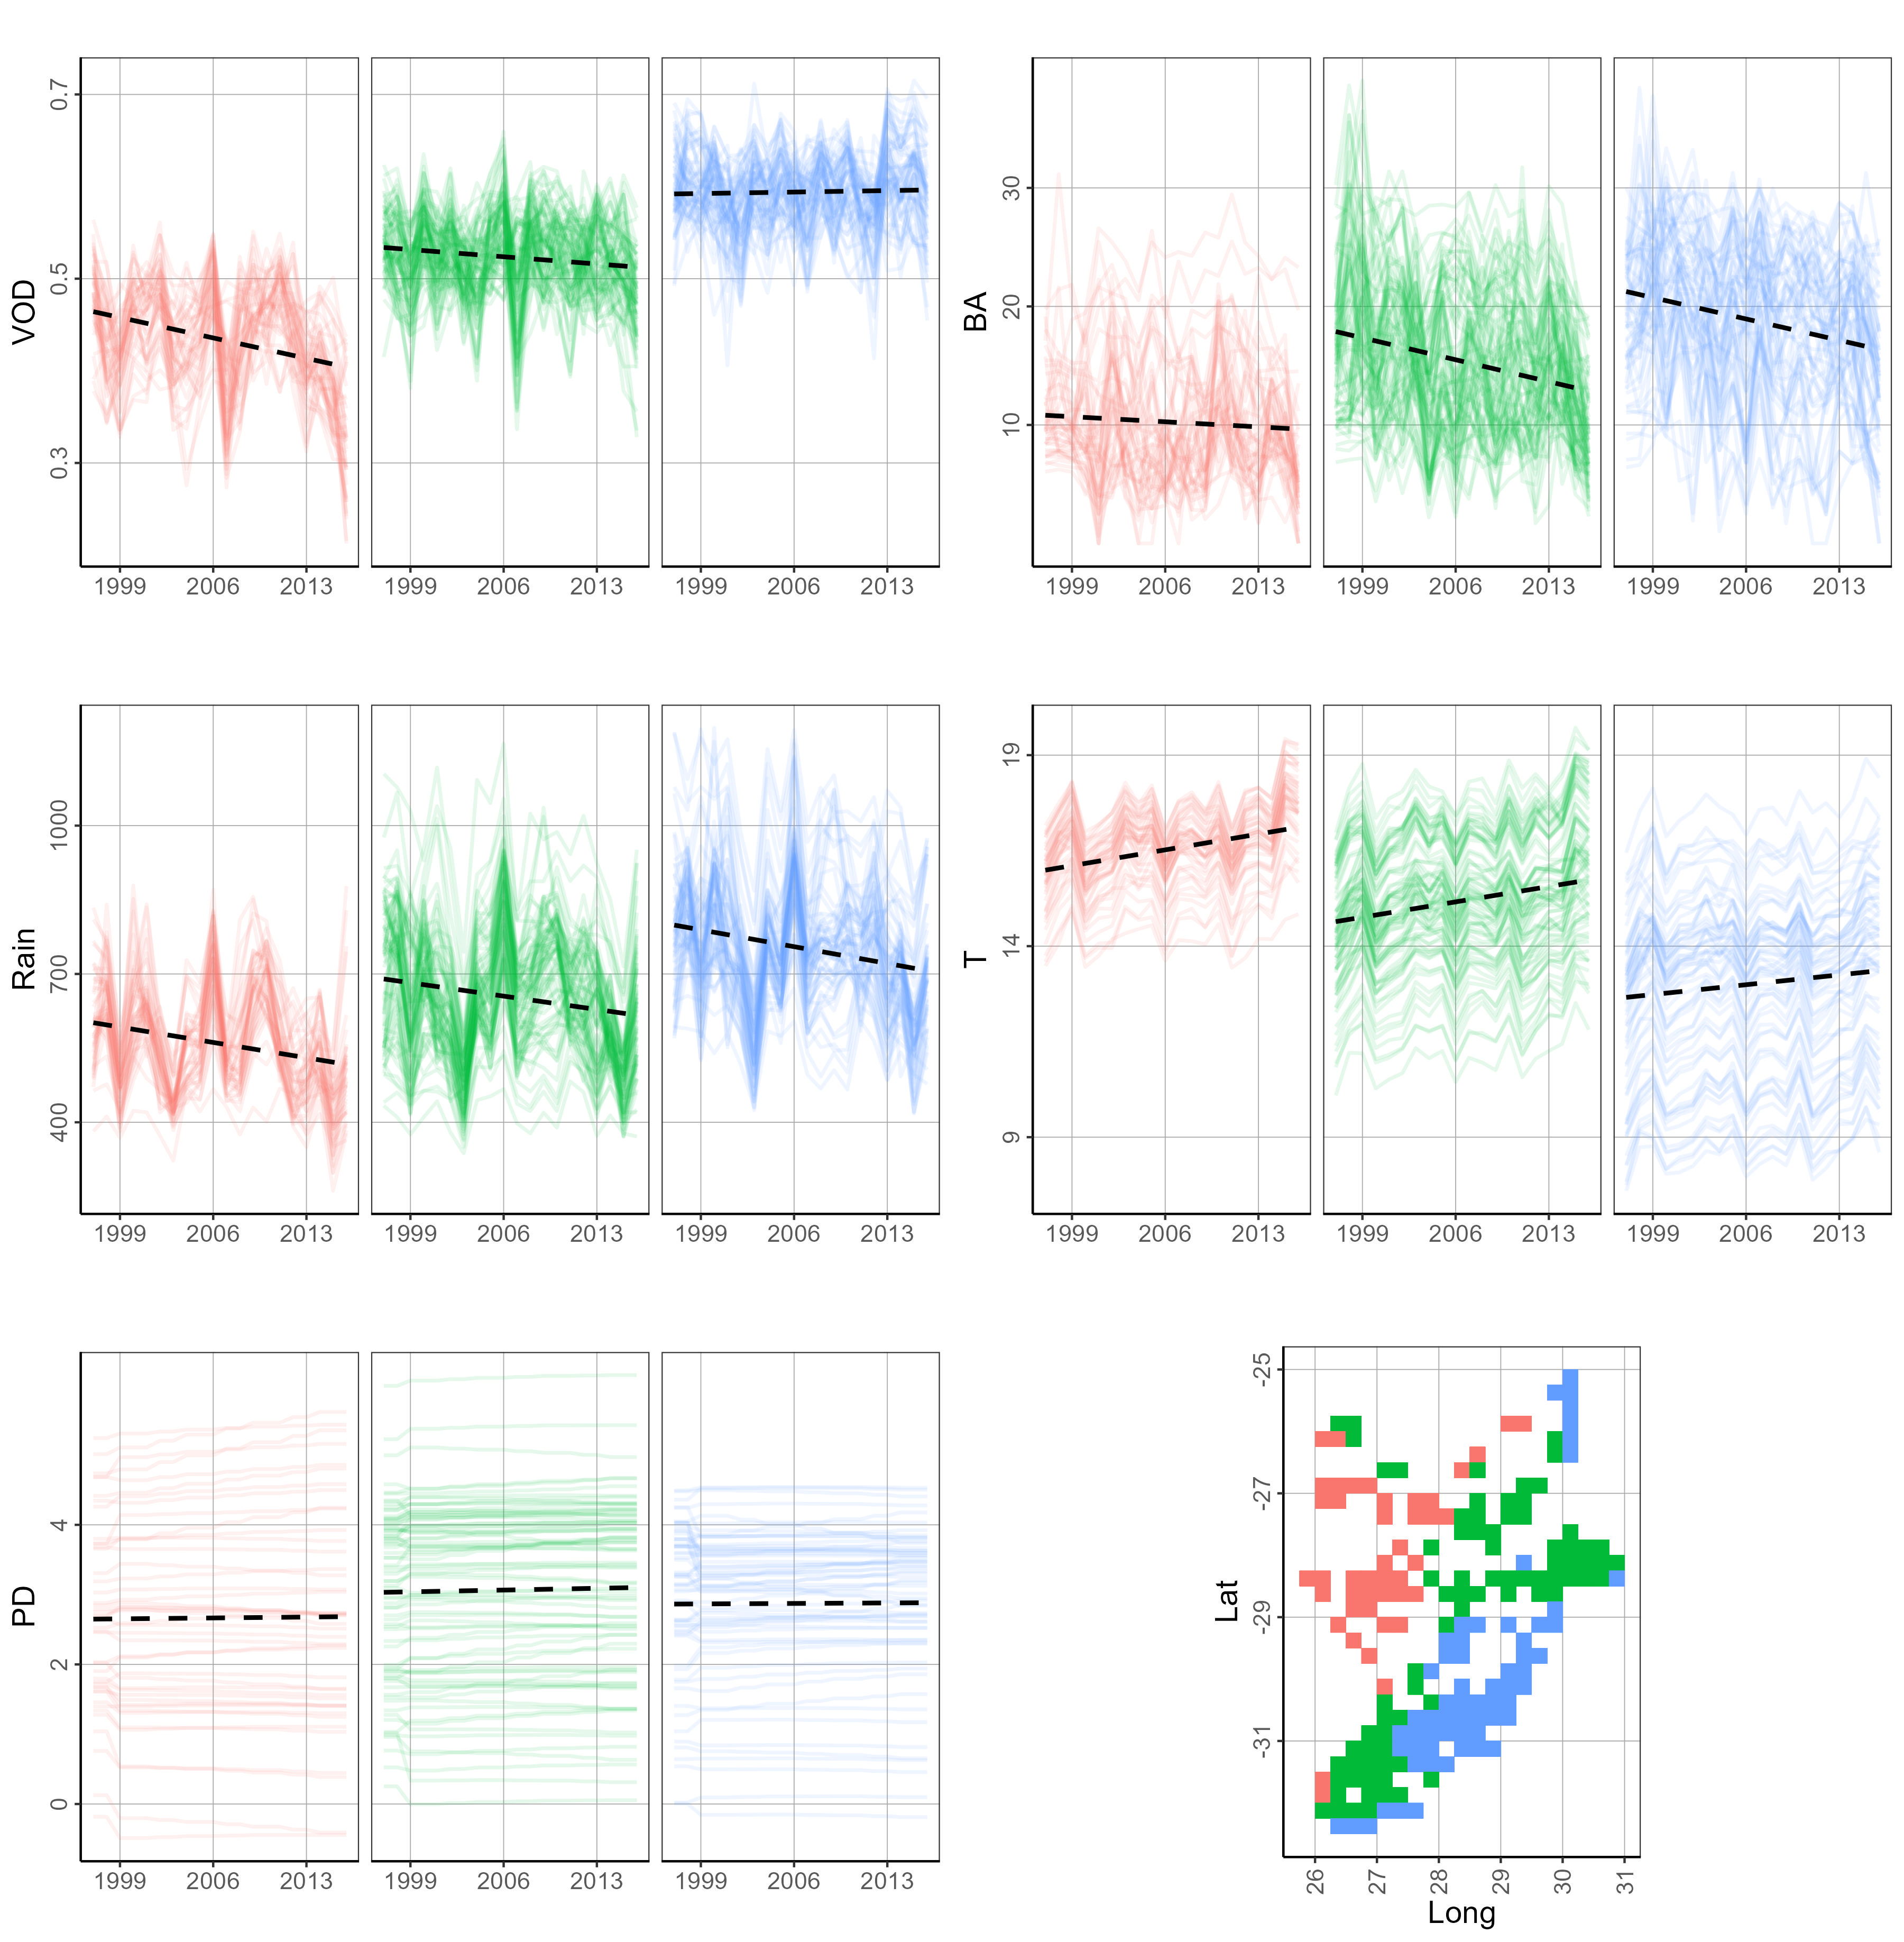
Appendix S8: Figure S3 Southeast African subtropical grasslands. Overall trends (slope of the regression) during 1997-2016: VOD = -0.0014 VOD unit yr⁻¹ (F(1, 5138) = 57.28, p < 0.001), BA = -0.2266 ha^{1/3} yr⁻¹ (F(1, 5136) = 193.8, p < 0.001), Rain = -4.2568 mm yr⁻² (F(1, 5136) = 156.9, p < 0.001), T = 0.0586 °C yr⁻¹ (F(1, 5136) = 141, p < 0.001), PD = 0.0041 log (p km⁻²) yr⁻¹ (F(1, 5136) = 1.872, p = 0.1713) (DSR, SM, and VOD_{yr-1} not shown). No overall changes in VOD, while burned areas changed significantly in the southern areas. Lower/higher rainfall values corresponded to lower/higher VOD. It is further shown the opposite behaviour of rainfall and temperature throughout the bioregion.
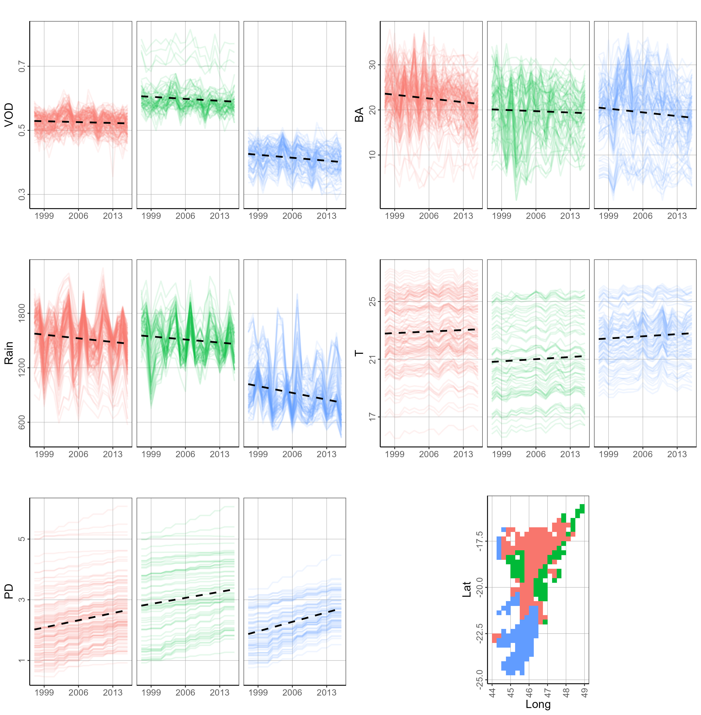
Appendix S8: Figure S4 Madagascar. Overall trends during 1997-2016 (slope of the regression): VOD = -0.0007 VOD unit yr⁻¹ (F(1, 6232) = 17.35, p < 0.001), BA = -0.0980 ha^{1/3} yr⁻¹ (F(1, 6232) = 51.3, p < 0.001), Rain = -6.4899 mm yr⁻² (F(1, 6232) = 64.47, p < 0.001), T = 0.0202 °C yr⁻¹ (F(1, 6232) = 14.58, p = 0.0001), PD = 0.0363 log (p km⁻²) yr⁻¹ (F(1, 6232) = 305.1, p < 0.001) (DSR, SM, and VOD_{yr-1} not shown). Changes in VOD appeared to be weak, while we observed clear variations in temperature (positive), population density (positive), and precipitation (negative) throughout the whole bioregion. Also in this bioregion, lower/higher rainfall values corresponded to lower/higher VOD. As in Greater Karoo and Kalahari drylands, the magnitude of the VOD-Rain standardised path regression coefficient (β = 0.126 [-0.069, 0.267]) was higher than the VOD-Temp one (β = -0.037 [-0.137, 0.133]) (see Figure 4d and Appendix S5: Table S8), yet here, the increase in population density (i.e., anthropogenic activities) has likely played a leading role at controlling ecosystem dynamics (e.g., fire decrease due to fragmentation).

