Supplementary information
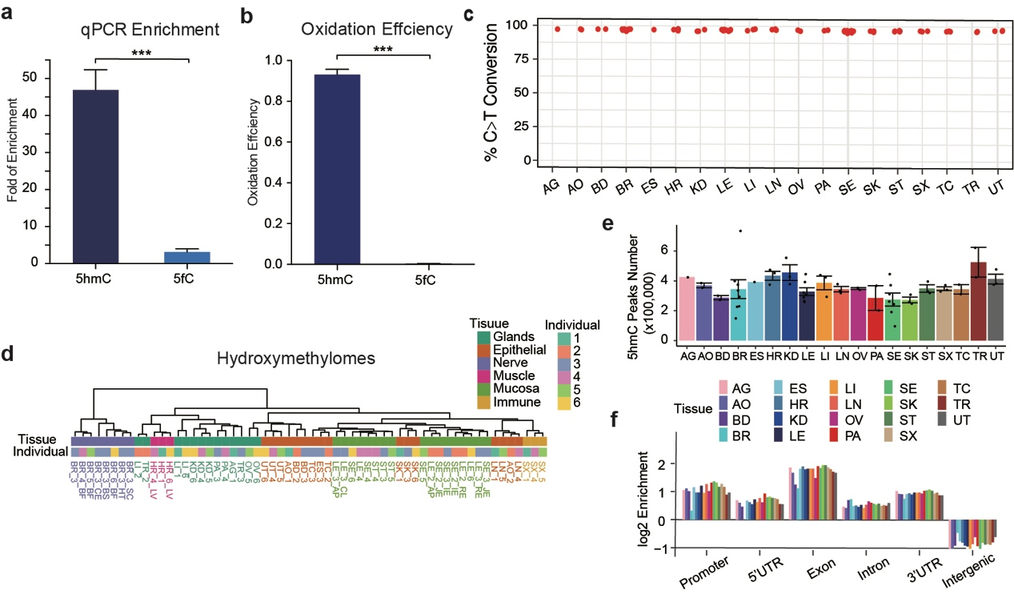
Figure S1. hmC-CATCH data from different tissues are high quality and reproducible. a. Enrichment of spike-in probes detected by qPCR. b. The oxidation efficiency in 5hmC and 5fC spike-in probes by high-throughput sequencing. c. Cytosine-to-thymine conversion rates in all samples. d. Hierarchical clustering of all samples using the first 20 principal components. e. Numbers of 5hmC peaks in all tissues. The error bar represents the standard deviation. f. Enrichment of 5hmC peaks in different genomic features in all tissues.

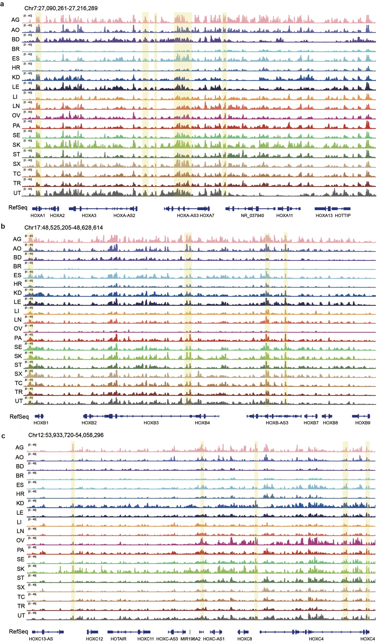
Figure S2. IGV visualization of the 5hmC signals surrounding the HOXA (a), HOXB (b) and HOXC (c) gene family. 5hmC signals in different genomic elements are highlighted.

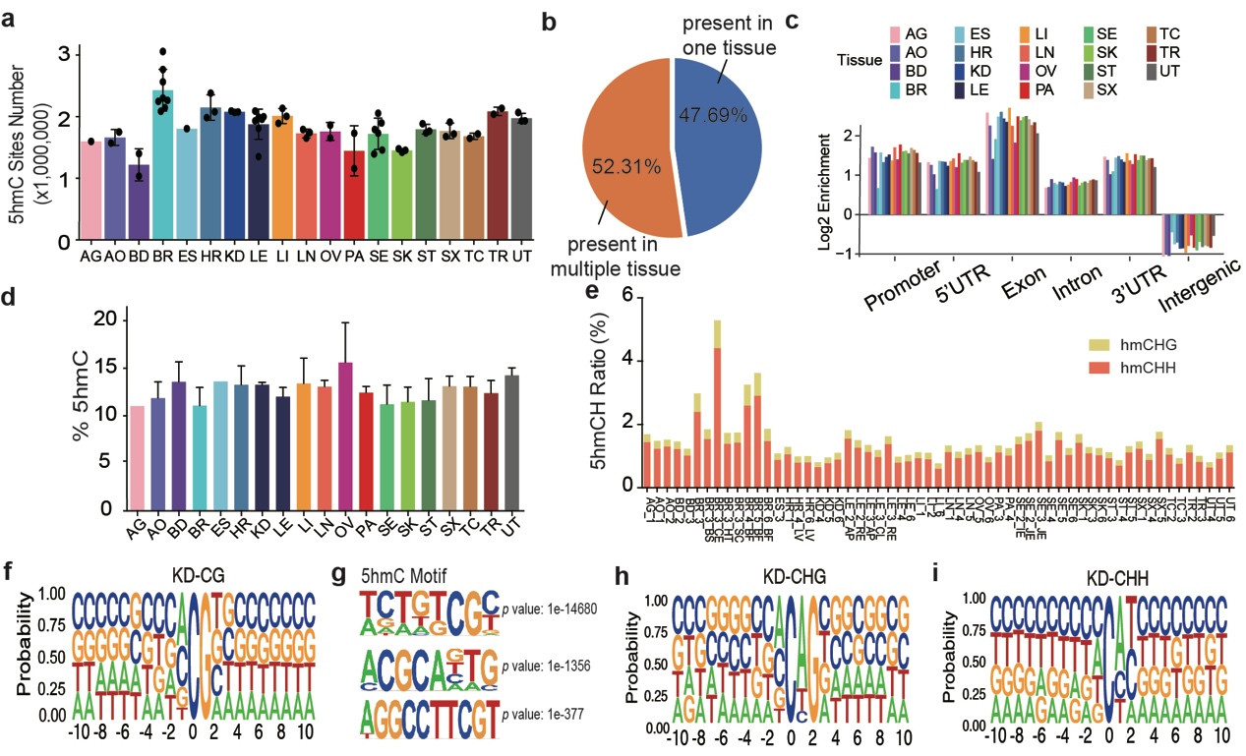
Figure S3: Brief introduction of 5hmC sites. a. Numbers of 5hmC sites in all tissues. Error bar represents standard deviation. b. Proportions of 5hmC present in unique tissue (only detected in one tissue, orange) or multiple tissues (detected in >1 tissues, blue). c. Enrichment of 5hmC sites in different genomic features of all tissues. d. Average proportion of symmetric distributed 5hmC sites. e. The proportions of 5hmCHH and 5hmCHG ratio. f. Sequence context ± 10 bp around 5hmCG sites in the kidney. g. The 5hmC site motif identified by HOMER. h. Sequence context ± 10 bp around 5hmCHG sites in kidney. i. Sequence context ± 10 bp around 5hmCHH sites in kidney.
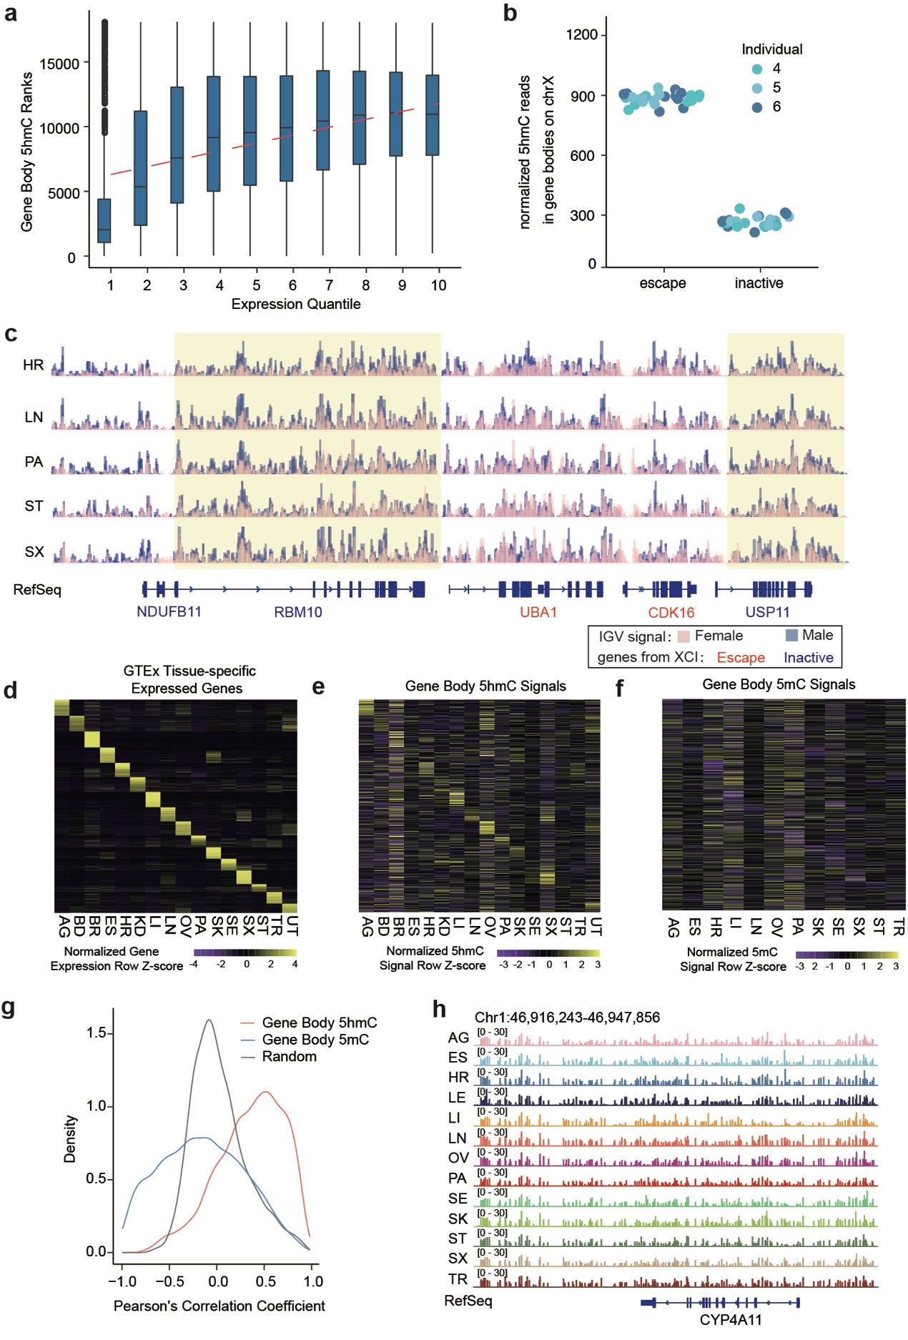
Figure S4. Gene body 5hmC is positively correlated with gene expression. a. Correlation of mean ranks of gene body 5hmC levels and gene expression levels in heart tissue. Genes were divided into ten groups according to their expression levels. b. The normalized read counts in escaped and inactivated genes. c. Overlapped IGV visualization of the normalized 5hmC signals of male and female tissues on chromosome X. The 5hmC signals of male tissues are multiplied by 2. Male samples are colored blue, and female samples are colored pink. The highlighted genes are inactive genes in XCI, and UBA1 and CDK16 escaped from XCI. d. Heatmap displaying the expression levels of genes with tissue-specific expression. Gene expression data of matched tissue samples were downloaded from the GTEx project. e. Heatmap displaying the normalized gene body 5hmC signals of genes with tissue-specific expression. The order of the row is identical to that in (e). f. Heatmap displaying the normalized gene body 5mC signals of genes with tissue-specific expression. The order of the row is identical to that in (e). The 5mC data were downloaded from ENCODE. g. Distribution of Pearson’s correlation between gene body 5hmC (5mC) levels and expression levels across all tissues. h. IGV visualization of the 5mC signals at the gene body of CYP4A11 and surrounding regions.

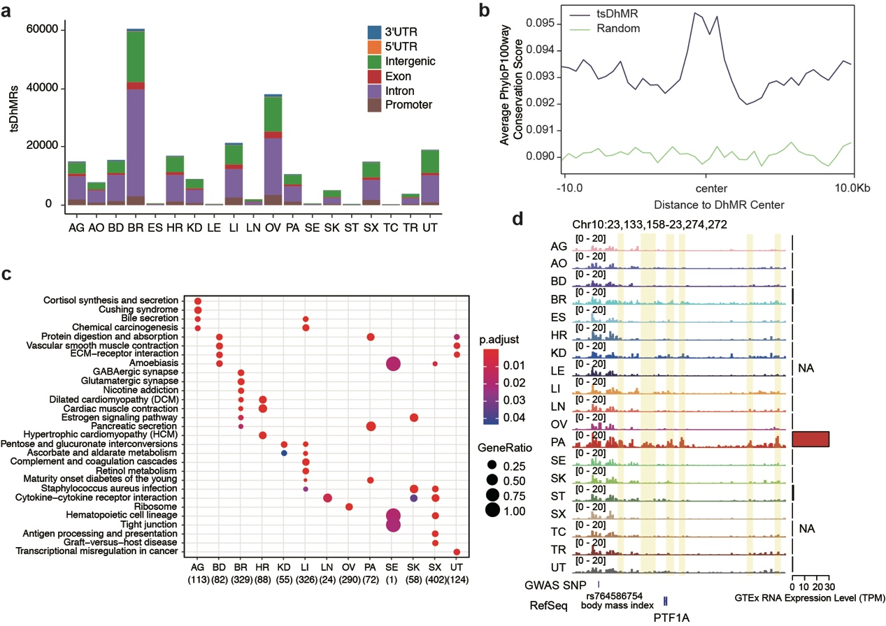
Figure S5. Functions of tsDhMRs. a. Number of tsDhMRs of each tissue. The color represents the genomic annotation of the tsDhMRs. b. KEGG pathway enrichment of tsDhMR-associated genes. c. Average phyloP100way conservation scores around tsDhMRs. Higher scores indicate greater conservation. d. IGV visualization of the 5hmC signals surrounding PTF1A on chromosome 10. The highlighted regions are pancreas-specific DhMRs.

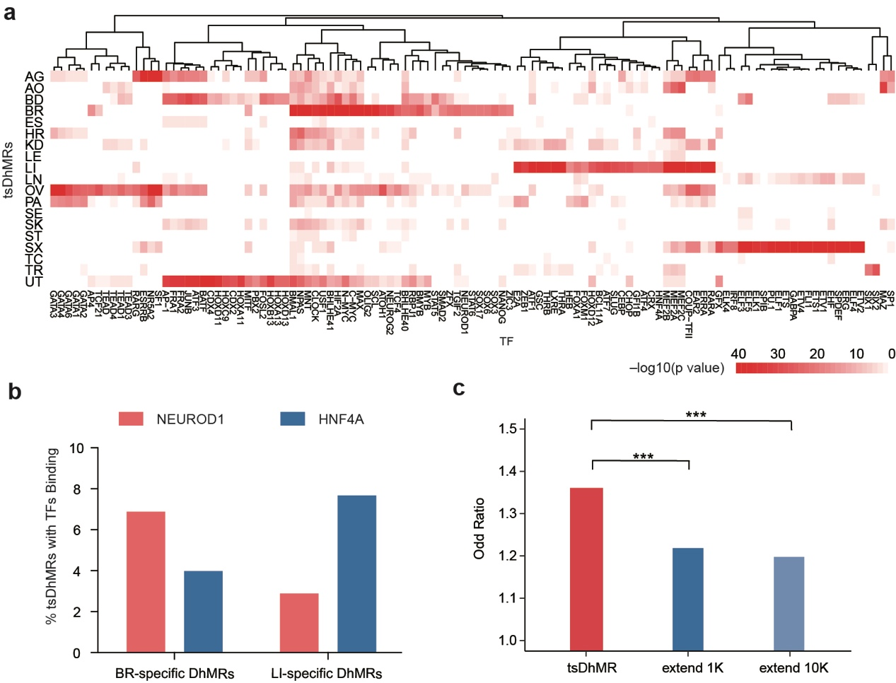
Figure S6. tsDhMRs enriched with TFs and GWAS SNPs. a. Motifs enriched in tsDhMRs of each tissue. The color scale represents the –log10(p value). b. Proportions of NERUOD1 and HNF4A ChIP-seq peaks in BR-tsDhMR or LI-tsDhMR. c. Overlap of GWAS SNPs in tsDhMRs or surrounding regions. Fisher’s test, *** represents p values < 0.0001.

