Figure S4: Comparisons of hunger sensations between fasting and feeding sessions in subjects living with obesity and normal-weight subjects (* p< 0.01).
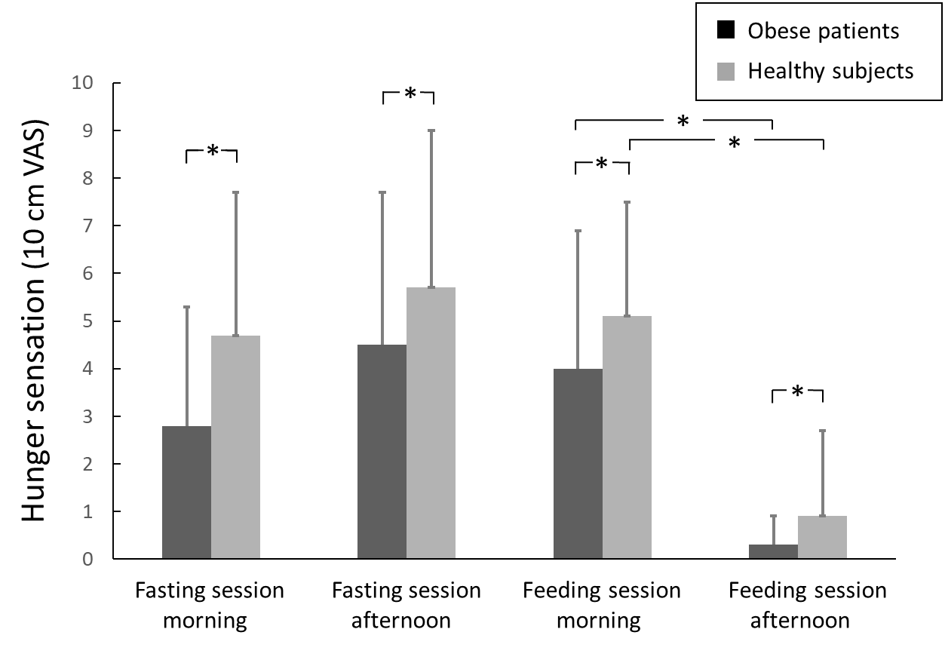
Subjects living with obesity
Normal-weight subjects

