Ion sensing with a calix[4]arene bifunctional receptor with thiosemicarbazone moieties and naphthalene chromophore.
Horacio Gómez-Machuca*, Cinthia Quiroga-Campano , Hernán Pessoa-Mahana and Claudio Saitz*
Departamento de Química Orgánica y Fisicoquímica, Facultad de Ciencias Químicas y Farmacéuticas, Universidad de Chile, Olivos 1007, Independencia, Santiago, Chile.

Electronic Supporting Information

Contents Page Nº.
S1: Spectra for (L) 2
S2: Association constant and Job-Plot 5
S3: Determination of limit of detection (LOD) 6
S4: ¹H NMR titrations 7

S1: Spectra for (L): (a) ¹H NMR and ¹³C NMR; (b) FT-IR; (c) ESI-TOF.
L = 5,17-bis-(2-naphthalenothiosemicarbazone)-25,26,27,28-tetrapropoxycalix[4]arene.

a)

b)

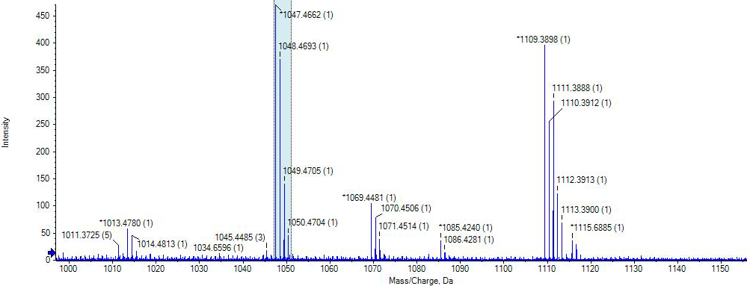
c)

S2: Association constant and Job-Plot.
Figure S2. The binding constant of (L) has been derived based on the non-linear method and equation using absorption titration with (a) Ag⁺ ; (b) Cu²⁺ ; (c) F⁻ and (d) CN⁻ and Job-Plot of interaction (L) with ions.

d)
c)
b)
a)

S3: Determination of limit of detection (LOD).
Figure S3. Linear fit of the data obtained in the titrations with the ions: a) Cu²⁺; b) Ag⁺; c) CN⁻; and d) F⁻.

b)
a)
d)
c)

S4: ¹H NMR titrations.
Figure S4. Titration of receptor (L) in CDCl₃ upon addition of a) 0 eq. of Cu²⁺, b) 0.35 eq. of Cu²⁺, c) 0.70 eq. of Cu²⁺ and d) 1.00 eq. of Cu²⁺.

d)
c)
b)
a)

Figure S5. Titration of receptor (L) in CDCl₃ upon addition of a) 0 eq. of Ag⁺, b) 0.35 eq. of Ag⁺, c) 0.70 eq. of Ag⁺ and d) 1.00 eq. of Ag⁺.

d)
c)
b)
a)

Figure S6. Titration of receptor (L) in CDCl₃ upon addition of a) 0 eq. of CN⁻, b) 0.35 eq. of CN⁻, c) 0.70 eq. of CN⁻ and d) 1.00 eq. of CN⁻.

d)
c)
b)
a)

Figure S7. Titration of receptor (L) in CDCl₃ upon addition of a) 0 eq. of F⁻, b) 0.35 eq. of F⁻, c) 0.70 eq. of F⁻ and d) 1.00 eq. of F⁻.

d)
c)
b)
a)

