Additional file 2

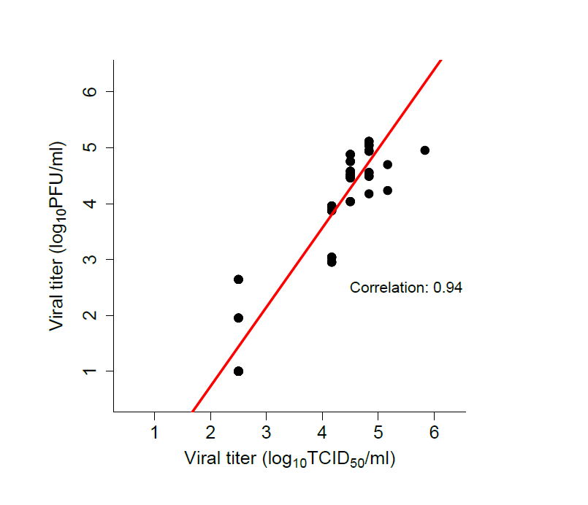
Additional file 2: Correlation between infectious viral titers from RSV-NICA as analysed by two different methods.

