Additional file 3

A B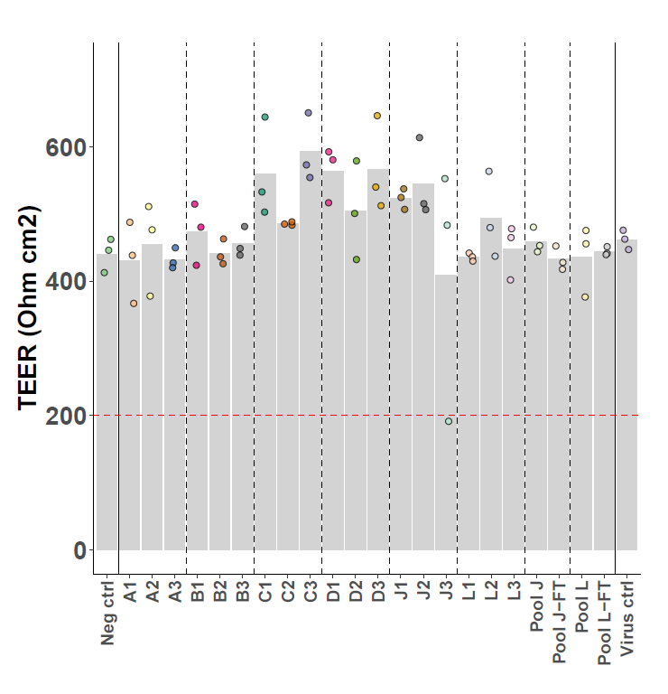 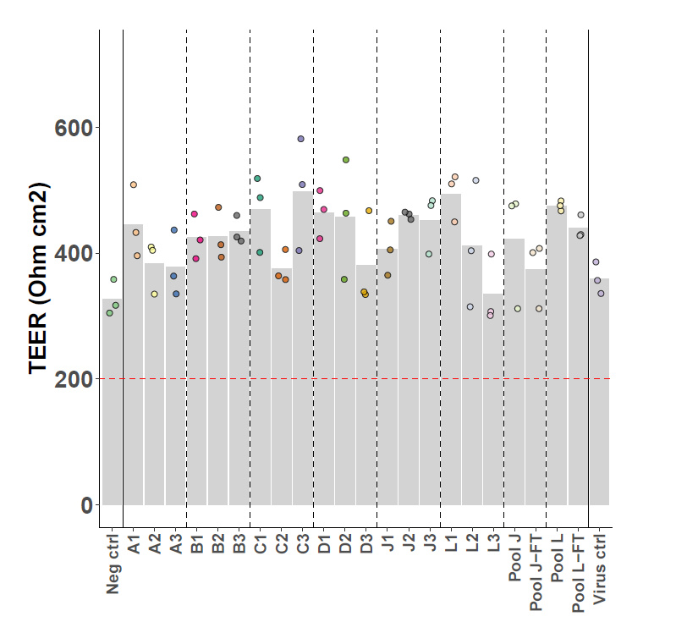

Additional file 3: Measurement of barrier integrity (TEER, Ohm.cm²) in MucilAir™ 3 days before infection (A) and 9 days after infection (B) with different RSV-NICA aliquots. Aliquots of the 3 vials from boxes J and L, respectively, were pooled and barrier integrity from the pools were determined before and after a freeze-thaw cycle. RSV Long-A was included as a positive virus control. Negative control did not include virus.

