A general strategy to significantly reduce thermal expansion and achieve high mechanical properties in iron alloys
Hao Lu^{1,7}, Chang Zhou^{2,7}, Yuzhu Song^{1*}, Yuanpeng Zhang³, Yiming Wu⁴, Feixiang Long¹, Yonghao Yao¹, Jiazheng Hao⁵, Yan Chen³, Dunji Yu³, J. Jakob Schwiedrzik⁴, Ke An³, Lunhua He⁵, Zhaoping Lu², Jun Chen^{1, 6*}
¹Department of Physical Chemistry, Beijing Advanced Innovation Center for Materials Genome Engineering, University of Science and Technology Beijing, Beijing 100083, China
²State Key Laboratory for Advanced Metals and Materials, University of Science and Technology Beijing, Beijing 100083, China
³Neutron Scattering Division, Oak Ridge National Laboratory, Oak Ridge, Tennessee 37831, United States
⁴Empa, Swiss Federal Laboratories for Materials Science and Technology, Laboratory for Mechanics of Materials and Nanostructures, Thun, Switzerland
⁵Spallation Neutron Source Science Center, Dongguan 523803, China
⁶Hainan University, Haikou 570228, Hainan Province, China
⁷These authors contributed equally to this work.
*Corresponding author. Email: yuzhusong@ustb.edu.cn; junchen@ustb.edu.cn

Supporting figures
Figure S1 Laboratory XRD patterns of the alloys mentioned in this work reveal the dual-phase crystal structure.

Figure S2 a NPD patterns of Z1-Z3 (left) and the enlarged (110)_{PTE} as well as (112)_{NTE} peaks (right). b Mass fractions of the PTE and NTE phases in Z1-Z3, obtained from the refining of the NPD data.

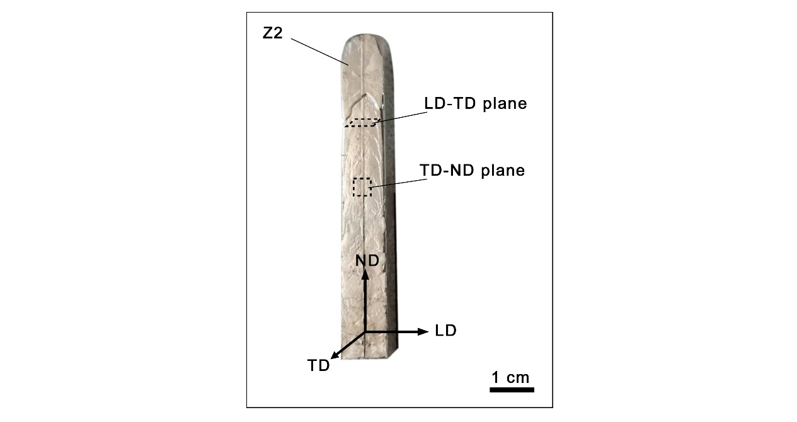
Figure S3. Longitudinal-transverse (LD-TD) and transverse-normal (TD-ND) planes of Z2 ingot.

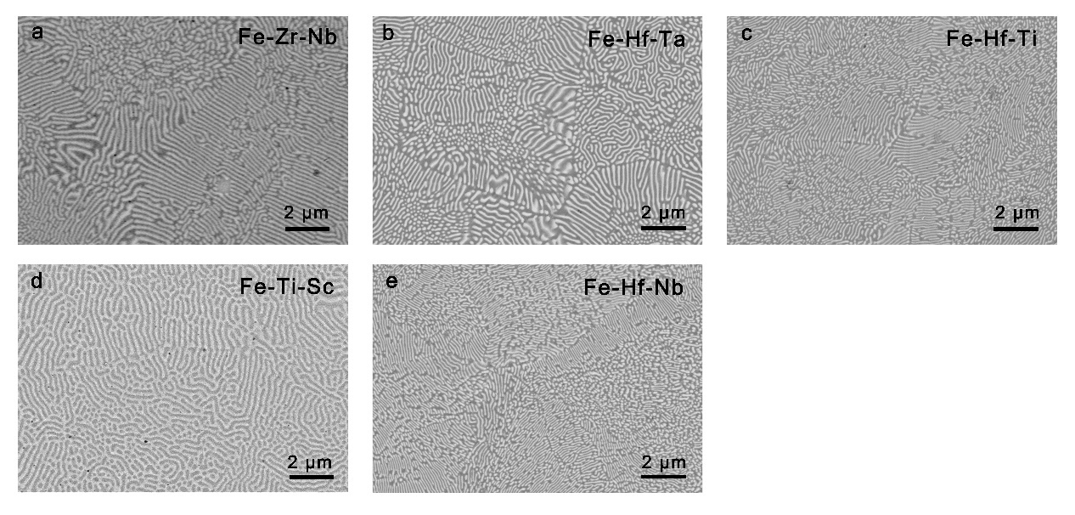
Figure S4 a-e SEM images of Fe₈₄Zr₁₀Nb₆ (a), Fe₇₈Hf₁₈Ta₃ (b), Fe₈₁Hf₁₈Ti₁ (c), Fe₈₆Ti₉Sc₅ (d), and Fe₇₉Hf₂₀Nb₁ (e).

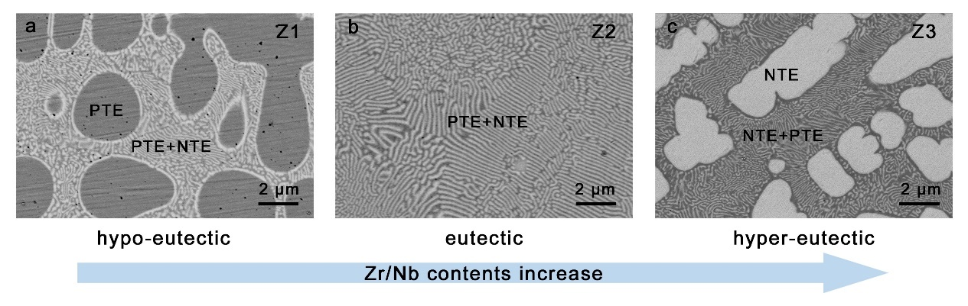
Figure S5 a-c SEM images of hypo-eutectic Z1(a), eutectic Z2(b), and hyper-eutectic Z3 (e).

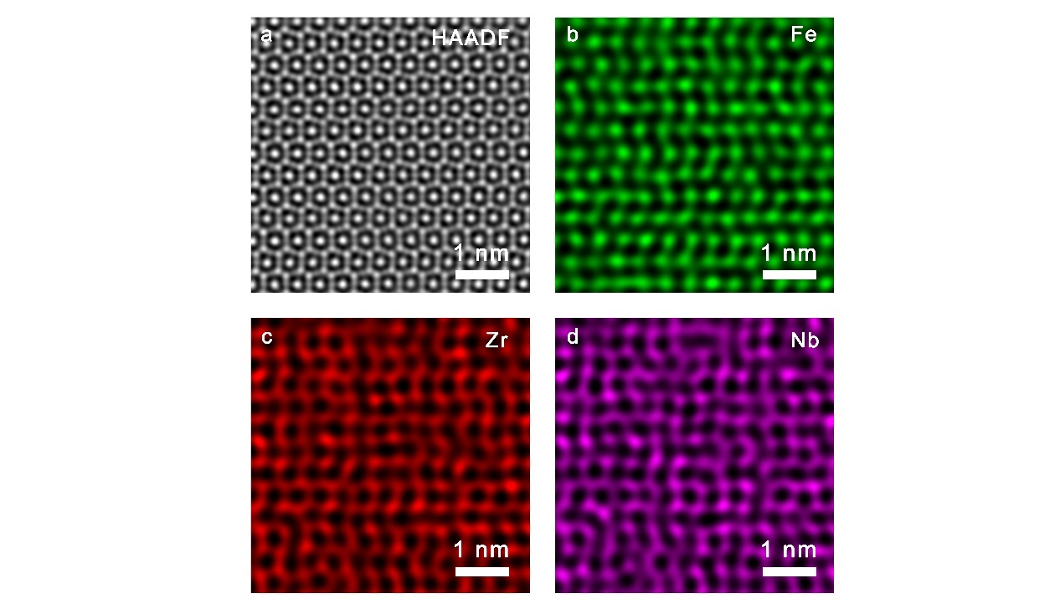
Figure S6 a HAADF-STEM image of the NTE phase along [001] zone axis. b–d EDS elemental mapping of Fe, Zr, and Nb, corresponding to the same area in a.

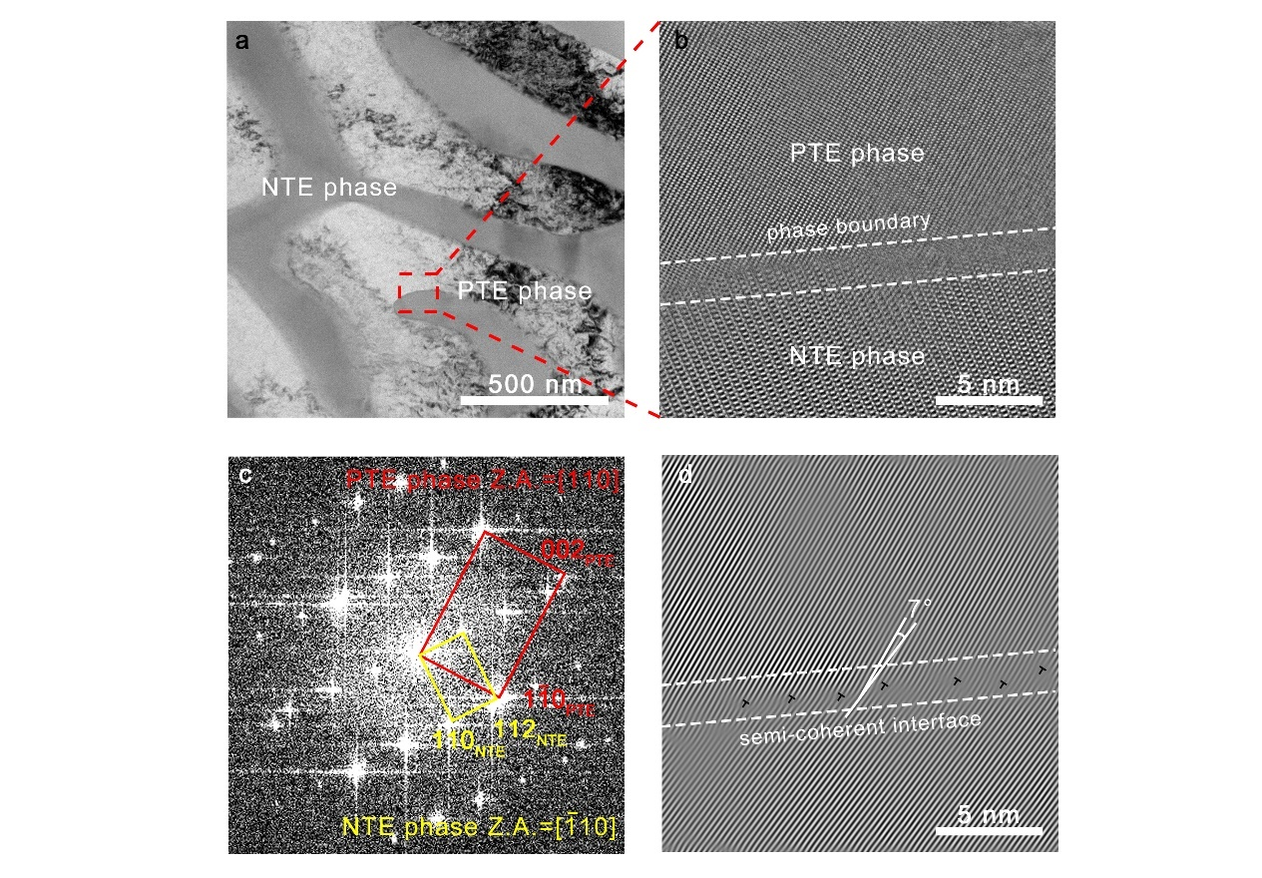
Figure S7 a TEM image of the hyper-fine microstructure in Z2. Scale bar, 500 nm. b HAADF-STEM image at the phase boundary. Scale bar, 5 nm. c, d FFT (c) and inverse FFT (d) profile of b. Scale bar, 5 nm.

Figure S8 a-d Linear thermal expansion coefficient of Fe₇₈Hf₁₈Ta₃ (a), Fe₈₁Hf₁₈Ti₁ (b), Fe₈₆Ti₉Sc₅ (c), and Fe₇₉Hf₂₀Nb₁ (d), compared with pure iron.

Figure S9 a-d Engineering stress-strain curves of Fe₇₈Hf₁₈Ta₃ (a), Fe₈₁Hf₁₈Ti₁ (b), Fe₈₆Ti₉Sc₅ (c), and Fe₇₉Hf₂₀Nb₁ (b), compared with pure iron.

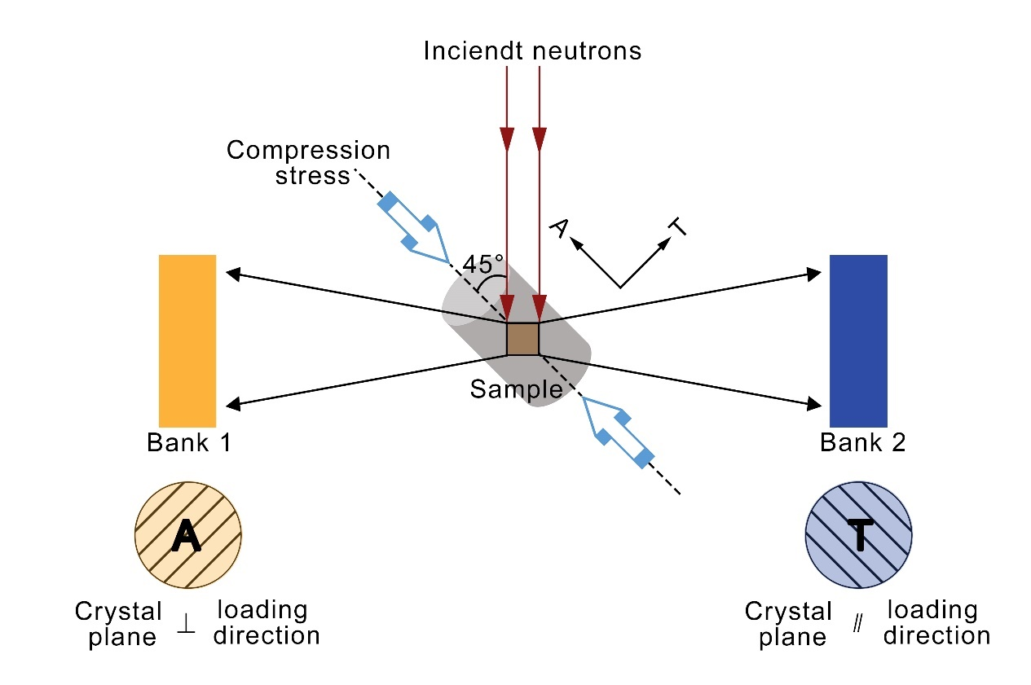
Fig S10 Schematic diagram of the in-situ neutron diffraction measurement under compression loading.

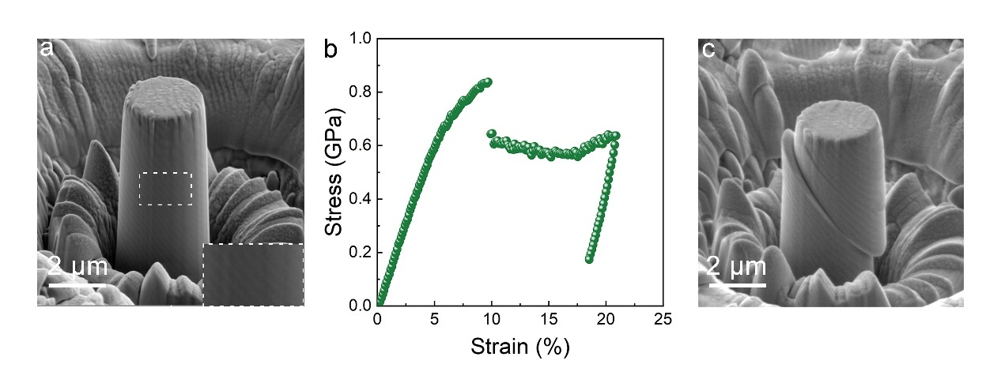
Figure S11 a SEM image of a micropillar with the lamellar layer tilted toward the loading direction. b Micromechanical properties of the micropillar shown in a. c SEM image after compression loading of the micropillar shown in a.

Table S1 Refined parameters of Z1-Z3 by NPD at room temperature.
 |  | Content (wet. %) | Atom parameters
 |  | Content (wet. %) | Atom | x, y, z | Occupancy | Site
Z1 | PTE phase | 76.08 | Fe | 0, 0, 0 | 1 | 2a
Z1 | NTE phase | 23.92 | Fe | 0, 0, 0 | 1 | 2a
Z1 | NTE phase | 23.92 | Fe | 0.828, 0.657, 0.250 | 1 | 6h
Z1 | NTE phase | 23.92 | Fe | 0.333, 0.667, 0.061 | 0.11 | 4f
Z1 | NTE phase | 23.92 | Zr | 0.333, 0.667, 0.061 | 0.62 | 4f
Z1 | NTE phase | 23.92 | Nb | 0.333, 0.667, 0.061 | 0.27 | 4f
Z2 | PTE phase | 65.69 | Fe | 0, 0, 0 | 1 | 2a
Z2 | NTE phase | 34.31 | Fe | 0, 0, 0 | 1 | 2a
Z2 | NTE phase | 34.31 | Fe | 0.828, 0.658, 0.250 | 1 | 6h
Z2 | NTE phase | 34.31 | Fe | 0.333, 0.667, 0.061 | 0.11 | 4f
Z2 | NTE phase | 34.31 | Zr | 0.333, 0.667, 0.061 | 0.62 | 4f
Z2 | NTE phase | 34.31 | Nb | 0.333, 0.667, 0.061 | 0.27 | 4f
Z3 | PTE phase | 47.55 | Fe | 0, 0, 0 | 1 | 2a
Z3 | NTE phase | 52.45 | Fe | 0, 0, 0 | 1 | 2a
Z3 | NTE phase | 52.45 | Fe | 0.831, 0.661, 0.250 | 1 | 6h
Z3 | NTE phase | 52.45 | Fe | 0.333, 0.667, 0.062 | 0.15 | 4f
Z3 | NTE phase | 52.45 | Zr | 0.333, 0.667, 0.062 | 0.59 | 4f
Z3 | NTE phase | 52.45 | Nb | 0.333, 0.667, 0.062 | 0.26 | 4f

Table S2 EDS element mapping result of the NTE phase in Z2.
Element | Atomic fraction (%) | Mass fraction (%) | Fit error (%)
Fe | 74.8 | 64.4 | 0.198
Zr | 18.3 | 25.8 | 0.304
Nb | 6.87 | 9.84 | 0.697

Table S3 Research in linear CTE of conventional iron-based alloys and the alloys mentioned in this work.

Iron-based alloys | CTE (ppm/K) | Ref.
304 | 17.3 | [1]
Cantor | 16.1 | [2]
GCr15MnSi | 16 | [3]
316 | 16 | [4]
42CrMo4 | 14.8 | [5]
Silicon steel | 12.9 | [6]
17-4 PH | 12.5 | [7]
Q235 | 12.2 | [8]
FeGa Alloy | 12 | [9]
18Ni300 | 12 | [10]
Pure iron | 11.8 | This work
9Cr | 11.7 | [11]
45# | 11.3 | [12]
HTCS 130 | 11.1 | [13]
410 | 11 | [14]
GCr15 | 10.9 | [3]
Cast iron | 10.5 | [15]
Permalloy | 9.19 | [16]
Fe₉₂Hf_{6.4}Ti_{1.6} | 7.82 | This work
Fe₉₂Hf_{6.7}Ta_{1.3} | 7.38 | This work
Fe₉₂Hf_{7.2}Nb_{0.8} | 7.3 | This work
Z1 | 7.2 | This work
Fe₈₄Ti_{9.6}Sc_{6.4} | 6.28 | This work
Z2 | 5.5 | This work
Z3 | 4.9 | This work

Table S4 Temperature dependence of lattice parameters and unit cell volume of the NTE phase within Z2 refined by NPD.
Temperature (K) | Lattice parameters (Å) |  | Unit cell volume (Å³)
Temperature (K) | a | c | Unit cell volume (Å³)
5 | 4.9008(5) | 7.9808(6) | 165.99(2)
55 | 4.9001(5) | 7.9806(6) | 166.02(2)
105 | 4.8998(5) | 7.9810(6) | 166.00(2)
155 | 4.9001(5) | 7.9832(6) | 166.05(2)
205 | 4.9010(5) | 7.9850(6) | 166.12(2)
230 | 4.9003(5) | 7.9857(6) | 166.10(2)
255 | 4.9011(5) | 7.9868(6) | 166.16(2)
280 | 4.9013(5) | 7.9875(6) | 166.18(2)
305 | 4.9015(5) | 7.9887(6) | 166.21(2)
330 | 4.9017(5) | 7.9894(6) | 166.24(2)
355 | 4.9023(6) | 7.9906(7) | 166.29(2)
380 | 4.9024(6) | 7.9914(7) | 166.31(2)
405 | 4.9032(6) | 7.9926(7) | 166.37(2)
455 | 4.9056(6) | 7.9956(7) | 166.53(2)
505 | 4.9069(6) | 7.9980(7) | 166.63(2)
555 | 4.9101(6) | 8.0023(8) | 166.85(2)

Table S5 Fitting parameters of the Mössbauer spectrum of Z2 at 5 K.
 | Ratio (%) | Magnetic hyperfine field (T) | Isomer shift (mm/s) | Quadrupole splitting (mm/s)
α-Fe | 62.20 | 33.7 | 0.13 | 0.004
Fe(2a) | 7.89 | 23.1 | 0.04 | 0.109
Fe(6h) | 23.67 | 19.2 | -0.08 | 0.199
Fe(4f) | 6.23 | 13.2 | 0.54 | -0.141

TableS6 Research in mechanical properties of typical metal-based LTE materials.
LTE materials |  | Ultimate stress (GPa) | Ultimate strain (%) | Ref.
Intermetallics | TbCo_{1.9}Fe_{0.1} | 1.5 | 260 | [17]
Intermetallics | Ho₂Fe₁₆Cr | 2 | 50 | [18]
Intermetallics | MnCoGe | 1 | 70.4 | [19]
Intermetallics | Hf_{0.87}Ta_{0.13}Fe₂ | 2.7 | 380 | [20]
Intermetallics | Mn₃Ge_{0.8}Sn_{0.2} | 5 | 450 | [21]
Intermetallics | Mn₃Ge | 5.6 | 204 | [21]
Intermetallics | La(FeCoSi)₁₃ | 1.6 | 256.4 | [22]
Intermetallics | GDFC | 1.2 | 154 | [23]
Intermetallics | Ho₂Fe₁₇Co | 2 | 49 | [24]
Intermetallics | FeMnGa | 6.7 | 517 | [25]
MMCs | xLFCS/Cu | 6.5 | 363 | [26]
MMCs | xLFCS/Cu | 13 | 443 | [26]
MMCs | MM'S/In | 15 | 41 | [27]
MMCs | MM'S/In | 15.7 | 48 | [27]
MMCs | MM'S/In | 9 | 45 | [27]
MMCs | MM'S/In | 15 | 32 | [27]
Dual-phase alloys | HoxFe_{1-x} | 5.68 | 1275.8 | [28]
Dual-phase alloys | HoxFe_{1-x} | 8.08 | 796.8 | [28]
Dual-phase alloys | HoxFe_{1-x} | 15.6 | 878 | [28]
Dual-phase alloys | LaFe_{10.2+x}Co_{1.2}Si_{1.6} | 2.9 | 864 | [29]
Dual-phase alloys | LaFe_{10.2+x}Co_{1.2}Si_{1.6} | 3.4 | 900 | [29]
Dual-phase alloys | LaFe_{10.2+x}Co_{1.2}Si_{1.6} | 3.7 | 970 | [29]
Dual-phase alloys | LaFe_{10.2+x}Co_{1.2}Si_{1.6} | 3.8 | 1004 | [29]
Dual-phase alloys | LaFe_{10.6-x}Cu_{x}Si_{2.4} | 4.5 | 551 | [30]
Dual-phase alloys | LaFe_{10.6-x}Cu_{x}Si_{2.4} | 7.3 | 1071 | [30]
Dual-phase alloys | LaFe_{10.6-x}Cu_{x}Si_{2.4} | 8 | 1246 | [30]
Dual-phase alloys | LaFe_{10.6-x}Cu_{x}Si_{2.4} | 9 | 1325 | [30]
Dual-phase alloys | Er-Fe-V-Mo | 2.31 | 1631.4 | [31]
Dual-phase alloys | Hf_{0.87}Ta_{0.13}Fe₂Cu_{x} | 9.15 | 1040 | [32]
Dual-phase alloys | Hf_{0.87}Ta_{0.13}Fe₂Cu_{x} | 9.4 | 1235 | [32]
Dual-phase alloys | Er-Fe-B | 2.7 | 1440 | [33]
Dual-phase alloys | Z2 | 17.5 | 1519 | This work
Dual-phase alloys | Z3 | 4.4 | 1339 | This work
Dual-phase alloys | Fe-Hf-Ti | 23 | 1560 | This work
Dual-phase alloys | Fe-Ti-Sc | 8.5 | 1477 | This work
Dual-phase alloys | Fe-Hf-Nb | 18.2 | 1477 | This work

Reference
1. Fang D, Jun-mao Q, Hao-hua D. Study on thermal physical properties of 304 stainless steel. In: Jiang T, Hwang J-Y, Alvear F GRF, Yücel O, Mao X, Sohn HY, et al. (eds). 6th international symposium on high-temperature metallurgical processing. Springer International Publishing: Cham, 2016, pp 99-104.
2. Laplanche G, Gadaud P, Horst O, Otto F, Eggeler G, George EP. Temperature dependencies of the elastic moduli and thermal expansion coefficient of an equiatomic, single-phase CoCrFeMnNi high-entropy alloy. J. Alloys Compd. 2015, 623: 348-353.
3. Jiang B, Dong ZQ, Zhou LY, Yang Z, Zhang CL, Liu YZ. Thermophysical properties of bearing steel GCr15SiMn. Metall. Res. Technol. 2015, 112(3).
4. Yakout M, Elbestawi MA, Veldhuis SC. A study of thermal expansion coefficients and microstructure during selective laser melting of Invar 36 and stainless steel 316L. Addit. Manuf. 2018, 24: 405-418.
5. Areitioaurtena M, Segurajauregi U, Fisk M, Cabello MJ, Ukar E. Numerical and experimental investigation of residual stresses during the induction hardening of 42CrMo4 steel. Eur. J. Mech. A Solids 2022, 96.
6. Souder WH, Hidnert P. Thermal expansion of a few steels. US Government Printing Office, 1922.
7. Kwon Y-S, Wu Y, Suri P, German RM. Simulation of the sintering densification and shrinkage behavior of powder-injection-molded 17-4 PH stainless steel. Metall. Mater. Trans. A 2004, 35(1): 257-263.
8. Fu JX, Li XD, Hwang WS. Study of the coefficient of thermal expansion for steel Q235. Adv. Mat. Res. 2011, 194-196: 326-330.
9. Shi J, Lu C, Jiang H, Ming W, Hu W, Zhao Y, et al. Structural, magnetic and magnetostrictive properties of Fe₈₃Ga₁₇ films with a Ti adhesion layer. J. Magn. Magn. Mater. 2019, 475: 662-667.
10. Bai Y, Zhao C, Zhang J, Wang H. Abnormal thermal expansion behaviour and phase transition of laser powder bed fusion maraging steel with different thermal histories during continuous heating. Addit. Manuf. 2022, 53.
11. Subramanian R, Tripathy H, Rai AK, Hajra RN, Saibaba S, Jayakumar T, et al. Thermal expansion characteristics of Fe–9Cr–0.12C–0.56Mn–0.24V–1.38W–0.06Ta (wt.%) reduced activation ferritic–martensitic steel. J. Nucl. Mater. 2015, 459: 150-158.
12. Winczek J, Kulawik A. Dilatometric and hardness analysis of C45 steel tempering with different heating-up rates. Metalurgija 2012, 51(1): 9-12.
13. Kaschnitz E, Hofer P, Funk W. Thermophysical properties of a hot-work tool-steel with high thermal conductivity. Int. J. Thermophys. 2012, 34(5): 843-850.
14. Elmer J, Olson D, Matlock D. Thermal expansion characteristics of stainless steel weld metal. Weld. J. 1982, 61(9): 293.
15. Hellström K, Diaconu V-L, Diószegi A. Density and thermal expansion coefficients of liquid and austenite phase in lamellar cast iron. China Foundry 2020, 17(2): 127-136.
16. Thurn J, Hughey MP. Evaluation of film biaxial modulus and coefficient of thermal expansion from thermoelastic film stress measurements. J. Appl. Phys. 2004, 95(12): 7892-7897.
17. Song Y, Chen J, Liu X, Wang C, Zhang J, Liu H, et al. Zero thermal expansion in magnetic and metallic Tb(Co,Fe)₂ intermetallic compounds. J. Am. Chem. Soc. 2018, 140(2): 602-605.
18. Dan S, Mukherjee S, Mazumdar C, Ranganathan R. Zero thermal expansion with high Curie temperature in Ho₂Fe₁₆Cr alloy. RSC Adv. 2016, 6(97): 94809-94814.
19. Zhao Y-Y, Hu F-X, Bao L-F, Wang J, Wu H, Huang Q-Z, et al. Giant negative thermal expansion in bonded MnCoGe-based compounds with Ni₂In-type hexagonal structure. J. Am. Chem. Soc. 2015, 137(5): 1746-1749.
20. Li LF, Tong P, Zou YM, Tong W, Jiang WB, Jiang Y, et al. Good comprehensive performance of Laves phase Hf_{1-x}Ta_{x}Fe₂ as negative thermal expansion materials. Acta Mater. 2018, 161: 258-265.
21. Song Y, Qiao Y, Huang Q, Wang C, Liu X, Li Q, et al. Opposite thermal expansion in isostructural noncollinear antiferromagnetic compounds of Mn₃A (A = Ge and Sn). Chem. Mater. 2018, 30(18): 6236-6241.
22. Huang R, Liu Y, Fan W, Tan J, Xiao F, Qian L, et al. Giant negative thermal expansion in NaZn₁₃-type La(Fe, Si, Co)₁₃ compounds. J. Am. Chem. Soc. 2013, 135(31): 11469-11472.
23. Hu J, Lin K, Cao Y, Yu C, Li W, Huang R, et al. Adjustable magnetic phase transition inducing unusual zero thermal expansion in cubic RCo₂-based intermetallic compounds (R = rare earth). Inorg. Chem. 2019, 58(9): 5401-5405.
24. Cao Y, Lin K, Khmelevskyi S, Avdeev M, Taddei KM, Zhang Q, et al. Ultrawide temperature range super-Invar behavior of R₂(Fe,Co)₁₇ materials (R = rare earth). Phys. Rev. Lett. 2021, 127(5).
25. Sun XM, Cong DY, Ren Y, Brown DE, Li RG, Li SH, et al. Giant negative thermal expansion in Fe-Mn-Ga magnetic shape memory alloys. Appl. Phys. Lett. 2018, 113(4).
26. Pang X, Song Y, Shi N, Xu M, Zhou C, Chen J. Design of zero thermal expansion and high thermal conductivity in machinable xLFCS/Cu metal matrix composites. Compos. B: Eng. 2022, 238.
27. Zhou H, Tao K, Chen B, Chen H, Qiao K, Yu Z, et al. Low-melting metal bonded MM′X/In composite with largely enhanced mechanical property and anisotropic negative thermal expansion. Acta Mater. 2022, 229.
28. Yu C, Lin K, Jiang S, Cao Y, Li W, Wang Y, et al. Plastic and low-cost axial zero thermal expansion alloy by a natural dual-phase composite. Nat. Commun. 2021, 12(1).
29. Wang J, Gong Y, Liu J, Miao X, Xu G, Chen F, et al. Balancing negative and positive thermal expansion effect in dual-phase La(Fe,Si)₁₃/α-Fe in-situ composite with improved compressive strength. J.Alloys Compd. 2018, 769: 233-238.
30. Liu J, Gong Y, Wang J, Peng G, Miao X, Xu G, et al. Realization of zero thermal expansion in La(Fe,Si)₁₃ -based system with high mechanical stability. Mater. Des. 2018, 148: 71-77.
31. Lin K, Li W, Yu C, Jiang S, Cao Y, Li Q, et al. High performance and low thermal expansion in Er-Fe-V-Mo dual-phase alloys. Acta Mater. 2020, 198: 271-280.
32. Li LF, Tong P, Jiang WB, Lin JC, Zhu F, Shu MF, et al. Near-zero thermal expansion and high thermal conductivity from ambient to cryogenic temperatures in Hf_{0.87}Ta_{0.13}Fe₂Cu_{x}. Materialia 2020, 9.
33. Yu C, Lin K, Chen X, Jiang S, Cao Y, Li W, et al. Superior zero thermal expansion dual-phase alloy via boron-migration mediated solid-state reaction. Nat. Commun. 2023, 14(1).

