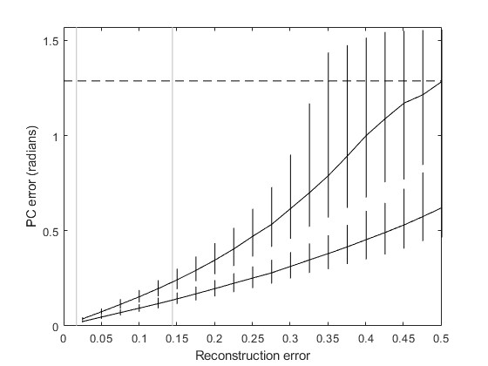
Fig SI1: Sensitivity analysis at varying levels of reconstruction error. Empirical jaw shapes based on fossil reconstructions (see SI Table 1) are perturbed by a vector drawn from a multi-variate normal distribution, scaled such that the average magnitude is a chosen Reconstruction error (x-axis). PCA is performed on perturbed data, and the angle between the PC axis and the PC axis from the unperturbed data is recorded. This is repeated 1,000 times per sample. Grey vertical lines represent the minimum and mean pairwise distances of the empirical jaw shape sample. Regions above the black dashed line represent those where the new PC vector is indistinguishable from a randomly chosen vector. Assuming that the average error from reconstructed shapes is smaller than the average interspecific change in jaw morphology within this sample, we can expect a maximum error in the direction of PC1 and 2 of approximately 0.14 radians (8 degrees) and 0.3 radians (17 degrees) respectively.
Maximum Pairwise Distance
Mean Pairwise Distance
Minimum Pairwise Distance
PC2
PC1

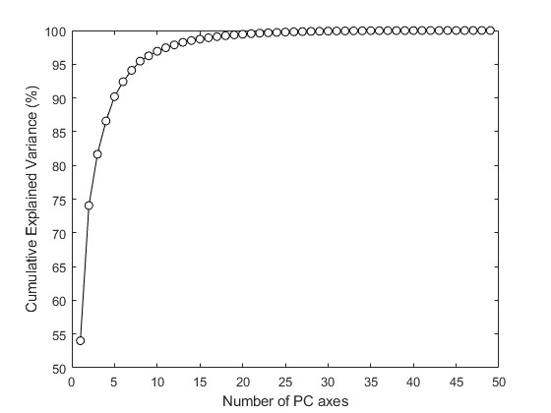
Fig SI2: PCA scree plot of empirical jaw EFA shape data.

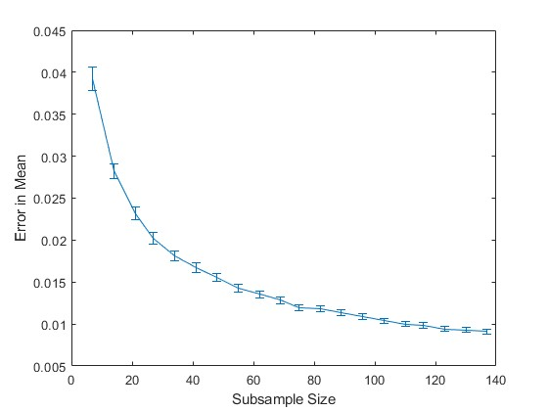
Fig SI3: Sensitivity of sample mean to random subsampling.
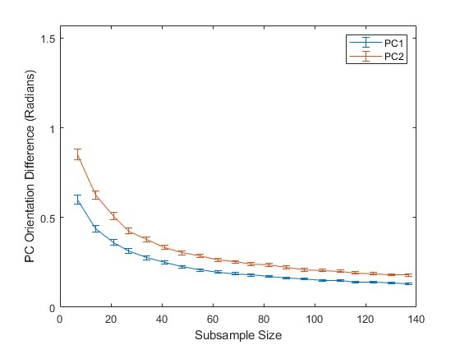
Fig SI4: Sensitivity of PC orientation to random subsampling.
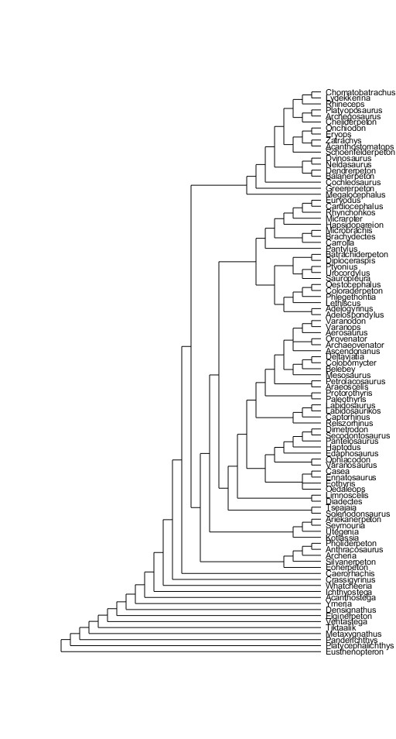
Fig SI5: Tree used for phylogenetic analyses.

