Supplementary Materials

Synthesis, Characterization of Two New Schiff Base and Their Palladium(II) Complexes and Investigation of Palladium-Catalyzed C-C Coupling Reactions

Nevin Turan*, Kenan Buldurun, Mustafa Bingöl, Naki Çolak

*Corresponding author: E-mail: nevintrn@hotmail.com; n.turan@alparslan.edu.tr

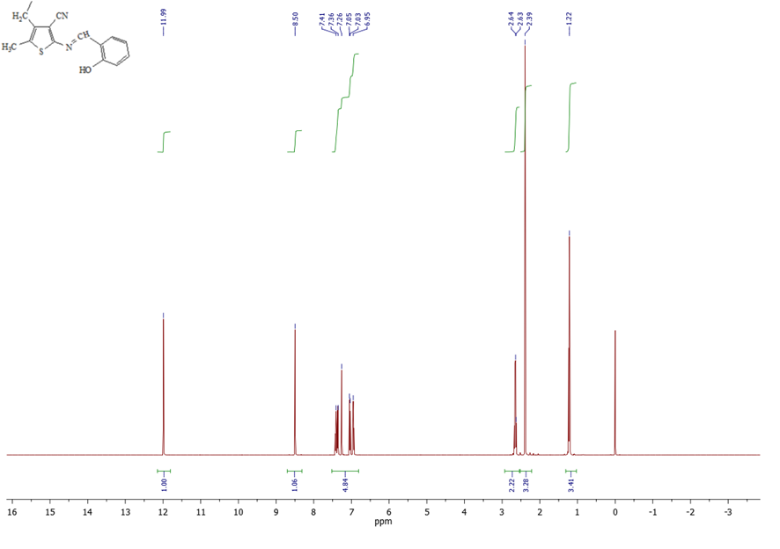Fig. S1. ¹H-NMR spectra of ligand S¹
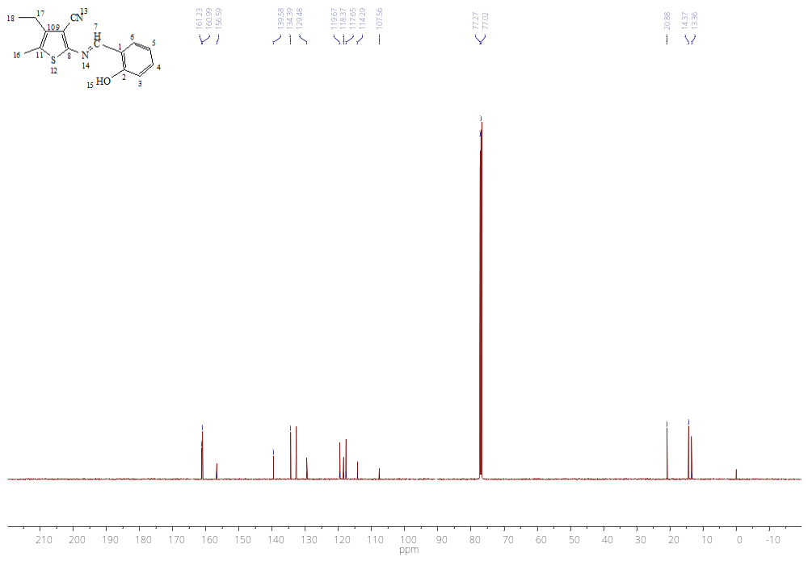
Fig. S2. ¹³C-NMR spectra of ligand S¹
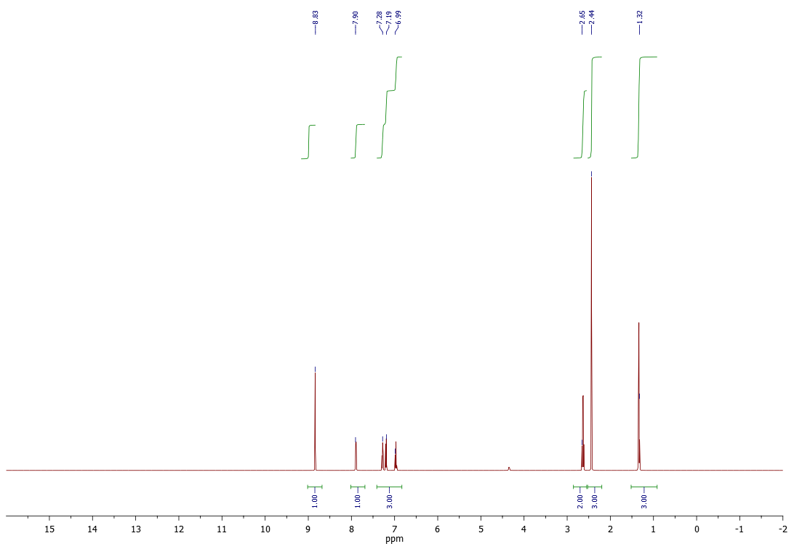
Fig. S3. ¹H-NMR spectra of complex 1
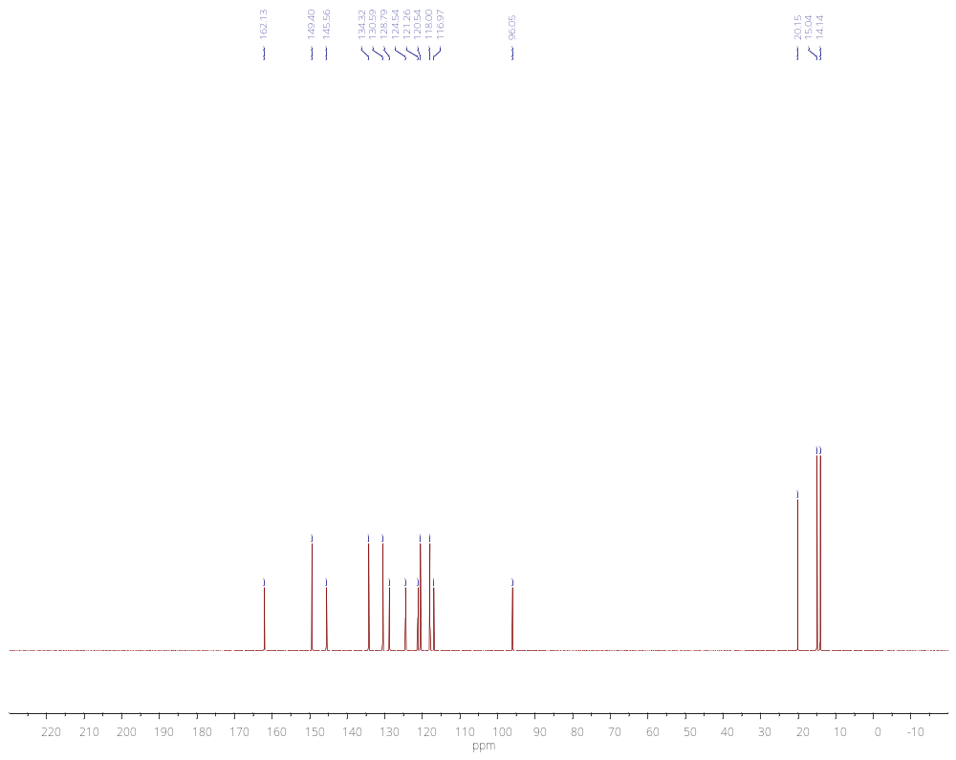
Fig. S4. ¹³C-NMR spectra of complex 1

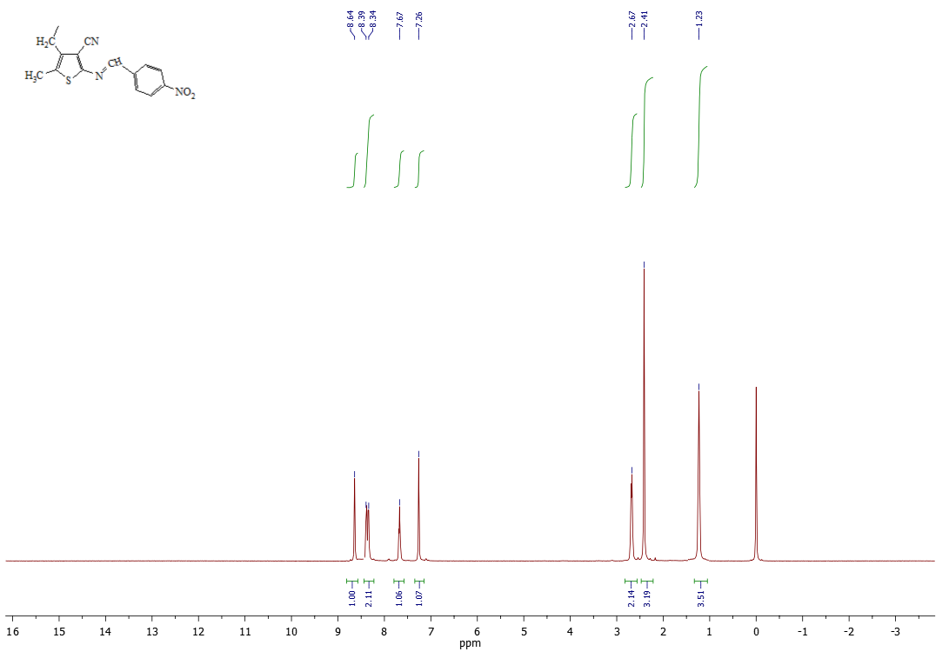
Fig. S5. ¹H-NMR spectra of ligand S²
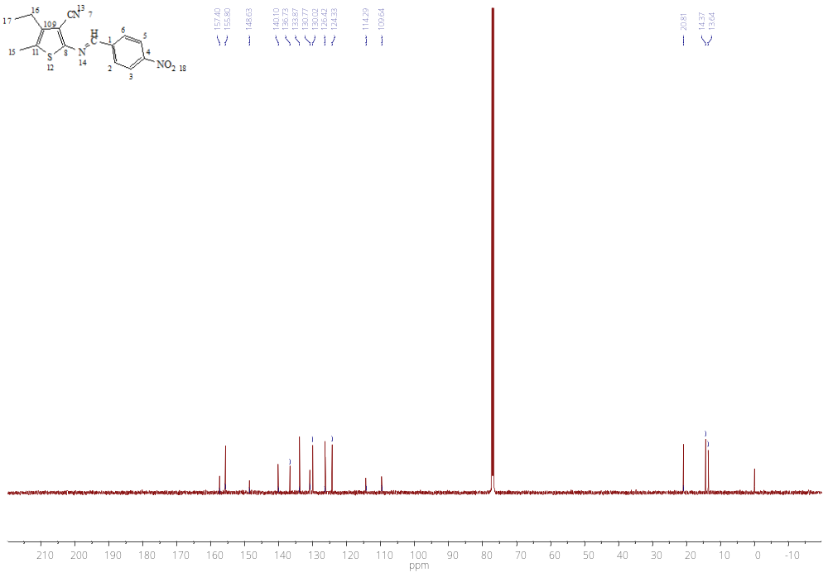 Fig. S6. ¹³C-NMR spectra of ligand S²

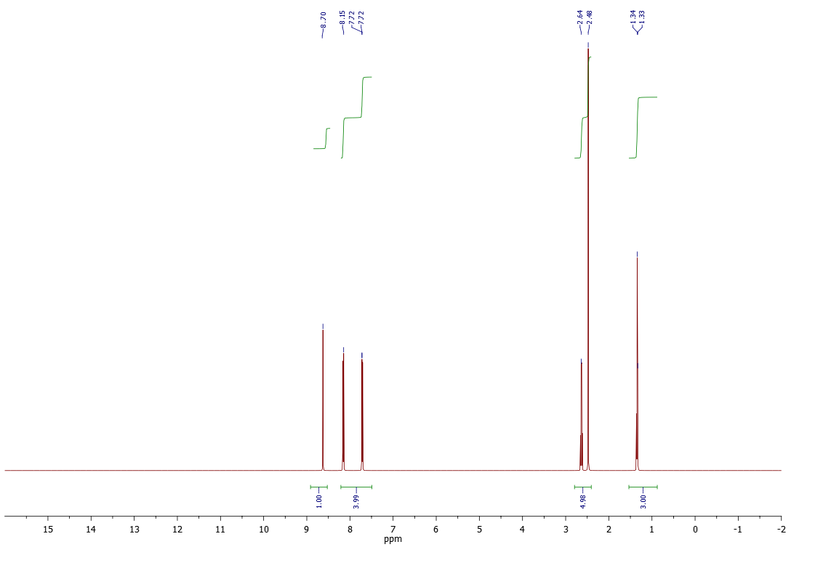
Fig. S7. ¹H-NMR spectra of complex 2
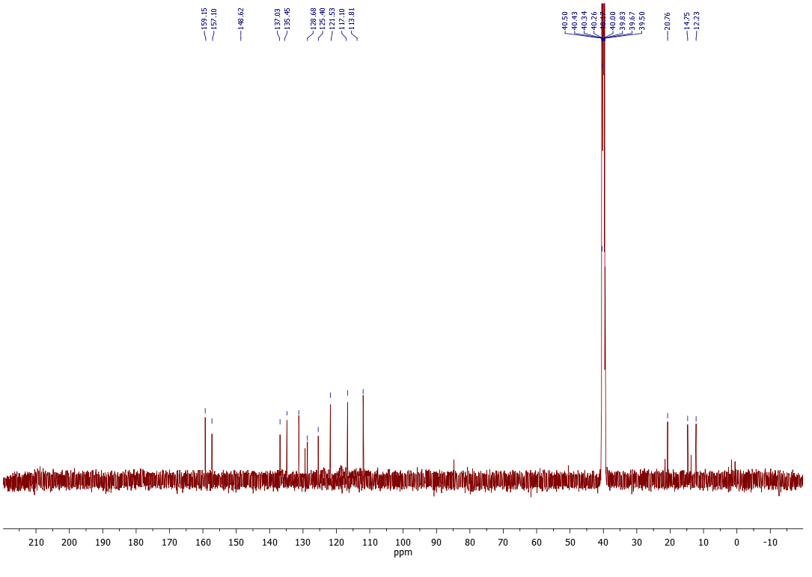
Fig. S8. ¹³C-NMR spectra of complex 2

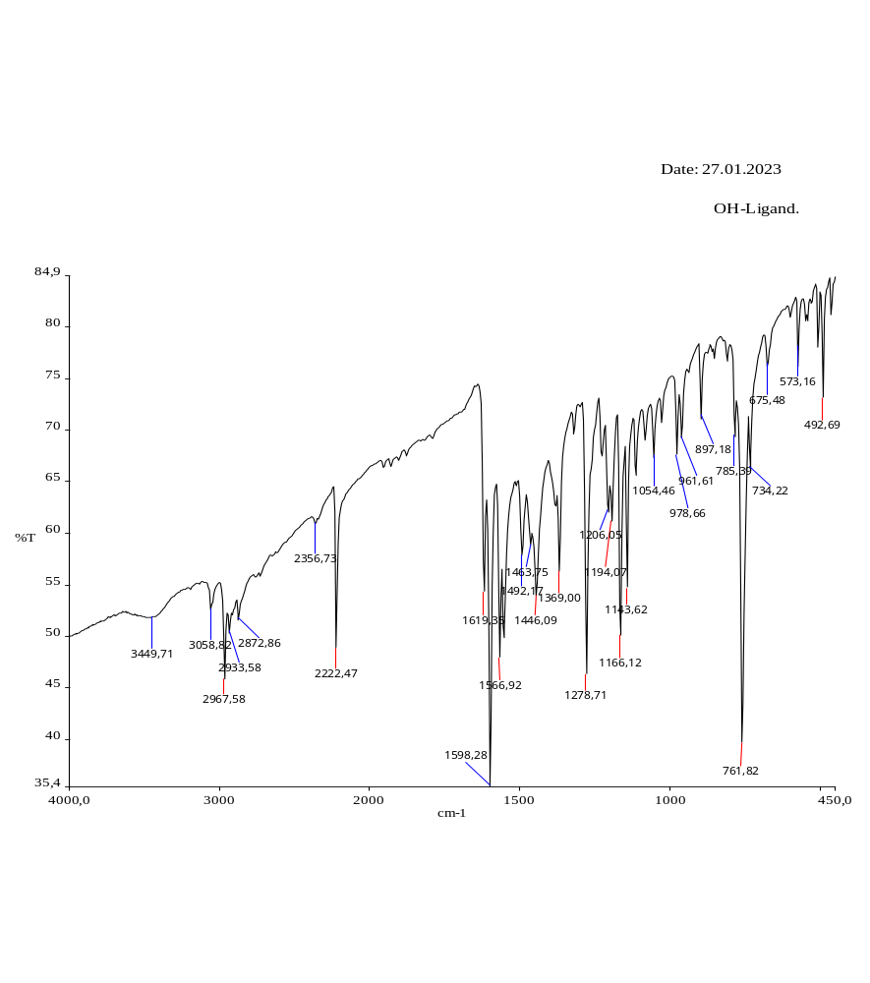
Fig. S9. IR spectra of ligand S¹

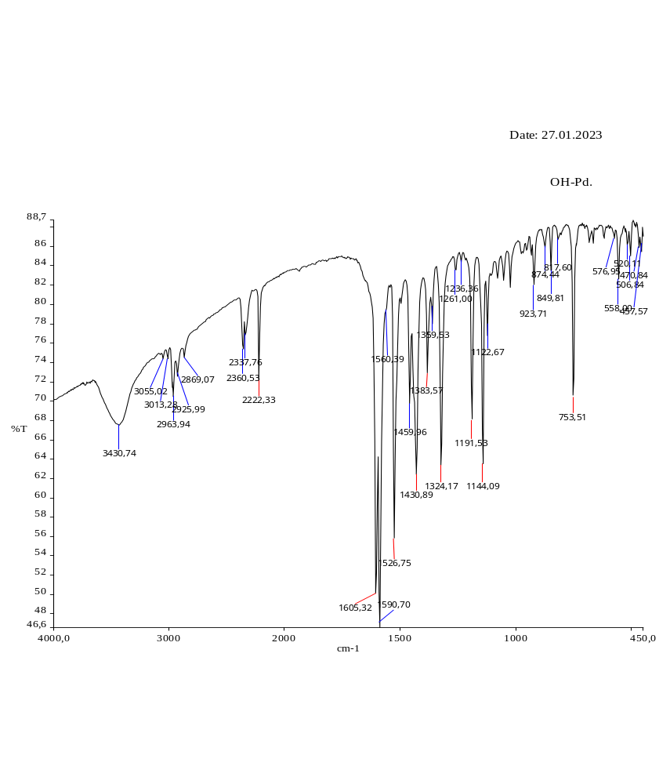
Fig. S10. IR spectra of complex 1
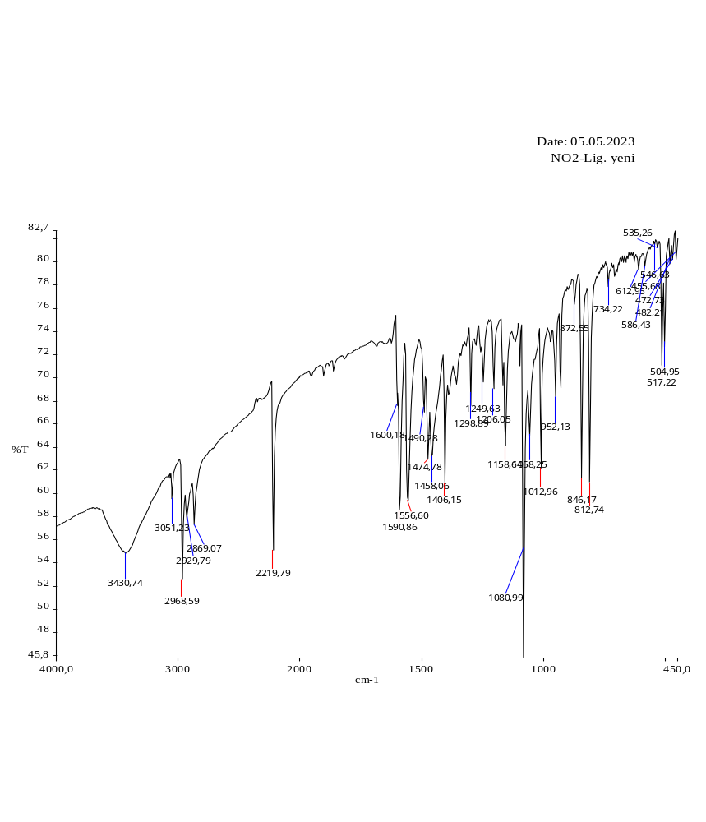
Fig. S11. IR spectra of ligand S²
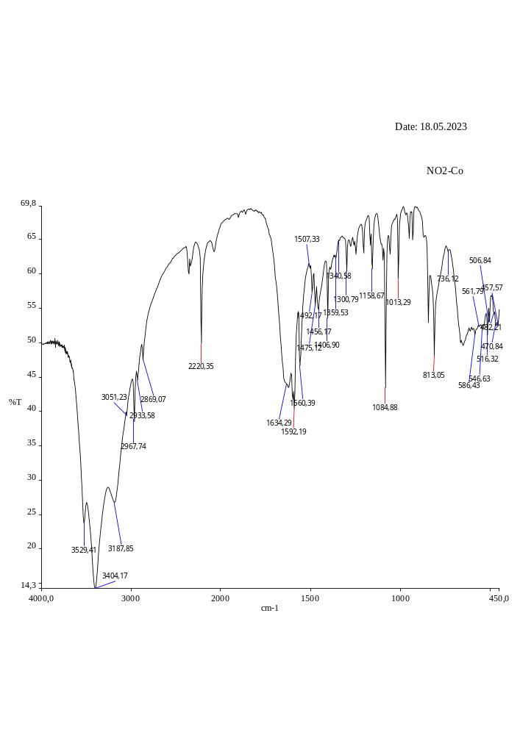
Fig. S12. IR spectra of complex 2

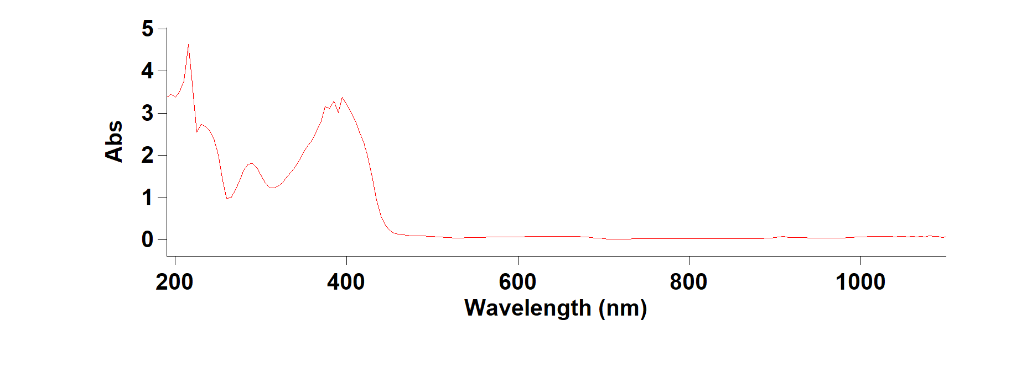 Fig. S13. UV-Vis. spectra of ligand S¹
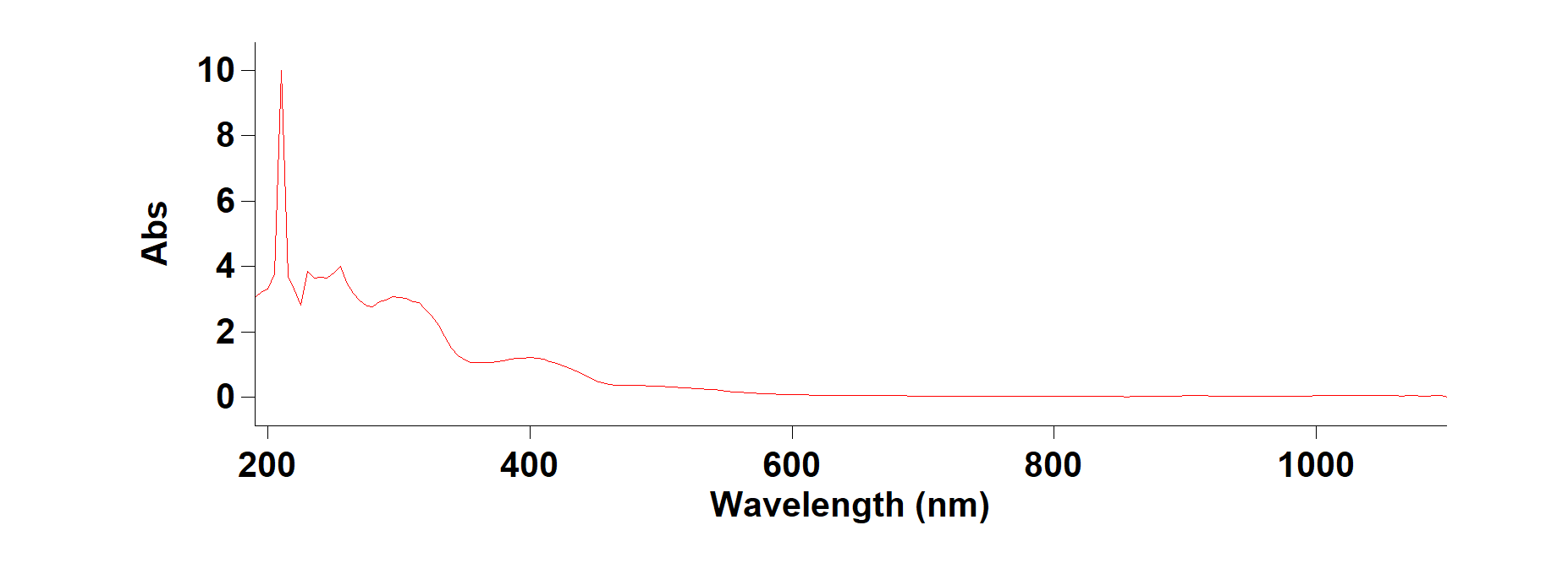
Fig. S14. UV-Vis. spectra of complex 1
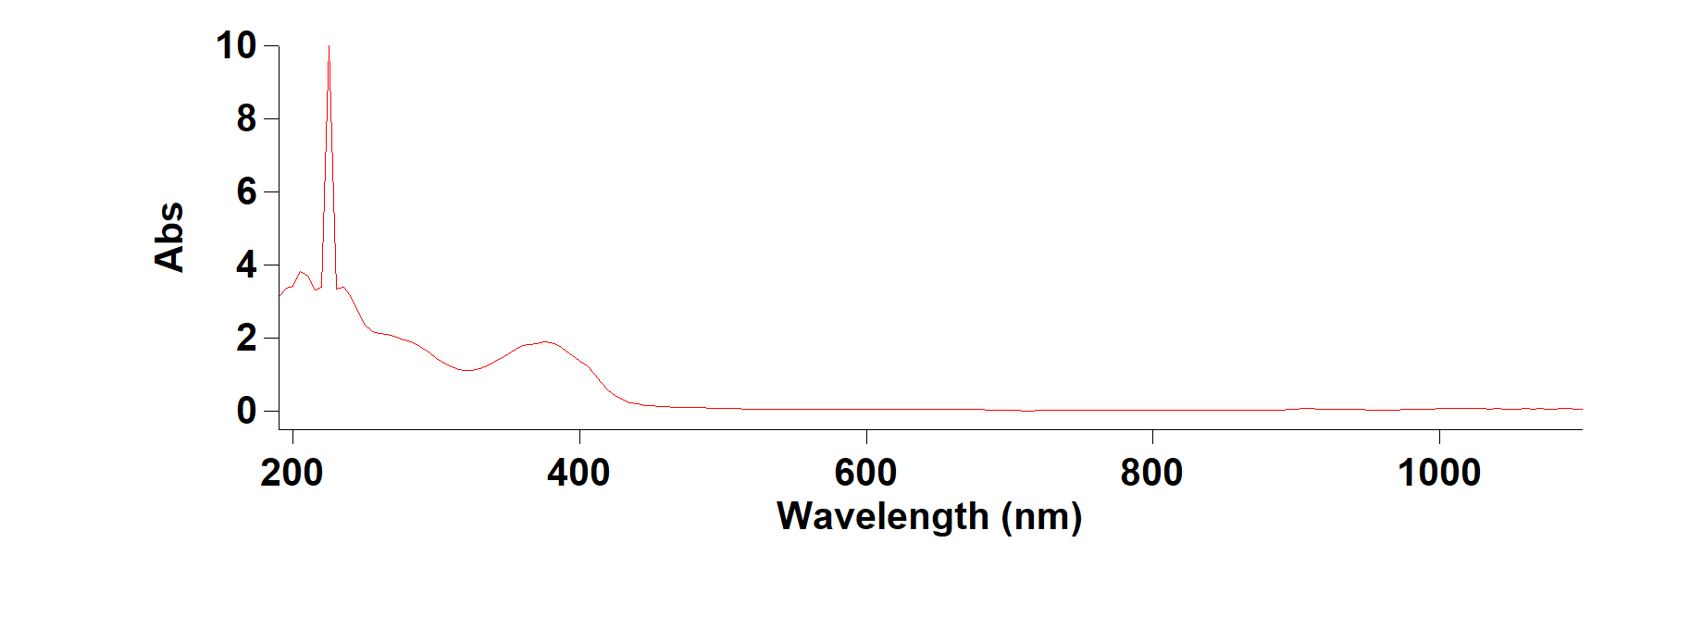 Fig. S15. UV-Vis. spectra of ligand S²
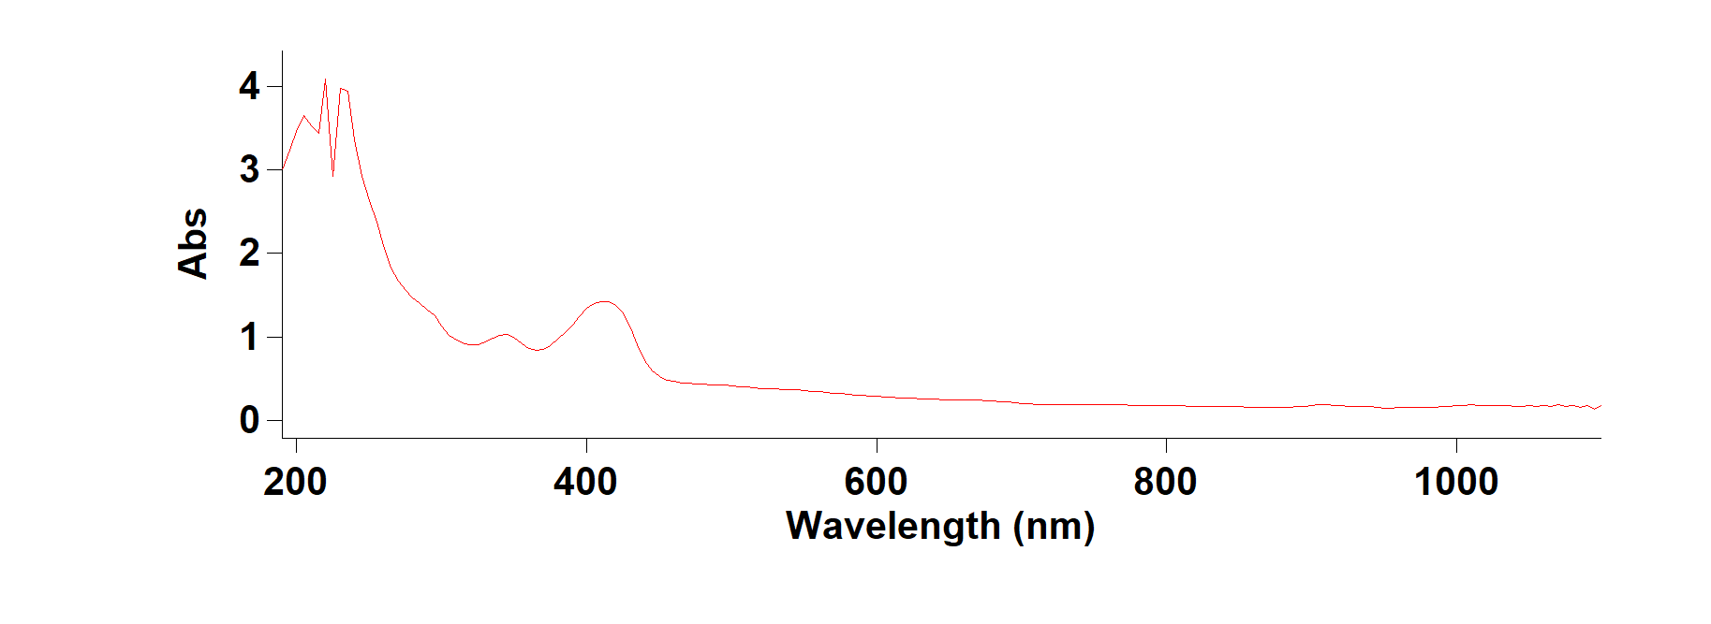 Fig. S16. UV-Vis. spectra of complex 2

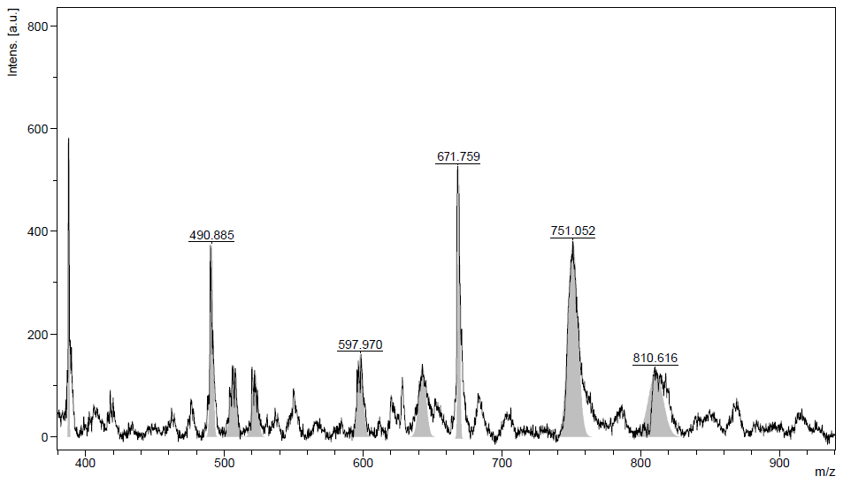
Fig. S17. Mass spectra of complex 1

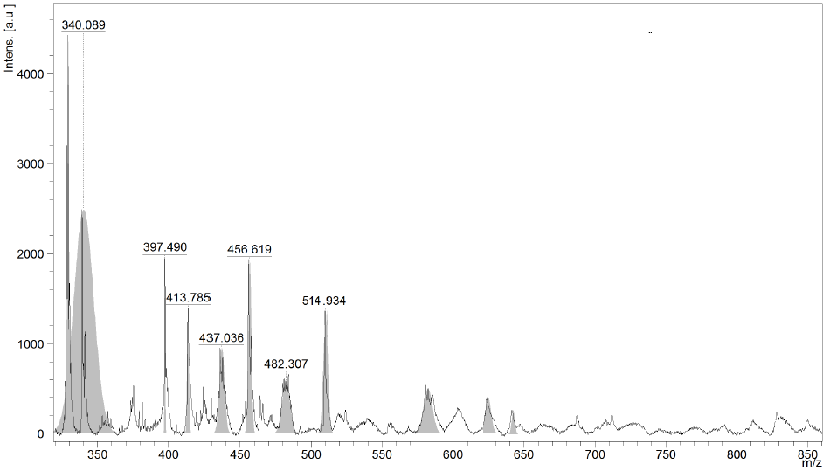
Fig. S18. Mass spectra of complex 2

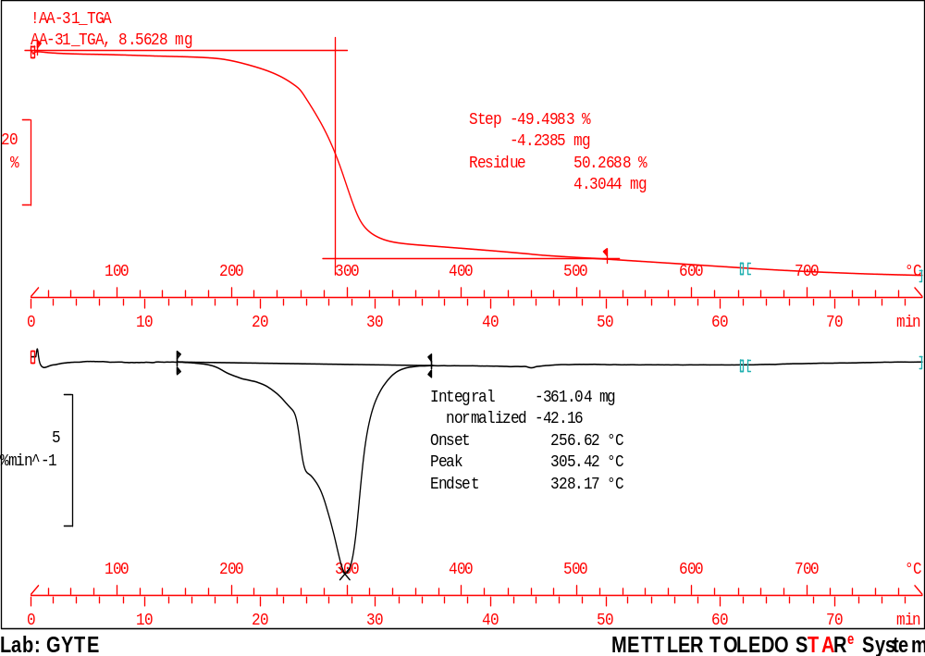
Fig. S19. Thermogram of complex 1

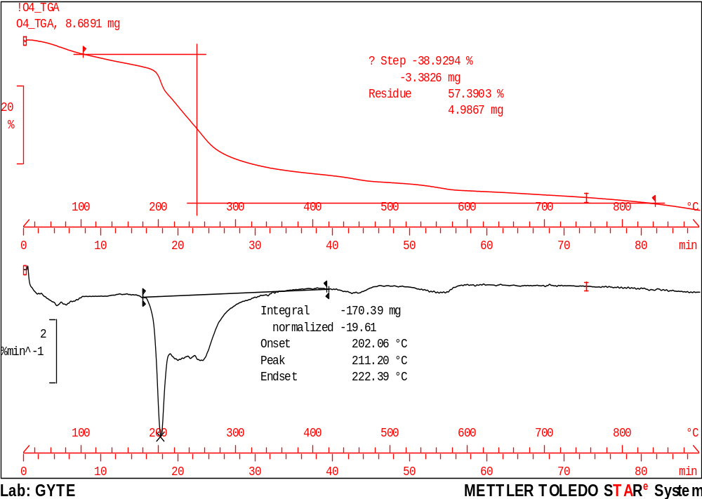
Fig. S20. Thermogram of complex 2

