Supplementary information

Highly Efficient Circularly Polarized Near-infrared Phosphorescence in Solution and Aggregate

Dan Liu^{†1}, Wenjin Wang^{†1}, Parvej Alam¹, Zhan Yang¹, Kaiwen Wu¹, Lixun Zhu¹, Yu Xiong³, Shuai Chang⁴, Yong Liu⁵, Bo Wu¹, Qian Wu², Zijie Qiu*¹, Zheng Zhao*¹, Ben Zhong Tang*^{1,2}

¹ Clinical Translational Research Center of Aggregation-Induced Emission, School of Medicine, The Second Affiliated Hospital, School of Science and Engineering, Shenzhen Institute of Aggregate Science and Technology, The Chinese University of Hong Kong, Shenzhen (CUHK-Shenzhen), Guangdong 518172, China
² Department of Chemistry, Hong Kong Branch of Chinese National Engineering Research Center for Tissue Restoration and Reconstruction, Institute of Molecular Functional Materials, Division of Life Science and State Key Laboratory of Molecular Neuroscience, The Hong Kong University of Science and Technology, Clear Water Bay, Kowloon, Hong Kong, China
³ Center for AIE Research, Shenzhen Key Laboratory of Polymer Science and Technology Guangdong Research Center for Interfacial Engineering of Functional Materials College of Materials Science and Engineering College of Physics and Optoelectronic Engineering, Shenzhen University, Guangdong, 518060, China
⁴ Platform for Applied Nanophotonics, Faculty of Materials Science, Shenzhen MSU-BIT University, Shenzhen, 518115, China
⁵ Yong Liu, AIE Institute, Guangzhou 510530, China.

† These authors contributed equally to this work.
*Email: zijieqiu@cuhk.edu.cn (Z. Q); zhaozheng@cuhk.edu.cn (Z. Z); tangbenz@cuhk.edu.cn (B.Z.T)

Content
I. Syntheses and characterizations 3
1.1 Materials and instruments 3
1.2 Synthetic routes 3
II. Theoretical simulations 4
2.1 Geometry optimization and the singlet point energy calculations 4
2.2 Spin-orbit coupling constant calculations 5
2.3 Circularly polarized fluorescent calculations 5
2.4 Circularly polarized phosphorescent calculations 5
III. In vitro and in vivo imaging 6
3.1 Cell culture and cell viability test 6
3.2 Hypoxia imaging of Hela cells 6
3.3 Preparation of nanoparticles 6
3.4 Hypoxia imaging in tumor 6
IV. Supplementary figures 7
4.1 Synthetic routes and characterization S1-S17 7
4.2 Single crystal analysis S18-S23 14
4.3 Photophysical properties S24-S29 16
4.4 Frontier molecular orbit (FMO) and natural transition orbit (NTO) analysis S30 19
4.5 Spin-orbit coupling analysis S31 21
4.6 Root-mean-square displacement (RMSD) analysis S32-S33 21
4.7 Reorganization energy analysis S34-S40 22
4.8 Transition density and transition dipole moment analysis S41 26
4.9 Photoactivated properties S42-S51 26
5.0 Anti-counterfeiting application S52-S53 30
V. Supplementary Tables 32
S1 Single crystal data 32
S2 Photophysical data 32
S3 Electronic transition data 33
S4 Electronic transition data 33
VI. References 33
- Syntheses and characterizations

  - Materials and instruments
All chemicals and reagents were received from commercial sources. Solvents for chemical synthesis were purified according to the standard procedures. 5,6-difluorobenzo[c][1,2,5]thiadiazole (2FBT) was further recrystallized from toluene before use. The air-sensitive reagents were handled under a nitrogen atmosphere.
¹H and ¹³C NMR spectra were obtained on a BRUKER AMX 500-MHz instrument. Molecular masses were measured by Waters Xevo G2-XS QTof. High-Performance Liquid Chromatography (HPLC) was conducted using an Agilent 1260 Infinity II Prime. The UV-Vis absorption spectra of the compounds were acquired by a Perkin Elmer Lambda 365. The photoluminescence emission spectra were obtained on the Edinburgh FLS1000 luminescence spectrometer; all the phosphorescence emission spectra were measured by setting a delay time of 1 ms, Liquid nitrogen was used for low-temperature (77 K) phosphorescence measurements. The lifetime and time-resolved emission spectra of solution, film, and crystal samples were recorded using an Edinburgh FLS1000 luminescence spectrophotometer equipped with a xenon arc lamp (Xe900), a 375 nm picosecond laser or a microsecond flash-lamp (μF 900). The PL quantum efficiency was measured on Quantaurus-QY C11347-11. Circular dichroism (CD) spectroscopy was collected on Applied Photophysics Chirascan. Circularly polarized luminescence (CPL) spectra were performed with a JASCO CPL-300 spectrometer. Single-crystal XRD was carried out on Bruker APEX-II CCD with graphite monochromate Mo-Kα radiation. Electron Paramagnetic Resonance (EPR) spectra were performed with BRUKER E500.

  - Synthetic routes
1.2.1: Synthesis of R dinaphtho[2'',1'':5',6';1''',2''':7',8'] [1,4]dioxocino[2',3':4,5]benzo[1,2⁃c] [1,2,5]thiadiazole(R-BBT): 5,6-difluorobenzo[c][1,2,5]thiadiazole (0.50 g, 2.90 mmol), (R)-[1,1'-binaphthalene]-2,2'-diol (1.00 g, 3.49 mmol) and potassium carbonate (1.2 g, 8.71 mmol) were dissolved in 10 mL N,N-dimethyl formamide (DMF) in a pear-shaped bottle. The mixture was stirred for 24 h under air. The resultant mixture was quenched with water, filtered, and dried in a vacuum oven overnight. The crude product was filtered and purified by silica gel column chromatography. The target product was recrystallized by ethyl acetate to give the white product (1.08 g, 89%).¹H NMR (500MHz, DMSO-d₆) δ 8.18 (d, J = 8.8 Hz, 2H), 8.10 (d, J = 8.0 Hz, 4H), 7.72 (d, J = 8.8 Hz, 2H), 7.58 (t, J = 7.5 Hz, 2H), 7.50 (t, J = 7.6 Hz, 2H), 7.44 (d, J = 8.5 Hz, 2H). ¹³C NMR (126 MHz, DMSO) δ 152.27, 151.72, 150.96, 132.00, 131.79, 131.61, 129.18, 127.91, 126.42, 126.21, 125.14, 121.31, 111.94. MS (LCMS-QTOF) [m/z]: calcd for C₂₆H₁₄N₂O₂S, 418.0776; found, 418.0771.

1.2.2: Synthesis of (S) dinaphtho[2'',1'':5',6';1''',2''':7',8'][1,4]dioxocino[2',3':4,5]benzo[1,2-c][1,2,5]thiadiazole (S-BBT): S-BBT was synthesized in a fashion similar to that for R-BBT but using (S)-[1,1'-binaphthalene]-2,2'-diol (1.00 g, 3.49 mmol). The product was obtained as a white product (1.11g, 91%). ¹H NMR (500 MHz, DMSO-d₆) δ 8.21 (d, J = 8.7 Hz, 2H), 8.13 (d, 4H), 7.76 (d, J = 8.7 Hz, 2H), 7.60 (t, J = 7.3 Hz, 2H), 7.52 (t, J = 7.3 Hz, 2H), 7.45 (d, J = 8.2 Hz, 2H). ¹³C NMR (126 MHz, DMSO) δ 152.29, 151.74, 150.99, 132.73, 131.80, 131.65, 129.21, 127.95, 126.45, 126.21, 125.14, 121.32, 111.98. MS (LCMS-QTOF) [m/z]: calcd for C₂₆H₁₄N₂O₂S, 418.0776; found, 418.0771.

1.2.3: Synthesis of (R)-14,18 diiododinaphtho[2'',1'':5',6';1''',2''':7',8'][1,4]dio-
xocino[2',3':4,5]benzo[1,2-c][1,2,5]thiadiazole (R-BBTI): 5,6-difluoro-4,7-diiodobenzo[c][1,2,5]thiadiazole (0.5 g, 1.18 mmol), (R)-[1,1'-binaphthalene]-2,2'-diol (0.40 g, 1.42 mmol) and potassium carbonate (0,49 g, 3.54 mmol) were dissolved in 10 mL DMF in a pear-shaped bottle. The mixture was stirred for 24 h under air. The resultant mixture was quenched with water, filtered, and dried in a vacuum oven overnight. The crude product was filtered and purified by silica gel column chromatography. The target product was recrystallized by ethyl acetate to give the pale-yellow product (0.68 g, 1.03 mmol). ¹H NMR (500 MHz, DMSO-d₆) δ 8.23 (dd, J = 9.0, 2.3 Hz, 2H), 8.14 (d, J = 8.2 Hz, 2H), 7.70 (dd, J = 8.8, 2.3 Hz, 2H), 7.62 (dt, J = 8.1, 4.5 Hz, 2H), 7.58-7.50 (m, 4H). ¹³C NMR (126 MHz, DMSO) δ 152.50, 151.98, 150.80, 132.24, 132.02, 131.64, 129.32, 128.20, 126.69, 126.29, 124.90, 120.91, 84.17. MS (LCMS-QTOF) [m/z]: calcd for C₂₆H₁₂I₂N₂O₂S, 669.8709; found, 669.8708.

1.2.4: Synthesis of (S)-14,18 diiododinaphtho [2'',1'':5',6';1''',2''':7',8'][1,4]dioxocino [2',3':4,5]benzo[1,2-c][1,2,5]thiadiazole (S-BBTI): S-BBTI was synthesized in a fashion similar to that for R-BBTI but using (R)-[1,1'-binaphthalene]-2,2'-diol (0.40 g, 1.42 mmol). The product was obtained as a pale-yellow product (0.66 g, 84%). ¹H NMR (500 MHz, DMSO-d₆) δ 8.24 (d, J = 8.8 Hz, 2H), 8.15 (d, J = 8.2 Hz, 2H), 7.70 (d, J = 8.8 Hz, 2H), 7.67-7.60 (m, 2H), 7.60-7.49 (m, 4H). 13C NMR (126 MHz, DMSO) δ 152.50, 151.99, 150.80, 132.25, 132.02, 131.64, 129.33, 128.21, 126.70, 126.29, 124.90, 120.91. MS (LCMS-QTOF) [m/z]: calcd for C₂₆H₁₂I₂N₂O₂S, 669.8709; found, 669.8704.

- Theoretical simulations
2.1 Geometry optimization and the singlet point energy calculations
The calculations were carried out using the Gaussian 16 program package.¹ The geometry optimization and frequency calculation were carried out for the ground state (S₀), the first excited singlet state (S₁), and the first excited triplet state (T₁) via DFT calculations at the B3LYP/def2-SVP level in both gas phase and crystal state. The solid-state effect was mimicked through combined quantum mechanics and molecular mechanics (QM/MM) by extracting a supercell from the experimental crystal structure, where the central molecule is selected as the QM region and its surroundings are taken as the MM region.² TD-DFT calculations for the S₀→S₁ and S₀→T₁ transitions were performed using the B3LYP functional and def2-SVP basis set. To understand the electronic transition characteristics at the molecular level, the natural transition orbital (NTO) analyses were also carried out by TD-DFT calculations.³ The reorganization energies caused by remarkable geometric changes were calculated by the normal mode analysis method (NM) applied in the MOMAP package.⁴ Here, all these calculational analyses were performed with the Gaussview, Multiwfn, and VMD programs.^{3, 5, 6}

2.2 Spin-orbit coupling constant calculations
Spin-orbit coupling constants were computed using the ORCA 5.0.2 software package with the B3LYP functional, and the def2-TZVP and DKH-def2-TZVP SARC/J basis sets were used for R/S-BBT and R/S-BBTI, respectively. ⁷

2.3 Circularly polarized fluorescence (CPF) calculations
The calculations about the geometry’s optimization were carried out using the Gaussian 16 program package. The CPF calculations were performed according to the geometry optimization in the lowest-lying singlet (S₁) states. The vectors of transition electronic dipole moments and magnetic dipole moments were performed by the Multiwfn and VMD programs.⁸ The rotatory strength (R) and fluorescent dissymmetry factors (g_{fluo}) were calculated by the equations as follows:
$g_{fluo}=\frac{4R}{D}=\frac{4\cos{θ\left|m\right|}\left|μ\right|}{{\left|m\right|}^{2}+{\left|μ\right|}^{2}}$ (1)

2.4 Circularly polarized phosphorescence (CPP) calculations
The CPP calculations were carried out using the Dalton program based on the B3LYP functional and def2-SVP basis set.⁹ Relativistic small-core effective core potential (ECP) approximation was employed for R/S-BBTI molecules. Dalton provides implementations of the calculation of the radiative T₁→S₀ transition process. Considering T₁ has three degenerate sub-states (m = 0, ±1), the transition velocity dipole moment and orbital angular momentum of the three sub-states are given by the matrices:
$DIPVEL=\left[\begin{matrix}μ_{1x} & μ_{2x} & μ_{3x} \\ μ_{1y} & μ_{2y} & μ_{3y} \\ μ_{1z} & μ_{2z} & μ_{3z}\end{matrix}\right]$a.u. (2)

$ANGMOM=\left[\begin{matrix}L_{1x} & L_{2x} & L_{3x} \\ L_{1y} & L_{2y} & L_{3y} \\ L_{1z} & L_{2z} & L_{3z}\end{matrix}\right]$a.u. (3)
Matrices (2) and (3) allow for transition electronic dipole moment (μ) and transition magnetic dipole moment (m) in X-polarization, Y-polarization, and Z-polarization. The vectors of transition electronic dipole moments and magnetic dipole moments were performed by the Multiwfn and VMD programs.
Meanwhile, matrices (2) and (3) allow for accurate simulation of rotatory strength (R), dipole strength (D) and dissymmetry factor (g_{phos}) of circularly polarized phosphorescence:
$R=-\frac{1}{2}\left[{(μ}_{1x}·L_{1x}+μ_{1y}·L_{1y}+μ_{1z}·L_{1z})+(μ_{2x}·L_{2x}+μ_{2y}·L_{2y}+μ_{2z}·L_{2z})+(μ_{3x}·L_{3x}+μ_{3y}·L_{3y}+μ_{3z}·L_{3z})\right]$a.u. (4)

$D={{(μ}_{1x}}^{2}+{μ_{2y}}^{2}{{+μ}_{3z}}^{2})+({μ_{2x}}^{2}{{+μ}_{2y}}^{2}+{μ_{2z}}^{2})+{{(μ}_{3x}}^{2}+{μ_{3y}}^{2}+{μ_{3z}}^{2})$ a.u. (5)

$g_{phos}=\frac{4R}{D}$ (6)

- In vitro and in vivo imaging
3.1 Cell culture and cell viability test
Hela cells were cultured in Dulbecco’s Modified Eagle Medium (DMEM) supplemented with 10% fetal bovine serum (FBS) and 1% antibiotics (penicillin and streptomycin) in a humidified normoxia (20% O₂) or hypoxia (1% O₂) environment containing 5% carbon dioxide (CO₂) at 37 ºC. The cytotoxicity of the tested S-BBTI compounds against Hela cells was measured by the MTT assay as reported methods.^{10, 11} In detail, cells were seeded in 96-well plates, and incubated for 24 h at normoxia or hypoxia before being treated with the tested compounds for 20 h. Then, 20 μL 3-(4,5-Dimethyl-2-thiazolyl)-2,5-diphenyl-2H-tetrazolium bromide (MTT) (5 mg/mL) was added to each well, and incubated for another 4 h. Then, the absorbance of MTT at 595 nm was measured by SpectraMax M5 microplate/cuvette reader. The cell viability was calculated as the ratio of the absorbance for the experiment group to that of the control group.

3.2 Hypoxia imaging of Hela cells
Hela cells were cultured in confocal imaging Petri dishes for 24 hours under hypoxia conditions. Before imaging measurements, fresh DMEM medium and PBS were deoxidized through bubbled N₂ for 20 min. Then cells were incubated with the deoxidized DMEM containing 20 μM S-BBTI nanoparticles for 12 h under hypoxia conditions. After that, cells were washed with cold PBS 3 times and replenished with fresh DMEM medium before imaging with the confocal microscopic imager (Leica STELLARIS 8, German).

3.3 Preparation of nanoparticles
S-BBTI nanoparticles were prepared by an approach as previously described.^{12, 13} Briefly, S-BBTI (10 mg) and DSPE-PEG 2000 (100 mg) were dissolved in THF (10 mL). The solution was sonicated for 10 minutes before being filtered through a 220 nm nylon microporous syringe-driven filter. Then, the THF solution was slowly injected into 100 mL H₂O under vigorous stirring. Then the mixture was sonicated for 5 minutes before stirring at room temperature overnight to evaporate the organic solvent. After THF was evaporated, the solutions were filtered through a 220 nm polyvinylidene fluoride (PVDF) syringe-driven filter (Millipore) to remove large precipitates. Afterward, the obtained S-BBTI nanoparticles were stored in the dark at room temperature.

3.4 Hypoxia imaging in tumor
The animal experiments were conducted at all the animal operations under the guidelines of the Laboratory Animal Resource Center of The Chinese University of Hong Kong, Shenzhen. Pathogen-free female BALB/c nude mice, 4˗5 weeks of age, were purchased and bred in the Guangdong Medical Laboratory Animal Center. The xenograft tumors model was established by subcutaneous injection of Hela cells (1 × 106) into the right axilla of nude mice. When the tumor volume reached approximately 200 mm³, 50 μL of S-BBTI (2 mg•mL⁻¹) in PBS solution was injected through the tail vein of the mice. The treated mice were imaged after 12, 24, 48, and 72 h, and the main organs of the mice were separated and imaged to investigate the time-dependent distribution of the S-BBTI. The Maestro Ex fluorescence imaging system was used for imaging observations. The entire process from the neck dislocation treatment to the end of the imaging in the experimental mice was completed in 10 minutes.

- Supplementary figures
4.1 Synthetic routes and characterization
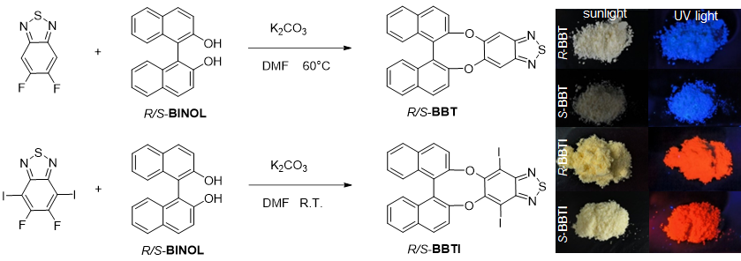
Figure S1 The synthetic route of R/S-BBT and R/S-BBTI and photographs of their powders taken under daylight and 365 nm UV irradiation.

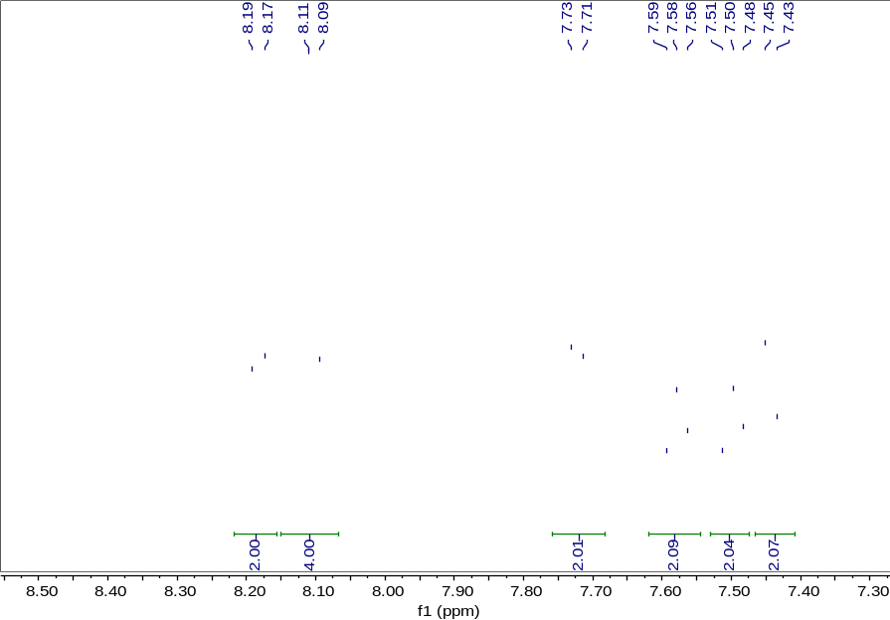
Figure S2 The ¹H NMR spectra of R-BBT in DMSO-d₆.

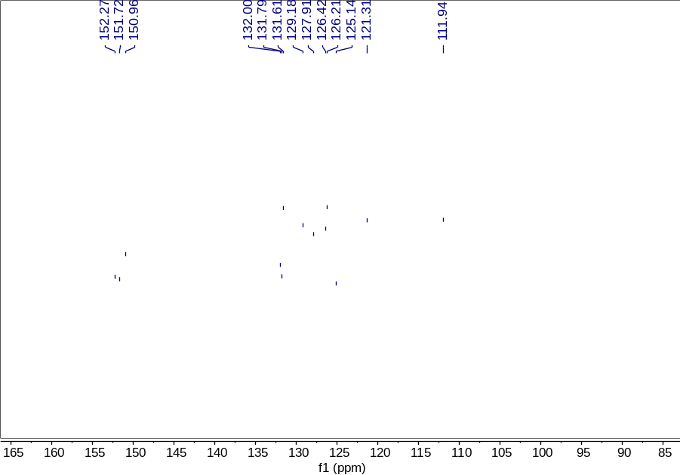
Figure S3 The ¹³C NMR spectra of R-BBT in DMSO-d₆.

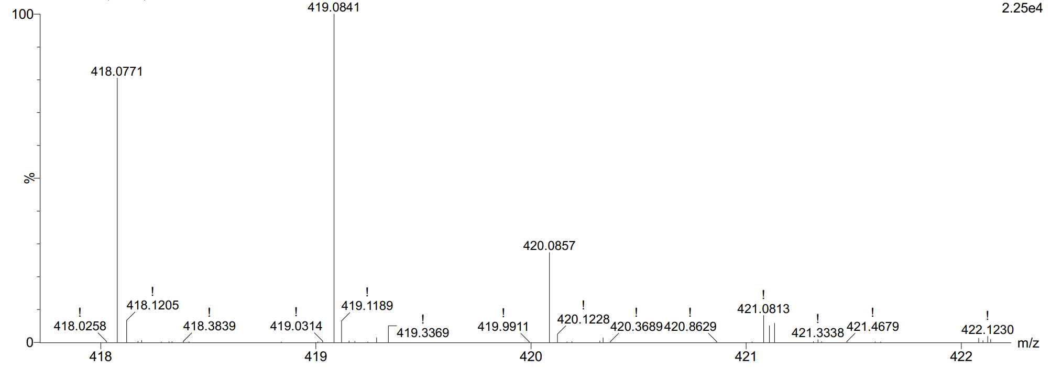
Figure S4 The HRMS of R-BBT.

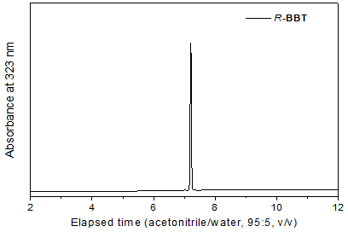
Figure S5 The HPLC spectrum of R-BBT with acetonitrile-water as eluent in ratios of 95/5 (v/v).

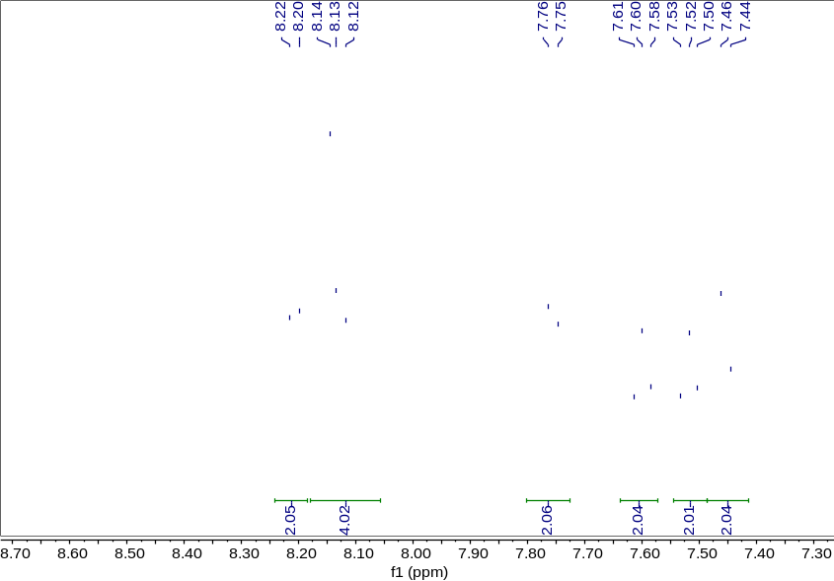
Figure S6 The ¹H NMR spectrum of S-BBT in DMSO-d₆.
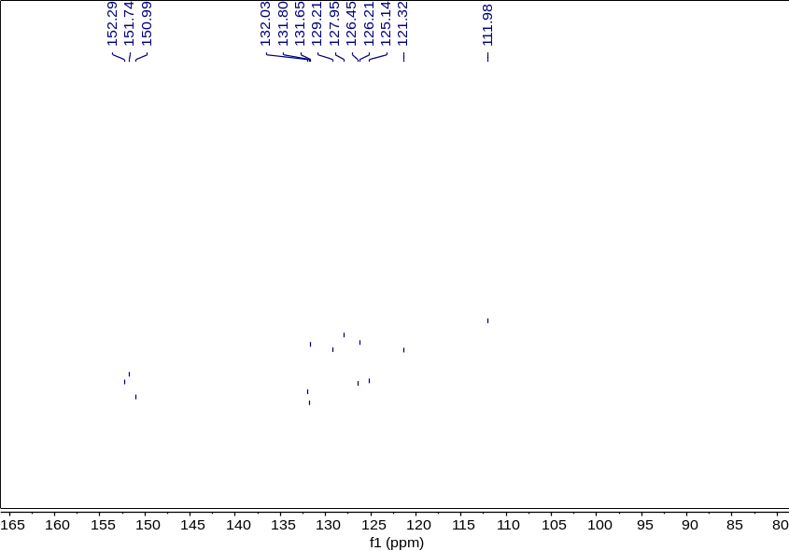
Figure S7 The ¹³C NMR spectrum of S-BBT in DMSO-d₆.

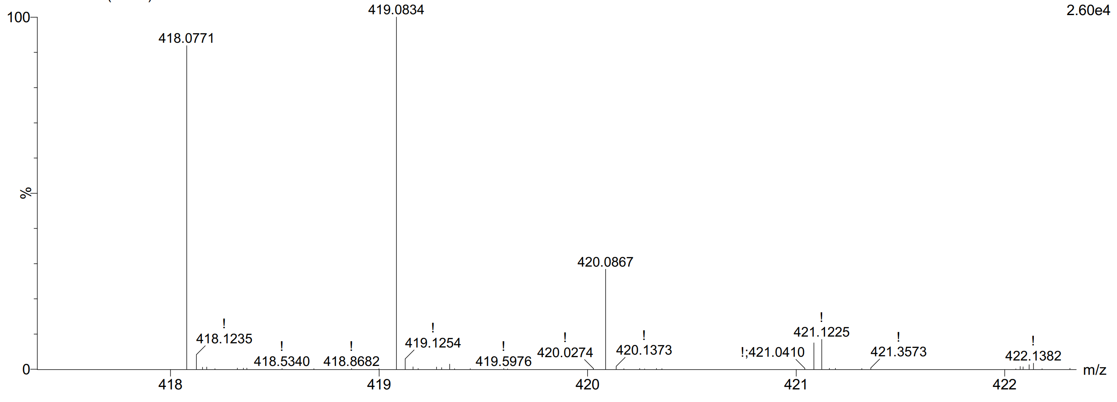
Figure S8 The HRMS of S-BBT.

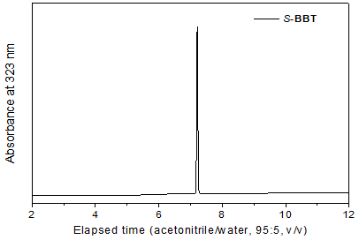
Figure S9 The HPLC spectrum of S-BBT with acetonitrile-water as eluent in ratios of 95/5 (v/v).

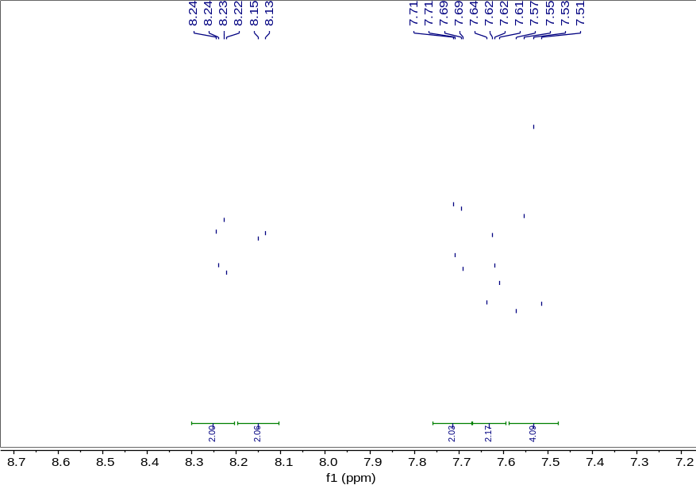
Figure S10 The ¹H NMR spectrum of R-BBTI in DMSO-d₆.

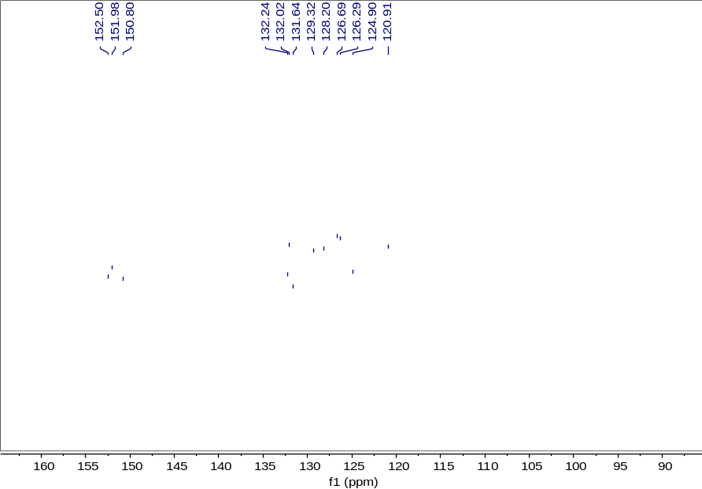
Figure S11 The ¹³C NMR spectrum of R-BBTI in DMSO-d₆.

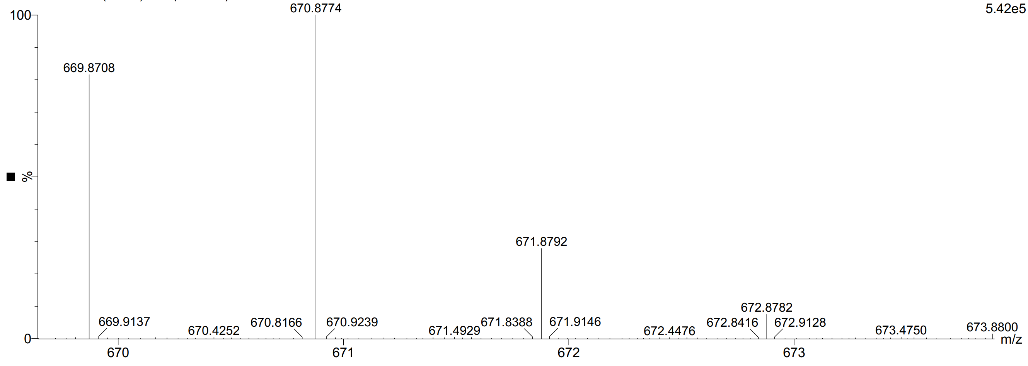
Figure S12 The HRMS of R-BBTI.

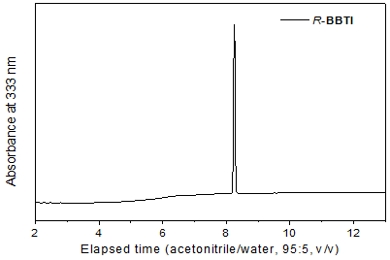
Figure S13 The HPLC spectrum of R-BBTI with acetonitrile-water as eluent in ratios of 95/5 (v/v).

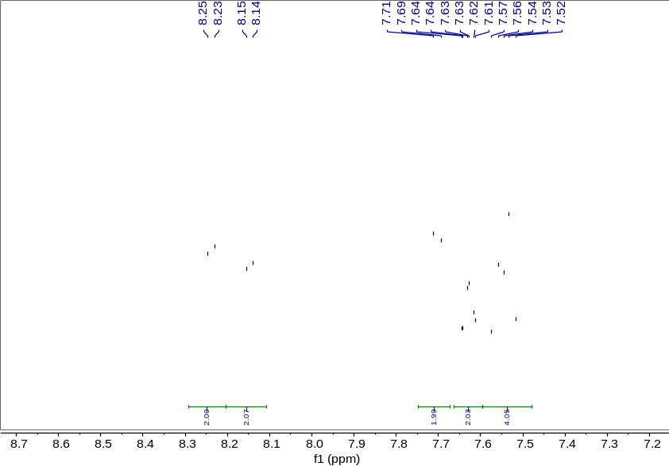
Figure S14 The ¹H NMR spectrum of S-BBTI in DMSO-d₆.
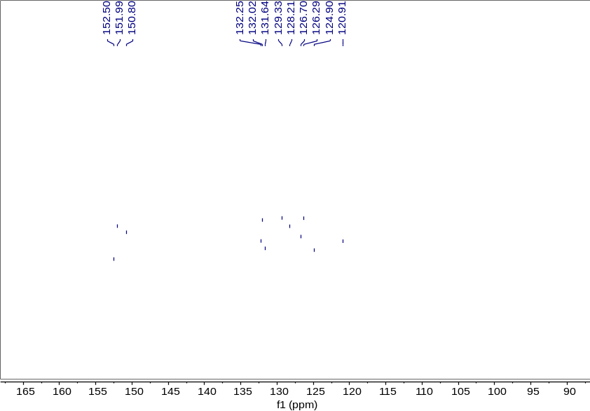
Figure S15 The ¹³C NMR spectrum of S-BBTI in DMSO-d₆.

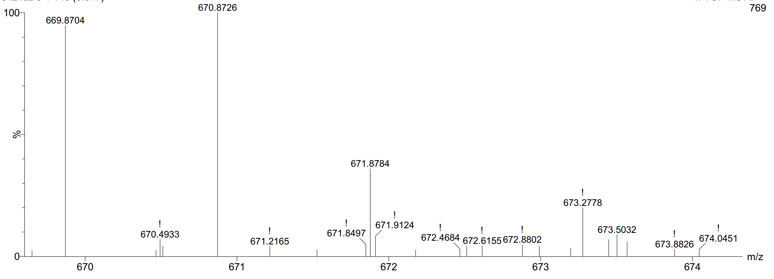
Figure S16 The HRMS of S-BBTI.

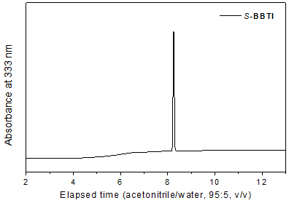
Figure S17 The HPLC spectrum of S-BBTI with acetonitrile-water as eluent in ratios of 95/5 (v/v).

4.2 Single crystal analysis

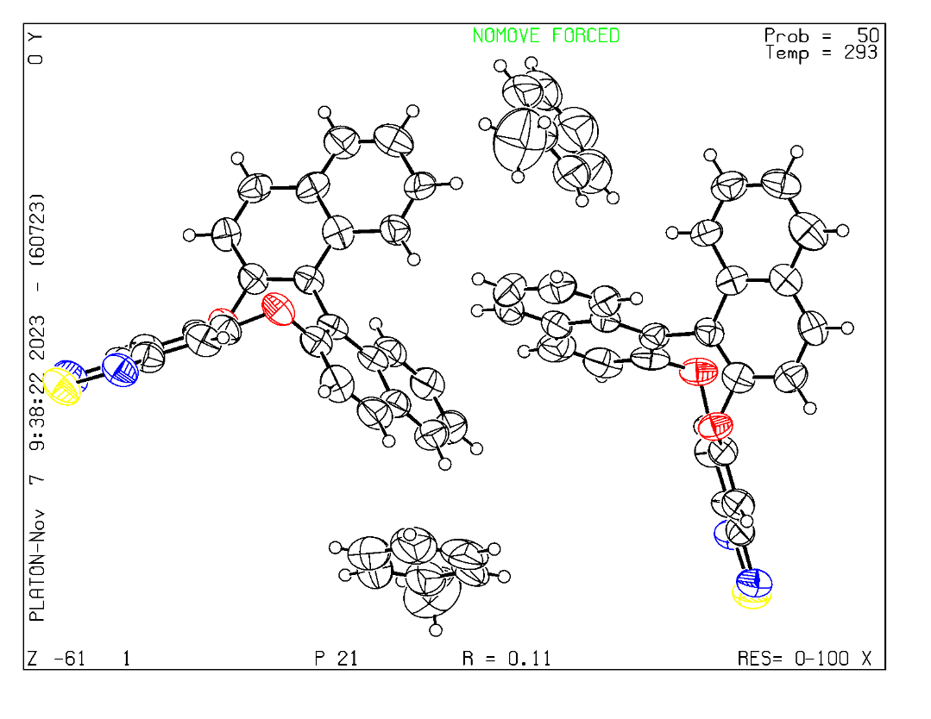
Figure S18 ORTEP drawings of single-crystal X-ray diffraction of R-BBT. Color code: white, C; red, O; blue, N; yellow, S; White circles represent H atoms. Ellipsoids are shown at the 50% probability level.

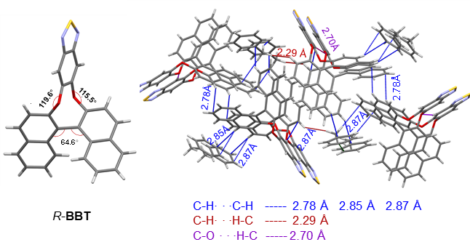
Figure S19. Crystal structure and packing of R-BBT.

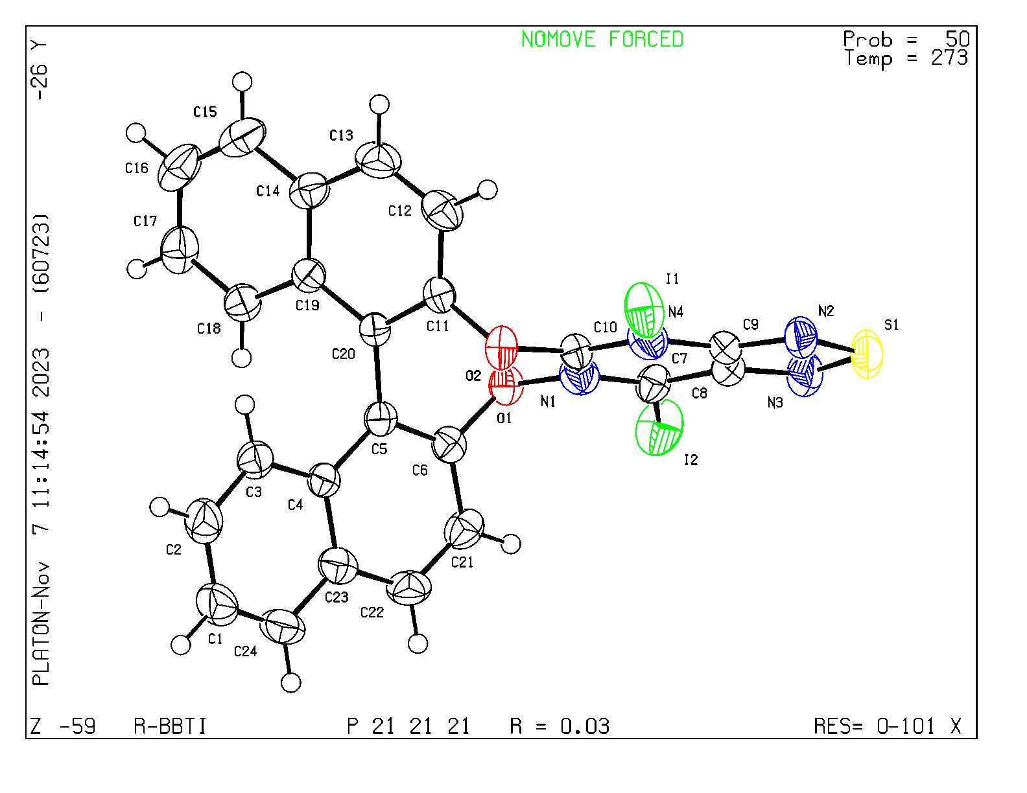
Figure S20 ORTEP drawings of single-crystal X-ray diffraction of of R-BBTI. Color code: white, C; red, O; blue, N; yellow, S; green, I; White circles represent H atoms. Ellipsoids are shown at the 50% probability level.

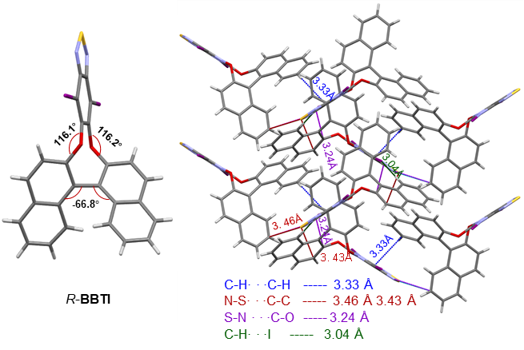
Figure S21. Crystal structure and packing of R-BBTI.
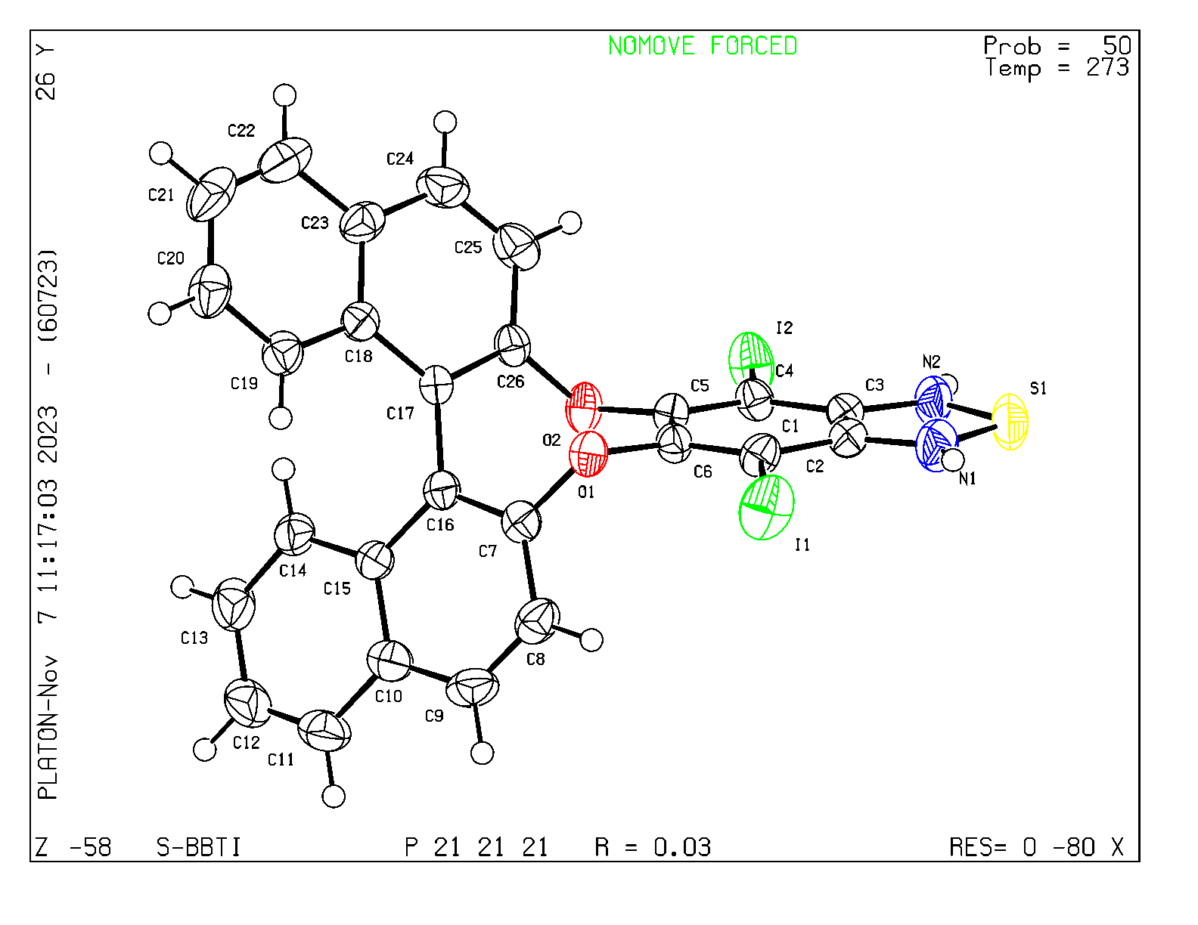
Figure S22 ORTEP drawings of single-crystal X-ray diffraction of S-BBTI. Color code: white, C; red, O; blue, N; yellow, S; green, I; White circles represent H atoms. Ellipsoids are shown at the 50% probability level.

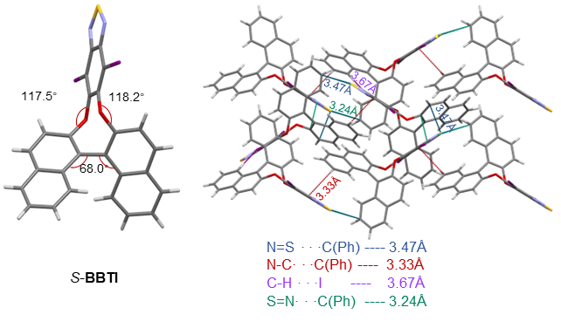
Figure S23. Crystal structure and packing of S-BBTI.

4.3 Photophysical properties
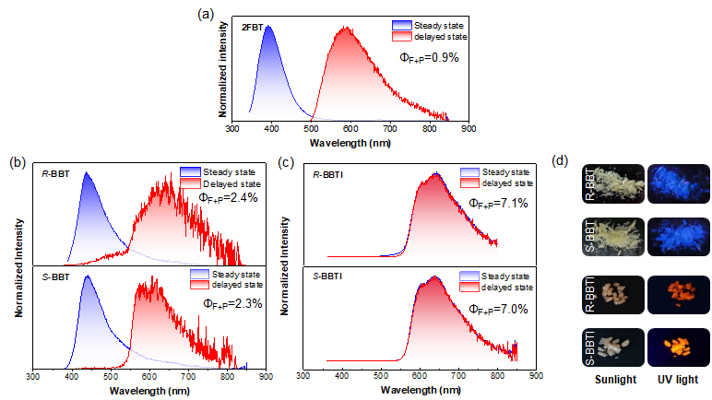
Figure S24 The steady-state and delayed-state photoluminescence spectra of (a) 2FBT, (b) R/S-BBT, (c) R/S-BBTI were recorded in crystalline states by excitation at 340 nm and 1ms. delayed time, (d) photographs of R/S-BBT and R/S-BBTI crystals were taken under daylight and 365-nm UV light.

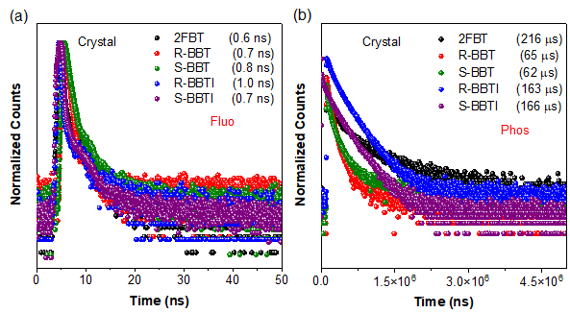
Figure S25. (a) Time-resolved PL decay curves of 2FBT, R-BBT, S-BBT, R-BBTI and S-BBTI in the crystalline states measured at 392 nm, 440 nm, 440 nm, 439 nm, and 435 nm, respectively using 375 nm excitation wavelength, (b) time-resolved PL decay curves of 2FBT, R-BBT, and R-BBTI in the crystalline states measured at 570 nm, 617 nm, and 648 nm, respectively using 375 nm excitation wavelength.
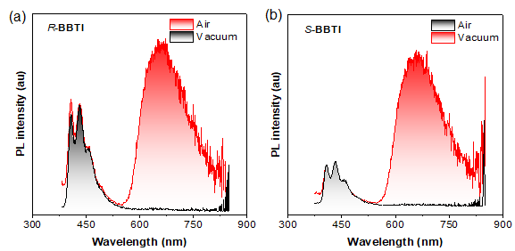
Figure S26. The photoluminescence spectra of (a) R-BBTI and (b) S-BBTI in DMF solution before and after the removal of oxygen.

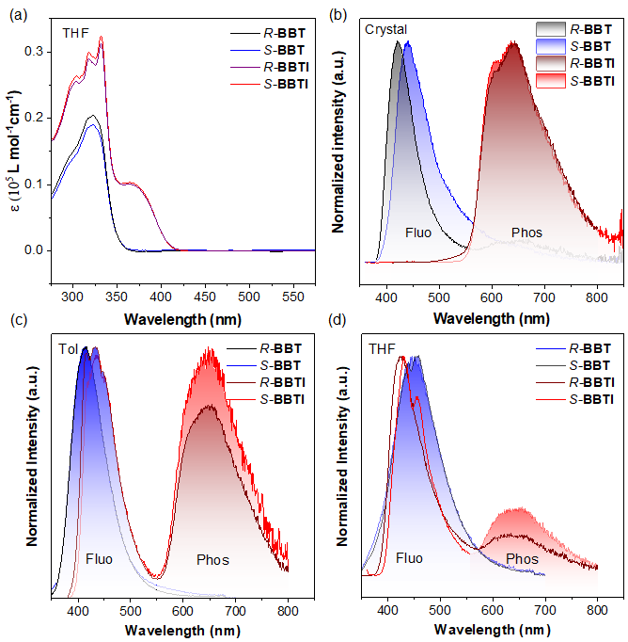
Figure S27 (a) The UV-Vis absorption spectra of R/S-BBT and R/S-BBTI in THF solution; The photoluminescence spectra of R/S-BBT and R/S-BBTI in (b) crystalline states, (c) toluene solution in ambient condition, and (d) THF solution in ambient condition. (Concentration: 10⁻⁵ mol/L).
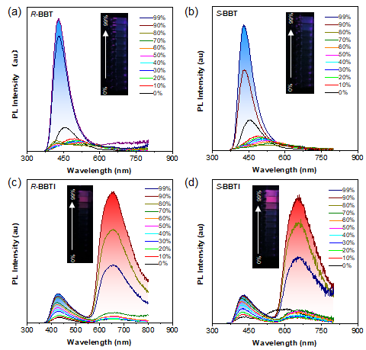
Figure S28 The photoluminescent spectra of R/S-BBT and R/S-BBTI in THF/H₂O solution with different water fractions (f_{w}). Concentration: 10 × 10⁻⁵ M.

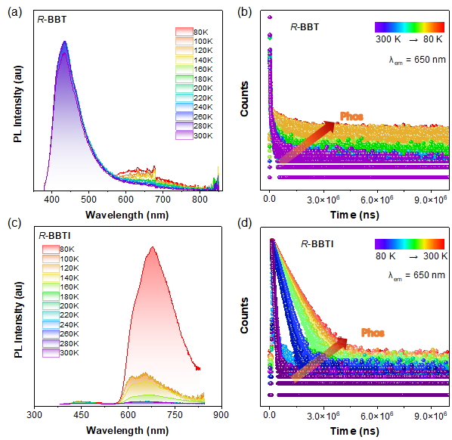
Figure S29. The temperature dependent photoluminescence spectra and decay curves of (a,b) R-BBT and (c,d) R-BBTI in THF solution.

4.4 Frontier molecular orbital (HOMO-LUMO) and natural transition orbital (NTO) analysis
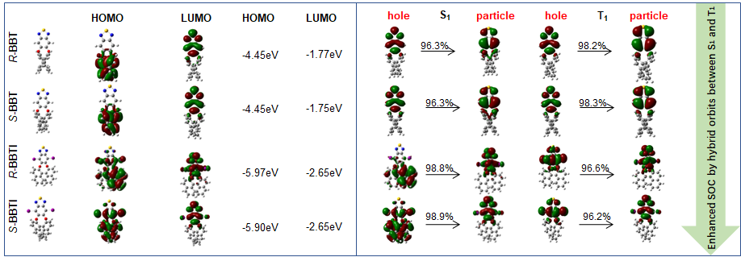
Figure S30. (a) Frontier molecular orbital (HOMO-LUMO) and (b) natural transition orbital (NTO) of R/S-BBT and R/S-BBTI in the gas phase.

4.5 Spin-orbit coupling analysis
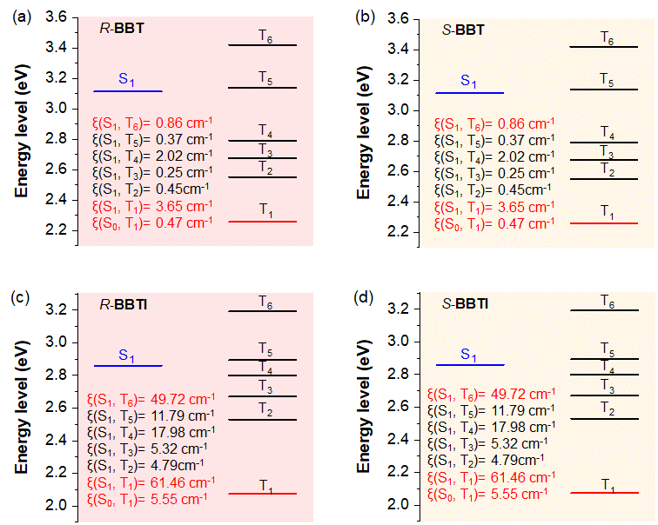
Figure S31. The calculated energy levels of excited states and spin-orbit coupling constants of R-BBT (a), S-BBT (b), R-BBTI (c) and S-BBTI (d) in the gas phase.

4.6 Root-mean-square displacement (RMSD) analysis
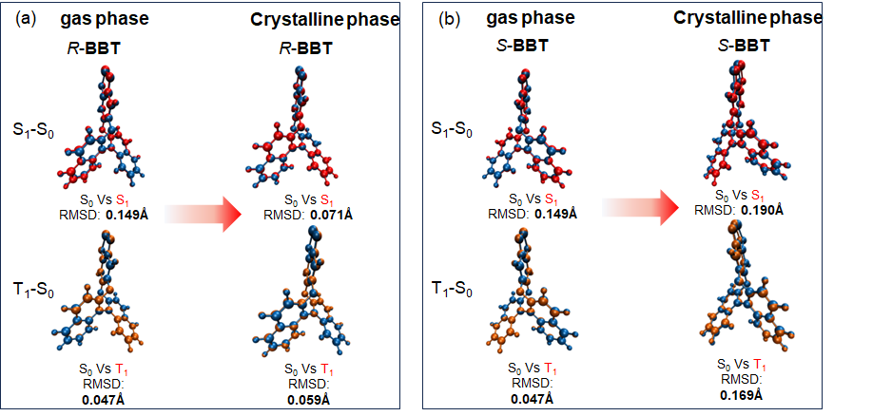
Figure S32. Overlaps of the optimized ground state (blue color), the first excited singlet state (red color), and the first excited triplet state (green color) geometries of (a) R-BBT and (b) S-BBT in the gas phase and crystalline phase.
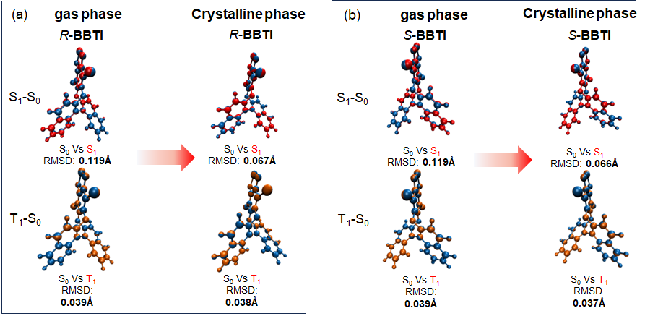
Figure S33. Overlaps of the optimized ground state (blue color), the first excited singlet state (red color), and the first excited triplet state (green color) geometries of (a) R-BBTI and (b) S-BBTI in the gas phase and crystalline phase.

4.7 Reorganization energy analysis
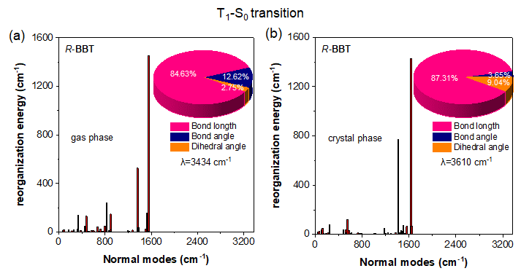
Figure S34. Plots of reorganization energy versus normal mode wavenumber of R-BBT in the (a) gas phase and (b) crystalline phase during T₁→S₀ transition calculated by TD-DFT method. Inset: Proportions of bond length, bond angle, and dihedral angle contributed to the total reorganization energy.
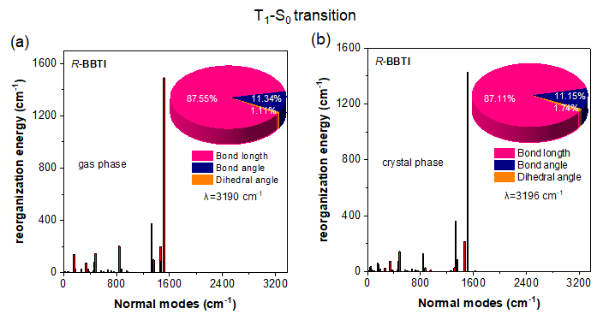
Figure S35. Plots of reorganization energy versus normal mode wavenumber of R-BBTI in the (a) gas phase and (b) crystalline phase during T₁→S₀ transition calculated by TD-DFT method. Inset: Proportions of bond length, bond angle, and dihedral angle contributed to the total reorganization energy.

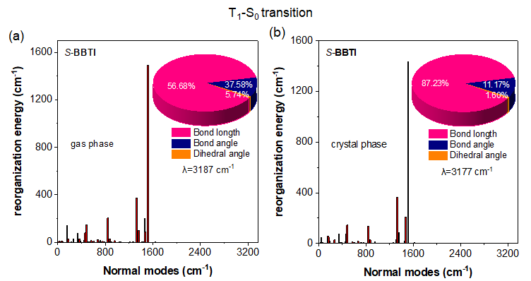
Figure S36. Plots of reorganization energy versus normal mode wavenumber of S-BBTI in the gas phase (a) and (b) crystalline phase during T₁→S₀ transition calculated by TD-DFT method. Inset: Proportions of bond length, bond angle, and dihedral angle contributed to the total reorganization energy.
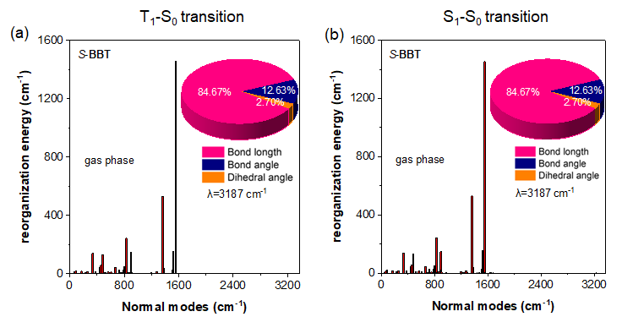
Figure S37. Plots of reorganization energy versus normal mode wavenumber of S-BBT in the gas phase during (a) T₁→S₀ transition and (b) S₁→S₀ transition calculated by TD-DFT method. Inset: Proportions of bond length, bond angle, and dihedral angle contributed to the total reorganization energy.

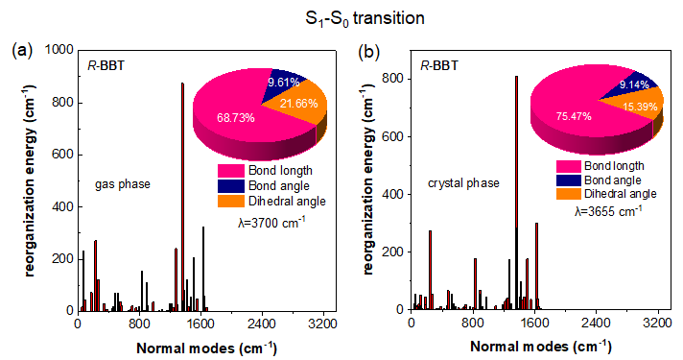
Figure S38. Plots of reorganization energy versus normal mode wavenumber of R-BBT in the gas phase (a) and (b) crystalline phase during S₁→S₀ transition calculated by TD-DFT method. Inset: Proportions of bond length, bond angle, and dihedral angle contributed to the total reorganization energy.

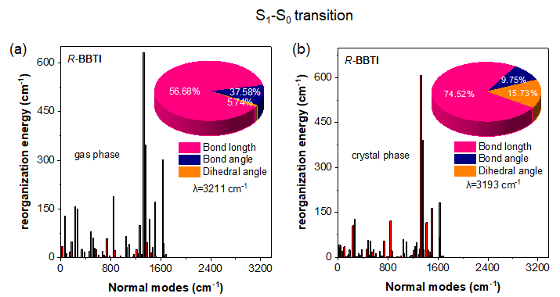
Figure S39. Plots of reorganization energy versus normal mode wavenumber of R-BBTI in the (a) gas phase and (b) crystalline phase during S₁→S₀ transition calculated by TD-DFT method. Inset: Proportions of bond length, bond angle, and dihedral angle contributed to the total reorganization energy.

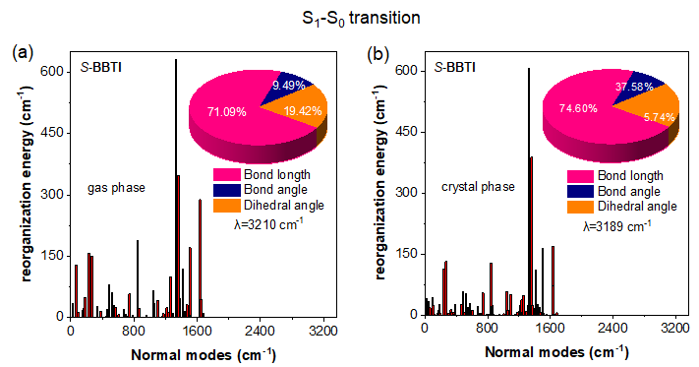
Figure S40. Plots of reorganization energy versus normal mode wavenumber of S-BBTI in the (a) gas phase and (b) crystalline phase during S₁→S₀ transition calculated by TD-DFT method. Inset: Proportions of bond length, bond angle, and dihedral angle contributed to the total reorganization energy.

4.8 Transition density and transition dipole moments analysis
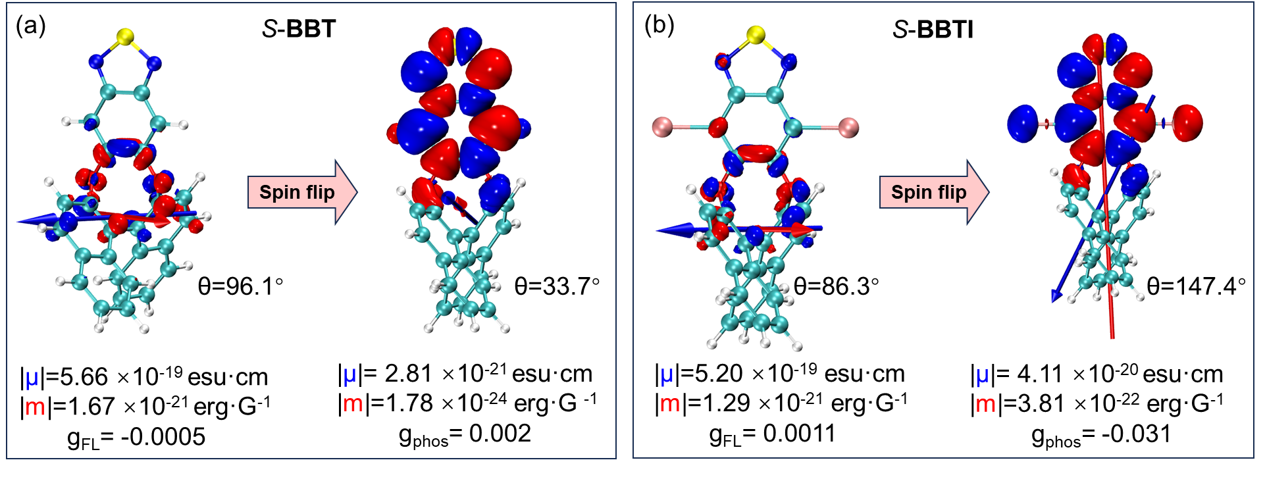
Figure S41. (a) Transition density analysis of S-BBT calculated at the TD-B3LYP-def2-SVP level of theory displayed with an isosurface value of 0.001 au. Left: The spatial arrangement of transition electronic dipole moments (TEDM) (blue stick) and transition magnetic dipole moments (TMDM) (red stick) vectors for the S₁→S₀ transition. Right: The spatial arrangement of TEDM and TMDM vectors for the T₁→S₀ transition, (b) transition density analysis of S-BBTI calculated at the TD-B3LYP-def2-SVP level of theory. Left: The spatial arrangement of TEDM and TMDM vectors for the S₁→S₀ transition. Right: The spatial arrangement of TEDM and TMDM vectors for the T₁→S₀ transition.

4.9 Photoactivated properties
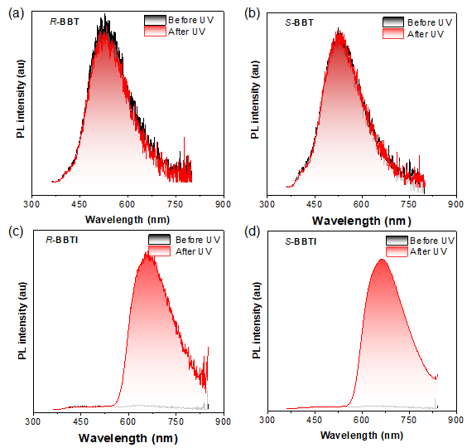
Figure S42. The photoluminescence spectra of (a) R-BBT, (b) S-BBT, (c) R-BBTI, and (d) S-BBTI in DMSO solution before and after UV irradiation for 10 s.
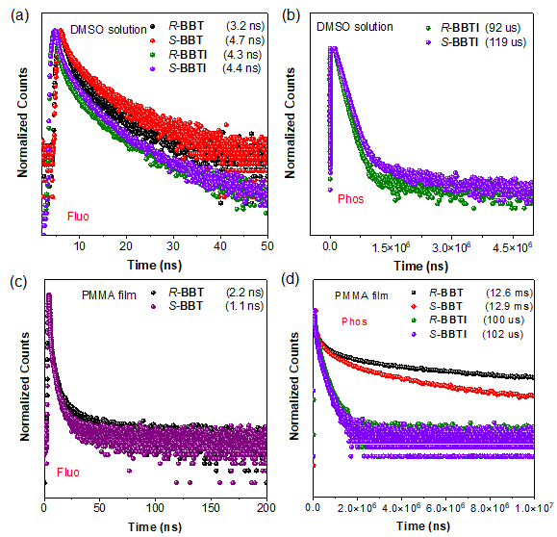
Figure S43. (a) Time-resolved fluorescence decay curves of R/S-BBT and R/S-BBTI in DMSO solution before UV irradiation using 375 nm excitation wavelength. (b) Time-resolved phosphorescence decay curves of R/S-BBT and R/S-BBTI in DMSO solution after UV irradiation using 375 nm excitation wavelength. (c) Time-resolved fluorescence decay curves of R/S-BBT in doped PMMA film (1wt %) before UV irradiation using 375 nm excitation wavelength. (d) Time-resolved phosphorescence decay curves of R/S-BBT and R/S-BBTI in doped PMMA films (1wt %) after UV irradiation using 375 nm excitation wavelength.
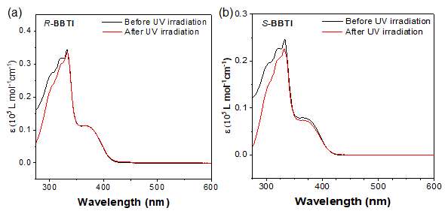
Figure S44. The absorption spectra of (a) R-BBTI and (b) S-BBTI in DMSO solution before and after UV irradiation (10 s).
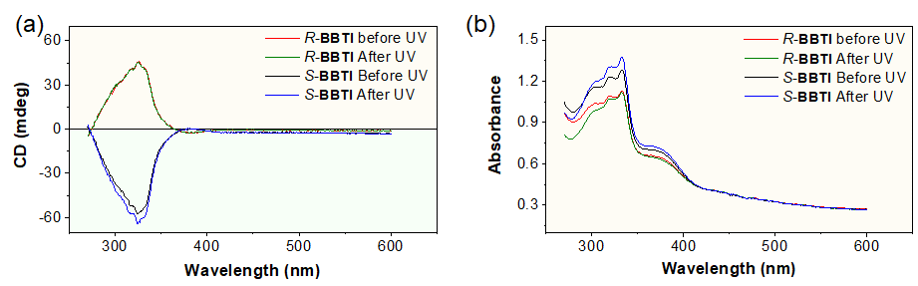
Figure S45. (a) CD and (b) absorption spectra of R/S-BBTI in DMSO solution before and after UV irradiation (10s).
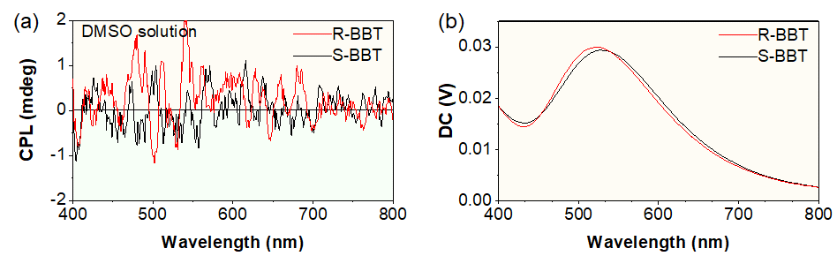
Figure S46. (a) CPL spectra and (b) direct current (DC) spectra of S/R-BBT in DMSO solution.
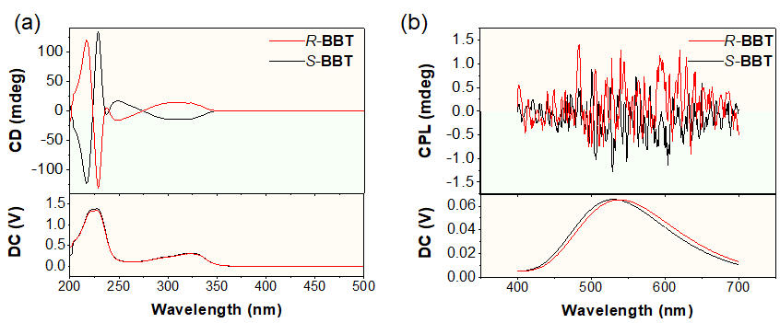
Figure S47. (a) CD and absorption spectra of R/S-BBT; (b) CPL spectra and direct current (DC) spectra of R/S-BBT in acetonitrile solution.
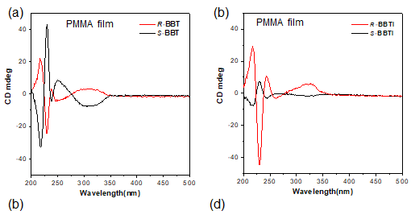
Figure S48. CD spectra of (a) R/S-BBT and (b) R/S-BBTI in the PMMA films.
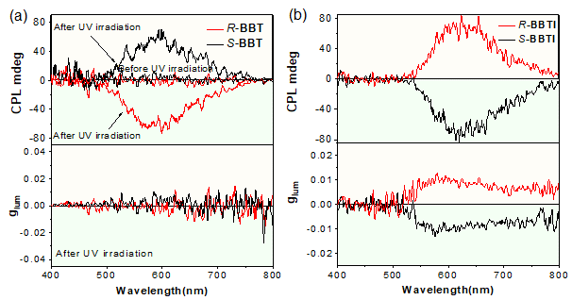
Figure S49. (a) CPL spectra and g_{lum} value of R/S-BBT-doped PMMA films before and after UV excitation (λ_{ex} = 340 nm) for 30s; (b) CPL spectra and g_{lum} value of R/S-BBTI-doped PMMA films upon λ_{ex} = 340 nm UV excitation.
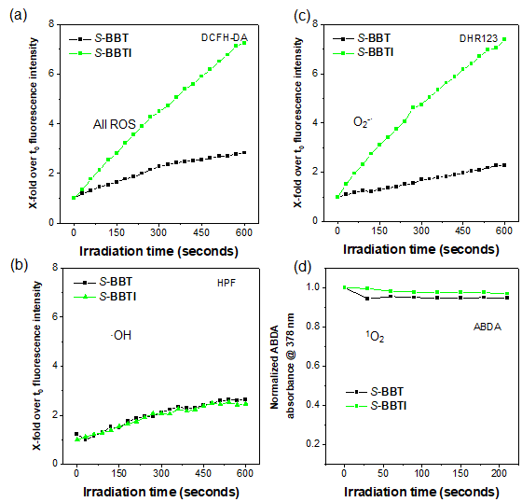
Figure S50. Photophysical properties and measurement of ROS types. Relative changes in PL intensity of (a) DCFH for overall ROS detection, (b) HPF for •OH detection, (c) DHR 123 for O₂^{-•} detection, (d) decomposition rates of ABDA for ¹O₂ detection in the presence of S-BBT and S-BBTI upon UV light irradiation (1 mW cm⁻¹) for different times.
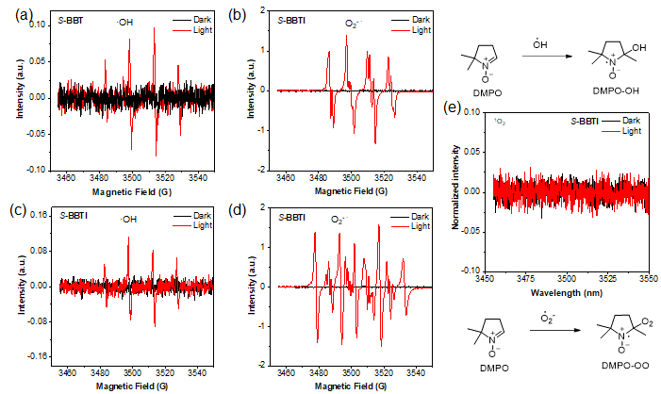
Figure S51. (a) DMPO radical adducts DMPO-OH in the S-BBT in ultrapure water; (b) DMPO-OO formed in the S-BBT in methanol solution; (c) DMPO radical adducts DMPO-OH in the S-BBTI in ultrapure water; (d) DMPO-OO formed in the S-BBTI in methanol solution; (e) No tempo radical adducts in S-BBTI system in DMSO solution;
4.10 Anti-counterfeiting application
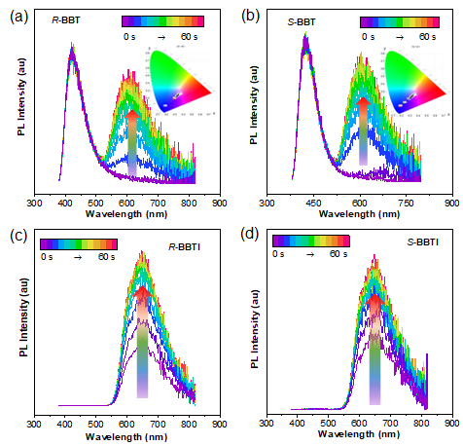
Figure S52. The photoluminescence spectra of R-BBT(a), S-BBT (b), R-BBTI (c) and S-BBTI (d) doped in PMMA film (1 wt%)) recorded after different UV radiation time.
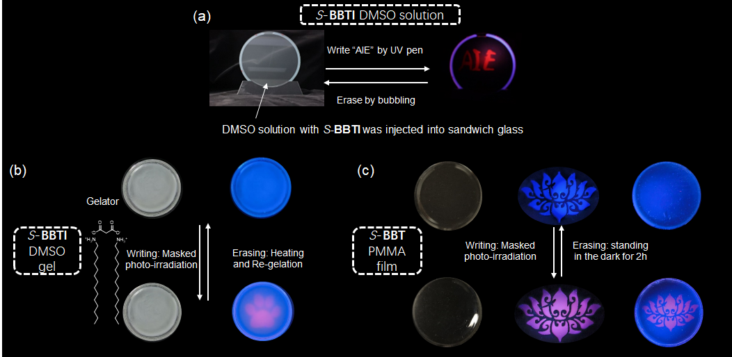
Figure S53. Anti-counterfeiting application of oxygen-sensitive phosphorescence of S-BBTI. (a) Photographic description of the writing–erasing–rewriting processes with a 365 nm UV pen in DMSO solution (10⁻⁵ M S-BBTI), (b) the writing–erasing–rewriting processes with a 365 nm UV lamp on a piece of DMSO gel containing S-BBTI, (c) the writing–erasing–rewriting processes in PMMA film (1 wt% S-BBTI).

- Supplementary tables

5.1 Single crystal data

[CCDC 2329575, 2329576, and 2329577 contains the supplementary crystallographic data for this paper. These data can be obtained free of charge from The Cambridge Crystallographic Data Centre via www.ccdc.cam.ac.uk/data_request/cif.]

Table S1. Crystallographic data for the single crystal of R-BBT, R-BBTI, and S-BBTI.
Single crystal | R-BBT | R-BBTI | S-BBTI
Formula | C₂₆H₁₄N₂O₂S | C₂₆H₁₄I₂N₂O₂S | C₂₆H₁₄I₂N₂O₂S
Formula weight | 510.58 | 674.24 | 674.24
Temperature (K) | 293K | 273K | 273K
Crystal system | monoclinic | orthorhombic | orthorhombic
Space group | P 21 | P 21 | P 21
a (Å) | 14.9253(13) | 8.8295(5) | 8.8185(12)
b (Å) | 6.9663(6) | 13.2854(7) | 13.2829(17)
c (Å) | 26.245(3) | 19.6544(11) | 19.635(3)
α (°) | 90 | 90 | 90
β(°) | 106.520(4) | 90 | 90
γ(°) | 90 | 90 | 90
V (Å³) | 2616.2(4) | 2305.5(5) | 2299.9(5)
Z | 4 | 4 | 4
F (000) | 1064.0 | 1288.0 | 1288.0
Dc (g·cm⁻³) | 1.296 | 1.942 | 1.947
Radiation | λ=1.54178(CuKα) | 0.71073(MoKα) | 0.71073(MoKα)
Reflections collected | 10431 | 5665 | 5639
R_{int} | 0.076 | 0.023 | 0.024
Flack x | 0.12(4) | 0.004(5) | 0.008(6)
Unique reflns | 6723 | 5665 | 5639
Parameters | 664 | 298 | 298
μ (mm⁻¹) | 1.362 | 2.849 | 2.856
R₁ [I≥2σ(I)] ª | 0.1072 | 0.0289 | 0.0299
ωR₂ [I≥2σ(I)] ^{b} | 0.3148 | 0.0649 | 0.0696
GOF | 1.059 | 1.078 | 1.073
ª R₁=Σ||F_{o}|-|F_{c}||/Σ|F_{o}|.
^{b} ωR₂=[Σw(F_{o}²-F_{c}²)²/Σw(F_{o}²)²]^{1/2}

Table S2. Photophysical parameters of 2FBT, R/S-BBT and R/S-BBTI in crystal states.
Sample | 2FBT | R-BBT | S-BBT | R-BBTI | S-BBTI
Φ_{total}(%) | 0.9 | 2.4 | 2.3 | 7.1 | 7.0
τ_{F} (ns) | 0.6 | 0.7 | 0.8 | 1.0 | 0.7
Φ_{F} | 0.7 | 2.1 | 2.1 | 0.1 | 0.1
τ_{P} (μs) | 216 | 65 | 62 | 163 | 166
Φ_{P} | 0.2 | 0.3 | 0.3 | 6.9 | 6.9
k_{nr,P} (s⁻¹)ª | 4.6×10³ | 1.5×10⁴ | 1.6×10⁴ | 5.7×10³ | 5.6×10³
k_{ISC} (s⁻¹)^{b} | 3.3×10⁶ | 4.3×10⁶ | 2.5×10⁶ | 7.0×10⁷ | 9.9×10⁷
ª k_{nr,P}=(1-Φ_{P})/τ_{P}, ^{b} k_{ISC}=Φ_{P}/τ_{P}.

Table S3. Electronic Transition Properties of R/S-BBT and R/S-BBTI.
compd | S1→S0 transition |  |  |  | S1→S0 transition
compd | |μ|ª/10⁻²⁰ esu·cm | |m|^{b}/10⁻²⁰ erg·G⁻¹ | cosθ ^{c} | g_{fluo} ^{d} | |μ|/10⁻²⁰ esu·cm | |m|/10⁻²⁰ erg·G⁻¹ | cosθ | g_{phos}
R-BBT | 56.691 | 0.166 | -0.0433 | -0.0005 | 0.281 | 0.00018 | -0.820 | -0.002
S-BBT | 56.648 | 0.166 | 0.0439 | 0.0005 | 0.281 | 0.00018 | 0.832 | 0.002
R-BBTI | 51.962 | 0.129 | 0.110 | 0.0011 | 4.107 | 0.038 | 0.843 | 0.031
S-BBTI | 51.996 | 0.129 | -0.110 | -0.0011 | 4.107 | 0.038 | -0.843 | -0.031
ª Transition electric dipole moment (TEDM). ^{b} Transition magnetic dipole moment (TMDM). ^{c} θ represents the angle of TEDM and TMDM. ^{d} Dissymmerty factor calculated as follows: g = 4cosθ|m||μ|/(|m|²+|μ|²).

Table S4. The phototoxicity (IC₅₀, μM) of S-BBTI in different conditions.
 | In Darkª | In light^{b}
In normoxia | 346.34±27.22 | 248.13 ± 72.61
In hypoxia | 215.59 ± 42.78 | 195.92 ± 23.44
ª Cells were incubated with the tested compounds for 24 h and detected by MTT assay; ^{b} Cells were incubated with the compounds for 24 h in the dark and then irradiated with 405 nm (12 J cm⁻²).

- References
1. Frisch MJ, et al. Gaussian 16 Rev. C.01. Wallingford CT (2016).

2. Ma HL, Yu HD, Peng Q, An ZF, Wang D, Shuai ZG. Hydrogen Bonding-Induced Morphology Dependence of Long-Lived Organic Room-Temperature Phosphorescence: A Computational Study. J Phys Chem Lett 10, 6948-6954 (2019).

3. Roy Dennington TAK, and John M. Millam, Semichem Inc., Shawnee Mission, KS,. GaussView, Version 6.1. (2016).

4. Shuai Z. Thermal Vibration Correlation Function Formalism for Molecular Excited State Decay Rates. Chinese Journal of Chemistry 38, 1223-1232 (2020).

5. Lu T, Chen F. Multiwfn: a multifunctional wavefunction analyzer. J Comput Chem 33, 580-592 (2012).

6. William Humphrey AD, and Klaus Schulten. VMD: Visual Molecular Dynamics. J Mol Graph, 33-38 (1996).

7. Neese F. Software update: the ORCA program system, version 4.0. WIREs Comput Mol Sci 8, e1327 (2017).

8. Lu T, Chen F. How to cite Multiwfn. J Phys Chem A 117, 3100-3108 (2013).

9. Aidas K, et al. The Dalton quantum chemistry program system. Wiley Interdiscip Rev Comput Mol Sci 4, 269-284 (2014).

10. Gavanji S, Bakhtari A, Famurewa AC, Othman EM. Cytotoxic Activity of Herbal Medicines as Assessed in Vitro: A Review. Chem Biodivers 20, e202201098 (2023).

11. Mosmann T. Rapid Colorimetric Assay for Cellular Growth and Survival: Application to Proliferation and Cytotoxicity Assays. J lmmunol 65, 55-63 (1983).

12. Ma H, Hu D, Zhao J, Tian M, Yuan J, Wei Y. Ultrastable Near-Infrared Aggregation-Induced Emission Nanoparticles as a Fluorescent Probe: Long-Term Tumor Monitoring and Lipid Droplet Tracking. CCS Chemistry 3, 1569-1606 (2021).

13. Zhi J, Zhou Q, Shi H, An Z, Huang W. Organic Room Temperature Phosphorescence Materials for Biomedical Applications. Chem Asian J 15, 947-957 (2020).

