Liguzinediol ameliorates doxorubicin-induced cardiotoxicity and potentiates the metabolic remodeling by activating the AMPK/SIRT3 pathway and represses Caspase-3/GSDME-mediated pyroptosis

Weijie Zhu^{a#}, Naqi Lian^{a#}, Jia Wangª, Fengming Zhaoª, Bowen Liuª, Jiaxing Shengª, Chenyan Zhangª, Xuan Zhou^{b}, Wenbai Gaoª, Chen Xie^{c}, Haoyu Guª, Yuxin Zhangª, Mianli Bianª*, Miao Jiangª*, Yu Liª*

ª School of Medicine, Nanjing University of Chinese Medicine, Nanjing 210023, China
^{b} School of Senior Care Services and Management, Nanjing University of Chinese Medicine, Nanjing 210023, China
^{c} College of Acupuncture and Massage health and rehabilitation, Nanjing University of Chinese Medicine, Nanjing 210023, China

#The first two authors contributed equally to this work.
*Correspondence
Dr. Mianli Bian, E-mail: bianmianli@njucm.edu.cn.
Dr. Miao Jiang, E-mail: jiangmiao820701@163.com.
Dr. Yu Li, E-mail: liyu@njucm.edu.cn.

Fig. S1. Lig improves cardiac function in rats, activates AMPK/SIRT3 pathway, reduces caspase-3/GSDME-N mediated pyroptosis, and alleviates heart failure. (A) Schematic diagram of coronary ligation and Lig treatment. (B-E) Left ventricular function was measured by hemodynamics, including LVSP, LVEDP, +dp/dt max and -dp/dt max (n = 6). (F-J) Effects of Lig on NO, FFA, MDA, SOD and ATP in rats with heart failure (n = 4). (K) Protein expression of p-AMPK, AMPK, SIRT3, GSDME-N, Cleaved-caspase-3, and caspase-3 in rats with heart failure (n = 3). Data are presented as the mean ± SD. *P < 0.05, **p < 0.01, ***p < 0.001, ****p < 0.0001 compared with sham control group; #p < 0.05, ##p < 0.01, ###p < 0.001 compared with model group.

Fig. S2. Lig inhibits cardiac apoptosis induced by DOX in mice. (A) Effects of Lig on the expression levels of Bax and Bcl-2 in mice treated by DOX (n = 3). (B) AIF expression in mice treated by DOX (n = 3). Data are presented as the mean ± SD. **p < 0.01, ***p < 0.001 compared with control group; #p < 0.05, ##p < 0.01, ###p < 0.001 compared with DOX model group.

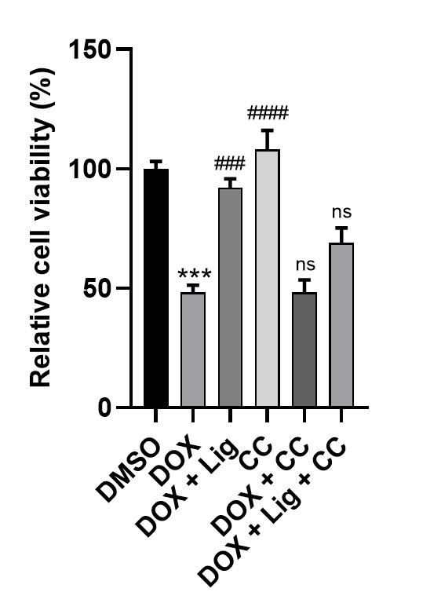
Fig. S3. The activity of H9C2 cell under the intervention of AMPK inhibitor CC. Cell viability in H9C2 cells (n = 5). Data are presented as the mean ± SD. ***p < 0.001 compared with DMSO control group; ###p < 0.001, ####p < 0.0001 compared with DOX model group.

Fig. S4. Knockdown of GSDME enhances the protective effect of Lig against DOX-induced H9C2 cytotoxicity. (A) Effects of siGSDME on the expression levels of GSDME-N in H9C2 cells (n = 3). (B) Representative images of Hochest staining. Scale bar represents 50 µm (n = 6). (C) Effects of siGSDME and Lig on the expression levels of GSDME-N in H9C2 cells treated by DOX (n = 3). Data are presented as the mean ± SD. *p < 0.05, **p < 0.01, ***p < 0.001 compared with DMSO control group; #p < 0.05, ##p < 0.01 compared with DOX model group.

Fig. S5. Effect of Lig combined with CC on DOX stimulation of caspase-3/GSDME pathway in mouse heart. (A) Effects of Lig combined with CC on the expression levels of GSDME, cleaved-caspase-3, caspase-3, IL-6 and IL-1β in mice treated by DOX (n = 3). (B-C) Effects of Lig and CC on serum levels of IL-1β and IL-18 in mice caused by DOX. Data are presented as the mean ± SD. **p < 0.01, ***p < 0.001, ****p < 0.0001 compared with control group; #p < 0.05, ##p < 0.01, ###p < 0.001 compared with DOX model group.

