Figure 1. Schematic diagram of plant expression vector harboring AhNF-YB1 or AhNF-YB10. (a) The construct pC211:B1/B10 components include the T-border(left), LB; CaMV35S polyA, PolyA Site; Basta resistance gene in plants, BAR; CaMV35S promoter, P35S; Napin A 211bp promoter, P211; AhNF-YB1/10; NOS terminator, NOS Ter; T-border(right), RB. (b) The construct pCAtLEC1:B1/B10 components include the T-border(left), LB; CaMV35S polyA, PolyA Site; Basta resistance gene in plants, BAR; CaMV35S promoter, P35S; AtLEC1 promoter, AhNF-YB1/10; NOS terminator, NOS Ter; T-border(right), RB.

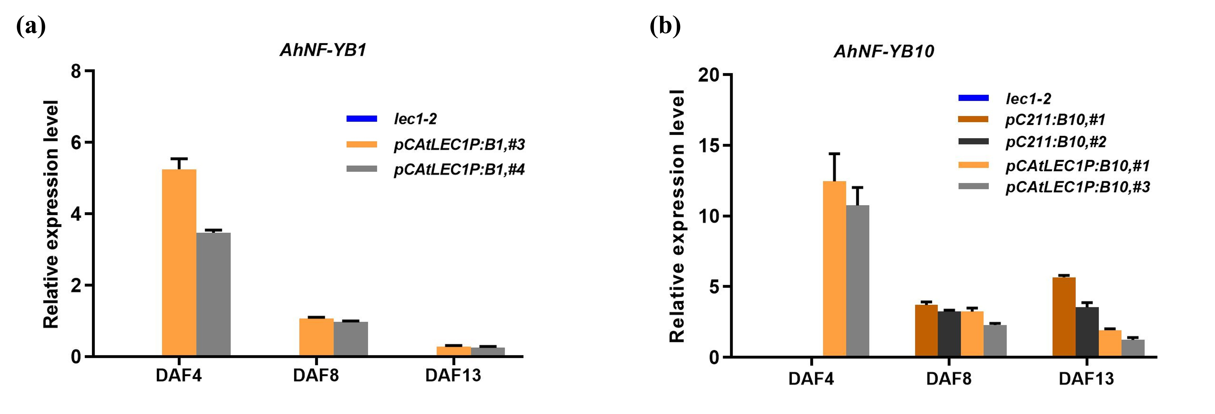

Figure 2. Expression of AhNF-YB1 and AhNF-YB10 during seed development in transgenic Arabidopsis in lec1-2 background. (a) Expression of AhNF-YB1 driven by AtLEC1 promoter in transgenic lec1-2 and lec1-2 mutant. (b) Expression of AhNF-YB10 driven respectively by P211 promoter and AtLEC1 promoter in transgenic lec1-2 and lec1-2 mutant. Seeds collected at 4 DAF, 8 DAF, 13 DAF were used for extracting total RNA. Relative expression level was calculated by 2^{-ΔCt} using AtACTIN as an internal control.
Note: DAF. days after flowering

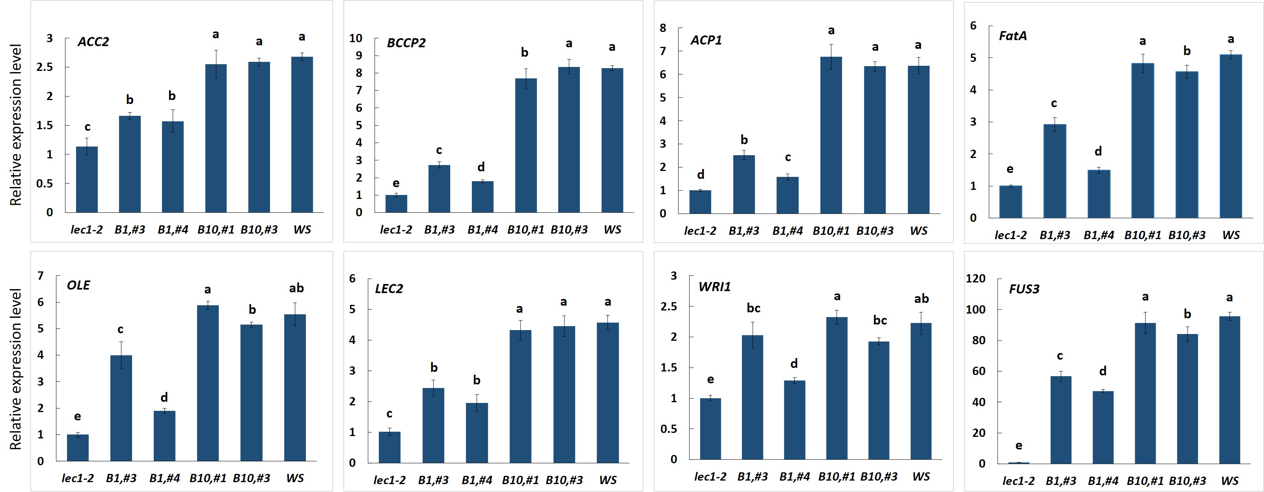
Figure 3. Expression of AhNF-YB1 and AhNF-YB10 driven by AtLEC1 promoter affects the expression levels of several genes related to lipid accumulation and seed development in developing transgenic lec1-2 mutants seeds. Total RNA was extracted from seeds collected at 13 DAF. The relative expression level was calculated by 2^{-ΔΔCt} using AtACTIN as an internal control. Different letters above bars indicate significant (P＜0.05) differences when analyzed by one-way ANOVA with Turkey’s HSD.
Note: DAF. days after flowering

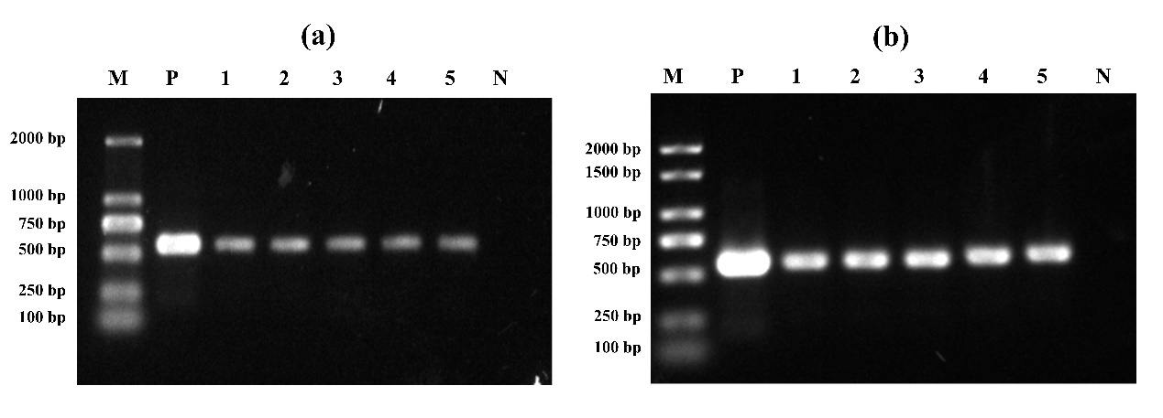
Figure 4. Detection of AhNF-YB1 and AhNF-YB10 overexpressing Arabidopsis by PCR. (a) PCR analysis of AhNF-YB1 over-expressed plants. M. DL2000 DNA Marker, P. pC211P:AhNF-YB1 vector, 1-5. Different transgenic lines, N. COL; (b) PCR analysis of AhNF-YB10 over-expressed plants. M. DL2000 Plus DNA Marker, P. pC211P:AhNF-YB10 vector, 1-5. Different transgenic lines, N. COL.

Figure 5. Characterization of transgenic AhNF-YB1 and AhNF-YB10 Arabidopsis. (a) Eight-day-old seedlings germinated and grown on 1/2 MS medium plates. (b) Forty-day-old Arabidopsis grown in green house.

Figure 6. Transcript level of endogenous LEC1-type gene AtLEC1 and foreign LEC1-type gene in AhNF-YB10 overexpressed Arabidopsis seeds. (a) Expression of AtLEC1 at 4 DAF, 8 DAF or 13 DAF in transgenic Arabidopsis seeds. (b) Expression of AhNF-YB10 at 4 DAF, 8 DAF or 13 DAF in transgenic Arabidopsis seeds. DAF. Days after flowering.
Table 1 Primers used in this study.
Primer | Sequence (5'-3') | Experiments
qRT-AhACTIN7-F | GTCATCGTCATCCTCTTCTC | qRT-PCR
qRT-AhACTIN7-R | CATTCCTGTTCCATTGTCAC | qRT-PCR
AhNF-YB1/10-F | GGATCCATGGAAACTGGAGGAGGCTTT | Cloning
AhNF-TB1/10-R | AAGCTTTTTGTATTGAGTATTTGGTTCA | Cloning
P211-NF-YB1/10-F | CAATCTTTCTCAGCCGTTCGAT | Detection
P211-NF-YB1/10-R | CTCTGACACCGCTCGTTGGCT | Detection
qAhNF-YB1-F | CACAGGAAGCAGTAATAATAA | qRT-PCR
qAhNF-YB1-R | AGAGATTTTAGCGTGCGGTGGT | qRT-PCR
qAhNF-YB10-F | ACACAGGAAGCAATAATAATAC | qRT-PCR
qAhNF-YB10-R | AAAGCTGATGTACTCCGATACGCAC | qRT-PCR
qAtACTIN-F | GGAACTGGAATGGTGAAGGCTG | qRT-PCR
qAtACTIN-R | CGATTGGATACTTCAGAGTGAGGA | qRT-PCR
AtLEC1-promoter-F | AAGCTTCTTTAAGGGAAGCAAAGTG | Cloning
AtLEC1-promoter-R | GGATCCGTTTCTCTGCCGTCTTTT | Cloning
qRT-AtAtLEC1-F | AACCGGTACCGTGAGATAGA | qRT-PCR
qRT-AtAtLEC1-R | ACCCAATACCATTTCCTCCATAG | qRT-PCR
qRT-AtAtLPD1-F | ATCATCATCGGAGCTGGAGTTGGT | qRT-PCR
qRT-AtAtLPD1-R | TGAAGTTCCCGCATTCGACCACTA | qRT-PCR
qRT-AtPDH-E1α-F | GCATTTGGGATGCCTGGTGTTCAT | qRT-PCR
qRT-AtPDH-E1α-R | GCGTATTTGGCTTTCTCAGCAGCA | qRT-PCR
qRT-AtACC2-F | TTCCGAATGTTCTGTCTGCGGCTA | qRT-PCR
qRT-AtACC2-R | TCGCTTTGTCTCCCATAACACGGA | qRT-PCR
qRT-AtBCCP2-F | AACCCAATGGGATCTCCTTTCCCT | qRT-PCR
qRT-AtBCCP2-R | ATAAATTCAGAGAGCTCGGCGGGT | qRT-PCR
qRT-AtACP1-F | AATCTATCCTTCAACCTCCGCCGT | qRT-PCR
qRT-AtACP1-R | AGAGAATCTGCTCCAAGGTCAGCA | qRT-PCR
qRT-AtMCAT-F | ATTCAAAGCACGAATGACGGTGCG | qRT-PCR
qRT-AtMCAT-R | TCACCTGGCGTGCAAGTATCTTCT | qRT-PCR
qRT-AtFatA-F | AGCTGATCTCGACATGAACCAGCA | qRT-PCR
qRT-AtFatA-R | ATTTCAGAGGTGGTGGTGGTGAGT | qRT-PCR
qRT-AtEAR-F | TCAAGGAAAGGCTATCTCGCTGCT | qRT-PCR
qRT-AtEAR-R | TCACTCTCTAGTGCAGCTTTGGCA | qRT-PCR
qRT-AtFAB2-F | CGCTGTGCATAAGCATTCTC | qRT-PCR
qRT-AtFAB2-R | TTGGGGCCGGAGCTGAGAGC | qRT-PCR
qRT-AtFAD2-F | ATGGGTGCAGGTGGAAGAAT | qRT-PCR
qRT-AtFAD2-R | CCAGGAGAGTAAGGGACGA | qRT-PCR
qRT-AtFAD3-F | CATAAGCGCGTGCATTTTG | qRT-PCR
qRT-AtFAD3-R | ACGAAAGCAGCTAAACATGT | qRT-PCR
qRT-AtFAE1-F | CGTTAAGCTCCTTTACCGTT | qRT-PCR
qRT-AtFAE1-R | TCTGTCTCTTCACGTGACGC | qRT-PCR
qRT-AtOLE1-F | TCCTTTATCCTCAGAGTGGCCCTT | qRT-PCR
qRT-AtOLE1-R | AAGGCTGCTGGTACAATAACCGGA | qRT-PCR
qRT-AtLEC2-F | GCTCGCACTTCACAACAGTC | qRT-PCR
qRT-AtLEC2-R | CCACCGGGTATGAAAACGGA | qRT-PCR
qRT-AtWRI1-F | ATTGTTGCGTGGTGGGAAGA | qRT-PCR
qRT-AtWRI1-R | ACGAACAAGCCCTGAAACAA | qRT-PCR
qRT-AtFUS3-F | CTGTGCCTCTTCTTGGTGTTA | qRT-PCR
qRT-AtFUS3-R | CATAGGAGGAGGGAAAGAGAGA | qRT-PCR
qRT-AtFPA1-F | CACCGCTGCTTACTACCAAC | qRT-PCR
qRT-AtFPA1-R | TTCTCCGTCCAACATAATCTC | qRT-PCR
qRT-AtPFK1-F | TTGTTACTGGTCCCGCCGGT | qRT-PCR
qRT-AtPFK1-R | CGTGGTCCTGCACGACGGAAA | qRT-PCR
qRT-AtAGP-F | CGCCAAGCCTGCCGTTCCTA | qRT-PCR
qRT-AtAGP-R | TGGCGTTTGAGTGGCCGCAA | qRT-PCR

Table 2 General information and physicochemical properties of NF-YBs in peanut
Name | Sequence ID | Chr | Deduced polypeptide
Name | Sequence ID | Chr | Length (aa) | pI | MW (kDa)
AhNF-YB1 | arahy.Tifrunner.gnm1.ann1. TAFY85.1 | 01 | 225 | 6.17 | 25.29
AhNF-YB2 | arahy.Tifrunner.gnm1.ann1. B1KVMA.1 | 01 | 156 | 4.62 | 17.31
AhNF-YB3 | arahy.Tifrunner.gnm1.ann1. UG6V14.1 | 03 | 151 | 5.68 | 16.76
AhNF-YB4 | arahy.Tifrunner.gnm1.ann1. M2R7LU.1 | 04 | 171 | 5.74 | 18.88
AhNF-YB5 | arahy.Tifrunner.gnm1.ann1. S3VJK6.2 | 06 | 172 | 6.09 | 18.67
AhNF-YB6 | arahy.Tifrunner.gnm1.ann1. F546B5.1 | 07 | 160 | 5.50 | 17.52
AhNF-YB7 | arahy.Tifrunner.gnm1.ann1. BTE5MM.1 | 07 | 195 | 5.77 | 20.59
AhNF-YB8 | arahy.Tifrunner.gnm1.ann1. SP9TFP.1 | 09 | 180 | 5.82 | 19.53
AhNF-YB9 | arahy.Tifrunner.gnm1.ann1. Y51BP6.2 | 11 | 157 | 4.62 | 17.44
AhNF-YB10 | arahy.Tifrunner.gnm1.ann1. CHFV0I.1 | 11 | 226 | 6.11 | 25.44
AhNF-YB11 | arahy.Tifrunner.gnm1.ann1. I7PXCJ.1 | 13 | 151 | 6.03 | 16.73
AhNF-YB12 | arahy.Tifrunner.gnm1.ann1. D0EVJ3.1 | 14 | 174 | 5.83 | 19.15
AhNF-YB13 | arahy.Tifrunner.gnm1.ann1. UWY0VP.3 | 16 | 171 | 6.09 | 18.70
AhNF-YB14 | arahy.Tifrunner.gnm1.ann1. 18DJCD.1 | 17 | 160 | 5.50 | 17.52
AhNF-YB15 | arahy.Tifrunner.gnm1.ann1. 8XPX7R.1 | 17 | 195 | 5.77 | 20.61
AhNF-YB16 | arahy.Tifrunner.gnm1.ann1. 83ESWU.1 | 19 | 180 | 5.82 | 19.50

