Intracellular reactive oxygen species scavenging activity and lipid peroxidation inhibition by secondary metabolites isolated from the endophytic fungus, Daldinia eschscholtzii

Shazia Anjum Musthafa^{a,b}, Muhammad Sadiq^{a,d}, Kesavan Muthuª, Saraniya Sekarª, Dhamodharan Umapathy^{c}, Ganesh Munuswamy-Ramanujam^{*a,d}

ªMolecular biology and Immunobiology division, Interdisciplinary Institute of Indian System Of Medicine, SRM- IST, Kattankulathur, Kanchipuram Dist, TN, India
^{b}Department of Biotechnology, Faculty of Science & Humanities, SRM-IST, Kattankulathur, Kanchipuram Dist, TN, India
^{c}SRM-DBT Facility, School of Bioengineering, SRM-IST, Kattankulathur, Kanchipuram Dist, TN India.
^{d}Department of Chemistry, Faculty of Engineering & Technology, SRM-IST, Kattankulathur, Kanchipuram Dist, TN, India

*Corresponding Author
Ganesh Munuswamy-Ramanujam,
Molecular biology and Immunobiology Division, Interdisciplinary Institute Of Indian System Of Medicine,
SRM-IST, Kattankulathur, Kanchipuram Dist, Tamil Nadu, India
Email Id: mrganesh2000@hotmail.com
ORCID: 0000-0001-8021-601X

SUPPLEMENTARY FIGURES
Figure S1
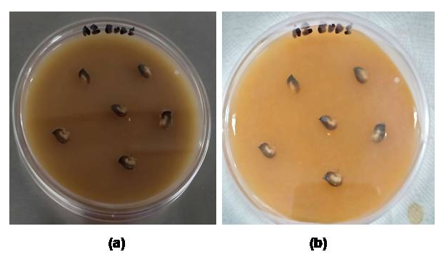
Figure S2
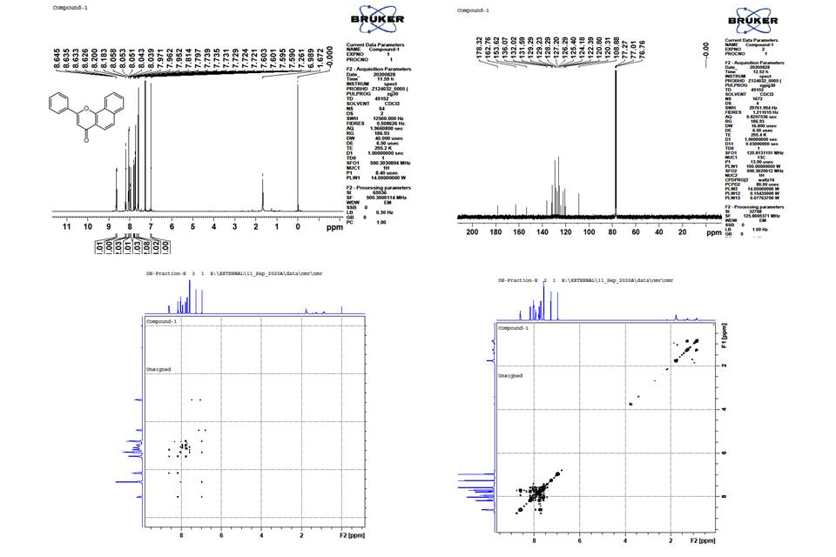

Figure S3
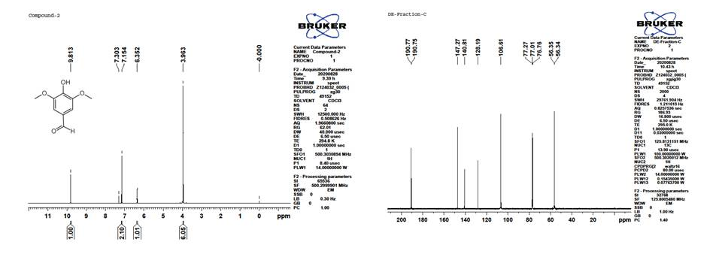

Figure S4
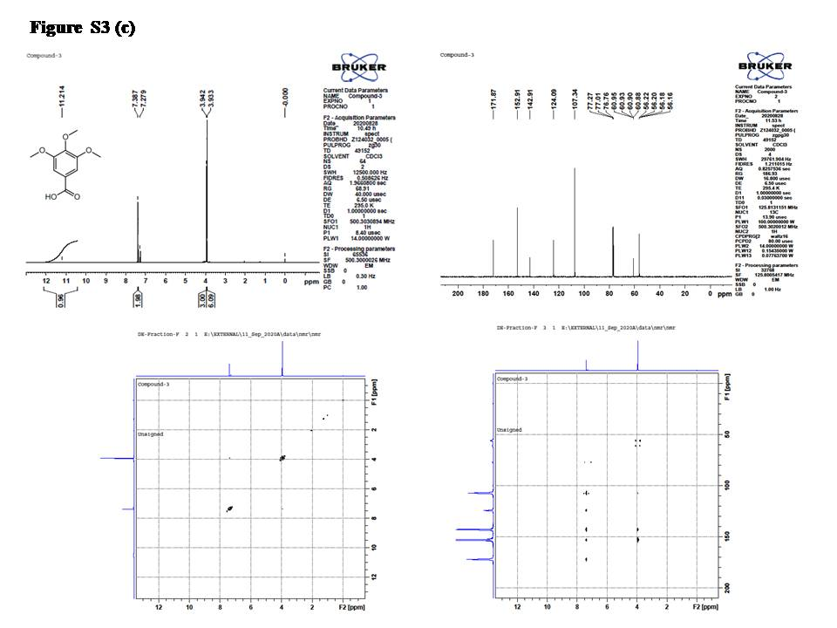

Figure S5
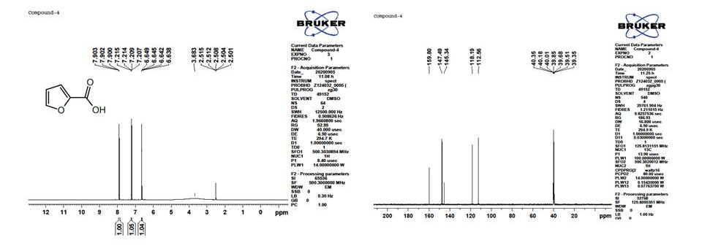

Figure S6
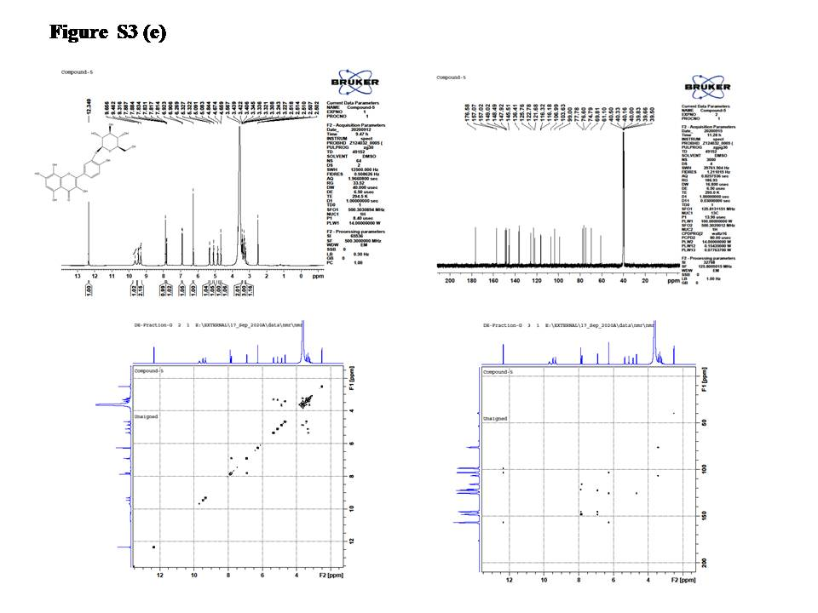

Figure S7
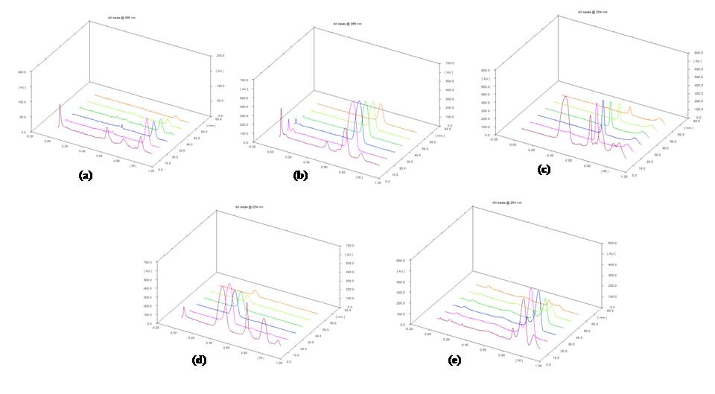
Figure S8
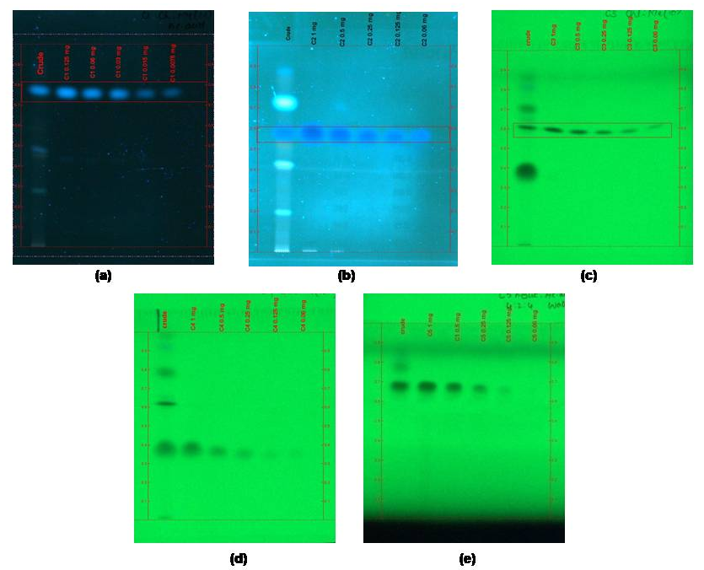
TABLE S1 R_{f,} linear regression data for the calibration curve of compounds C1-C5
Parameters | ɑ-Napthoflavone | Syringaldehyde | 3,4,5 trimethoxy benzoic acid | 2-Furoic acid | Gossypetin 3′O glycoside
Linearity range (µg) | 7.5 - 125 | 60 - 1000 | 60 - 1000 | 60 - 1000 | 60 - 1000
Regression equation | Y = 568.8x -550.4 | Y = 5456.x + 1352 | Y = 1707.x - 72.5 | Y = 5267.x - 5778 | Y = 4868.x - 3134
Correlation coefficient (R²) | 0.991 | 0.991 | 0.994 | 0.989 | 0.984
Slope | 568.8 | 5456 | 1707 | 5267 | 4868
Intercept | -550.4 | 1352 | -72.5 | -5778 | -3134
R_{f} | 0.93 | 0.70 | 0.68 | 0.39 | 0.9
Amount of compounds present in 5 µl EFEA 001crude fraction ( µg) | 45 | 200 | 960 | 910 | 800
Amount of compounds present in 5 µl EFEA 002 crude fraction (µg) | 19 | - | 201 | 297 | -
Percentage of compounds present in EFEA 001 fraction | 10% | 7.5% | 16% | 21% | 15%
Percentage of compounds present in EFEA 002 fraction | 4% | - | 5.3% | 7% | -

SUPPLEMENTARY FIGURE LEGENDS
Figure S1 Surface sterilized seed podsections fromAbutilon indicumplaced on PDA (i) Day 1 (ii) Day 7 – did not show any fungal growth
Figure S2 ¹H , ¹³C, COSY and HMBC NMR spectrum of Compound C1– ɑ-napthoflavone
Figure S3 ¹H and¹³C NMR spectrum of Compound C2 – syringaldehyde
Figure S4 ¹H , ¹³C, COSY and HMBC NMR spectrum ofCompound C3 – 3,4,5-trimethoxybenzoic acid
Figure S5 ¹H and¹³C NMR spectrum of Compound C4 – 2-Furoic acid
Figure S6 ¹H , ¹³C, COSY and HMBC NMR spectrum of Compound C5 – Gossypetin 3’O glycoside
Figure S7 HPTLC Quantification of compounds C1-C5 in the EFEA fraction. 3D HPTLC chromatogram of pure compounds (C1: 7.5 – 125 µg/ml , C2-C5: 60 – 1000 µg/ml) and EFEA fractions (a) C1- ɑ-napthoflavone (b) C2 – Syringaldehyde (c) C3 – 3,4,5 trimethoxy benzoic acid (d) 2-Furoic acid (e) C5 - Gossypetin 3′O glycoside.
Figure S8 Images of developed HPTLC plates of compounds C1-C5 and EFEA fraction. Lane 1: crude extract (30 mg/ml), Lane 2- 6: pure compounds (C1: 7.5 – 125 µg/ml, C2-C5: 60 µg – 1000 µg). (a) C1- ɑ-napthoflavone (b) C2 – Syringaldehyde (c) C3 – 3,4,5 trimethoxy benzoic acid (d) 2-Furoic acid (e) C5 - Gossypetin 3′O glycoside.

