Fig.S1 Identifying translocated A. cristatum segments using whole‐genome sequencing data
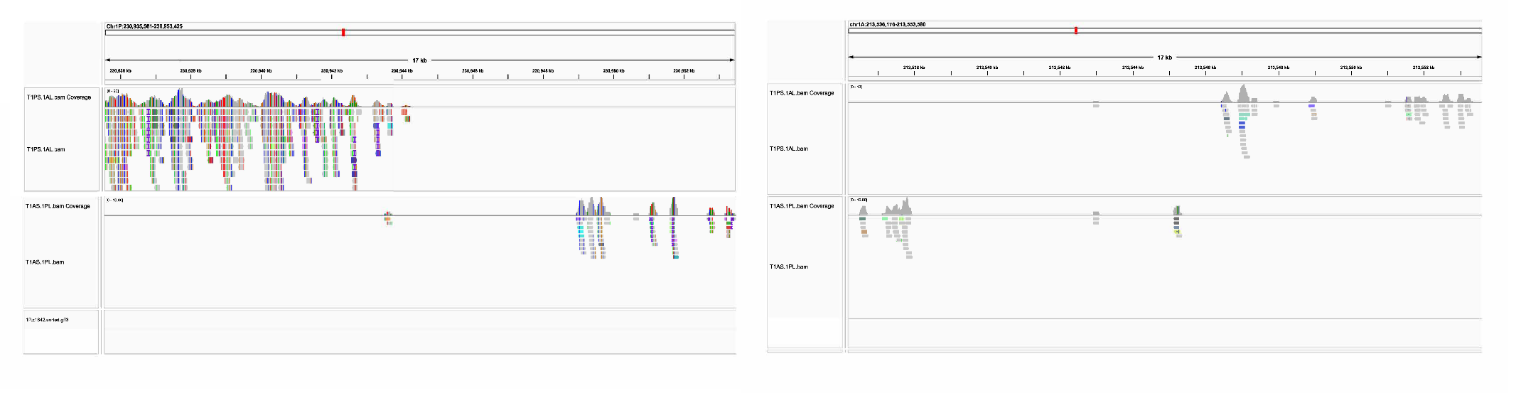
Fig.S2 Agronomic traits of T1PS.1AL and T1PL.1AS Robertsonian translocations. Investigation of plant height(a), fertile tiller number(b), grain number per spike(c) and thousand grain weight(d) in wheat-A. cristatum 1P translocation lines.

Table S1 GISH pattern of T1PS.1AL and T1PL.1AS Robertsonian translocation lines
Strain | Translocation type | GISH
66475-6 | Short arm translocation
66696-6 | Short arm translocation
66696-2 | Short arm translocation
66700-16 | Short arm translocation
66701-3 | Short arm translocation | 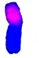
66739-7 | Short arm translocation
66749-3 | Short arm translocation
66691-3 | Short arm translocation
66742-6 | Short arm translocation
66501-8 | Long arm translocation
66501-6 | Long arm translocation
66688-12 | Long arm translocation
66698-66699-2 | Long arm translocation
66705-2 | Long arm translocation
66706-1 | Long arm translocation
66721-1 | Long arm translocation

Table S2 Agronomic traits investigation of T1PS.1AL and T1PL.1AS Robertsonian translocation lines.
strain | plant height  (cm) | fertile tiller number | spike length  (cm) | spikelet number per spike | grain number per spike
66475-6 | 79 | 11 | 9 | 18 | 52
66696-6 | 90 | 16 | 9 | 17 | 29
66696-2 | 96 | 9 | 10 | 16 | 38
66700-16 | 79 | 13 | 7.8 | 16 | 53
66701-3 | 98.5 | 12 | 9 | 18 | 41
66739-7 | 94 | 13 | 7.5 | 18 | 33
66749-3 | 77 | 9 | 9.5 | 18 | 25
66691-3 | 90 | 19 | 9.8 | 19 | 55
66742-6 | 81 | 15 | 10 | 17 | 54
66501-8 | 75 | 14 | 7.5 | 18 | 25
66501-6 | 69.5 | 17 | 11.5 | 17 | 46
66688-12 | 82 | 21 | 8.7 | 15 | 47
66688-66699-2 | 87 | 16 | 10.8 | 18 | 42
66705-2 | 68 | 29 | 8.5 | 18 | 43
66706-1 | 75 | 13 | 10.4 | 20 | 48
66721-1 | 85 | 16 | 7.8 | 20 | 43

Table S3 Results of genotyping of the isolated T1PS.1AL and T1PL.1AS Robertsonian translocation lines
Translocation type | Population | Year | W:W | W:P | P:P | Population size
T1PS.1AL | F_{3:4} family | 2020-2021 | 35 | 78 | 26 | 139
T1PS.1AL | F_{4:5} family | 2021-2022 | 86 | 129 | 51 | 266
T1PL.1AS | F_{3:4} family | 2020-2021 | 88 | 143 | 32 | 263
T1PL.1AS | F_{4:5} family | 2021-2022 | 55 | 132 | 74 | 261
W:W represents the number of negative plants, W:P represents the number of heterozygous plants and P:P represents the number of homozygous plants.

