Supplementary Information (SI)

Selection of odors in multimedia based on correspondence with the odor categories of objects in scenes

Kwangsu Kim¹, Jisub Bae², JeeWon Lee³, Sun Ae Moon³, Sang-ho Lee^{1,4} Won-seok Kang^{1,4}, and Cheil Moon^{1,3,*}

¹Convergence Research Advanced Centre for Olfaction, Daegu Gyeongbuk Institute of Science and Technology (DGIST), Daegu, Korea
²Center for Cognition and Sociality, Institute for Basic Science (IBS), Daejeon, South Korea
³Department of Brain Sciences, Graduate School, Daegu Gyeongbuk Institute of Science and Technology (DGIST), Daegu, Korea
⁴Division of Intelligent Robot, Daegu Gyeongbuk Institute of Science and Technology (DGIST), Daegu, Korea

* Corresponding author

Correspondence:
Cheil Moon, PhD, Department of Brain Sciences, Graduate School, Daegu Gyeongbuk Institute of Science and Technology, 333, Techno Jung-Ang Daero, Hyeonpung-Myeon, Dalseong-Gun, Daegu, 711-873, Korea. E-mail: cmoon@dgist.ac.kr; Tel: +82-53-785-6110; Fax: +82-53-785-6109

Video | Condition | Frequency  band | Count of odor pairs |  |  |  | X²-value
Video | Condition | Frequency  band | FO1 – FO2 | FO1 – CO1 | FO2 – CO1 | Total | X²-value
Flower | Within group | Delta | 444 | 157 | 399 | 1000 | 142.96***
Flower | Within group | Theta | 563 | 48 | 389 | 1000 | 411.78***
Flower | Within group | Alpha | 218 | 679 | 103 | 1000 | 557.52***
Flower | Within group | Beta | 59 | 560 | 381 | 1000 | 386.73***
Flower | Within group | Gamma | 53 | 280 | 667 | 1000 | 578.29***
Flower | Random sampling | Delta | 340 | 332 | 328 | 1000 | 0.22 (n.s)
Flower | Random sampling | Theta | 331 | 333 | 336 | 1000 | 0.04 (n.s)
Flower | Random sampling | Alpha | 326 | 346 | 328 | 1000 | 0.73 (n.s)
Flower | Random sampling | Beta | 310 | 350 | 340 | 1000 | 2.60 (n.s)
Flower | Random sampling | Gamma | 323 | 337 | 340 | 1000 | 0.49 (n.s)

Table S1. K-means results in each frequency band depending on categories of odors in the flower video (FV). All k-means clustering results were repeated 1000 times. The number of odor pairs was calculated during the repetitions. The clustering numbers of odor pairs in the FV were reported based on five frequency bands. A chi-square test was performed to analyze the data. Significance levels were denoted as follows: *: p-value < 0.05, **: p-value < 0.01, ***: p-value < 0.001, n.s.: non-significant.

Video | Condition | Frequency  band | Count of odor pairs |  |  |  | X²-value
Video | Condition | Frequency  band | CO1 – CO2 | CO1 – FO1 | CO2 – FO1 | Total | X²-value
Coffee | Within group | Delta | 457 | 182 | 361 | 1000 | 116.882***
Coffee | Within group | Theta | 640 | 112 | 248 | 1000 | 450.944***
Coffee | Within group | Alpha | 444 | 319 | 237 | 1000 | 65.198***
Coffee | Within group | Beta | 244 | 317 | 439 | 1000 | 58.238***
Coffee | Within group | Gamma | 26 | 693 | 281 | 1000 | 679.658***
Coffee | Random sampling | Delta | 321 | 345 | 334 | 1000 | 0.87 (n.s)
Coffee | Random sampling | Theta | 342 | 325 | 333 | 1000 | 0.43 (n.s)
Coffee | Random sampling | Alpha | 339 | 339 | 322 | 1000 | 0.58 (n.s)
Coffee | Random sampling | Beta | 321 | 340 | 339 | 1000 | 0.69 (n.s)
Coffee | Random sampling | Gamma | 333 | 319 | 348 | 1000 | 1.26 (n.s)

Table S2. K-means results in each frequency band depending on categories of odors in the coffee video (CV). All k-means clustering results were repeated 1000 times. The number of odor pairs was calculated during the repetitions. The clustering numbers of odor pairs in the FV were reported based on five frequency bands. A chi-square test was performed to analyze the data. Significance levels were denoted as follows: *: p-value < 0.05, **: p-value < 0.01, ***: p-value < 0.001, n.s.: non-significant.

Video clip | Condition | Frequency band | Accuracy
Video clip | Condition | Frequency band | FO1 vs CO1 / FO2 (Average) | Total
Flower | Within group | Delta | 71.4 | 1000
Flower | Within group | Theta | 35.8 | 1000
Flower | Within group | Alpha | 49.8 | 1000
Flower | Within group | Beta | 50.1 | 1000
Flower | Within group | Gamma | 35.9 | 1000
Flower | Random sampling | Delta | 50.7 | 1000
Flower | Random sampling | Theta | 49.6 | 1000
Flower | Random sampling | Alpha | 48.9 | 1000
Flower | Random sampling | Beta | 49.5 | 1000
Flower | Random sampling | Gamma | 49.9 | 1000

Table S3. SVM accuracy results in each frequency band depending on categories of odors in the flower video (FV). All SVM accuracy results were repeated 1000 times. The average of 1000 SVM accuracy results was reported based on frequency bands.
Video clip | Condition | Frequency band | Accuracy
Video clip | Condition | Frequency band | CO1 vs FO1 / CO2 (Average) | Total
Coffee | Within group | Delta | 64.3 | 1000
Coffee | Within group | Theta | 78.6 | 1000
Coffee | Within group | Alpha | 21.4 | 1000
Coffee | Within group | Beta | 42.9 | 1000
Coffee | Within group | Gamma | 35.7 | 1000
Coffee | Random sampling | Delta | 49.4 | 1000
Coffee | Random sampling | Theta | 51.0 | 1000
Coffee | Random sampling | Alpha | 49.8 | 1000
Coffee | Random sampling | Beta | 49.8 | 1000
Coffee | Random sampling | Gamma | 49.9 | 1000

Table S4. SVM accuracy results in each frequency band depending on categories of odors in the coffee video (CV). All SVM accuracy results were repeated 1000 times. The average of 1000 SVM accuracy results was reported based on frequency bands.

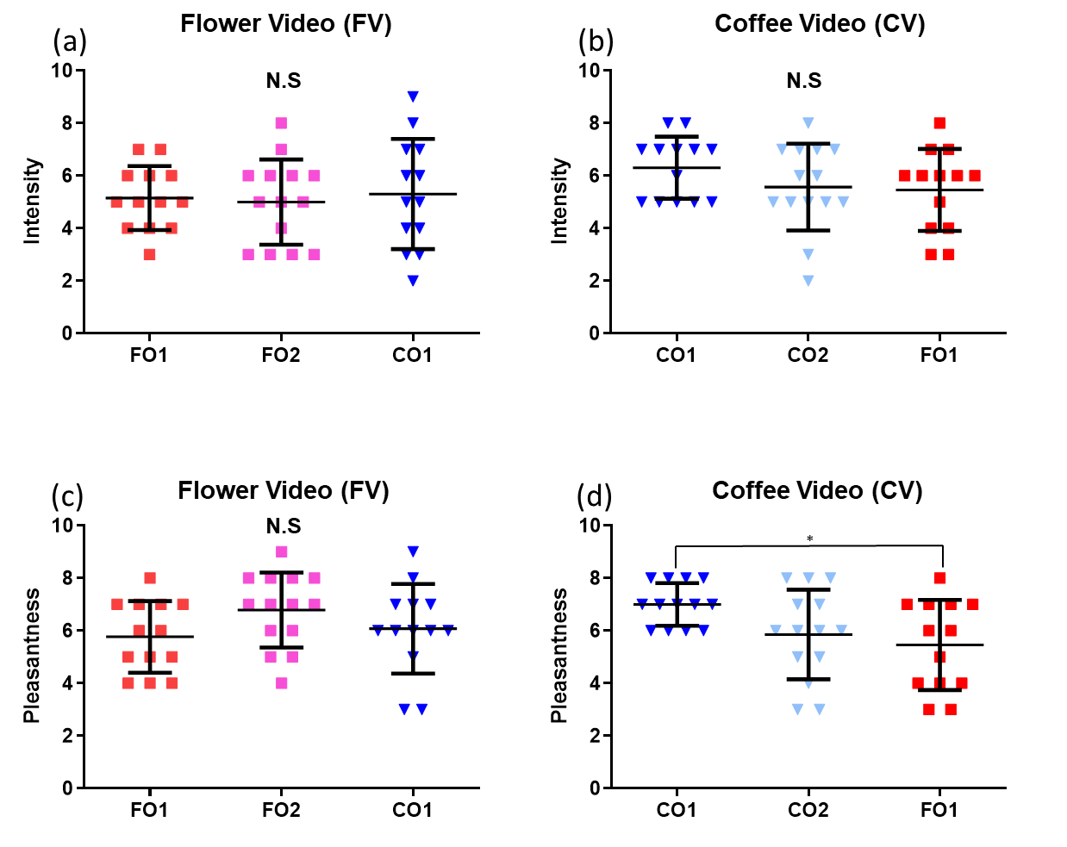
Fig. S1. Intensity and pleasantness in each video. Y-axes show the pleasantness and intensity scores of the odors evaluated by using a 9-point Likert scale questionnaire. *p<0.05.

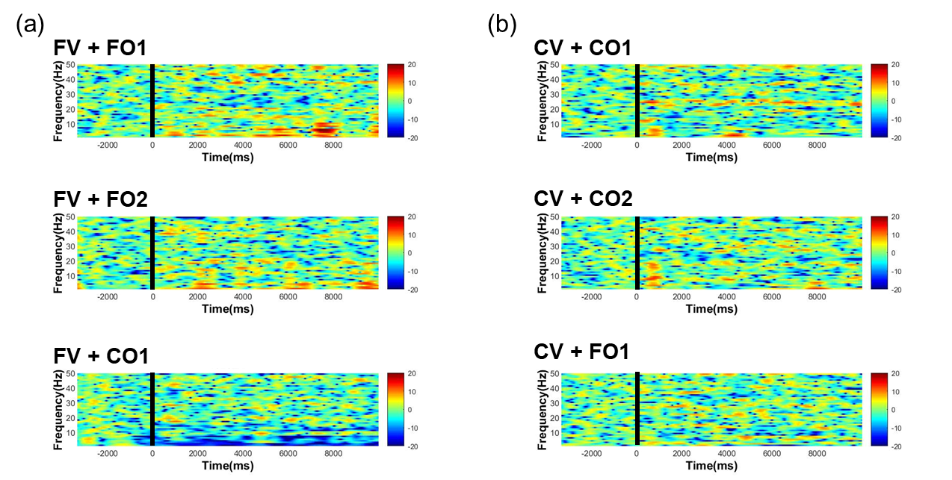
Fig. S2. Representative event-related spectral perturbation (ERSP) data of the videos with the odors depending on the categories of odors. X-axis is the time and Y-axis is the frequency. a. Representative ERSP data of the FV and three odors. b. Representative ERSP data of the CV and three odors.

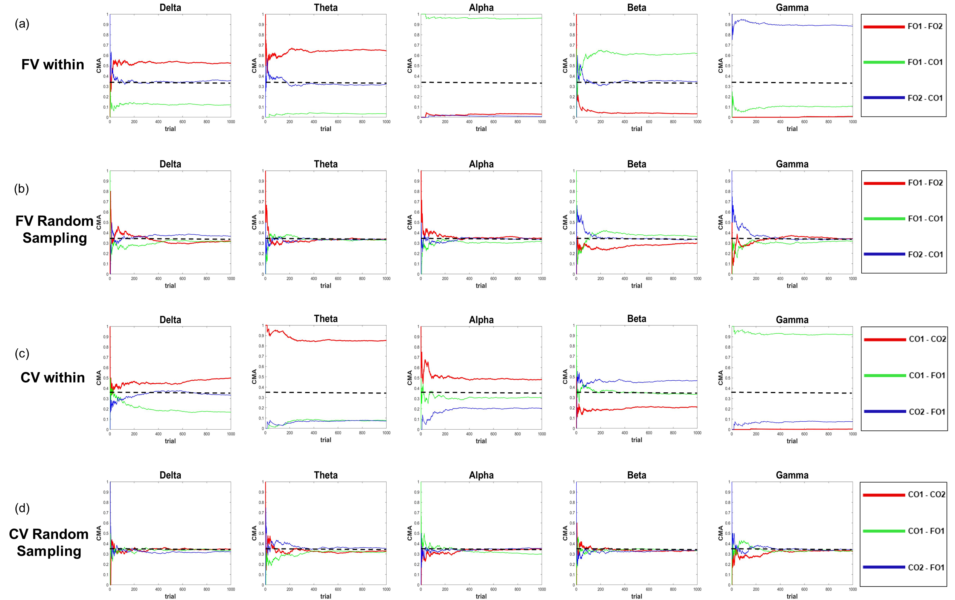
Fig. S3. Cumulative moving average (CMA) plots in agglomerative hierarchical clustering (AHC) of 1000 repetitions. AHC of the ERSP data of the videos presented with the odors depending on frequency bands repeated 1000 times. X-axis is the number of repeated trials, and Y-axis is the cumulative moving average in the closest odor pairs rate. AHC was repeated 1000 times by changing the participants’ order of the ERPS data as “within group condition” and “random sampling group condition.” a. b. CMA plots in AHC of EEG data of the flower video (FV). c. d. CMA plots in AHC of EEG data of the coffee video (CV). EEG, electroencephalography.

