Supplementary Materials
Spatiotemporal analysis of PM_{2.5} estimated using machine learning over Greater Bangkok: Variability, trends, and persistence

By Aman et al.

S1 AOD imputation with random forest
Missing values are frequently found with satellite AOD due to clouds, rainfall, high surface reflectance, etc. The meteorological conditions that cause missing AOD also affect PM_{2.5} and hence can lead to inaccuracy in the spatiotemporal estimation of PM_{2.5} (Song et al. 2019). Hence, to avoid this inaccuracy due to sampling bias and obtain a continuous spatiotemporal estimation of PM_{2.5}, missing AOD was gap filled. Various methods have been used by researchers for AOD gap filling which include spatiotemporal kriging (Yang et al. 2018), inverse distance weighting with mixed effect model (Chen et al. 2019), merging multiple satellite AODs datasets (Chi et al. 2020), merging satellite AOD with reanalysis-based AOD (Jiang et al. 2021; Stafoggia et al. 2019), AOD estimation using meteorological and other predictor variables with the different data-driven model, e.g., non-linear statistical model (Xiao et al. 2017), random forest (Bi et al. 2019; Di et al. 2019), gradient boosting (Zeng et al. 2023). Given the frequent use of the random forest model for AOD gap filling, it was used in this study also. Different meteorological variables (as given in Section on Data) were used as predictor variables to fit the random forest model which was then used for estimating AOD for the grids with missing values. Firstly, the dataset was randomly split into the training and testing datasets with proportions of 80% and 20%, respectively. For model development, five hyperparameters were tuned from a manually selected hyperparameter grid space using the Random Search method to make it computationally cost-effective. These hyperparameters and their values are a) n_estimator = 500, b) max_depth = 20, c) max_features= log2, d) min_sample_split = 1, e), and min_sample_leaf = 2. The final model was evaluated using the remaining 20 % dataset with different statistical metrics. The gap-filling model exhibited a strong correlation coefficient of 0.8 along with low mean bias at 0.06, mean error at 0.08, and low root mean square error at 0.11. These results collectively indicate the model's proficient performance, reinforcing its viability for imputing AOD values to address missing data points.

Table S1. Performance evaluation of different machine learning models by hours
Hour |  | ρ | MB  (μg m^{–3}) | ME  (μg m^{–3}) | RMSE  (μg m^{–3}) |  | ρ | MB  (μg m^{–3}) |  | ME  (μg m^{–3}) | RMSE  (μg m^{–3}) |  | ρ | MB  (μg m^{–3}) | ME  (μg m^{–3}) | RMSE  (μg m^{–3})
Hour |  | Random Forest |  |  |  |  | Adaptive boosting |  |  |  |  |  | Gradient Boosting
08 LT |  | 0.85 | 0.21 | 8.7 | 12.4 |  | 0.84 | −0.9 |  | 8.5 | 12.5 |  | 0.89 | −0.03 | 7.2 | 10.7
09 LT |  | 0.84 | −0.63 | 8.8 | 13.3 |  | 0.84 | −1.1 |  | 8.5 | 13.1 |  | 0.88 | −0.38 | 7.2 | 11.2
10 LT |  | 0.85 | −0.72 | 8.5 | 12.5 |  | 0.84 | −1.0 |  | 7.9 | 12.1 |  | 0.89 | −0.45 | 6.8 | 10.3
11LT |  | 0.80 | −0.57 | 7.9 | 12.4 |  | 0.82 | −0.95 |  | 7.0 | 11.6 |  | 0.86 | −0.41 | 6.3 | 10.5
12LT |  | 0.82 | −0.18 | 7.1 | 9.9 |  | 0.85 | −0.62 |  | 6.2 | 9.0 |  | 0.88 | −0.19 | 5.7 | 8.2
13 LT |  | 0.81 | 0.44 | 6.8 | 9.4 |  | 0.84 | −0.33 |  | 5.9 | 8.5 |  | 0.87 | 0.27 | 5.5 | 7.8
14 LT |  | 0.81 | 0.36 | 6.6 | 8.9 |  | 0.85 | −0.33 |  | 5.4 | 7.7 |  | 0.87 | 0.17 | 5.2 | 7.2
15 LT |  | 0.80 | 0.44 | 6.6 | 9.2 |  | 0.85 | −0.26 |  | 5.3 | 7.9 |  | 0.87 | 0.32 | 5.1 | 7.4
16 LT |  | 0.79 | 0.28 | 6.8 | 9.3 |  | 0.84 | −0.39 |  | 5.5 | 7.9 |  | 0.86 | 0.08 | 5.3 | 7.5
17 LT |  | 0.73 | 0.29 | 7.0 | 11.0 |  | 0.7 | −0.34 |  | 6.2 | 11.5 |  | 0.78 | 0.27 | 5.8 | 9.9
 |  | Extreme Gradient Boosting |  |  |  |  | Light Gradient Boosting |  |  |  |  |  | Cat Boosting
08 LT |  | 0.9 | 0.01 | 6.8 | 10.2 |  | 0.9 | −0.05 |  | 6.7 | 9.9 |  | 0.89 | −0.1 | 7.3 | 10.6
09 LT |  | 0.9 | −0.39 | 6.7 | 10.7 |  | 0.9 | −0.25 |  | 6.7 | 10.5 |  | 0.88 | −0.29 | 7.4 | 11.4
10 LT |  | 0.91 | −0.42 | 6.4 | 9.7 |  | 0.91 | −0.29 |  | 6.3 | 9.4 |  | 0.89 | −0.3 | 7.2 | 10.6
11LT |  | 0.87 | −0.38 | 5.9 | 10.2 |  | 0.87 | −0.29 |  | 5.9 | 9.9 |  | 0.85 | −0.37 | 6.7 | 10.8
12LT |  | 0.9 | −0.16 | 5.3 | 7.7 |  | 0.89 | −0.11 |  | 5.3 | 7.6 |  | 0.87 | −0.25 | 6.1 | 8.6
13 LT |  | 0.88 | 0.27 | 5.1 | 7.3 |  | 0.88 | 0.23 |  | 5.1 | 7.3 |  | 0.85 | 0.37 | 5.9 | 8.2
14 LT |  | 0.89 | 0.22 | 4.8 | 6.8 |  | 0.89 | 0.14 |  | 4.8 | 6.7 |  | 0.85 | 0.22 | 5.7 | 7.7
15 LT |  | 0.88 | 0.31 | 4.8 | 7.0 |  | 0.88 | 0.24 |  | 4.8 | 7.1 |  | 0.84 | 0.38 | 5.7 | 8.0
16 LT |  | 0.88 | 0.13 | 4.9 | 7.0 |  | 0.87 | 0.09 |  | 4.9 | 7.1 |  | 0.84 | 0.05 | 5.7 | 8.0
17 LT |  | 0.8 | 0.32 | 5.4 | 9.5 |  | 0.79 | 0.27 |  | 5.4 | 9.6 |  | 0.76 | 0.22 | 6.0 | 10.2
 |  | Stacked Ensemble model
08 LT |  | 0.91 | −0.19 | 6.5 | 9.7
09 LT |  | 0.91 | −0.22 | 6.4 | 10.1
10 LT |  | 0.92 | −0.2 | 5.9 | 8.9
11LT |  | 0.88 | −0.22 | 5.5 | 9.6
12LT |  | 0.91 | −0.1 | 4.9 | 7.2
13 LT |  | 0.89 | 0.16 | 4.7 | 6.9
14 LT |  | 0.9 | 0.13 | 4.4 | 6.3
15 LT |  | 0.89 | 0.23 | 4.4 | 6.6
16 LT |  | 0.89 | 0.1 | 4.5 | 6.6
17 LT |  | 0.81 | 0.3 | 5.1 | 9.3

Nov. | Dec. | Jan. | Feb. | Non–Missing  (%)
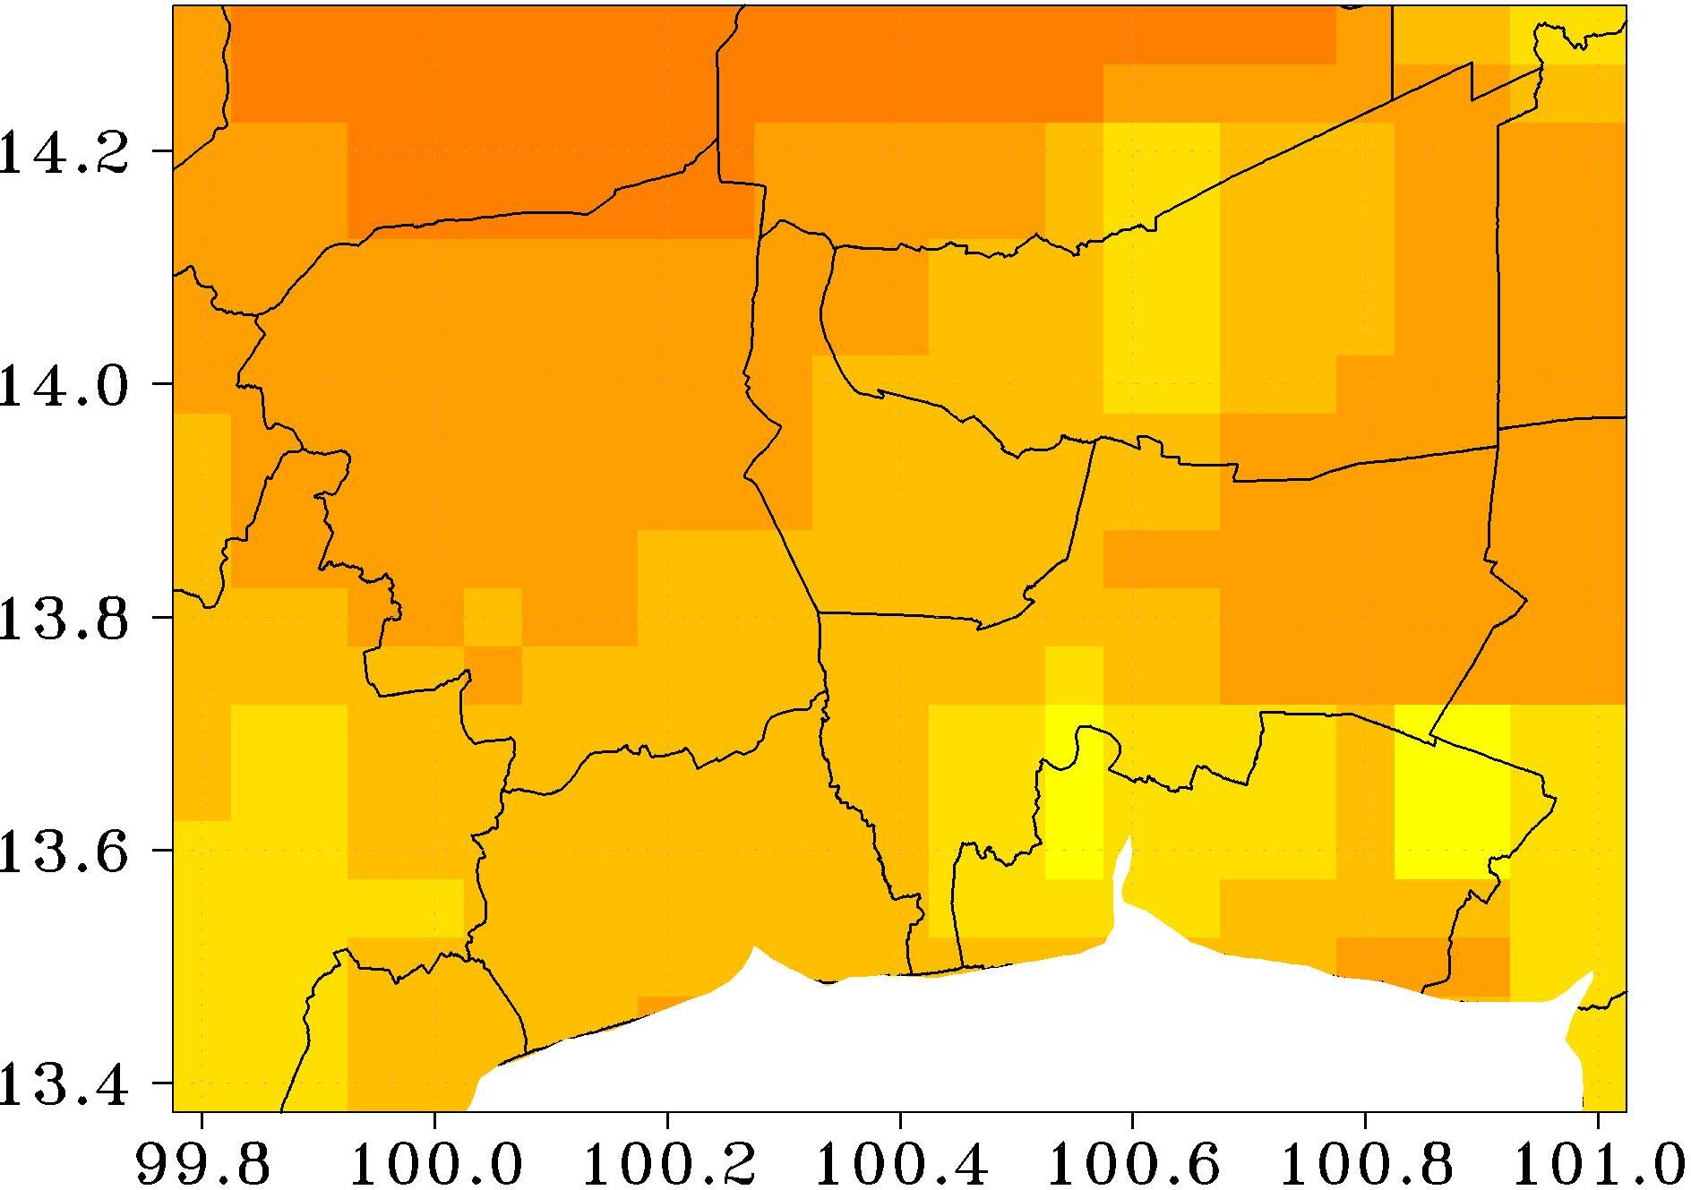 | 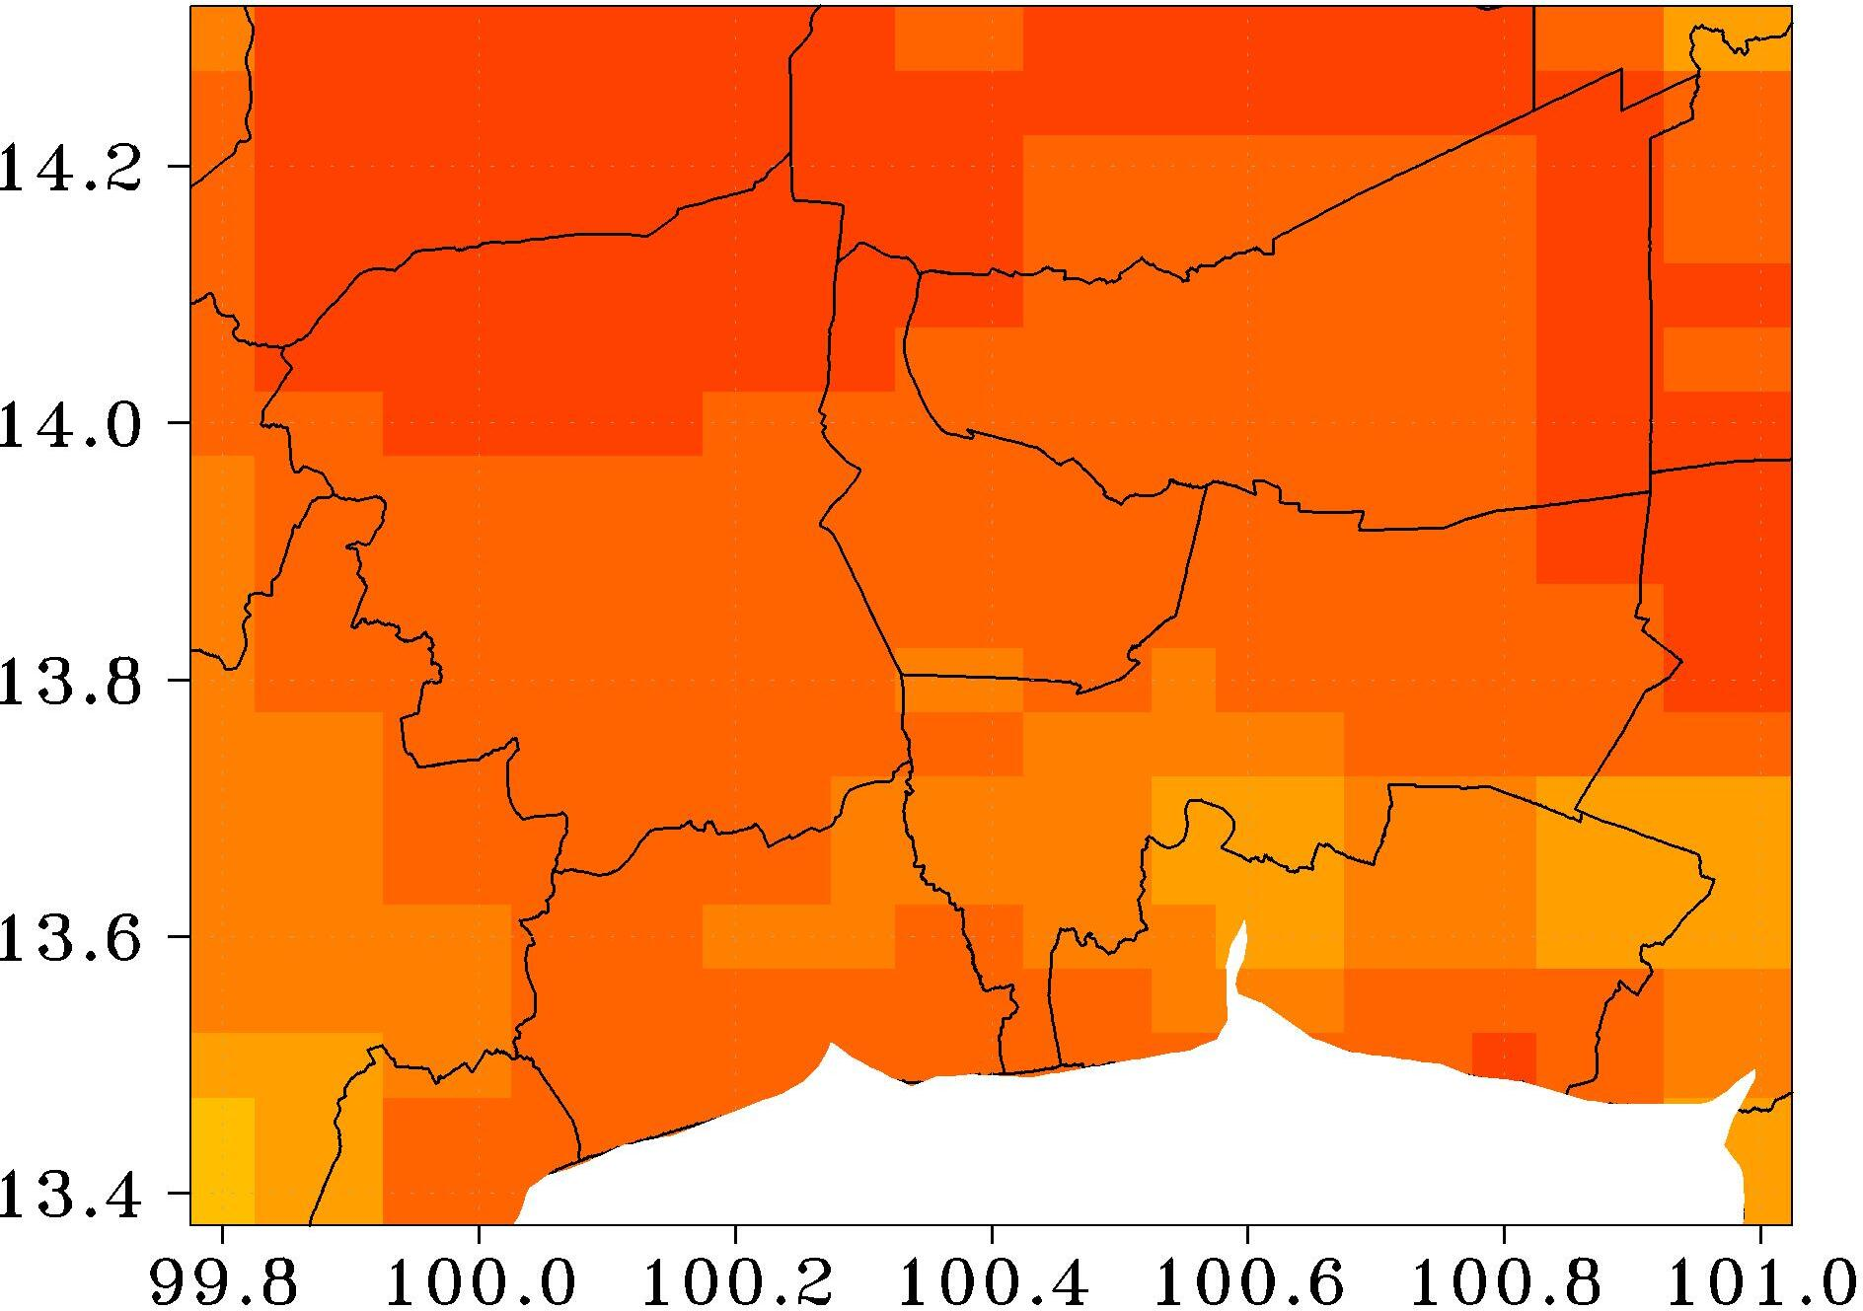 | 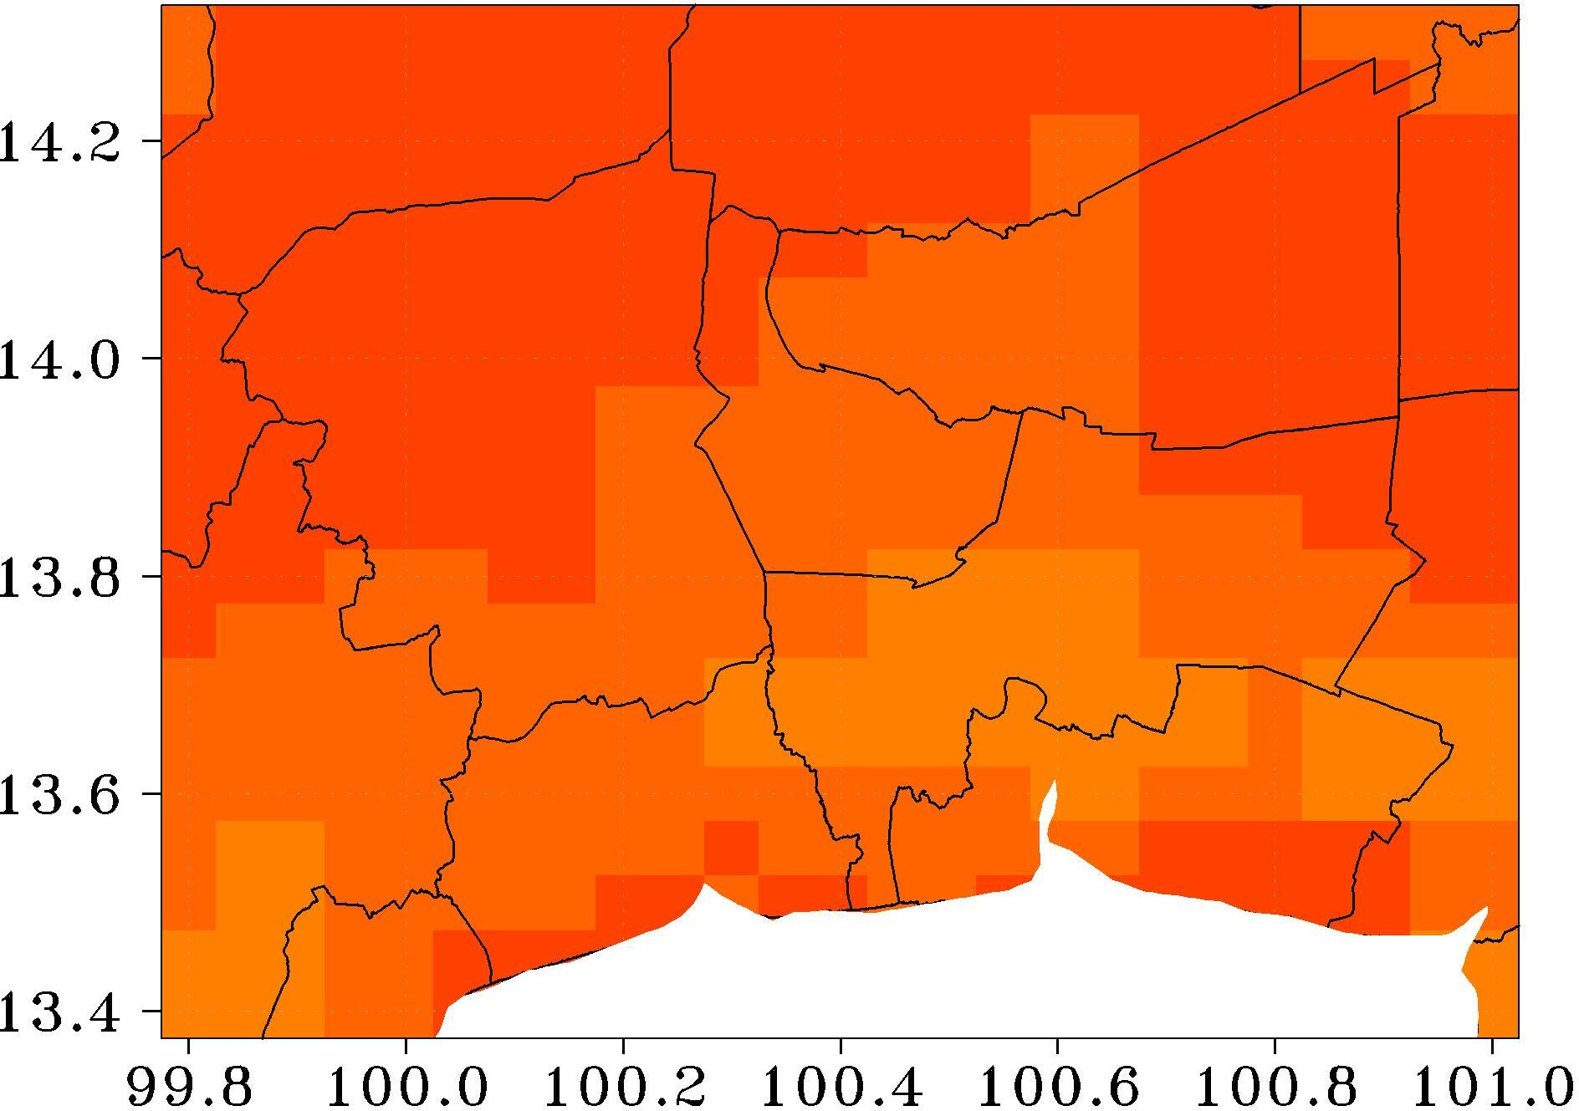 | 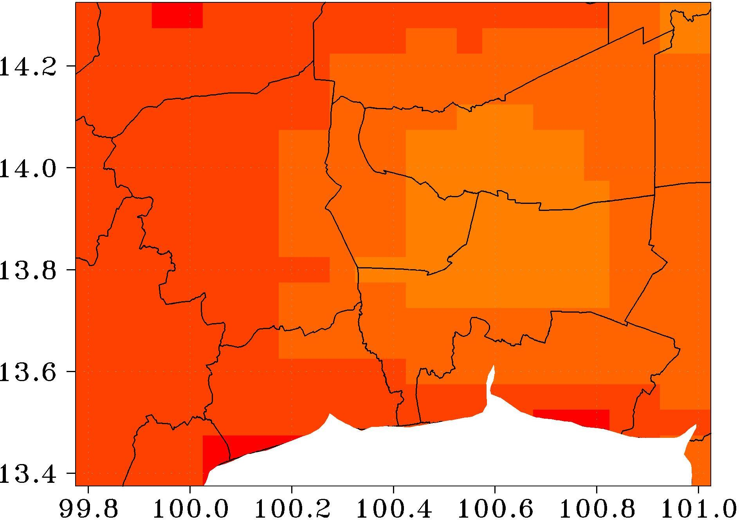
Mar. | Apr. | May | Jun.
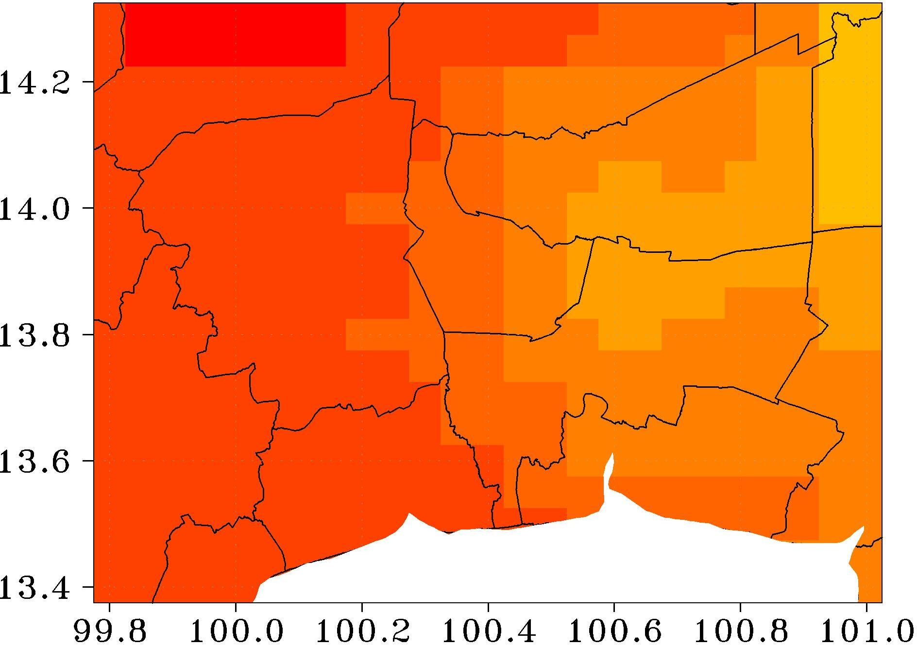 | 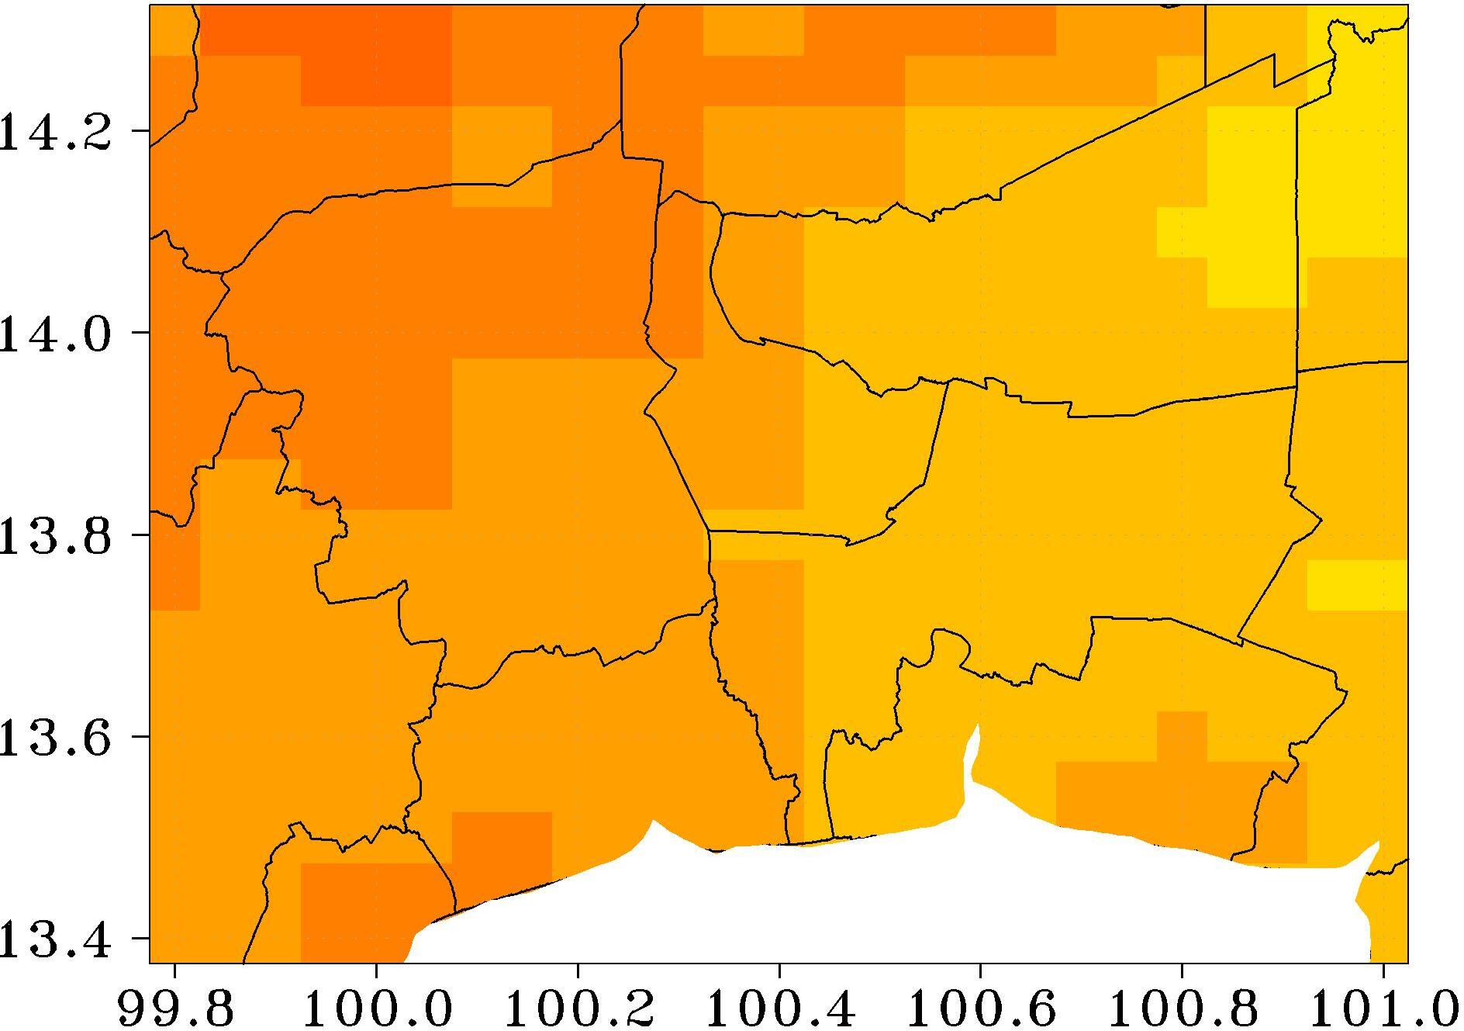 | 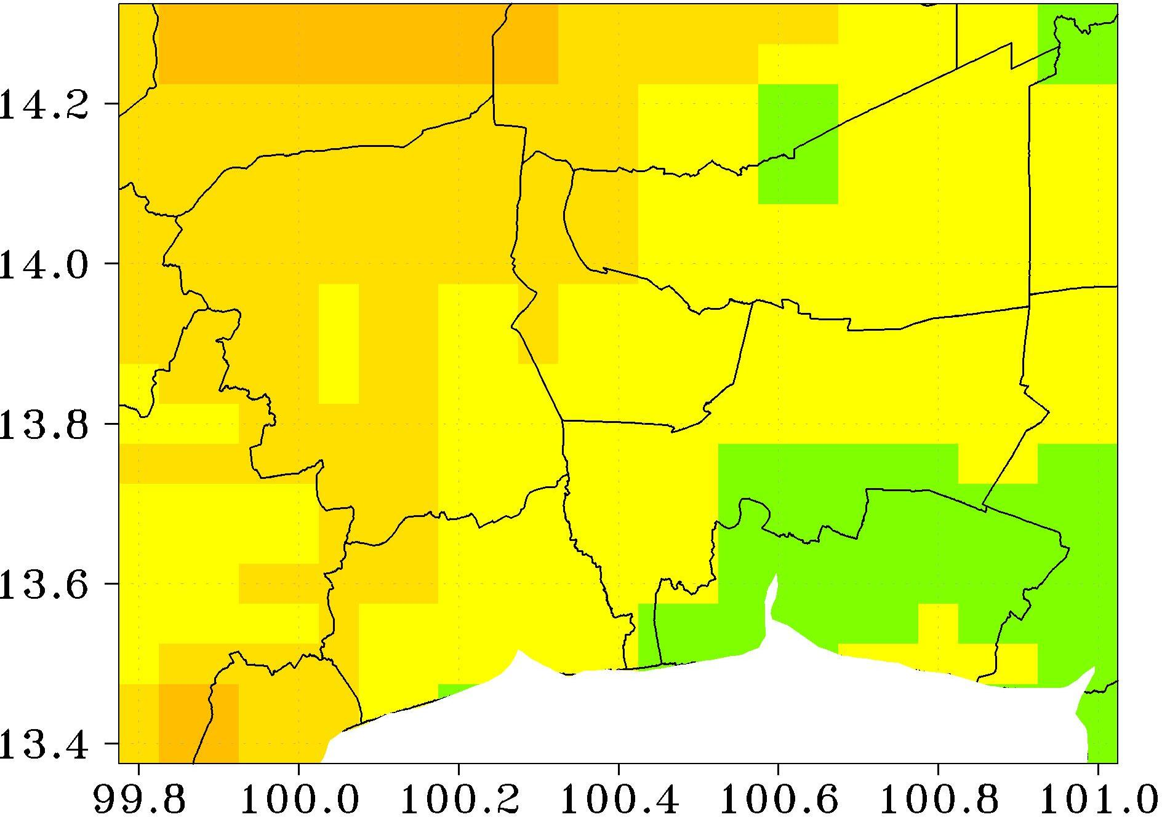 | 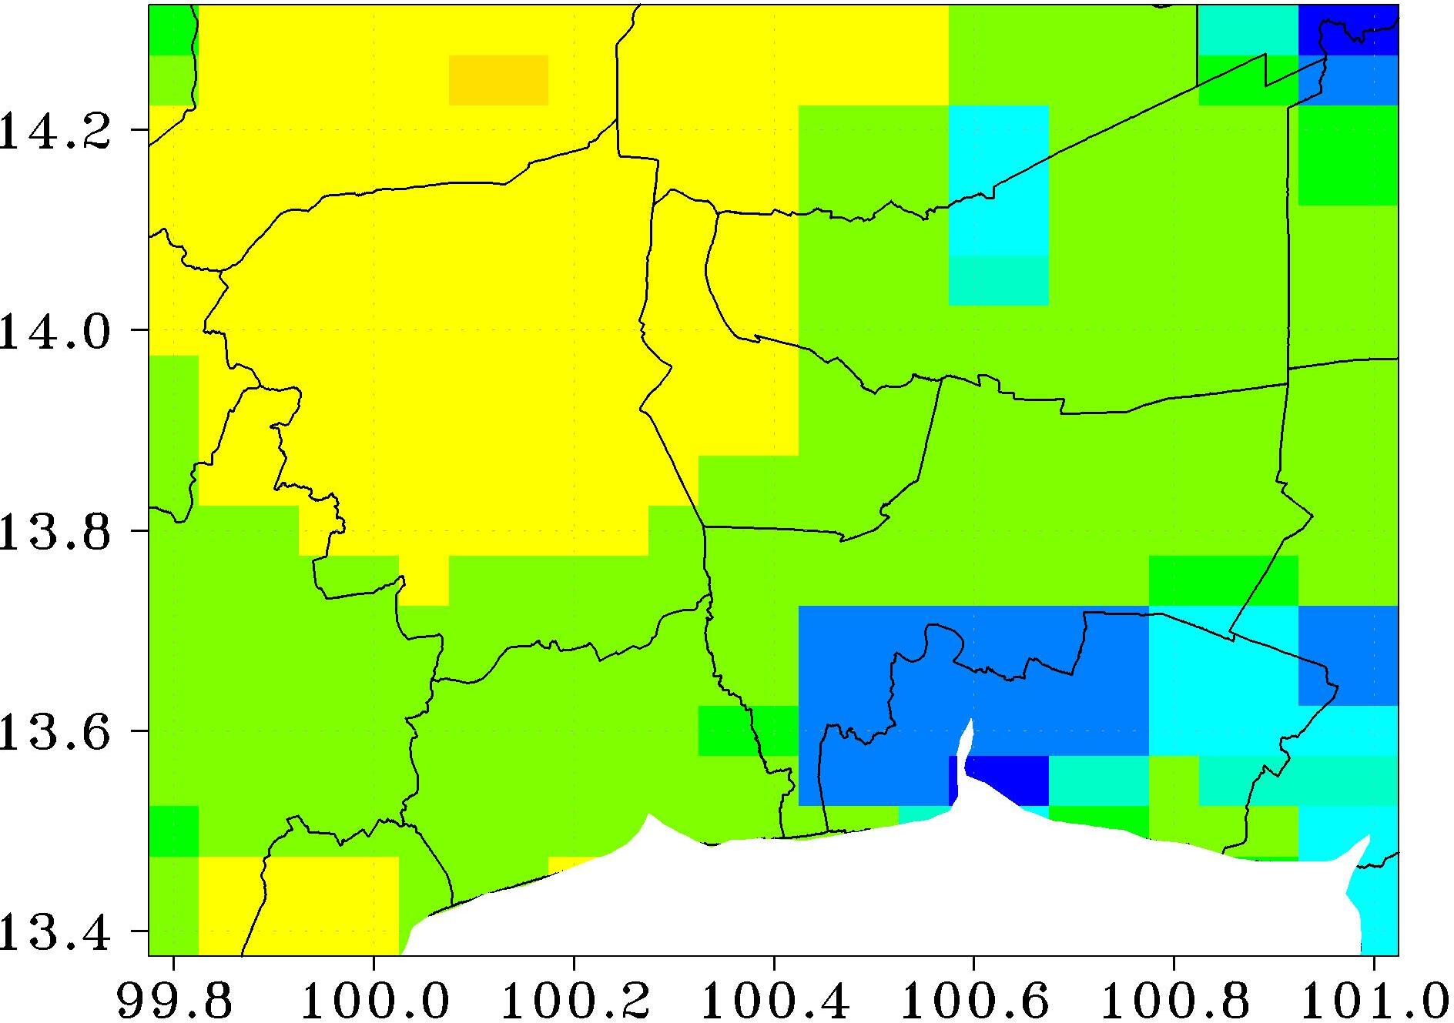
Jul. | Aug. | Sep. | Oct.
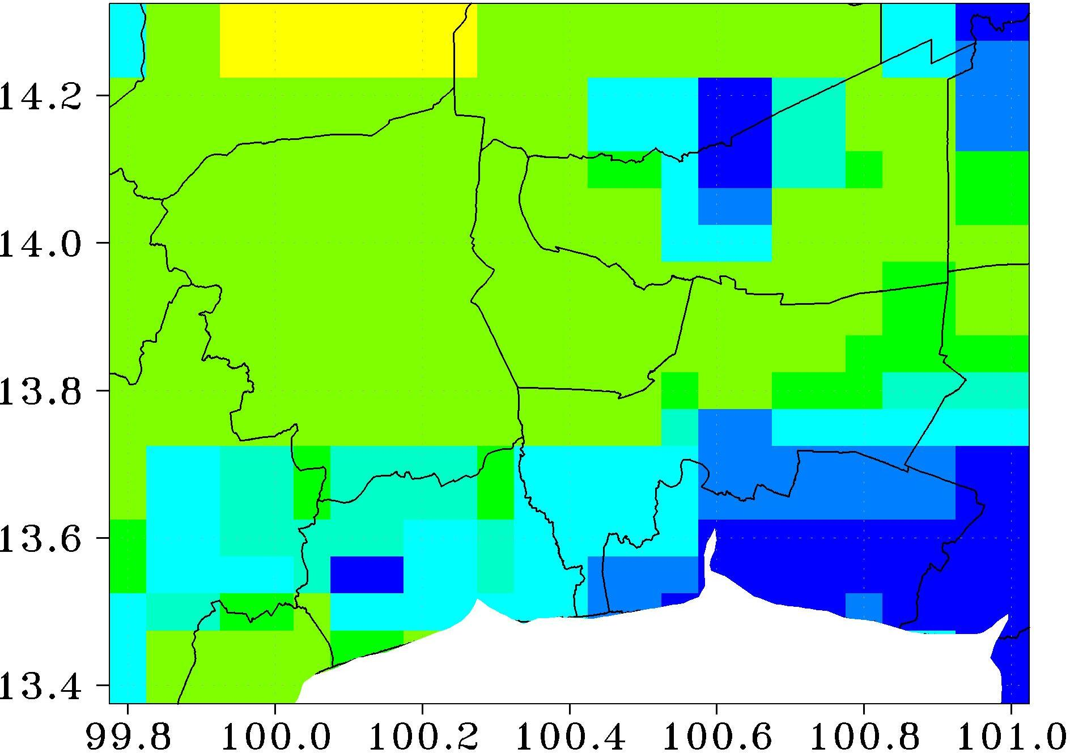 | 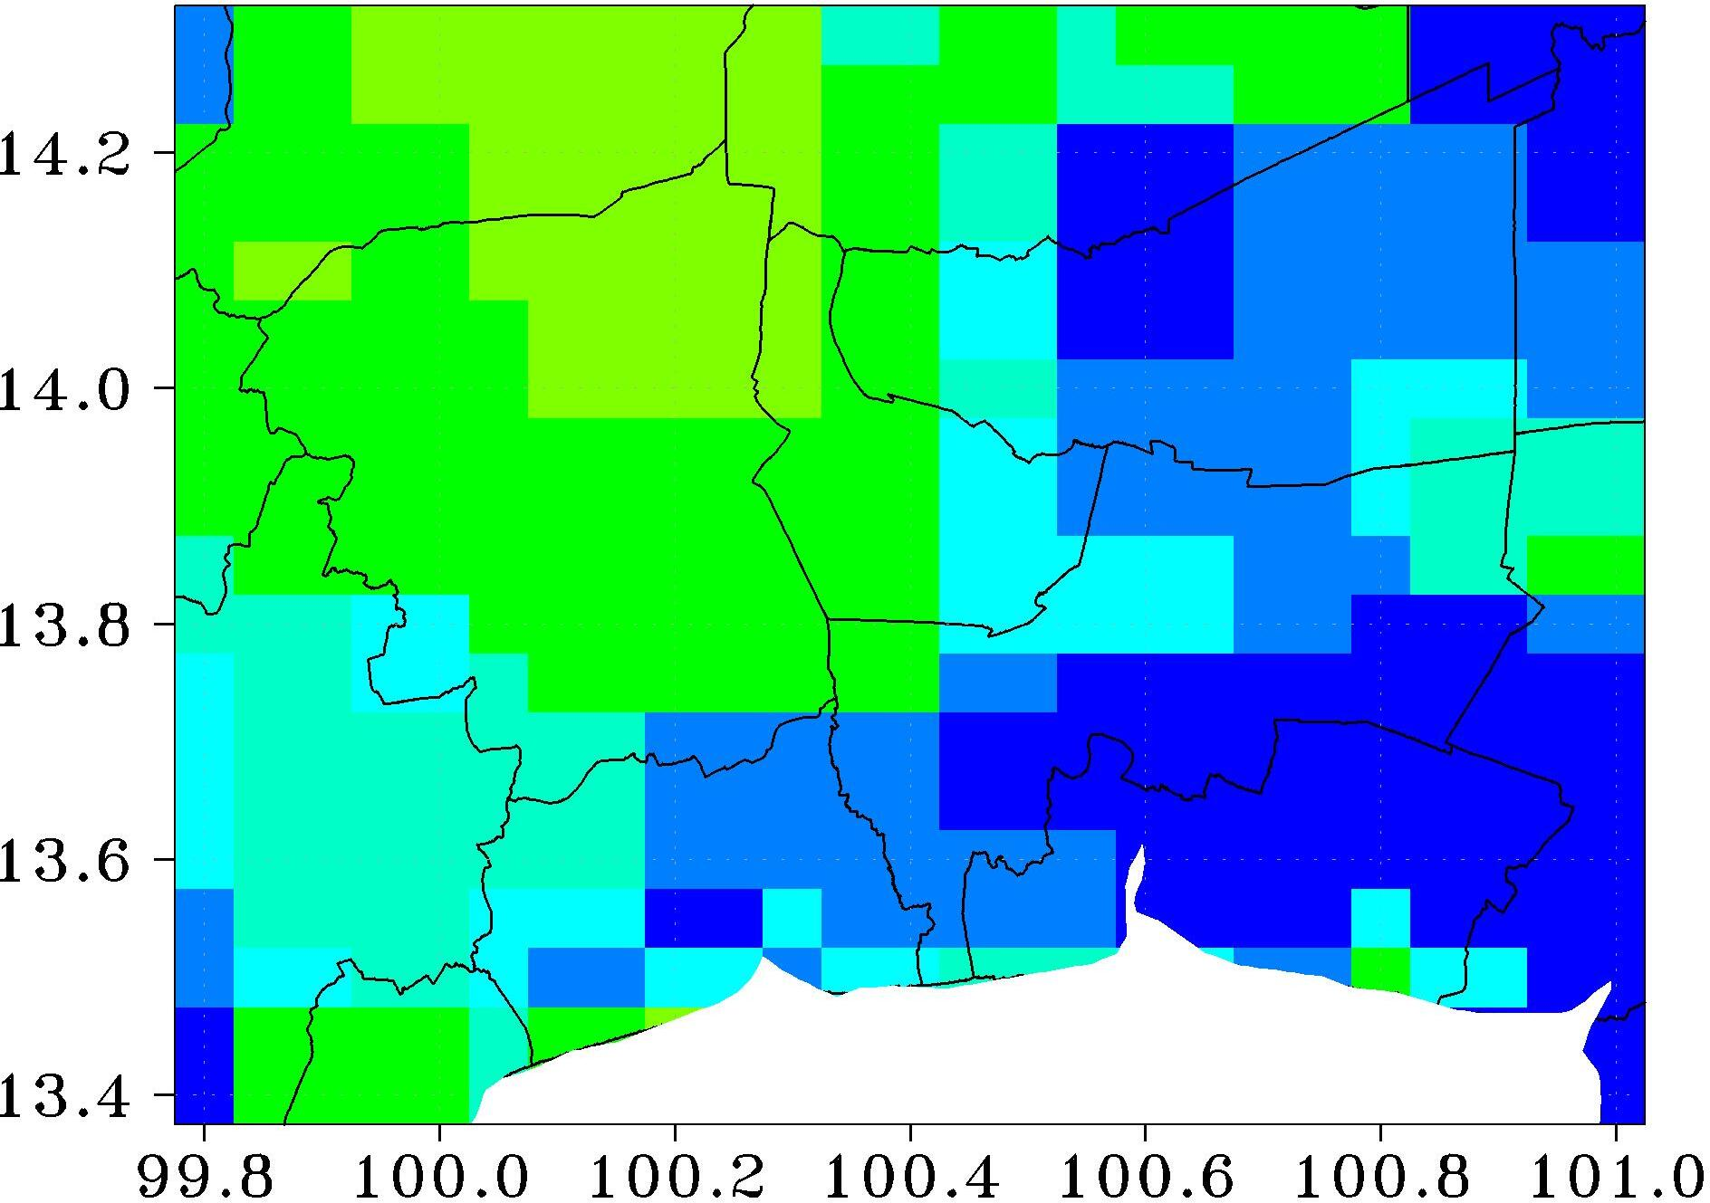 | 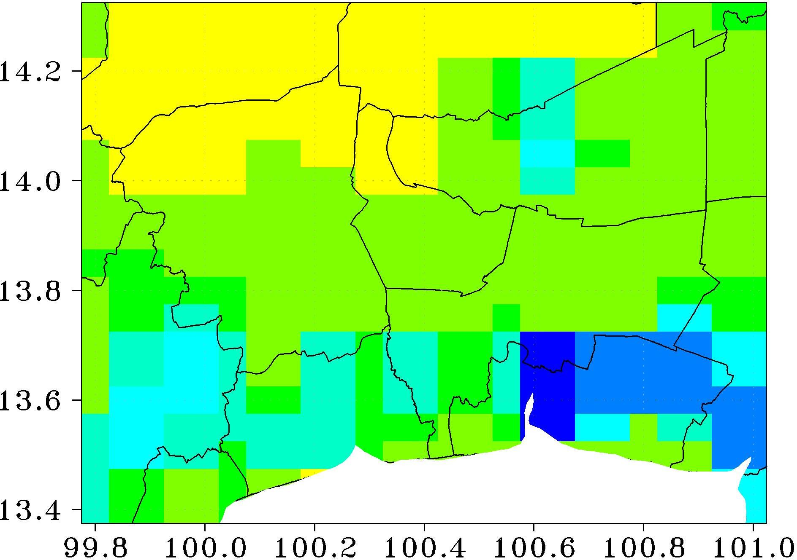 | 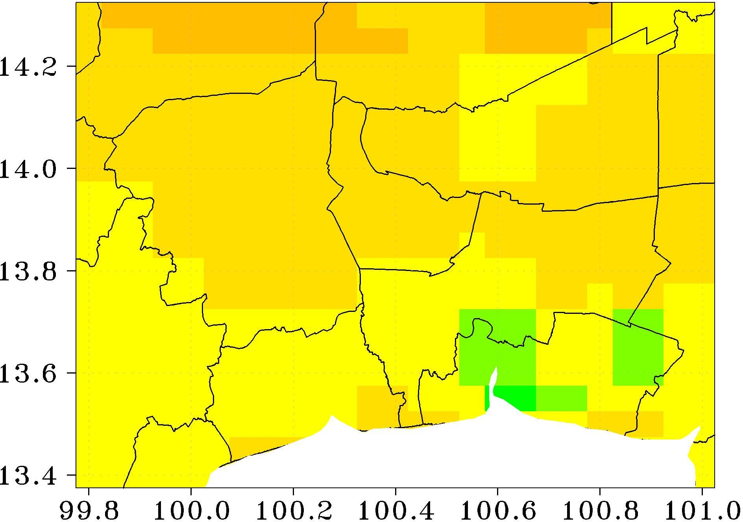
Fig. S1 Non–missing amount (%) in Himawari-8/AHI AOD data by month, based on daily values before gap-filling
Nov. | Dec. | Jan. | Feb. | AOD  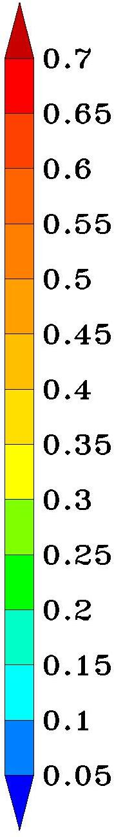
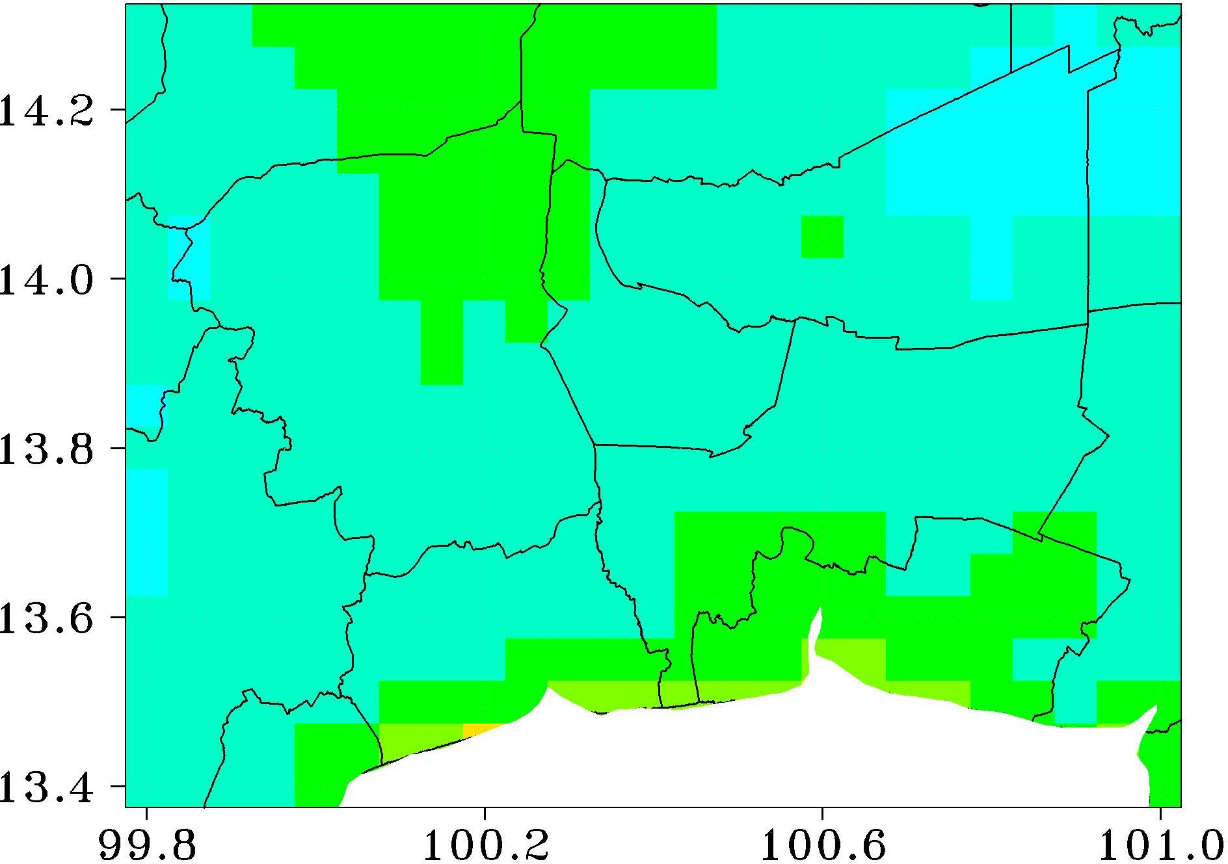 | 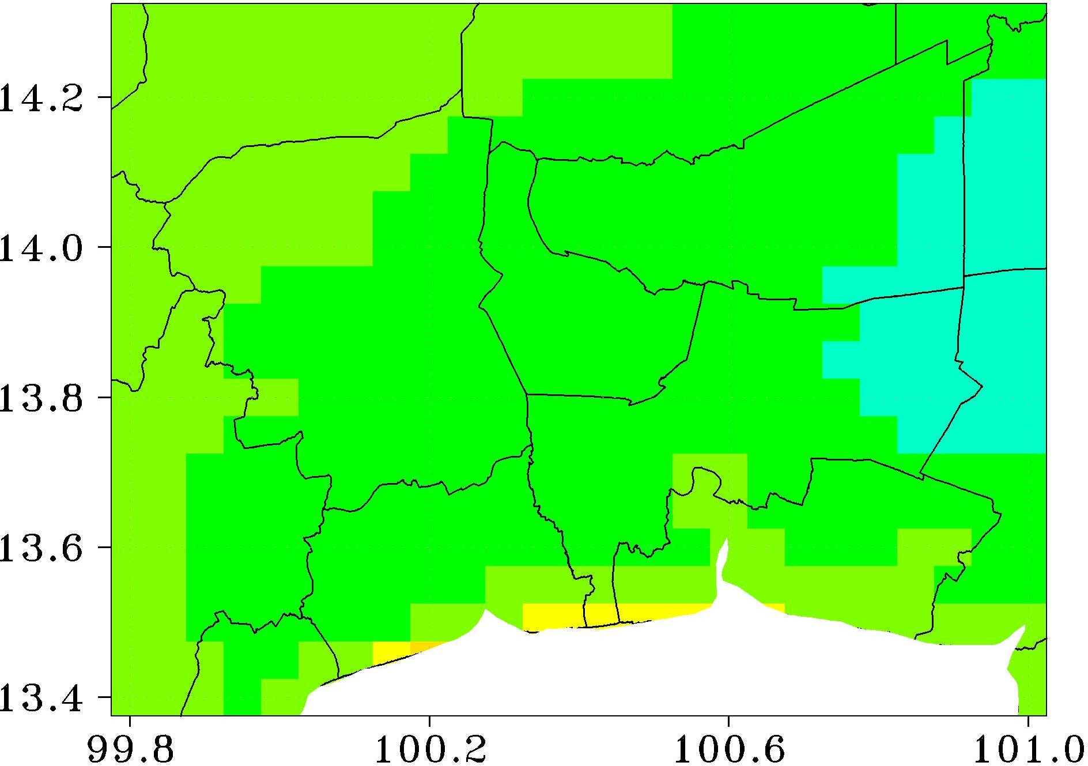 | 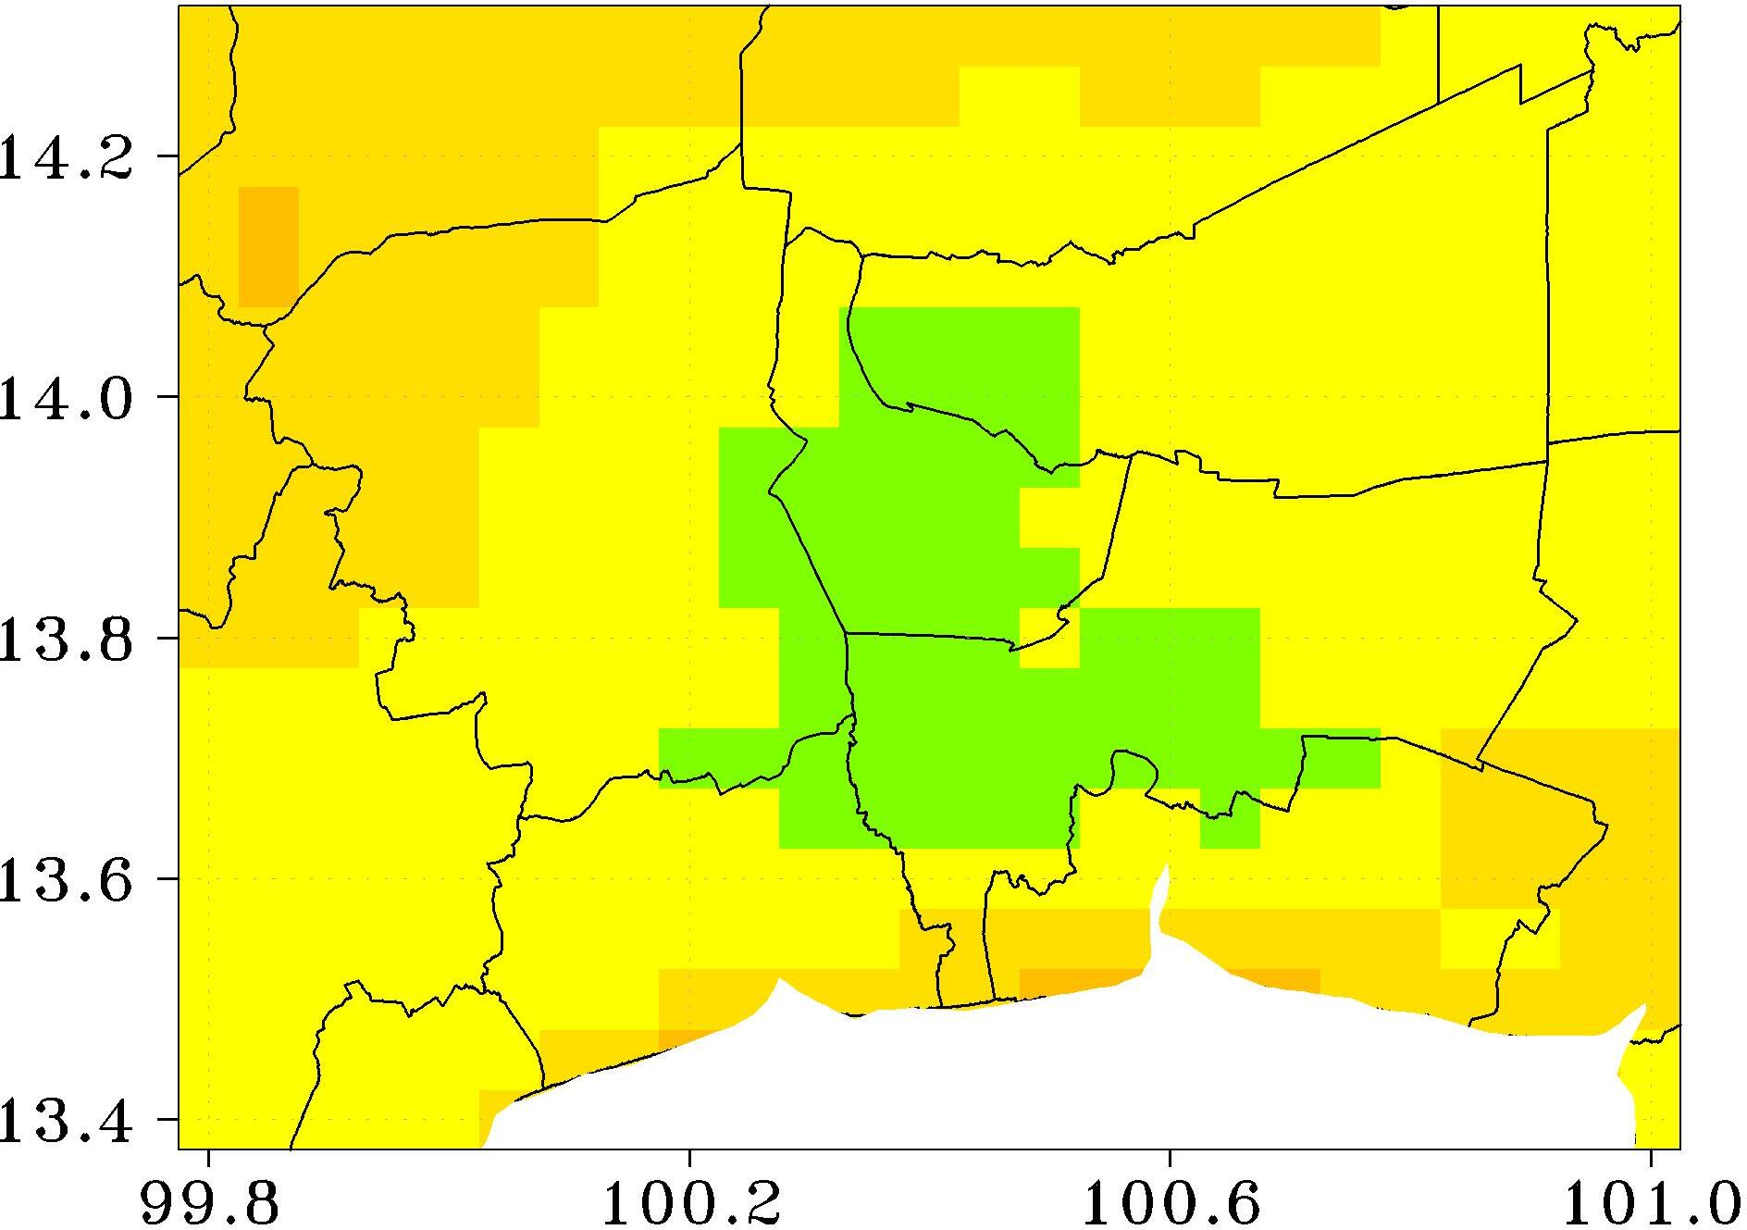 | 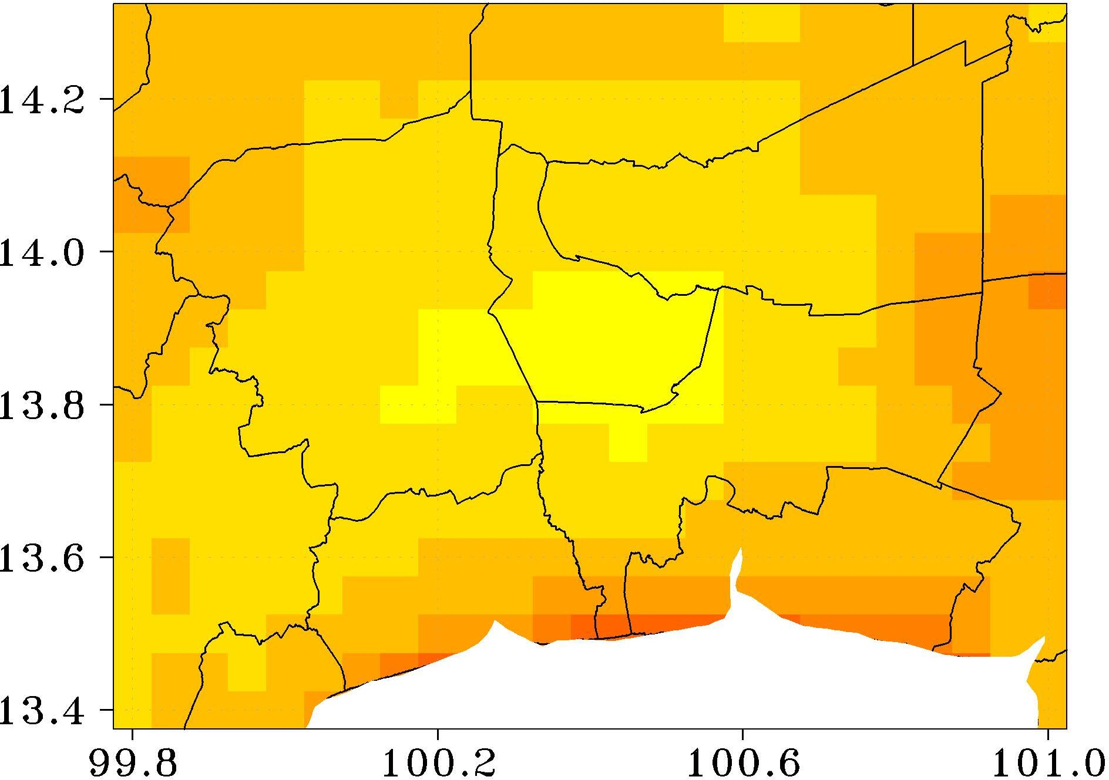
Mar. | Apr. | May | Jun.
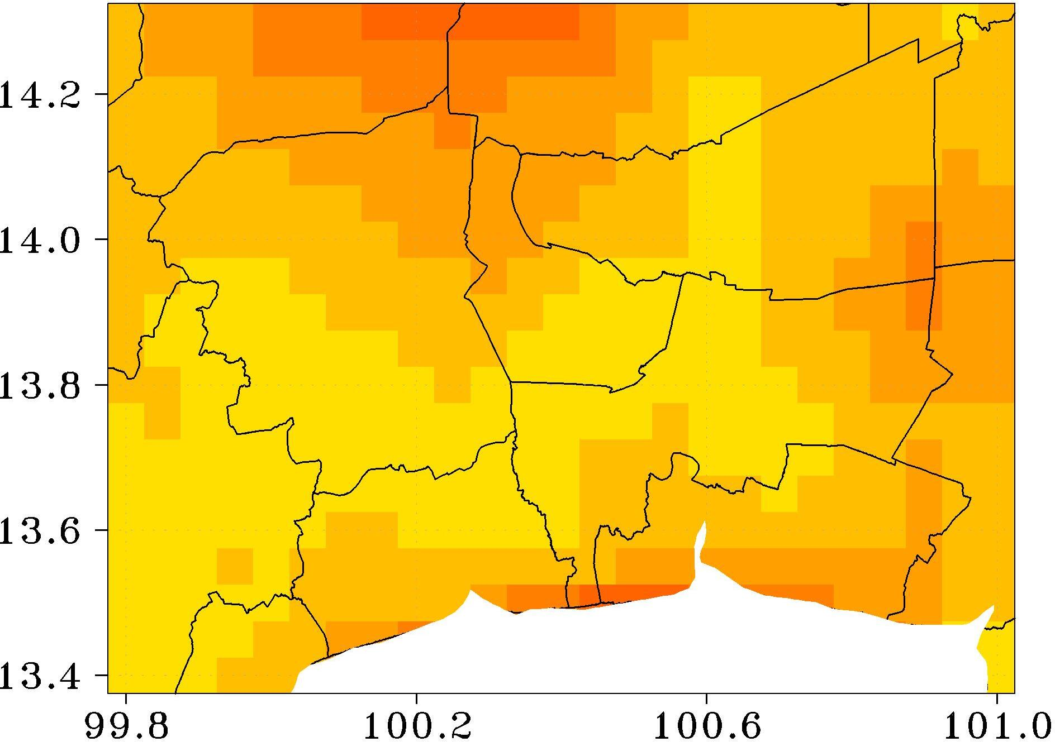 | 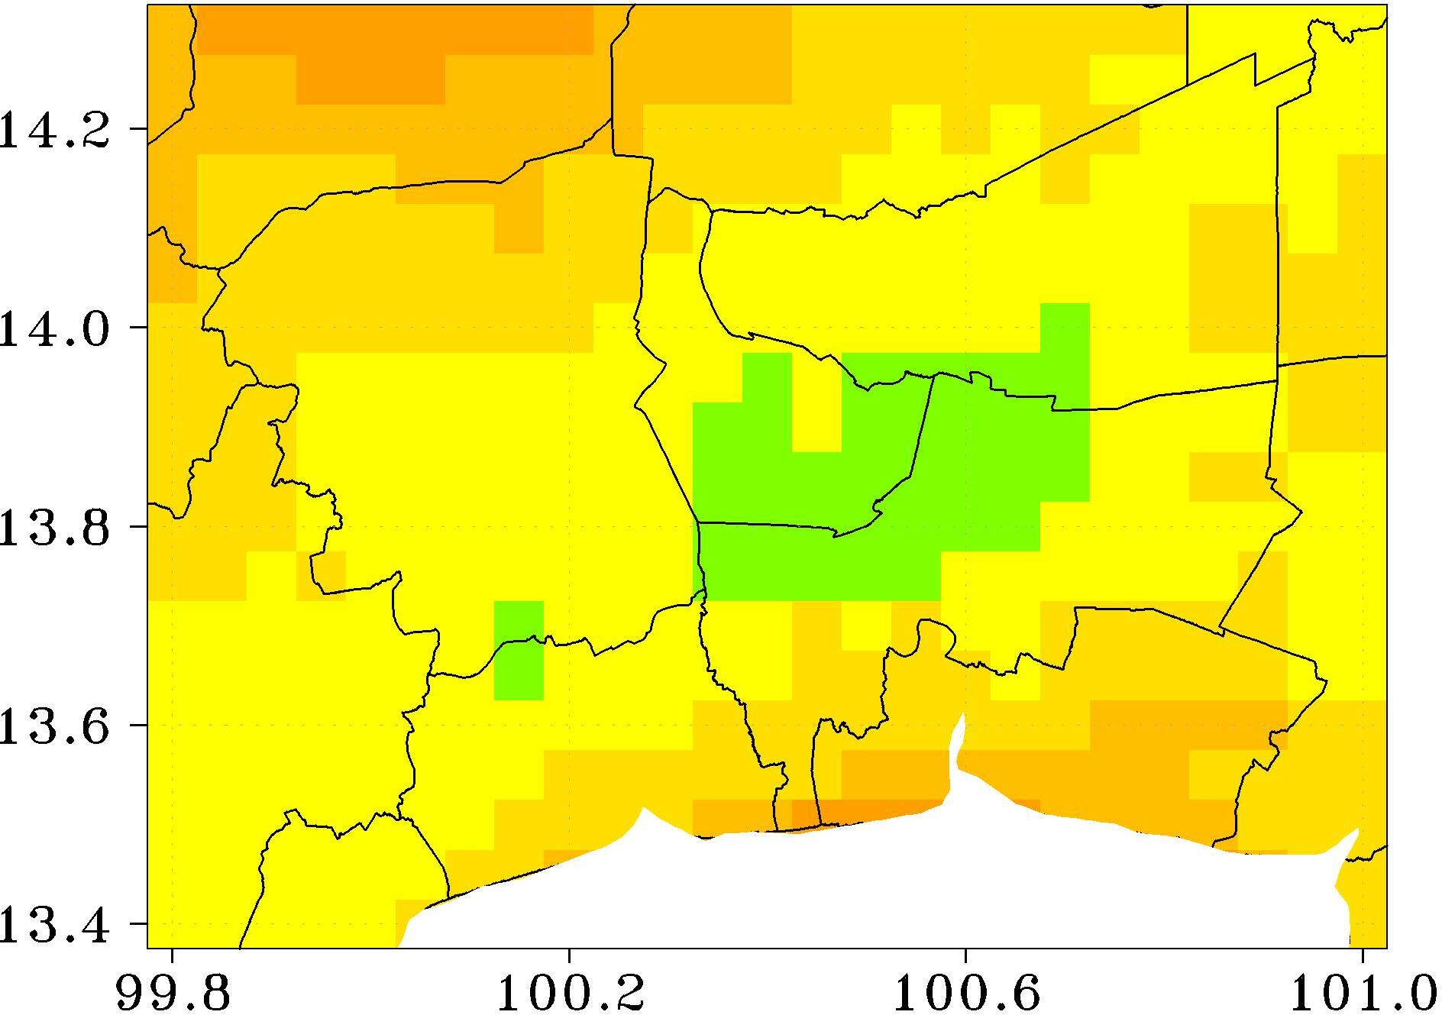 | 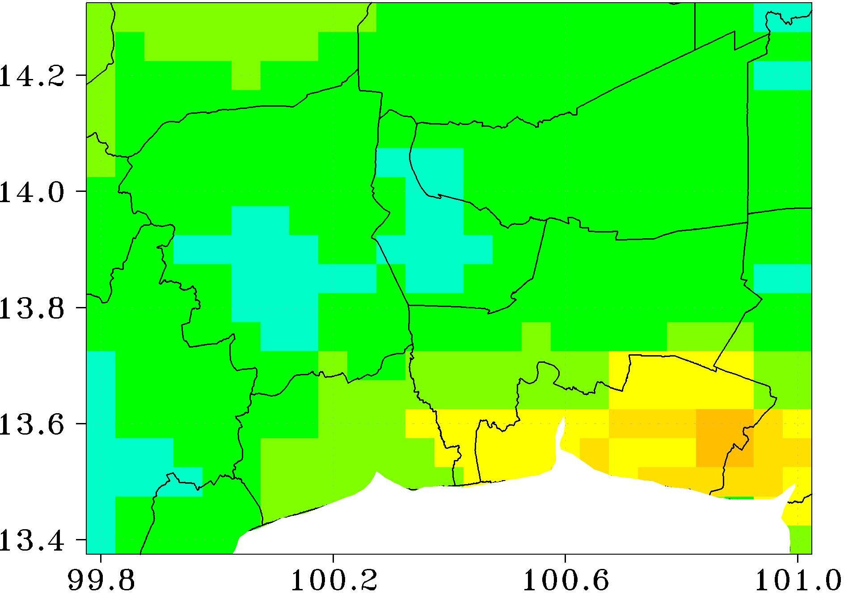 | 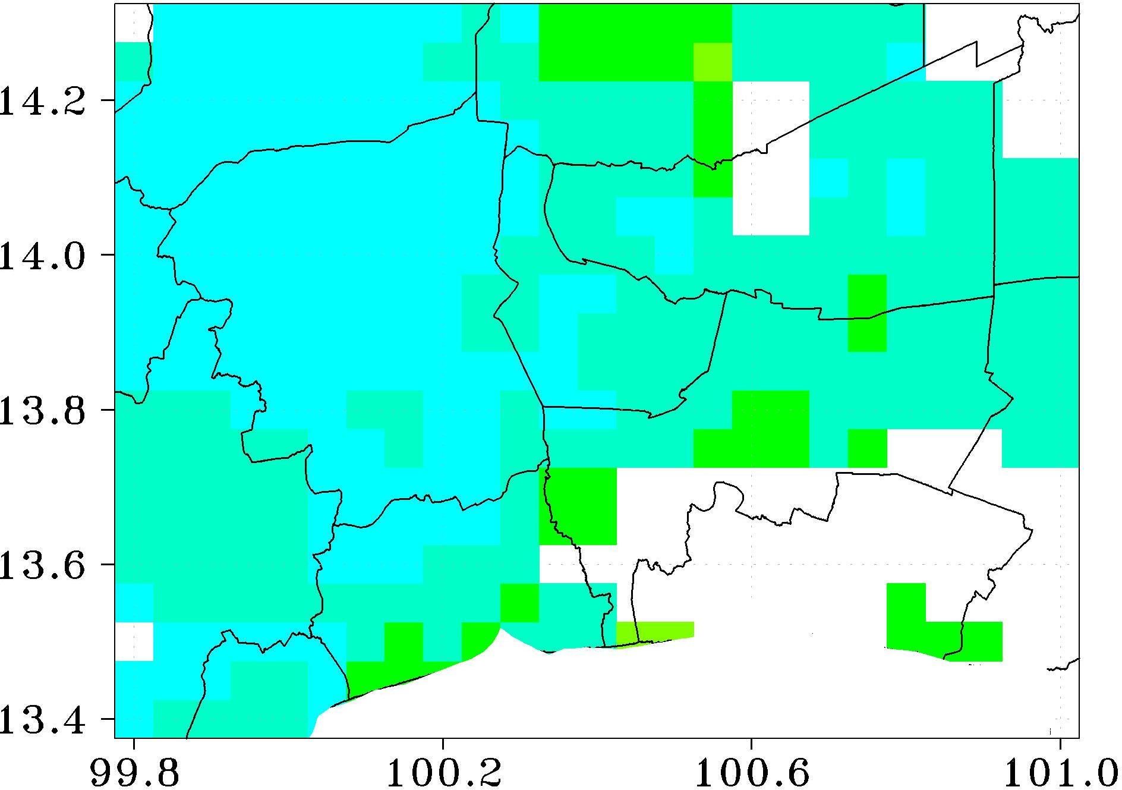
Jul. | Aug. | Sep. | Oct.
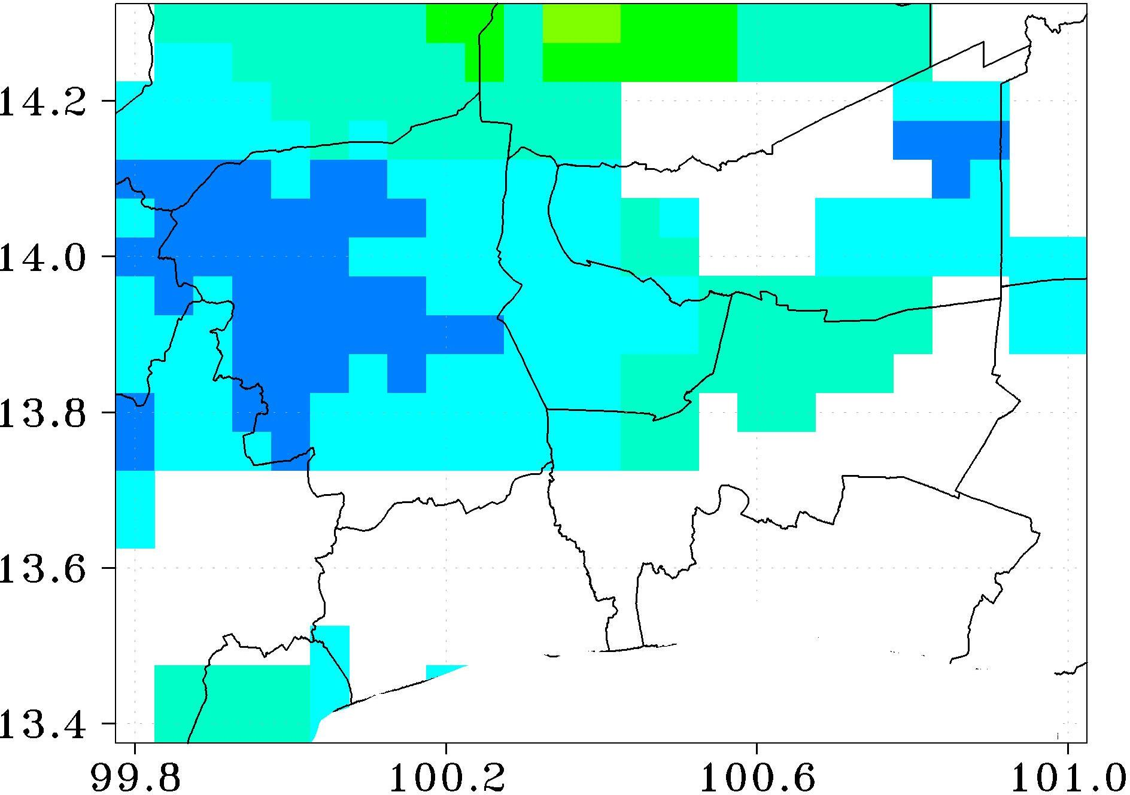 | 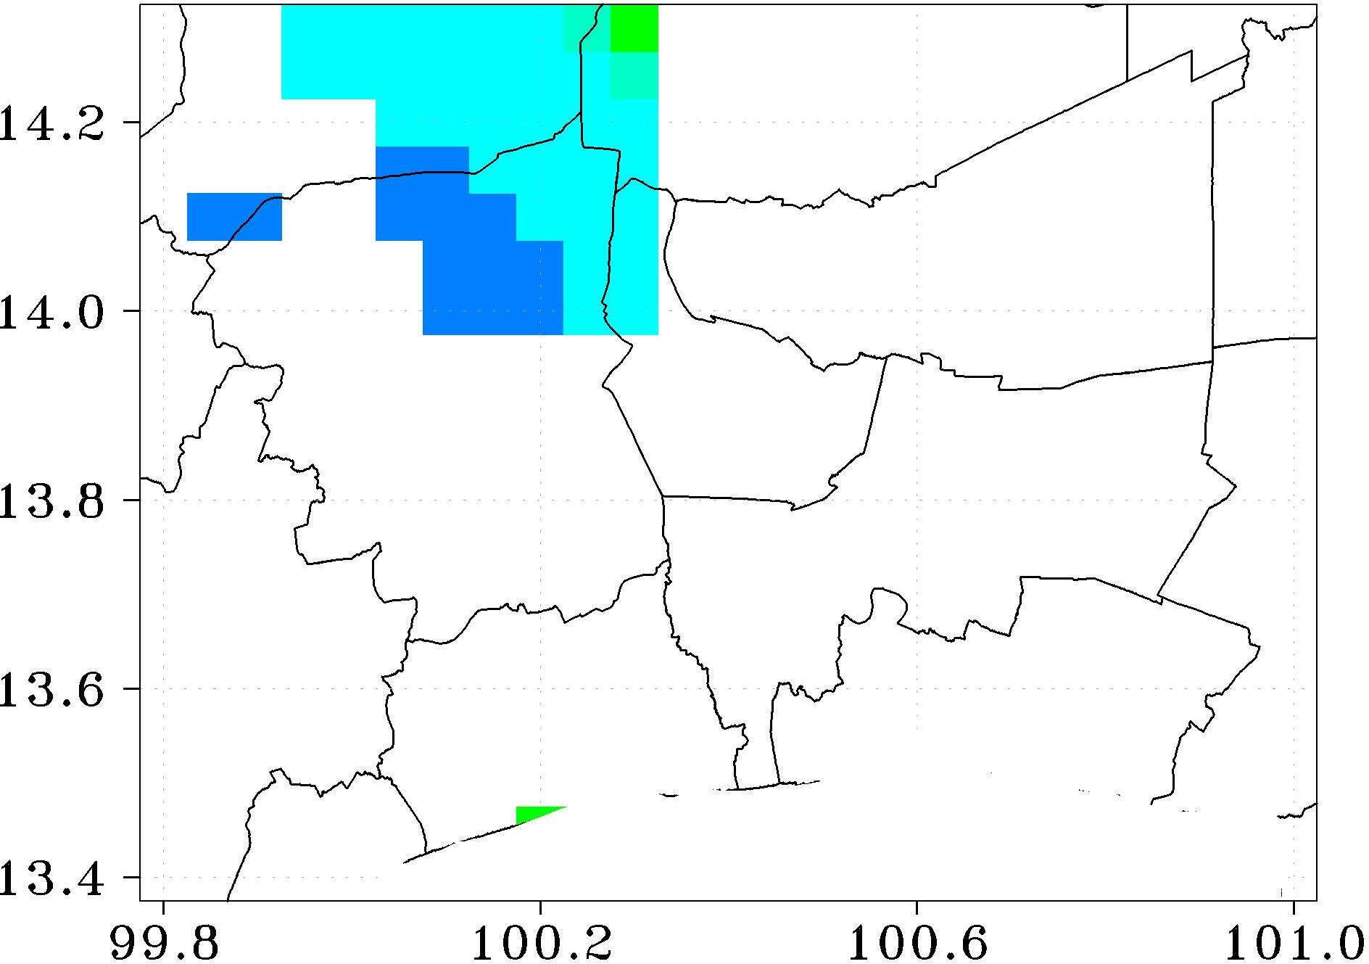 | 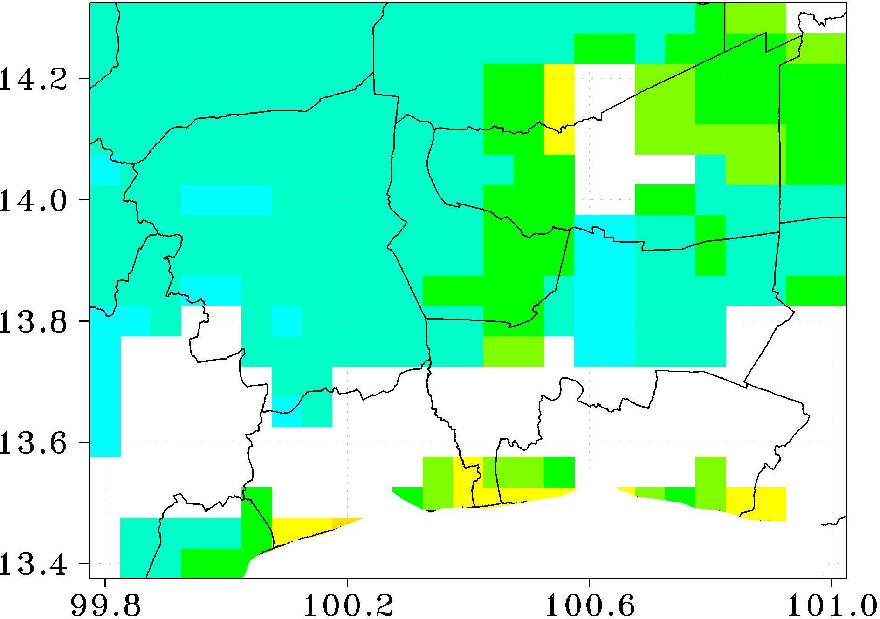 | 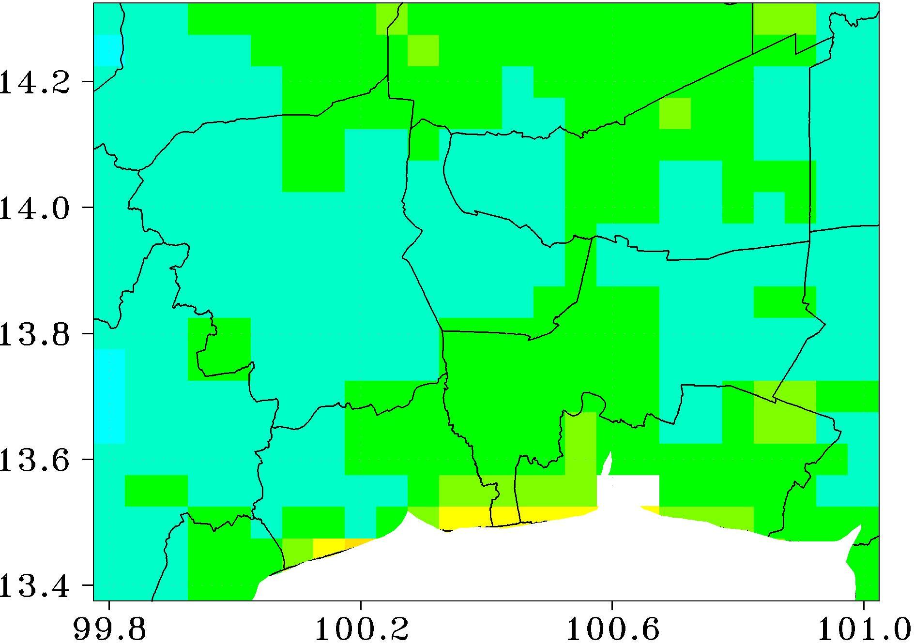
Fig. S2 Monthly variation of Himawari-8/AHI AOD before gap-filling
Section References
Song Z, Fu D, Zhang Z, Han X, Song J, Zhang J, Wang J, Xia X (2019) MODIS AOD sampling rate and its effect on PM_{2.5} estimation in North China. Atmos Environ 209:14–22. https://doi.org/10.1016/j.atmosenv.2019.04.020.

Yang J, Hu M (2018) Filling the missing data gaps of daily MODIS AOD using spatiotemporal interpolation. Sci Total Environ 633:677–683. https://doi.org/10.1016/j.scitotenv.2018.03.202.

Chen, Z, Zhang T, Zhang R, Zhu ZM, Yang J, Chen PY, Ou CQ, Guo Y (2019) Extreme gradient boosting model to estimate PM_{2.5} concentrations with missing-filled satellite data in China. Atmos Environ 202:180–189.
https://doi.org/10.1016/j.atmosenv.2019.01.027.

Chi Y, Wu Z, Liao K, Ren Y (2020) Handling missing data in large-scale MODIS AOD products using a two-step model. Remote Sens 12:3786.
https://doi.org/10.3390/rs12223786.

Jiang T, Chen B, Nie Z, Ren Z, Xu B, Tang S (2021) Estimation of hourly full-coverage PM_{2.5} concentrations at 1-km resolution in China using a two-stage random forest model. Atmos Res 248:105146. https://doi.org/10.1016/j.atmosres.2020.105146.

Stafoggia M, Bellander T, Bucci S, Davoli M, de Hoogh K, de’ Donato F, Gariazzo C, Lyapustin A, Michelozzi P, Renzi M et al. (2019) Estimation of daily PM₁₀ and PM_{2.5} concentrations in Italy, 2013–2015, using a spatiotemporal land-use random-forest model. Environ Int 124:170–179. https://doi.org/10.1016/j.envint.2019.01.016.

Xiao Q, Wang Y, Chang HH, Meng X, Geng G, Lyapustin A, Liu Y (2017) Full-coverage high-resolution daily PM_{2.5} estimation using MAIAC AOD in the Yangtze River Delta of China. Remote Sens Environ 199:437–446.
https://doi.org/10.1016/j.rse.2017.07.023.

Bi J, Belle JH, Wang Y, Lyapustin, AI, Wildani A, Liu Y (2019) Impacts of snow and cloud covers on satellite-derived PM_{2.5} levels. Remote Sens Environ 221:665–674. https://doi.org/10.1016/j.rse.2018.12.002.

Di Q, Amini H, Shi L, Kloog I, Silvern R, Kelly J, Sabath MB, Choirat C, Koutrakis P, Lyapustin A, Wang Y, Mickley LJ, Schwartz J (2019) An ensemble-based model of PM_{2.5} concentration across the contiguous United States with high spatiotemporal resolution. Environ Int 130:104909. https://doi.org/10.1016/j.envint.2019.104909.

Lin L, Liang Y, Liu L, Zhang Y, Xie D, Yin F, Ashraf T (2022) Estimating PM_{2.5} concentrations using the machine learning RF-XGBoost model in Guanzhong urban agglomeration, China. Remote Sens 14:5239. https://doi.org/10.3390/rs14205239.

Zeng Q, Li Y, Tao J, Fan M, Chen L, Wang L, Wang Y (2023) Full-coverage estimation of PM_{2.5} in the Beijing-Tianjin-Hebei region by using a two-stage model. Atmos Environ 309:119956. https://doi.org/10.1016/j.atmosenv.2023.119956.

