Table 1 Structural Information of Dataset Compounds with Diverse Substitutions
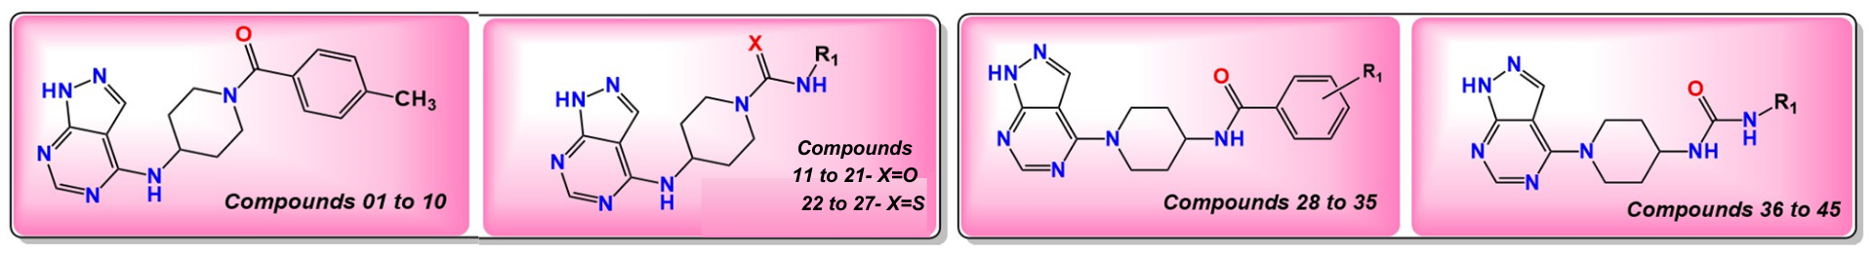
S.NO | COMPOUND | SUBSTITUTION | S.NO | COMPOUND | SUBSTITUTION | S.NO | COMPOUND | SUBSTITUTION
1 | 5a | 4-methyl | 16 | 6f | 4-bromophenyl | 31 | 7d | 4-trimethyl
2 | 5b | 2-methyl | 17 | 6 g | 4-trifluoromethylphenyl | 32 | 7e | 4-fluoro
3 | 5c | 2,4,6-methyl | 18 | 6 h | 2,4-difluorophenyl | 33 | 7f | 4-bromo
4 | 5d | 4-fluoro | 19 | 6i | 3,4-dichlorophenyl | 34 | 7 g | 4-trifluoromethyl
5 | 5e | 4-chloro | 20 | 6j | 2,4-dichlorophenyl | 35 | 7i | 2-chloro
6 | 5f | 2-chloro | 21 | 6 l | naphthyl | 36 | 8a | 4-methylphenyl
7 | 5 g | 4-bromo | 22 | 6 m | 4-methylphenyl | 37 | 8b | 2,6-di methylphenyl
8 | 5 h | 4-trifluoromethyl | 23 | 6n | 2,6-dimethylphenyl | 38 | 8c | 4-methoxyphenyl
9 | 5i | 3-trifluoromethyl | 24 | 6o | 4-methoxyphenyl | 39 | 8d | 4-bromophenyl
10 | 5j | 2,3-dichloro | 25 | 6p | 2-chlorophenyl | 40 | 8e | 4- trifluoromethylphenyl
11 | 6a | 4-methylphenyl | 26 | 6q | 3-chlorophenyl | 41 | 8f | 3-chlorophenyl
12 | 6b | 2,6-di methylphenyl | 27 | 6s | naphthyl | 42 | 8 g | 2-chlorophenyl
13 | 6c | 4-methoxyphenyl | 28 | 7a | 4-methyl | 43 | 8 h | 3,4-dichlorophenyl
14 | 6d | 3-chlorophenyl | 29 | 7b | 2- methyl | 44 | 8i | 2,4-difluoro
15 | 6e | 2-Chlorophenyl | 30 | 7c | 2,4,6- trimethyl | 45 | 8k | 2-napthyl

Table 2 Anticancer activity of the dataset compounds against P21-activated kinase consisting of compound code, IUPAC name, experimental IC₅₀ and pIC₅₀ values.

Molecule | 5a(Training) | 5b(Training) | 5c(Test) | 5d(Test) | 5e(Training) | 5f(Training) | 5 g(Test) | 5 h(Training) | 5i(Training) | 5j(Training)
IUPAC name | (4-((1H-pyrazolo[3,4-d] pyrimidin-4-yl) amino) piperidin-1-yl) (p-tolyl) methanone | (4-((1H-pyrazolo[3,4-d] pyrimidin-4-yl) amino) piperidin-1-yl) (o-tolyl) methanone | (4-((1H-pyrazolo[3,4-d] pyrimidin-4-yl) amino) piperidin-1-yl) (mesityl) methanone | (4-((1H-pyrazolo[3,4-d] pyrimidin-4-yl) amino) piperidin-1-yl) (4-fluorophenyl) methanone | (4-((1H-pyrazolo[3,4-d] pyrimidin-4-yl) amino) piperidin-1-yl) (4-chlorophenyl) methanone | (4-((1H-pyrazolo[3,4-d] pyrimidin-4-yl) amino) piperidin-1-yl) (2-chlorophenyl) methanone | (4-((1H-pyrazolo[3,4-d] pyrimidin-4-yl) amino) piperidin-1-yl) (4-bromophenyl) methanone | (4-((1H-pyrazolo[3,4-d] pyrimidin-4-yl) amino) piperidin-1-yl) (4-(trifluoromethyl)phenyl) methanone | (4-((1H-pyrazolo[3,4-d] pyrimidin-4-yl) amino) piperidin-1-yl) (3-(trifluoromethyl)phenyl) methanone | (4-((1H-pyrazolo[3,4-d] pyrimidin-4-yl) amino) piperidin-1-yl) (2,3-dichlorophenyl) methanone
Exp IC₅₀(µm) | 39.45 | 33.21 | 31.09 | 7.82 | 9.44 | 6.84 | 29.21 | 50 | 50 | 6.77
pIC50 | 4.403953 | 4.478731 | 4.507379 | 5.106793 | 5.025028 | 5.164944 | 4.534468 | 4.30103 | 4.30103 | 5.169411

Molecule | 6a(Training) | 6b(Test) | 6c(Training) | 6d(Training) | 6e(Training) | 6f(Training) | 6 g(Test) | 6 h(Training) | 6i(Training) | 6j(Test)
IUPAC name | 4-((1H-pyrazolo[3,4-d] pyrimidin-4-yl) amino)-N-(p-tolyl) piperidine-1-carboxamide | 4-((1H-pyrazolo[3,4-d] pyrimidin-4-yl) amino)-N-(2,6-dimethylphenyl) piperidine-1-carboxamide | 4-((1H-pyrazolo[3,4-d] pyrimidin-4-yl) amino)-N-(4-methoxyphenyl) piperidine-1-carboxamide | 4-((1H-pyrazolo[3,4-d] pyrimidin-4-yl) amino)-N-(3-chlorophenyl) piperidine-1-carboxamide | 4-((1H-pyrazolo[3,4-d] pyrimidin-4-yl) amino)-N-(2-chlorophenyl) piperidine-1-carboxamide | 4-((1H-pyrazolo[3,4-d] pyrimidin-4-yl) amino)-N-(4-bromophenyl) piperidine-1-carboxamide | 4-((1H-pyrazolo[3,4-d] pyrimidin-4-yl) amino)-N-(4-(trifluoromethyl) phenyl) piperidine-1-carboxamide | 4-((1H-pyrazolo[3,4-d] pyrimidin-4-yl) amino)-N-(2,4-difluorophenyl) piperidine-1-carboxamide | 4-((1H-pyrazolo[3,4-d] pyrimidin-4-yl) amino)-N-(3,4-dichlorophenyl) piperidine-1-carboxamide | 4-((1H-pyrazolo[3,4-d] pyrimidin-4-yl) amino)-N-(2,4-dichlorophenyl) piperidine-1-carboxamide
Exp IC₅₀(µm) | 17.44 | 6.27 | 13.76 | 7.18 | 5.24 | 17.89 | 15.75 | 5.17 | 10.85 | 5.46
pIC50 | 4.758454 | 5.202732 | 4.861382 | 5.143876 | 5.280669 | 4.74739 | 4.802719 | 5.286509 | 4.96457 | 5.262807

Table 2 (Continued)
Molecule | 6 l(Training) | 6 m(Test) | 6n(Training) | 6o(Training) | 6p(Test) | 6q(Training) | 6s(Training)
IUPAC name | 4-((1H-pyrazolo[3,4-d] pyrimidin-4-yl) amino)-N-(naphthalen-1-yl) piperidine-1-carboxamide | 4-((1H-pyrazolo[3,4-d] pyrimidin-4-yl) amino)-N-(p-tolyl) piperidine-1-carbothioamide | 4-((1H-pyrazolo[3,4-d] pyrimidin-4-yl) amino)-N-(2,6-dimethylphenyl) piperidine-1-carbothioamide | 4-((1H-pyrazolo[3,4-d] pyrimidin-4-yl) amino)-N-(4-methoxyphenyl) piperidine-1-carbothioamide | 4-((1H-pyrazolo[3,4-d] pyrimidin-4-yl) amino)-N-(2-chlorophenyl) piperidine-1-carbothioamide | 4-((1H-pyrazolo[3,4-d] pyrimidin-4-yl) amino)-N-(3-chlorophenyl) piperidine-1-carbothioamide | 4-((1H-pyrazolo[3,4-d] pyrimidin-4-yl) amino)-N-(naphthalen-1-yl) piperidine-1-carbothioamide
Exp IC50(µm) | 50 | 19.55 | 7.36 | 15.11 | 6.67 | 7.89 | 50
p IC50 | 4.30103 | 4.708853 | 5.133122 | 4.820736 | 5.175874 | 5.102923 | 4.30103

Molecule | 7a(Training) | 7b(Test) | 7c(Training) | 7d(Training) | 7e(Training) | 7f(Training) | 7 g(Training) | 7i(Training)
IUPAC name | N-(1-(1H-pyrazolo[3,4-d] pyrimidin-4-yl) piperidin-4-yl)-4-methylbenzamide | N-(1-(1H-pyrazolo[3,4-d] pyrimidin-4-yl) piperidin-4-yl)-2-methylbenzamide | N-(1-(1H-pyrazolo[3,4-d] pyrimidin-4-yl) piperidin-4-yl)-2,4,6-trimethylbenzamide | N-(1-(1H-pyrazolo[3,4-d] pyrimidin-4-yl) piperidin-4-yl)-4-methoxybenzamide | N-(1-(1H-pyrazolo[3,4-d] pyrimidin-4-yl) piperidin-4-yl)-4-fluorobenzamide | N-(1-(1H-pyrazolo[3,4-d] pyrimidin-4-yl) piperidin-4-yl)-4-bromobenzamide | N-(1-(1H-pyrazolo[3,4-d] pyrimidin-4-yl) piperidin-4-yl)-4-(trifluoromethyl)benzamide | N-(1-(1H-pyrazolo[3,4-d] pyrimidin-4-yl) piperidin-4-yl)-2-chlorobenzamide
Exp IC₅₀(µm) | 5.61 | 6.26 | 6.77 | 8.82 | 4.54 | 16.4 | 5.74 | 5.24
pIC50 | 5.251037 | 5.203426 | 5.169411 | 5.054531 | 5.342944 | 4.785156 | 5.241088 | 5.280669

Molecule | 8a(Training) | 8b(Training) | 8c(Training) | 8d(Training) | 8e(Training) | 8f(Training) | 8 g(Test) | 8 h(Training) | 8i(Training) | 8k(Training)
IUPAC name | 1-(1-(1H-pyrazolo[3,4-d] pyrimidin-4-yl) piperidin-4- yl)-3-(p-tolyl) urea | 1-(1-(1H-pyrazolo[3,4-d] pyrimidin-4-yl) piperidin-4-yl)-3-(2,6-dimethylphenyl) urea | 1-(1-(1H-pyrazolo[3,4-d] pyrimidin-4-yl) piperidin-4-yl)-3-(4-bromophenyl) urea | N-(1-(1H-pyrazolo[3,4-d] pyrimidin-4-yl) piperidin-4-yl)-4-methoxybenzamide | N-(1-(1H-pyrazolo[3,4-d] pyrimidin-4-yl) piperidin-4-yl)-4-fluorobenzamide | 1-(1-(1H-pyrazolo[3,4-d] pyrimidin-4-yl) piperidin-4-yl)-3-(3-chlorophenyl) urea | 1-(1-(1H-pyrazolo[3,4-d] pyrimidin-4-yl) piperidin-4-yl)-3-(2-chlorophenyl) urea | 1-(1-(1H-pyrazolo[3,4-d] pyrimidin-4-yl) piperidin-4-yl)-3-(3,4-dichlorophenyl) urea | 1-(1-(1H-pyrazolo[3,4-d] pyrimidin-4-yl) piperidin-4-yl)-3-(2,4-difluorophenyl) urea | 1-(1-(1H-pyrazolo[3,4-d] pyrimidin-4-yl) piperidin-4-yl)-3-(naphthalen-1-yl) urea
Exp IC₅₀(µm) | 4.17 | 2.16 | 6.37 | 4.03 | 7.15 | 1.24 | 0.56 | 2.29 | 1.14 | 11.14
pIC50 | 5.379864 | 5.665546 | 5.195861 | 5.394695 | 5.145694 | 5.906578 | 6.251812 | 5.640165 | 5.943095 | 4.953115

Table 3 Statistical parameters for developed QSAR models 1, 2, 3 and 4.
Statistical Parameters | Threshold value | Model 1 | Model 2 | Model 3 | Model 4
Fitting criteria
R² | > 0.6 | 0.6493 | 0.7798 | 0.8683 | 0.9100
S | < 0.3 | 0.2655 | 0.2139 | 0.1682 | 0.1441
R²_{adj} | > 0.6 | 0.6267 | 0.7577 | 0.8501 | 0.8900
R² – R²_{adj} | < 0.3 | 0.0226 | 0.0220 | 0.0182 | 0.0200
LOF | < 0.3 | 0.0825 | 0.0595 | 0.0413 | 0.0394
RMSE tr | Better < 0.3 | 0.2535 | 0.2009 | 0.1554 | 0.1284
CCC tr | > 0.85 | 0.7874 | 0.8763 | 0.9295 | 0.9529
F | Higher than the theoretical value | 28.6971 | 35.4063 | 47.7833 | 45.4929
Internal validation criteria
Q²_{loo} (r² _{cv}) | > 0.5 | 0.5879 | 0.7277 | 0.8228 | 0.8633
R² – Q² _{loo} | < 0.3 | 0.0614 | 0.0521 | 0.0455 | 0.0467
Q² _{lmo} | > 0.5 | 0.5745 | 0.7107 | 0.8061
RMSE cv | < 0.3 | 0.2748 | 0.2234 | 0.4010 | 0.1583
R²Yscr | < R² (smallest is better) | 0.0617 | 0.0927 | 0.1205 | 0.1866
Q²Yscr | < Q² (smallest is better) | -0.1317 | -0.1750 | -0.2188 | -0.3044
External validation criteria
R²ext | > 0.6 | 0.5249 | 0.7752 | 0.8574 | 0.8939
RMSE ext | Better < 0.3 | 0.3508 | 0.2821 | 0.2208 | 0.1892
Q2-F1 | > 0.7 | 0.4116 | 0.6196 | 0.7669 | 0.8289
Q2-F2 | > 0.7 | 0.4115 | 0.6195 | 0.7669 | 0.8289
Q2-F3 | > 0.7 | 0.3284 | 0.5658 | 0.7340 | 0.8047
CCC ext | > 0.85 | 0.6159 | 0.7310 | 0.8587 | 0.9045
r²m | > 0.5 | 0.3109 | 0.3653 | 0.6464 | 0.7753
Δr²m | < 0.2 | 0.3721 | 0.3879 | 0.1776 | 0.1128
K’ | 0.85 < k or k’ < 1.15 | 0.9973 | 0.9725 | 0.9989 | 0.9995
K | 0.85 < k or k’ < 1.15 | 0.9997 | 0.9995 | 1.0244 | 0.9995

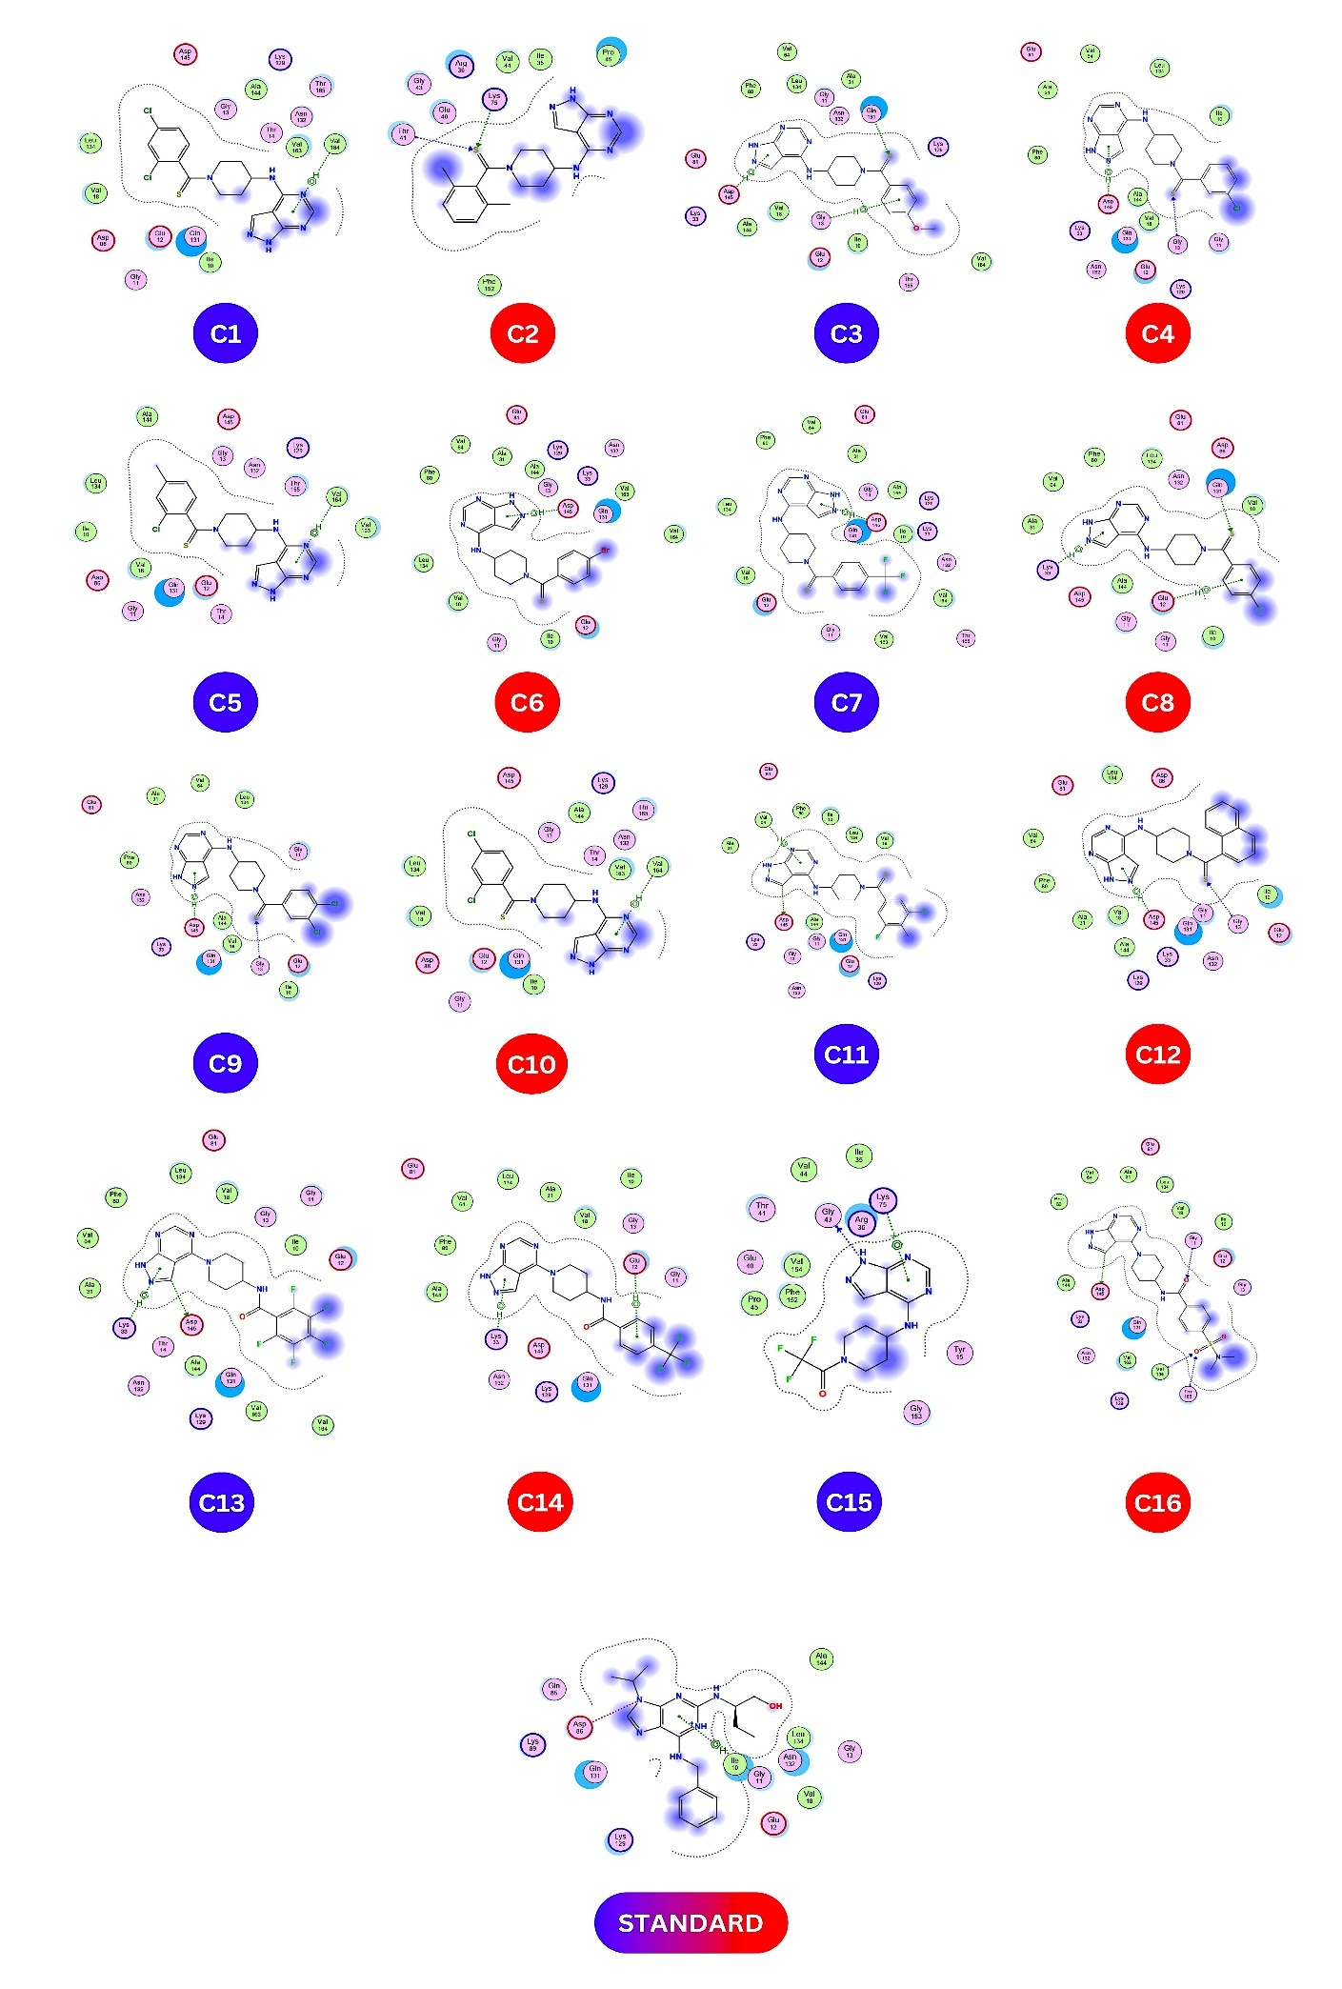
p
Table 4 Correlation Matrixes between the descriptors.
 | SlogP_VSA5 | fr_Ndealkylation2 | EstateVSA2 | CIC3 | slogPVSA5 | diameter
SlogP_VSA5 | 1
fr_Ndealkylation2 | -0.03837 | 1
EstateVSA2 | -0.11680 | 0.24828 | 1
CIC3 | 0.66568 | -0.07989 | -0.17935 | 1
slogPVSA5 | -0.45560 | -0.11019 | -0.10916 | -0.1248 | 1
diameter | -0.46540 | -0.13966 | 0.25139 | 0.14456 | 0.56709 | 1

Table 5 pIC₅₀ values of the dataset predicted by model 4 along with residuals
Compound code | Exp _{P}IC₅₀ | Pred _{P}IC₅₀ | Residuals
5a | 4.404 | 4.4533 | 0.0493
5b | 4.4787 | 4.6033 | -0.1246
5c | 4.5074 | 4.5447 | -0.0373
5d | 5.1068 | 4.7418 | 0.365
5e | 5.025 | 4.7841 | 0.2409
5f | 5.1649 | 4.9651 | 0.1998
5 g | 4.5345 | 4.3611 | 0.1734
5 h | 4.301 | 4.4392 | -0.1382
5i | 4.301 | 4.357 | -0.056
5j | 5.1694 | 5.0987 | 0.0707
6a | 4.7585 | 4.7599 | -0.0014
6b | 5.2027 | 5.1468 | 0.0559
6c | 4.8614 | 4.7735 | 0.0879
6d | 5.1439 | 5.2412 | -0.0973
6e | 5.2807 | 5.3109 | -0.0302
6f | 4.7474 | 4.8562 | -0.1088
6 g | 4.8027 | 4.6833 | -0.0303
6 h | 5.2865 | 5.217 | 0.0695
6i | 4.9646 | 5.262 | -0.2974
6j | 5.2628 | 5.1923 | 0.0705
6 l | 4.301 | 4.322 | -0.021
6 m | 4.7089 | 4.7004 | 0.0085
6n | 5.1331 | 5.0873 | 0.0458
6o | 4.8207 | 4.6664 | 0.1543
6p | 5.1759 | 5.1989 | -0.023
6q | 5.1029 | 5.0861 | 0.0168
6s | 4.301 | 4.2626 | 0.0384
7a | 5.251 | 5.1569 | 0.0941
7b | 5.2034 | 5.26 | -0.0566
7c | 5.1694 | 5.2014 | -0.032
7d | 5.0545 | 4.9805 | 0.074
7e | 5.3429 | 5.2404 | 0.1025
7f | 4.7852 | 5.0647 | -0.2616
7 g | 5.2411 | 5.0468 | 0.1943
7i | 5.2807 | 5.4637 | -0.183
8a | 5.3799 | 5.3061 | 0.0738
8b | 5.6655 | 5.693 | -0.0275
8c | 5.1959 | 5.2721 | -0.0762
8d | 5.3947 | 5.3548 | 0.0399
8e | 5.1457 | 5.2909 | -0.1452
8f | 5.9066 | 5.7398 | 0.1668
8 g | 6.2518 | 5.8095 | 1.1568
8 h | 5.6402 | 5.7606 | -0.1204
8i | 5.9431 | 5.8246 | 0.1185
8k | 4.9531 | 4.8683 | 0.0848

Fig 11. 2D interactions of all hit molecules C1-C16.
Table 6 Model 4 predicted pIC₅₀ values for the designed compounds (hit molecules)
Compound  code | SlogP_VSA5 | fr_Ndealkylation2 | EstateVSA2 | CIC3 | slogPVSA5 | diametert | pIC₅₀
C1 | 23.969 | 1 | 6.042 | 0.861 | 36.79 | 14 | 9.447431
C2 | 29.532 | 1 | 6.042 | 0.906 | 30.723 | 13 | 9.3716907
C3 | 18.405 | 1 | 6.042 | 0.712 | 36.79 | 15 | 9.6006504
C4 | 18.405 | 1 | 11.064 | 0.524 | 36.79 | 13 | 9.3517548
C5 | 23.969 | 1 | 6.042 | 0.639 | 30.723 | 14 | 9.3421416
C6 | 18.405 | 1 | 6.042 | 0.667 | 41.262 | 14 | 9.3552273
C7 | 23.969 | 1 | 16.199 | 0.861 | 36.79 | 15 | 9.5327499
C8 | 18.405 | 1 | 6.042 | 0.667 | 36.79 | 14 | 9.5309769
C9 | 18.405 | 1 | 16.087 | 0.571 | 30.723 | 14 | 9.7051512
C10 | 18.405 | 1 | 16.087 | 0.524 | 30.723 | 14 | 9.6323811
C11 | 23.969 | 1 | 29.289 | 0.728 | 24.657 | 14 | 9.9136089
C12 | 18.405 | 1 | 6.042 | 0.766 | 54.989 | 14 | 8.9690379
C13 | 12.842 | 1 | 24.307 | 0.707 | 12.5214 | 11 | 7.458235
C14 | 12.842 | 0 | 37.396 | 0.707 | 12.524 | 11 | 8.2147661
C15 | 23.2 | 0 | 37.396 | 0.732 | 12.524 | 14 | 7.5387716
C16 | 23.2 | 0 | 37.396 | 0.712 | 12.524 | 15 | 7.5078056

Table 7 CDK2–ligand interactions recorded during docking
Compound  code | Docking Score  Kcal/mol | Number of Interacting Residues | Amino acid interaction
C1 | -6.9 | 3 | Asp 145, Glu 12, Lys 33  (H-bond)
C2 | -5.5 | 2 | Lys 75, Thr41 (H-bond)
C3 | -7.2 | 3 | Asp 145, Glu 13, Gln 131  (H-bond)
C4 | -6.6 | 2 | Asp 145, Glu 13 (H-bond)
C5 | -6.6 | 1 | Val 164 (H-bond)
C6 | -7.0 | 1 | Asp 145 (H-bond)
C7 | -7.1 | 1 | Asp 145 (H-bond)
C8 | -6.5 | 3 | Lys 33, Gln 131, Glu 12  (H-bond)
C9 | -6.6 | 2 | Asp 145 (H-bond), Gly 13 (Hydrophobic)
C10 | -6.7 | 1 | Val 164, (H-bond)
C11 | -6.5 | 2 | ASP 145, Val 64, (H-bond)
C12 | -6.6 | 2 | ASP 145, Gly 13, (H-bond)
C13 | -6.6 | 2 | ASP 145, Lys 33, (H-bond)
C14 | -6.7 | 2 | Lys 33 (H-bond)  Glu 12 (Hydrophobic)
C15 | -7.0 | 4 | ASP 145(H-bond)  Gly 11, Thr 165, Val 164 (Hydrophobic)
C16 | -5.1 | 2 | Lys 75 (H-bond)  Gly 43 (Hydrophobic)
Standard | -7.1 | 2 | ASP 86, Gly 11 (H-bond)

