Automation of Flow Cytometry Data Analysis with Elastic Image Registration
Allison Irvine†, Mohamed Mahmoud Moustafa†, Sahul Patel, Aniket Patel, Lilja Hardardottir, Francesca Delvecchio, Taylor Foreman, Jean Oak, Scott J. Bornheimer‡, Raffaello Cimbro‡
†‡These authors contributed equally.

Supplementary Materials
including Supplementary Figures and Supplementary Text

Supplementary Figures
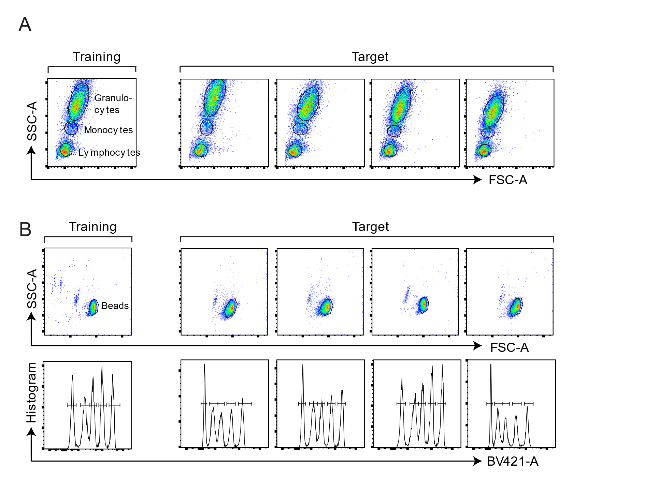
Supplementary Figure 1. Training gates and Elastigate results on representative target files for (A) Lysed whole-blood scatter dataset and (B) Multilevel fluorescence quantitation beads data set.
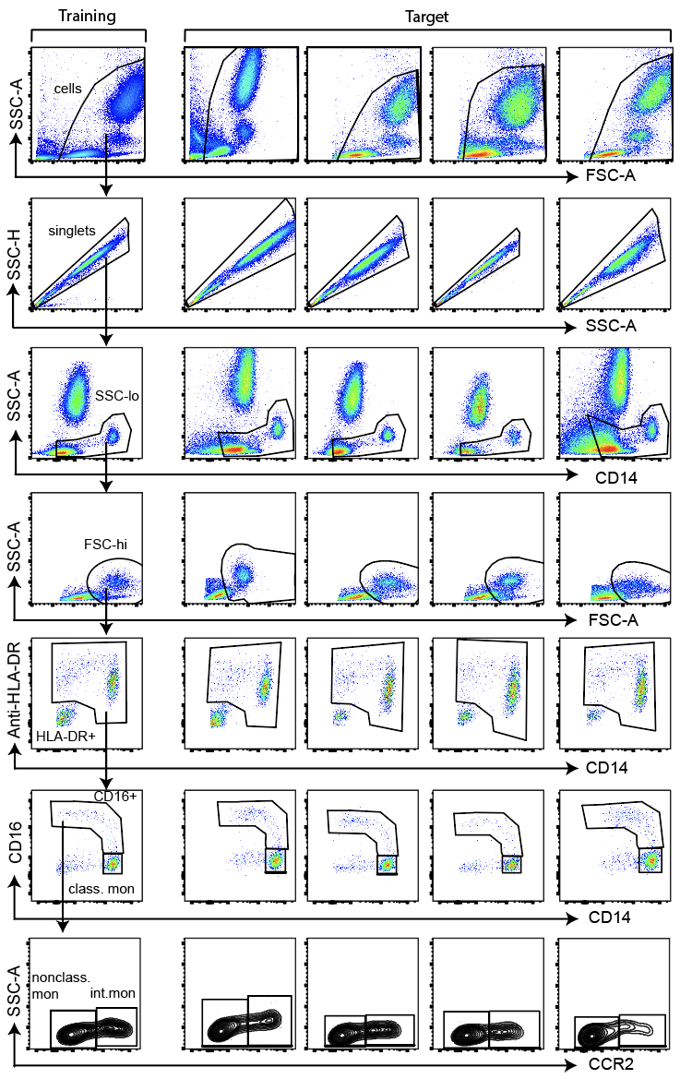
Supplementary Figure 2. Training gates and Elastigate results on representative target files in the monoset subset analysis dataset. Class. mon: classical monocytes, nonclass. mon: nonclassical monocytes, int. mon: intermediate monocytes.

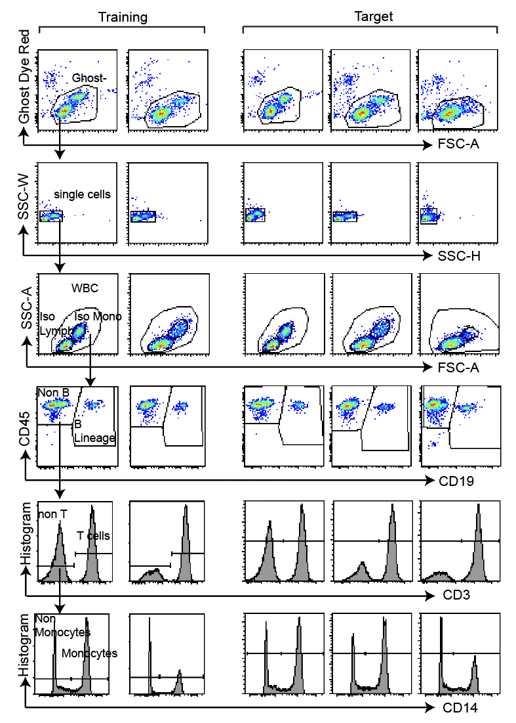
Supplementary Figure 3. Training gates and Elastigate results on representative target files in a cell therapy quality control testing data set.
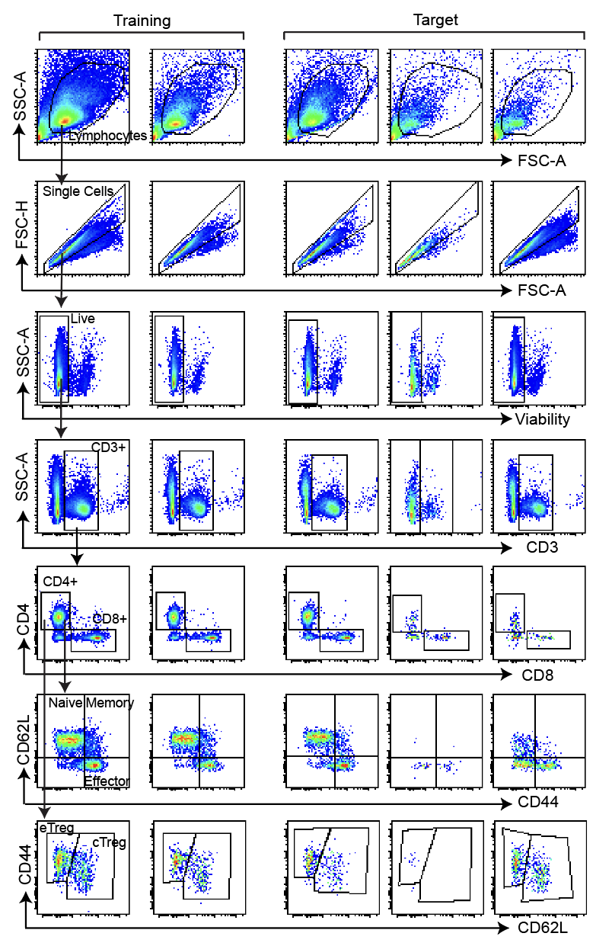
Supplementary Figure 4. Representative training gates from the six training files used and Elastigate results on some representative target files from the 44 total target files used in the tumor infiltrating lymphocyte immunophenotyping data set.

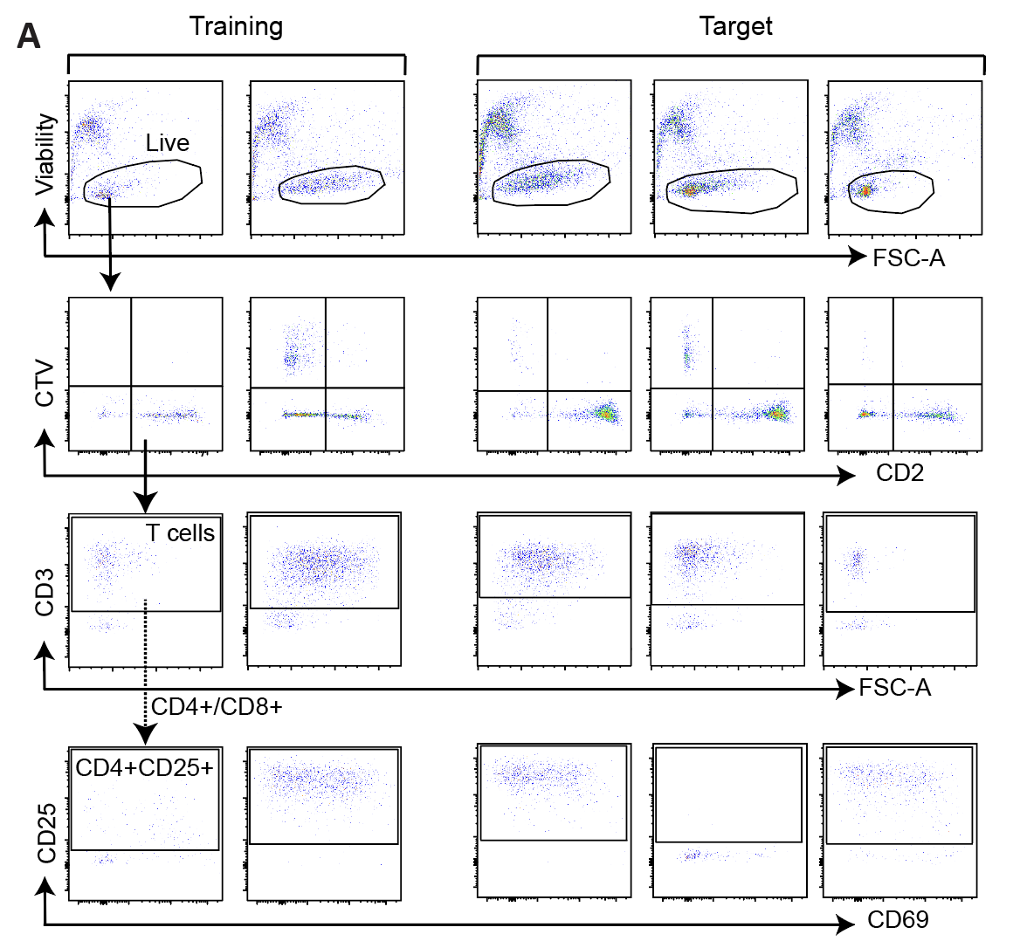

Supplementary Figure 5. Gating strategy from the high throughput cytotoxicity assay. Representative training gates from the 15 training files used and Elastigate results on some representative target files from the 425 total target files. Dotted arrow represents gating strategy from CD3+ to CD4+CD28+ gates (the intermediate CD8+ or CD4+ gates are not shown).

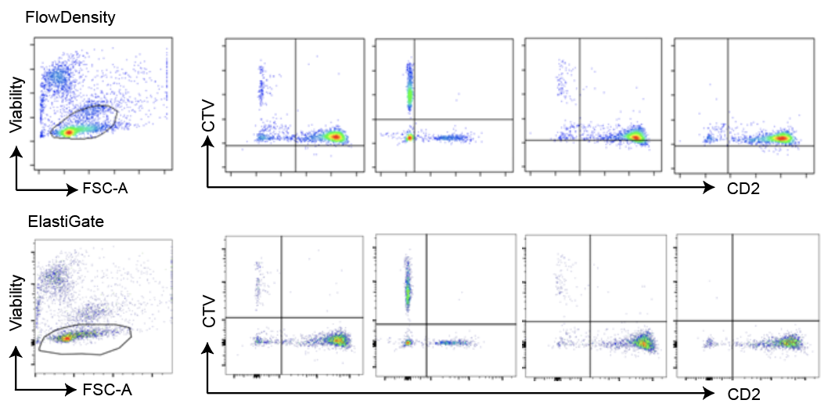

Supplementary Figure 6. Comparison of gates from flowDensity (top row) and Elastigate (bottom row) algorithms from the high throughput cytotoxicity assay.

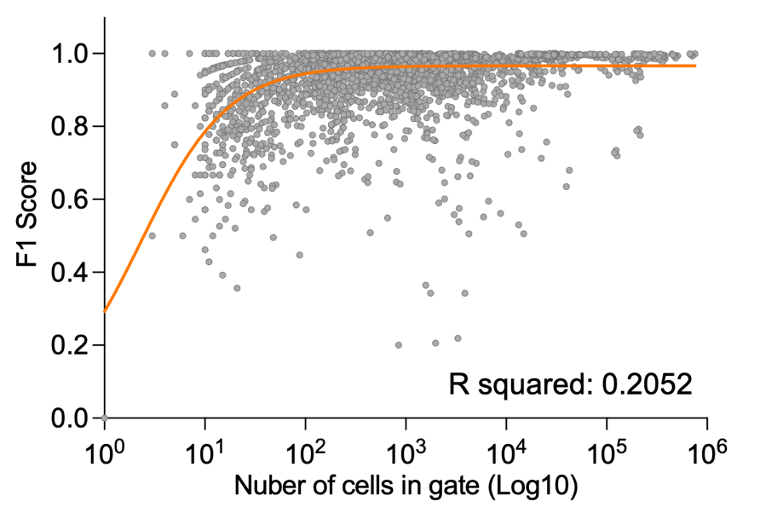
Supplementary Figure 7. Correlation of F1 score and cell counts. Plot includes datapoints from three benchmarking datasets, CAR-T cell manufacturing dataset, tumor-infiltrating lymphocyte immunophenotyping dataset and high throughput cytotoxicity assay, n= 5039. Gates with 10< cells were excluded from the analysis. Orange line indicates nonlinear regression.

#”Live”
f1 = function(x){
fdResult = flowDensity(obj=x,channels=c(1:2),position=c(T, F),
percentile=c(0.3, NA),use.percentile=c(T, F),
ellip.gate=TRUE,scale=0.85)
lines(fdResult@filter,type=”l”)
return(fdResult@index)
}

# “++”
f2 = function(x){
threshX <- deGate(obj = x,channel = 1)
threshY <- deGate(obj = x,channel = 2)
abline(v=threshX)
abline(h=threshY)
return(which((x[,1]>threshX) & (x[,2]>threshY)))
}

# “—"
f3 = function(x){
threshX <- deGate(obj = x,channel = 1)
threshY <- deGate(obj = x,channel = 2)
abline(v=threshX)
abline(h=threshY)
return(which((x[,1]<=threshX) & (x[,2]<=threshY)))
}

# “CD2+”
f4 = function(x){
threshX <- deGate(obj = x,channel = 1)
threshY <- deGate(obj = x,channel = 2)
abline(v=threshX)
abline(h=threshY)
return(which((x[,1]>threshX) & (x[,2]<=threshY)))
}

# “CTV+”
f5 = function(x){
threshX <- deGate(obj = x,channel = 1)
threshY <- deGate(obj = x,channel = 2)
abline(v=threshX)
abline(h=threshY)
return(which((x[,1]<=threshX) & (x[,2]>threshY)))
}

# “CD3+”
f6 = function(x){
threshY <- deGate(obj = x,channel = 2,use.upper=F,upper=F,
alpha = 0.1)
abline(h=threshY)
return(which((x[,2]>threshY)))
}

# “CD4+”
f7 = function(x){
fdResult = flowDensity(obj=x, channels=c(1:2),
position=c(FALSE, TRUE))
lines(fdResult@filter,type=”l”)
return(fdResult@index)
}

# “CD8+”
f8 = function(x){
threshY <- deGate(obj = x,channel = 2)
abline(h=threshY)
return(which(x[,2]<=threshY))
}

# “CD25+”
f9 = function(x){
threshY <- deGate(obj = x,channel = 2,use.percentile = T,
percentile = 0.09)
abline(h=threshY)
return(which(x[,2]>threshY))
}

# “CD25+”
f10 = function(x){
threshY <- deGate(obj = x,channel = 2,use.upper=T,upper=T,
percentile = 0.1)
abline(h=threshY)
return(which(x[,2]>threshY))
}
Supplementary Figure 8. Code used to define each of the gates with the flowDensity package for R. A function was written for each gate. Each function plots the gate boundary and returns the indexes of which cells were inside the gate.

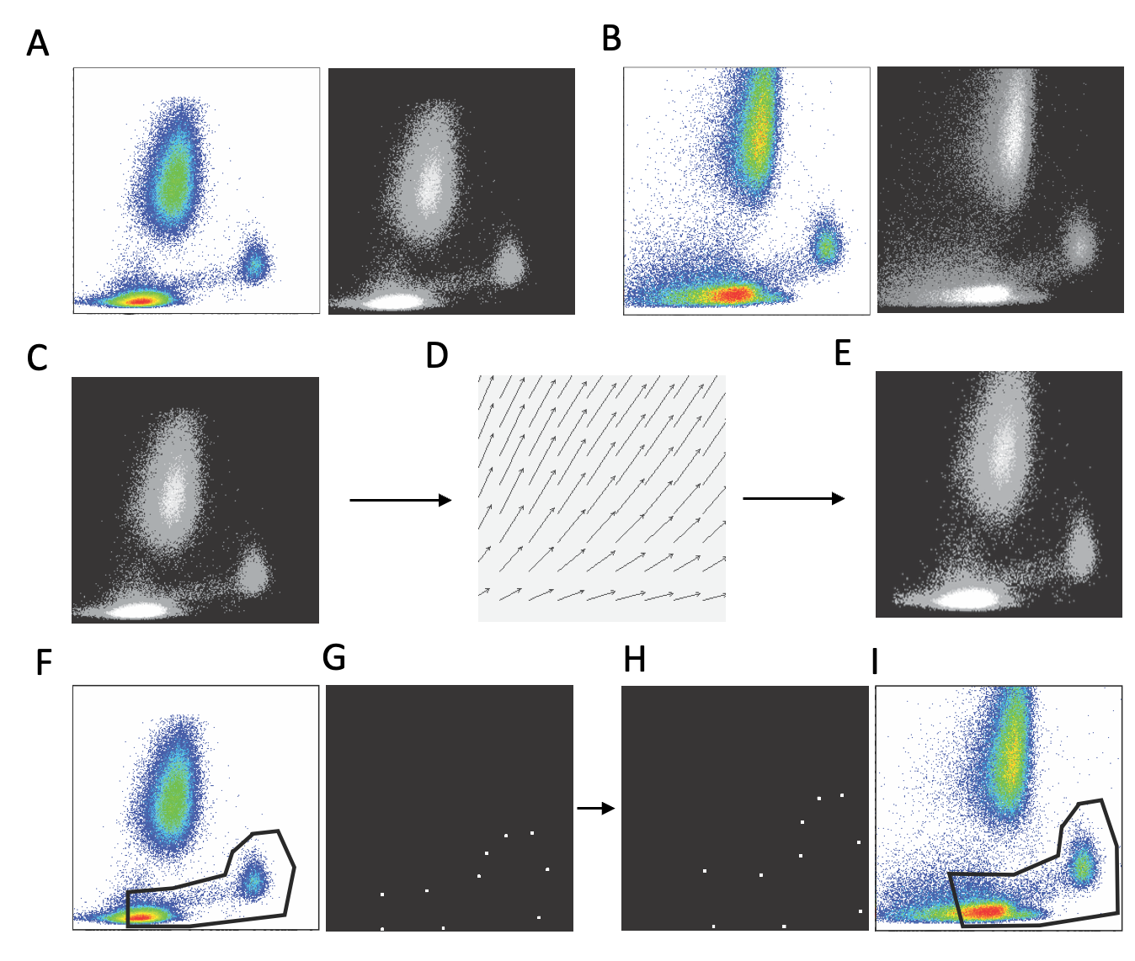
Supplementary Figure 9. A schematic overview of the Elastigate method.
A) Example training plot (left), and image created from training plot (right). B) Target plot (left) and image created from target plot (right). C) Training plot image. D) Deformation field of the transformation which registers the training plot image to the target plot image. E) Registered training plot image. F) Original gate vertices of the gate drawn on the training plot. G) Gate vertices with the transformation applied to them.

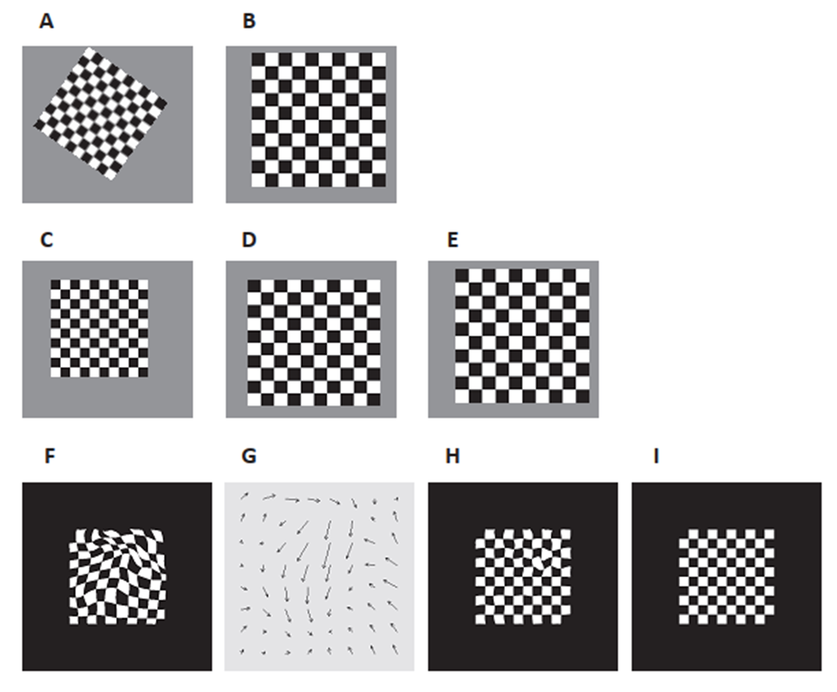

Supplementary Figure 10. Comparing rigid and elastic registration. A–E) An example of rigid registration. A) the source image, B) the target image. To get the registered source image shown in E, the source image is rotated (C), scaled (D), and translated (E). F-H) An example of elastic registration. F) the source image, I) the target image. Applying the elastic transformation shown in G results in the registered source image (H). One region of the transformed source image still does not match the target image. This is because the region in the original source image had a sharp irregularity in it and the B-spline functions are smooth, and a limited number of B-spline functions were used to model the image.

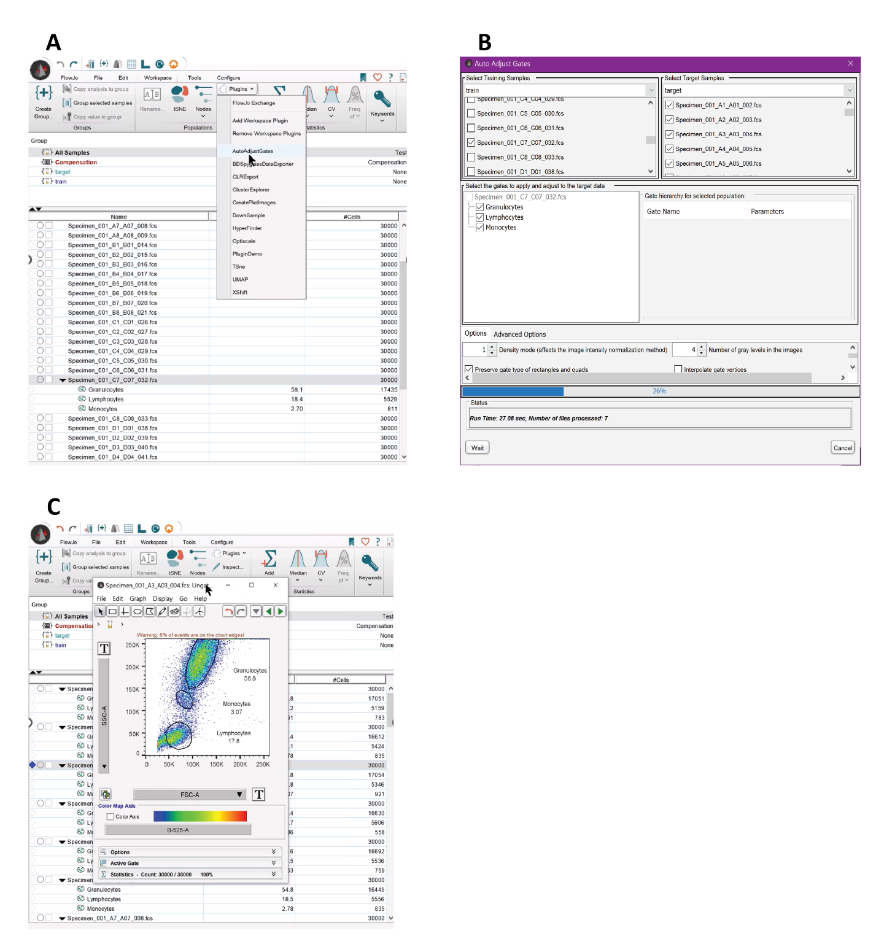
Supplementary Figure 11. Workflow of Elastigate plugin in FlowJo.
A) An instance of the plugin is created on the gated training sample. B) The training samples, target samples, and gates are selected, and then the plugin is started. C) After the computation is complete, the User Interface (UI) is closed. At this point all the target samples will have the selected gates drawn on them.

Supplementary Text

B-splines
B-splines can be used to approximate many different linear and nonlinear functions, are differentiable, and are computationally efficient. B-spline basis functions can have different degrees and are defined recursively. Splines are piecewise polynomial functions, and the spots where the pieces connect are called knots. The knots, annotated as $t_{i},$are a non-decreasing sequence of real values, and i goes from 0 to N+1, where N>=0. Interior knots are the $t_{i}$ in between the first and last $t_{i}$. Then there is the augmented knot set where $i=0,..., N+2m-1$, where the lower and upper boundary knots $t_{0}$ and $t_{1}$ have appended m-1 times. The set of real-valued functions $B_{\left(i,j\right)}$ are defined recursively for each augmented knot, and $B_{\left(i,j\right)}$ is the i-th B-spline basis function of order j. n is the degree of the B-spline basis function and $j=0,..., n$.
$$B_{\left(i,0\right)}\left(x\right)=\left\{\begin{aligned}1, t_{i}≤x<t_{i+1}, \\ 0 otherwise\end{aligned}\right.$$
$$B_{i,j+1}=w_{i,j+1}\left(x\right)B_{i,j}\left(x\right)+\left[1-w_{i+1,j+1}\left(x\right)\right]B_{i+1,j}\left(x\right)$$
$$w_{i,j}\left(x\right) = \left\{\begin{matrix}\frac{x-t_{i}}{t_{i+j}-t_{i}}, t_{i+j}≠t_{i} \\ 0 otherwise\end{matrix}\right.$$
$$\sum_{i}{B_{i,n}\left(x\right)=1 for all x between the first and last knot}$$
A B-spline function of degree $n$, where $(m=n+1)$ is a parametric curve composed of a linear combination of basis B-splines $B_{\left(i,n\right)}\left(x\right)$.
$$B(x) =\sum_{i=0}^{N+n}{α_{i}B_{i,n}\left(x\right)} ,$$
$$x∈[t_{0}, t_{N+1}]$$
$α_{i}$ are the control points, and there are$K=N+m$ of them for a B-spline of order m with $N$ interior knots. In the bUnwarpJ library the source image I is represented by a linear combination of degree-3 B-splines¹.
$$I_{s}\left(x,y;h\right)=\sum_{k,l∈Z^{2}}{c_{k,l} β^{3}\left(\frac{x}{h} - k\right)β^{3}\left(\frac{y}{h} - l\right)}$$
In this equation, $β^{3}(x)$ is a degree-3 B-spline and $c_{k,l}$ are the coefficients. The value of $h$ and $l$ control the degree of detail of the B-spline model and are a power of 2. Smaller values of $h$ and $l$ result in more detail.
The deformation field $g\left(x\right)$is a 2-dimensional linear combination of B-splines:
$$g\left(x\right)=g\left(x,y\right) \\ = \left(g_{1}\left(x,y\right),g_{2}\left(x,y\right)\right) \\ = \sum_{k,l∈Z^{2}}{\left({c_{1,k,l} \atop c_{2,k,l}}\right)β^{3}\left(\frac{x}{s_{x}} - k\right)β^{3}\left(\frac{y}{s_{y}} - l\right)}$$
In this equation, $β^{3}(x)$ is the B-spline of degree 3, $c_{k,l}$ are the coefficients, and $s_{x}$ and $s_{y}$ are scalars that control the degree of detail in the deformation field¹. The coordinates at each position ($x,y$) are evaluated. The coefficients $c_{1,k,l}$ and $c_{2,k,l}$ are calculated using least-squares fitting. $h=2^{0}, 2^{1}, 2^{2}, …$ and $l=2^{0}, 2^{1}, 2^{2}, …$ are parameters controlling amount of detail in the B-spline representation of the source image in the x and y directions, respectively.
The bUnwarpJ algorithm calculates a deformation field by minimizing an energy function. This minimization is performed with a Levenburg-Marquardt algorithm, which is enhanced by estimating the local Hessian of the objective function using the Broyden-Fletcher-Goldfarb-Shanno algorithm^{1,2}. The energy function (objective function) being used in our implementation is:
$$E=w_{i}E_{img}+\left(w_{d}E_{div}+w_{r}E_{rot}\right)$$
This definition omits a few of the terms included in the bUnwarpJ reference paper¹, since they are not being used. The energy function is numerically optimized with respect to the coefficients $c_{k,l}$. $E_{img}$ is the similarity error between the two images. More specifically, it is the sum of squared pixel value differences between the target image and the source image with the current transformation applied to it. $E_{div}$ and $E_{rot}$ are regularization terms based on the divergence and curl of the transformation defined by the coefficients. The $w$ terms are weights on each of the components of the energy function and determine the importance of each of these terms in calculating a transformation.

F1 scores for quantifying performance
For each gate, we examine which cells are inside of the gate and use these numbers to calculate true positives, true negatives, and $F1$ scores.
$$f_{1}=2\left(\frac{precision * recall}{precision + recall}\right)$$
$$precision = \frac{t_{p}}{\left(t_{p}+f_{p}\right)}$$
$$recall = \frac{t_{p}}{\left(t_{p}+f_{n}\right)}$$
In this equation, $t_{p}$ is the number of true positives, $f_{p}$ is the number of false positives, and $f_{n}$ is the number of false negatives. In cases where the number of cells in the ground truth gate were zero, the F1 score is 1 if the gate being compared also contained 0 cells, and 0 otherwise. In this paper, F1 scores are calculated in comparison to a reference ‘ground truth’ for each datafile as manually gated by an expert.

Biological samples
For the experiments on ‘lysed whole blood scatter gating’ and ‘monocyte subset analysis’, healthy donor blood samples were obtained from the IRB approved BD Associate Sample Collection Program (BDX-ASCP01) with informed consent for research use. For the ‘cell therapy quality control testing’ experiments, healthy donor leukapheresis samples were approved and collected by contracted vendors after obtaining written informed consent. For the ‘high throughput cytotoxicity assay’, healthy donor PBMCs were approved and collected by contracted vendors after obtaining written informed consent. For the ‘TIL immunophenotyping’ experiments, all experiments were performed in accordance with the UK Home Office guidelines and approved project license (PPL PP5259481), including local ethical review, and the Animals (Scientific Procedures) Act 1986.

Development benchmarking experiments
Lysed whole-blood scatter gating experiments were performed with lysed whole blood from healthy donors acquired on BD LSRFortessaTM X-20 Cell Analyzer. Multilevel fluorescence quantitation bead experiments were obtained with BD custom quantitation beads in BV421 acquired across many days on BD FACSLyricTM flow cytometer. Monocyte subset analysis experiments were performed on lysed whole blood from healthy donors stained with BD HorizonTM Dri Monoset Panel and acquired on BD FACSLyricTM flow cytometer.

Cell therapy quality control testing
In production of cell therapies, flow cytometry is routinely used for important in-process and final quality control tests. In this example from autologous CAR-T cell therapy manufacturing, the leukapheresis product from the patient arrives at the manufacturing site and is first tested for the percentage of T and B cells. Further manufacturing occurs including enrichment of T cells and transduction with chimeric antigen receptor against CD19. The final cell product is tested for the percentage of live cells expressing CART-19 as well as impurities. Due to the heterogenous nature of patient-derived cells there is variability in the incoming material and manufacturing result. CAR-T expression in particular is typically a continuous distribution (not a tight peak) presenting challenges for gating. Rigorous gating SOPs must be followed in this environment since the flow cytometry results are an important element in production of a regulated drug product. Many elements of standardized flow cytometry are advisable to include such as using well-maintained and standardized instruments, reagent panels that are dried or lyophilized in pre-titrated, cocktailed form for long term stability, automated sample preparation, operators trained on defined SOPs, and controlling for or removing operator variability in flow cytometry gating. In this particular example, many such standardization methods are followed, and Fig. 4 and Supplementary Fig. 5 provide information on cell populations identified. Further details of the specific reagent panel and protocol are proprietary to Novartis.

Tumor infiltrating lymphocyte immunophenotyping
Eight- to ten-week-old female C57BL/6 mice were subcutaneously injected with 100 µL of 5e3 B16 F10 cells in 50% growth factor-reduced matrigel (Corning) and dosed intraperitoneally with either anti-PDL1 antibody (clone 80) mIgG1 (AstraZeneca) or with an isotype control antibody at 10 mg/kg two times per week starting 7 days after tumor cell implantation for a total of six doses.
At day 15 post-implantation, single cell suspensions were obtained by digesting whole tumor at 37°C for 20 min using the Tumor Dissociation Kit (Miltenyi Biotec) and gentleMACS dissociator (Miltenyi Biotec). Two FACS panels were designed to provide a deep dive into intratumoral lymphoid subset immunophenotyping and functional characterization after immunotherapy treatment (Tables 1-2). A 14-color T cell panel defines the activation status of intratumoral CD4+ and CD8+ T cells (naïve, effector memory, central memory) and T regulatory cells (central Tregs and effector Tregs), and the T helper and cytotoxic T cell populations based on the intracellular expression of cytokines.
The cell suspensions were stained with a fixable viability dye (Thermo Fisher) and blocked with antibodies to CD16/CD32 (eBioscience) before staining with fluorescence-conjugated antibodies in flow cytometry staining buffer (2% bovine serum albumin, 0.1% sodium azide, 2 mM EDTA) with 50% BD HorizonTM Brilliant Stain Buffer (BD Biosciences). FoxP3/Transcription Factor Staining Buffer Set (eBioscience) was used to perform intracellular staining.

High-throughput cytotoxicity assay
CTV-labelled OCILy18 (Target) were mixed with PBMC from healthy donor (Effector) at a 5:1 E:T ratio in U-bottom 96 well plates and cultured with the indicated doses of drugs. After 3 days, cells were stained with CD2 (Clone RPA-2.10), CD3 (Clone SP34-2), CD4 (Clone OKT4), CD8 (Clone RPA-T8), CD25 (Clone 2A3) and CD69 (Clone FN50) to determine T cell activation status. Cytotoxicity activity was calculated based on the fraction of CTV+ Target cells in each well with T cell engagers compared to control wells without drugs.

FlowDensity comparison for high-throughput dataset
To use flowDensity, we tuned parameters to model each gate as closely as possible resulting in one customized flowDensity function call for each gate. There is no training data in flowDensity, only programmatic definitions of where the gate boundaries are, for each gate. To see how the parameters affect the accuracy of results, we tried three different parameter settings for each gate. We then calculated F1 scores of the results for each of these, and for each gate used the parameter settings which resulted in the highest F1 score for our comparative study. The final code used to call flowDensity for the comparison study is shown in Supplementary Figure 9.
To evaluate the accuracy of each gate independently of error introduced by applying the algorithm to the parent gates, we calculated each automatic gate on the manually gated parent population, for this comparison only. Note that, for the Elastigate method discussed in this paper, we used the parent population created by the automatically adjusted gates. This means that as one goes further down the gating hierarchy, errors introduced by the automatically adjusted parent gate are compounded with any errors introduced by the next child gate. Since the error was generally low for our Elastigate algorithm, we did not feel the need to remove these compounded errors before reporting results in the rest of the paper.

References

1. C. O. S. Sorzano, P. Thevenaz, & M. Unser. Elastic registration of biological images using vector-spline regularization. IEEE Trans. Biomed. Eng. 52, 652–663 (2005).
2. Arganda-Carreras, I. et al. Consistent and Elastic Registration of Histological Sections Using Vector-Spline Regularization. Lecture Notes in Computer Science 4241, 85-95 (2006).

