A digital liver twin demonstrating the interplay between biomechanics and cell kinetics can explain fibrotic scar formation

Jieling Zhao^{1,2†}, Seddik Hammad^{3,4†}, Mathieu de Langlard², Pia Erdoesi³, Yueni Li³, Paul Van Liedekerke^{2,5}, Andreas Buttenschoen⁶, Manuel Winkler^{7,8}, Sina W. Kürschner^{7,8}, Philipp-Sebastian Reiners-Koch^{7,8}, Niels Grabe⁹, Stephanie D. Wolf¹⁰, Johannes Bode¹⁰, Jan G. Hengstler¹, Matthias P. Ebert^{11,12,13}, Steven Dooley^{3*}, Dirk Drasdo^{1,2*}

¹Leibniz Research Centre for Working Environment and Human Factors, Technical University of Dortmund (IfADo), Dortmund, Germany. ²National Institute for Research in Computer Science and Automation (INRIA de Saclay), Palaiseau, France. ³Molecular Hepatology Section, Department of Medicine II, Medical Faculty Mannheim Heidelberg University, Mannheim, Germany. ⁴Department of Forensic Medicine and Veterinary Toxicology, Faculty of Veterinary Medicine, South Valley University, 83523-Qena, Egypt. ⁵BioNamix group, Department Data Analysis and Mathematical Modelling, Ghent University, Gent, Belgium. ⁶Department of Mathematics and Statistics, University of Massachusetts Amherst, Amherst, USA. ⁷Department of Dermatology, Venereology and Allergology, University Medical Center and Medical Faculty Mannheim, Heidelberg University, Mannheim, Germany. ⁸European Center for Angioscience, Medical Faculty Mannheim, Heidelberg University, Mannheim, Germany. ⁹Hamamatsu Tissue Imaging and Analysis Center (TIGA), BIOQUANT, University Heidelberg, Heidelberg, Germany. ¹⁰Clinic for Gastroenterology, Hepatology and Infectious Diseases, Hospital of the Heinrich-Heine-University, Düsseldorf, Germany. ¹¹Department of Medicine II, Medical Faculty Mannheim Heidelberg University, Mannheim, Germany. ¹²Mannheim Institute for Innate Immunoscience (MI3), Medical Faculty Mannheim, Heidelberg University, Mannheim, Germany. ¹³DKFZ-Hector Cancer Institute at the University Medical Center, Mannheim, Germany.
†These two authors contribute equally to this work
*Corresponding authors: steven.dooley@medma.uni-heidelberg.de & dirk.drasdo@inria.fr

Supplementary Information
Methods
Assessment of liver transaminases. Blood is collected in Li-Heparin vials from the retrobulbar plexus and centrifuged at 13,000 rpm at 4°C for 6 min. Plasma is subsequently stored at − 80°C until further analysis. Then, alanine aminotransferase (ALT), and aspartate aminotransferase (AST) are measured using a Hitachi automatic analyzer (Core facility-Medical Faculty Mannheim, Germany).
RNA isolation and quantitative real-time (RT)-PCR. RNA from liver tissues is isolated using the InviTrap spin kit according to the manufacturer’s instructions. Liver tissues from the mice are cut into approximately 20 mg and are homogenized with a Precellys Evolution machine two times (20 s, 5 s pulse, 2s break), then the supernatants are collected. Then, 300 μL β-mercaptoethanol-containing lysis solution TR are immediately added to each sample. The resulting lysate is directly pipetted onto the DNA-Binding Spin Filter which is placed in a 2 mL Receiver Tube. Samples are incubated for 1 min at room temperature and are centrifuged at 11000 rpm for 2 min. After discarding the DNA-Binding Spin Filter, 250 μL of 70% ethanol are added to each tube and are completely mixed with the lysates. The mixtures are transferred to RNA-RTA Spin Filters, and are incubated for 1 min. Samples are centrifuged at 11000 rpm for 1 min. Then 600 μL of Wash Buffer R1 are added into the RNA-RTA Spin Filter after discarding the flow-through, then this mixture is centrifuged for 1 min at 11000 rpm. After discarding the flow-through, 700 μL of Wash Buffer R2 are added into the Filter, the same centrifuge step is performed as a wash step using buffer R1. The R2 washing step is repeated once. To eliminate any trace of ethanol in the RNA-RTA Spin Filter membrane, the tubes are centrifuged for 4 min at maximum speed. The RNA-RTA Spin Filters are transferred into RNase-free Elution Tubes and 30 μL of Elution Buffer R is pipetted. After 2 min incubation and 1 min centrifugation at 11000rpm, total RNA is collected, and transferred immediately on ice. The concentration is photometrically determined by measuring the RNA solution in a nanocrystalline plate at 260 nm with a Tecan infinite M200. From 1 µg total RNA, cDNA is transcribed with RevertAid H Minus Reverse Transcriptase (Thermo Fischer Scientific, USA, cat. no. EP0451) and used for RT-PCR with PowerUP SYBR Green Master Mix (Life Technologies, USA, cat. no. A25918) in a StepOnePlus RT-PCR System (Applied Biosystems USA from Thermo Fisher Scientific, Germany, cat. no. 4376600). A list of the primer pairs used (Eurofins, Germany) is provided in Supplementary Table 1. Ppia is used as an internal reference gene. Target gene relative expression is determined with the ΔΔCt method, and a melt curve is created to ensure primer specificity. Each sample is measured in triplicate.

Imaging analysis of spatial distribution of proliferating hepatocytes and aHSC
The detection of the dividing cells nuclei (Fig. 2F) is obtained by a global thresholding on the Hue and Saturation channels¹ of the images. A post-processing step is applied to remove artifacts (too small and too large, connected components). Furthermore, touching nuclei are separated using the morphological Watershed algorithm. The segmentation function is the Euclidean distance transform on the binary image of the nuclei and the markers are obtained by computing the extended minima transform on the Euclidean transform image. These different morphological operations are standard in image analysis and further details can be found in ref². A final post-processing based on a shape criterion, i.e. the eccentricity, is performed: objects with an eccentricity less than 0.9 are removed.
The stained histological images of HSC are first binarized using local Otsu thresholding to obtain the whole fibrotic pattern. In order to individualize the fibrotic streets, the fibrotic region around each central vein is computed using the so-called rolling ball algorithm³: a disk of iteratively increasing radius r is rolling over the central vein boundary until the area ratio of HSC reaches a certain threshold ($≤0.8$ in practice). The maximal radius $r_{max, i}$ returned by the algorithm defines the width of the fibrotic region around the central vein labeled $i$, a region which is called the central fibrotic region (Supplementary Fig. 5A, here the green circles do not cover all brown staining around CV, which is not needed as our purpose is not to quantify the precise width of the brownish region around the CV, but to identify the fibrotic region between the CVs and quantify it. For this an accurate segmentation of the brown staining around the CV is not required). An individual fibrotic street is therefore defined as the fibrotic pattern linking two neighboring central fibrotic regions. The second main step is the computation of the envelope image of each fibrotic street using (1) a morphological closing operation on the binary image of the street to smooth its contour, and (2) an operation to fill the holes within the street. The envelope image is the resulting binary image after these two operations (see Supplementary Fig. 5). The third and final step before quantifying the width distribution of the fibrotic streets is the rotation of each envelope image to align their main axis with the y-axis (see Supplementary Fig. 5). Consequently, the width distribution of a given street is defined as the length distribution of the intersections between a horizontal line and the envelope image, the horizontal line being translated in the y-direction. To remove noise in the computation of these lengths, a moving average technique is used. The final results are presented in Supplementary Fig. 5 as the concatenation of all width distributions of the fibrotic streets for the three mice M1, M2 and M3. In order to check whether or not there is a significant difference between widths computed for stripes connecting close central veins and those connecting central veins further away from each other, the width distributions are presented with respect to the normalized distance to its closest central vein, hence encompassing the spatial nature of the fibrotic street formation (the maximal distance being in the middle of the given fibrotic street). The results do not show any large dependency of the fibrotic street width with respect to the central vein distance.
The computation of the spatial distribution of the dividing cells is performed using a non-parametric kernel density estimator, for which the probability that a nucleus of a dividing cell belongs to the position $x∈R^{2}$ is given by:
$f\left(x\right)=\sum_{i=1}^{n}{\frac{1}{nh^{2}}k(\frac{\left\|x-x_{i}\right\|}{h})}$,
where $k$ is a symmetric kernel function (typically a Gaussian kernel is used here), $n$ is the total number of nuclei segmented and $x_{i}$ is the centroid location of nuclei $i$.
The polygonal contours of the necrotic regions are drawn on the image by a biologist expert using ImageJ. The mask image of the necrotic region is obtained and a morphological closing, using a small size structuring element, is performed to get smoother contours for the necrotic regions.

Mathematical modeling of all DT components. To capture the approximate shape of cells and elements (e.g. sinusoids and collagen fibres), they are represented as individual objects with different geometric shapes. The cell surface of a hepatocyte close to the lesion is represented by a triangulated structure consisting of nodes connected by viscoelastic elements (DCM model, Fig. 2G) while a hepatocyte far away from the lesion is represented by a homogeneous isotropic elastic adhesive sphere (CBM model)⁴; a macrophages is represented by a homogeneous isotropic elastic adhesive spheres; an HSC is represented as a sphere forming the cell’s core body, connected to four semi-flexible chains of spheres⁵; sinusoids are represented as semi-flexible chains of spheres⁶; collagen fibres are represented as elastic springs that can resist stretching and bending.

Equation of motion for CBM-based hepatocytes. Each CBM (center-based model) for a hepatocyte is represented as a homogeneous isotropic, elastic, adhesive sphere. It can migrate, grow, divide, and interact with other cells or elements. The position of a hepatocyte $i$ is updated from a force balance equation:
$Γ_{env,i}{\vec{v}}_{i}+\sum_{j}{Γ_{i,j}\left({\vec{v}}_{i}-{\vec{v}}_{j}\right)}=\sum_{j}{{\vec{F}}_{ij}}+{\vec{F}}_{mig,i}$, (1)
where $Γ_{env,i}$ is the $3×3$ - friction matrix with the environment, which we here approximate by a scalar, $Γ_{i,j}=γ_{⊥}\left({\vec{e}}_{ij}⨂{\vec{e}}_{ij}\right)+γ_{∥}\left(I-{\vec{e}}_{ij}⨂{\vec{e}}_{ij}\right)$ is the friction tensor between cell $i$ and sphere (another cell, a sinusoidal element, or a cellular element) $j$, ${\vec{e}}_{ij}$ is the unit vector from $i$ towards $j$, ${\vec{F}}_{ij}$ is the corresponding central repulsion/adhesion interaction force, and ${\vec{F}}_{mig,i}$ is force mimicking the (active) migration force of cell $i$. The central interaction force between cells is computed by⁴:
${\vec{F}}_{ij}=(\frac{4\hat{E}}{3\hat{R}}{\left[a\left(δ_{ij}\right)\right]}^{3}-\sqrt{8πσ\hat{E}{[a(δ_{ij})]}^{3}}){\vec{e}}_{ij}$, (2)
where $a(δ_{ij})$ is the radius of the hepatocyte-hepatocyte contact area, which is related to the indentation of the neighboring deformed cells via $δ_{ij}=\frac{a^{2}}{\hat{R}}-\sqrt{\frac{2πσ}{\hat{E}}}$. $\hat{E}$ and $\hat{R}$ are defined as $\hat{E}={(\frac{1-ν_{i}^{2}}{E_{i}}+\frac{1-ν_{j}^{2}}{E_{j}})}^{-1}$ and $\hat{R}={(\frac{1}{r_{i}}+\frac{1}{r_{j}})}^{-1}$, with $E_{i}$ and $E_{j}$ being the Young’s moduli, $ν_{i}$ and $ν_{j}$ the Poisson ratios, and $r_{i}$ and $r_{j}$ the radii of $i$ and $j$. To consider the limited cell volume compressibility in a pairwise cell-cell interaction force, we further fitted $\hat{E}$ by a function that depends on the local average distance ${\hat{d}}_{ij}=1-d_{ij}/(r_{i}+r_{j})$ for a bulk cell in the simulated experiment: $\hat{E}=\left\{\begin{matrix}\hat{E},0≤{\hat{d}}_{ij}≤0.08 \\ a_{0}+a_{1}{\hat{d}}_{ij}+…+a_{6}{\hat{d}}_{ij}^{6},0.08<{\hat{d}}_{ij}\end{matrix}\right.$, where $d_{ij}$ is the distance between $i$ and $j$ (see more details of choosing the values of $a_{i},i=0,…,6$ in Van Liedekerke et al.⁵. The (active) migration force is approximated by ${\vec{F}}_{mig,i}=f_{dir}{∙\vec{e}}_{i}+\sqrt{2{Γ_{env,i}}^{2}D_{i}}∙{\vec{η}}_{i}$, where $f_{dir}$ has been chosen as a constant force magnitude, ${\vec{e}}_{i}$ is the unit vector of migration direction, $D_{i}$ is the diffusion constant of $i$, ${\vec{η}}_{i}$ is an uncorrelated noise term with amplitude $〈η_{in}(t)η_{jm}(t^{'})〉=δ_{ij}δ_{mn}δ(t-t^{'})$, $t$ and $t^{'}$ denote time, and $m,n∈(x,y,z)$ denote the coordinates⁶.

Equation of motion for DCM-based hepatocytes. Each DCM (deformable cell model)-based hepatocyte is represented by nodes that are connected by parametrized viscoelastic elements. The nodes constitute a flexible triangulated surface which models the boundary (membrane and actin cortex) of the cell. To keep the model computationally tractable, the inside of the cell is assumed to be homogeneous and slightly compressible. The adhesion between two cells is determined by the attraction forces between those nodes of the cells that are in each other's neighborhood. To update the configuration for each cell, a force-balance equation for every of its nodes has to be solved. For a hepatocyte, the position of each of its nodes $i$ can be updated by solving the following equation of motion:
$Γ_{env,i}{\vec{v}}_{i}+\sum_{j}{Γ_{i,j}\left({\vec{v}}_{i}-{\vec{v}}_{j}\right)}=\sum_{j}{{\vec{F}}_{e,ij}}+\sum_{m}{{\vec{F}}_{m,i}}+{\vec{F}}_{vol,i}+\sum_{T}{{\vec{F}}_{T,i}}+{\vec{F}}_{rep,i}+{\vec{F}}_{adh,i}$, (3)
where $Γ_{env,i}$ is the friction coefficient with the environment, $Γ_{i,j}=γ_{⊥}\left({\vec{e}}_{ij}⨂{\vec{e}}_{ij}\right)+γ_{∥}\left(I-{\vec{e}}_{ij}⨂{\vec{e}}_{ij}\right)$ is the friction tensor between $i$ and another node $j$, and ${\vec{e}}_{ij}$ is the unit vector from $i$ towards $j$ (whereby $j$ can be either a node of the hepatocyte or a neighboring structure the hepatocyte interacts with), ${\vec{F}}_{e,ij}$ is the in-plane elastic force with node $j$, ${\vec{F}}_{m,i}$ is the bending force with node $m$, ${\vec{F}}_{vol,i}$ is the volume force controlled by the cell compressibility, $\sum_{T}{{\vec{F}}_{T,i}}$ is the force that avoids excessive triangle distortion of triangle $T$ which contains $i$, ${\vec{F}}_{rep,i}$ is the repulsion force on the local surface, ${\vec{F}}_{adh,i}$ is the adhesion force with nearby objects (for more details on the DCM and equation (3), see Van Liedekerke et al.⁵).

Equation of motion for macrophages. Each macrophage is represented as a homogeneous isotropic, elastic, adhesive sphere. The position of macrophage $i$ is updated by solving the following equation:
$Γ_{env,i}{\vec{v}}_{i}+\sum_{j}{Γ_{i,j}\left({\vec{v}}_{i}-{\vec{v}}_{j}\right)}=\sum_{j}{{\vec{F}}_{ij}}+{\vec{F}}_{mig,i}$, (4)
where $Γ_{env,i}$ is the friction coefficient with the environment, $Γ_{i,j}$ is the friction tensor between $i$ and $j$ (same as equation (1)), ${\vec{F}}_{ij}$ is the corresponding central repulsion/adhesion interaction force, ${\vec{F}}_{mig,i}={f_{dir}∙(\vec{e}}_{i}+{\vec{θ}}_{i})/(‖{\vec{e}}_{i}+{\vec{θ}}_{i}‖)$ is the migration force, where $f_{dir}$ has been chosen as a constant force magnitude, ${\vec{e}}_{i}$ is the unit vector of migration direction, ${\vec{θ}}_{i}$ is a random direction unit vector of $i$, where $<{\vec{θ}}_{i}>={\vec{e}}_{i}$.

Equation of motion for HSC. The core body of an HSC is modeled as a homogeneous isotropic, elastic, adhesive sphere (mainly representing the HSC’s nucleus) with four semi-flexible chains of spheres as “arms” (to mimic the long HSC’s protruding branches). The position of an HSC sphere $i$ is updated by solving the following equation of motion⁶:
$Γ_{env,i}{\vec{v}}_{i}+\sum_{j}{Γ_{i,j}\left({\vec{v}}_{i}-{\vec{v}}_{j}\right)}=\sum_{j}{{\vec{F}}_{ij}}+{\vec{F}}_{mig,i}+\sum_{k}{{\vec{F}}_{ela,ik}}$, (5)
where $Γ_{env,i}$ is the friction coefficient with the environment, $Γ_{i,j}$ is the friction tensor between $i$ and another cell or element $j$ (same as equation (1)), ${\vec{F}}_{ij}$ is the interaction force between $i$ and another cell or element $j$ (same as equation (2)). ${\vec{F}}_{ela,ik}$ represents elastic force between the body center $i$ and the connected spheres $k$ of its arms. ${\vec{F}}_{mig,i}={f_{dir}∙(\vec{e}}_{i}+{\vec{θ}}_{i})/(‖{\vec{e}}_{i}+{\vec{θ}}_{i}‖)$ is the migration force to drive $i$ to migrate, where $f_{dir}$ has been chosen as a constant force magnitude, ${\vec{e}}_{i}$ is the unit vector of migration direction, ${\vec{θ}}_{i}$ is a random direction unit vector of $i$, where $<{\vec{θ}}_{i}>={\vec{e}}_{i}$. The equation of motion for a sphere representing element $i$ of an HSC’s arm is approximated by:
$Γ_{env,i}{\vec{v}}_{i}+\sum_{j}{Γ_{i,j}\left({\vec{v}}_{i}-{\vec{v}}_{j}\right)}=\sum_{j}{{\vec{F}}_{ij}}+\sum_{k}{{\vec{F}}_{ela,ik}}$, (5b)
where $j$ represents the cells or elements interacting with $i$, and $k$ represents the spheres in the same HSC’s arm of element $i$ and connecting to $i$.

Equation of motion for the sinusoid spheres. Sinusoids are modeled as chains of semi-flexible spheres⁷. For each sinusoid sphere $i$, the position of $i$ is updated by solving the following equation of motion⁶:
$Γ_{env,i}{\vec{v}}_{i}=\sum_{j}{(Γ_{∥,SE}({\vec{w}}_{ij}-{\vec{e}}_{ij}({\vec{w}}_{ij}∙{\vec{e}}_{ij}))+{\vec{F}}_{ij})}+\sum_{k}{(Γ_{∥,SS}\left({\vec{w}}_{ik}-{\vec{e}}_{ik}\left({\vec{w}}_{ik}∙{\vec{e}}_{ik}\right)\right)+{\vec{F}}_{ik})}+{\vec{F}}_{i,ela}$, (6)
where $Γ_{env,i}$ is the friction coefficient with the environment, $Γ_{∥,SE}$ denotes the longitudinal friction between sinusoid sphere $i$ and its interacting cells or elements, for example hepatocyte $j$, ${\vec{w}}_{ij}={\vec{v}}_{j}-{\vec{v}}_{i}$ is the difference of velocity between $i$ and $j$, ${\vec{e}}_{ij}$ is the unit direction vector from $i$ towards $j$, ${\vec{F}}_{ij}$ is the interaction force between $i$ and $j$ (same as equation (2)), $Γ_{∥,SS}$ denotes the longitudinal friction between two sinusoid spheres $i$ and $k$, ${\vec{w}}_{ik}={\vec{v}}_{k}-{\vec{v}}_{i}$ is the difference of velocity between $i$ and $k$, ${\vec{e}}_{ik}$ is the unit direction vector from $i$ towards $k$, ${\vec{F}}_{ik}$ is the interaction force between $i$ and $k$, ${\vec{F}}_{i,ela}$ is the spring force that arises from the chain connections between spheres belonging to the same sinusoid.

Modeling of collagen fibres
In the fibrosis development simulations, the collagen fibres are generated by the aHSCs. In order to calibrate the network parameters, we perform a simulated compression test and compare the simulation results with experimental data. The network is generated as follows.
Network generation approach. In a given gel space $Ω_{g}$ (volume of $Ω_{g}$ is $V_{g}$), the total volume of the collagen fibre $V_{c}$ is determined by ${V_{c}=V}_{g}ρ_{c}υ_{c}$, where $υ_{c}=1.89 ml/g$ is the specific volume of collagen⁸, $ρ_{c}=1.0 mg/ml$ is the mass density of collagen⁹. The total length of collagen fibre, $L_{tot}$ deposited in the given space is given by $L_{tot}=V_{c}/πr_{c}^{2}$, where $r_{c}$ is the radius of collagen fibre. A network is grown by one fibre at a time until the network reaches the total fibre length $L_{tot}$. The fibre network is generated in the following steps:
(1) Insert a fibre $i$ in $Ω_{g}$. It is assigned an initial point $u_{0}^{i}$ and an initial tangent direction ${\vec{θ}}_{0}^{i}$, both are chosen from a uniform distribution. A fibre length $L_{f}$ is also assigned to $i$, where $<L_{f}>\sim 6μm$ (see ref⁹). Grow the fibre after $n$ extensions of segments in particular direction ${\vec{θ}}_{j+1}^{i}={\vec{θ}}_{j}^{i}+∆{\vec{θ}}_{j}^{i},j=0,…,n-1$ until $L_{f}$ is reached. The length of each extended segment is $L_{c}=3 μm$ (see ref⁹). Stop until the target total fibre length $L_{tot}$ is reached.
(2) Apply a random force onto each of the fibres and update their positions. Crosslinks are added if any two fibre segments are closer than a distance threshold of 1.5 μm (Supplementary Fig. 6A).
(3) Repeat step (2) until all fibres in $Ω_{g}$ are connected into one network through crosslinks.
The elastic forces and bending forces on a collagen fibre. Suppose a collagen fibre consists of several nodes and edges (Supplementary Fig. 6B). The elastic force at node $x_{n}$ can be written as ${\vec{f}}_{e}(x_{n})=k(∆l_{n-1}\frac{{\vec{l}}_{n-1}}{\left|{\vec{l}}_{n-1}\right|}+∆l_{n}\frac{{\vec{l}}_{n}}{\left|{\vec{l}}_{n}\right|})$, where $k$ is the elasticity constant, $Δl_{n}$ is the difference between the current length ${\vec{|l}}_{n}|$ and the equilibrium length |${\vec{l}}_{n,0}|$ of the spring connecting the vertices (nodes) $n+1$ and $n$ (see ref¹⁰).
The bending energy at $x_{n}$ can be written as ${U(x}_{n})=\frac{1}{2}\int_{x_{0}}^{x_{n}}{EI{κ(s)}^{2}ds}$, where $E$ is the Young’s modulus, $I$ is the second moment of area, $κ$ is the local curvature at $x_{n}$. The bending energy due to the bending angle $θ_{n}$ at $x_{n}$ can be approximated as:
$ΔU\left(x_{n}\right)=U\left(x_{n}\right)-U(x_{n-1})≈\frac{1}{2}EI{κ(x_{n})}^{2}|l_{n}|≈\frac{1}{2}EI{(θ_{n}-θ_{n,0})}^{2}/|l_{n}|$ (for $κ(x_{n})≈θ_{n}/l_{n}$), where $θ_{n,0}$ is a constant equilibrium angle for $x_{n}$. The bending force is evaluated by derivative of involved $∆U(x_{n+i})$ over $x_{n}$:
${\vec{f}}_{b}\left(x_{n}\right)=\sum_{i=-1}^{1}{∇_{x_{n}}∆U(x_{n+i})}=\sum_{i=-1}^{1}{∂∆U(x_{n+i})/(∂cos⁡(θ_{n+i}-θ_{n,0}))∇_{x_{n}}cos(θ_{n+i}-θ_{n,0})}$, (7)
We denote ${\vec{l}}_{n}={\vec{x}}_{n+1}-{\vec{x}}_{n}$ and ${\vec{l}}_{n-1}={\vec{x}}_{n}-{\vec{x}}_{n-1}$, we can get $cos \left(θ_{n}-θ_{n,0}\right) =\frac{{\left(R_{θ_{1}}{\vec{l}}_{n}\right)}^{T}(R_{θ_{2}}{\vec{l}}_{n-1})}{\left|l_{n}\right||l_{n-1}|}$, where $R_{θ_{1}}$ and $R_{θ_{2}}$ are two rotational matrices satisfying $θ_{1}-θ_{2}=θ_{n,0}$. It is easy to get $R_{θ_{2}}^{T}R_{θ_{1}}=R_{θ_{1}-θ_{2}}=R_{θ_{n,0}}$, which is also a constant matrix. In addition, we also have $\frac{∂∆U(x_{n})}{∂cos⁡(θ_{n}-θ_{n,0})}=-EI\frac{θ_{n}-θ_{n,0}}{sin⁡(θ_{n}-θ_{n,0})}$. Using the property of vector calculus identities $∇\left(A∙B\right)=B∙\left(∇A\right)+A∙(∇B)$, we have:
$∇_{x_{n}}cos(θ_{n}-θ_{n,0})=∇_{x_{n}}\frac{{\left(R_{θ_{1}}{\vec{l}}_{n}\right)}^{T}(R_{θ_{2}}{\vec{l}}_{n-1})}{\left|l_{n}\right||l_{n-1}|}=\frac{∇_{x_{n}}\left({\left(R_{θ_{1}}{\vec{l}}_{n}\right)}^{T}\left(R_{θ_{2}}{\vec{l}}_{n-1}\right)\right)\left|l_{n}\right|\left|l_{n-1}\right|-{\left(R_{θ_{1}}{\vec{l}}_{n}\right)}^{T}\left(R_{θ_{2}}{\vec{l}}_{n-1}\right)∇_{x_{n}}(\left|l_{n}\right|\left|l_{n-1}\right|)}{{\left|l_{n}\right|}^{2}{|l_{n-1}|}^{2}}=\frac{R_{θ_{n,0}}{\vec{l}}_{n}-R_{{-θ}_{n,0}}{\vec{l}}_{n-1}}{\left|l_{n}\right||l_{n-1}|}+\frac{{{\vec{l}}_{n}}^{T}\left(R_{{-θ}_{n,0}}{\vec{l}}_{n-1}\right)}{\left|l_{n}\right|\left|l_{n-1}\right|}(\frac{{\vec{l}}_{n}}{{\left|l_{n}\right|}^{2}}-\frac{{\vec{l}}_{n-1}}{{\left|l_{n-1}\right|}^{2}})$, (8)
Accordingly, we also have
$∇_{x_{n}}cos(θ_{n-1}-θ_{n,0})=\frac{-1}{\left|l_{n-1}\right|\left|l_{n-2}\right|}(\frac{{{\vec{l}}_{n-1}}^{T}R_{{-θ}_{n,0}}{\vec{l}}_{n-2}}{{\left|l_{n-1}\right|}^{2}}{\vec{l}}_{n-1}-R_{{-θ}_{n,0}}{\vec{l}}_{n-2})$ and
$∇_{x_{n}}cos(θ_{n+1}-θ_{n,0})=\frac{1}{\left|l_{n+1}\right|\left|l_{n}\right|}(\frac{{{\vec{l}}_{n+1}}^{T}R_{{-θ}_{n,0}}{\vec{l}}_{n}}{{\left|l_{n}\right|}^{2}}{\vec{l}}_{n}-R_{θ_{n,0}}{\vec{l}}_{n+1})$.
We denote $∇_{x_{n}}cos(θ_{n-1}-θ_{n,0})$ as a vector ${\vec{d}}_{1}(x_{n})$, $∇_{x_{n}}cos(θ_{n}-θ_{n,0})$ as a vector ${\vec{d}}_{2}(x_{n})$, and $∇_{x_{n}}cos(θ_{n+1}-θ_{n,0})$ as a vector ${\vec{d}}_{3}(x_{n})$,. Thus, for each node $x_{n}$ in the fibre, the bending force is obtained as:
${\vec{f}}_{b}\left(x_{n}\right)=\frac{-EI}{{|l}_{n-1}|}\frac{θ_{n-1}-θ_{n,0}}{sinsin \left(θ_{n-1}-θ_{n,0}\right) }{\vec{d}}_{1}\left(x_{n}\right)+\frac{-EI}{{|l}_{n}|}\frac{θ_{n}-θ_{n,0}}{sinsin \left(θ_{n}-θ_{n,0}\right) }{\vec{d}}_{2}\left(x_{n}\right)+\frac{-EI}{{|l}_{n+1}|}\frac{θ_{n+1}-θ_{n,0}}{sinsin \left(θ_{n+1}-θ_{n,0}\right) }{\vec{d}}_{3}\left(x_{n}\right)$, (9)

Equation of motion for collagen fibre nodes. The center of mass position of a collagen fibre node $i$ is obtained by an overdamped Langevin equation of motion, which summarizes all forces exerted on $i$:
$Γ_{c,i}{\vec{v}}_{i}+\sum_{j}{Γ_{i,j}\left({\vec{v}}_{i}-{\vec{v}}_{j}\right)}=\sum_{j}{{\vec{F}}_{c,el,ij}}+\sum_{j}{{\vec{F}}_{c,be,ij}}+\sum_{j}{{\vec{F}}_{cc,ij}}$, (10)
where $Γ_{c,i}=\frac{1}{2}\sum_{j}{γ_{⊥}^{c,j}\left({\vec{e}}_{ij}⨂{\vec{e}}_{ij}\right)+γ_{∥}^{c,j}\left({I-\vec{e}}_{ij}⨂{\vec{e}}_{ij}\right)}$ is the collagen-environment friction tensor, ${\vec{e}}_{ij}$ is the unit orientation vector of fibre $j$ connecting node $i$. $γ_{⊥}^{c,j}$ and $γ_{∥}^{c,j}$ are the perpendicular and parallel components of the friction of fibre $j$. $γ_{⊥}^{c,j}$ and $γ_{∥}^{c,j}$ can be approximated as $γ_{⊥}^{c,j}=4πη_{0}L_{j}/(ln \left(\frac{L_{j}}{{2r}_{j}}\right) +ρ_{⊥})$ and$γ_{∥}^{c,j}=2πη_{0}L_{j}/(ln \left(\frac{L_{j}}{{2r}_{j}}\right) +ρ_{∥}$ (see ref¹¹), where $L_{j}$ and $r_{j}$ are the length and radius of fibre $j$. $ρ_{⊥}$ and $ρ_{∥}$ are two correction factors for approximating friction coefficient for rod-like objects¹². $Γ_{i,j}$ is the friction tensor between the spring containing $i$ and other cell or element $j$ (for example, a sinusoidal element) in contact with the spring (same as in equation (3)). The first term of the right-hand side (rhs) of equation (10) represents the elastic force exerted on $i$ from elastic springs connecting $i$. The second term of rhs of equation (10) represents the bending force exerted on $i$ from bending springs connecting $i$. The third term of rhs of equation (10) represents the interaction force between the spring containing $i$ and other elements (e.g. hepatocytes or sinusoids).

Measurement of the height of the collagen network
The height of the collagen network is measured by the gyration radius in $y$-axis (the direction of pressure from other cells) of the collagen network by $r_{gyr}=\sqrt{\frac{1}{N}\sum_{i}{{(r_{i,y}-\frac{1}{N}\sum_{j}{r_{j,y}})}^{2}}}$, where $r_{i,y}$ is the $y$-coordinate of collagen node $i$. This gyration radius is a measure for the spatial spread of the network in y-direction.

Forces between cells and elements. The total force between cell/element $i$ and cell/element $j$ can be approximated by the sum of a repulsive and an adhesive force, which are characterized by a function of the geometrical overlap $δ_{ij}$. Since the cellular adhesion force is due to the specific ligand-receptor on cell surface, we assume that there is only adhesive force between two hepatocytes, which can be approximated by the Johnson-Kendal-Roberts (JKR) model following a previous study¹³. For two hepatocytes $i$ and $j$, the interaction force is computed using equation (2). For the other cells and elements (e.g. collagen fibre), we use Hertz model to approximate the repulsive force between them¹³.
For two spherical cell objects $i$ and $j$, the Hertz repulsive force is computed by
${\vec{F}}_{rep,ij}=\frac{4\hat{E}}{3}\sqrt{\hat{R}}{δ_{ij}}^{3/2}\frac{{\vec{e}}_{ij}}{|{\vec{e}}_{ij}|}$, (11)
where $\hat{E}$ and $\hat{R}$ are as defined in equation (2). ${\vec{e}}_{ij}$ is the unit vector from $i$ towards $j$. $\hat{R}={(\frac{1}{r_{i}}+\frac{1}{r_{j}})}^{-1}$, where $r_{i}$ and $r_{j}$ are the radii of cell objects $i$ and $j$.
For two collagen fibre springs $i$ and $j$, the Hertz repulsive force is computed by
${\vec{F}}_{rep,ij}=\frac{4\hat{E}}{3}\sqrt{\hat{R}}{δ_{ij}}^{3/2}\frac{{\vec{e}}_{ij}}{|{\vec{e}}_{ij}|}$, (12)
where $r_{i}$ and $r_{j}$ are the radii of springs $i$ and $j$, which are associated with the radii of the two interacting collagen filament bundles. In our model, $r_{i}{=r}_{j}$, hence $\hat{R}=r_{i}$.
For a spherical cell object $i$ and a collagen fibre $j$, the Hertz force repulsive force can be shown to be well approximated by (Buttenschoen et. al., in preparation):
${\vec{F}}_{rep,ij}=\frac{2\hat{E}}{3}(\sqrt{\hat{R}}+\sqrt{r_{i}}){δ_{ij}}^{3/2}\frac{{\vec{e}}_{ij}}{|{\vec{e}}_{ij}|}$, (13)
where $r_{j}$ is the radius of the fibre spring $j$.
For a triangle of DCM-based hepatocyte $i$ and fibre spring $j$, we apply the algorithm of triangle-cylinder collision detection⁶³ to check the collision type between $i$ and $j$. If $i$ and $j$ contact with parallel axes, the Hertz force repulsive force is computed by¹³
${\vec{F}}_{rep,ij}=\frac{π}{4}\hat{E}L_{ij}δ_{ij}\frac{{\vec{e}}_{ij}}{|{\vec{e}}_{ij}|}$, (14)
where $L_{ij}$ is the length of the overlapped section between $i$ and $j$ (see ref¹⁴ for the calculation of $L_{ij}$).
If $i$ and $j$ contact with non-parallel axes, the Hertz force repulsive force is computed by¹⁵
${\vec{F}}_{rep,ij}=2\hat{E}r_{j}δ_{ij}\frac{{\vec{e}}_{ij}}{|{\vec{e}}_{ij}|}$, (15)
where $r_{j}$ is the radius of $j$.
Validation of the collagen model
We compare simulations of our collagen model directly with experimental data of two types of mechanical tests. This permits us to validate the structure of the model and to fine-tune the model parameters. We first apply the model to simulate the deformation of a single collagen fibre upon external force as depicted in ref¹⁶. A fibre with length of 3$μm$ consisting of 20 segments is fixed at its two ends. A force is applied perpendicularly on the fibre on three different positions (we assume y-axis is along the direction of the applied force, Supplementary Fig. 6C). The displacement of the fibre is computed as the largest displacement of the fibre node on the y-axis. The simulated relationship between fibre displacement and magnitude of applied force can perfectly fit the experimental observation (Supplementary Fig. 6D).

We then apply the model to simulate the stress of the collagen network under compression (Supplementary Fig. 6E). A fibre network with size of 42.8$×$42.8$×$42.8 ${μm}^{3}$ is generated. The collagen nodes in the top layer (< 3 $μm$ from the top) is fixed. The collagen network is compressed by pushing the nodes in the bottom layer (< 3 $μm$ from the bottom) upwards (y-axis is along the up-bottom direction). The strain is calculated as $(\sum_{i∈top}{y_{i}}-\sum_{i∈bottom}{y_{i}})/(\sum_{i∈top}{y_{i,0}}-\sum_{i∈bottom}{y_{i,0}})$, where $y_{i}$ and $y_{i,0}$ are the y-coordinate and initial y-coordinate of collagen node $i$. We use two approaches to measure stress.
Approach one. Stress is calculated as $\sum_{i∈top}{f_{y,i}}/A$, where $f_{y,i}$ is the projection of force on the y-axis of collagen node $i$, $A=(x_{max}-x_{min})×(z_{max}-z_{min})$, $x_{max}$, $x_{min}$, $z_{max}$ and $z_{min}$ are the maximum and minimum x-coordinates and z-coordinates of all collagen nodes in the network, respectively.
Approach two. This approach is based on the concept of virial stress, a well-known concept in particle based simulations, whereby the volume averaged stress tensor reads $σ=\frac{1}{V}\sum_{i,j:i>j}{{\vec{f}}_{ij}⊗{\vec{e}}_{ij}}$, where ${\vec{e}}_{ij}$ is the string vector between collagen nodes $i$ and $j$, ${\vec{f}}_{ij}$ is the force exerted on ${\vec{e}}_{ij}$, $V$ is the volume of the cubic space occupied by the network, that is 42.8$×$42.8$×$42.8 ${μm}^{3}$. Then the stress is taken as the y-element of the diagonal of the virial stress tensor $σ$ (compression is along the y-axis).
The strain-stress curve of our simulation can fit the experimental data¹⁷ (Supplementary Fig. 6G).

Plasticity test of the collagen network. During the progression of liver fibrosis, HSCs produce collagen fibres while macrophages degrade collagen fibres simultaneously. The dynamic of production and degradation of collagen fibres might change the mechanical property of the collagen network (e.g. plasticity instead of elasticity). Here we do one plasticity test by rebuilding the collagen network which we use for the compression test (Supplementary Fig. 6F):
(1) We compress the collagen network until it experiences a strain of 15%.
(2) We randomly remove some collagen fibres from the network (the removed number of fibres is calculated according to a given fraction, e.g. if the given fraction is 5%, then 5% of the fibres would be removed. Any crosslink node joint with the removed fibre would be removed as well) and add the same number of new collagen fibres back.
(3) The newly added collagen fibres are crosslinked within the network.
(4) We release the compressed network and measure the stress-strain curve and compare it with the curve of the pure compression test.
Such rebuilding process (removing and adding fibres) is to mimic the process that Mphs degrade while HSCs produce collagen fibres simultaneously during fibrosis progression. As shown in Supplementary Fig. 6G, after removing and adding new collagen fibres, the stress of the collagen network drops significantly, and it displays the property of plasticity (permanent deformation after stress reaches to zero) (Supplementary Fig. 6G).

Organizational structure of collagen network
The spatial organization of the collagen fibres during the formation of a fibrotic wall is still unknown. Therefore, we assume six different scenarios (S) of the organizational structure of collagen network: the collagen fibres are deposited as single fibres and not anchoring to the nearest sinusoids (S1); as single fibres and anchoring to the nearest sinusoids (S2); as single fibres and crosslinked to form a network, but not anchoring to the nearest sinusoids (S3); as single fibres and crosslinked to form a network, and anchoring to the nearest sinusoids (S4); as single fibres firstly and gradually crosslinked to form a network, but not anchoring to the nearest sinusoids (S5); as single fibres firstly and gradually crosslink to from a network, and anchoring to the nearest sinusoids (S6) (Supplementary Fig. 10A). One simplified section of the two-lobules system without HSC and Mph in DT (the lesion region of the section is set to locate in the middle of the section, with the width of 4 hepatocytes’ diameter) is run for 21 days to test these scenarios. The initial lesion size is set to 45 μm (in y-axis). Six rounds of CCl₄ are injected at day 0, 3, 7, 10, 14, 17, respectively. At the moment of the second injection, namely, day 3, all collagen fibres are generated homogeneously distributed in the lesion. The total length of generated collagen fibres are calculated according to the given collagen density (see section of Network generation approach for details of transforming the density into the total length of fibres). Hepatocytes outside of the lesion region proliferate to fill up the lesion and compress the fibres (the proliferation rate data is from ref⁶. For each scenario, we study three different collagen densities: 0.4 mg/mL, 1.0 mg/mL, and 2.0 mg/mL. The deformation of the collagen network is measured by its gyration radius in y-axis (see section of Measurement of the height of the collagen network). For each density within each scenario, three simulation runs are performed to calculate the average and standard deviation.

Our results show that in S1 the proliferating hepatocytes result in a displacement of the fibres, or pass through the fibres. As a consequence, part of the fibres remain between the hepatocytes (scenario 1 in Supplementary Fig. 10B-D). In S2, fibres are assumed to anchor to the sinusoids. They can partially resist hepatocyte movement as they bend upon contact with the hepatocytes (scenario 2 in Supplementary Fig. 10B-D, gyration radius curve in Supplementary Fig. 10E-G). The difference between S3 and S4 is similar to the difference between S1 and S2. This can be attributed to the fact that the crosslinked fibres are integrated into one scaffold that is much more difficult to be displaced or compressed than individual fibres as long as cells cannot push or pass through the network. In addition, in S4, fibres are assumed to anchor to the sinusoids, so it is even more difficult for hepatocytes to deform them (reflected by the gyration radius curve in Supplementary Fig. 10E-G, scenarios 3 & 4 in Supplementary Fig. 10B-D). Moreover, as we increase the collagen density from 0.4 mg/mL to 2.0 mg/mL, the fibre network is more resistant to the penetration of proliferating hepatocytes. In the case of the highest collagen density (2.0 mg/mL), the network is barely deformed compared to those with lower densities (Supplementary Fig. 10D and gyration radius curve in Supplementary Fig. 10G). In S5, fibres are compressed and concentrated in the middle of the lesion region and form a wall-like structure (scenario 5 in Supplementary Fig. 10B-D). This can be attributed to the fact that the fibre network is formed through crosslinks gradually. So compared to the network formed immediately through crosslinks (in S3), it is easier to be deformed. In addition, since all fibres are eventually crosslinked, they are not distributed scatteredly as shown in S1 and S2. Moreover, under each collagen density, the thickness of the fibre network in S5 is among the thinnest (gyration radius curve in Supplementary Fig. 10E-G). In S6, the fibre network is more resistant to the penetration of proliferating hepatocytes than that in S5 (scenario 6 in Supplementary Fig. 10B-D). This is because the fibres are anchored to the nearest sinusoids in S6.

These simulation results suggest that the crosslinks between collagen fibres are important to maintain the elastic property of the collagen network. Otherwise, fibres without crosslinks cannot remain as integrity against the penetration of proliferating hepatocytes (Supplementary Fig. 10B-D). However, if the crosslinks are formed too early or if the fibres can anchor to the sinusoids, the network is highly resistant to the compression from hepatocytes. Among all six scenarios of organizational structure of collagens, scenario (5), namely, collagen initiated as single fibres and gradually crosslinked but not anchoring to the closest sinusoids seems to be the optimal scenario for our simulation of fibrosis progression. In addition, the collagen network under low density (0.4 mg/mL) is too sparse to form a thick wall-like structure as observed in experiments (Fig. 1A) while the network under high density (2.0 mg/mL) is too dense for hepatocytes to deform (Supplementary Fig. 10D). Therefore, we take the median density 1.0 mg/mL for our next simulation.

Production and degradation of collagen fibres by HSC and Mph. During liver fibrosis, excessive amounts of ECM proteins are secreted by activated HSC¹⁸. Collagen fibres are degraded by macrophages⁴³. We model the whole procedure of the migration of HSC and macrophages into the lesion, producing and degrading collagen fibres, respectively. In addition, we assume that if the local collagen density at the location of an aHSC (calculated as the density of collagen fibres within the sphere whose radius is equal to HSC’s branch) is above a threshold, it would stop producing collagen fibre.
Signal-gradient based migration of HSC and macrophages. Previous studies have reported that injured hepatocytes can produce DAMP signals to activate macrophages^{19,20}. Here we assume that DAMP is produced by necrotic hepatocytes. HSC and Mph migrate following the gradient of DAMP (Supplementary Fig. 8A). The concentration of DAMP $ϕ_{DAMP}$ is updated by solving a partial differential equation (PDE)⁵:
$\frac{∂ϕ_{DAMP}}{∂t}=∇\left(D_{DAMP}∇ϕ_{DAMP}\right)+s_{DAMP}(\sum_{j}{δ(x-x_{j})})-γ_{DAMP}ϕ_{DAMP}$, (16)
where $D_{DAMP}$, $s_{DAMP}$, $γ_{DAMP}$ are the diffusion coefficient, production rate, decay rate of DAMP, respectively; $x_{j}$ denotes the position of necrotic hepatocyte $j$, which produces DAMP. The first term of the rhs of equation (16) denotes the diffusion of DAMPs, the second term denotes the production of DAMPs (produced by HSC which is localized at positions $x_{j}$, where index $j$ enumerates the HSCs, the center of mass of the cell body of HSC $j$ is set as the origin of the source). The simulation domain $Ω$ is set as a box large enough to contain the entire lobule. For a macrophage or HSC $i$, if the concentration of DAMP at the location of $i$, ${∇ϕ}_{DAMP,i}$ becomes higher than a threshold, a migration force ${\vec{F}}_{mig,i}=f_{mig,i}(\frac{{∇ϕ}_{DAMP,i}}{‖{∇ϕ}_{DAMP,i}‖}+{\vec{θ}}_{i})/(‖\frac{{∇ϕ}_{DAMP,i}}{‖{∇ϕ}_{DAMP,i}‖}+{\vec{θ}}_{i}‖), f_{mig,i}\sim N(F_{mig,i,mean},F_{mig,i,sd})$ is applied on $i$, where $F_{mig,i,mean}$ and $F_{mig,i,sd}$ are the mean and standard deviation of migration force magnitude calibrated from the mean and standard deviation of migration speed of $i$ ^{21,22}, ${\vec{θ}}_{i}$ is a random direction unit vector of $i$, where $<{\vec{θ}}_{i}>=\frac{{∇ϕ}_{DAMP,i}}{‖{∇ϕ}_{DAMP,i}‖}$.
Production of collagen fibres. Previous studies have reported that HSCs proliferate and become activated. Activated HSCs are the major source of collagens and other matrix proteins²³. It is also documented that the recovery from liver fibrosis is accompanied by apoptosis of activated HSC²⁴. Here we assume that after each dose of CCl₄ injection, HSCs in the lesion are activated and proliferate. After cell division, half of the aHSCs are killed²⁴ (according to the report 50% of the aHSCs are killed during fibrosis, but the total number is maintained²⁴). The activated HSC can produce collagen fibres. We observe that after the second dose of CCl₄, collagen fibres gradually accumulate within one day after the injection. We denote the coordinates of the head spheres of all activated HSCs as $V_{aHSC}≡\{x_{i}\}$. For a given collagen mass density $ρ_{c}$, the total length of deposited collagen fibre is $L_{tot}$. The fibres are produced equally by all aHSCs within one day after the injection of CCl₄. For a deposited fibre $j$, the initial position $x_{j,0}$, is sampled randomly from $V_{aHSC}$ by HSC $i$, which satisfies $\left\|x_{j,0}-x_{i}\right\|<L_{i,HSCB}$, where $L_{i,HSCB}$ is the length of the HSC branch of $i$. The choice of initial tangent direction and direction of extending segment of $j$ is described in the section of Network generation approach. One day after the injection of CCl₄, the rest half of aHSCs are switched to quiescence (if it is activated before, it is switched to reverted phenotype, according to the report that 50% of the aHSCs are switched to quiescence during fibrosis²⁴).
Degradation of collagen fibres. We observe that F4/80 positive macrophages only start to appear 12 hours after the injection of CCl₄. We assume that macrophages in the lesion display a F4/80 negative phenotype within 1-12 hours after the injection of CCl₄ and switch to a F4/80 positive phenotype from 12 hours on after the injection. To mimic the digestion process, for each F4/80 positive phenotype macrophage $i$, if the distance between $i$ and a collagen fibre segment $j$ satisfies $d_{ij}<r_{i}+r_{j}$, where $r_{i}$ is the radius of $i$ and $r_{j}$ is the radius of $j$, we remove $j$ from the system. Since a previous study has reported that the engulfment time one macrophage takes to digest an object is about 3 hours²⁵, we assume that a F4/80 positive macrophage is only able to digest the next fibre 3 hours after it engulfs the previous fibre.
Digestion of dead hepatocytes by macrophages. As shown in Supplementary Fig. 7B, the AST level (partially correlated with the number of necrotic cells) after the second dose of CCl₄ is only 1/10 of that after the first dose of CCl₄. As shown in Fig. 2A (HE & IgG staining), after the first dose of CCl₄, there are about 8 layers of hepatocytes dying due to intoxication. Under the hypothesis that the AST level correlates linearly with the number of necrotic hepatocytes, we assume that there is only one layer of necrotic hepatocytes in the middle of the lesion (1/10 $×$ 8 $≈$ 1) after the second dose of CCl₄. The F4/80-positive macrophage can digest the necrotic hepatocytes. To mimic the digestion process, for a F4/80-positive macrophage $i$, if the distance between $i$ and a necrotic hepatocyte $j$ satisfies $d_{ij}<r_{i}+r_{j}$, where $r_{i}$ is the radius of $i$ and $r_{j}$ is the radius of $j$, we remove $j$ from the system. We also assume that the F4/80 positive macrophage is only able to digest a necrotic hepatocyte 3 hours after it engulfs a previous necrotic hepatocyte.

Supplementary Figures
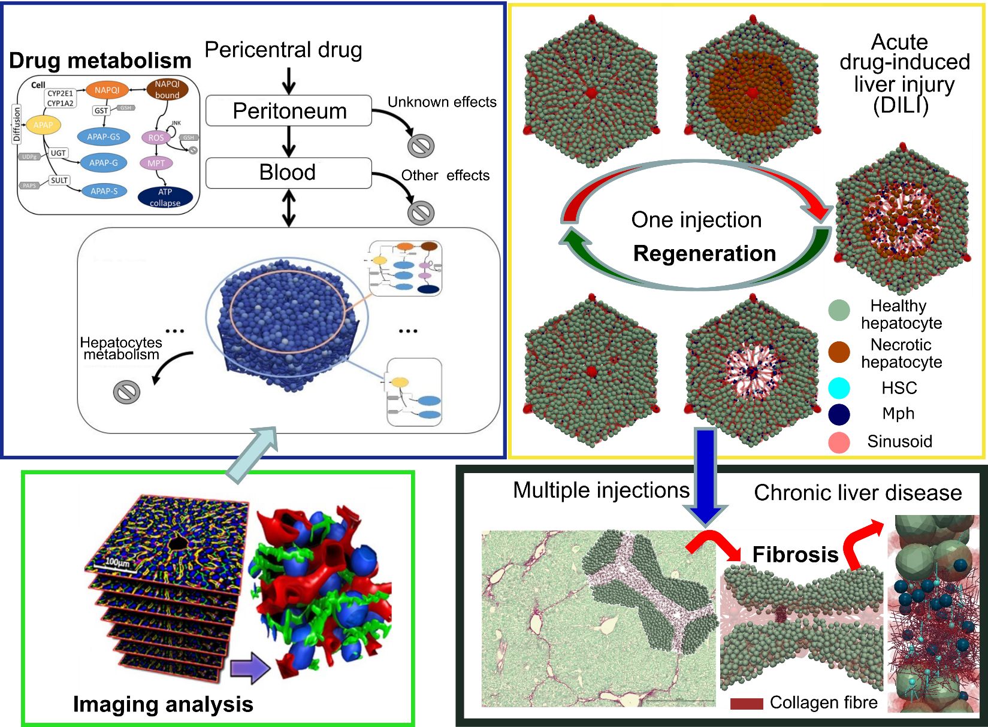
Supplementary Figure 1. Scheme of the digital twin concept in studying liver related disease. Construction of the liver microarchitecture of the digital twin from imaging analysis (green box, Hoehme et al.⁶ (2010)). Modeling the drug metabolism in the liver cell (blue box, Dichamp et al.²⁶ (2023)). Modeling the liver regeneration upon one injection of drug-induced injury (yellow box, Zhao et al.⁵ (2023)). Modeling liver fibrosis (black box, the focus of this study).
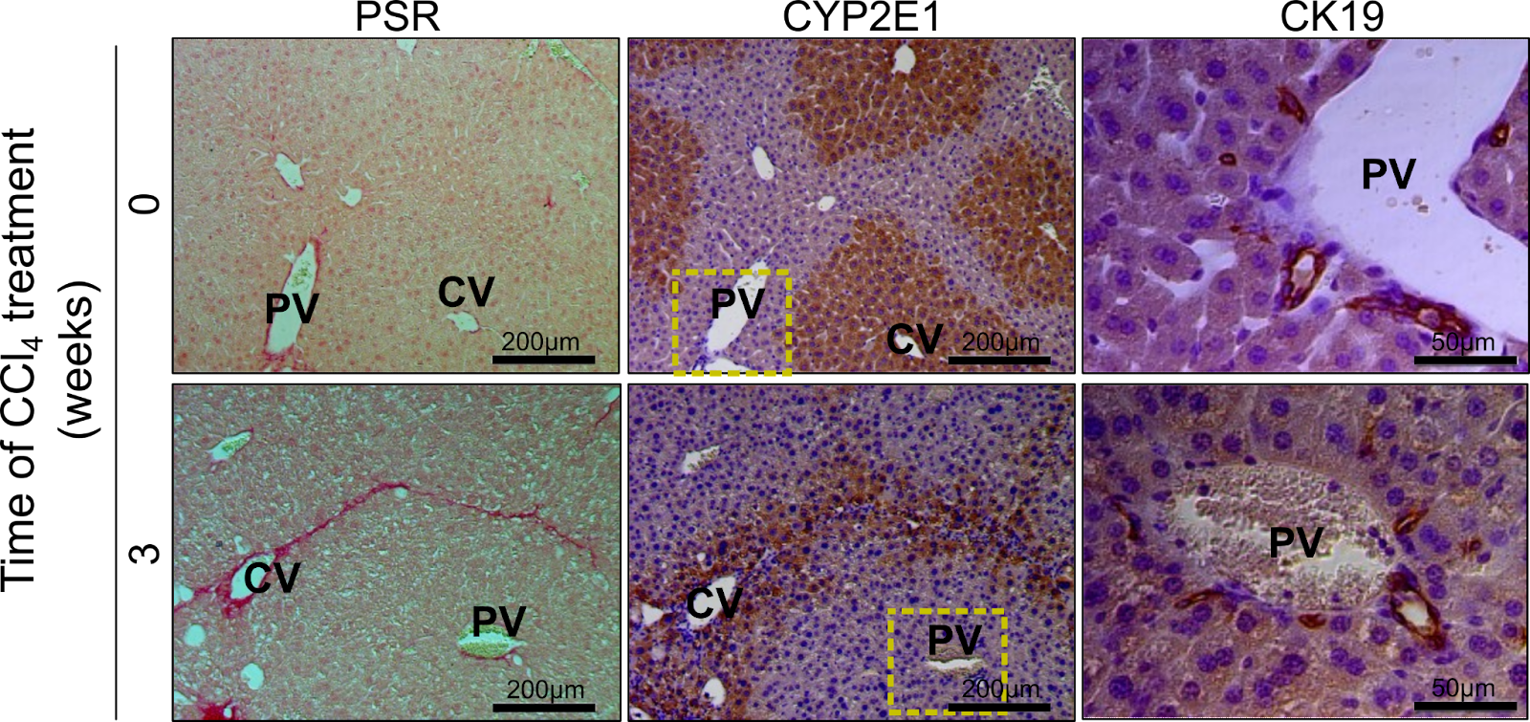
Supplementary Figure 2. CYP2E1 expressing hepatocytes guide ECM deposition upon repetitive CCl₄ injections. Serial sections from control and fibrotic mouse liver (3 weeks of CCl₄) are stained with PSR (ECM deposition; red), CYP2E1 (CCl4 metabolizing enzyme; brown) and CK19 (bile duct epithelial cell marker in periportal compartments). Scale bars are 200μm (PSR and CYP2E1 images) and 50μm (CK19 images).
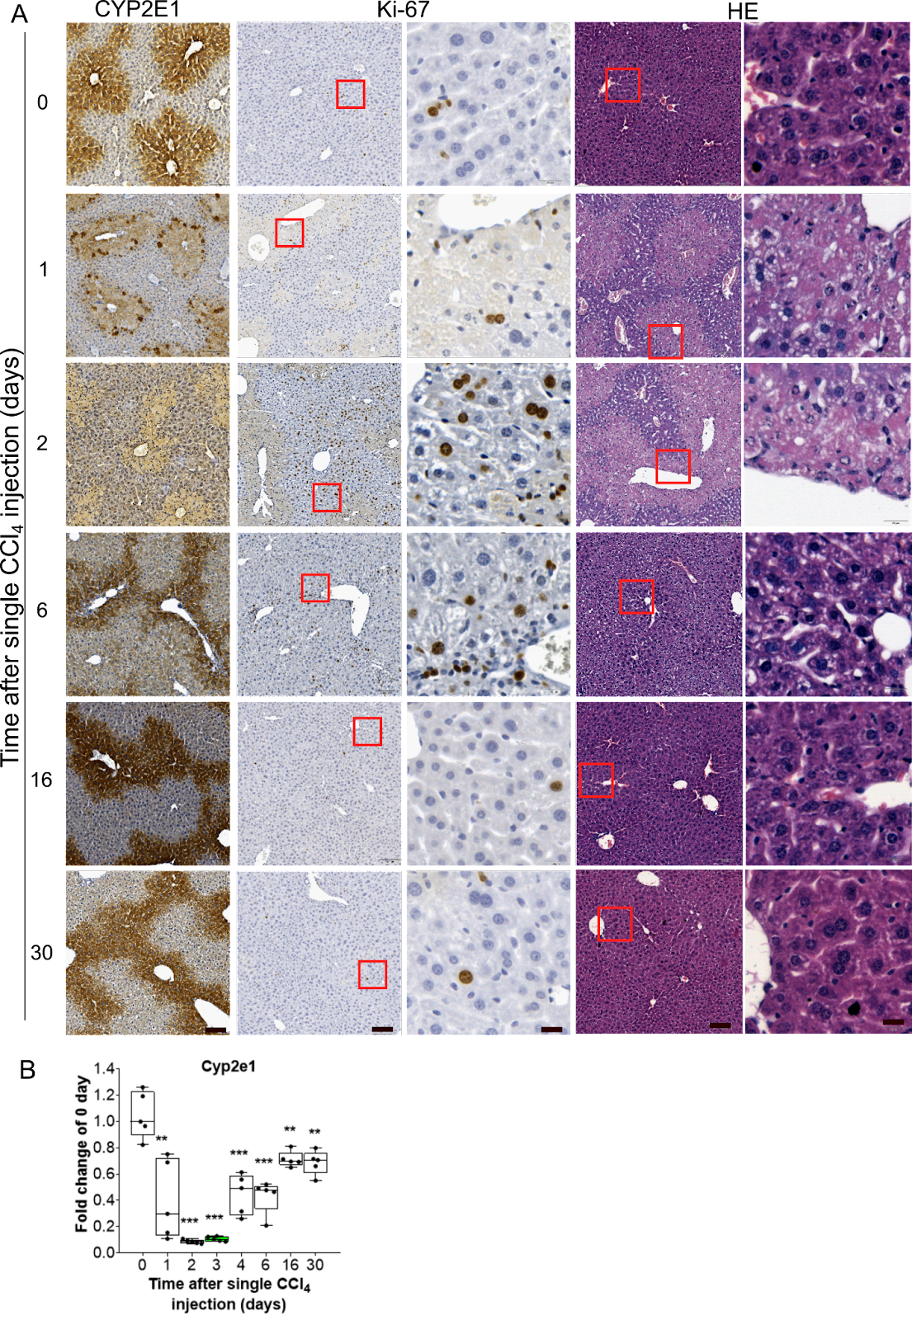
Supplementary Figure 3. Regeneration upon acute liver injury in mice from one CCl₄ injection. (A) Representative time-resolved images of CYP2E1, Ki-67 and HE stained livers upon one dose of CCl₄. Scale bars are 100μm and 20μm for overviews and closeups, respectively. (B) mRNA level of Cyp2e1, determined at different time points after administration of CCl₄ as indicated. Data are shown as the means ± SD of 5 mice per group. The values at day 0 represent the controls. ** P <0.01, *** P <0.001.
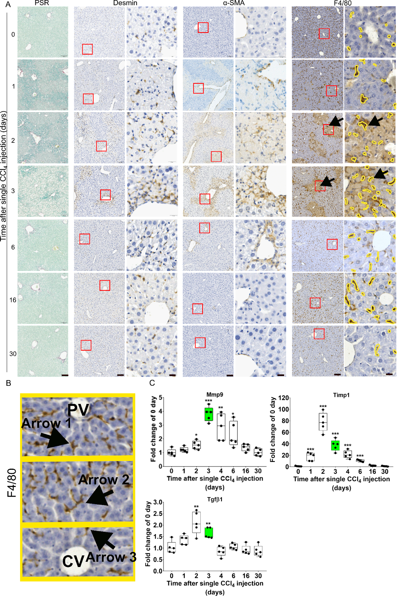
Supplementary Figure 4. ECM, HSC and macrophages during liver regeneration upon one CCl₄ injection. (A) Time-resolved histopathological data after a single CCl₄ injection, showing PSR (ECM), desmin (quiescent and activated HSC), α-SMA (activated HSC), F4/80 (resident macrophages, highlighted in yellow). Desmin, α-SMA and F4/80 are each displayed at overview-magnification (left, scale bar 100μm) and high magnification for closeup (right, scale bar 20μm). (B) The close view of Fig. 3A, F4.80. (C) Time resolved RT-PCR data for Tgfβ1, Mmp9 and Timp1. Data are shown as the means ± SD of 5 mice per group. * P <0.05, ** P <0.01, *** P <0.001.
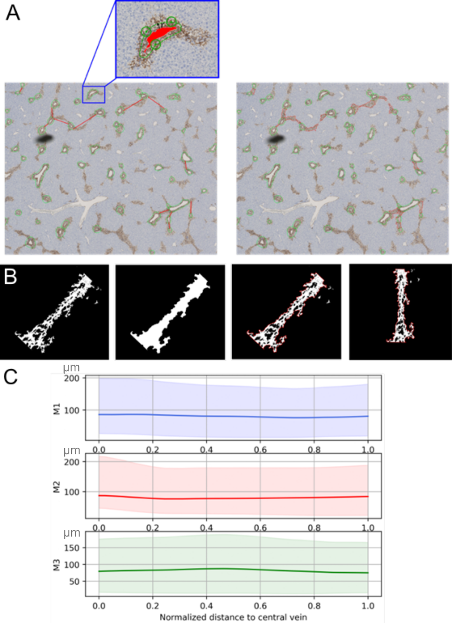
Supplementary Figure 5. Computation of the distribution of the spanning width of ɑ-SMA positive cells. (A) Example of a region of interest showing the activated HSCs in brown; brown regions with void representing CVs are marked by green circles. In the left subfigure, the red lines are drawn manually to identify neighboring CVs connected by areas occupied by activated HSCs; in the right subfigure the red curved lines demarcate the borders of these areas ("stripes"). (B) The different steps to obtain the envelope (border) of an aHSC positive area (stripe) connecting two neighboring CVs. Each stripe is finally oriented vertically before computing its spanning width along the axis starting at one CV and ending at the neighboring CV. (C) The resulting values for the width of the stripe along the CV-CV connection is then normalized by division of the length of the CV-CV connection to permit accumulation of the data for CV-CV connections of different lengths (shown are accumulated data, each from multiple CV-CV connections from different mice M1, M2, and M3). Interestingly, the width of the stripes does not vary along the CV-CV connection.
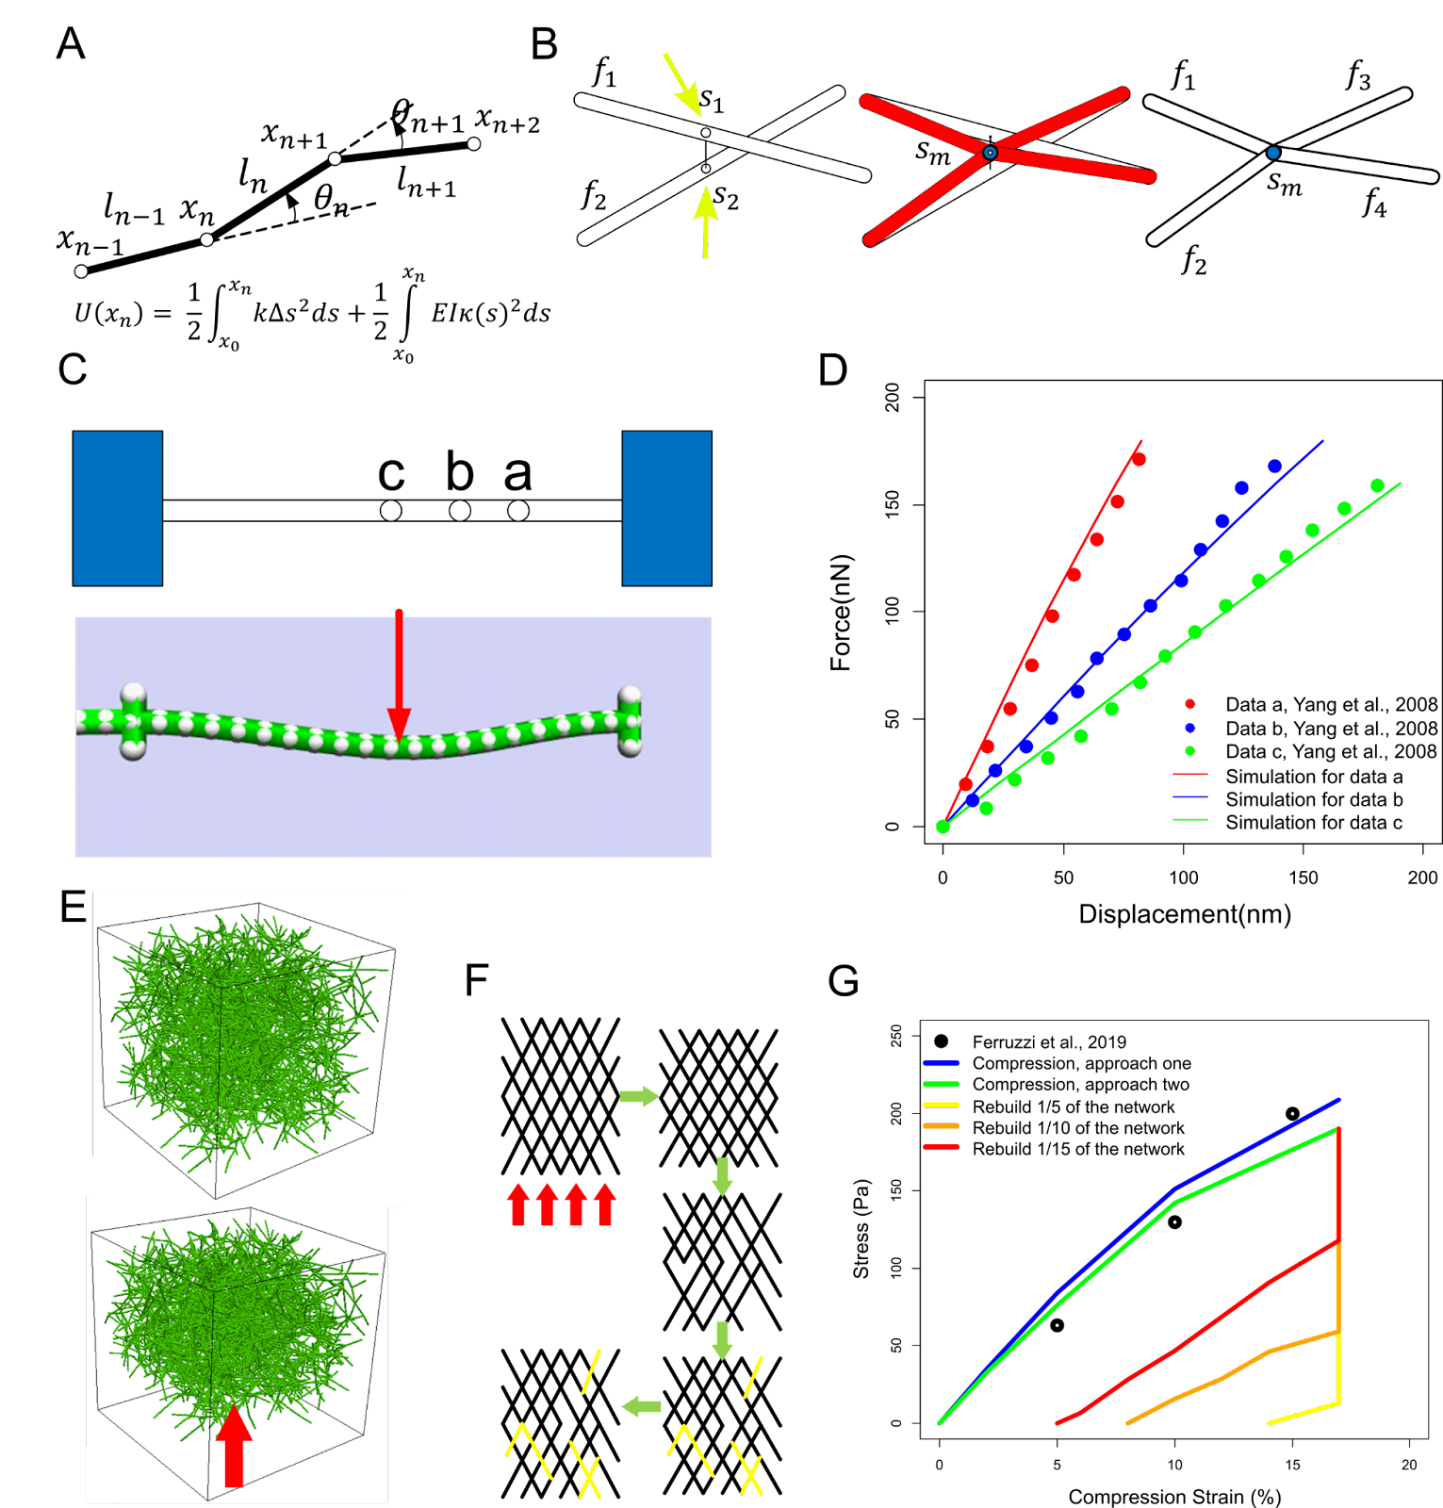
Supplementary Figure 6. Construction and validation of the collagen (ECM) model. (A) Elastic and bending energy of the collagen fibre network. (B) Addition of crosslink nodes: If the distance between two fibre segments $f_{1}$ and $f_{2}$ (between two perpendicular nodes $s_{1}$ and $s_{2}$ on $f_{1}$ and $f_{2}$, respectively, indicated by yellow arrows) is smaller than a predefined threshold, a crosslink node sm (blue) is added, where $f_{1}$ and $f_{2}$ would crosslink (red). After crosslinking, the segments are re-enumerated: $f_{1}$ and $f_{2}$ are divided generating two additional segments ($f_{3}$ and $f_{4}$), which are all attached at $s_{m}$ (blue). (C) Calibration of mechanical parameters for the bundles mimicking the bending test by Yang et al.¹⁶. ‘a’, ‘b’, and ‘c’ indicate the corresponding positions where the force is applied on the fibre. The simulated fibre (length of 3 µm) bends upon the exerted force (red arrow). (D) Simulation result and experimental data from Yang et al.¹⁶. (E) The modeled compression of the collagen network. The size of the network is 42.8×42.8×42.8μm3. The network is compressed by fixing the collagen nodes on the top layer and moving the bottom layer of collagen nodes upwards. (F) Rebuild the network for plasticity test: After the 3D network of cross-linked fibres (from D, E) is compressed, some fibres are randomly removed from and subsequently randomly added back to the network; subsequently, the compressed network is relaxed. This algorithm mimics a visco-elastic network with a plastic response. (G) Strain-stress curve of simulation and experimental data from Ferruzzi et al.¹⁷. Different fractions of total fibres rebuilt (removed first and then added back) in the network are tested.
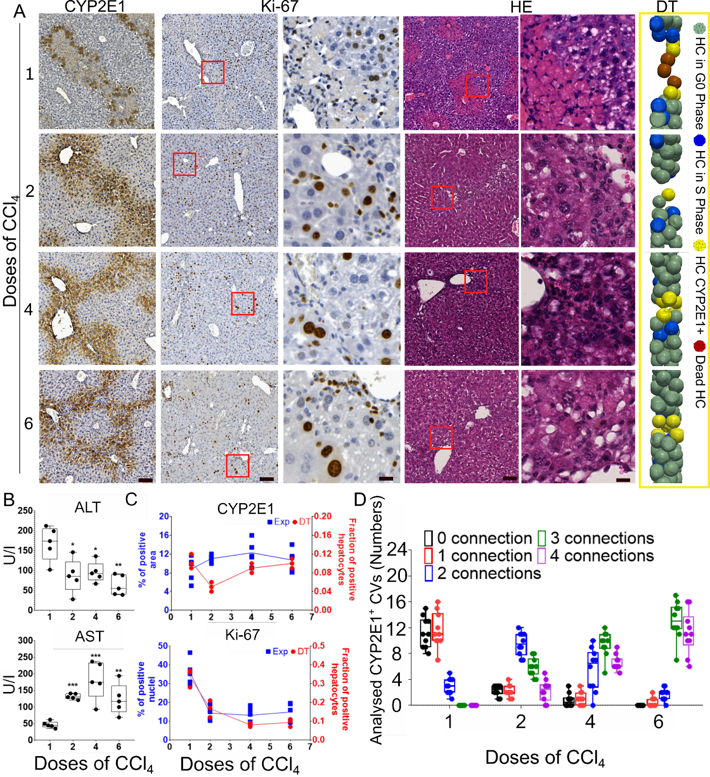
Supplementary Figure 7. Chronic liver injury in mice from 6 injections of CCl₄. (A) Representative images of CYP2E1, Ki-67 and HE stained livers plus snapshots of the DT for repeated doses of CCl₄ (scale bars are 100μm for overview and 20μm for closeup images). The corresponding days are day 3 (3 days after dose 1), 7 (4 days after dose 2), 14 (4 days after dose 4), 21 (4 days after dose 6). (B) Blood levels of liver transaminases (AST and ALT), upon repetitive CCl₄ injections (compare Fig. 2D for the control). (C) (Top) Quantification of the experimentally determined CYP2E1 positive area and fraction of CYP2E1 positive cells in the DT. (Bottom) Quantification of Ki-67 positive nuclei and fraction of S-phase hepatocytes in the DT. (D) Quantification of CVs connected by CYP2E1 positive hepatocytes. Experimental data are shown as the means ± SD of 5 mice per group. * P <0.05, ** P <0.01, *** P <0.001. DT simulation data are shown as the means ± SD of 3 independent simulation runs.
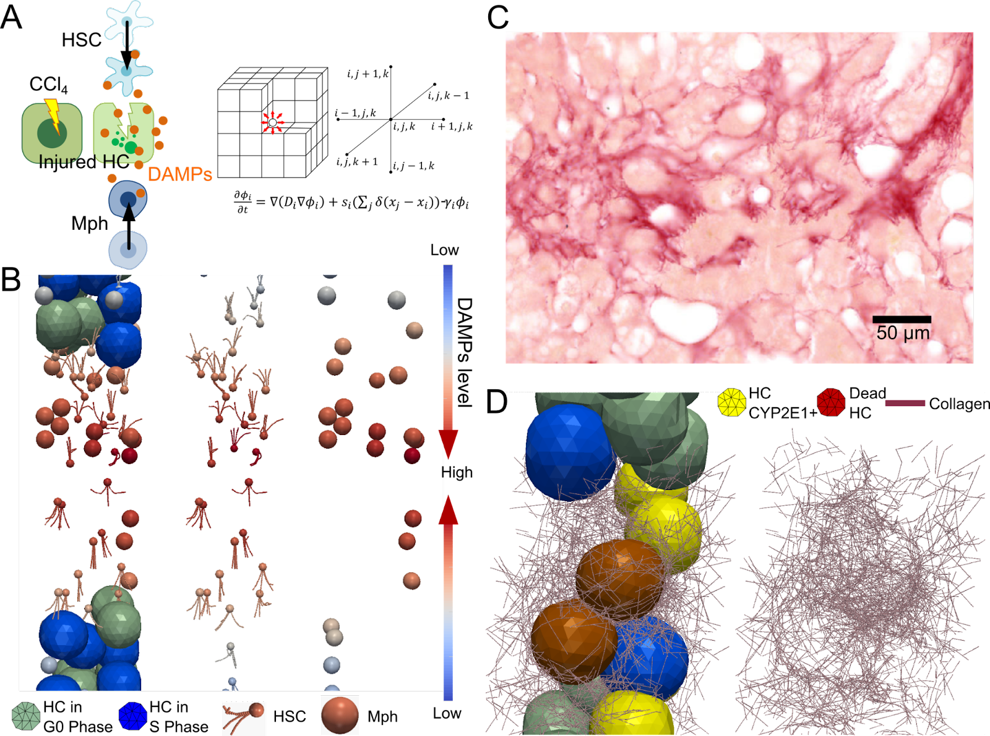
Supplementary Figure 8. Migration of HSC and Mph to mediate liver fibrosis formation. (A) Scheme of DAMPs gradient in the model (DT). Injured HC produce DAMPs. DAMPs can activate HSCs and macrophage (Mph) to migrate towards the largest DAMP gradient. The spatio-temporal DAMP concentration is calculated by solving a differential equation that takes into account synthesis, diffusion, and decay of DAMPs. The differential equations are solved in a discretized cubic system. (B) Snapshots representative for migrating HSCs and Mphs from low (blue) to high (red) DAMP concentrations (Supplementary Movie 3). (C) Chicken wire pattern of liver fibrosis (collagen fibres wrap liver cells), as observed in NASH mouse model. Scale bars are 50μm. (D) Chicken wire pattern, as captured by the DT. Left: collagen fibres wrapping HC; Right: the same structure in left by excluding the HC.
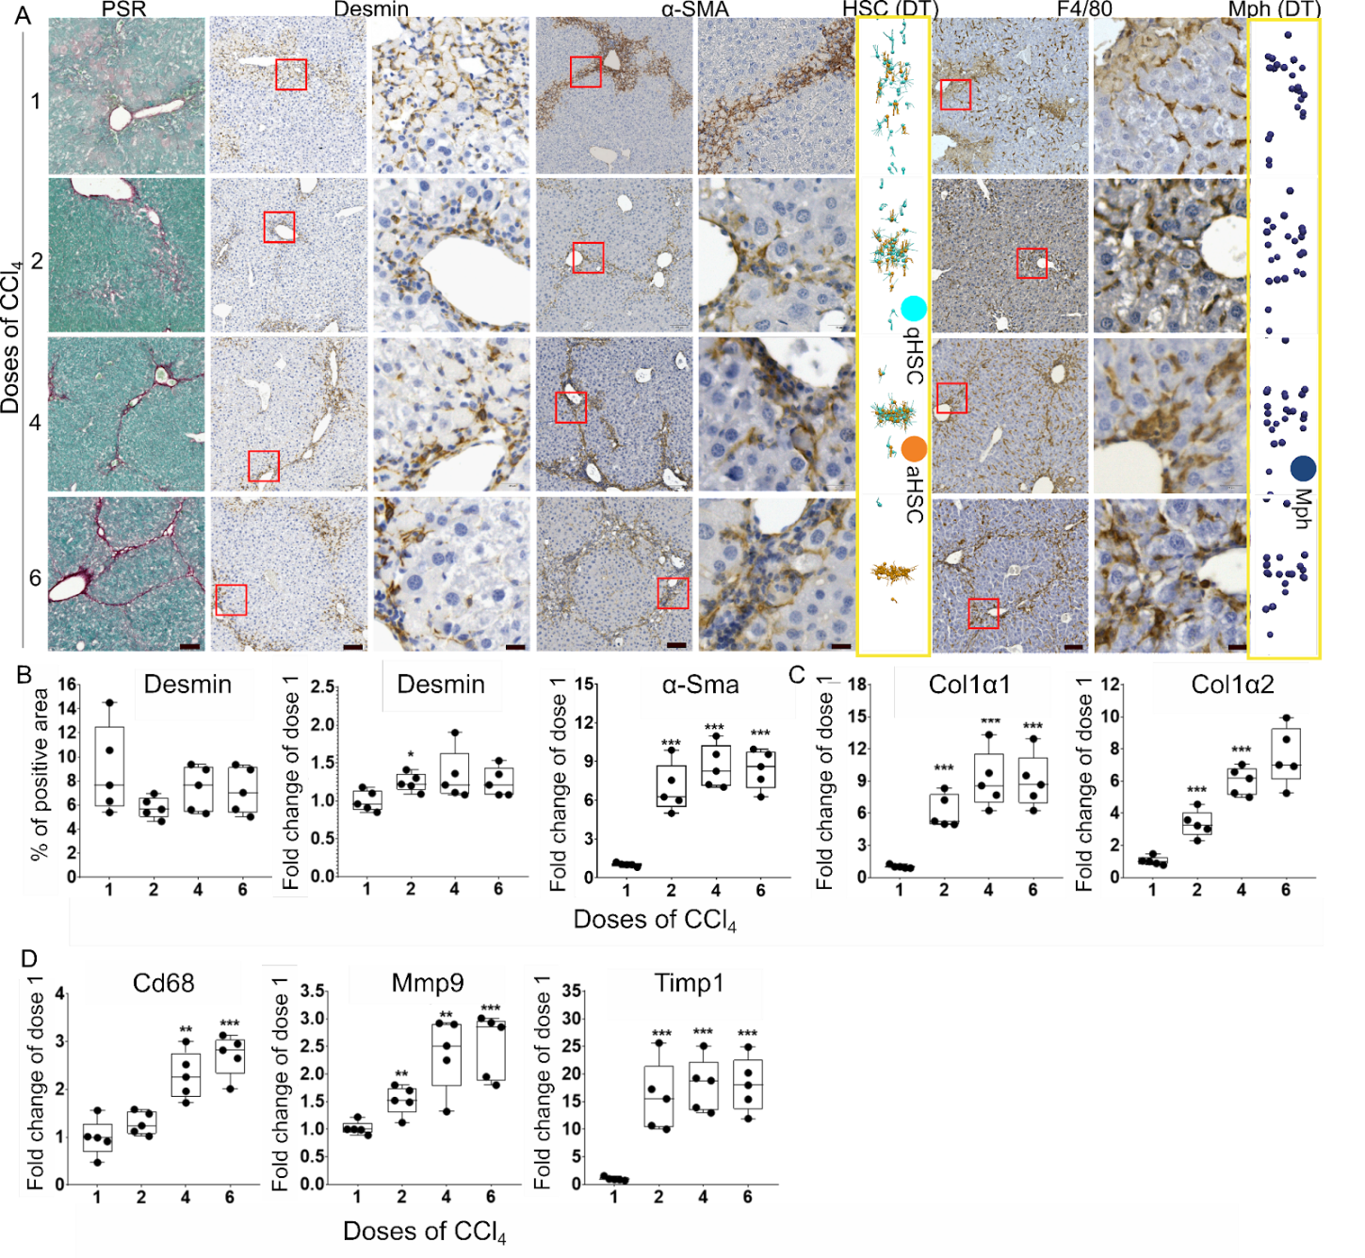
Supplementary Figure 9. HSC, Mph and matrisome analysis in the dynamics of CCl₄ mediated chronic liver disease. (A) Representative images of PSR, desmin, α-SMA, and F4/80 stained livers and snapshots of HSC and Mph in the DT simulation. (B-D) Protein/mRNA levels of desmin, α-SMA, Collagen1α1, Collagen1α2, Cd68, Mmp9, and Timp1 determined by IHC or RT-PCR, as indicated. Scale bars are 100μm for overview and 20μm for closeup images. Experimental data are shown as the means ± SD of 5 mice per group. * P <0.05, ** P <0.01, *** P <0.001. DT simulation data are shown as the means ± SD of 3 independent simulation runs.
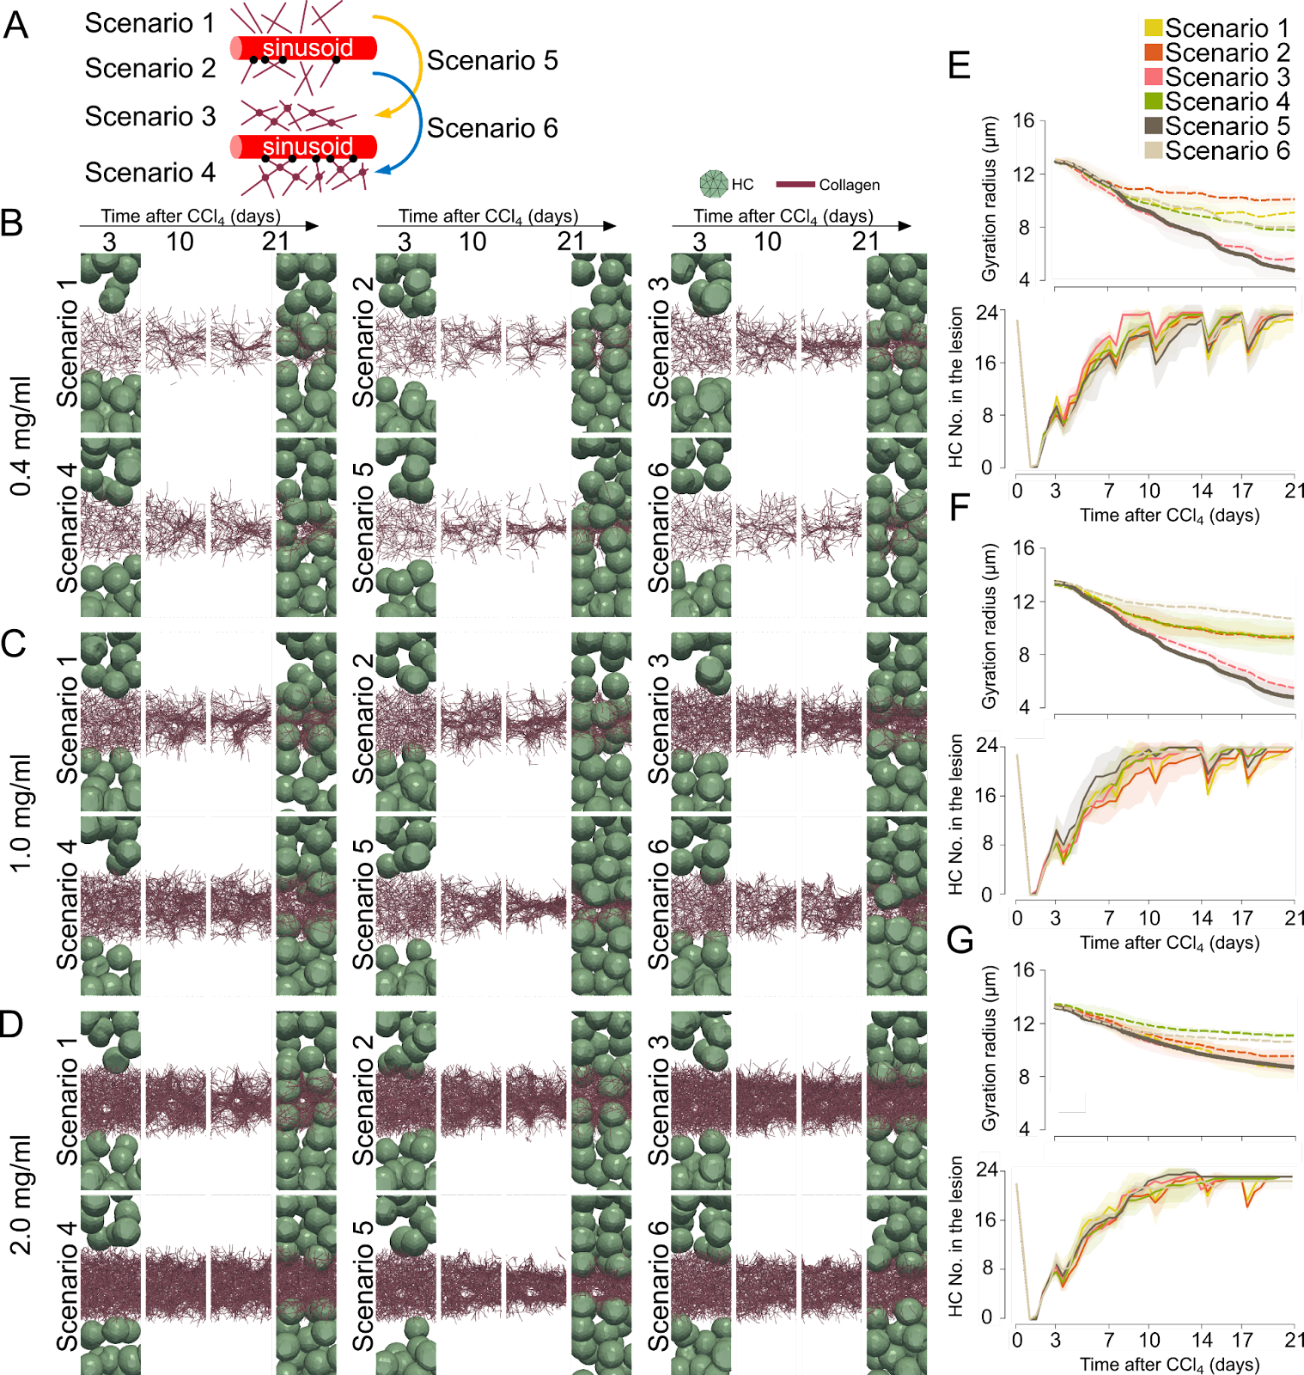
Supplementary Figure 10. Organizational structure of the collagen network. (A) There are six scenarios (S) for the structure of collagen deposition. Collagen fibres are deposited as single fibres in S1, single fibres anchored to the nearest sinusoids in S2, crosslinked single fibres in S3, crosslinked single fibres anchored to the nearest sinusoids in S4. In S5, collagen fibres are firstly deposited as single fibres and then gradually crosslinked while in S6, collagen fibres are firstly deposited as single fibres anchored to the nearest sinusoids and then gradually crosslinked. (B-D) Snapshots of collagen fibre organization as resulting from the different simulation scenarios with the DT based on assuming collagen densities of 0.4 mg/mL, 1.0 mg/mL and 2.0 mg/mL, respectively. (E-G) Gyration radius of the fibres and number of hepatocytes in the lesion in the different scenarios. Scenario 5 in the graph depicting the gyration radius is highlighted in a solid line, while the other scenarios are presented in dashed lines. The error bars represent the standard deviation of 3 simulation runs.
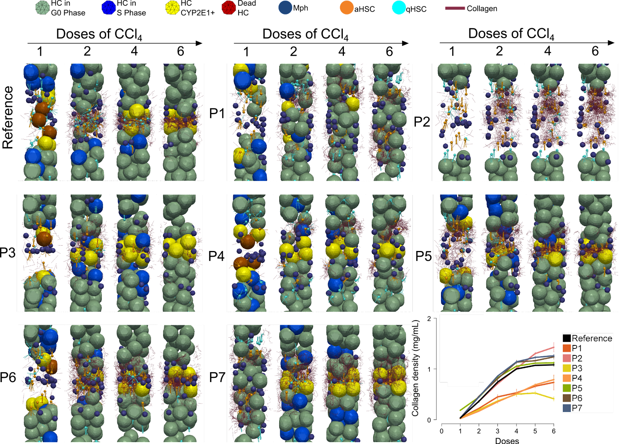
Supplementary Figure 11. Snapshots of DT simulation result from the different perturbation runs. Seven perturbation scenarios are tested. P1, random distribution of CYP2E1+ hepatocytes; P2, lack of hepatocyte proliferation; P3, 70% of activated HSC undergo cell death; P4, HSC are not able to migrate; P5, HSC display an inverted phenotype after CCl4 injections; P6, macrophages become Ly6C^{low}, 5 days after CCl₄ injections, and P7, macrophages cannot migrate. Typical time-lapse DT simulations are shown as Supplementary Movies 4-10. The plot of collagen density over the lesion region after doses of CCl₄ under each perturbation is also shown.

Supplementary Tables
Supplementary table 1. Sequences of primer pairs used for real time PCR
Gene | Species | Forward | Reverse
Acta2 (α-Sma) | Mouse | TTCGCTGTCTACCTTCCAGC | GAGGCGCTGATCCACAAAAC
Timp1 | Mouse | GGCATCTGGCATCCTCTTGT | ACTCTTCACTGCGGTTCTGG
Cd68 | Mouse | GGCGGTGGAATACAATGTGTCC | AGCAGGTCAAGGTGAACAGCTG
Col1α1 | Mouse | ACGTGGAAACCCGAGGTATG | TTGGGTCCCTCGACTCCTAC
Col1α2 | Mouse | AGTCGATGGCTGCTCCAAAA | AGCACCACCAATGTCCAGAG
Cyp2e1 | Mouse | CGTTGCCTTGCTTGTCTGGA | AAGAAAGGAATTGGGAAAGGTCC
Desmin | Mouse | TACACCTGCGAGATTGATGC | ACATCCAAGGCCATCTTCAC
Mmp9 | Mouse | GCAGAGGCATACTTGTACCG | TGATGTTATGATGGTCCCACTTG
Ppia | Mouse | GAGCTGTTTGCAGACAAAGTC | CCCTGGCACATGAATCCTGG
Tgfβ1 | Mouse | AGGGCTACCATGCCAACTTC | CCACGTAGTAGACGATGGGC

Supplementary Table 2. DT (digital twin) parameters.
Description | Value | Reference
Hepatocyte radius | ~10.7 µm | Estimated from data
Sinusoid radius | ~2.1 µm | Hoehme et al.⁶ (2010)
HSC radius | ~2 µm | Wake²⁷ (2006)
HSC branch length | ~12 µm | Wake²⁷ (2006)
Mph radius | ~6 µm | Shi et al.²⁸ (2011)
Collagen fibre radius | ~0.1 µm | Wenger et al.²⁹ (2007)
Collagen fibre segment length | ~3 µm | Stein et al.⁹ (2008)
Young’s modulus of hepatocyte | ~400 Pa | Hoehme et al.⁷ (2010)
Young’s modulus of sinusoid | ~600 Pa | Hoehme et al.⁷ (2010)
Young’s modulus of HSC | ~700 Pa | Estimated from fibroblast, Yang et al.³⁰ (2012)
Young’s modulus of macrophage | ~1400 Pa | Estimated from immune macrophage, Bufi et al.³¹ (2015)
Young’s modulus of collagen fibre | ~50 MPa | Manssor et al.³² (2016)
Poisson ratio of all components | 0.4 | Hoehme et al.⁷ (2010)
Cell cycle time of hepatocyte | 24 hours | Hoehme et al.⁷ (2010)
Cell cycle time of HSC | 24 hours | Estimated
Medium friction for hepatocyte, sinusoid and macrophage | 10⁸ Ns/m³ | Estimated
Medium friction for HSC | 10¹⁰ Ns/m³ | Estimated
Medium friction for collagen fibre | 10¹¹ Ns/m³ | Estimated
Friction between all components | 10⁸ Ns/m³ | Estimated
HSC density in the liver | ~1/70 µm of the sinsoid | Wake²⁷ (2006)
Mph density in the liver | ~2×10⁴/mm³ | Bouwens et al.³³ (1986)
Collagen density | ~1 mg/ML | Stein et al.⁹ (2008)
Local collagen density restriction of further collagen production by aHSC | ~10 mg/ML | Estimated
Mean of migration speed of HSC | ~2.1 µm/hour | Tangkijvanich et al.²² (2001)
SD of migration speed of HSC | ~0.1 µm/hour | Tangkijvanich et al.²² (2001)
Mean of migration speed of Mph | ~5 µm/min | Grabher et al.²¹ (2007)
SD of migration speed of Mph | ~1.8 µm/min | Grabher et al.²¹ (2007)
Diffusion rate of DAMPs, estimated from its molecular weight, 28 kDa | ~2.5×10⁻¹¹ m²/s | Davies et al.³⁴ (2018)
Decay rate of DAMPs, estimated from its half-life, ~1000 seconds | ~5.7×10⁻⁴ /s | Zandarashvili et al.³⁵ (2013)
Fraction of HSC switching to inverted phenotype | 0.5 | Kisseleva et al.²⁴ (2012)
Fraction of apoptosis HSC after each injection of CCl₄ | 0.5 | Kisseleva et al.²⁴ (2012)
Time of macrophage switching to Ly6C^{low} phenotype after each injection of CCl₄ | 12 hours | Estimated from data
Engulfment and elimination duration of Mph | ~3 hours | Estimated from Haecker et al.²⁵ (2002)
The width of the lesion size | ~80 µm | Estimated from data

Supplementary Movies
Supplementary Movie 1. 3D reconstruction of a hepatocyte (yellow), nucleus (blue) and wrapped by sinusoids (red). This cell reconstruction is generated from confocal images obtained from healthy mouse liver³⁶.
Supplementary Movie 2. Time-Lapse video of a typical model simulation of the formation of fibrotic pattern in the reference model (Light green: healthy hepatocyte; Yellow: CYP2E1+ hepatocyte; Brown: dead hepatocyte; Blue: dividing hepatocyte; Dark Blue: Mph; Cyan: qHSC; Orange: aHSC; Dark purple: collagen fibre).
Supplementary Movie 3. Time-Lapse video of a typical model simulation showing migration of HSC and Mph towards the gradient of DAMPs. Mph is represented as a sphere and HSC is represented as a sphere attached with several chains.
Supplementary Movie 4. Time-Lapse video of a typical model simulation of the perturbation 1 (randomly distributed CYP2E1+ cells) upon the reference model (Light green: healthy hepatocyte; Yellow: CYP2E1+ hepatocyte; Brown: dead hepatocyte; Blue: dividing hepatocyte; Dark Blue: Mph; Cyan: qHSC; Orange: aHSC; Dark purple: collagen fibre).
Supplementary Movie 5. Time-Lapse video of a typical model simulation of the perturbation 2 (no hepatocyte proliferation) upon the reference model (Light green: healthy hepatocyte; Yellow: CYP2E1+ hepatocyte; Brown: dead hepatocyte; Blue: dividing hepatocyte; Dark Blue: Mph; Cyan: qHSC; Orange: aHSC; Dark purple: collagen fibre)
Supplementary Movie 6. Time-Lapse video of a typical model simulation of the perturbation 3 (70% of the activated HSC are killed) upon the reference model (Light green: healthy hepatocyte; Yellow: CYP2E1+ hepatocyte; Brown: dead hepatocyte; Blue: dividing hepatocyte; Dark Blue: Mph; Cyan: qHSC; Orange: aHSC; Dark purple: collagen fibre).
Supplementary Movie 7. Time-Lapse video of a typical model simulation of the perturbation 4 (no HSC migration) upon the reference model ((Light green: healthy hepatocyte; Yellow: CYP2E1+ hepatocyte; Brown: dead hepatocyte; Blue: dividing hepatocyte; Dark Blue: Mph; Cyan: qHSC; Orange: aHSC; Dark purple: collagen fibre).
Supplementary Movie 8. Time-Lapse video of a typical model simulation of the perturbation 5 (HSC is initiated as inverted phenotype) upon the reference model (Light green: healthy hepatocyte; Yellow: CYP2E1+ hepatocyte; Brown: dead hepatocyte; Blue: dividing hepatocyte; Dark Blue: Mph; Cyan: qHSC; Orange: aHSC; Dark purple: collagen fibre).
Supplementary Movie 9. Time-Lapse video of a typical model simulation of the perturbation case 6 (macrophage becomes Ly6C^{low} after 5 days) upon the reference model (Light green: healthy hepatocyte; Yellow: CYP2E1+ hepatocyte; Brown: dead hepatocyte; Blue: dividing hepatocyte; Dark Blue: Mph; Cyan: qHSC; Orange: aHSC; Dark purple: collagen fibre).
Supplementary Movie 10. Time-Lapse video of a typical model simulation of the perturbation 7 (no macrophage migration) upon the reference model (Light green: healthy hepatocyte; Yellow: CYP2E1+ hepatocyte; Brown: dead hepatocyte; Blue: dividing hepatocyte; Dark Blue: Mph; Cyan: qHSC; Orange: aHSC; Dark purple: collagen fibre).

References
- Gonzalez, R.C., Woods, R.E. Digital Image Processing. (Pearson/Prentice Hall, 2010).
- Soille, P. Morphological image analysis: principles and applications. Vol. 2, No. 3. (Berlin: Springer,1999).
- Sternberg, S.R. Grayscale morphology. Computer Vision, Graphics, and Image Processing 35(3), 333-355 (1986).
- Van Liedekerke, P., Palm, M.M., Jagiella, N., Drasdo, D. Simulating tissue mechanics with agent-based models: concepts, perspectives and some novel results. Computational Particle Mechanics 2, 401-444 (2015).
- Van Liedekerke, P., Neitsch, J., Johann, T., Alessandri, K., Nassoy, P., Drasdo, D. Quantitative cell-based model predicts mechanical stress response of growing tumor spheroids over various growth conditions and cell lines. PLoS Computational Biology 15(3), e1006273 (2019).
- Zhao, J., Ghallab, A., Hassan, R., Dooley, S., Hengstler, J.G., Drasdo, D. A digital twin of liver predicts regeneration after drug-induced damage at the level of cell type orchestration. Accepted by iScience (2023).
- Hoehme, S., Brulport, M., Bauer, A., Bedawy, E., Schormann, W., Hermes, M., Puppe, V., Gebhardt, R., Zellmer, S., Schwarz, M., Bockamp, E., Timmel, T., Hengstler, J.G., Drasdo, D. Prediction and validation of cell alignment along microvessels as order principle to restore tissue architecture in liver regeneration. Proc. Natl Acad Sci USA 107(23), 10371-10376 (2010).
- Levick, J.R. Flow through interstitium and other fibrous matrices. Quarterly Journal of Experimental Physiology 72(4), 409-437 (1987).
- Stein, A.M., Vader, D.A., Jawerth, L.M., Weitz, D.A., Sander, L.M. An algorithm for extracting the network geometry of three-dimensional collagen gels. Journal of Microscopy 232, 463-475 (2008).
- Allens, M.P., Tildesley, D.J. Computer Simulation of Liquids. (Oxford University Press, 1987).
- Yang, K., Lu, C., Zhao, X., Kawamura, R. From bead to rod: Comparison of theories by measuring translational drag coefficients of micron-sized magnetic bead-chains in Stokes flow. PLoS ONE 12(11), e0188015 (2017).
- Cox, R.G. The motion of long slender bodies in a viscous fluid Part 1. General theory. Journal of Fluid Mechanics 44, 791-810 (1970).
- Popov, V.L. Contact mechanics and friction. (Springer, 2010).
- Karabassi, E., Papaioannou, G., Theoharis, T., Boehm, A. Intersection test for collision detection in particle systems. Journal of Graphics Tools 4(1), 25-37 (1999).
- Sneddon, I.N. The relation between load and penetration in the axisymmetric boussinesq problem for a punch of arbitrary profile. International Journal of Engineering Science 3(1), 47-57 (1965).
- Yang, L., Fitie, C.F.C., Van der Werf, K.O., Bennink, M.L., Dijkstra, P.J., Feijen, J. Mechanical properties of single electrospun collagen type I fibres. Biomaterials 29, 955-962 (2008).
- Ferruzzi, J., Sun, M., Gkousioudi, A., Pillar, A., Roblyer, D., Zhang, Y., Zaman, M.H. Compressive remodeling alters fluid transport properties of collagen networks - implications for tumor growth. Scientific Reports 9, 17151 (2019).
- Ghosh, S., Kaplan, K.J., Schrum, L.W., Bonkovsky, H.L. Chapter Five – cytoskeletal proteins: shaping progression of Hepatitis C virus-induced liver disease. International Review of Cell and Molecular Biology 302, 279-319 (2013).
- Calderwood, S.K., Gong, J., Murshid, A. Extracellular HSPs: the complicated roles of extracellular HSPs in immunity. Frontiers in Immunology 7, 159 (2016).
- Martin-Murphy, B.V., Holt, M.P., Ju, C. The role of damage associated molecular pattern molecules in acetaminophen-induced liver injury in mice. Toxicology Letters 192: 387-394 (2010).
- Grabher, C., Cliffe, A., Miura, K., Hayflick, J., Pepperkik, R., Rørth, P., Wittbrodt, J. Birth and life of tissue macrophages and their migration in embryogenesis and inflammation in medaka. Journal of Leukocyte Biology 81(1), 263-271 (2007).
- Tangkijvanich, P., Tam, S.P., Yee, J.F. Wound-induced migration of rat hepatic stellate cells is modulated by endothelin-1 through Rho-kinase-mediated alterations in the acto-myosin cytoskeleton. Hepatology 3(1), 74-80 (2001).
- Iredale, J.P., Benyon, R.C., Pickering, J., McCullen, M., Northrop, M, Pawley, S., Hovell, C., Arthur, M.J. Mechanisms of spontaneous resolution of rat liver fibrosis. Hepatic stellate cell apoptosis and reduced hepatic expression of metalloproteinase inhibitors. The Journal of Clinical Investigation 102(3), 538-549 (1998).
- Kisseleva, T., Cong, M., Paik, Y., Scholten, D., Jiang, C., Benner, C., Iwaisako, K., Moore-Morris, T., Scott, B., Tsukamoto, H., Evans, S.M., Dillmann, W., Glass, C.K., Brenner, D.A. Myofibroblasts revert to an inactive phenotype during regression of liver fibrosis. Proc. Natl Acad Sci USA 109(24), 9448-53 (2012).
- Haecker, H., Fuermann, C., Wagner, H., Haecker, G. Caspase-9/-3 activation and apoptosis are induced in mouse macrophages upon ingestion and digestion of Escherichia coli bacteria. J. Immunol. 169, 3172-3179 (2002).
- Dichamp, J., Celliere, G., Ghallab, A., Hassan, R., Boissier, N., Hofmann, U., Reinders, J., Sezgin, S., Zuehlke, S., Hengstler, J.G., Drasdo, D. In vitro to in vivo acetaminophen hepatotoxicity extrapolation using classical schemes, pharmacodynamic models and a multiscale spatial-temporal liver twin. Front. Bioeng. Biotechnol. 11, 1049564 (2023).
- Wake, K. Hepatic stellate cells: Three-dimensional structure, localization, heterogeneity and development. Proceedings of the Japan Academy, Series B 82(4), 155-164 (2006).
- Shi, C., Jia, T., Mendez-Ferrer, S., Hohl, T.M., Serbina, N.V., Lipuma, L., Leiner, I., Li, M.O., Frenette, P.S., Pamer, E.G. Bone marrow mesenchymal stem and progenitor cells induce monocyte emigration in response to circulating Toll-like receptor ligands. Immunity 34(4), 590-601 (2011).
- Wenger, M.P., Bozec, L., Horton, M.A., Mesquida, P. Mechanical properties of collagen fibrils. Biophysical Journal 93(4), 1255-1263 (2007).
- Yang, Y., Liao, J., Lin, C., Chang, C., Wang, S., Ju, M. Characterization of cholesterol-depleted or -restored cell membranes by depth-sensing nano-indentation. Soft Matter 8(3): 682-687 (2012).
- Bufi, N., Saitakis, M., Dogniaux, S., Buschinger, O., Bohineust, A., Richert, A., Maurin, M., Hivroz, C., Asnacios, A. Human primary immune cells exhibit distinct mechanical properties that are modified by inflammation. Biophysical Journal 108(9), 2181-2190 (2015).
- Manssor, N.A.S., Radzi, Z., Yahya, N.A., Yusof, L.M., Hariri, F., Khairuddin, N.H., Kasim, N.H.A., Czernuszka, J.T. Characteristics and Young’s modulus of collagen fibrils from expanded skin using anisotropic controlled rate self-inflating tissue expander. Skin Pharmacology and Physiology 29(2), 55--62 (2016).
- Bouwens, L., Knook, D.L., Wisse, E. Local proliferation and extrahepatic recruitment of liver macrophages (Kupffer cells) in partial-body irradiated rats. Journal of Leukocyte Biology 39, 687-697 (1986).
- Davies, J.E., Apta, B.H.R., Harper, M.T. Cross-reactivity of anti-HMGB1 antibodies for HMGB2. Journal of Immunological Methods 456: 72—76 (2018).
- Zandarashvili, L., Sahu, D., Lee, K., Lee, Y.S., Singh, P., Rajarathnam, K., Iwahara, J. Real-time kinetics of high-mobility group box 1 (HMGB1) oxidation in extracellular fluids studied by in Situ protein NMR spectroscopy. Journal of Biological Chemistry 288(17): 11621—11627 (2013).
- Hammad, S., Hoehme, S., Friebel, A., Von Recklinghausen, I., Othman, A., Begher-Tibbe, B., Reif, R., Godoy, P., Johann, T., Vartak, A., Golka, K., Bucur, O.P., Vibert, E., Marchan, R., Christ, B., Dooley, S., Meyer, C., Ilkavets, I., Dahmen, U., Dirsch, O., Bottger, J., Gebhardt, R., Drasdo, D., Hengstler, J.G. Protocols for staining of bile canalicular and sinusoidal networks of human, mouse and pig livers, three-dimensional reconstruction and quantification of tissue microarchitecture by image processing and analysis. Archives of Toxicology 88, 1161-1183 (2014).

