Supporting information

Irradiated Microparticles for Treatment of Prostate cancer by Reprograming Tumor Microenvironment and Inducing Multi-modal Death of Tumor
Zihan Deng^{a,1}, Binghui Li^{b,c,1}, Muyang Yang^{d,1}, Lisen Lu^{d}, Jonathan F. Lovell^{e}, Xiantao Zeng^{b,c,}*, Weidong Hu^{a,}*, Honglin Jin^{d,}*
ªDepartment of Thoracic Surgery, ZhongNan Hospital of Wuhan University, Wuhan, Hubei, China.
^{b}Center for Evidence-Based and Translational Medicine, Zhongnan Hospital of Wuhan University, Wuhan, China.
^{c}Department of Urology, Zhongnan Hospital of Wuhan University, Wuhan, China.
^{d}College of Biomedicine and Health and College of Life Science and Technology, Huazhong Agricultural University, Wuhan, 430070, China.
^{e}Department of Biomedical Engineering, University at Buffalo, State University of New York, Buffalo, NY 14260, USA

¹ These authors contributed equally to this work.
*Corresponding authors.
E-mail addresses: huwd@whu.edu.cn (W. Hu), jin@hust.edu.cn (H. Jin), zengxiantao1128@whu.edu.cn (X.Zeng)

Figure S1. HPLC chromatogram of RSL3 and RSL3 in RMPs.

Figure S2. DCs and macrophages ingest RMPs and RC@RMPs in a dose manner. (A) DC2.4 and (B) RAW264.7 were incubated with DiO pre-dyed RMPs and RC@RMPs for 24 hours and detected MFI in FL1 channel by flow cytometer. P-values were calculated by one-way analysis of variance (ANOVA). *P < 0.05, **P < 0.01 and ****P < 0.0001.

Figure S3. The toxicity of all the RMPs to DCs and macrophages. RM-1 cells were incubated with RMPs, RSL3@ RMPs, CT20p@RMPs and RC@RMPs for 24 hours. Relative cell growth of RM-1 cells was measured by CCK-8 assay.

Figure S4. RSL3 and CT20p loading maintains RMPs’ ability to activate cGAS-STING pathway. DC2.4 was incubated with RMPs, RSL3@RMPs, CT20p@RMPs and RC@RMPs for 24 hours. Western blotting analyzed the level of p-STING, p-NFκB, STING, and NF-κB in DC2.4 lysis. GAPDH and Laminin B1 were respectively applied as internal references of cytoplasm and nucleus protein.

Figure S5. RSL3 and CT20p loading does not influence RMPs to inhibit M2 macrophage polarization. RAW264.7 was incubated with RMPs, RSL3@ RMPs, CT20p@RMPs and RC@RMPs for 24 hours. Flow cytometer analyzed the expression of CD206.

Figure S6. Distribution of RMPs and RC@RMPs in vivo. 100 μg PKH26 pre-dyed RMPs and RC@RMPs were intratumorally injected and the mice were sacrificed 24 hour after treatment. (A) PKH26 imaging of main organs and tumor by IVIS system. (B) Representative immunofluorescence images showing colocalization of RMPs and Ly6G⁺ neutrophils in tumor tissue 24 hour after treatment.
Figure S7. The gating of flow cytometer for different immune cells in Figure 5D-L.

Figure S8. The spectrum of cytokines is changed by RC@RMPs and anti-PD-1 mAb combination. The levels of related cytokines in homogenate of RM-1 tumor in mice treated according to Figure 5A were measured by Cytokine Release Syndrome Panel. P-values of other experiments were calculated by one-way analysis of variance (ANOVA). *P < 0.05, **P < 0.01, ***P < 0.001 and ****P < 0.0001, ns stands for on significance.

Figure S9. Increasing infiltration of T cells after RC@RMPs treatment for RM-1 tumor. RM-1 tumor burden mice were treated and sacrificed according to Figure 5A. Representative immunofluorescence images showing the number of CD3⁺ T cells (A) and Ly6G⁺ neutrophils (B) in tumor tissue.

Figure S10. Confirmation of immune cell subset depletion. The percentages of CD4⁺ T cells, CD8⁺ T cells, neutrophils and macrophages in peripheral blood were detected by flow cytometer 24 hour after treatment of corresponding agents for immunocyte depletion.

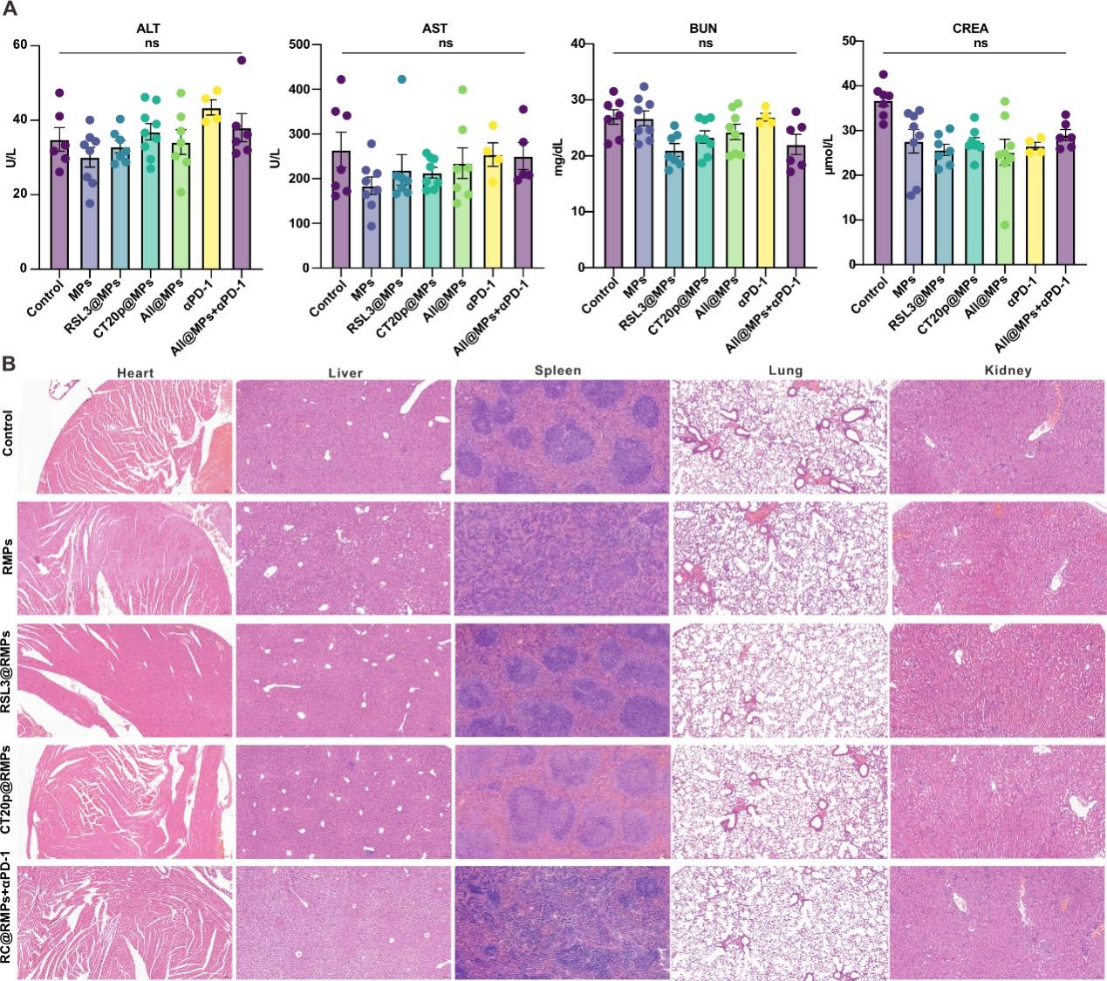
Figure S11. All the treatments for RM-1 tumor were safe. (A) The level of alanine transaminase (ALT), aspartate transaminase (AST), blood urea nitrogen (BUN) and creatinine (CREA) in serum for evaluation of hepatic and renal function. (B) The histopathological examination of heart, liver, spleen, lung and kidney.

