Sediment load assessments under climate change scenarios - lack of integration between climatologists and environmental modelers

Supplementary Information

Summary

S1. Detailed description of the research area
S2. Additional Details on Methods
S2.1. Modeling tool
S2.2. Climate change projections
S2.3. Precipitation changes in variant scenarios
S3. Supplementary results
S4. SI References

S1. Detailed description of the research area
The upper Raba River is a typical example of a mountain catchment in the Western Carpathian region. It flows 60 km from its source, located in the Gorce Mts. (780 m a.s.l.), to the Dobczyce dammed reservoir (265 m a.s.l.) which supplies the population with drinking water, protects against floods and droughts, generates electricity, and is a place for fish farming. The catchment area is 768 km² [1, 2] of which almost half (43%) has slopes above 25% and is covered with forests (Fig. S1). The mountainous nature of this catchment also manifests with a fast reaction to precipitation. The river features very large amplitudes of water levels and flows, with maximum values recorded in the snow melt period, and early-summer long-lasting rainfall events. The studied catchment is covered generally by clays, and its lower slopes are used mostly for agricultural activities (over 40%). The entire area is well known as being particularly vulnerable to water erosion [3, 4].
The upper Raba River catchment belongs to the Carpathian climatic region of Poland [5, 6] where the topography has great influence on climatic conditions [2, 7]. Average annual air temperature is around 7ºC, however, the annual temperature amplitude reaches 21ºC. The varied relief of the land makes it an area with a very high temporal and spatial variability of precipitation ranging from about 700 mm to about 1600 mm at higher altitudes [8-11]. The growing season lasts about 200-210 days (April to mid-October).

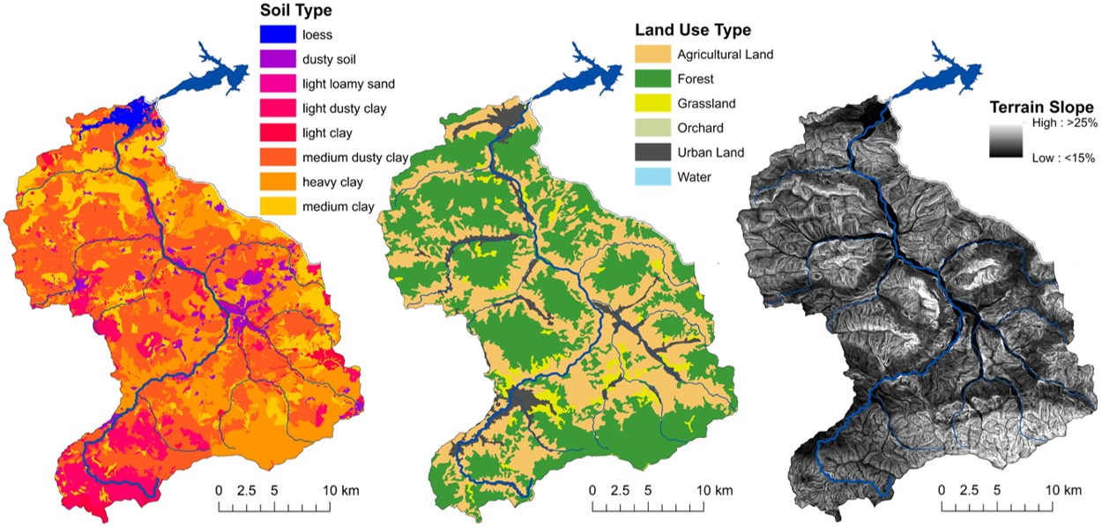
Figure S1. Slopes and distribution of soils and land use types in the upper Raba River catchment.

S2. Additional Details on Methods
S2.1. Modeling tool
The SWAT (Soil and Water Assessment Tool) model used in this study (2012 version) [12, 13] of the upper Raba River catchment was adopted from the model built for the entire Raba River catchment (1537 km²) divided by the Dobczyce Reservoir into upper and lower parts. To create this model an extensive and multi-source database has been used (Table S1).

Table S1. The Raba River baseline scenario input and calibration data.
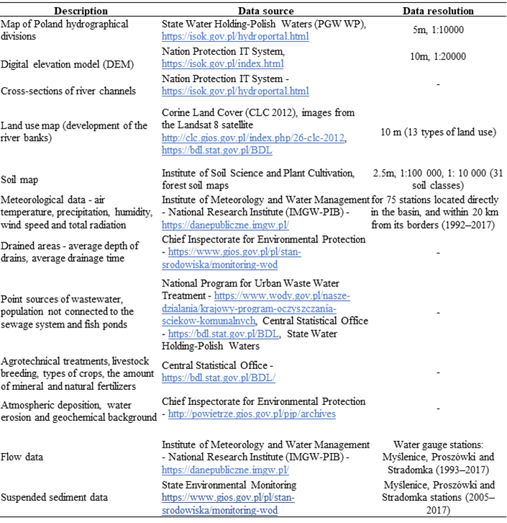

Both meteorological and hydrological data have been entered into the model for a period of 27 years (1991–2017). Information on precipitation, temperature, air humidity, wind speed, and total radiation came from 75 stations located directly in the catchment and within 20 km from its borders. Due to the fact that data from sewage treatment plants and surface water quality in Poland has been available since only 2005, the calibration and validation of the model, taking into account the sediment, could be carried out for a period of 13 years (2005-2017). The first two years of the simulation were used for the warm-up of the model.
Calibration, verification, and validation of the Raba River model was performed using the SWAT-CUP [14, 15] and the SUFI-2 algorithm [16, 17]. The Latin Hypercube (LH-OAT) was used to identify the most influential model parameters [18, 19]. Model calibration and validation were performed for the calculation profiles closing both parts of the catchment with the use of flow data obtained from the IMGW-PIB [20], and total suspended sediment concentrations from the Polish State Monitoring System [21]. Due to the fact that the state monitoring frequency is relatively low (12 times per year) the LOAD ESTimator program (LOADEST) was used to assist in development of the regression model for reliable estimation of constituent load (calibration). Model validation was performed for one of the Raba River right-bank tributaries, which is also subjected to flow and suspended sediment monitoring measurements.
To evaluate the fit of the model to the monitoring results, four statistical measures were used, determination coefficient (R²) [22], efficiency coefficient of the Nash-Sutcliffe model (NSE) [23], percentage of load (PBIAS) [24], and Kling-Gupta efficiency (KGE) [23] whose respective value ranges are shown in Table S2 .

Table S2. Classification of value ranges for statistical measures used during calibration, verification, and validation.
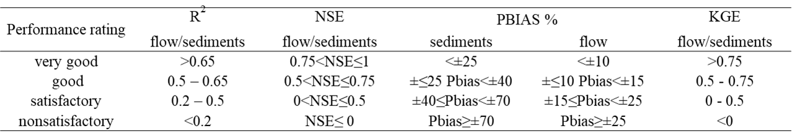
For the flow calibration statistical measures, R², NSE, and KGE classified the model performance as good and very good, and PBIAS obtained satisfactory values. Sediment calibration for the upper Raba River catchment indicated a satisfactory model performance according to R² and NSE, and very good and good according to PBIAS and KGE. Better results were obtained for the lower part of the catchment, where the efficiency of the model can be considered very good (R²) and good (NSE, PBIAS, and KGE). The validation of the flow model (according to R², PBIAS, and KGE) showed good performance of the model, while only NSE had obtained a satisfactory value. For sediments, according to R², NSE, and KGE, the efficiency of the model can be considered satisfactory and good according to PBIAS (Table S3).

Table S3. Calibration and validation results for monthly simulations for the Raba River module.
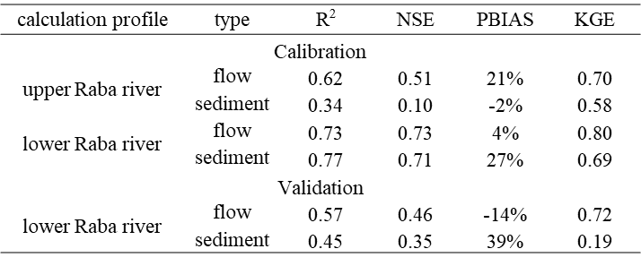

S2.2. Climate change projections
Climate change projections used in the study were adopted and implemented to further modeling as relative changes with a reference to historical climate conditions. Precipitation and temperature data were obtained from two historical meteorological data sources: i) station data from Kraków-Balice synoptic station [WMO 12566, 19°47'42''E, 50°04'40''N]; ii) E-OBS gridded data on a spatial resolution of 0.1° regular grid [v26e, https://surfobs.climate.copernicus.eu/dataaccess/access_eobs.php] which enabled further comparison of sediment loads estimated based on the point and areal approach.
For both point and areal reference data, two historical periods were taken into account: 30-year (1981-2010) and 10-year (2006-2015). To provide future climate information, CORDEX regional climate model data for European domain with 0.11° x 0.11° horizontal resolution (https://cds.climate.copernicus.eu) was used. Future projections were calculated for two time horizons: near (2026-2035) and far (2046-2055) future and for two greenhouse gas concentration trajectories (Representative Concentration Pathways): RCP 4.5 and RCP 8.5. 14 GCM-RCM model pairs available in the Euro-CORDEX repository were taken into account (Table S4).

Table S4. GCM-RCM model pairs applied in the current study
GCM model name | RCM model name | Ensemble member | Model abbreviation*
CNRM-CERFACS-CM5 (France) | CCLM4-8-17 | r1i1p1 | CNRM_CLM
CNRM-CERFACS-CM5 (France) | ALADIN53 | r1i1p1 | CNRM_AL
CNRM-CERFACS-CM5 (France) | RCA4 | r1i1p1 | CNRM_SMHI
ICHEC-EC-EARTH (Ireland) | RACMO22E | r1i1p1  r12i1p1 | ICHEC_KNMI_r1  ICHEC_KNMI_r12
ICHEC-EC-EARTH (Ireland) | HIRHAM5 | r1i1p1 | ICHEC_DMI
ICHEC-EC-EARTH (Ireland) | CCLM4-8-17 | r1i1p1 | ICHEC_CLM
ICHEC-EC-EARTH (Ireland) | RCA4 | r1i1p1 | ICHEC_SMHI
IPSL-CM5A-MR (France) | WRF331F | r1i1p1 | IPSL_WRF
NCC-NorESM1-M (Norway) | HIRHAM5 | r1i1p1 | NCC_DMI
MPI-M-MPI-ESM-LR (Germany) | CCLM4-8-17 | r1i1p1 | MPI_CLM
MPI-M-MPI-ESM-LR (Germany) | REMO2009 | r1i1p1 | MPI_MPI
MPI-M-MPI-ESM-LR (Germany) | RCA4 | r1i1p1 | MPI_SMHI
MPI-M-MPI-ESM-LR (Germany) | WRF361H | r1i1p1 | MPI_WRF
* used in this study
The climate change projections for the point approach were sourced from the Development of Urban Adaptation Plans (UAP) for cities with more than 100,000 inhabitants in Poland [25, 26]. Kraków-Balice station (WMO 12566, 19°47'42''E, 50°04'40''N) was closest to the study area. The distance between the city and the outlet of the upper Raba River to the dammed reservoir (25 km) and altitude difference (150 m) permitted usage of this data without necessity of any transposition; according to both the World Meteorological Organization (WMO), and IMGW-PIB recommendations [27-29]. To calculate future projections for a point location, statistical downscaling [30-33] was performed using the tools available in the R environment [34]. These projections have been validated using the 2006-2015 reference period. Final analyses were conducted using multi-model ensembles for each scenario (RCP 4.5 and RCP 8.5) and each time horizon (2026-2035 and 2046-2055) separately: P10e451, P10e452, P10e851, and P10e852.
Gridded data scenarios for the areal approach were prepared using E-OBS daily precipitation and temperature data for the area 19.75-20.55E and 49.45-50.15N (Fig.1). Monthly precipitation totals and mean temperature values were downscaled to a fine resolution of 1 km using bilinear interpolation for precipitation and multiple regression models for temperature and used to calculate areal means for the Raba River basin for two historical reference periods (1981-2010 and 2006-2015).
Before being effectively used, all the RCMs were downscaled to finer resolution using the change factor method. Multi-year monthly means of air temperature and precipitation totals were calculated for the reference period (1981-2005 - historical experiment of all climate models), and future periods (2026-2035 and 2036-2055). All projected monthly data were calculated as anomalies relative to the baseline period. The additive model for temperature and multiplicative for precipitation were used [35]. The change factor method reduces the impact of model bias on future projection results to a minimum. Finally, the anomalies were bilinearly interpolated to 1 km resolution [5].
Final analyses were conducted using multi-model ensembles for each scenario (RCP 4.5 and RCP 8.5) and each time horizon (2026-2035 and 2046-2055) separately, and for two reference periods, i.e. 2006-2015 and 1981-2010: A10e451, A10e452, A10e851, and A10e852; and ii) for a 30-year reference period: A30e451, A30e452, A30e851, and A30e852.
To distinguish dry and wet sub-ensembles from the 14-model ensemble, precipitation, regarding its decisive impact on initiation and transport of soil particles, was taken into account as the source of such discrimination. To choose dry and wet models to compile sub-ensembles the relative monthly change calculated using historical model simulations and the reference E-OBS data was taken into account according to eq. 1.
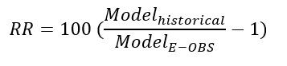 [1]
Using the probabilistic method, anomaly dry (RR<25th percentile, i.e. 1.1%) and wet (RR>75th percentile, i.e. 39.2%) months were indicated for each model (Table S5) followed by the annual mean value of the calculated deviations. Finally, extreme 4 dry models and 4 wet models were distinguished and used to calculate wet and dry sub-ensembles. It needs to be emphasized that models with a wide intra annual range were excluded from the final choice (CNRM_CLM – close to being a dry model, and IPSL_WRF – well placed among wet models).

Table S5. Deviations of projected monthly precipitation totals from the reference values (RR in %) (1981-2010, areal mean). Wet and dry simulations and sub-ensembles indicated in colors: blue and yellow, respectively.
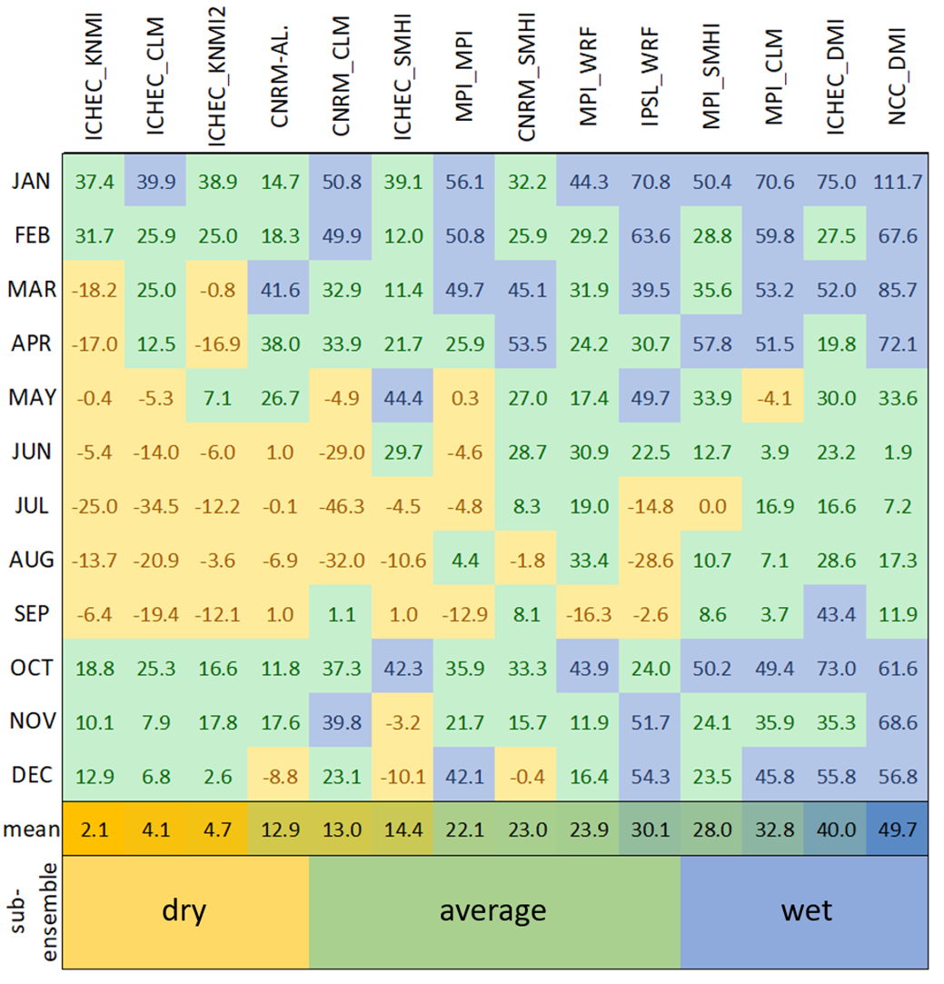

S2.3. Precipitation changes in variant scenarios
Precipitation changes in all adopted scenarios are presented as relative (%) and absolute (mm) monthly changes compared to average monthly values for the 10- and 30-year reference periods (2006-2015 and 1981-2010). Absolute values were inserted into the model as monthly change rates in accordance with the delta change method used. The complete precipitation output data, resulting from the SWAT model simulations for all variant scenarios have been presented in the Mendeley dataset (https://data.mendeley.com/datasets/g58vhcykcj/2).
For the point approach, regardless of the selected scenario and time horizon, the largest changes can be expected in December and April (an increase of up to 70-80% - approx. 22 mm on average). On the other hand, from May to September, a decrease in rainfall is expected, which in August will amount to over 25% (over 8 mm on average) (Fig. S2).

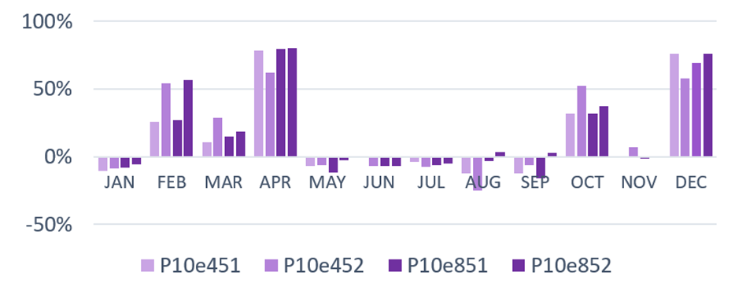
Figure S2. Projected changes of monthly precipitation totals relative to 2006-2015 – point data (P) ensemble approach
Changing from a point to areal approach with the same reference period will result in an increased precipitation in all months of the year (in April and December by almost 15 and 40% - approx. 25 and 21 mm, respectively) compared to the point approach (Fig. S3). At the same time, only May and September will remain the months in which slight decreases in precipitation should be expected, by a maximum of over 6% - about 8 mm.
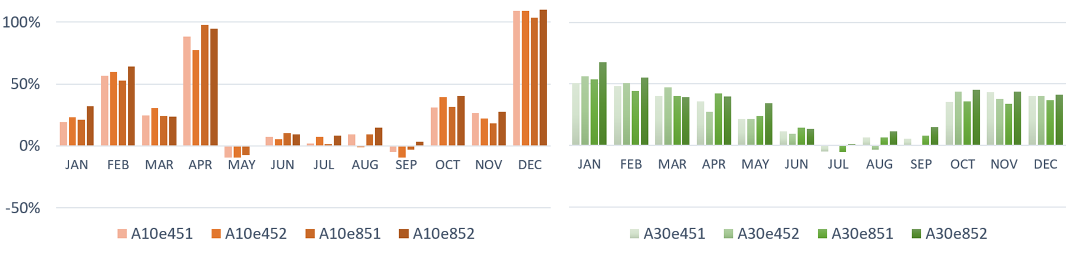
Figure S3. Projected changes of monthly precipitation totals relative to 2006-2015 (left panel) and 1981-2010 (right panel) – areal data (A) ensemble approach.
The extension of the reference period causes a significant change in the monthly rainfall distribution. The highest values characterize the autumn and winter months (maximum slightly over 67% - 28 mm in January) (Fig. S3). In turn, from July to September, depending on the scenario, precipitation drops by almost 6% - about 8 mm.
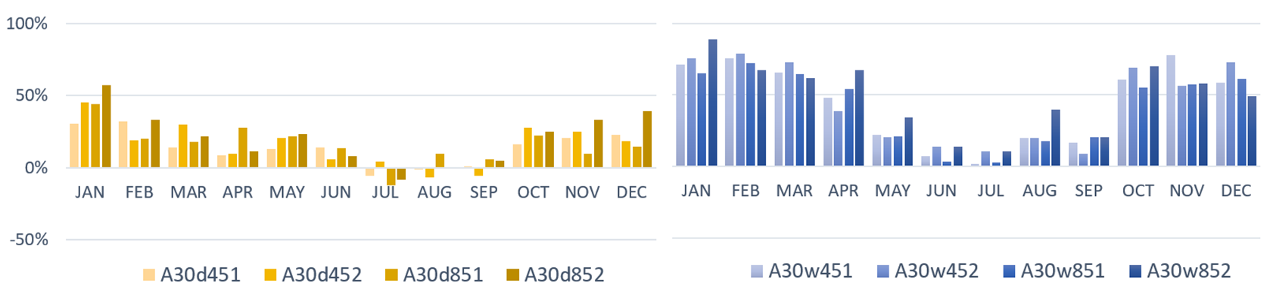
Figure S4. Projected changes of monthly precipitation totals relative to 1981-2010 - areal data for wet (left panel) and dry models sub-ensembles (right panel).
The last two figures show the effect of using only sub-ensembles consisting of four wet or dry models selected by the probabilistic method described in section S2.2. (Table S5). This approach results in extreme rainfall values varying on average by as much as 28% - 15 mm per year (Fig. S4).
S3. Supplementary results
Sediment loads for the calculation profile (delivered into the reservoir) for all variant scenarios used in the current study are presented as monthly (t/m) and yearly (t/y) values in Table S6, and also Mendeley dataset (https://data.mendeley.com/datasets/g58vhcykcj/2).

Table S6. Monthly (t/m) and yearly sediment (sum, t/y) loads for all 20 variant scenarios used in the study.
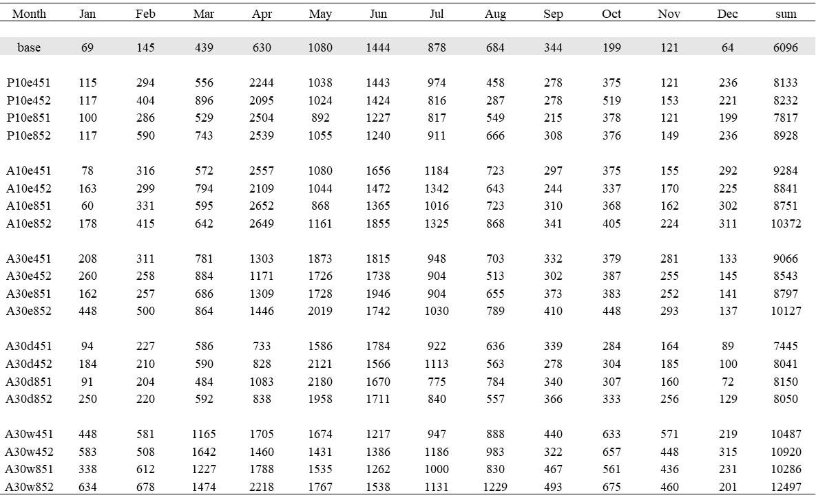

To depict differences between precipitation values in the month of April, in selected reference periods between 1966 and 2023, average monthly precipitation values have been presented in graphical form (Fig. S5) and compared statistically. The average value for the month of April in the period 2006-2015 was noticeably lower than in other periods, although not statistically significant (Kruskall-Wallis, p>0.05).

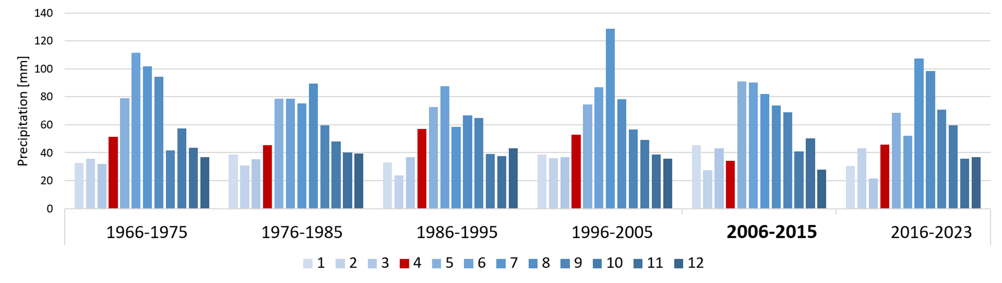
Figure S5. Average monthly precipitation values for the decadal periods between 2016 and 2015, and period of 2016-2023, for the point approach (Kraków-Balice synoptic station).
S4. SI References

- Orlińska-Woźniak, P., Szalińska, E. & Wilk, P. Do land use changes balance out sediment yields under climate change predictions on the Sub-Basin scale? The Carpathian Basin as an example. Water 12(5), 1499 (2020).
- Wilk, P. et al. From the source to the reservoir and beyond - tracking sediment particles with modeling tools under climate change predictions (Carpathian Mts.). J. Soil. Sediment. 22(11) 2929-2947 (2022).
- Kijowska-Strugała, M., Wiejaczka, Ł., Gil, E., Bochenek, W. & Kiszka, K. The impact of extreme hydro-meteorological events on the transformation of mountain river channels (Polish Flysch Carpathians). Z. Geomorphol. 61(1), 75-89 (2017).
- Halecki, W., Kruk, E. & Ryczek, M. Loss of topsoil and soil erosion by water in agricultural areas: A multi-criteria approach for various land use scenarios in the Western Carpathians using a SWAT model. Land Use Policy, 73, 363-372 (2018).
- Wypych, A., Ustrnul, Z. & Schmatz, D. R. Long-term variability of air temperature and precipitation conditions in the Polish Carpathians. J. Mt. Sci. 15(2), 237-253 (2018).
- Kędra, M. & Szczepanek, R. Land cover transitions and changing climate conditions in the Polish Carpathians: Assessment and management implications. Land Degrad. Dev. 30(9), 1040-1051 (2019).
- Wypych, A., Sulikowska, A., Ustrnul, Z. & Czekierda, D. Variability of growing degree days in Poland in response to ongoing climate changes in Europe. Int. J. Biometeorol. 61, 49-59 (2017).
- Kędra, M. Altered precipitation characteristics in two Polish Carpathian basins, with implications for water resources. Clim. Res. 72(3), 251-265 (2017).
- Gorczyca, E., Krzemień, K., Sobucki, M. & Jarzyna, K. Can beaver impact promote river renaturalization? The example of the Raba River, southern Poland. Sci. Total Environ. 615, 1048-1060 (2018).
- Twardosz, R. & Cebulska, M. Temporal variability of the highest and the lowest monthly precipitation totals in the Polish Carpathian Mountains (1881–2018). Theor. Appl. Climatol. 140, 327-341 (2020).
- Walanus, A., Cebulska, M. & Twardosz, R. Long-term variability pattern of monthly and annual atmospheric precipitation in the polish carpathian mountains and their Foreland (1881–2018). Pure Appl. Geophys. 178(2), 633-650 (2021).
- Tamm, O., Maasikamäe, S., Padari, A. & Tamm, T. Modelling the effects of land use and climate change on the water resources in the eastern Baltic Sea region using the SWAT model. Catena, 167, 78-89 (2018).
- Marin, M. et al. Assessing the vulnerability of water resources in the context of climate changes in a small forested watershed using SWAT: A review. Environ. Res. 184, 109330 (2020).
- Abbaspour, K.C. Swat-cup 2012. SWAT calibration and uncertainty program - A user manual, (2013)
- Hosseini, S. H. & Khaleghi, M. R. Application of SWAT model and SWAT-CUP software in simulation and analysis of sediment uncertainty in arid and semi-arid watersheds (case study: The Zoshk–Abardeh watershed). Model. Earth Syst. Environ. 6(4), 2003-2013 (2020).
- Houshmand Kouchi, D. et al. Sensitivity of calibrated parameters and water resource estimates on different objective functions and optimization algorithms. Water, 9(6), 384 (2017).
- Brighenti, T. M. et al. Two calibration methods for modeling streamflow and suspended sediment with the swat model. Ecol. Eng. 127, 103-113 (2019).
- Jaiswal, R. K., Nayak, T. R., Jain, S. K. & Lohani, A. K. Application of RS data for reservoir sediment profiling using latin hypercube-one at time (LH-OAT) technique. Int. J. Adv. Agric. Aci. Technol. 4(8), 10-17 (2017).
- Pan, J., Zhang, W., Liu, Z., Shi, X. & Chen, Z. Application of improved multi-coupling model based on LH-OAT method in water environment simulation. Desalin. Water Treat. 269, 238-248 (2022).
- IMGW, data from the monitoring of the flow rate in the Raba river catchment, http://danepubliczne.imgw.pl/api/data/hydro/ (2021)
- PSMS - Polish State Monitoring System - data on suspended sediment concentrations in the Raba river, http://www.gios.gov.pl/en/ (2021)
- Chicco, D., Warrens, M. J. & Jurman, G. The coefficient of determination R-squared is more informative than SMAPE, MAE, MAPE, MSE and RMSE in regression analysis evaluation. Peer. J. Comput. Sci. 7, 623 (2021).
- Knoben, W. J., Freer, J. E. & Woods, R. A. Inherent benchmark or not? Comparing Nash–Sutcliffe and Kling–Gupta efficiency scores. Hydrol. Earth Syst. Sc. 23(10), 4323-4331 (2019).
- Berhanu, B., Seleshi, Y., Demisse, S. S. & Melesse, A. M. Bias correction and characterization of climate forecast system re‐analysis daily precipitation in Ethiopia using fuzzy overlay. Meteorol. Appl. 23(2), 230-243 (2016).
- Dumieński, G., Lisowska, A. & Tiukało, A. Climatic hazards of 44 polish cities based on urban plans for adaptation to climate change. In: Chojnacka-Ożga, L., Lorenc, H. (Eds.), Contemporary Problems of Polish Climate, IMGW-PIB. 189–201 (2019) (in Polish).
- MPA. Development of urban adaptation plans for cities with more than 100,000 inhabitants in Poland. http://44mpa.pl/project-background/?lang=en (2020).
- Derek, P. et al. Instructions for Meteorological Stations. Institute of Meteorology and Water Management - National Research Institute (2014). (in Polish).
- WMO. World Meteorological Organization. WMO guidelines on the calculation of climate normals. WMO-No. 1203 https://library.wmo.int/records/item/55797-wmo-guidelines-on-the-calculation-of-climate-normals (2017).
- WMO. World Meteorological Organization. Guide to Instruments and Methods of Observation (WMO-No. 8) https://library.wmo.int/idurl/4/41650 (2021)
- Luo, Q. Necessity for post-processing dynamically downscaled climate projections for impact and adaptation studies. Stoch. Env. Res. Risk A. 30, 1835-1850 (2016).
- Eum, H. I. & Cannon, A. J. Intercomparison of projected changes in climate extremes for South Korea: application of trend preserving statistical downscaling methods to the CMIP5 ensemble. Int. J. Climatol. 37(8), 3381-3397 (2017).
- Vannitsem, S., Wilks, D. S. & Messner, J. (Eds.). Statistical postprocessing of ensemble forecasts. Elsevier. (2018).
- Iturbide, M. et al. The R-based climate4R open framework for reproducible climate data access and post-processing. Environ. Modell. Softw. 111, 42-54. (2019).
- R. The R project for statistical computing. https://www.r-project.org (2023).
- Anandhi, A., Frei, A., Pierson, D.C. et al. Examination of change factor methodologies for climate change impact assessment. Water Resour. Res. 47, 03501 (2011).

