Supplementary Information

In the Supplementary Information we present all relevant figures, photos, plots, tables etc. not contained by the main article file.

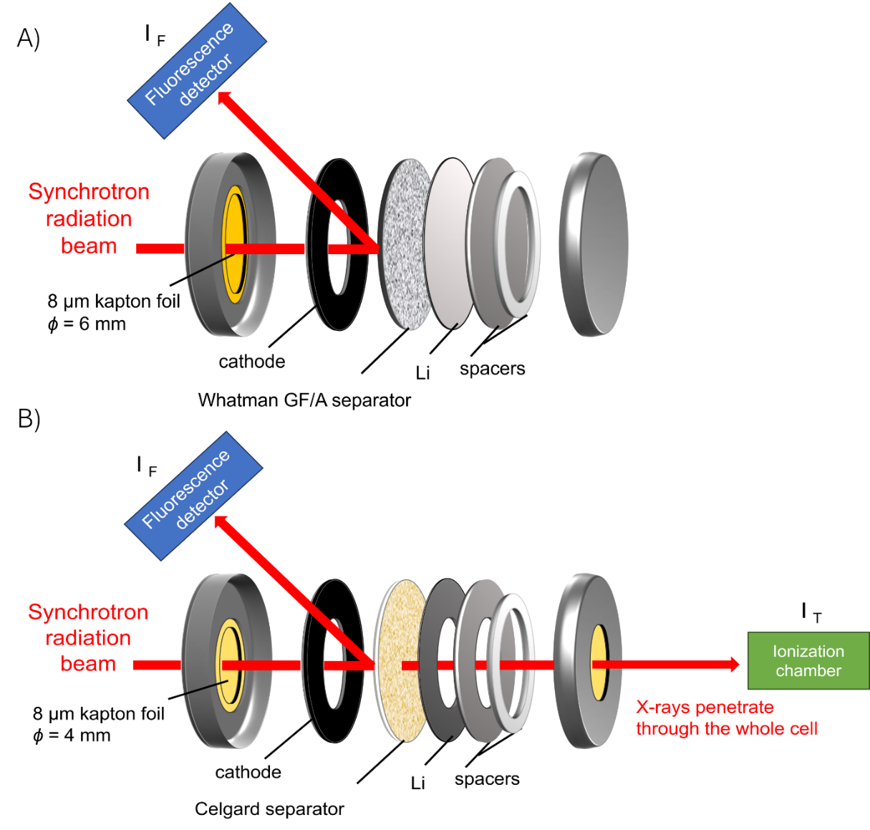
Figure S1 A) Original cell design: Tender energy X-rays can penetrate through the thin Kapton foil. Sulfur is detectable, but the whole volume of the separator is not illuminated here. Only XAS measurements in fluorescence are possible. B) Modified cell: Tender energy X-rays can penetrate through the thin Kapton foils and the thin separator. We can see the whole volume of the cell and detect the absorption signals directly.

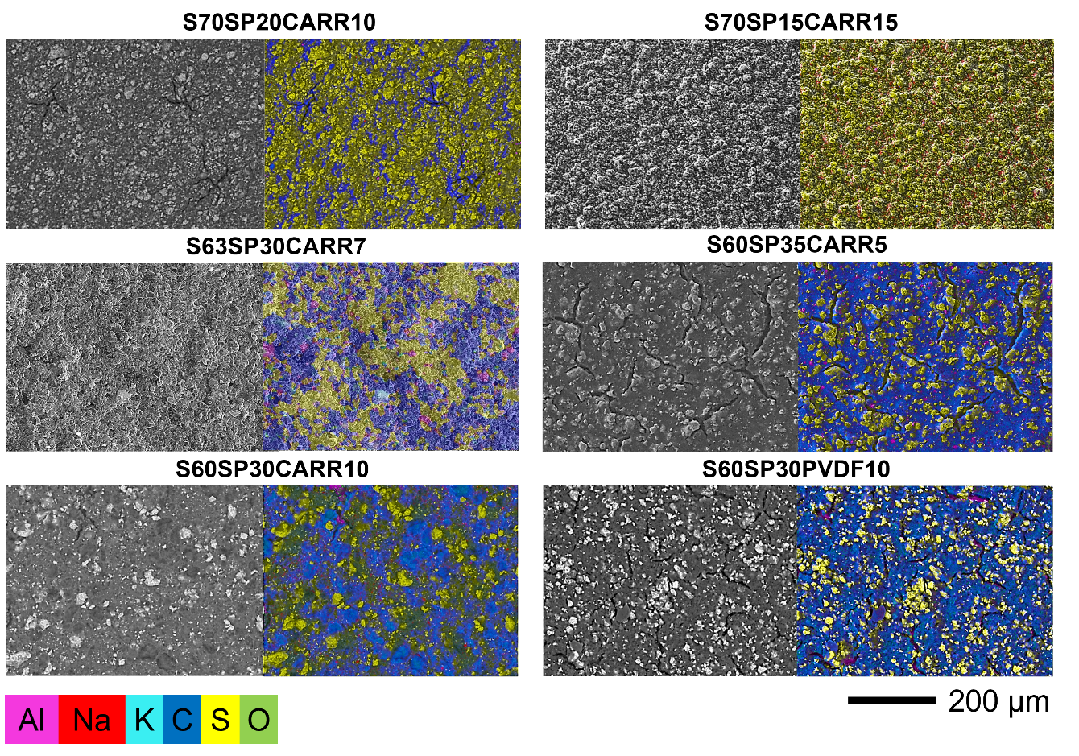
Figure S2 SEM and EDS elemental maps of the different carrageenan and PVdF - containing samples.
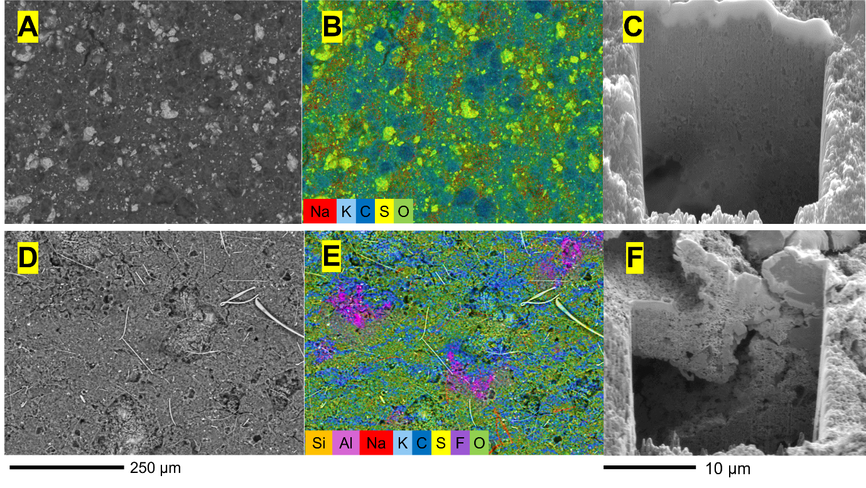
Figure S3 FIB-SEM analyses before electrochemical cycling A) as-prepared S60SP30CARR10 electrode, B) EDS elemental map of the corresponding area, C) FIB cross sectional image; FIB-SEM analyses after electrochemical cycling D) S60SP30CARR10 electrode after 250 cycles, E) EDS elemental map of the corresponding area F) FIB cross sectional image.
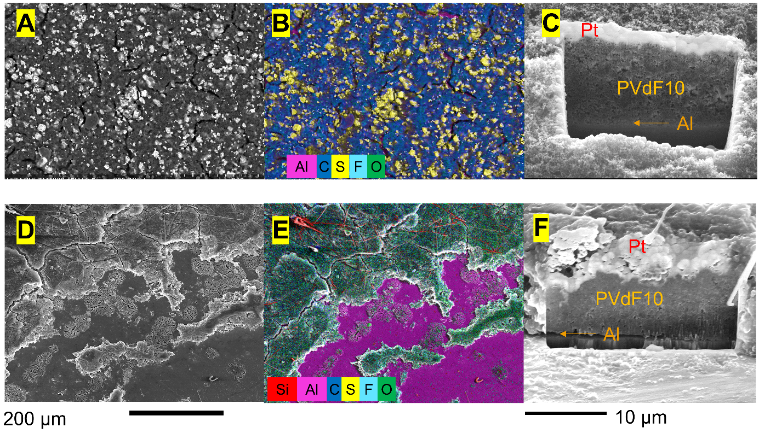
Figure S4 FIB-SEM analyses before electrochemical cycling A) as-prepared S60SP30PVDF10 electrode, B) EDS elemental map of the corresponding area, C) FIB cross sectional image; FIB-SEM analyses after electrochemical cycling D) S60SP30PVDF10 electrode after 250 cycles, E) EDS elemental map of the corresponding area F) FIB cross sectional image.

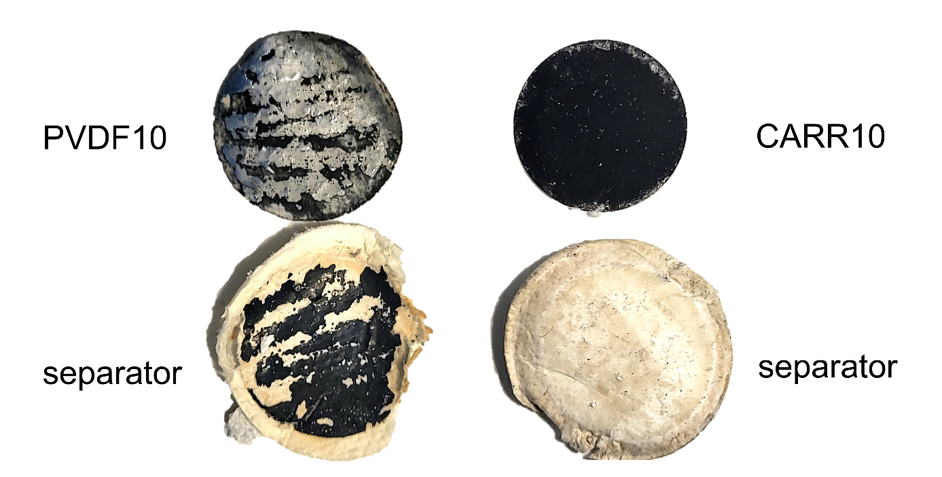
Figure S5 Photographs of the PVDF10 and CARR10 electrodes and separators from the disassembled cells after 250 cycles.

Table S1. Surface composition data determined by XPS for S60SP30CARR10 (initial state), S60SP30PVDF10 (initial state) and a reference Carbon Black - SuperP (in wt.%)

Sample | S60SP30CARR10 | S60SP30PVDF10 | Carbon Black
Element
C | 48.2 | 75.8 | 99.1
O | 34.7 | 1.2 | 0.4
S | 9.9 | 0.9 | --
Na | 4.2 | -- | 0.3
K | 3.0 | -- | --
F | -- | 22.0 | 0.1

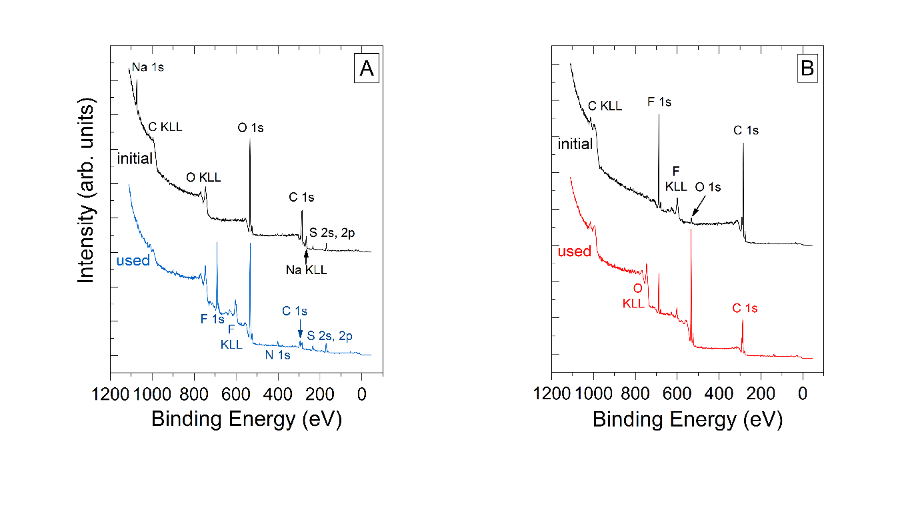

Figure S6. Survey spectra of the cathodes in the initial and the used state with (A): carrageenan and (B): PVDF binder.

Table S2 XPS results for the S60SP30CARR10 cathode – initial state.
CARR10, before cycling
Element/  peak | Binding  energy (eV) | Chemical state, relative contribution | Concentration  (atomic %)
C 1s  O 1s  S 2p  Na 1s  K 2p_{3/2} | 284.4  287.2-287.3  288.5-289.0  532.9  533.9  164.3  169.6  1072.8  293.9 | graphitic carbon (50-60%)  -OH, C-O-C (from carrageenan)  O-C-O, C-OSO₃ (from carrageenan)  Carrageenan: ~ 40-50% of the total C signal  -OH, C-O-C  O-C-O-like groups and sulphate groups  elemental or carbon-bound sulfur (1%)  sulfate (SO₄) (99%)  ionic Na  ionic K | C: 59.4  O: 32.1  S: 4.6  Na: 2.7  K: 1.2

Table S3 XPS results for the CARR10 cathode – after cycling.

CARR10, after 250 cycles
Element/  peak | Binding  energy (eV) | Chemical state, relative contribution | Concentration  (atomic %)
C 1s  O 1s  S 2p  Na 1s  K 2p_{3/2}  Li 1s  F 1s  N 1s | 284.4  285.3  287.0  288.7  290.3  293.2  531.9  533.2  534.8  160.1  162.0  167.4  169.8  1072.3  293.9  55.6  685.3  689.2  397.6  399.7  403.4 | graphitic carbon (0-10%)  hydrocarbons (15-25%)  -OH, C-O-C (from carrageenan)  O-C-O, maybe C-OSO₃ (from carrageenan, weak)  carbonate (Li₂CO₃, Li-alkyl-carbonates, 30%)  -CF₃ in TFSI (25%)  Carrageenan: some 20% of the total C signal  LiOH, Li-carbonates (60%)  C-OH, alkoxide, carboxylic, lactone, ether, sulfate groups (37%)  moisture (3%)  sulfide (Li₂S)  polysulfide (sulfides <10%, rapidly decreasing)  sulfite (15->25%, some increase during measurement)  sulfate (SO₄), S in TFSI (75%)  ionic Na  ionic K  LiF, Li₂CO₃/Li-alkyl-carbonates, LiOH, maybe sulfide  (Li)-fluoride (14%)  -CF₃ in TFSI (86%)  nitride, cianide (10%)  TFSI (83%)  -NO₂ (7%) | C: 12.6  O: 32.6  S: 6.8  Na: 0.3  K: 1.6  Li: 28.1  F: 15.2  N: 2.8

Table S4 XPS results for the S60SP30PVDF10 cathode – initial state.

S60SP30PVDF10, before cycling
Element/  peak | Binding  energy (eV) | Chemical state, relative contribution | Concentration  (atomic %)
C 1s  O 1s  S 2p  F 1s | 284.4  286.3  290.7  531.6  533.1  164.0  687.9  689.8 | graphitic carbon (85%)  -OH, C-O-C, -CH2 in PVDF (7%)  -CF₂ in PVDF (8%)  l  carbonyl, epoxide groups (46%)  carboxylic, lactone or ether groups (54%)  elemental or carbon-bound sulphur  F in PVDF (95%)  F in PVDF, different interaction? (5%) | C: 83.3  O: 1.0  S: 0.4  F: 15.3

Table S5 XPS results for the S60SP30PVDF10 cathode –used state.
S60SP30PVDF10, after 250 cycles
Element/  peak | Binding  energy (eV) | Chemical state, relative contribution | Concentration  (atomic %)
C 1s  O 1s  S 2p  N 1s  F 1s  Li 1s  P 2p | 285.9  287.5  289.6  291.1  532.9  534.4  --  --  687.9  53.4  56.4  137.9 | -OH, C-O-C, -CH2 in PVDF (33%)  carbonyl, alkoxide, -CHF-(CH2)-(40%)  carboxyl, ester (6%)  -CF₂ in PVDF, carbonates (21%)  alkoxide, carboxylic, lactone or ether groups (71%)  carbonate, moisture (29%)  not detected  not detected  F in PVDF  oxide (13%)  Li-alkoxide, Li-carbonate, LiPFO (87%)  PF_{x} | C: 35.8  O: 32.2  S: 0.0  N: 0.0  F: 5.7  Li: 25.1  P: 1.2

Supplementary Note 1 – Electrochemical Impedance Spectroscopy study
In order to understand the diffusion properties of the different carrageenan containing electrodes, EIS measurements were performed. As the lithium itself would have a large contribution to the impedance of the cell, symmetric coin cells composed of two identical sulfur electrodes were used for the EIS measurements according to the practice can be found in the literature [1], [2].
The impedance spectra were recorded from 100 kHz-10 mHz frequency range in all cases with the application of 10 mV sinusoid perturbation and the data points were collected 9 point per decade frequency step.
The applied model describes the system at the high frequency region with a resistance (R_{s}) which corresponds to the solution resistance. The high to medium frequency semicircle is not correlated in this case with a charge transfer reaction. Analogous to the work of Seid [3] and Walus [4], we can assume that clusters are formed by sulfur particles bound by the carbon particles and the binder. Since this is a local phenomenon and the distances that the electrons must travel are very small (in the range of 10⁻⁶ m), the characteristic time constant of this phenomenon is in the high to medium frequency range. This “semicircle” can be described with a resistance R in parallel with a constant phase element (Q) with the exponent α.
$$\begin{aligned}Z_{R+RQ}=R_{s}+ \frac{R}{{RQ(j2πf)}^{α}+1}\#\left(\text{ seq equation}\text{1}\right)\end{aligned}$$
For the description of the high-frequency part of the spectra an anomalous linear diffusion impedance element (Z_{diff}) was introduced [5], [6], [7], [8], [9]:
$$\begin{aligned}Z_{diff}\left(f\right)= R_{d}\frac{{coth⁡(τ_{d}j2πf)}^{γ/2}}{{\left(τ_{d}j2πf\right)}^{1-γ/2}}\#\left(\text{ seq equation}\text{2}\right)\end{aligned}$$

Where $τ_{d}$ is the diffusion time constant in s, and R_{d} is the resistance associated with the linear diffusion mechanism. It should be noted that $τ_{d}$ is directly related to the diffusion coefficient D_{x} by:
$$\begin{aligned}τ_{d}= \frac{δ^{2}}{D_{x}}\#\left(\text{ seq equation}\text{3}\right)\end{aligned}$$
where δ is the thickness of the electrode in which the species x with a diffusion coefficient D_{x} is inserted.
The full impedance equation of the symmetrical cell can be described as:
$$\begin{aligned}Z_{total}= Z_{R+RQ}+ Z_{diff}=Rs+ \frac{R}{{RQ(j2πf)}^{α}+1}+R_{d}\frac{{coth⁡(τ_{d}j2πf)}^{γ/2}}{{\left(τ_{d}j2πf\right)}^{1-γ/2}}\#\left(\text{ seq equation}\text{4}\right)\end{aligned}$$
The calculated impedances are listed in Table S6 and the time constants with the D_{x} values are shown in Table S7.

Table S6 CNLS fitting results of the different samples measured in symmetric cells.
sample name | CARR5 |  | CARR7 |  | CARR10
parameters | value | error | value | error | value | error
R_{s} [Ohm] | 12.47 | 0.1 | 3.51 | 0.09263 | 5.86 | 7.40·10⁻²
R [Ohm] | 246.1 | 2.55 | 142.1 | 0.6555 | 20.2 | 1.02·10⁻¹
Q [F·s ^{α- 1}] | 1.36·10⁻⁶ | 3.53·10⁻⁸ | 4.09·10⁻⁶ | 2.58·10⁻³ | 1.08·10⁻⁶ | 3.86·10⁻⁸
α | 0.98 | 1.55·10⁻³ | 0.8324 | 2.58·10⁻³ | 0.88 | 1.70·10⁻³
R_{d} [Ohm] | 13886.56 | 47.67 | 10377 | 24.85 | 1590 | 6.96
t [s] | 12.86 | 0.624 | 7.365 | 0.1891 | 1.70 | 1.80·10⁻²
γ | 0.798 | 4.51·10⁻³ | 0.2431 | 1.89·10⁻³ | 0.6088 | 9.14·10⁻³
sample name | CARR10b |  | CARR15 |  | PVDF10
parameters | value | error | value | error | value | error
R_{s} [Ohm] | 8.48 | 0.234 | 6.90 | 0.2271 | 27.69 | 0.78
R [Ohm] | 62.4 | 4.63·10⁻³ | 160.2 | 0.8525 | 280.9 | 2.765
Q [F·s ^{α- 1}] | 8.17·10⁻⁷ | 7.67·10⁻⁸ | 1.28·10⁻⁶ | 3.70·10⁻⁸ | 1.67·10⁻⁵ | 1.68·10⁻⁷
α | 0.8962 | 4.63·10⁻³ | 0.8534 | 2.81·10⁻³ | 0.59 | 7.13·10⁻⁵
R_{d} [Ohm] | 7849.5 | 253.8 | 11324.5 | 405.1 | 2649 | 26.2
t [s] | 9.13 | 0.6798 | 13.48 | 1.311 | 3.89 | 0.041
γ | 0.4994 | 1.41·10⁻⁵ | 0.474 | 9.35·10⁻⁴ | 0.6652 | 3.16·10⁻³

Table S7 Diffusion time constants and calculated diffusion coefficients from the CNLS fitting results for the PVDF and CARR samples.
sample | t [s] | D_{x} [cm² / s]
CARR5 | 12.86 | 1.12·10⁻⁵
CARR7 | 7.37 | 1.96·10⁻⁵
CARR10 | 1.70 | 8.45·10⁻⁵
CARR10b | 9.13 | 1.58·10⁻⁵
CARR15 | 13.48 | 1.07·10⁻⁵
PVDF10 | 3.945 | 7.40·10⁻⁵

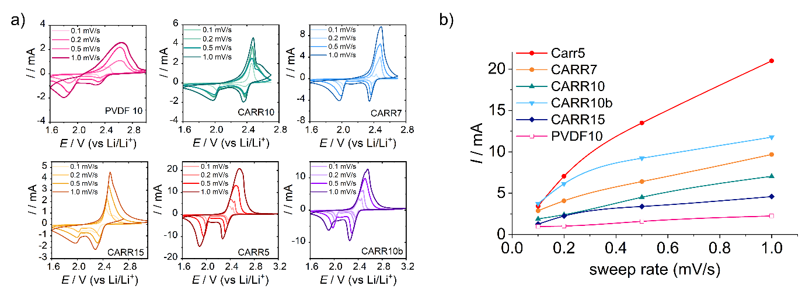
Figure S7 a) Cyclic voltammograms recorded at different sweep rates (0.1 mV/s, 0.2 mV/s, 0.5 mV/s, 1 mV/s) on the PVDF10, CARR10, CARR7, CARR15, CARR5 and CARR10b samples; b) peak currents of anode peaks for the samples shown in (a) at different speeds.

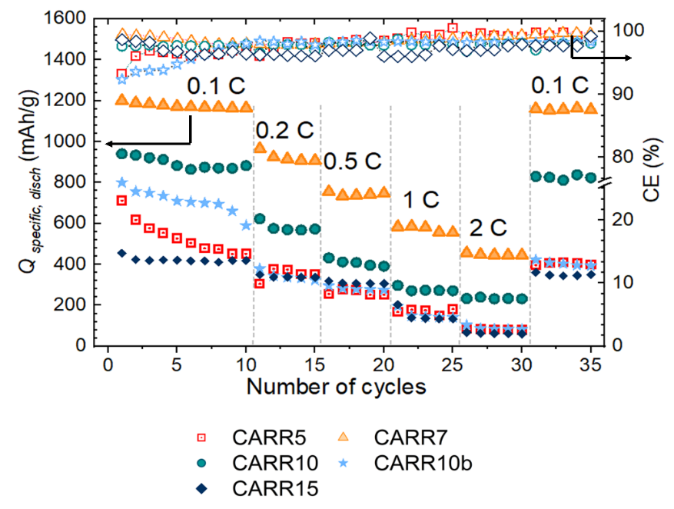
Figure S8 Changes in specific discharge capacity at different rates.

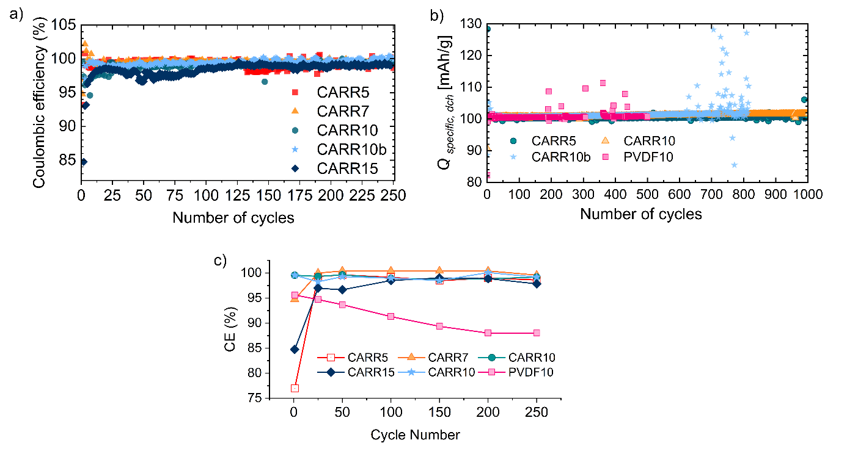
Figure S9 a) Coulombic efficiency values in case of 250 charge-discharge cycles at 0.1 C rate, b) CE values in case of 1000 cycles at 4C rate, c) the changes of the CE values with the cycle number in case of 0.1 C rate, 250 cycles.

Table S8 CE values at different cycle numbers in case of 0.1 C rate, 250 cycles.
 | 1st cycle | 25th cycle | 50th cycle | 100th cycle | 150th cycle | 200th cycle | 250th cycle
CARR5 | 77.00 | 99.29 | 99.61 | 99.14 | 98.47 | 98.99 | 98.61
CARR7 | 99.58 | 99.98 | 100.40 | 100.40 | 100.40 | 100.40 | 99.58
CARR10 | 99.55 | 99.32 | 99.63 | 98.92 | 98.73 | 98.84 | 99.17
CARR15 | 84.75 | 96.97 | 96.65 | 98.50 | 99.01 | 98.88 | 97.84
CARR10b | 99.55 | 98.24 | 99.26 | 98.97 | 98.49 | 100.08 | 99.05
PVDF10 | 95.61 | 94.70 | 93.68 | 91.29 | 89.36 | 88.01 | 88.01

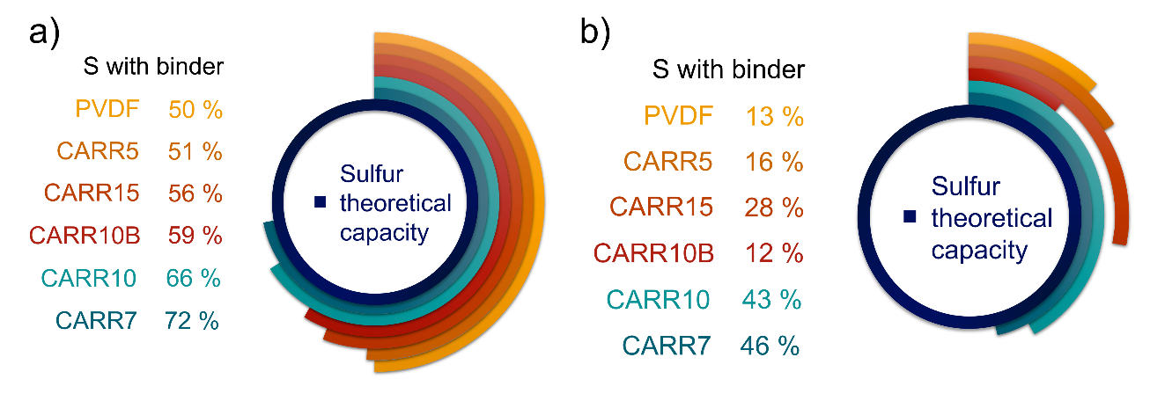
Figure S10 a) Sulfur utilization in the case of the initial cycles, b) sulfur utilization values after 250 cycles.

sample | binder | slurry prep | Q_{initial}  (mAh g⁻¹) | rate | cycles | Q  (mAh g⁻¹) | Q ret.(%) | Ref
S60SP30PVDF10 | PVdF | Mild milling  (~ 2h) | 934.5 | 0.1 C | 250 | 203 | 21.7 | present study
S60SP35CARR5 | carrageenan | Mild milling  (~ 2h) | 1274 | 0.1 C | 250 | 234.5 | 18.4 | present study
S63SP30CARR7 | carrageenan | Mild milling  (~ 2h) | 1260 | 0.1 C | 250 | 715.5 | 56.8 | present study
S60SP30CARR10 | carrageenan | Mild milling  (~ 2h) | 997.9 | 0.1 C | 250 | 685 | 68.6 | present study
S70SP15CARR15 | carrageenan | Mild milling  (~ 2h) | 896.7 | 0.1 C | 250 | 376 | 41.9 | present study
S70SP20CARR10 | carrageenan | Mild milling  (~ 2h) | 904.5 | 0.1 C | 250 | 173 | 19.1 | present study
S60SP30PVDF10 | PVdF | Mild milling  (~ 2h) | 188 | 4 C | sh. c. after 500 | 73.9 | 39.3 | present study
S60SP30CARR10 | carrageenan | Mild milling  (~ 2h) | 450 | 4 C | 1000  1000 | 311 | 69.1 | present study
S60SP35CARR5 | carrageenan | Mild milling  (~ 2h) | 75.9 | 4 C | 1000  1000 | 49.5 | 65.8 | present study
S70SP20CARR10 | carrageenan | Mild milling  (~ 2h) | 355 | 4 C | sh. c. after 814 | 136.6 | 38.48 | present study
S70SP20PVDF10 | PVdF | stirring for 20 h | 257 | 0.1 C | 250 | 119 | 46.3 | [9]
S60SP38PANI2 | PANI | Multi-step synthesis, 24 h stirring | 872 | 0.1 C | 50 | 439 | 50.3 | [10]
S55SP25GA20 | gum arabic | 140°C, 4 h, stirring | 1386 |  | 250 | 841 | 60.6 | [11]
S55SP25Gel20 | Gelatin | 140°C, 4 h, stirring | 1200 |  | 50 | 600 | 50 | [11]
S80SP15PVDF5 | PVdF | 155°C for 12 h, stirring | 813 |  | 250 | 392 | 48 | [1]
S80SP15TG5 | Tragach. Gum | 155°C for 12h, stirring | 1000 | 4 C | 1000 | 406 | 40.6 | [1]
S60SP30CSEG10 | chitosan sulfate ethylamide glycinamide | Melt diffusion, 155°C for 12 h + mixing | 835 | 1 C | 700 | 543 | 65 | [12]
S55SP35GG/XG10 | guar gum-xanthan gum | Melt diffusion, 155°C for 16h + stirring | ~1000 | 0.5 C | 150 | 724 | 72.4 | [13]
S60CB20APP20 | ammonium polyphosphate |  | 753 | 0.5 C | 400 | 640 | 84.9 | [14]
S70SP22Li-PBI8 | lithiated perylene bisimide | Melt diffusion, 155°C for 18h + stirring | 1000 | 0.5 C | 250 | 612 | 61.2 | [15]
S70SP20PGA10 | γ-polyglutamic acid | mixing | 991 | 0.2 C | 100 | 620 | 62.5 | [16]
S70SP20PVDF10 | PVdF | mixing | 845 | 0.2 C | 100 | 456 | 53.9 | [16]
S70SP20PVP10 | PVP | mixing | 769 | 0.2 C | 100 | 406 | 52.8 | [16]
S70SP20CMC10 | CMC | mixing | 764.1 | 0.2 C | 100 | 311 | 40.7 | [16]
S70SP20PAN10 | PAN | mixing | 706.8 | 0.2 C | 100 | 364 | 51.5 | [16]
S70SP20PEO | PEO | mixing | 628 | 0.2 C | 100 | 421 | 67 | [16]
Table S9 Comparison of the results of the present study of the literature (sample sulfur-carbon-binder ratio in the sample name, binder type, slurry preparation method, initial capacity (Q_{initial}), cycling rate, number of cycles, capacity after cycling, capacity retention, references)

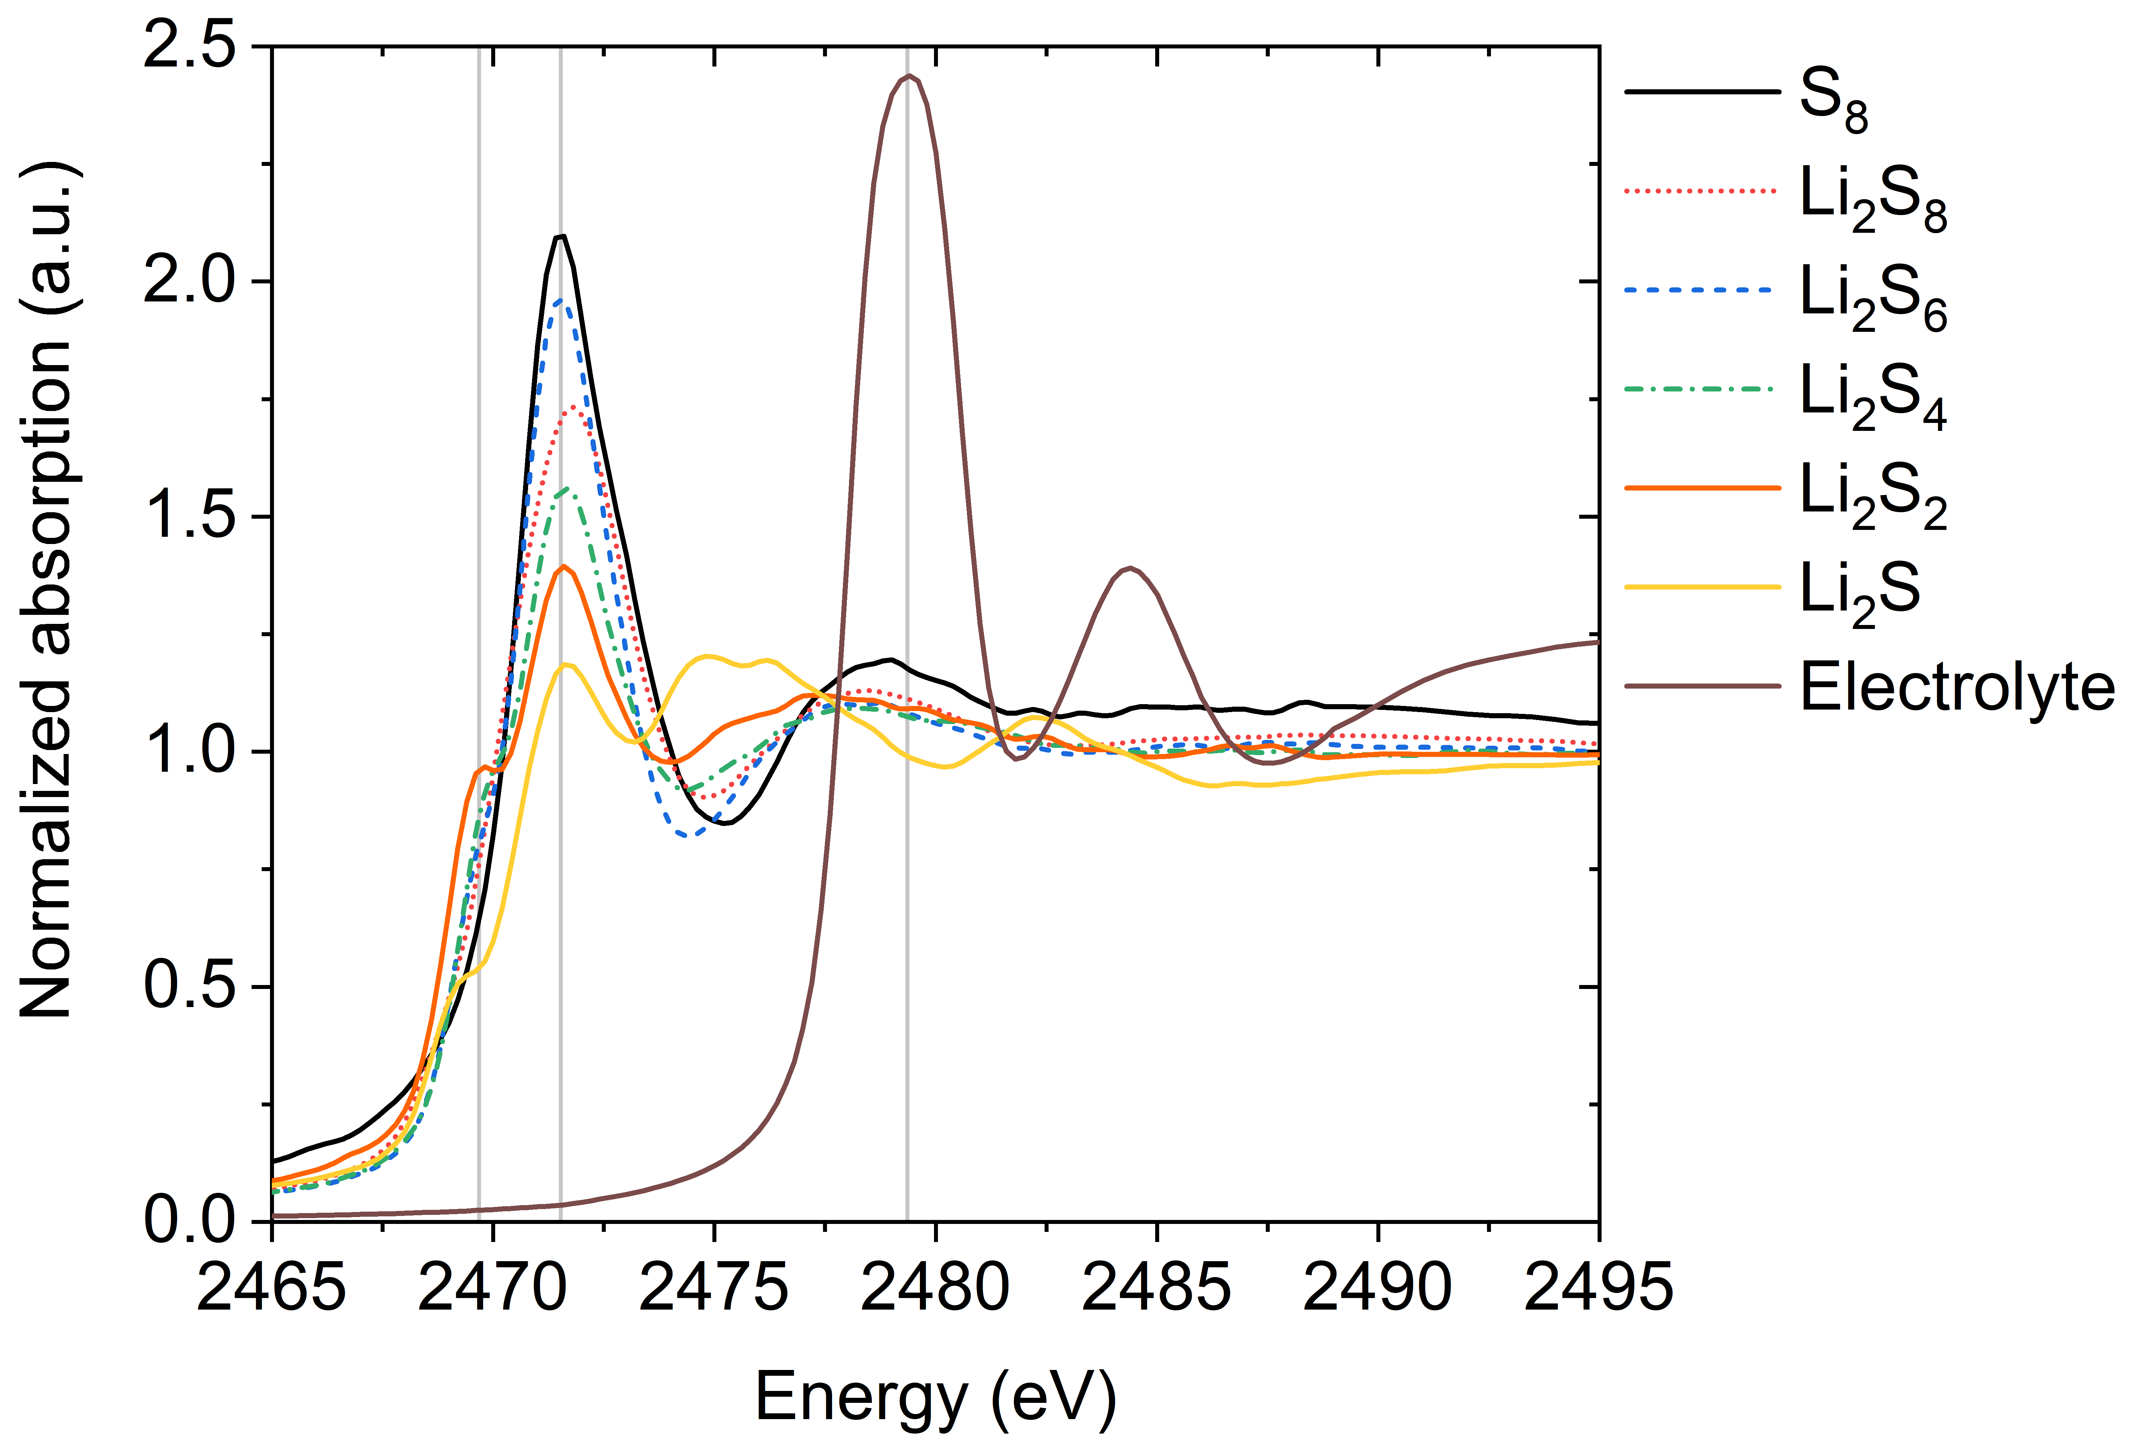
Figure S11 Sulfur K-edge XANES spectra of different lithium polysulfides (S²⁻), sulfur (S⁰) and the electrolyte (which contains S⁶⁺ oxidation state molecule, LiTFSI).

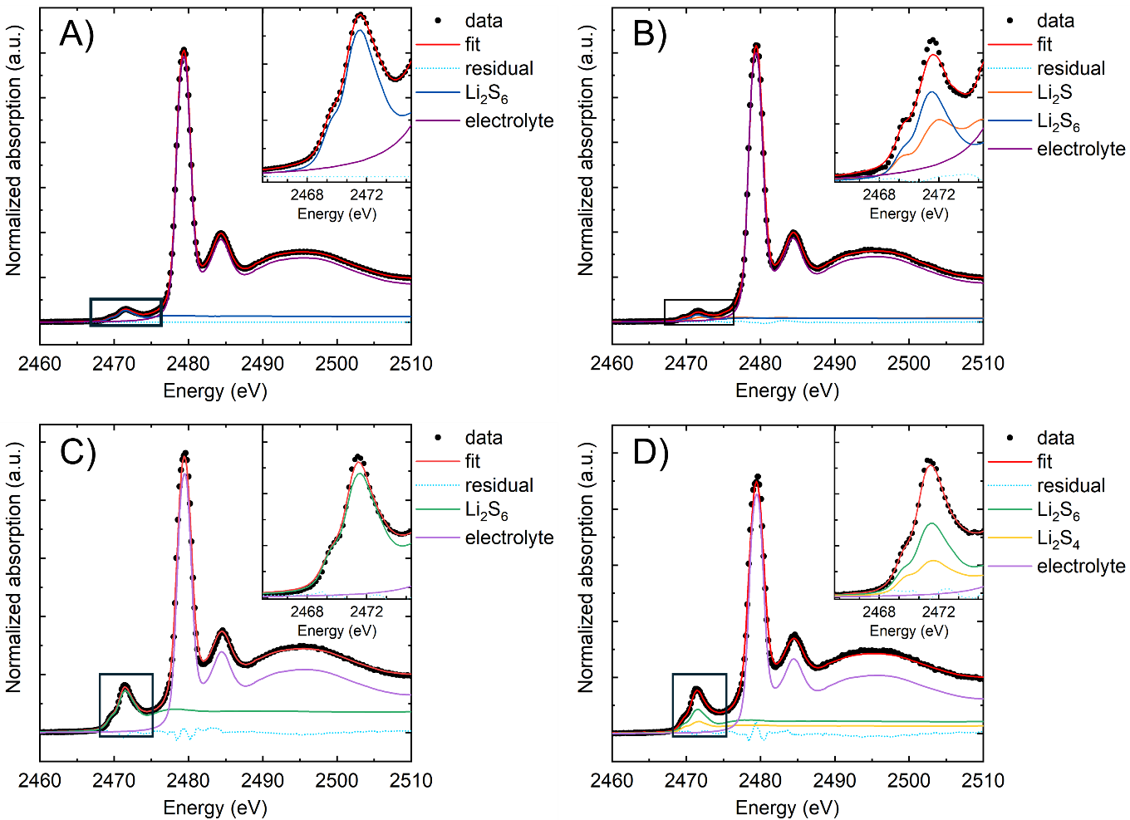

Figure S12 Sulfur K-edge XANES spectra of the 10 wt.% PVdF containing Li–S battery: A) initial state at 2.4 V (3rd spectrum), B) fully discharged state at 1.7 V, C) XANES spectra of the 10 wt.% carrageenan containing Li–S battery at 2.4 V (3rd spectrum) and D) fully discharged state at 1.7 V. The red line indicates the best fit best fit with linear combination of reference XANES profiles, plotted below. The inlets show in all cases the zoomed pre-edge and S K-edge regions.
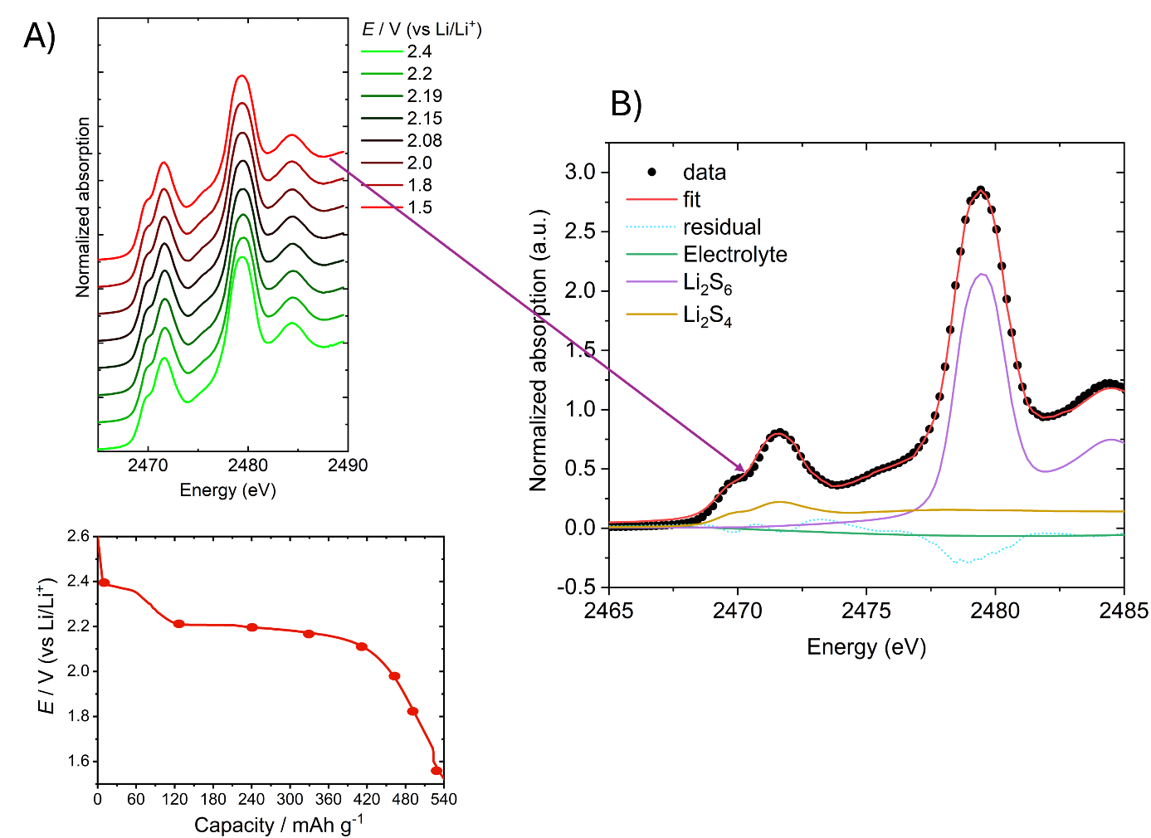
Figure S13 A) Sulfur K-edge XANES spectra of the 15 wt.% carrageen containing Li–S battery B) fully dis

Nuclear Magnetic Resonance study

¹H- and ¹³C-NMR spectra were recorded using a Varian 500 MHz INOVA spectrometer. Chemical shifts are referenced to the residual solvent signals (CD₃CN: δ = 1.94 ppm for ¹H, δ = 1.3 ppm and 118.3 ppm for ¹³C. All spectra were recorded with the standard spectrometer pulse sequences and settings, ¹H decoupling was used for ¹³C-NMR measurements. All samples were filtered and measured without dilution using a coaxial insert containing CD₃CN. During the ¹H and ¹³C NMR analysis of the different components of the electrolyte, it was found that the DME-DOL mixture stayed stable when it was exposed to each component of the mixture. No polymerization [10]-[13] was observed even after prolonged storage at ambient temperature with any of the components.
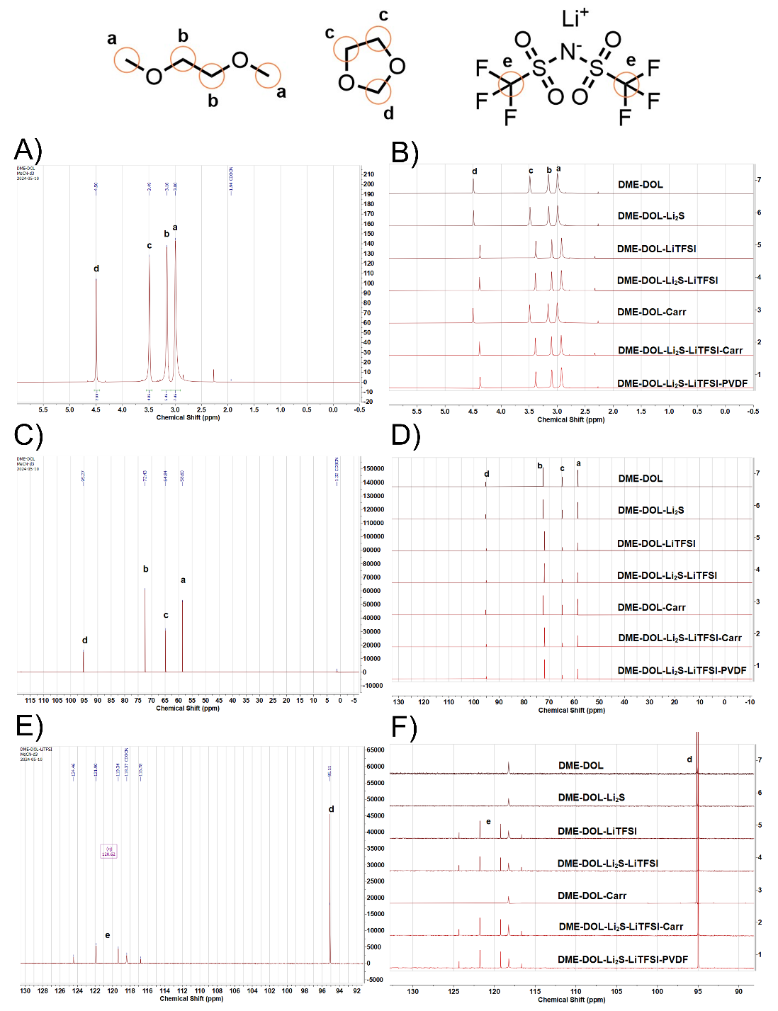
Figure S14 ¹H-NMR spectra A) of the DME-DOL mixture and B) of the different samples; ¹³C-NMR spectra C) DME-DOL mixture and D) of the different samples. ¹³C-NMR spectra E) of the DME-DOL-LiTFSI mixture and F) of the different samples. The assignments are given by the a-e bold letters in the figure.
Electrolyte uptake test
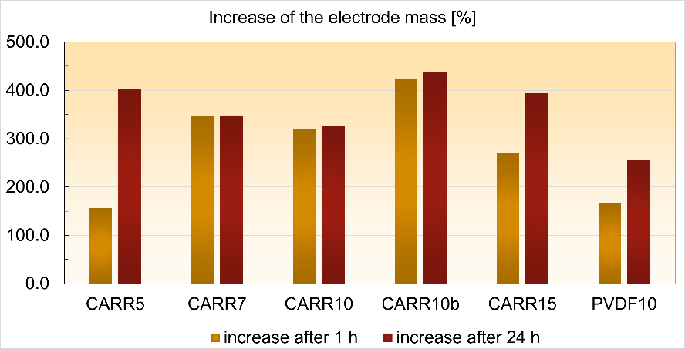
Figure S15 Increase of the electrode mass after soaking in the electrolyte for 1 h and 24 h.

Post-mortem XAS result

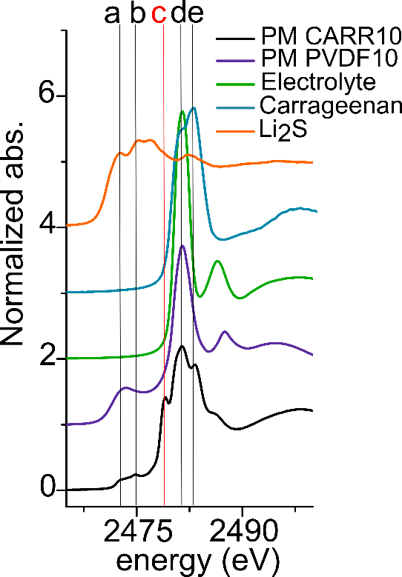
Figure S16 XAS spectrum of the CARR10 and PVDF10 samples after 250 cycles (ex-situ measurement). The lines help to guide the eye and a = 2472.1 eV, b = 2474.9 eV, c = 2477.4 eV, d = 2481 eV, e = 2483 eV, resp. The red line marked with “c” at 2477.4 eV shows the appearance of a new oxidation state (+4) sulfur species.

Supplementary references
[1] A. Varzi, R. Raccichini, M. Marinaro, M. Wohlfahrt-Mehrens, and S. Passerini, “Probing the characteristics of casein as green binder for non-aqueous electrochemical double layer capacitors’ electrodes,” J Power Sources, vol. 326, pp. 672–679, Sep. 2016, doi: 10.1016/j.jpowsour.2016.03.072.
[2] R. Raccichini, L. Furness, J. W. Dibden, J. R. Owen, and N. García-Araez, “Impedance Characterization of the Transport Properties of Electrolytes Contained within Porous Electrodes and Separators Useful for Li-S Batteries,” J Electrochem Soc, vol. 165, no. 11, pp. A2741–A2749, 2018, doi: 10.1149/2.0631811jes.
[3] K. A. Seid, J. C. Badot, O. Dubrunfaut, S. Levasseur, D. Guyomard, and B. Lestriez, “Multiscale electronic transport mechanism and true conductivities in amorphous carbon-LiFePO4 nanocomposites,” J Mater Chem, vol. 22, no. 6, pp. 2641–2649, Feb. 2012, doi: 10.1039/c2jm13429b.
[4] S. Walus, “Lithium / Sulfur batteries : development and understanding of the working mechanisms Sylwia Walus Accumulateur Lithium / Soufre : développement et compréhension des mécanismes électrochimiques,” p. 45, 2015.
[5] B. A. Boukamp and H. J. M. Bouwmeester, “Interpretation of the Gerischer impedance in solid state ionics,” Solid State Ion, vol. 157, no. 1–4, pp. 29–33, 2003.
[6] H. Gerischer, “Wechselstrompolarisation von elektroden mit einem potentialbestimmenden schritt beim gleichgewichtspotential I.,” Z. Phys. Chem., vol. 198, no. 1, p. 268, 1951.
[7] S. Havrilak and S. Negami, “A complex plane analysis of α -dispersions in some polymer systems,” J. Polymer Sci. C, vol. 99, p. 14, 1966.
[8] J. Bisquert, “Theory of the impedance of electron diffusion and recombination in a thin layer,” J. Phys. Chem. B, vol. 325, p. 106, 2002.
[9] “How to fit transmission lines with ZFit.”
[10] Q. Zhao, X. Liu, S. Stalin, K. Khan, and L. A. Archer, “Solid-state polymer electrolytes with in-built fast interfacial transport for secondary lithium batteries,” Nat Energy, vol. 4, no. 5, pp. 365–373, May 2019, doi: 10.1038/s41560-019-0349-7.
[11] E. Sahadeo, Y. Wang, C. F. Lin, Y. Li, G. Rubloff, and S. B. Lee, “Mg²⁺ ion-catalyzed polymerization of 1,3-dioxolane in battery electrolytes,” Chemical Communications, vol. 56, no. 33, pp. 4583–4586, Apr. 2020, doi: 10.1039/d0cc01769h.
[12] L. Lodovico, A. Varzi, and S. Passerini, “ Radical Decomposition of Ether-Based Electrolytes for Li-S Batteries ,” J Electrochem Soc, vol. 164, no. 9, pp. A1812–A1819, 2017, doi: 10.1149/2.0311709jes.
[13] L. Lodovico, A. Varzi, and S. Passerini, “Effect of Aging-Induced Dioxolane Polymerization on the Electrochemistry of Carbon-Coated Lithium Sulfide,” Front Chem, vol. 7, Jan. 2020, doi: 10.3389/fchem.2019.00893.

