Supplementary data

1) Dry weight vs. dilution calibration curve:
dilutions | Real DW [mg/mL] | Theoretical DW [mg/mL] | difference (theoretical vs. real)
1.00 | 1.3 | 1.3 | 0
1.00 | 1.3 | 1.3 | 0
1.00 | 1.3 | 1.3 | 0
0.67 | 1.1 | 0.866666667 | 0.233333
0.67 | 1 | 0.866666667 | 0.133333
0.67 | 1 | 0.866666667 | 0.133333
0.50 | 0.9 | 0.65 | 0.25
0.50 | 1 | 0.65 | 0.35
0.50 | 1 | 0.65 | 0.35
0.33 | 0.8 | 0.433333333 | 0.366667
0.33 | 0.85 | 0.433333333 | 0.416667
0.33 | 0.7 | 0.433333333 | 0.266667

Before centrifugation DW [mg/mL] | After centrifugation DW [mg/mL] | difference (theoretical vs. real)
1.5 | 1.4 | 0.1
1.35 | 1.35 | 0
1.3 | 1.5 | -0.2
1.3 | 1.3 | 0
1.25 | 1.5 | -0.25
1.25 | 1.45 | -0.2
t-test: no significant difference (p = 0.1).

2) Growth curves of regrown cultures after storage (experiment 1-5)
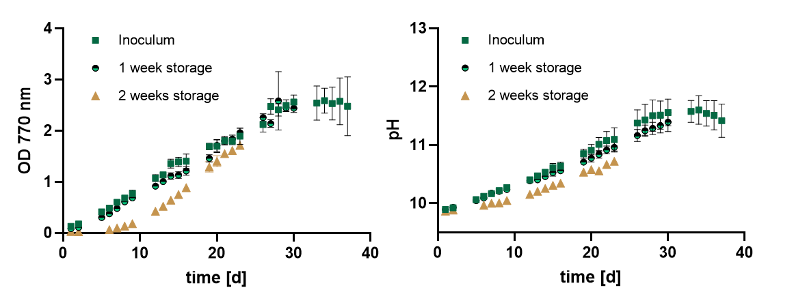
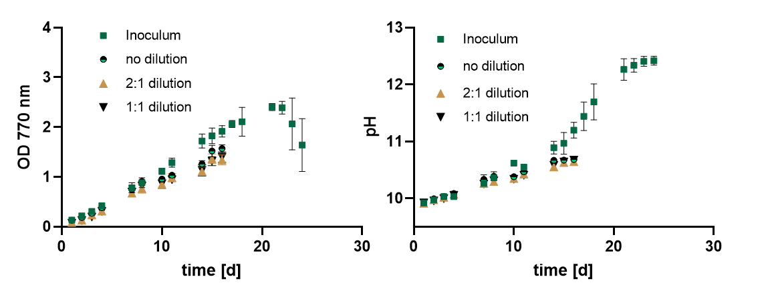

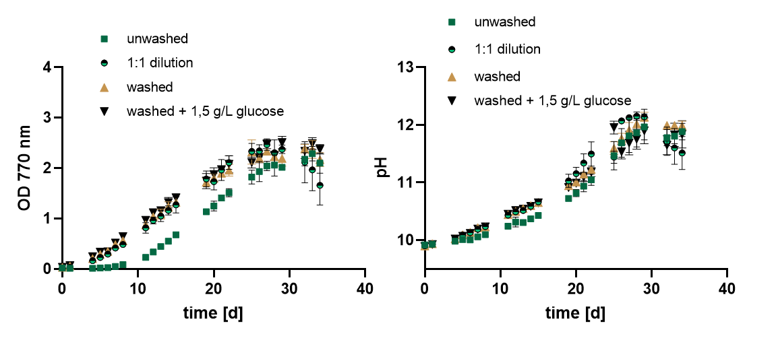

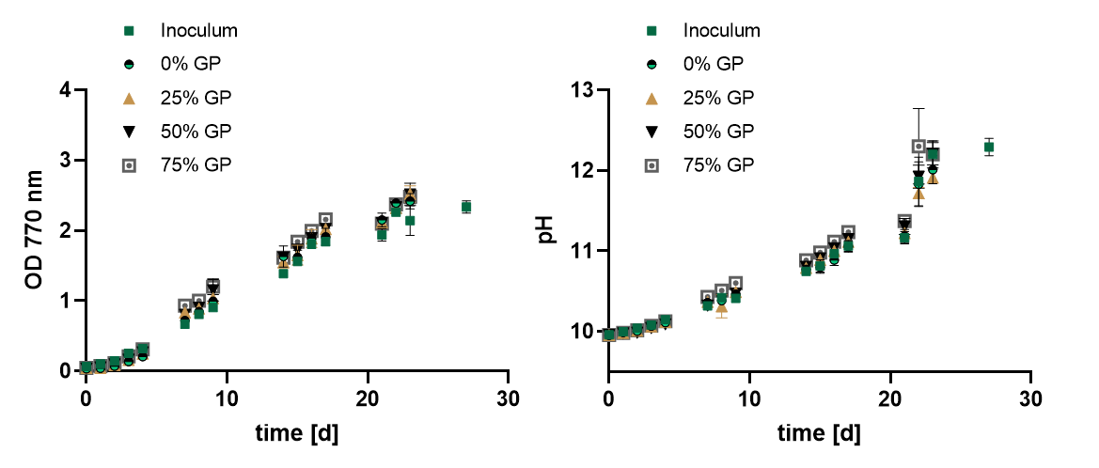
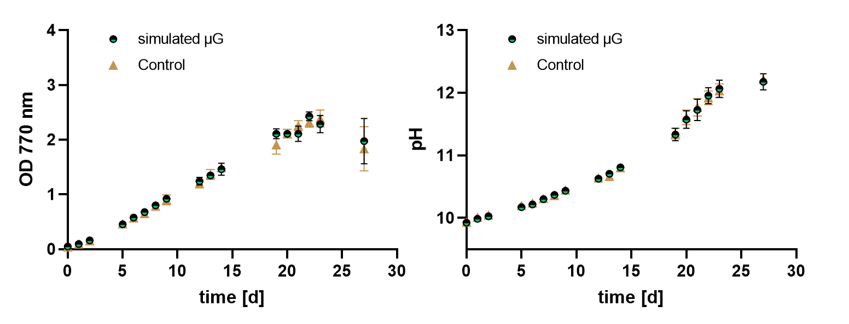

3) Pressure date off-gassing experiment

Figure 1 Pressure profile from 14 days in SM2 (20/09/2021 until 04/10/2021) without precooling

Figure 2 Temperature evolution between the 22/09/2021 and 04/10/2021 (without precooling)

Figure 3 Relative humidity profile between 22/09/2021 and 04/10/2021 (without precooling)

Figure 4 Pressure profile between 14 days in SM2 (23/12/2021 and 06/01/2022) with precooling

Figure 5 Temperature profile between 23/12/2021 and 06/01/2022 (with precooling)

Figure 6 Relative humidity profile between 23/12/2021 and 06/01/2022 (with precooling)

4) Percentage P1 depends on light

Inoculum Exp. 1; P3 | 30-35 µmol photons m-2 s-1
2023-06-07 | 1 | 2 | 3 | 4 | Mean | SD
ALL | 287610 | 290055 | 304545 | 289885 | 293023,8 | 6721,479
P1 | 54195 | 63000 | 57255 | 56555 | 57751,25 | 3235,489
%P1 | 18,843225 | 21,72002 | 18,80018 | 19,50946 | 19,71822 | 1,189453

Inoculum Exp. 4; P3 | 35-40 µmol photons m-2 s-1
2023-06-07 | 1 | 2 | 3 | 4 | Mean | SD
ALL | 488330 | 493035 | 484710 | 469350 | 4,84E+05 | 8,88E+03
P1 | 35620 | 35865 | 37910 | 38300 | 3,69E+04 | 1,19E+03
%P1 | 7,294248 | 7,274331 | 7,821171 | 8,160222 | 7,6374930 | 0,3730571

(Biorat cultures, P3) | 60-65 µmol photons m-2 s-1
2023-06-07 | 1 | 2 | 3 | 4 | Mean | SD
ALL | 237563 | 234391 | 225985 | 240844 | 234695,8 | 5522,503
P1 | 12560 | 12939 | 12367 | 11584 | 12362,5 | 494,3281
%P1 | 5,287019 | 5,520263 | 5,472487 | 4,809752 | 5,27238 | 0,280948

5) Microscopy shows broken trichomes

Exp.1
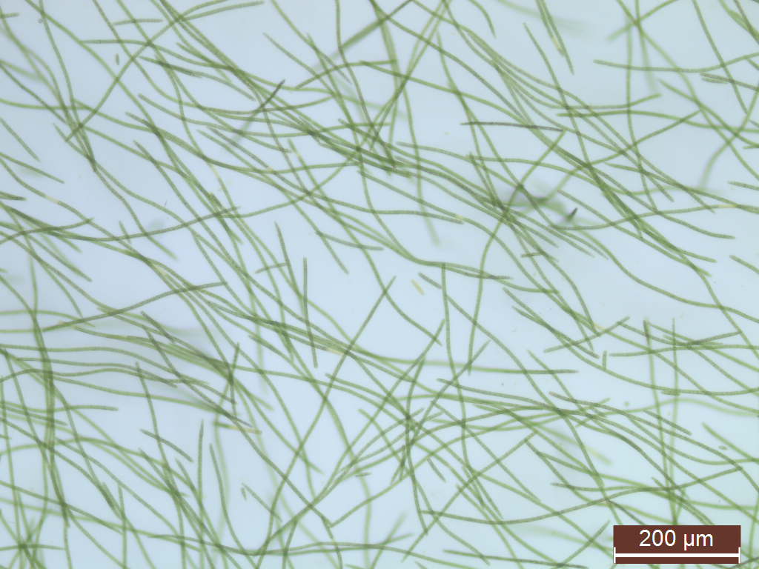
Figure 7 Inoculum before storage
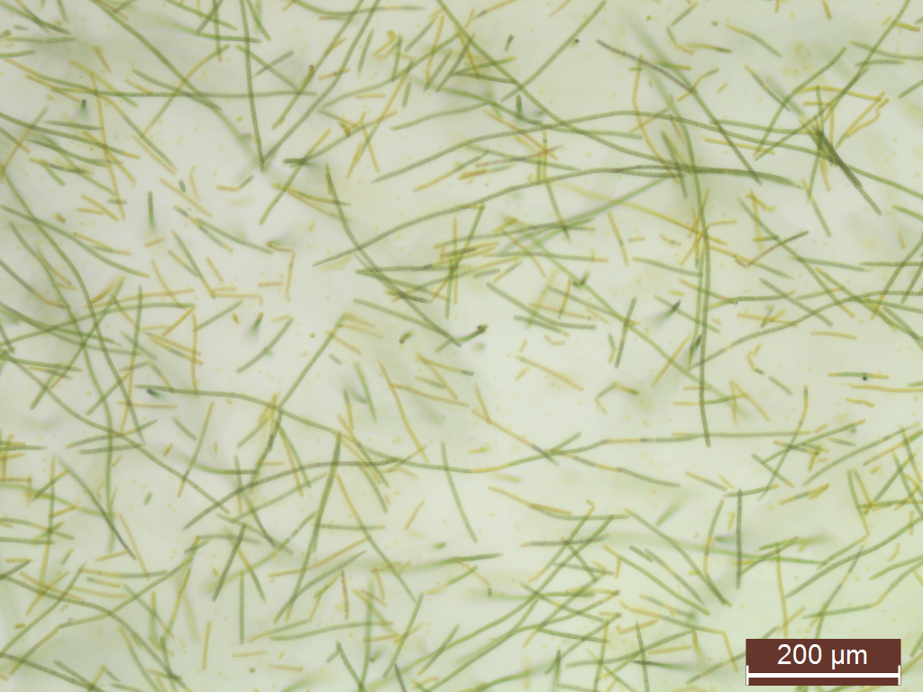
Figure 8 Slight fragmentation after 1 week of storage (4°C, dark, static)
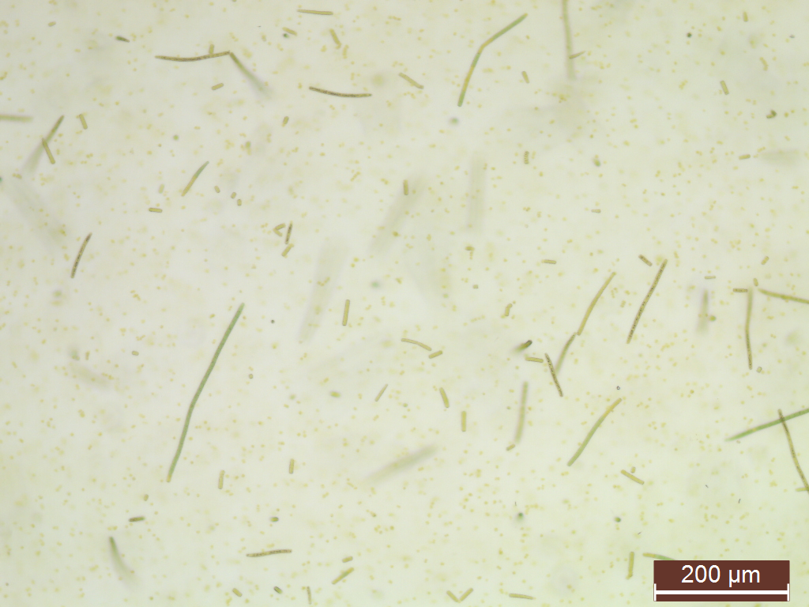
Figure 9 Strong trichome breakage after 2 weeks of storage (4°C, dark, static). Most trichomes even broke into single cells

Exp. 3
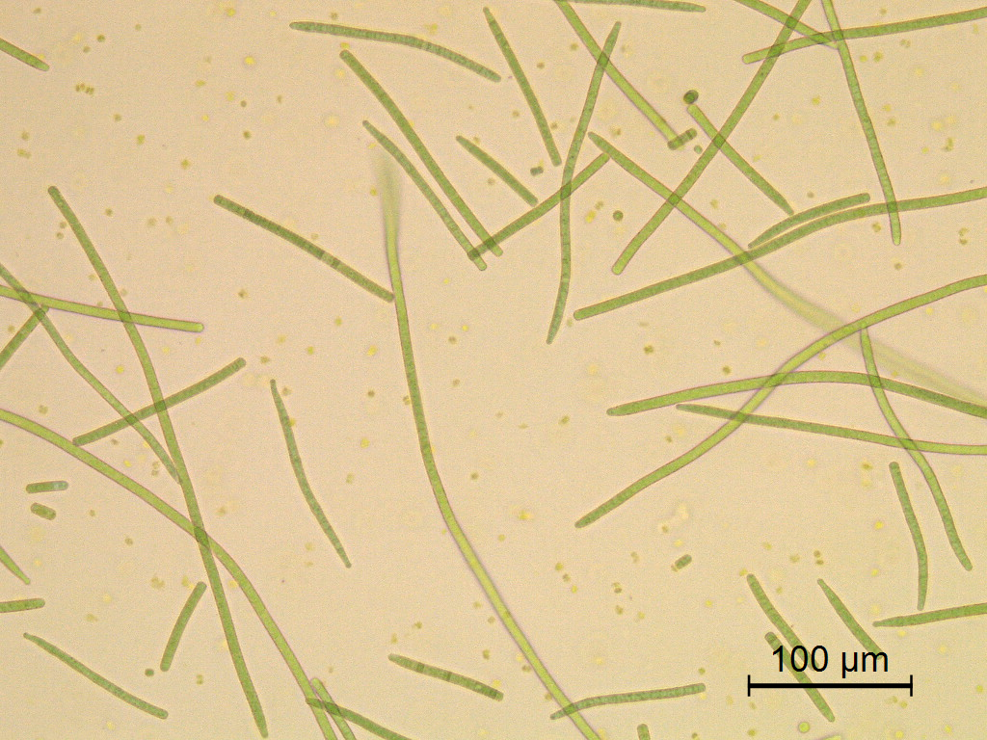
Figure 10 Slight fragmentation in the cultures stored after washing and addition of Glucose (14 days at 4°C, dark, static)
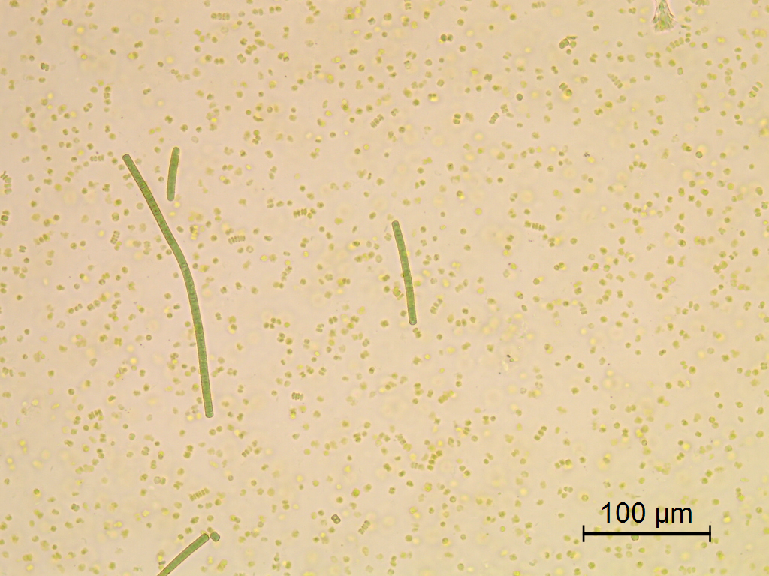
Figure 11 Strong fragmentation in the cultures stored without previous treatments ("unwashed") after 14 days at 4°C in the dark, static.

