Supplementary information
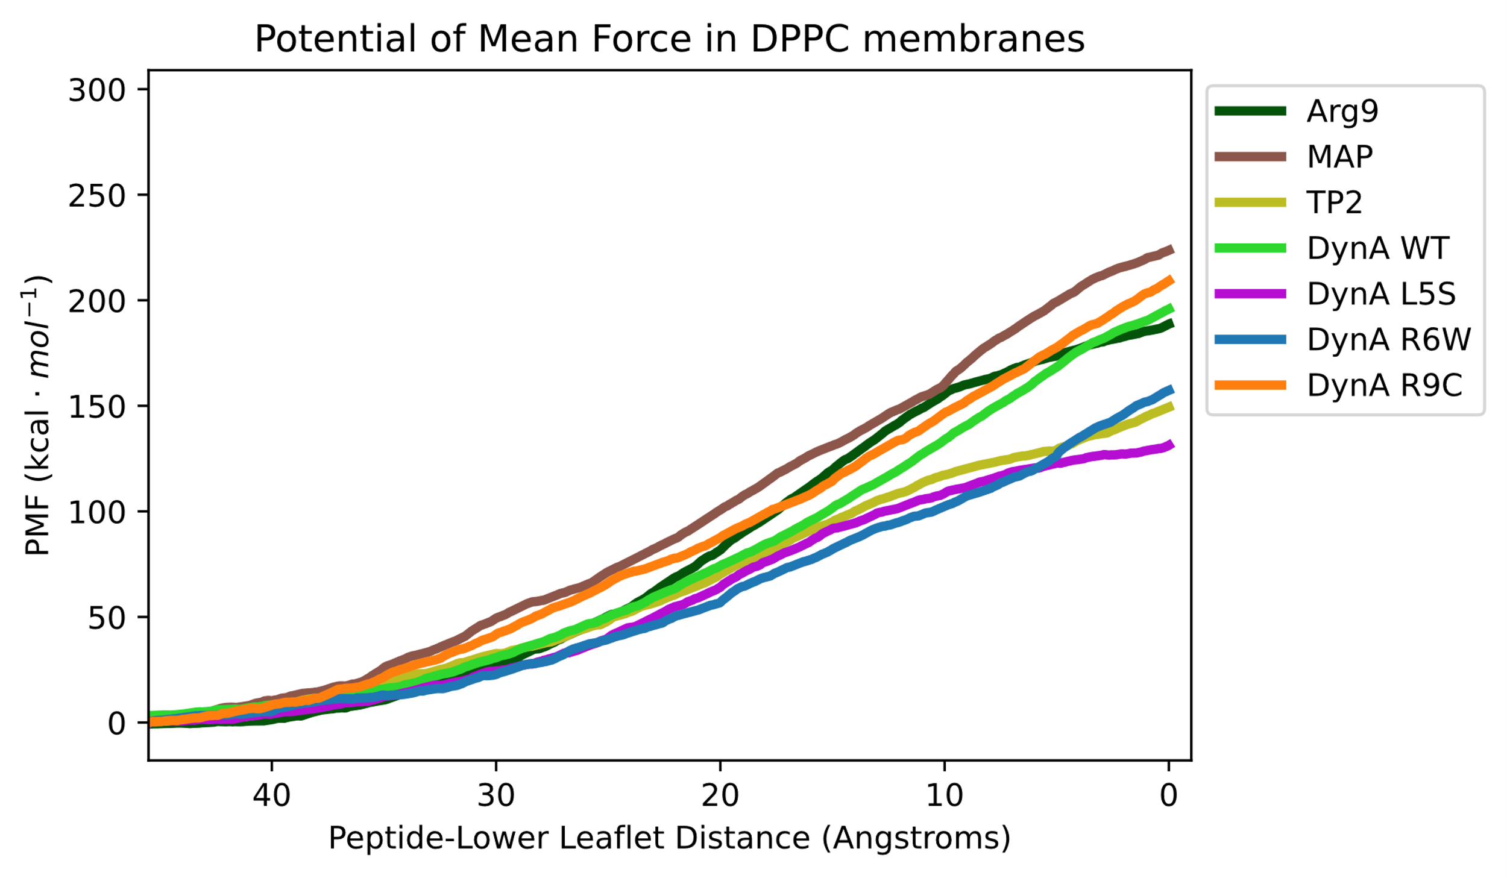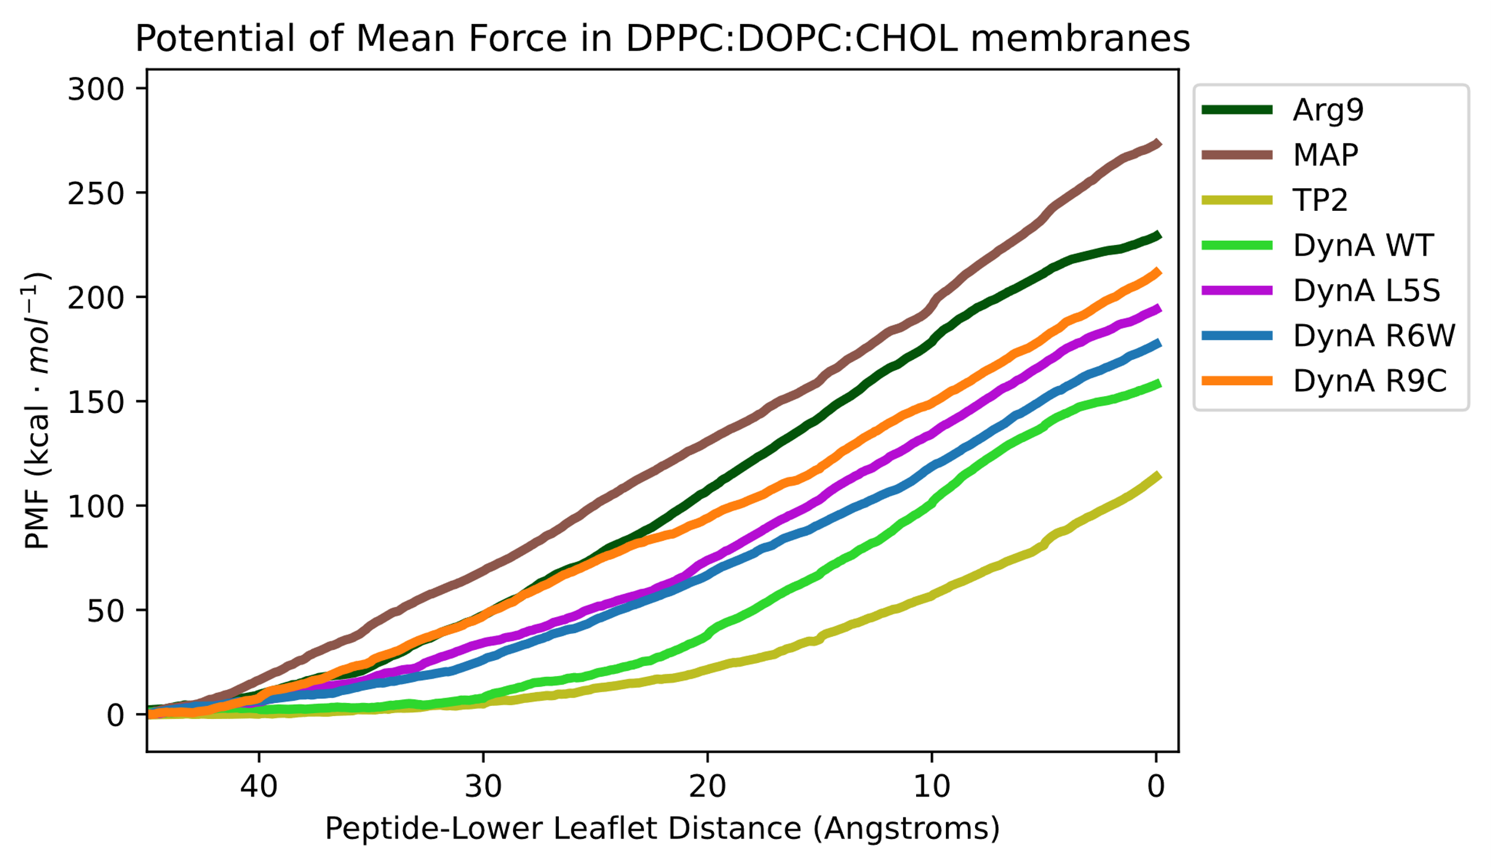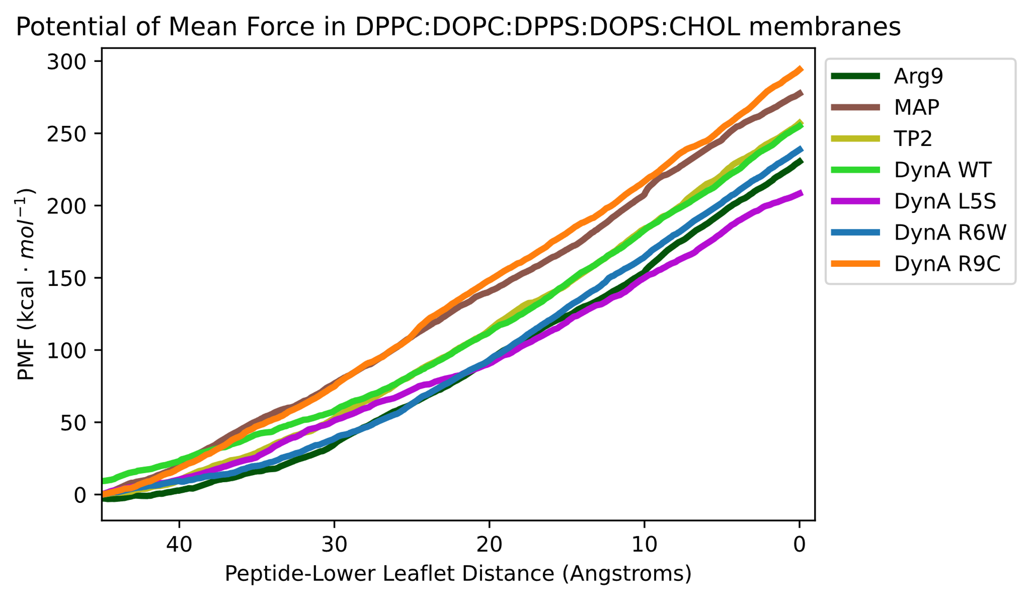
Figure S1. PMF profile of CPPs and DynA WT and its clinical variants. The PMF correspond to DPPC, DPPC:DOPC:CHOL, and DPPC:DOPC:DPPS:DOPS:CHOL membranes, respectively.

Figure S2. Electron density plots in DPPC:DOPC:CHOL. (A) Electron density plots of CPPs. (B) Electron density plots of DynA WT and its clinical variants.
Figure S3. Electron density plots in DPPC:DOPC:DPPS:DOPS:CHOL. (A) Electron density plots of CPPs. (B) Electron density plots of DynA WT and its clinical variants.

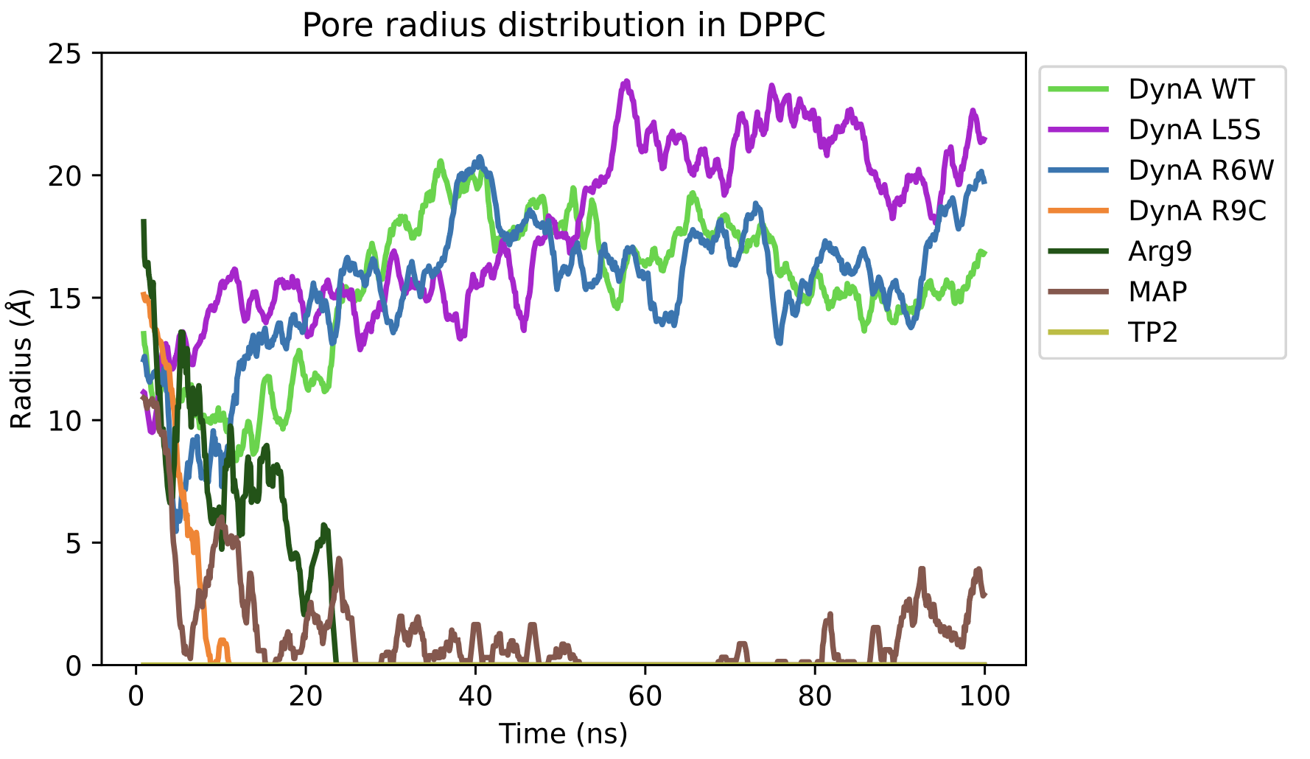
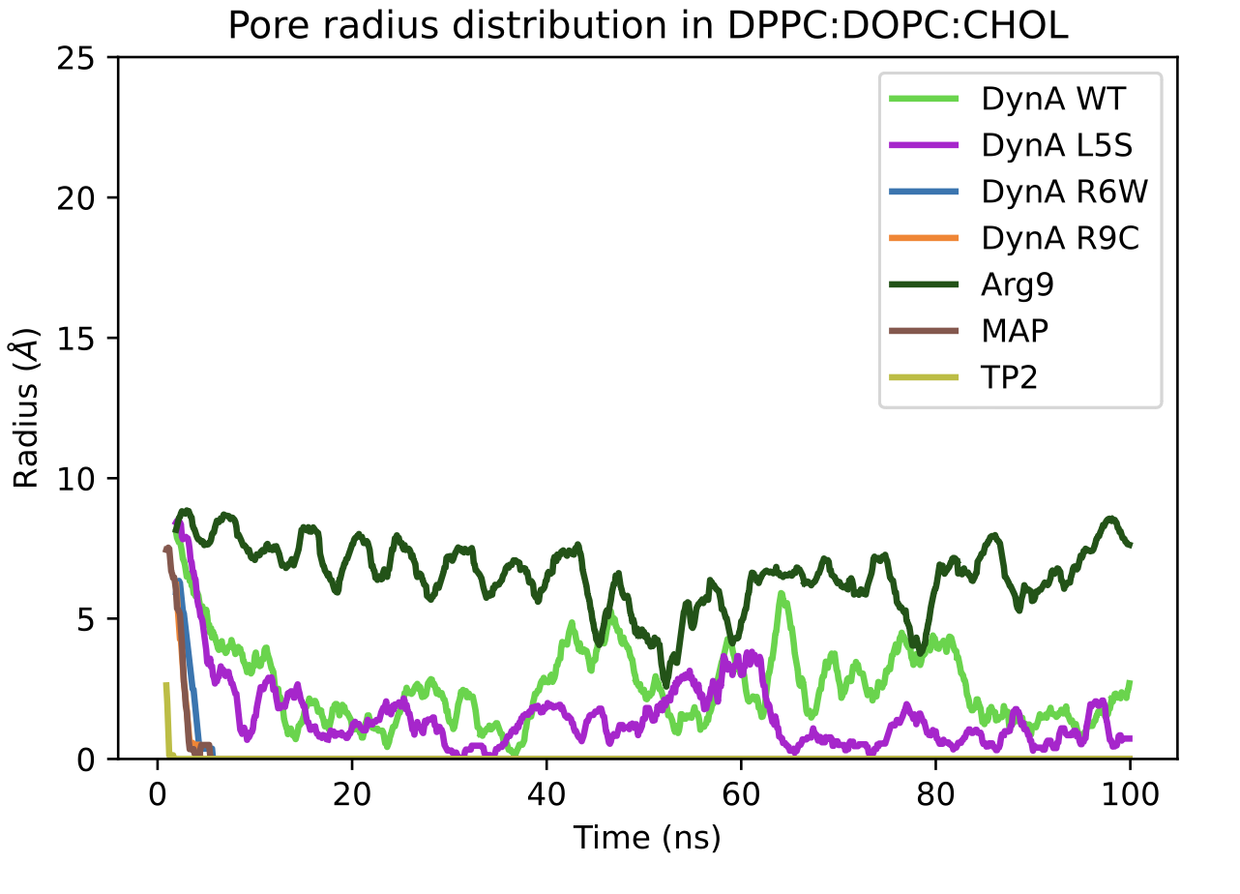
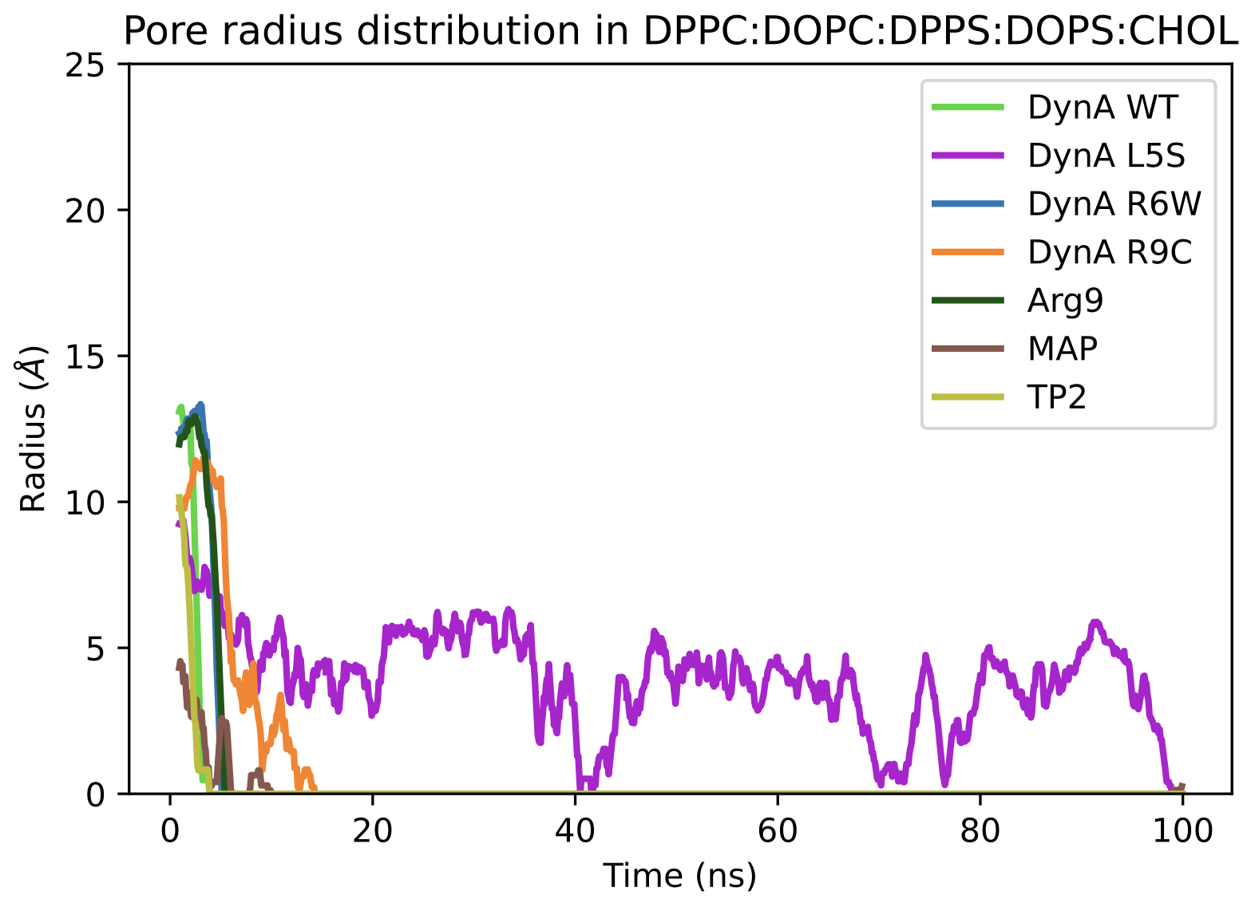
Figure S4. Pore radius evolution in DPPC, DPPC:DOPC:CHOL, and DPPC:DOPC:DPPS:DOPS:CHOL membranes, respectively.

Video S1. aSMD and cMD simulation of CPPs. Peptides are represented as VDW and coloured as: Arg9 in dark green, MAP in rose, TP2 in gold. The polar heads of phospholipids in both the upper and lower bilayers are illustrated in darker and lighter shades of grey, respectively. The lipid tails are omitted for clarity. At the end of the video, waters are shown as quick surface in cyan.
Video S2. aSMD and cMD simulation of DynA WT and its clinical variants. Peptides are represented as VDW and coloured as: DynA in light green, DynA L5S in purple, DynA R6W in cornflower blue, and R9C in orange. The polar heads of phospholipids in both the upper and lower bilayers are illustrated in darker and lighter shades of grey, respectively. The lipid tails are omitted for clarity. At the end of the video, waters are shown as quick surface in cyan.

