Supplement materials

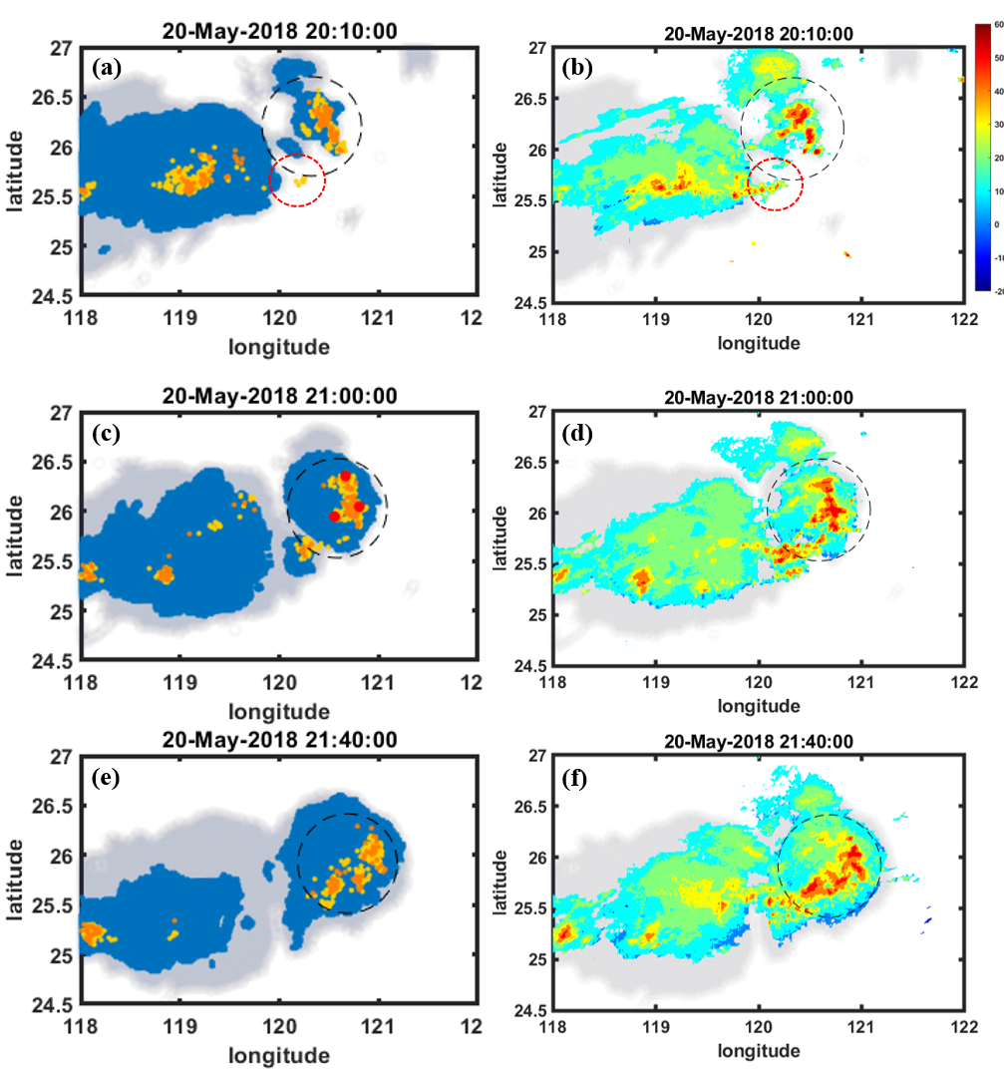Figure A. The flashes were dotted within +/- 5 minutes (orange/yellow for IC/CG), filled red circles for TLEs, dark blue for cloud height > 12 km, and gray for cloud region at > 10 km at (a) 20:10, (c) 21:00 and (e) 21:40 LT, and their maximum reflectivity for the old and new cells in the thunderstorm system at (b) 20:10, (d) 21:00 and (f) 21:40 LT on May 20 2018. The red dashed circles in (a) and (b) indicate the newly detected flashes inside the cloud bridge between old and new cells on 20:10 LT.

