Supplementary figures
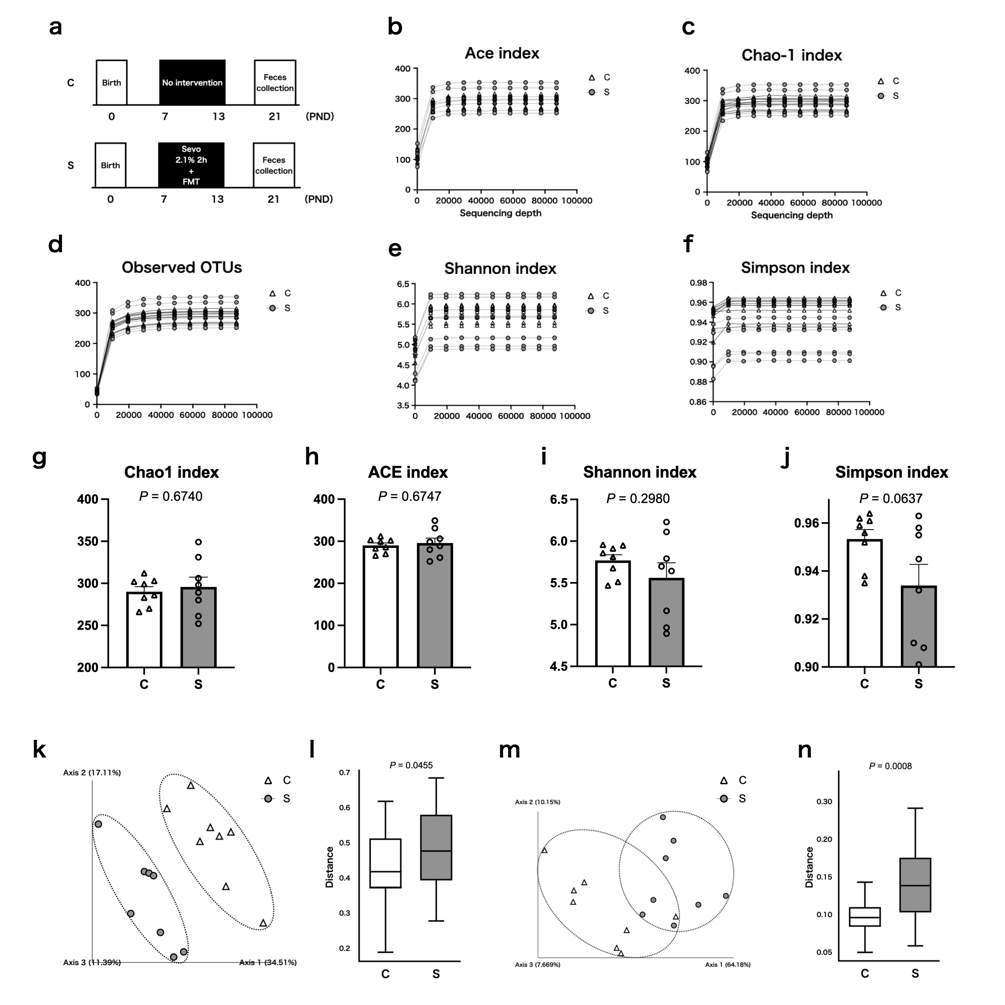
Figure S1. α- and β-diversity analyses in C and S groups. a, Experimental protocol of C (control) and S (sevoflurane) groups in Experiment 1. Neonatal rats were divided into C or S groups. In S group, the rats were exposed 2.1% sevoflurane 2 hours on postnatal days (PND) 7-13. Feces were collected on PND 21. b–f, Rarefaction curve of ACE index, Chao1 index, observed operational taxonomic units, Shannon index and Simpson index. g, Chao1 index. h, ACE index. i, Shannon index. j, Simpson index. k–l, Unweighted UniFrac principal coordinate analysis (PCoA). Gut microbiota composition of the C and S groups were found to differ significantly in the unweighted anlysis. Permutational analysis of variance (ANOVA) was performed to compare gut microbiota composition between C and S groups (n=7 in each group). m–n, Weighted UniFrac PCoA. Gut microbiota composition of the C and S groups were found to differ significantly in the weighted analysis. Permutational ANOVA was performed to compare gut microbiota composition between the C and S groups (n = 7 in each group). In PCoA, data are expressed as median (interquartile range). For other outcomes, data are expressed as mean ± standard error of the mean.

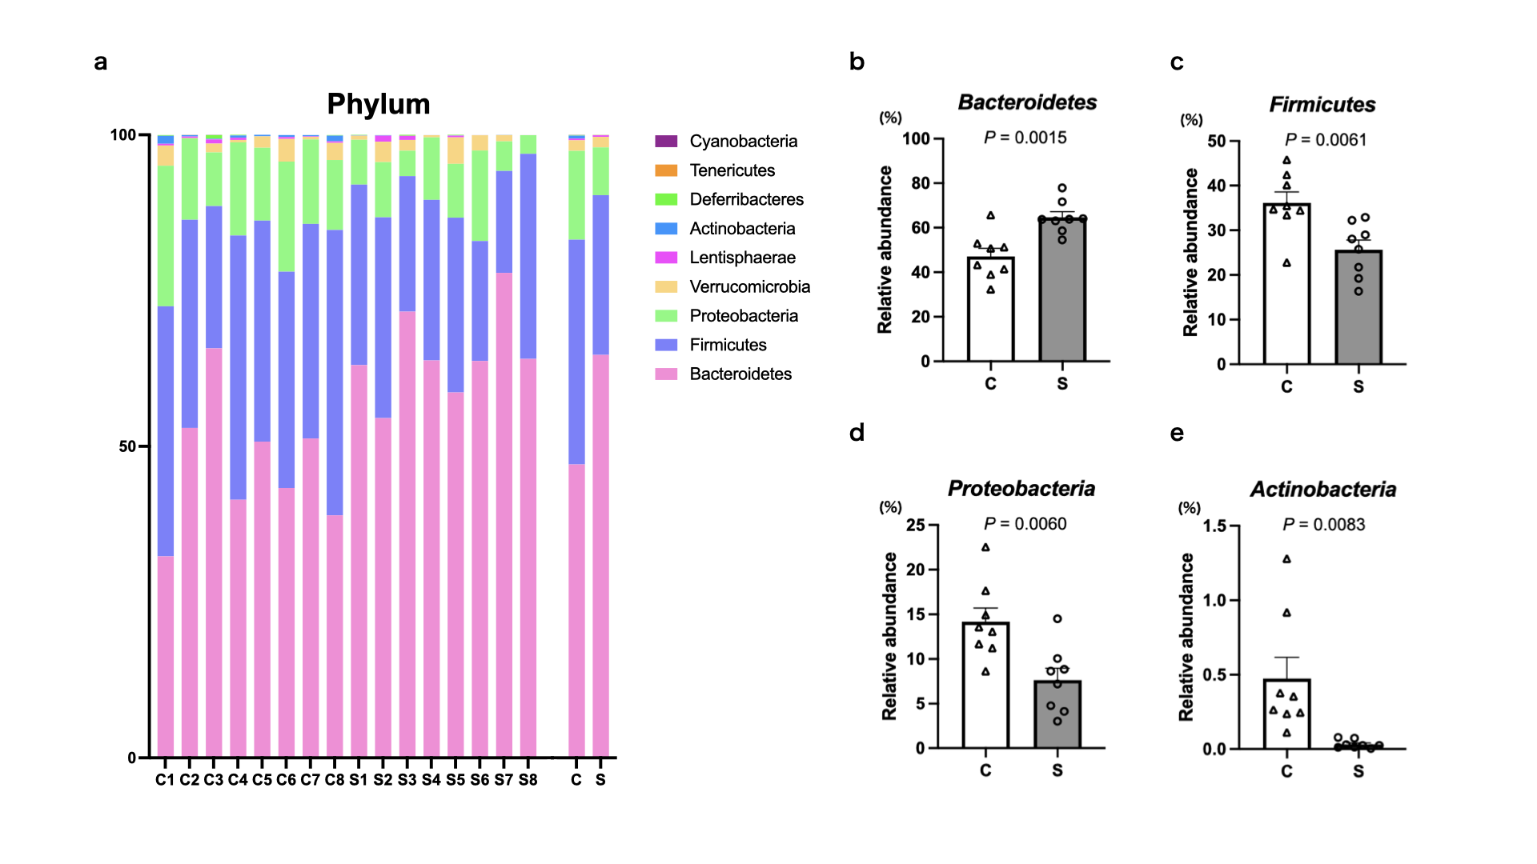
Figure S2. Differential abundant analysis at phylum level in C and S groups. a, Taxonomy chart at the phylum level in C and S groups. b, Relative abundance of Bacteroidetes phylum. c, Relative abundance of Firmicutes phylum. d, Relative abundance of Proteobacteria phylum. e, Relative abundance of Actinobacteria phylum. Sevoflurane exposure significantly increased the relative abundance of Bacteroidetes phylum, and decreased those of Firmicutes, Proteobacteria and Actinobacteria phyla. Unpaired t-test was used for statistical analysis (n = 7 in each group). Data are expressed as mean ± standard error of mean.

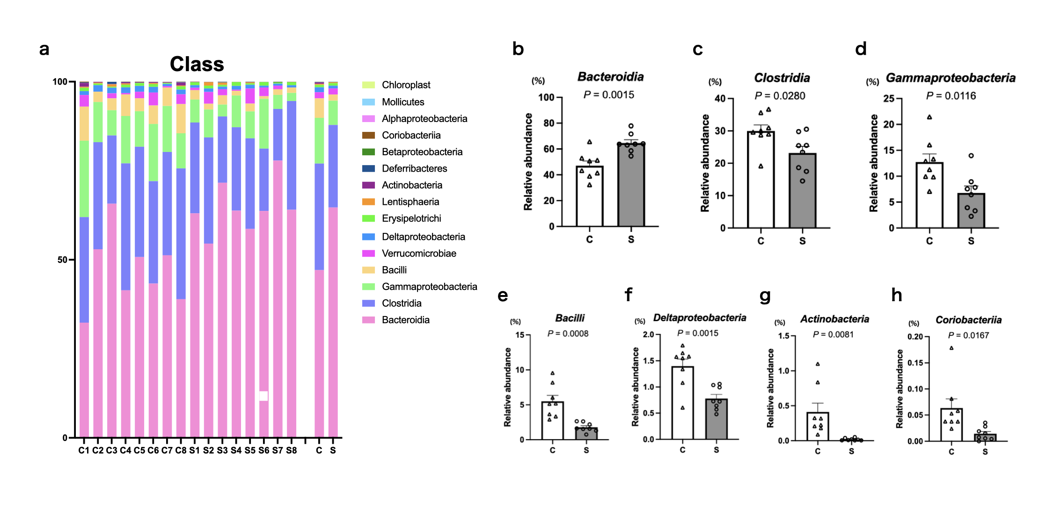
Figure S3. Differential abundant analysis at class level in C and S groups.
a, Taxonomy chart at the class level in C and S groups. b, Relative abundance of Bacteroidia class. c, Relative abundance of Clostridia class. d, Relative abundance of Gammaproteobacteria class. e, Relative abundance of Bacilli class. f, Relative abundance of Deltaproteobacteria class. g, Relative abundance of Actinobacteria class. h, Relative abundance of Coriobacteriia class. Sevoflurane exposure significantly increased the relative abundance of Bacteroidia class, and decreased those of Clostridia, Gammaproteobacteria, Bacilli, Deltaproteobacteria, Actinobacteria and Coriobacteriia classes. Unpaired t-test was used for statistical analysis (n = 7 in each group). Data are expressed as mean ± standard error of mean.

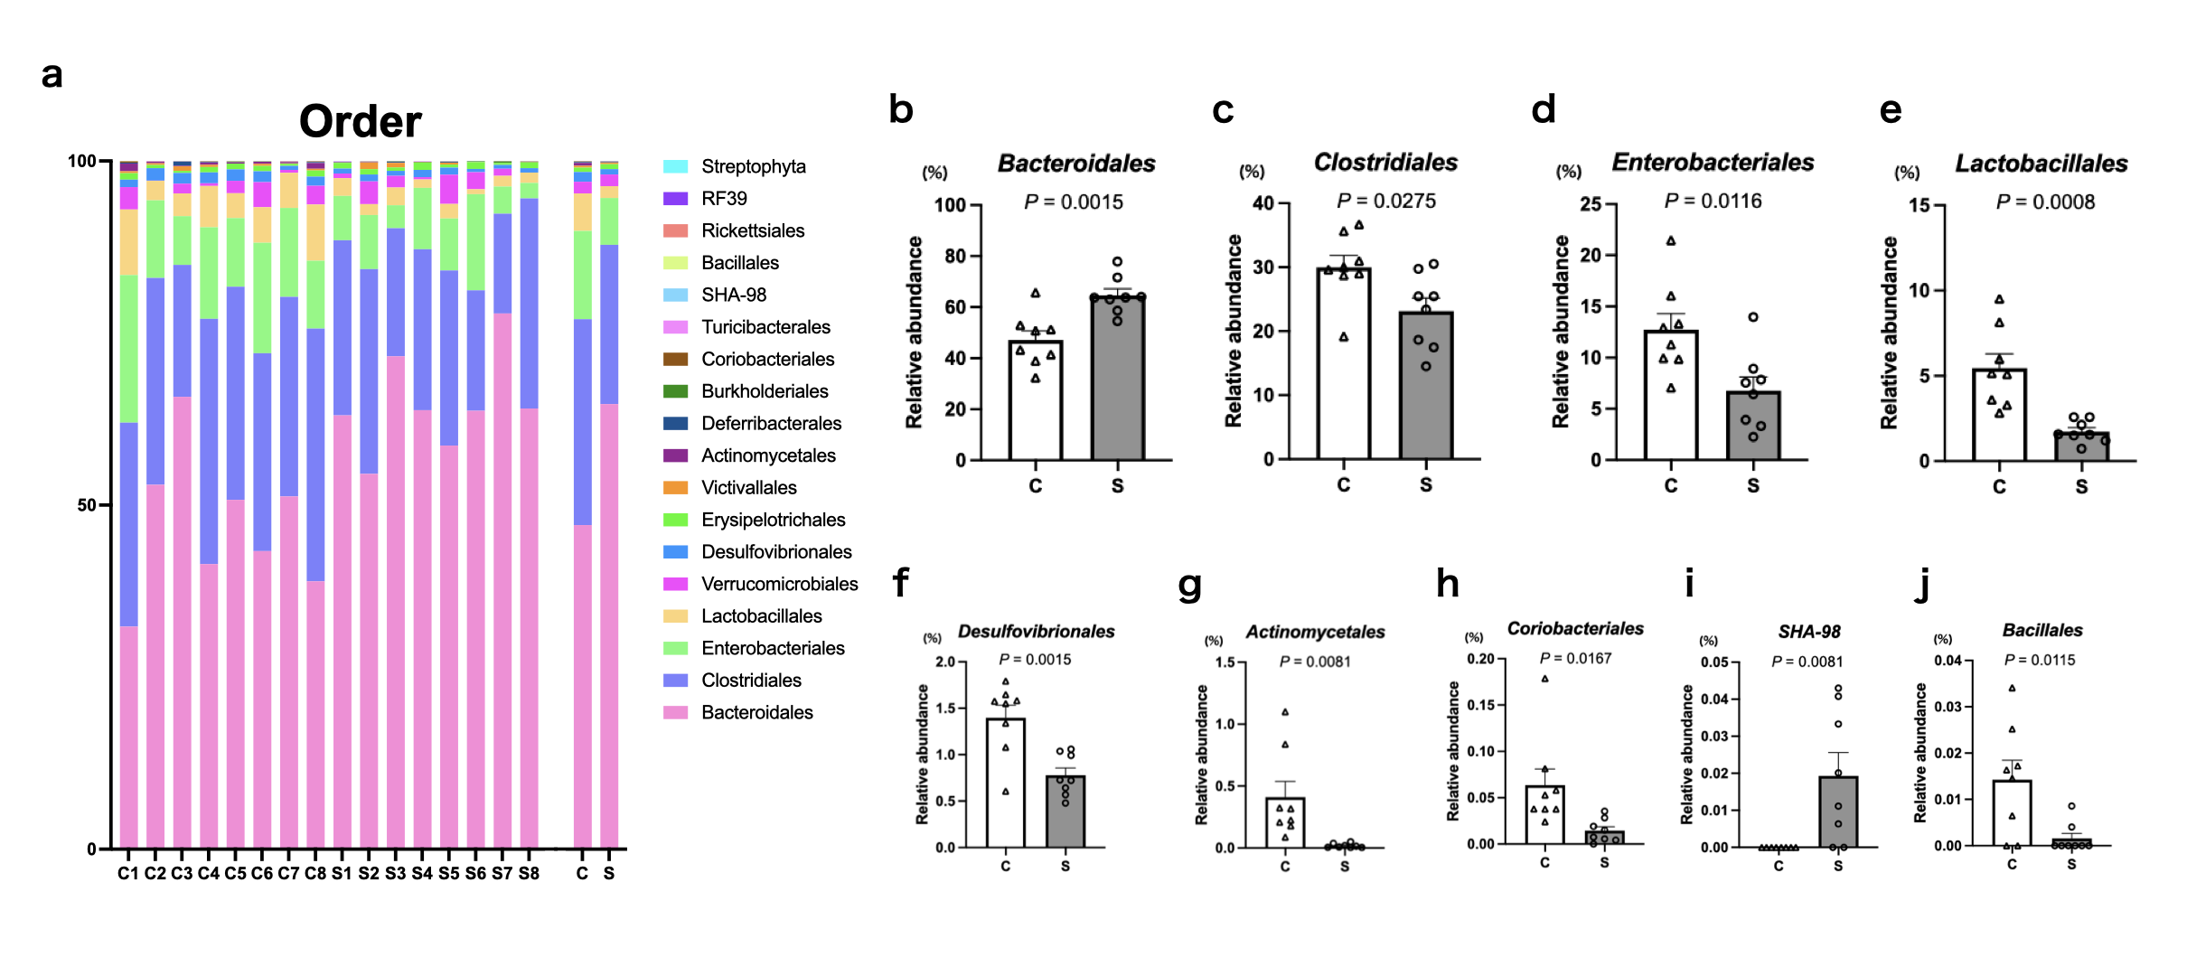
Figure S4. Differential abundant analysis at order level in C and S groups.
a, Taxonomy chart at the order level in C and S groups. b, Relative abundance of Bacteroidales class. c, Relative abundance of Clostridiales class. d, Relative abundance of Enterobacteriales class. e, Relative abundance of Lactobacillales class. f, Relative abundance of Desulfovibrionales class. g, Relative abundance of Actinomycetales class. h, Relative abundance of Coriobacteriales class. i, Relative abundance of SHA-98 class. j, Relative abundance of Bacillales class. Sevoflurane exposure significantly increased the relative abundances of Bacteroidales and SHA-98 classes, and decreased those of Clostridiales, Enterobacteriales, Lactobacillales, Desulfovibrionales, Actinomyceltales, Coriobacteriales and Bacillales classes. Unpaired t-test was used for statistical analysis (n = 7 in each group). Data are expressed as mean ± standard error of mean.

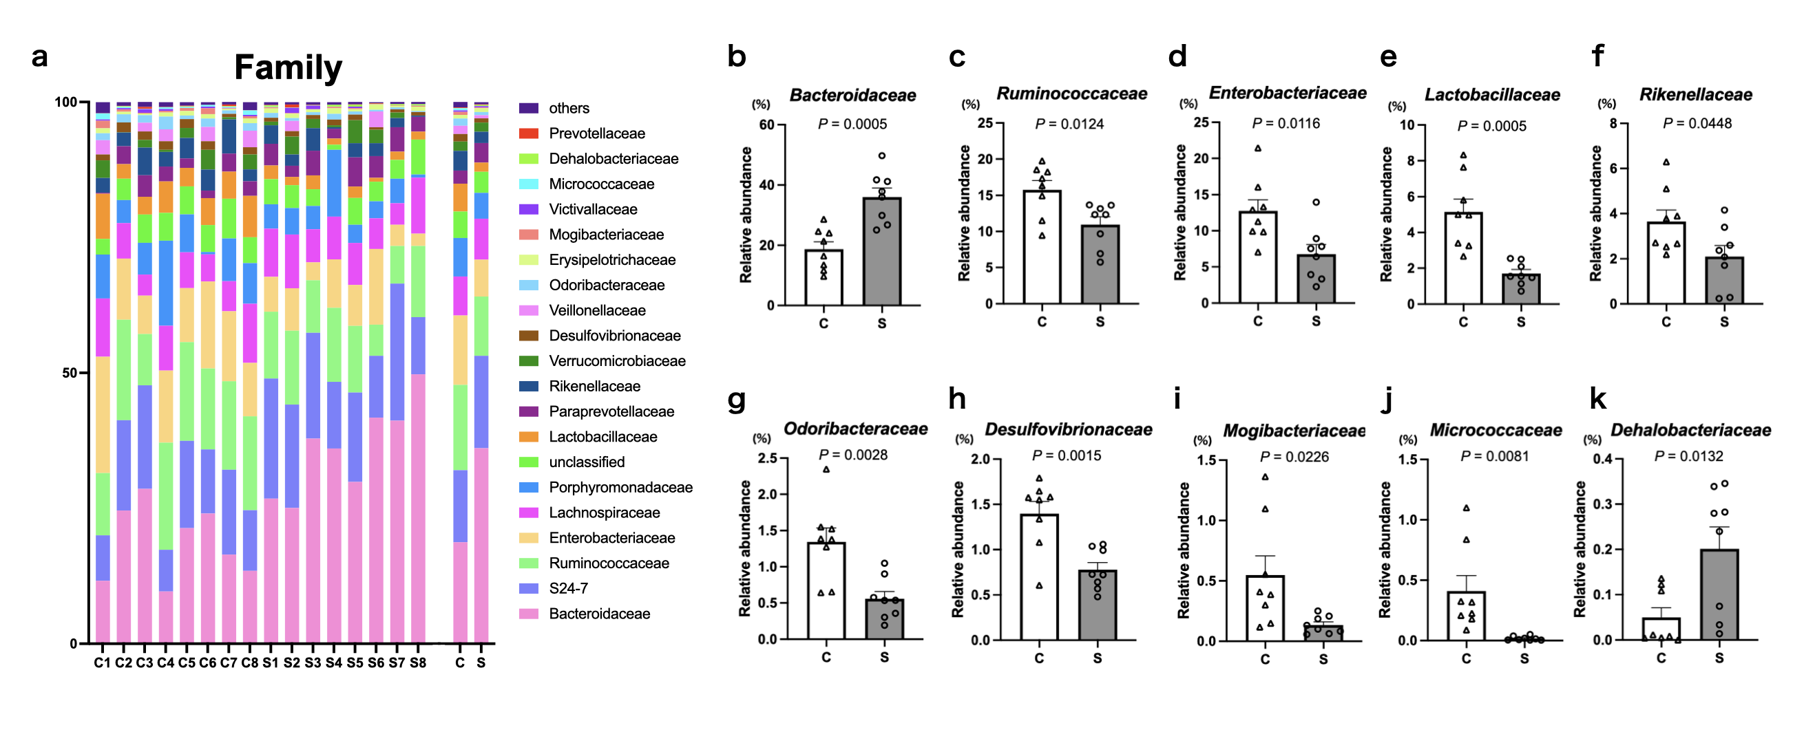
Figure S5. Differential abundant analysis at family level in C and S groups. a, Taxonomy chart at the level of family in C and S groups. b, Relative abundance of Bacteroidaceae family. c, Relative abundance of Ruminococcaceae family. d, Relative abundance of Enterobacteriaceae family. e, Relative abundance of Lactobacillaceae family. f, Relative abundance of Rikenellaceae family. g, Odoribacteraceae family. h, Relative abundance of Desulfovibrionaceae family. i, Relative abundance of Mogibacteriaceae family. j, Relative abundance of Micrococcaceae family. k, Relative abundance of Dehalobacteriaceae family. Sevoflurane exposure significantly increased the relative abundances of Bacteroidaceae and Dehalobacteriaceae families, and decreased Ruminococcaceae, Enterobacteriaceae, Lactobacillaceae, Rikenellaceae, Odoribacteraceae, Desulfovibrionaceae, Mogibacteriaceae and Micrococcaceae families. Unpaired t-test was used for statistical analysis (n = 7 in each group). Data are expressed as mean ± standard error of mean.

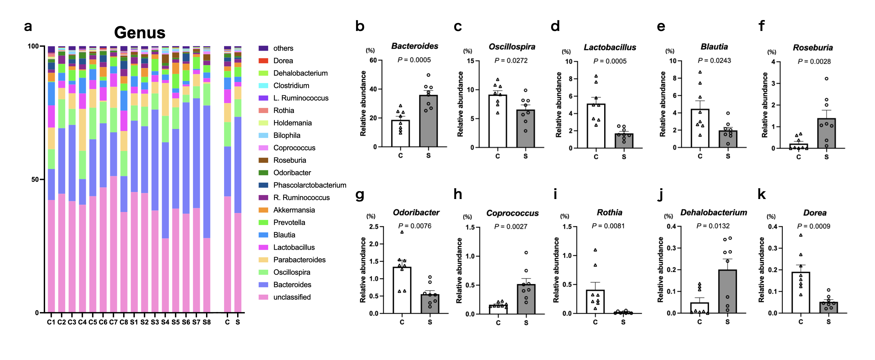
Figure S6. Differential abundant analysis at genus level in C and S groups.
a, Taxonomy chart at the level of genus in C and S groups. b, Relative abundance of Bacteroides genus. c, Relative abundance of Oscillospira genus. d, Relative abundance of Lactobacillus genus. e, Relative abundance of Blautia genus. f, Relative abundance of Roseburia genus. g, Relative abundance of Odoribacter genus. h, Relative abundance of Coprococcus genus. i, Relative abundance of Rothia genus. j, Relative abundance of Dehalobacterium genus. k, Relative abundance of Dorea genus. Sevoflurane exposure significantly increased the relative abundances of Bacteroides, Roseburia, Coprococcus and Dehalobacterium genera, and decreased those of Oscillospira, Lactobacillus, Blautia, Odoribacter, Rothia and Dorea genera. Unpaired t-test was used for statistical analysis (n = 7 in each group). Data are expressed as mean ± standard error of mean.

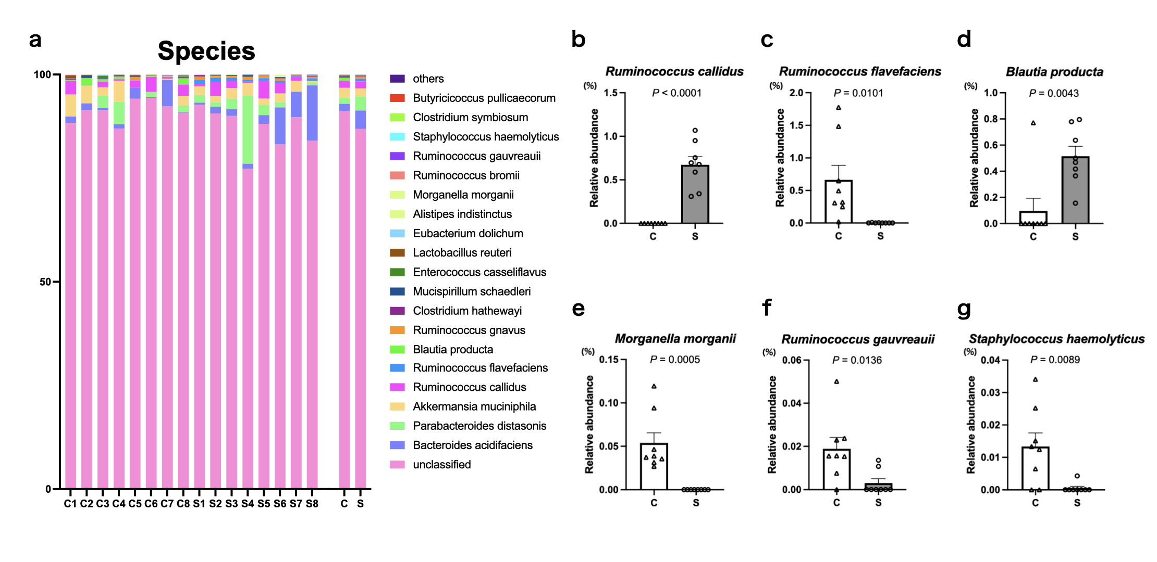
Figure S7. Differential abundant analysis at species level in C and S groups. a, Taxonomy chart at the level of species in C and S groups. b, Relative abundance of Ruminococcus callidus species. c, Relative abundance of Ruminococcus flavefaciens species. d, Relative abundance of Blautia producta speices. e, Relative abundance of Morganella morganii species. f, Relative abundance of Ruminococcus gauvreauii species. g, Relative abundance of Staphylococcus haemolyticus species. Sevoflurane exposure significantly increased the relative abundances of Ruminococcus callidus and Blautia producta species, and decreased those of Ruminococcus flavefaciens, Morganella morganii, Rumionococcus gauvreauii and Staphylococcus haemolyticus species. Unpaired t-test was used for statistical analysis (n = 7 in each group). Data are expressed as mean ± standard error of mean.

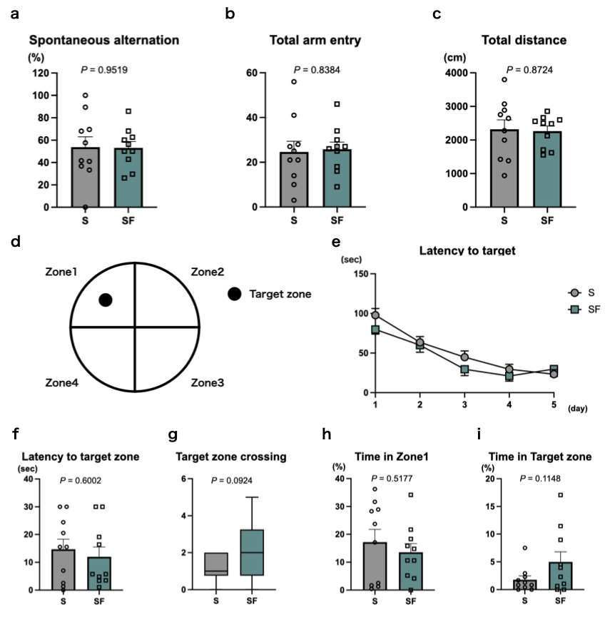
Figure S8. Spatial learning ability evaluation of Y-maze test and Morris water maze test. a-c, Spatial learning ability evaluated by Y-maze test. In Y-maze test, there were no significant differences in spatial learning ability between S and SF groups. Un-paired t-test was used for statistical analysis. d, Schema of Morris water maze test. The platform was placed in Zone1. e, Latency to target in acquisition trial phase. The latency to target was not significantly different between S and SF group in acquisition trial day 1-5. Two-way ANOVA with Bonferroni multiple comparison was used for statistical analysis. f-i, Spatial learning ability evaluated by probe test. FMT did not improve the spatial learning ability in probe test of Morris water maze test. The rats in S group were exposed to 2.1% sevoflurane for 2 hours from postnatal day (PND) 7 to 13. The rats in SF group were also exposed sevoflurane in same manner, but fecal microbiota transplantation was performed after sevoflurane exposure from PND 7 to 13. Unpaired t-test was used for statistical analysis. n=10 in each group (female: n=6, male: n=4). Data are shown as mean ± standard error of mean.

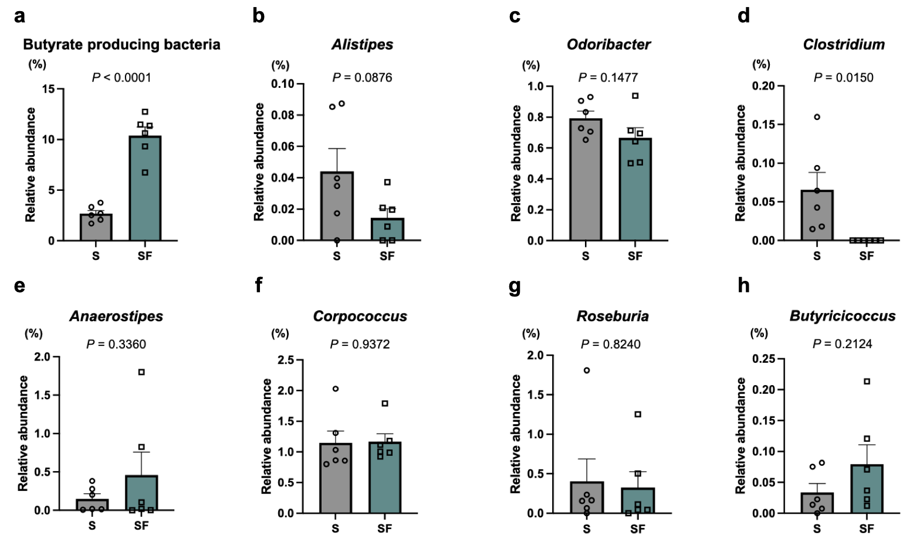
Figure S9. Differential abundant analysis of butyrate producing bacteria at genus level. a, Relative abundance of butyrate producing bacteria. b, Relative abundance of Alistipes genus. c, Relative abundance of Odoribacter genus. d, Relative abundance of Clostridium genus. e, Relative abundance of Anaerostipes genus. f, Relative abundance of Corpococcus genus. g, Relative abundance of Roseburia genus. h, Relative abundance of Butyricicoccus genus. Relative abundance of Ruminococcus genus was presented in Fig. 6c. Fecal microbiota transplantation (FMT) increased the relative abundance of total butyrate producing bacteria. The relative abundance of Clostridium genus was decreased by FMT. The relative abundances of the other bacteria were not significantly different between S and SF groups. The rats in S group were exposed to 2.1% sevoflurane for 2 hours from postnatal day (PND) 7 to 13. The rats in SF group were also exposed sevoflurane in same manner, but FMT was performed after sevoflurane exposure from PND 7 to 13. Unpaired t-test was used for statistical analysis. n=6 in each group. Data are shown as mean ± standard error of mean.
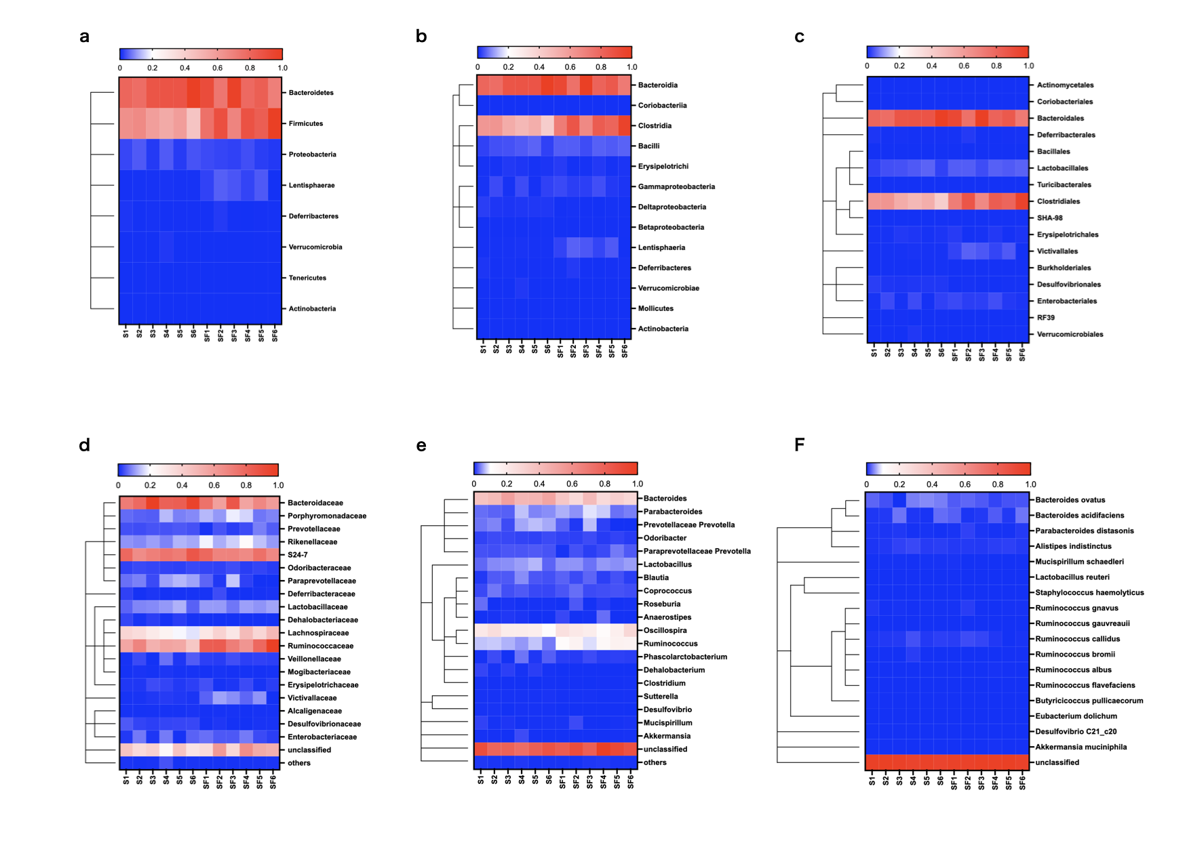
Figure S10. Heatmap analysis of gut microbiota changed by fecal microbiota transplantation. a, Heatmap analysis of phylum level. b, Heatmap analysis of class level. c, Heatmap analysis of order level. d, Heatmap analysis of family level. e, Heatmap analysis of genus level. f, Heatmap analysis of species level. A color range from blue to red indicates the relative abundance of each bacterium. The color intensity was normalized to represent the relative abundance in S and SF group. (n = 6 in each group). The rats in S group were exposed to 2.1% sevoflurane for 2 hours from postnatal day (PND) 7 to PND 13. The rats in SF group were also exposed sevoflurane in same manner, but fecal microbiota transplantation was performed after sevoflurane exposure from PND 7 to 13.

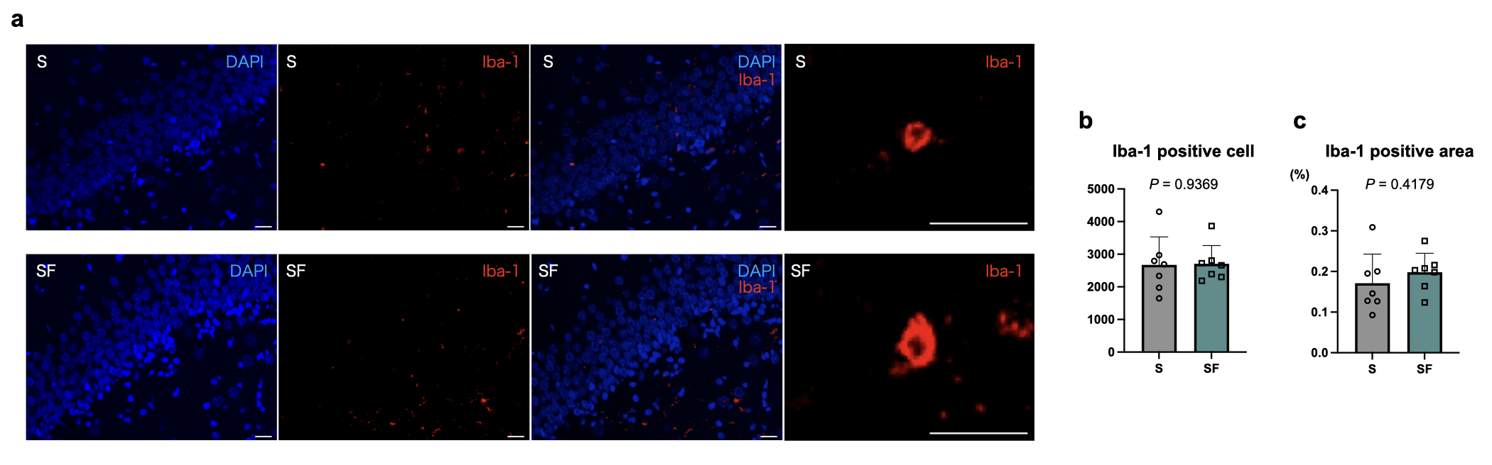
Figure S11. Microglia infiltration in hippocampus at postnatal day 21. a, Representative image of microglia infiltration in hippocampus. Red cell indicated microglia (Iba-1 positive cell). b, Quantitative evaluation of Iba-1 positive cell. c, Quantitative evaluation of Iba-1 positive area. The fecal microbiota transplantation did not change the infiltration of microglia in hippocampus at postnatal day 21. The rats in S group were exposed to 2.1% sevoflurane for 2 hours from postnatal day (PND) 7 to PND 13. The rats in SF group were also exposed sevoflurane in same manner, but fecal microbiota transplantation was performed after sevoflurane exposure from PND 7 to 13. Unpaired t-test was used for statistical analysis. n = 7 in each group. Data are shown as mean ± standard error of mean.

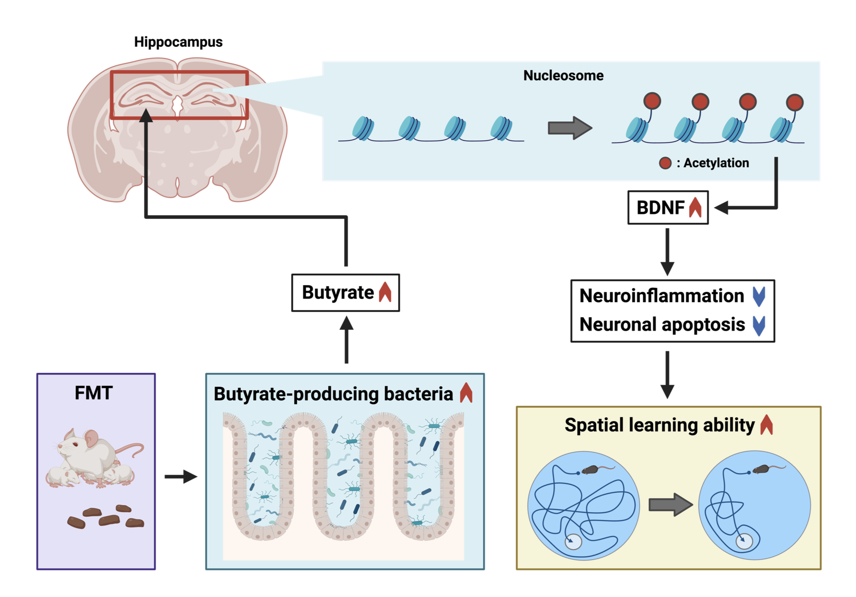
Figure S12. Mechanism of improved spatial learning ability by fecal microbiota transplantation in sevoflurane exposed rats. Fecal microbiota transplantation (FMT) from non-anesthetized mother rat increases the relative abundance of Butyrate-producing bacteria in feces and these bacteria produce butyrate, which acts as histone deacetylase inhibitor and promotes the mRNA expression of brain-derived neurotrophic factor (BDNF) in hippocampus. BDNF has anti-neuroinflammatory and anti-apoptotic effects and results in improvement of spatial learning ability.

