Supplementary Figure

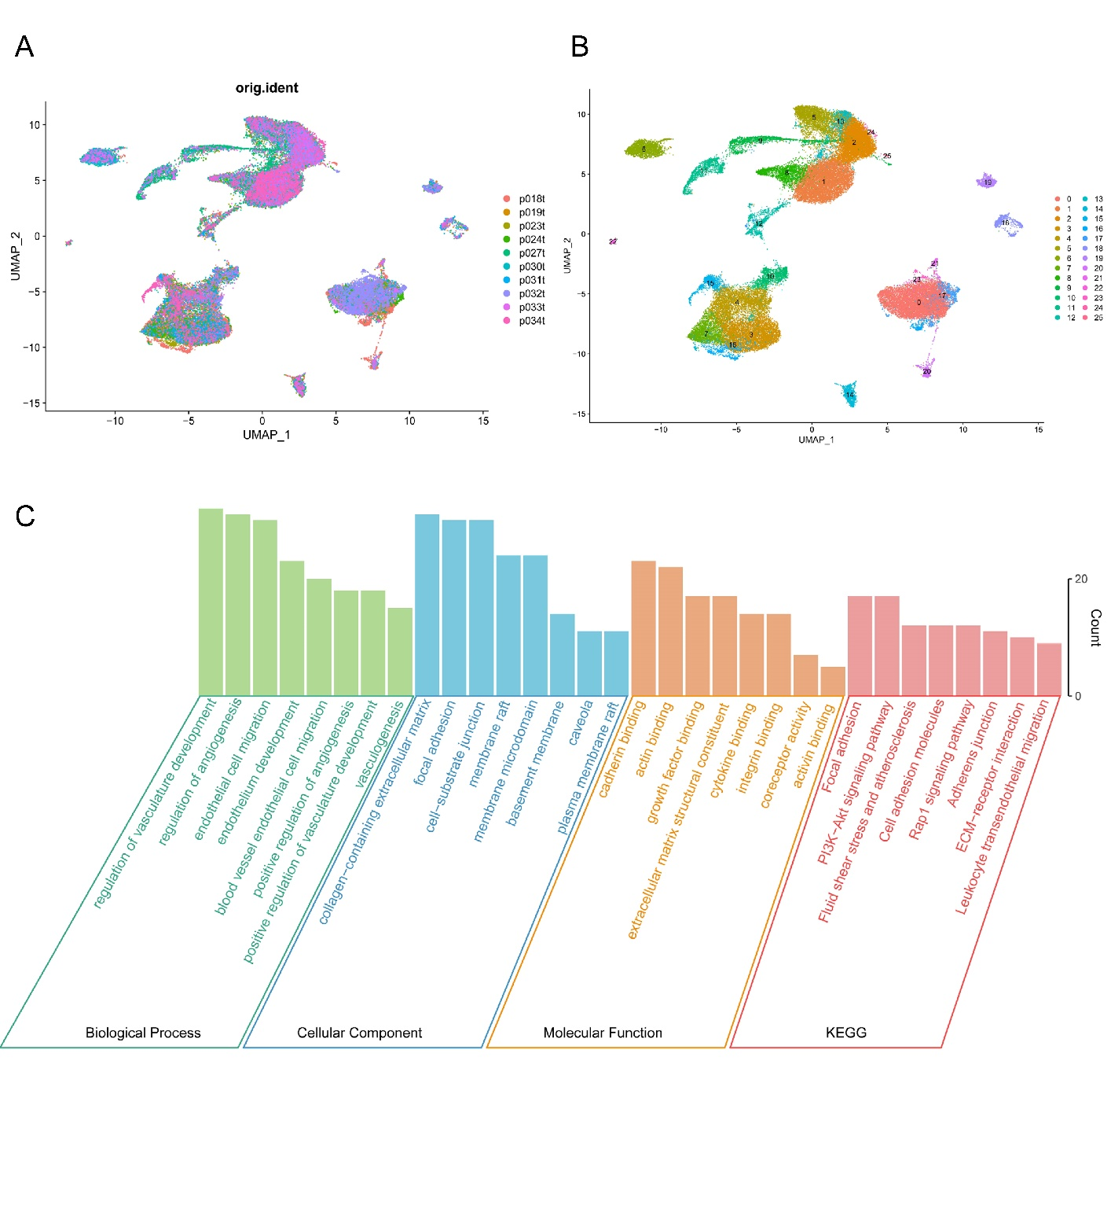
Supplementary Figure1. Single-cell transcriptome analysis and GO, KEGG enrichment analysis.
A. Distribution of the ten lung adenocarcinoma samples used for analysis in different clusters. B. Ten lung adenocarcinoma samples clustered to form 26 different Clusters. C. Results of GO, KEGG enrichment analysis of TEC marker genes.

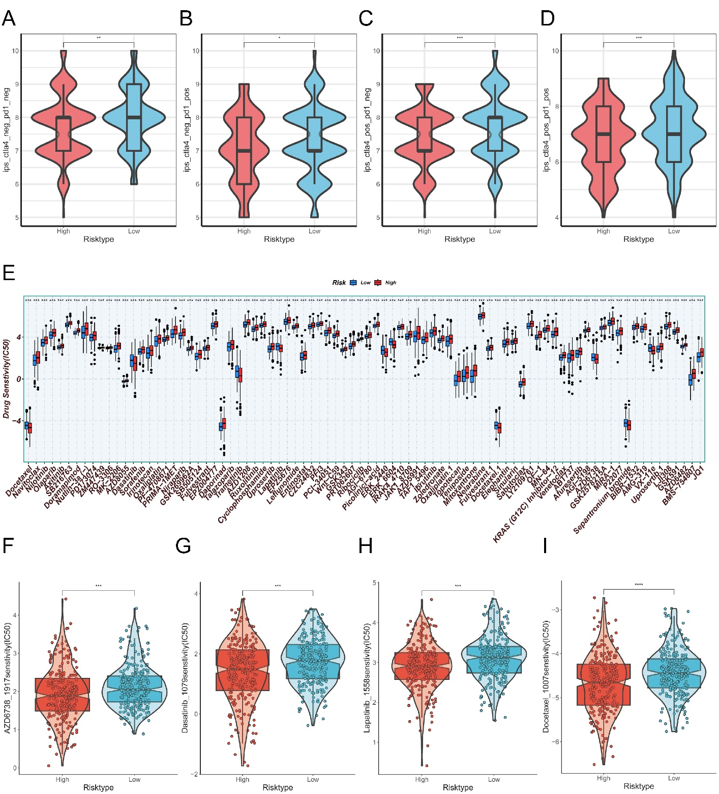

Supplementary Figure 2. IPS score analysis of differences and drug sensitivity analysis.
A-D. Differences in IPS scores between high and low-risk groups. E. Drugs with different sensitivities for high- and low-risk groups. F-I. Drugs with significant sensitivities for high-risk groups, including: AZD6738 (F), Dasatinib (G), Lapatinib (H), Docetaxel (I). (*P < 0.05, **P < 0.01; ***P < 0.001; ****P< 0.0001).

