Supplementary Information Ⅰ

Acinetobacter lentus sp. nov. isolated from Landfill

Mengli Xia,^{1,2} Yuandong Zhao,^{1,2} Bo Wu,^{1,2} Guoquan Hu,^{1,2} Mingxiong He,^{1,2,*} Yanwei Wang^{1,2,*}

¹ Biogas Institute of Ministry of Agriculture, No. 13, Section 4, Renmin South Road, Chengdu, Sichuan province, 610041
2 Key LabOratOry of Deve10pment and Application of Rural Renewable Energy, Ministry of Agriculture and Rural Affairs, P. R. China

* Corresponding author: Yanwei Wang, Mingxiong He
Email address: wyw19861124@163.com, hemingxiong@caas.cn
Phone & Fax: +86-028-8524-2281
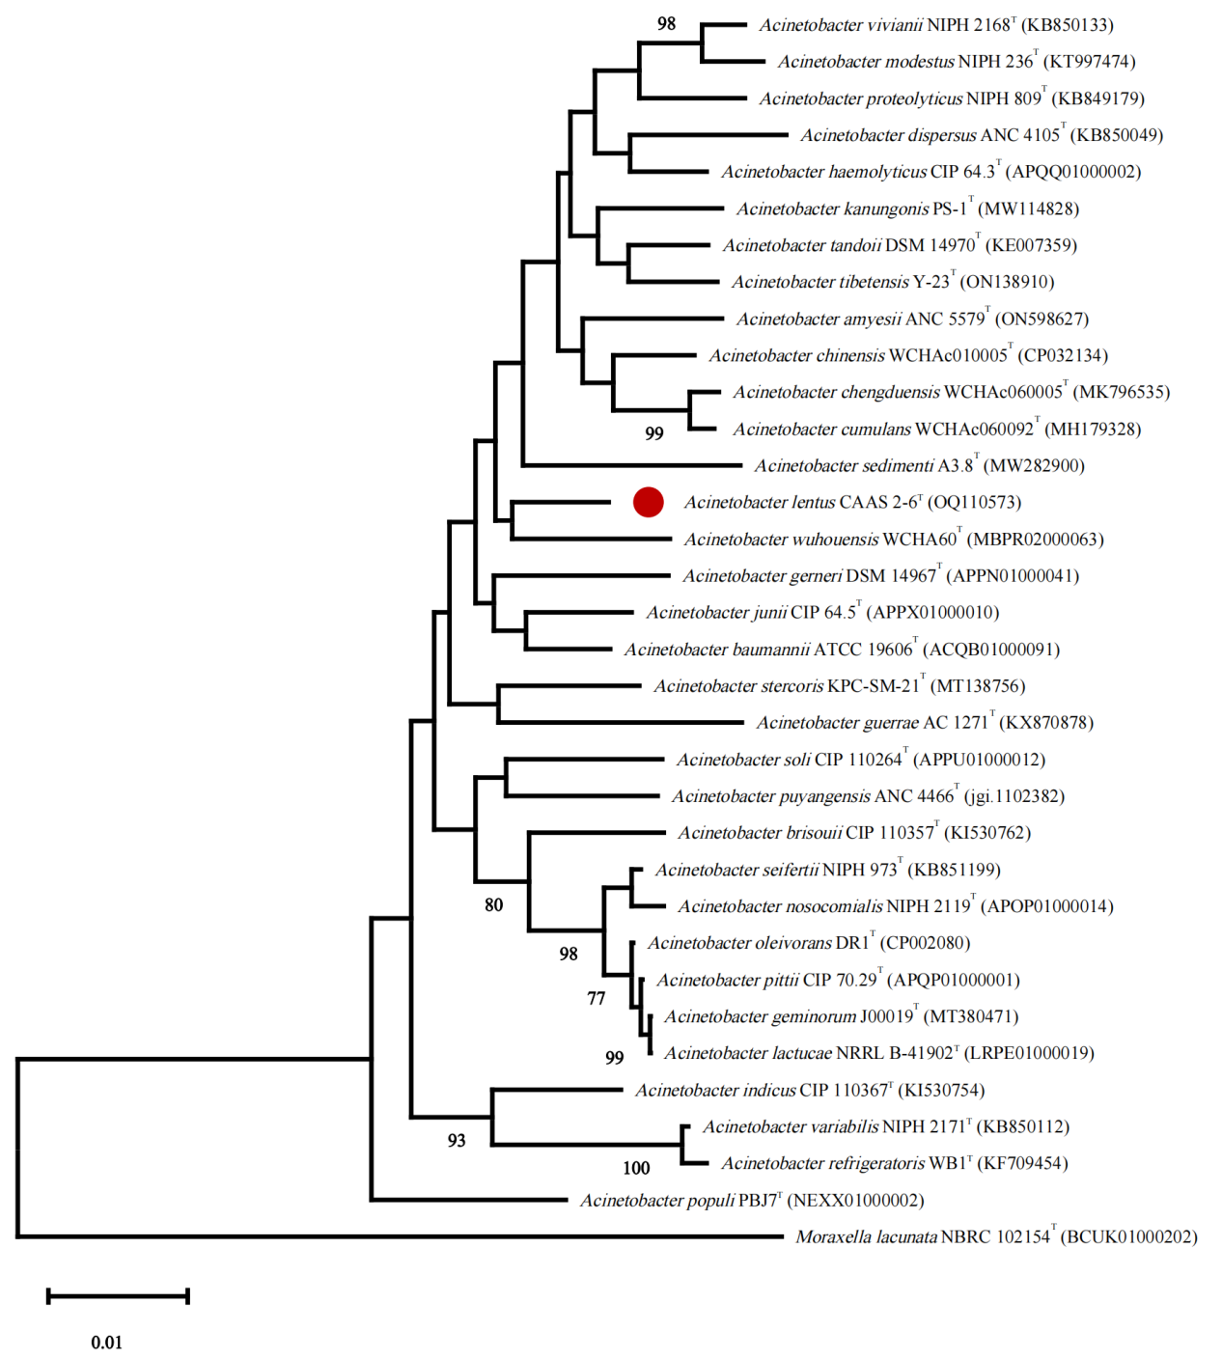
Supplementary Fig. S1. Neighbour-joining tree based on 16S rRNA gene sequences of strain CAAS 2-6^{T} and its top 32 closest relatives with validly published names. Bootstrap values based on 1000 replicates are expressed as percentages. The 16S rRNA gene sequence of Moraxella lacunata NBRC 102154^{T} was used as an outgroup. Bar represents 0.01 substitutions per nucleotide position. Bootstrap values based on 1000 replicates are expressed as percentages. Less than 70 of the Bootstrap value are not displayed.
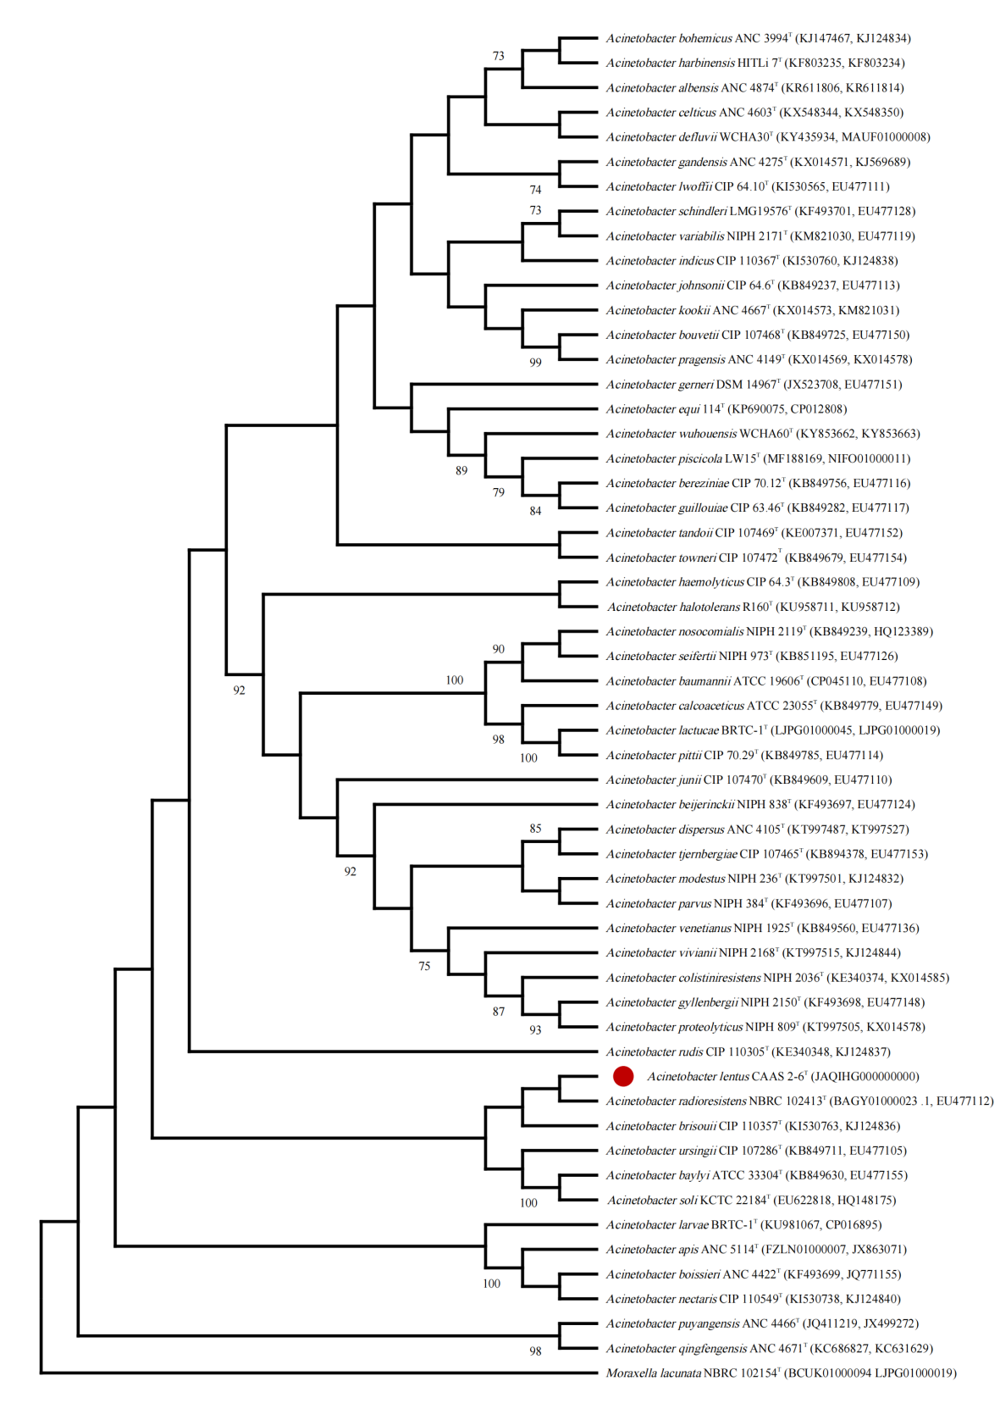
Supplementary Fig. S2. Neighbour-joining tree based on concatenated partial nucleotide sequences of the gyrB (664 bp) and rpoB (742 bp) genes of strain CAAS 2-6^{T} and recognized species/the type or reference strains of known species or taxa of the genus Acinetobacter. Similar protein sequences of Moraxella lacunata NBRC 102154^{T} were used as an outgroup. Bootstrap values based on 1000 replicates are expressed as percentages. Less than 50 of of the Bootstrap value are not displayed.
Supplementary Fig. S3. Scanning electron micrograph (SEM) of strain CAAS 2-6^{T} cells showing the rod-shape with the size of approx. 0.7 µm×0.9–1.6 µm. Bar, 3 μm.
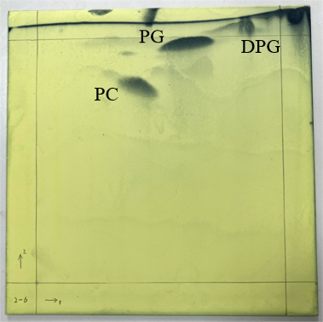
Supplementary Fig. S4. Two dimensional TLC of polar lipids of strain CAAS 2-13^{T}. DPG, diphosphatidylglycerol; PG, phosphatidylglycerol; PC, phosphatidylcholine.

Supplementary Table S2. Comparative genomic analysis of strain CAAS 2-6^{T} with the close related species within the genus Acinetobacter.
DDH results are percentages based on Formula 2: sum of all identities found in high-scoring segment pairs (HSPs) divided by overall HSP length.
Features | Acc. NO. ⁎ | Assembly type | Genome size (bp) | G+C mol% | Total genes | DDH (%)‡ | ANI (%)⁋
A. fragariae CAAS 2-6^{T} | JAQIHH000000000 | Scaffold | 3,492,366 | 42.0 | 3,332 | 100 | 100
A. baylyi DSM 14961^{T} | GCA_000368685.1 | Scaffold | 3,611,649 | 40.5 | 3,343 | 20.40 | 74.47
A. beijerinckii CIP 110307^{T} | GCA_000369005.1 | Scaffold | 3,563,334 | 38.3 | 3,390 | 20.90 | 74.95
A. bereziniae LMG 1003^{T} | GCA_000368925.1 | Scaffold | 5,026,532 | 38.3 | 4,709 | 21.50 | 75.50
A. bouvetii DSM 14964^{T} | GCA_000368865.1 | Scaffold | 3,388,822 | 45.0 | 3,212 | 20.50 | 75.57
A. brisouii CIP 110357^{T} | GCA_000488275.1 | Scaffold | 3,148,512 | 41.7 | 3,026 | 22.00 | 74.98
A. calcoaceticus DSM 30006^{T} | GCA_000368965.1 | Scaffold | 3,929,658 | 38.7 | 3,775 | 20.80 | 75.05
A. chinensis WCHAc010005^{T} | GCA_002165375.2 | Complete Genome | 3,737,289 | 42.5 | 3,461 | 20.90 | 75.51
A. colistiniresistens NIPH 2036^{T} | GCA_000413935.1 | Scaffold | 3,897,684 | 41.3 | 3,651 | 21.00 | 75.28
A. courvalinii ANC 3623^{T} | GCA_000369785.1 | Scaffold | 3,992,489 | 42.8 | 3,701 | 20.80 | 74.95
A. cumulans WCHAc060092^{T} | GCA_003024525.3 | Complete Genome | 3,710,871 | 40.4 | 3,235 | 21.40 | 76.26
A. dispersus ANC 4105^{T} | GCA_000369485.1 | Scaffold | 4,106,934 | 40.5 | 3,890 | 21.00 | 75.13
A. equi 114^{T} | GCA_001307195.1 | Complete Genome | 3,054,269 | 34.9 | 2,914 | 21.70 | 76.22
A. gerneri DSM 14967^{T} | GCA_000368565.1 | Scaffold | 4,595,172 | 37.9 | 4,284 | 21.60 | 75.16
A. guerrae AC 1271^{T} | GCA_009372255.1 | Scaffold | 3,421,735 | 39.2 | 3,293 | 19.90 | 74.67
A. guillouiae CIP 63.46^{T} | GCA_000368145.1 | Scaffold | 4,902,283 | 38.2 | 4,656 | 21.50 | 75.77
A. gyllenbergii CIP 110306^{T} | GCA_000414075.1 | Contig | 4,305,849 | 40.9 | 4,188 | 21.00 | 75.18
A. haemolyticus CIP 64.3^{T} | GCA_900444835.1 | Contig | 3,598,237 | 39.8 | 3,417 | 21.20 | 74.82
A. indicus CIP 110367^{T} | GCA_000488255.1 | Scaffold | 3,211,639 | 45.4 | 3,080 | 21.00 | 76.66
A. junii CIP 64.5^{T} | GCA_900444875.1 | Contig | 3,361,057 | 38.8 | 3,194 | 21.50 | 75.26
A. kanungonis PS-1^{T} | GCA_009939195.1 | Contig | 3,507,903 | 42.0 | 3,317 | 66.50 | 95.81
A. kookii ANC 4667^{T} | GCA_900096895.1 | Scaffold | 3,085,401 | 43.0 | 2,949 | 21.10 | 77.36
A. lactucae NRRL B-41902^{T} | GCA_001605885.1 | Scaffold | 3,916,209 | 38.6 | 3,721 | 20.40 | 74.92
A. modestus NIPH 236^{T} | GCA_000367965.1 | Scaffold | 3,544,061 | 38.5 | 3,433 | 21.10 | 75.22
A. nosocomialis NIPH 2119^{T} | GCA_000368085.1 | Scaffold | 3,906,876 | 38.8 | 3,697 | 20.70 | 74.86
A. oleivorans DR1^{T} | GCA_000196795.1 | Complete Genome | 4,152,543 | 38.7 | 3,970 | 20.70 | 74.95
A. parvus DSM 16617^{T} | GCA_000368025.1 | Scaffold | 2,912,642 | 41.8 | 2,871 | 21.10 | 75.30
A. piscicola LW15^{T} | GCA_002233755.1 | Scaffold | 3,576,146 | 37.2 | 3,319 | 21.10 | 75.91
A. pittii CIP 70.29^{T} | GCA_000369045.1 | Scaffold | 3,830,310 | 38.9 | 3,634 | 20.80 | 74.98
A. portensis Ac_877^{T} | GCA_009372215.1 | Scaffold | 2,897,281 | 36.6 | 2,813 | 21.20 | 76.55
A. proteolyticus NIPH 809^{T} | GCA_000367945.1 | Scaffold | 4,313,783 | 41.3 | 4,008 | 21.10 | 74.97
A. puyangensis ANC 4466^{T} | GCA_900096995.1 | Scaffold | 3,781,219 | 40.2 | 3,477 | 20.20 | 72.75
A. schindleri CIP 107287^{T} | GCA_000368625.1 | Scaffold | 3,394,558 | 42.3 | 3,257 | 20.80 | 75.63
A. seifertii NIPH 973^{T} | GCA_000368065.1 | Scaffold | 4,231,694 | 38.6 | 4,133 | 20.80 | 74.82
A. sichuanensis WCHAc060041^{T} | GCA_003024515.2 | Contig | 4,666,610 | 37.0 | 4,609 | 21.40 | 75.71
A. soli CIP 110264^{T} | GCA_000368705.1 | Scaffold | 3,359,986 | 43.2 | 3,161 | 20.20 | 74.07
A. tandoii DSM 14970^{T} | GCA_000400735.1 | Scaffold | 4,048,239 | 40.0 | 4,005 | 28.70 | 85.08
A. tjernbergiae DSM 14971^{T} | GCA_000374425.1 | Scaffold | 3,692,377 | 38.5 | 3,550 | 21.10 | 75.33
A. ursingii DSM 16037^{T} | GCA_000368825.1 | Scaffold | 3,535,739 | 40.2 | 3,312 | 20.80 | 75.29
A. variabilis NIPH 2171^{T} | GCA_000369625.1 | Scaffold | 3,500,761 | 42.0 | 3,365 | 20.70 | 76
A. venetianus RAG-1^{T} | GCA_000368585.1 | Scaffold | 3,464,338 | 39.2 | 3,342 | 21.60 | 75.18
A. vivianii NIPH 2168^{T} | GCA_000369705.1 | Scaffold | 4,084,898 | 41.5 | 3,775 | 21.10 | 75.28
A. wuhouensis WCHA60^{T} | GCA_001696605.3 | Complete Genome | 3,960,451 | 38.3 | 3,668 | 21.70 | 75.96

⁎ Acc. NO., the Genbank accession number for the genome sequences;
‡ DDH, in silico DNA-DNA hybridizations between strain CAAS 2-6^{T} and the close related species within the genus Acinetobacter;
⁋ ANI, average nucleotide identity calculations between strain CAAS 2-6^{T} and the close related species within the genus Acinetobacter.

Supplementary Table S3. Physiological features of strain CAAS 2-6^{T} and its closest relatives in the genus Acinetobacter. Strains: 1, CAAS 2-6^{T}; 2, A. wuhouensis WCHA60^{T} (Hu et al. 2018); 3, A. chinensis WCHAc010005^{T} (Hu et al. 2019); 4, A. sichuanensis WCHAc060041^{T} (Qin et al. 2018); 5, A. chengduensis WCHAc060005^{T} (Qin et al. 2020). All dates from this study. +, Positive reaction; –, negative reaction; w, weakly positive reaction.
Characteristic | 1 | 2 | 3 | 4 | 5
Temperature for growth (℃) | 25–40 | 20–35 | 20–35 | 25–32 | 20–37
NaCl tolerance (%, w/v) | 0-7.5 | 0-3 | 0-6 | 0-2 | 0.5-1.5
pH value for growth | 6.0-8.0 | 5.0-10.0 | 5.0-8.0 | 5.0-10.0 | 5.0-9.0
Antibiotics resistance (antibacterial circle diameter, cm)
Carbenicillin | 2.0 | 0.0 | 1.0 | 0.0 | 3.3
Ampicillin | 1.5 | 0.0 | 0.0 | 0.0 | 2.8
Kanamycin | 2.0 | 0.0 | 0.0 | 1.2 | 2.9
Cefatriaxone | 1.6 | 2.1 | 1.5 | 0.0 | 2.6
Cefoperazone | 2.0 | 0.0 | 0.0 | 1.2 | 3.3
Ceftazidime | 0.0 | 0.0 | 0.0 | 0.0 | 0.0
Cefazolin | 1.4 | 0.0 | 0.0 | 0.0 | 0.0
Gentamicin | 1.5 | 2.4 | 0.0 | 2.2 | 2.5
Penicillin | 0.0 | 0.0 | 0.0 | 0.0 | 0.0
Cefuroxime | 2.0 | 0.0 | 0.0 | 0.0 | 1.7
Neomycin | 1.5 | 1.9 | 2.3 | 2.8 | 3.5
Cephalexin | 1.3 | 0.0 | 0.0 | 0.0 | 0.9
Doxycycline | 2.8 | 1.8 | 1.5 | 2.9 | 2.4
Tetracycline | 2.1 | 1.8 | 1.6 | 1.5 | 1.6
Piperacillin | 2.1 | 1.7 | 2.3 | 2.3 | 3.1
Topaminokana | 2.4 | 2.6 | 0.0 | 3.0 | 3.0
Erythromycin | 1.6 | 0.0 | 0.0 | 0.0 | 1.2
Cefradine | 1.3 | 0.0 | 0.0 | 0.0 | 1.6
Minocycline | 3.0 | 2.7 | 2.6 | 3.5 | 3.1
Oxacillin | 0.0 | 0.0 | 0.0 | 1.3 | 0.0
Chloramphenicol | 4.3 | 2.8 | 1.9 | 1.3 | 3.6
Spectacomycin | 2.1 | 2.5 | 0 | 2.2 | 2.8
Streptomycin | 2.7 | 2.1 | 0.9 | 3.3 | 3.6
Enzymatic activity
Alkaline phosphomonoesterase | + | W | W | W | +
Esterase lipase | + | W | + | W | +
Trypsin | - | W | - | - | -
Acid phosphomonoesterase | W | W | W | + | +
Urease | - | - | - | + | -
Gelatinase | - | - | - | + | -
Carbon source assimilation
D-glucose | - | + | W | W | -
L-arabinose | W | - | W | - | -
N-acetyl glucosamine | + | - | - | - | W
D-maltose | + | - | - | + | -
Gluconate | + | - | - | W | -
Adipic acid | - | - | - | W | W
Malic acid | + | + | + | W | -
Citric acid | + | W | + | - | +
Phenylacetic acid | + | + | - | + | -
Carbon source utilization
L-arabinose | - | W | - | - | -
Ribose | - | - | - | + | -
D-xylose | - | - | W | - | -
Glucose | + | - | + | - | +
Furctose | + | - | - | - | -
α-metyl-D-glucoside | - | + | - | - | -
N-Acetylglucosamine | + | - | - | - | +
Amygdalin | - | - | + | - | -
Arbutin | W | - | + | - | W
Esculin | + | + | - | - | -
Salicoside | - | - | + | - | -
Cellobiose | - | - | W | - | -
Maltose | + | - | + | + | +
Lactose | - | + | W | - | -
Sucrose | - | - | - | + | +
Trehalose | - | - | - | - | +
Starch | + | - | - | - | -
Glycogen | - | W | - | - | -
D-Lyxose | - | + | - | - | -
D-Tagatose | - | - | + | - | -

