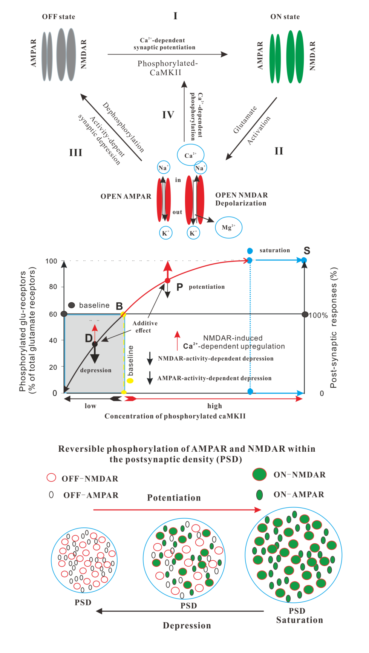
Graphical abstract
Graphical abstract explanation
Mechanisms of NMDAR-Dependent Synaptic Plasticity
Upper Section: Reversible Phosphorylation of Glutamate Receptors AMPAR and NMDAR
(I) The transition of glutamate receptors from the OFF (closed) to the ON (functional) state depends on a specific level of phosphorylated CaMKII. (II) Glutamate can activate AMPARs and NMDARs in the ON state, resulting in the opening of ion channels. The opening of NMDARs, in addition to glutamate, requires the removal of the Mg²⁺ blockage through membrane depolarization. (III) Activation of NMDAR allows the flow of sodium and potassium ions and permits the influx of Ca²⁺ into postsynaptic neurons. When AMPARs and NMDARs are open, sodium and potassium ions flow along their respective electrochemical gradients across the glutamate receptor channel. After the activation phase, the functional sites of the receptor undergo dephosphorylation, causing them to lose their open function and revert to the OFF state, inhibiting glutamate activation. This process is a primary contributor to activity-dependent synaptic depression. (Ⅳ) Ca²⁺ activate Ca²⁺/calmodulin-dependent protein kinase II (CaMKII, a serine/threonine-specific protein kinase that is regulated by the Ca²⁺/calmodulin complex), which, in turn, converts a portion of dephosphorylated CaMKII into phosphorylated CaMKII. This action activates glutamate receptors in the OFF state, returning them to the ON state.

Middle Section: NMDAR-Dependent Synaptic Plasticity
NMDAR-dependent synaptic plasticity, such as LTP and LTD, can be induced in very short timeframes (seconds or minutes), with LTP demonstrating saturation. Our hypothesis posits that the number of glutamate receptors in the postsynaptic membrane remains relatively constant, and the enhancement or reduction of synaptic responses is primarily determined by the percentage of functional receptors among the total receptors in the postsynaptic density (PSD, a protein dense specialization attached to the postsynaptic membrane). The baseline synaptic response is established by the proportion of functional to total glutamate receptors under a given condition. An increase in phosphorylated CaMKII leads to an elevation in the percentage of functional glutamate receptors (depicted on the left scale), subsequently amplifying synaptic responses (as indicated by the upper red arc). Once functional receptors constitute 100% of total glutamate receptors, the synaptic response reaches its maximum, beyond which further increases in postsynaptic phosphorylated CaMKII do not enhance synaptic response, a phenomenon referred to as saturation (depicted by the top right blue arrow). A reduction in phosphorylated CaMKII leads to synaptic depression by rendering receptors inactive; reactivating these OFF-state receptors to the ON state requires phosphorylated CaMKII, which decreases in quantity (illustrated by the left black arc).
Activation of either AMPARs or NMDARs, or both, induces activity-dependent synaptic depression (indicated by the black arrow). However, the activation of NMDARs can also trigger Ca²⁺-CaMKII-dependent synaptic upregulation (as shown by the red arrow). The synaptic responses mediated by NMDARs and AMPARs exhibit additive effects. Synaptic potentiation (as well as LTP) occurs if the NMDAR-induced Ca²⁺-CaMKII-dependent synaptic upregulation surpasses the downregulation resulting from the activation of NMDARs and/or AMPARs (depicted by the upper red arc). Conversely, synaptic depression (as well as LTD) takes place (as indicated by the lower left black arc). If the NMDAR-induced Ca²⁺-CaMKII-dependent synaptic upregulation equals the downregulation resulting from the activation of NMDARs and/or AMPARs, the postsynaptic responses remain stable. The dynamic balance between Ca²⁺-CaMKII-dependent synaptic upregulation and activity-dependent synaptic depression dictates the direction of NMDAR-dependent synaptic plasticity.
Bottom Section: Reversible phosphorylation of AMPAR and NMDAR within the postsynaptic density (PSD)

