Supplementary material
Supplementary Tables 1
TABLE S1 | PubMed Retrieval strategy.
No | Query
#1 | "trastuzumab deruxtecan" [Supplementary Concept]
#2 | ((trastuzumab deruxtecan[Title/Abstract]) OR (DS-8201a[Title/Abstract])) OR (DS-8201[Title/Abstract])
#3 | ("trastuzumab deruxtecan" [Supplementary Concept]) OR (((trastuzumab deruxtecan[Title/Abstract]) OR (DS-8201a[Title/Abstract])) OR (DS-8201[Title/Abstract]))
#4 | "Breast Neoplasms"[Mesh]
#5 | (Breast Neoplasms[Title/Abstract]) OR (Breast Neoplasms[Title/Abstract])
#6 | ("Breast Neoplasms"[Mesh]) OR ((Breast Neoplasms[Title/Abstract]) OR (Breast Neoplasms[Title/Abstract]))
#7 | (("trastuzumab deruxtecan" [Supplementary Concept]) OR (((trastuzumab deruxtecan[Title/Abstract]) OR (DS-8201a[Title/Abstract])) OR (DS-8201[Title/Abstract]))) AND (("Breast Neoplasms"[Mesh]) OR ((Breast Neoplasms[Title/Abstract]) OR (Breast Neoplasms[Title/Abstract])))
#8 | Breast Neoplasm Neoplasm, Breast Breast Tumors Breast Tumor Tumor, Breast Tumors, Breast Neoplasms, Breast Breast Cancer Cancer, Breast Mammary Cancer Cancer, Mammary Cancers, Mammary Mammary Cancers Malignant Neoplasm of Breast Breast Malignant Neoplasm Breast Malignant Neoplasms Malignant Tumor of Breast Breast Malignant Tumor Breast Malignant Tumors Cancer of Breast Cancer of the Breast Mammary Carcinoma, Human Carcinoma, Human Mammary Carcinomas, Human Mammary Human Mammary Carcinomas Mammary Carcinomas, Human Human Mammary Carcinoma Mammary Neoplasms, Human Human Mammary Neoplasm Human Mammary Neoplasms Neoplasm, Human Mammary Neoplasms, Human Mammary Mammary Neoplasm, Human Breast Carcinoma Breast Carcinomas Carcinoma, Breast Carcinomas, Breast
#9 | ((((((((((((((((((((((((((((((((((((((Breast Neoplasms[Title/Abstract]) OR (Breast Neoplasm[Title/Abstract])) OR (Neoplasm, Breas[Title/Abstract])) OR (Neoplasm, Breast[Title/Abstract])) OR (Breast Tumors[Title/Abstract])) OR (Breast Tumor[Title/Abstract])) OR (Tumor, Breast[Title/Abstract])) OR (Tumors, Breast[Title/Abstract])) OR (Neoplasms, Breast[Title/Abstract])) OR (Breast Cancer[Title/Abstract])) OR (Cancer, Breast[Title/Abstract])) OR (Mammary Cancer[Title/Abstract])) OR (Cancer, Mammary[Title/Abstract])) OR (Cancers, Mammary[Title/Abstract])) OR (Mammary Cancers[Title/Abstract])) OR (Malignant Neoplasm of Breast[Title/Abstract])) OR (Breast Malignant Neoplasm[Title/Abstract])) OR (Breast Malignant Neoplasms[Title/Abstract])) OR (Malignant Tumor of Breast[Title/Abstract])) OR (Breast Malignant Tumor[Title/Abstract])) OR (Breast Malignant Tumors[Title/Abstract])) OR (Cancer of Breast[Title/Abstract])) OR (Cancer of the Breast[Title/Abstract])) OR (Mammary Carcinoma, Human[Title/Abstract])) OR (Carcinoma, Human Mammary[Title/Abstract])) OR (Carcinomas, Human Mammary[Title/Abstract])) OR (Human Mammary Carcinomas[Title/Abstract])) OR (Mammary Carcinomas, Human[Title/Abstract])) OR (Human Mammary Carcinoma[Title/Abstract])) OR (Mammary Neoplasms, Human[Title/Abstract])) OR (Human Mammary Neoplasm[Title/Abstract])) OR (Human Mammary Neoplasms[Title/Abstract])) OR (Neoplasm, Human Mammary[Title/Abstract])) OR (Neoplasms, Human Mammary[Title/Abstract])) OR (Mammary Neoplasm, Human[Title/Abstract])) OR (Breast Carcinoma[Title/Abstract])) OR (Breast Carcinomas[Title/Abstract])) OR (Carcinoma, Breast[Title/Abstract])) OR (Carcinomas, Breast[Title/Abstract])
#10 | ("Breast Neoplasms"[Mesh]) OR (((((((((((((((((((((((((((((((((((((((Breast Neoplasms[Title/Abstract]) OR (Breast Neoplasm[Title/Abstract])) OR (Neoplasm, Breas[Title/Abstract])) OR (Neoplasm, Breast[Title/Abstract])) OR (Breast Tumors[Title/Abstract])) OR (Breast Tumor[Title/Abstract])) OR (Tumor, Breast[Title/Abstract])) OR (Tumors, Breast[Title/Abstract])) OR (Neoplasms, Breast[Title/Abstract])) OR (Breast Cancer[Title/Abstract])) OR (Cancer, Breast[Title/Abstract])) OR (Mammary Cancer[Title/Abstract])) OR (Cancer, Mammary[Title/Abstract])) OR (Cancers, Mammary[Title/Abstract])) OR (Mammary Cancers[Title/Abstract])) OR (Malignant Neoplasm of Breast[Title/Abstract])) OR (Breast Malignant Neoplasm[Title/Abstract])) OR (Breast Malignant Neoplasms[Title/Abstract])) OR (Malignant Tumor of Breast[Title/Abstract])) OR (Breast Malignant Tumor[Title/Abstract])) OR (Breast Malignant Tumors[Title/Abstract])) OR (Cancer of Breast[Title/Abstract])) OR (Cancer of the Breast[Title/Abstract])) OR (Mammary Carcinoma, Human[Title/Abstract])) OR (Carcinoma, Human Mammary[Title/Abstract])) OR (Carcinomas, Human Mammary[Title/Abstract])) OR (Human Mammary Carcinomas[Title/Abstract])) OR (Mammary Carcinomas, Human[Title/Abstract])) OR (Human Mammary Carcinoma[Title/Abstract])) OR (Mammary Neoplasms, Human[Title/Abstract])) OR (Human Mammary Neoplasm[Title/Abstract])) OR (Human Mammary Neoplasms[Title/Abstract])) OR (Neoplasm, Human Mammary[Title/Abstract])) OR (Neoplasms, Human Mammary[Title/Abstract])) OR (Mammary Neoplasm, Human[Title/Abstract])) OR (Breast Carcinoma[Title/Abstract])) OR (Breast Carcinomas[Title/Abstract])) OR (Carcinoma, Breast[Title/Abstract])) OR (Carcinomas, Breast[Title/Abstract]))
#11 | (("Breast Neoplasms"[Mesh]) OR (((((((((((((((((((((((((((((((((((((((Breast Neoplasms[Title/Abstract]) OR (Breast Neoplasm[Title/Abstract])) OR (Neoplasm, Breas[Title/Abstract])) OR (Neoplasm, Breast[Title/Abstract])) OR (Breast Tumors[Title/Abstract])) OR (Breast Tumor[Title/Abstract])) OR (Tumor, Breast[Title/Abstract])) OR (Tumors, Breast[Title/Abstract])) OR (Neoplasms, Breast[Title/Abstract])) OR (Breast Cancer[Title/Abstract])) OR (Cancer, Breast[Title/Abstract])) OR (Mammary Cancer[Title/Abstract])) OR (Cancer, Mammary[Title/Abstract])) OR (Cancers, Mammary[Title/Abstract])) OR (Mammary Cancers[Title/Abstract])) OR (Malignant Neoplasm of Breast[Title/Abstract])) OR (Breast Malignant Neoplasm[Title/Abstract])) OR (Breast Malignant Neoplasms[Title/Abstract])) OR (Malignant Tumor of Breast[Title/Abstract])) OR (Breast Malignant Tumor[Title/Abstract])) OR (Breast Malignant Tumors[Title/Abstract])) OR (Cancer of Breast[Title/Abstract])) OR (Cancer of the Breast[Title/Abstract])) OR (Mammary Carcinoma, Human[Title/Abstract])) OR (Carcinoma, Human Mammary[Title/Abstract])) OR (Carcinomas, Human Mammary[Title/Abstract])) OR (Human Mammary Carcinomas[Title/Abstract])) OR (Mammary Carcinomas, Human[Title/Abstract])) OR (Human Mammary Carcinoma[Title/Abstract])) OR (Mammary Neoplasms, Human[Title/Abstract])) OR (Human Mammary Neoplasm[Title/Abstract])) OR (Human Mammary Neoplasms[Title/Abstract])) OR (Neoplasm, Human Mammary[Title/Abstract])) OR (Neoplasms, Human Mammary[Title/Abstract])) OR (Mammary Neoplasm, Human[Title/Abstract])) OR (Breast Carcinoma[Title/Abstract])) OR (Breast Carcinomas[Title/Abstract])) OR (Carcinoma, Breast[Title/Abstract])) OR (Carcinomas, Breast[Title/Abstract]))) AND (("trastuzumab deruxtecan" [Supplementary Concept]) OR (((trastuzumab deruxtecan[Title/Abstract]) OR (DS-8201a[Title/Abstract])) OR (DS-8201[Title/Abstract])))

TABLE S2 | Embase Retrieval strategy.
No | Query
#44 | #5 AND #43
#43 | #6 OR #7 OR #8 OR #9 OR #10 OR #11 OR #12 OR #13 OR #14 OR #15 OR #16 OR #17 OR #18 OR #19 OR #20 OR #21 OR #22 OR #23 OR #24 OR #25 OR #26 OR #27 OR #28 OR #29 OR #30 OR #31 OR #32 OR #33 OR #34 OR #35 OR #36 OR #37 OR #38 OR #39 OR #40 OR #41 OR #42
#42 | 'carcinomas, breast':ab,ti
#41 | 'carcinoma, breast':ab,ti
#40 | 'breast carcinomas':ab,ti
#39 | 'breast carcinoma':ab,ti
#38 | 'mammary neoplasm, human':ab,ti
#37 | 'neoplasms, human mammary':ab,ti
#36 | 'neoplasm, human mammary':ab,ti
#35 | 'human mammary neoplasms':ab,ti
#34 | 'human mammary neoplasm':ab,ti
#33 | 'mammary carcinomas, human':ab,ti
#32 | 'human mammary carcinomas':ab,ti
#31 | 'carcinomas, human mammary':ab,ti
#30 | 'carcinoma, human mammary':ab,ti
#29 | 'mammary carcinoma, human':ab,ti
#28 | 'cancer of the breast':ab,ti
#27 | 'cancer of breast':ab,ti
#26 | 'breast malignant tumors':ab,ti
#25 | 'breast malignant tumor':ab,ti
#24 | 'malignant tumor of breast':ab,ti
#23 | 'breast malignant neoplasms':ab,ti
#22 | 'breast malignant neoplasm':ab,ti
#21 | 'malignant neoplasm of breast':ab,ti
#20 | 'mammary cancers':ab,ti
#19 | 'cancers, mammary':ab,ti
#18 | 'cancer, mammary':ab,ti
#17 | 'mammary cancer':ab,ti
#16 | 'cancer, breast':ab,ti
#15 | 'breast cancer':ab,ti
#14 | 'neoplasms, breast':ab,ti
#13 | 'tumors, breast':ab,ti
#12 | 'tumor, breast':ab,ti
#11 | 'breast tumor':ab,ti
#10 | 'breast tumors':ab,ti
#9 | 'neoplasm, breast':ab,ti
#8 | 'breast neoplasm':ab,ti
#7 | 'breast neoplasms':ab,ti
#6 | 'breast tumor'/exp
#5 | #1 OR #2 OR #3 OR #4
#4 | 'ds-8201':ab,ti
#3 | 'ds-8201a':ab,ti
#2 | 'trastuzumab deruxtecan':ab,ti
#1 | 'trastuzumab deruxtecan'/exp

TABLE S3 | Web of science Retrieval strategy.
No | Query
#1 | "TS=(trastuzumab deruxtecan) OR TS=(DS-8201a) OR TS=(DS-8201)"
#2 | "TS=(Breast Neoplasms) OR TS=(Breast Neoplasm) OR TS=(Neoplasm, Breast) OR TS=(Breast Tumors) OR TS=(Breast Tumor) OR TS=(Tumor, Breast) OR TS=(Tumors, Breast) OR TS=(Neoplasms, Breast) OR TS=(Breast Cancer) OR TS=(Cancer, Breast) OR TS=(Mammary Cancer) OR TS=(Cancer, Mammary) OR TS=(Cancers, Mammary) OR TS=(Mammary Cancers) OR TS=(Malignant Neoplasm of Breast) OR TS=(Breast Malignant Neoplasm) OR TS=(Breast Malignant Neoplasms) OR TS=(Malignant Tumor of Breast) OR TS=(Breast Malignant Tumor) OR TS=(Breast Malignant Tumors) OR TS=(Cancer of Breast) OR TS=(Cancer of the Breast)OR TS=(Mammary Carcinoma, Human) OR TS=(Carcinoma, Human Mammary) OR TS=(Carcinomas, Human Mammary) OR TS=(Human Mammary Carcinomas) OR TS=(Mammary Carcinomas, Human) OR TS=(Human Mammary Carcinoma) OR TS=(Mammary Neoplasms, Human) OR TS=(Human Mammary Neoplasm) OR TS=(Human Mammary Neoplasms) OR TS=(Neoplasm, Human Mammary) OR TS=(Neoplasms, Human Mammary) OR TS=(Mammary Neoplasm, Human) OR TS=(Breast Carcinoma) OR TS=(Breast Carcinomas) OR TS=(Carcinoma, Breast) OR TS=(Carcinomas, Breast) "
#3 | "#1 AND #2 "

TABLE S4| Cochrane library Retrieval strategy.
No | Query
#1 | (trastuzumab deruxtecan):ti,ab,kw OR (DS-8201a):ti,ab,kw OR (DS-8201):ti,ab,kw
#2 | MeSH descriptor: [Breast Neoplasms] explode all trees
#3 | (Breast Neoplasms):ti,ab,kw OR (Breast Neoplasm):ti,ab,kw OR (Neoplasm, Breast):ti,ab,kw OR (Breast Tumors):ti,ab,kw OR (Breast Tumor):ti,ab,kw
#4 | (Tumor, Breast):ti,ab,kw OR (Tumors, Breast):ti,ab,kw OR (Neoplasms, Breast):ti,ab,kw OR (Breast Cancer):ti,ab,kw OR (Cancer, Breast):ti,ab,kw
#5 | (Mammary Cancer):ti,ab,kw OR (Cancer, Mammary):ti,ab,kw OR (Cancers, Mammary):ti,ab,kw OR (Mammary Cancers):ti,ab,kw OR (Malignant Neoplasm of Breast):ti,ab,kw
#6 | (Breast Malignant Neoplasm):ti,ab,kw OR (Breast Malignant Neoplasms):ti,ab,kw OR (Malignant Tumor of Breast):ti,ab,kw OR (Breast Malignant Tumor):ti,ab,kw OR (Breast Malignant Tumors):ti,ab,kw
#7 | (Cancer of Breast):ti,ab,kw OR (Cancer of the Breast):ti,ab,kw OR (Mammary Carcinoma, Human):ti,ab,kw OR (Carcinoma, Human Mammary):ti,ab,kw OR (Carcinomas, Human Mammary):ti,ab,kw
#8 | (Human Mammary Carcinomas):ti,ab,kw OR (Mammary Carcinomas, Human):ti,ab,kw OR (Human Mammary Carcinoma):ti,ab,kw OR (Mammary Neoplasms, Human):ti,ab,kw OR (Human Mammary Neoplasm):ti,ab,kw
#9 | (Human Mammary Neoplasms):ti,ab,kw OR (Neoplasm, Human Mammary):ti,ab,kw OR (Neoplasms, Human Mammary):ti,ab,kw OR (Mammary Neoplasm, Human):ti,ab,kw OR (Breast Carcinoma):ti,ab,kw
#10 | (Breast Carcinomas):ti,ab,kw OR (Carcinoma, Breast):ti,ab,kw OR (Carcinomas, Breast):ti,ab,kw
#11 | #2 OR #3 OR #4 OR #5 OR #6 OR #7 OR #8 OR #10

Supplementary Tables 2 Newcastle-Ottawa Scale (NOS) for Single arm studies
Newcastle-Ottawa Scale (NOS) for Single arm studies
Study | 1 | 2 | 3 | 4 | 5 | 6 | 7 | 8 | 总分
Bartsch R | ** | ** | ** | ** | / | ** | ** | / | 12
Jerusalem G | ** | ** | ** | ** | / | ** | ** | / | 12
Modi S | ** | ** | ** | ** | / | ** | ** | / | 12
Nakajima H. | ** | ** | ** | ** | / | ** | ** | / | 12
Shimomura A | ** | ** | ** | ** | / | ** | ** | / | 12
Pérez-García J. M. | ** | ** | ** | ** | / | ** | ** | / | 12
Modi S | ** | ** | ** | ** | / | ** | ** | / | 12
Tamura K | ** | ** | ** | ** | ** | ** | ** | / | 14
T Doi | ** | ** | / | ** | / | ** | ** | / | 10
*: one score
Evaluation of entries according to MINORS：
1:A clearly stated aim: the question addressed should be precise and relevant in the light of available literature
2:Inclusion of consecutive patients: all patients potentially fit for inclusion (satisfying the criteria for inclusion) have been included in the study during the study period (no exclusion or details about the reasons for exclusion)
3. Prospective collection of data: data were collected according to a protocol established before the beginning of the study
4. Endpoints appropriate to the aim of the study: unambiguous explanation of the criteria used to evaluate the main outcome which should be in accordance with the question addressed by the study. Also, the endpoints should be assessed on an intention-to-treat basis.
5. Unbiased assessment of the study endpoint: blind evaluation of objective endpoints and double-blind evaluation of subjective endpoints. Otherwise the reasons for not blinding should be stated
6. Follow-up period appropriate to the aim of the study: the follow-up should be sufficiently long to allow the assessment of the main endpoint and possible adverse events
7. Loss to follow up less than 5%: all patients should be included in the follow up. Otherwise, the proportion lost to follow up should not exceed the proportion experiencing the major endpoint
8. Prospective calculation of the study size: information of the size of detectable difference of interest with a calculation of 95% confidence interval, according to the expected incidence of the outcome event, and information about the level for statistical significance and estimates of power when comparing the outcomes

TABLE 3 Results of meta-analysis of adverse events
adverse event | Any grade |  |  |  |  |  | Grade≥3
adverse event | study | Heterogeneity |  | ES (95%CI) | P | Egger test | study | Heterogeneity |  | ES (95%CI) | P | Egger test
adverse event | study | P | I²(%) |  |  |  |  | P | I²(%) | ES (95%CI) | P | Egger test
Neutropenia | 11 | 0.000 | 78.5 | 0.36(0.31,0.42) | 0.000 | 0.648 | 11 | 0.000 | 69.9 | 0.20(0.16,0.24) | 0.000 | 0.074
Anemia | 11 | 0.001 | 65.8 | 0.35(0.30,0.39) | 0.000 | 0.419 | 10 | 0.316 | 34 | 0.09(0.07,0.11) | 0.000 | 0.023
Leukopenia | 8 | 0.000 | 84.1 | 0.28(0.22,0.33) | 0.000 | 0.070 | 8 | 0.006 | 65 | 0.08(0.06,0.10) | 0.000 | 0.001
Thrombocytopenia | 10 | 0.188 | 27.9 | 0.23(0.20,0.26) | 0.000 | 0.338 | 7 | 0.000 | 78.5 | 0.05(0.03,0.13) | 0.000 | 0.020
Nausea | 11 | 0.020 | 52.7 | 0.75(0.71,0.78) | 0.000 | 0.212 | 8 | 0.513 | 0 | 0.06(0.04,0.07) | 0.000 | 0.772
Vomiting | 10 | 0.000 | 74.3 | 0.42(0.37,0.48) | 0.000 | 0.864 | 6 | 0.140 | 39.8 | 0.02(0.01,0.03) | 0.000 | 0.001
Diarrhea | 10 | 0.003 | 64.5 | 0.29(0.25,0.34) | 0.000 | 0.189 | 8 | 0.186 | 30.4 | 0.01(0.01,0.02) | 0.001 | 0.002
Constipation | 10 | 0.000 | 78.2 | 0.31(0.26,0.37) | 0.000 | 0.249 | 3 | 0.942 | 0 | 0.01(-0.00,0.01) | 0.089 | NR
Fatigue | 10 | 0.000 | 79.3 | 0.46(0.40,0.52) | 0.000 | 0.309 | 9 | 0.858 | 0 | 0.06(0.05,0.07) | 0.000 | 0.951
Aspartate aminotransferase increased | 5 | 0.773 | 0 | 0.25(0.22,0.28) | 0.000 | 0.558 | 4 | 0.507 | 0 | 0.01(0.00,0.02) | 0.015 | 0.055
Alanine aminotransferase increased | 5 | 0.587 | 0 | 0.20(0.17,0.23) | 0.000 | 0.187 | 3 | 0.986 | 0 | 0.01(0.01,0.03) | 0.003 | NR
Decreased appetite | 8 | 0.000 | 83.4 | 0.35(0.29,0.41) | 0.000 | 0.083 | 7 | 0.798 | 0 | 0.02(0.01,0.02) | 0.000 | 0.064
Alopecia | 10 | 0.000 | 69.9 | 0.40(0.35,0.45) | 0.000 | 0.610 | 4 | 0.990 | 0 | 0.00(0.00,0.01) | 0.048 | NR
Adjudicated drug-related interstitial lung | 8 | 0.018 | 58.4 | 0.12(0.09,0.15) | 0.000 | 0.259 | 7 | 0.250 | 23.5 | 0.01(0.01,0.02) | 0.001 | 0.054
Headache | 7 | 0.031 | 56.8 | 0.17(0.13,0.22) | 0.000 | 0.666 | 2 | 0.607 | 0 | 0.00(-0.00,0.01) | 0.186 | NR
ventricular dysfunction | 5 | 0.016 | 67 | 0.07(0.04,0.11) | 0.000 | 0.870 | 4 | 0.845 | 0 | 0.01(0.01,0.02) | 0.002 | 0.168
Abbreviation: CI: confidence interval; NR: Not reported

TABLE 4 Publish biased assessments.
Outcome | P value for Egger test | P value for Begg test
Single-armed experiment
ORR | 0.798 | 0.180
DCR | 0.005
Randomized controlled trial
ORR | 0.075 | 0.117
OS | 0.187 | 1.000
PFS | 0.018 | 1.040
Abbreviation: OS: Overall survival; PFS: progression free survival; ORR: Objective response rate;DCR:disease control rate.

Supplementary Figures
S1 ROB2.0 for RCT
（A）
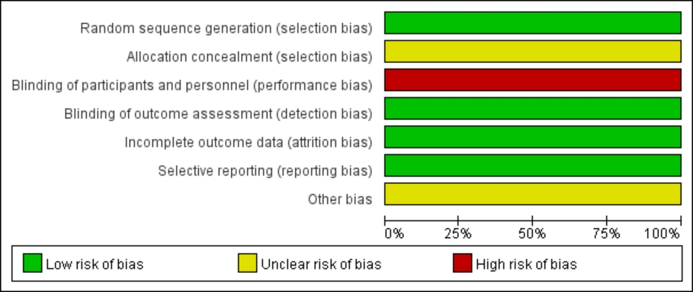
（B）

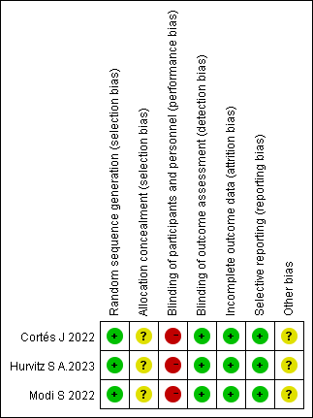

Risk of bias assessment. (A) Risk of bias graph; (B) Risk of bias summary.

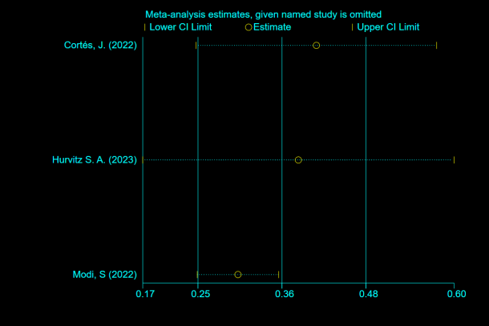
S2
（A）

Sensitivity analysis. (A) PFS Sensitivity analysis- RCT.

S3
- ORR (B)DCR
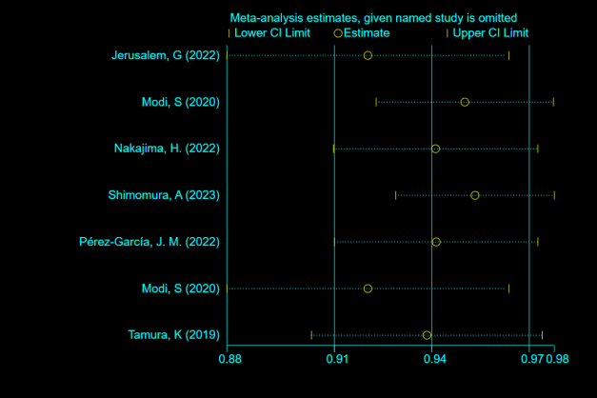
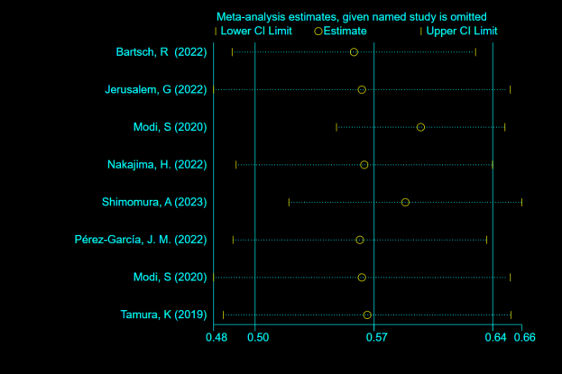

Sensitivity analysis. (A) ORR Sensitivity analysis- single arm study; (B) DCR Sensitivity analysis- single arm study.

S4
- (B)
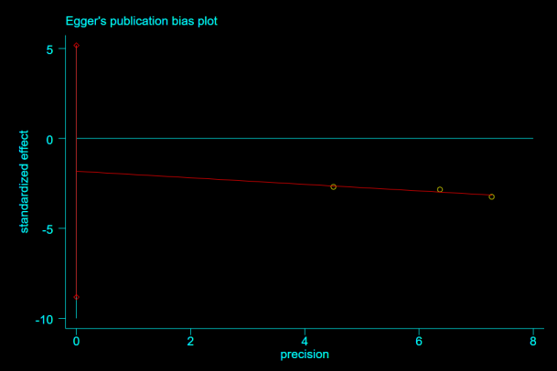
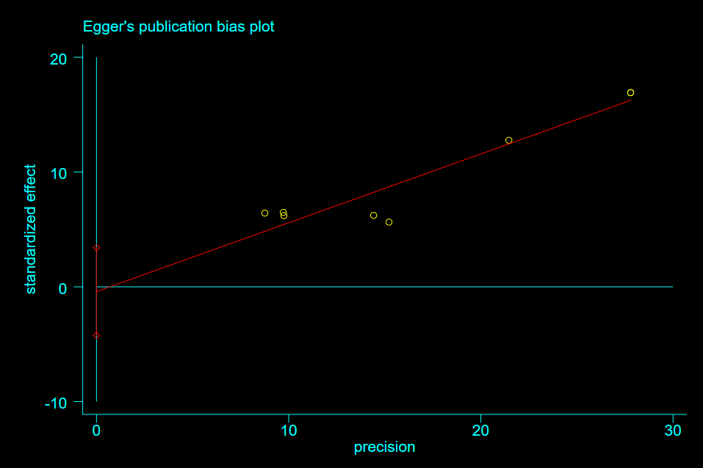

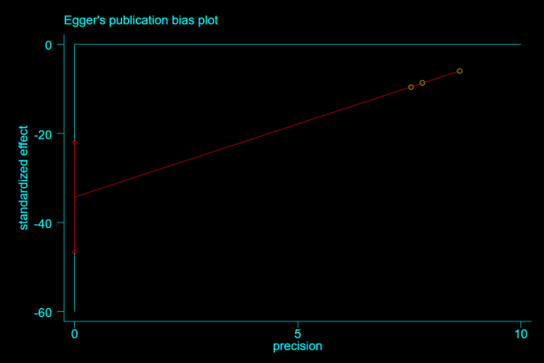
- （D）

(E)
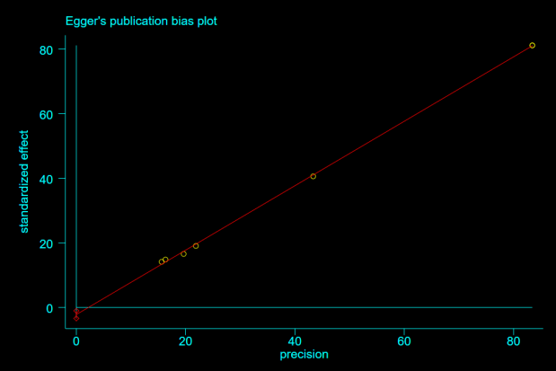

Egger's test:(A) ORR Egger's test-RCT; (B) OS Egger's test-RCT; (C) PFS Egger's test-RCT; (D) ORR Egger's test-single arm study; (B) DCR Egger's tests- single arm study.

