SUPPLEMENTARY DATA
Supplementary figure 1: Surface plots and RGB plots of confocal microscopy showing fluorescence signal intensity in response to Rv1039c and Rv1039c-/-Cterm stimulated cells after 6, 16 and 24 hrs.

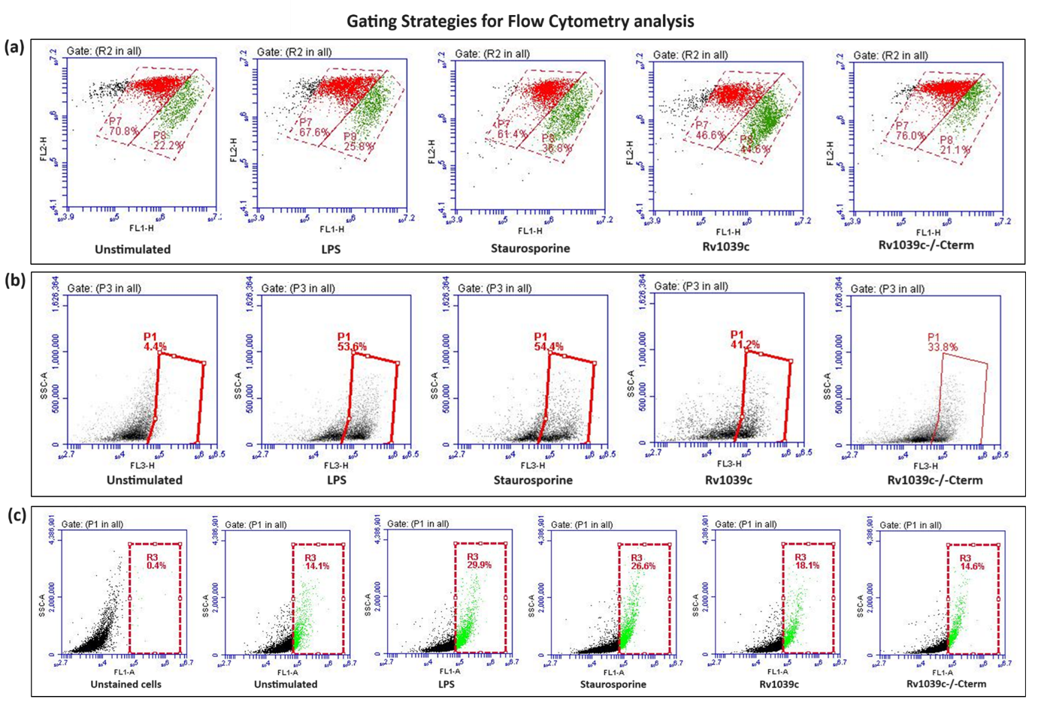
Supplementary figure 2: Gating strategies for flow cytometry analysis. (a) Mitochondrial membrane potential, (b) Mitochondrial superoxides release and (c) Cytochorome-C release.
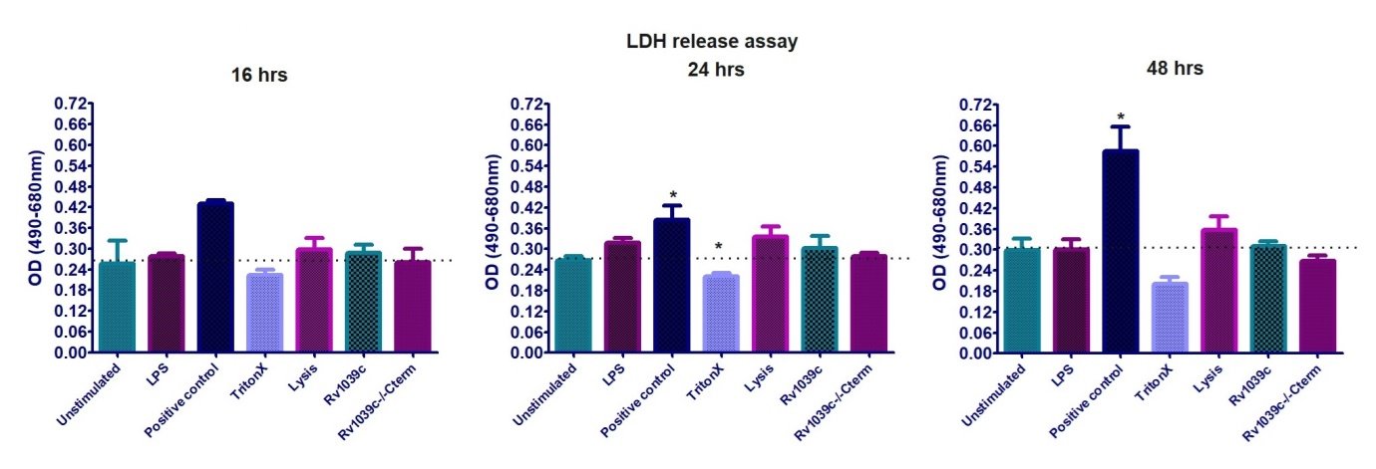
Supplementary figure 3: Rv1039c does not induce necrotic cell death in THP1 macrophages. The release of LDH was estimated in response to Rv1039c and Rv1039-/-Cterm after 16, 24 and 48 hrs of stimulation. Data represents Mean ± SEM of three independent experiments and Student’s T-test was used for statistical analysis. The level of significance with respect to unstimulated cells was shown as *P<0.05.

