Elucidating Synergistic Effect of In-Situ Hybrid Process Towards Paraquat Abatement
Yamini Pandey ª, Aarsee Dhindsa ª, Anoop Verma ^{b}, Amrit Pal Toor ^{a, c.*}
ª Energy Research Centre, Panjab University, Chandigarh, India
^{b} Thapar Institute of Engg. & Technology, Patiala, Punjab, India
^{c} Dr. SSB University Institute of Chemical Engg & Technology, Panjab University, Chandigarh, India
*Corresponding Author: aptoor@yahoo.com
a) C-PT |  |   Ti
 |   O |   C
b) Ni-PT | 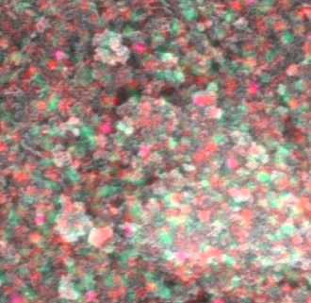 |   Ti
 |   O |   Ni
c) Fe-PT |  |   Ti
 |   O |   Fe
d) S-PT | 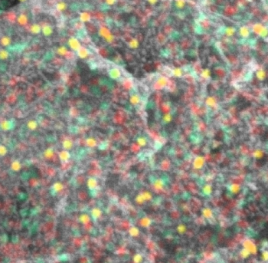 | Ti
 |   O |   S
e) Fe-S-PT |  | O
 | Ti | Fe

S

Fig. S1 Elemental Mapping showing distribution of different atoms

Fig. S2. Effect of different light conditions on PQ removal
1S. Variation with changing calcination temperature
In order to study the effect of heat treatment over catalytic activity, both the photocatalyst i.e., Fe-PT and S-PT were subjected to varying calcination temperature from 150ºC to 550ºC as shown in Fig. S3. From insight 450ºC can be stated as the optimum temperature resulting into maximum PQ degradation since the activity of TiO₂ is due to its anatase phase which is temperature dependent. As the temperature increases anatase phase become more activated however, at higher temperature anatase gets converted into rutile form causing a decline in catalytic activity.

Fig. S3. Effect of calcination temperature on degradation of PQ (Sunlight, PQ 25 ppm, pH 6.3, Catalyst Loading 1.5 g/L, Time 180 mins)

Fig. S4. Effect of initial concertation on the degradation of PQ using Photocatalysis and Hybrid Process (Sunlight, PQ 25 ppm, pH 6.3, 1.5% Fe-1.5% S-PT, Catalyst Loading 1.5 g/L)
2S. Trapping Experiments
To realize the role of various active species involved in the degradation of PQ via hybrid process, trapping experiments were performed. To determine the inhibitory effect of various radicals NaCl (for h⁺), IPA (for OH˙), AgNO₃ (for e⁻), and p-BQ (for O₂⁻˙) were used as sacrificial agents. The result of Fig.S5 disclosed retardation in the degradation of PQ from 97% to 24% (with the addition of IPA) and 33% (with AgNO₃). However, a nominal decline to 79% with p-BQ and 86% with NaCl was attained confirming OH˙ and e⁻ play the decisive role in the hybrid process.

Fig. S5. Role of various Scavengers on PQ degradation

Fig. S6. Mass spectra of PQ solution at different time intervals

