Supplementary Materials
Acidic preconditioning induced intracellular acid adaptation to protect renal injury via dynamic phosphorylation of focal adhesion kinase dependent activation of sodium hydrogen exchanger 1
Annan Chen^{1#}, Jian Zhang^{1#}, Zhixin Yan^{1#}, Yufei Lu¹, Weize Chen¹, Yingxue Sun¹, Qiuyu Gu¹, Kailin Sun¹, Fang Li¹, Yan Yang¹, Shuan Zhao¹, Zhouping Zou¹, Shanfang Qiu², Xueping Lin², Dong Zhang², Jie Teng^{1, 2}, Yi Fang¹, Bo Shen^{1*}, Nana Song^{1,3*}, Xiaoqiang Ding^{1*}

Table of contents
Figure S1, related to Figure1. Intra-Kidney pH value was measured after IPC, I/R, and IPC+I/R.
Figure S2, related to Figure1. The AP process of PTEC was similar to that of HK2 cells
Immunoblots of cleaved Casp-3 in proximal tubular epithelial cells (PTEC) treated with A12R6 after H/R.
Figure S3, related to Figure5. The effects of varying treatment times and withdrawal times of Defacitib and Pyrintegrin on the phosphorylation level of pFAK Y397 in HK2 cells.
Figure S4, related to Figure6. The localization of NOX4 in HK2 cells is primarily in the mitochondria.
Figure S5, related to Figure6. Co-localization of pFAK and NOX4 was also observed in PTEC cells.
Figure S6, related to Figure7. The colocalization of NHE1 with F-actin and focal adhesions in PTEC cells is similar to that in HK2 cells.
Table S1, related to Key resources table. Composition and Preparation of Solution

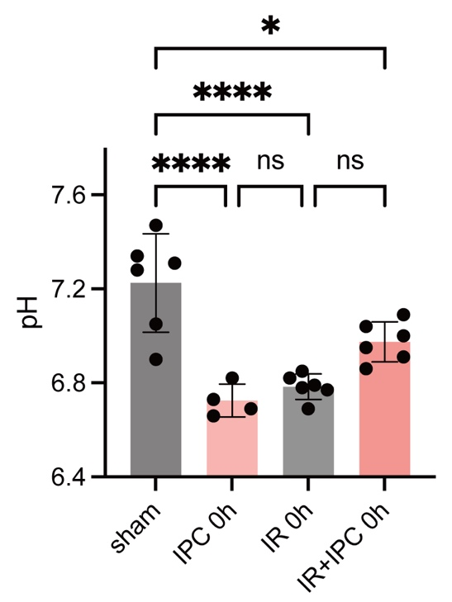
Figure S1, related to Figure1. Intra-Kidney pH value was measured after IPC, I/R, and IPC+I/R.
Data are mean ± SEM. *p<0.05, ****p＜0.0001. One-way ANOVA followed by Sidak’s post test.

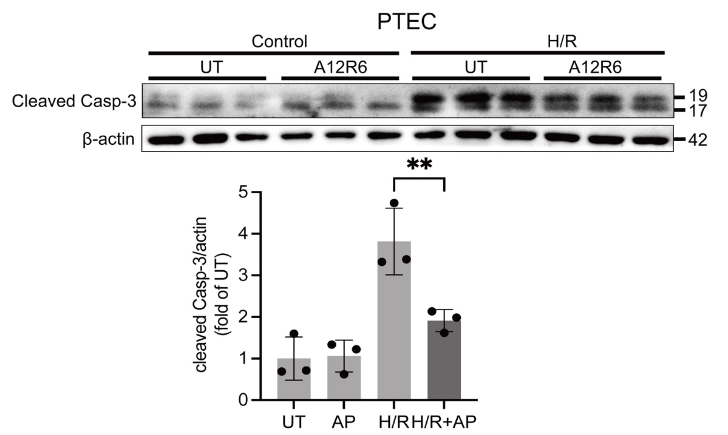
Figure S2, related to Figure1. The AP process of PTEC was similar to that of HK2 cells
Immunoblots of cleaved Casp-3 in proximal tubular epithelial cells (PTEC) treated with A12R6 after H/R. Data are mean ± SEM. **p＜0.01. One-way ANOVA followed by Sidak’s post test.

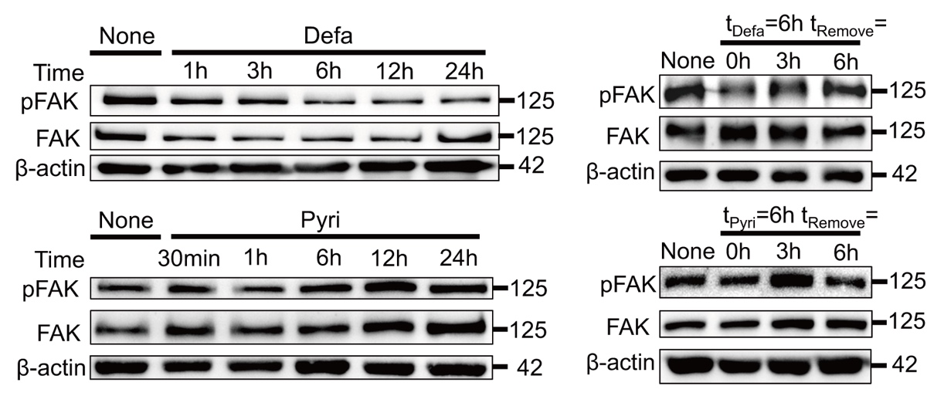
Figure S3, related to Figure5. The effects of varying treatment times and withdrawal times of Defacitib and Pyrintegrin on the phosphorylation level of pFAK Y397 in HK2 cells.

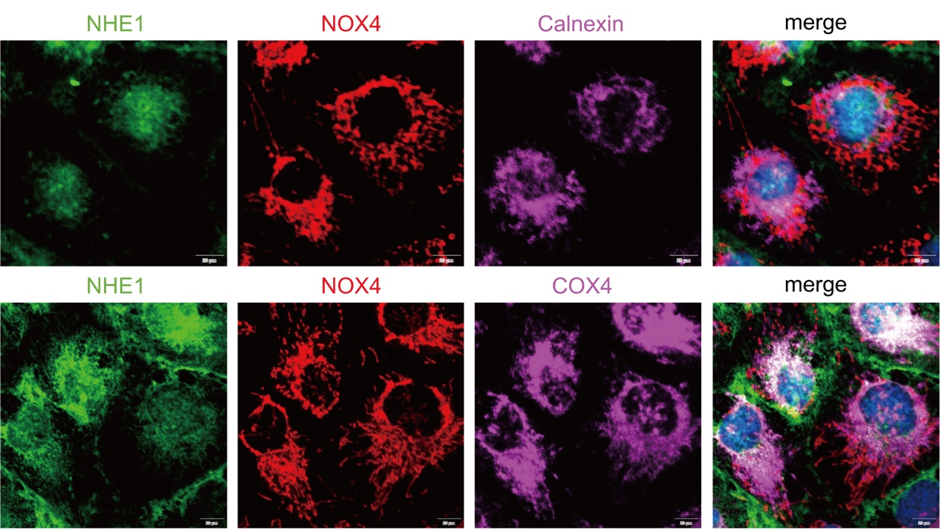
Figure S4, related to Figure6. The localization of NOX4 in HK2 cells is primarily in the mitochondria.
Staining of NHE1 (green, anti-NHE1), NOX4 (red, anti-NOX4), Calnexin (magenta, anti-Calnexin) and NOX4 ( magenta, anti-NOX4) in HK2 cells.

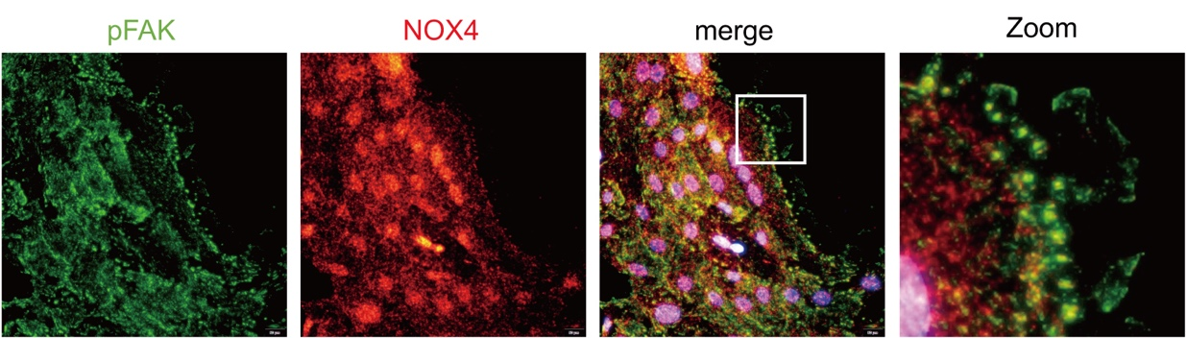
Figure S5, related to Figure6. Co-localization of pFAK and NOX4 was also observed in PTEC cells.
Immunofluorescence staining of pFAK (green, anti-pFAK) and NOX4 (red, anti-NOX4) was conducted in PTEC cells.

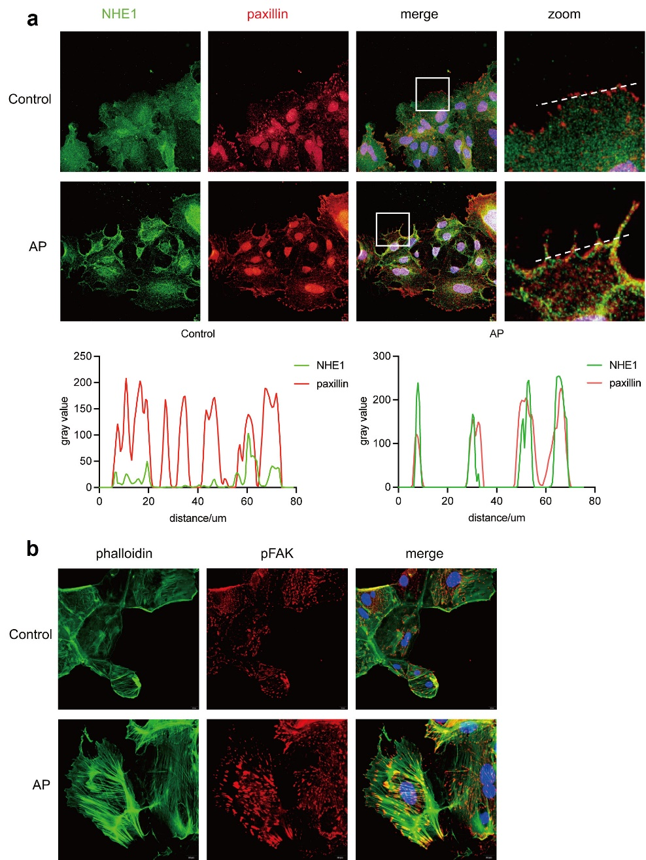
Figure S6, related to Figure7. The colocalization of NHE1 with F-actin and focal adhesions in PTEC cells is similar to that in HK2 cells.
a, Staining of NHE1 (red, anti-NHE1) and F-actin (green, Phalloidin-FITC) for staining. b, Staining of NHE1 (green, anti-NHE1) and pFAK (red, anti-pFAK) in PTEC cells.

Table S1 Composition and Preparation of Solution
Component (mM) | Sample Buffer | pH Calibration Buffer | NH4Cl Buffer | Low Chloride Medium
NaCl | 135 | 0 | 115 |  | 0
Sodium Gluconate | 0 | 0 | 0 |  | 115
NaHCO3 | 0 | 0 | 0 |  | 20
KCl | 5 | 135 | 5 |  | 5
NH4Cl | 0 | 0 | 20 |  | 0
CaCl2 | 1
MgCl2 | 0.5
NaH2PO4 | 1
Glucose | 5
HEPES | 20
pH | 7.4 | 6.9～7.6 | 7.4 |  | 7.4
Nigericin | 0 | 0.01 | 0 |  | 0

