Table 4. Illustrating the Binding affinity of selected phytochemicals with Ebola virus VP24 protein
Ligands | Binding with Ebola virus VP24 protein | Binding affinity energy kcal/mol
Withaferin-A | 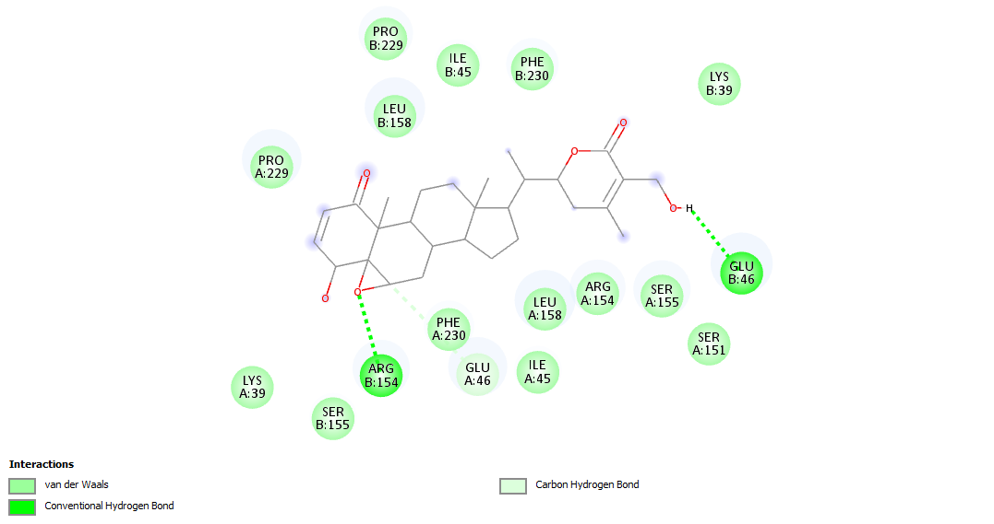 | -10
Withanolide-D | 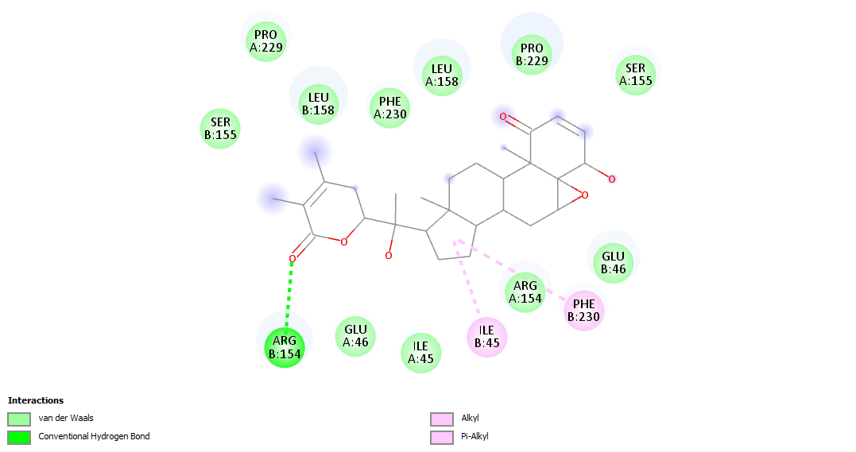 | -10.1
Withanolide-F | 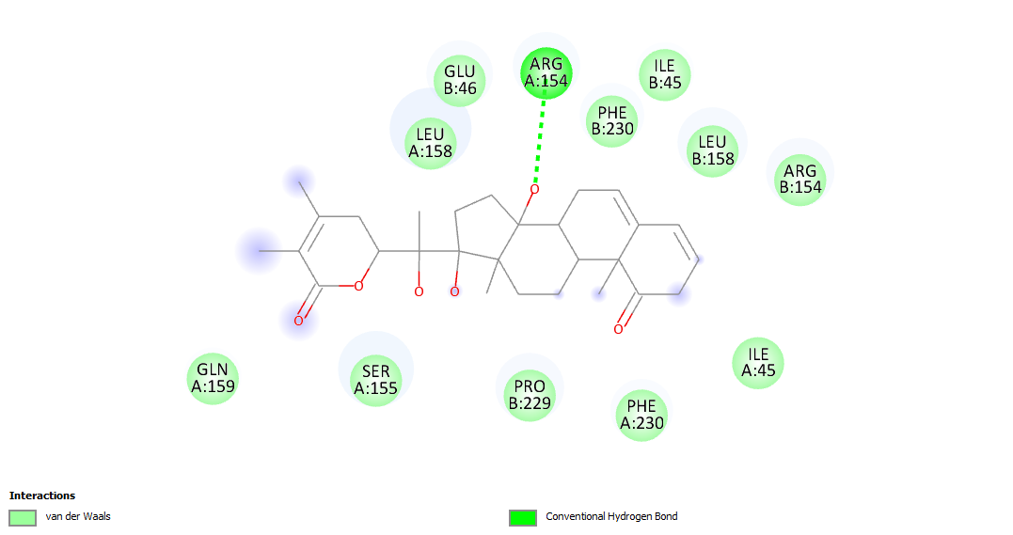 | -9.1
Catechin | 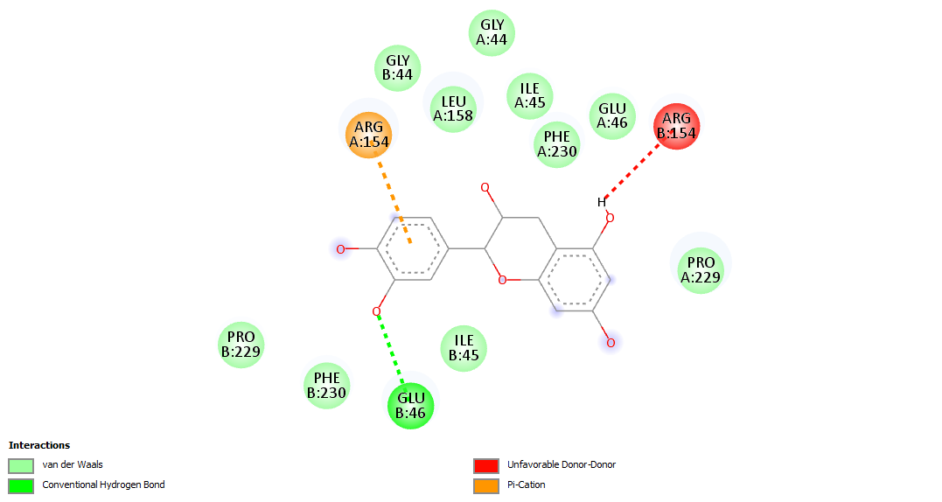 | -7.4
Epicatechin | 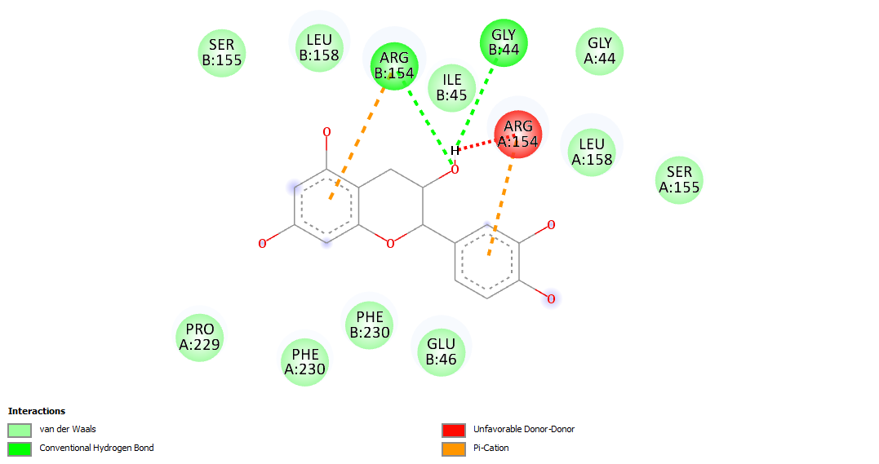 | -7.2
Isolariciresinol | 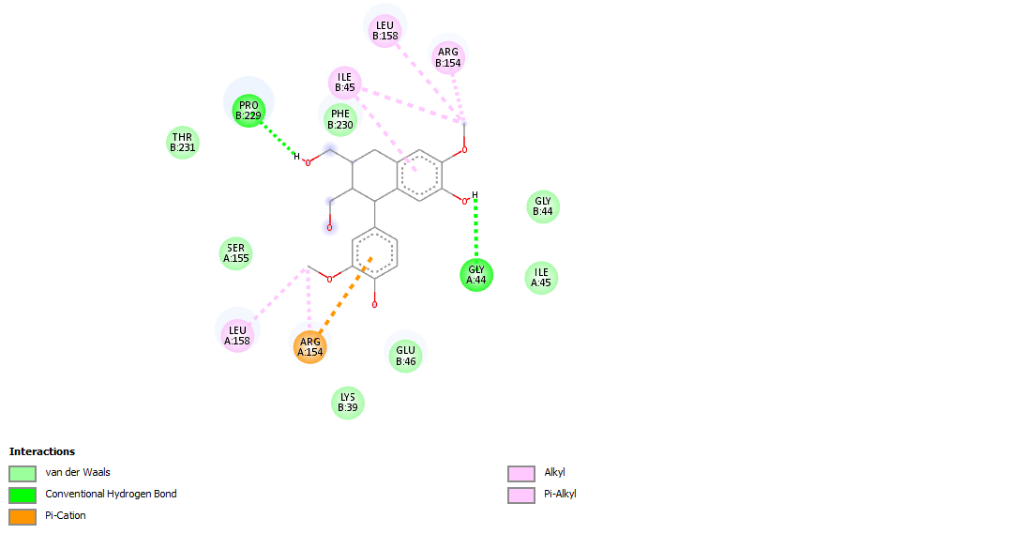 | -7.2
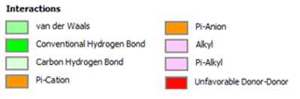

Table 5. Illustrating the Binding affinity of selected phytochemicals with Marburg virus VP24 protein
Ligands | Binding with Marburg virus VP24 protein | Binding affinity energy kcal/mol
Withaferin-A | 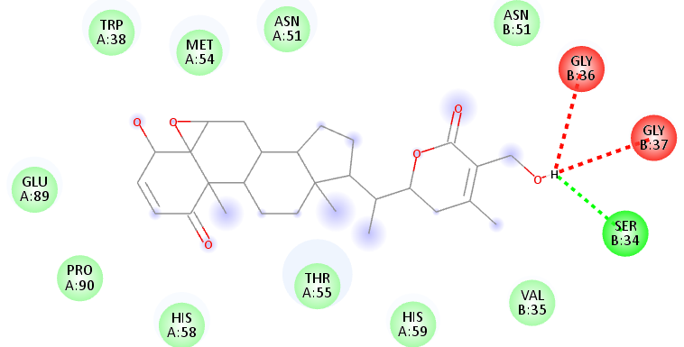 | -6.2
Withanolide-D | 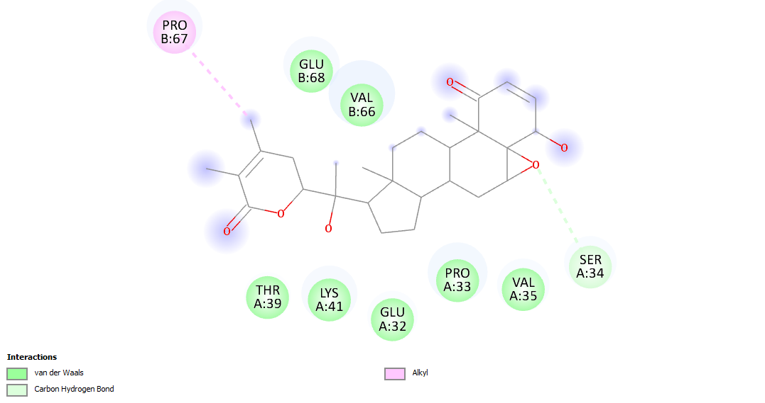 | -6.7
Withanolide-F | 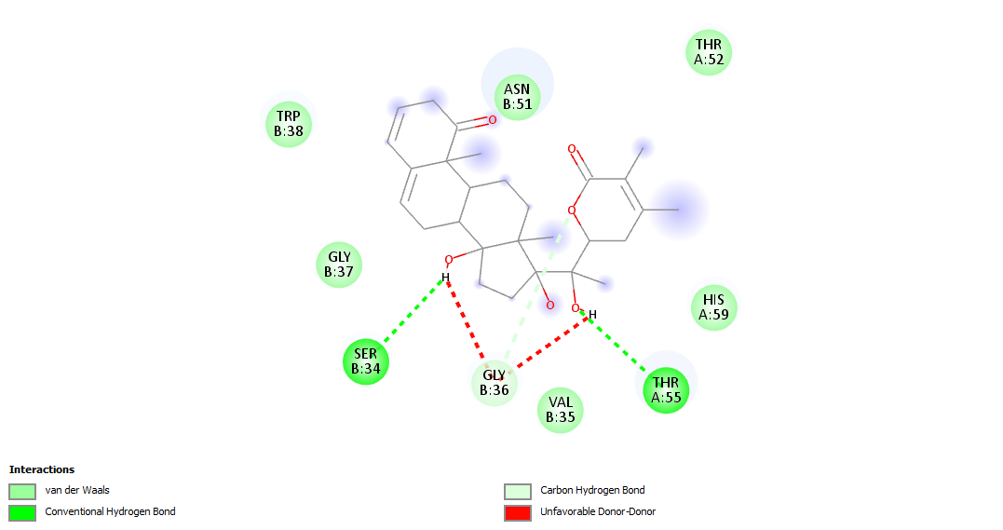 | -6.3
Catechin | 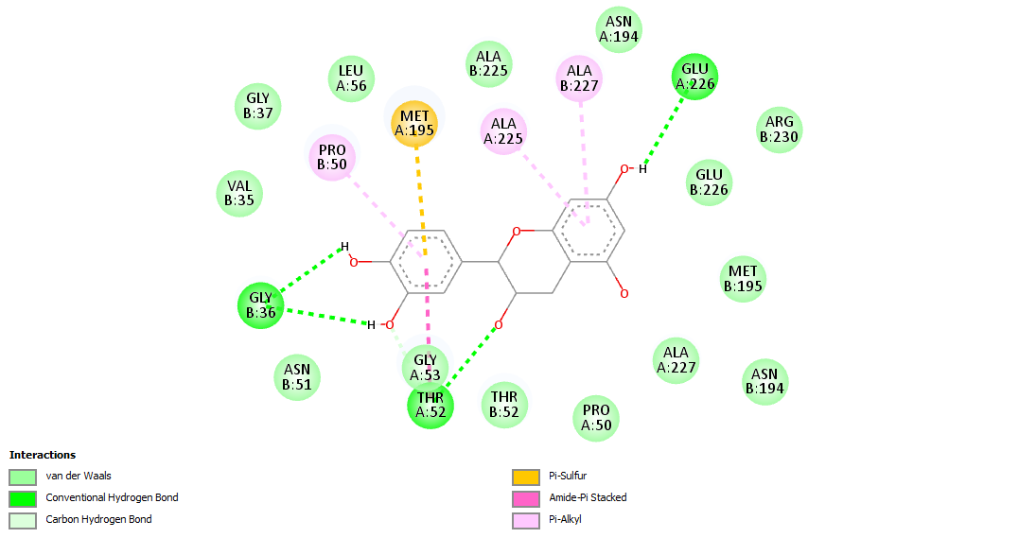 | -6.5
Epicatechin | 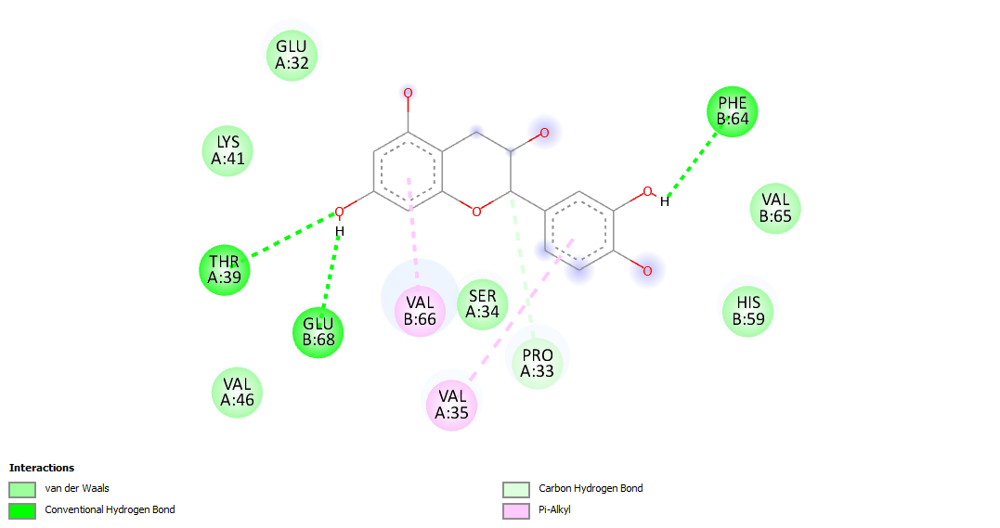 | -5.4
Isolariciresinol | 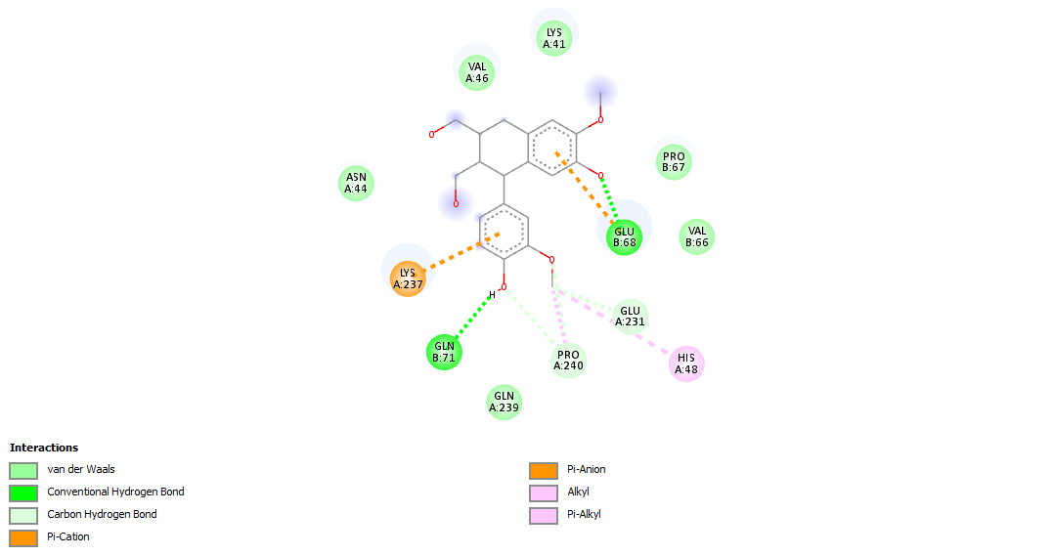 | -5.2
