Study on the inhibitory activity and mechanism of Mentha haplocalyx essential oils nanoemulsion against Fusarium oxysporum growth
Hongxin Liao¹, Jinrui Wen¹, Hongyan Nie¹, Cuiqiong Ling¹, Liyan Zhang¹, Furong Xu¹, Wei Wang², Xian Dong^{1, *}
ª School of Chinese Materia Medica, Yunnan University of Chinese Medicine, Kunming 650000, China,
^{b} Feixian Agriculture Bureau, Feixian 273400, P. R. China
* Corresponding author: dongxian_1655129@163.com
Abstract: As a green and environmentally friendly natural product, Mentha haplocalyx essential oil (MEO) inhibits F. oxysporum, but its field application is limited by its poor water solubility. The nanoemulsion can improve bioavailability and provide a green way to prevent and control P. notoginseng root rot. In this study, Tween-80 and anhydrous ethanol were selected as carriers, and the ultrasonic method was adopted to prepare a nanoemulsion (MNEO) with an average particle size of 26.07 nm. Compared with MTEO (MEO dissolved in an aqueous solution of 2% DMSO and 0.1% Tween 80), MNEO was superior in inhibiting F. oxysporum in terms of spore germination, hyphal growth, and minimum inhibitory concentration (MIC). Through transcriptomic and metabolomic analyses, it was found that both MNEO and MTEO can inhibit the Glycolysis/Gluconeogenesis and starch and sucrose metabolism pathways of F. oxysporum. Nevertheless, MNEO can inhibit the expression of more genes and metabolites, such as FOYG_01354, FOYG_05053, dihydroxyacetone phosphate, and glucose-1-phosphate. In addition, some key genes in meiosis, ribosome, and ribosome biogenesis were also significantly downregulated only under MNEO treatment. These genes and metabolites provide valuable information for the later prevention and control of F. oxysporum and provide a theoretical basis for better utilization of MEO resources to develop plant-derived bacteriostatic agents and agricultural modernization and ecological development.
Keywords: nanometer emulsion, ultrasonic method, antifungal mechanism, metabolism pathways, prevention of root rot.
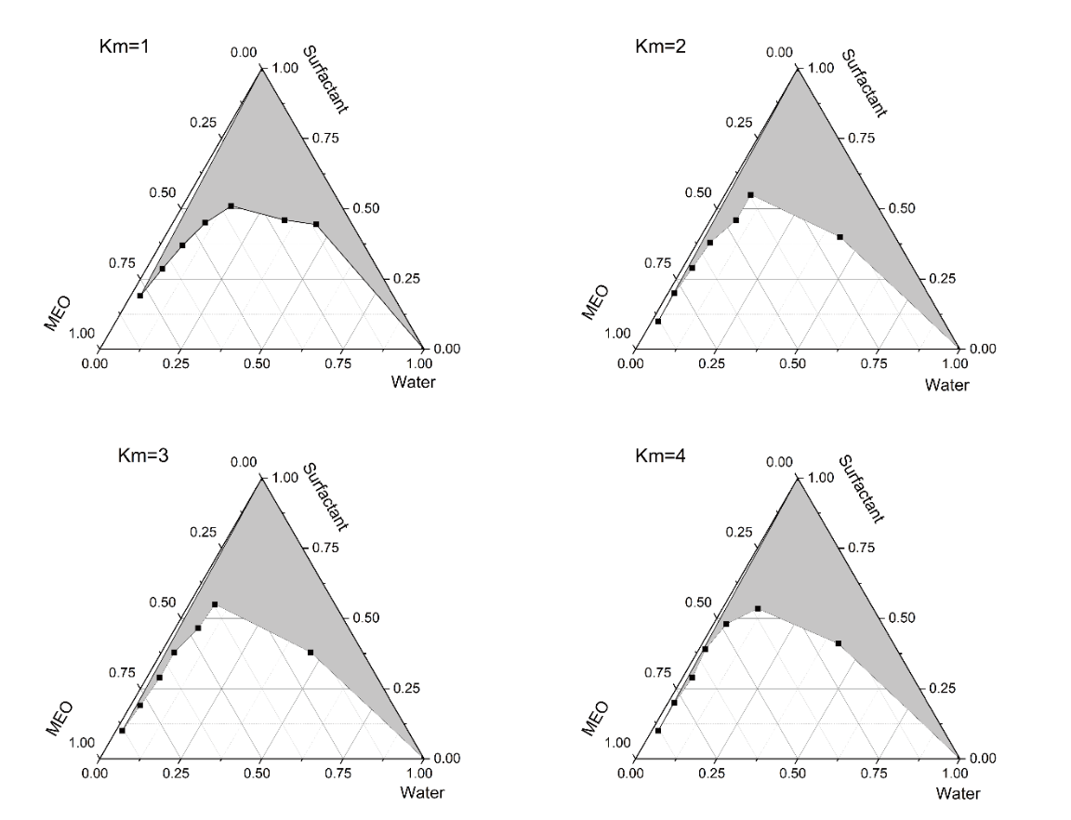
Figure S1 The effect of mixing Tween 80 with anhydrous ethanol according to different Km values on the ternary phase diagram of the nanoemulsion. The area of the shaded part screened the best Km.
Figure S2 Nanoemulsion stability testing. (A) Transmittance at different temperatures for 30 min. (B) The effect of varying salinity on the nanoemulsion. (C) Changes in the light transmittance of the nanoemulsion after centrifugation with different centrifugal forces for 30 min. (D) Changes in the light transmittance of the nanoemulsion after adjusting to different pH values with 0.2 M HCl and 0.2 M NaOH. (E) Effect of different light intensities on the stability and antifungal activity of MNEO after 48 h of treatment. (F) Pictures of the upward and downward growth of the colonies on the seventh day. 0%, 30%, 60%, and 90% represented different light intensities, and CK was not treated with MNEO. Data are presented as the means ± SDs of three biological replicates performed in triplicate.
Figure S3 Analysis of metabolite differences following MNEO and MTEO treatment of F. oxysporum. (A) MNEO-treated group; (B) MTEO-treated group. (C, D) Heatmaps of saccharide metabolites treated with MNEO and MTEO changed significantly. ko00500 indicates starch and sucrose metabolism, ko00010 indicates Glycolysis/Gluconeogenesi
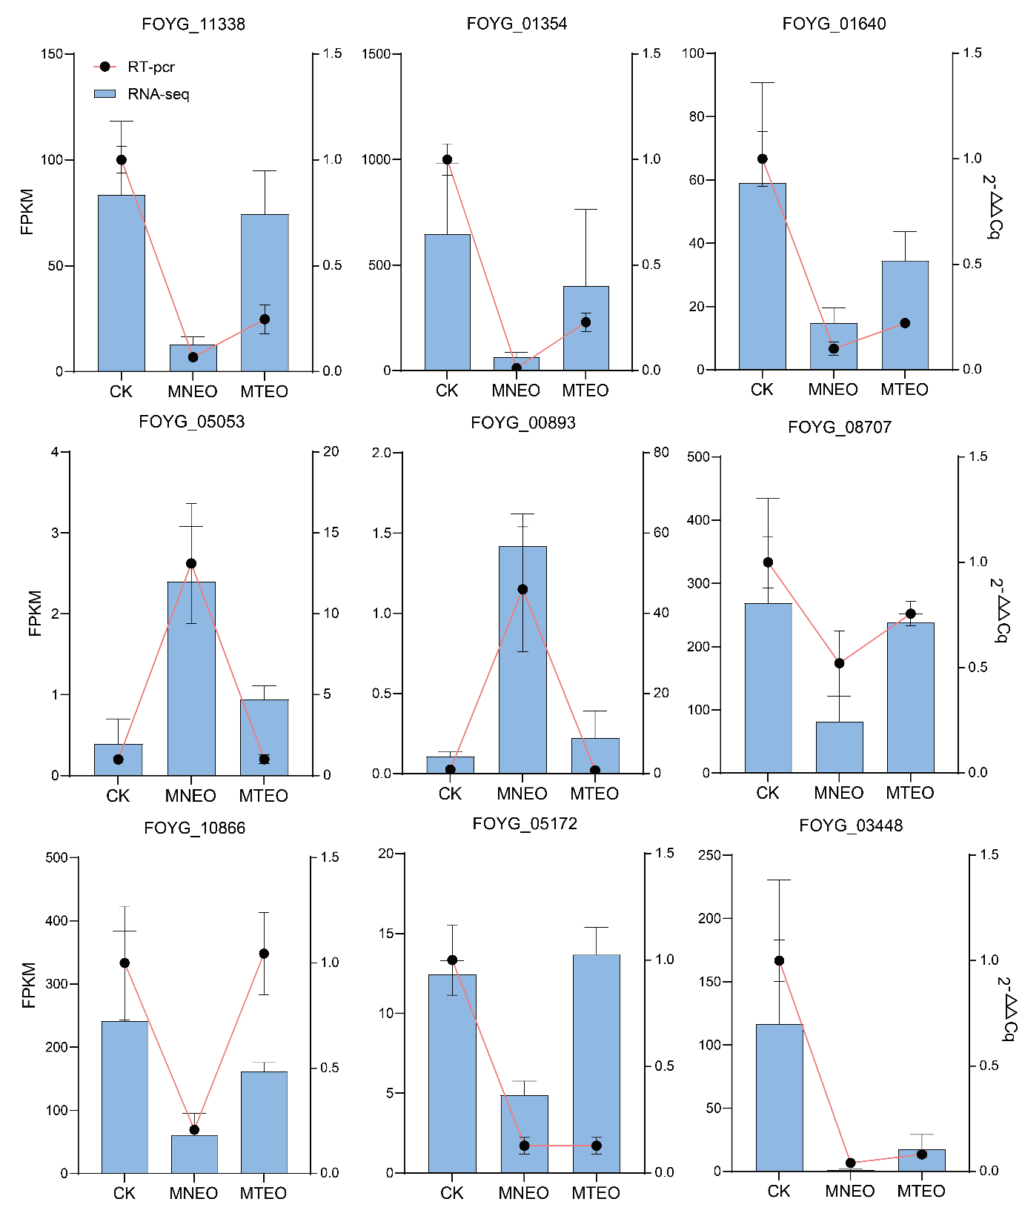
Figure S4 Effect of MNEO and MTEO on the expression of deacetylase-regulated genes.
Each RT-qPCR assay was repeated three times. Bars = mean ± SD from three technical replicates.

Table S1 DEGs for metabolic pathways enriched in the MNEO and MTEO treatment groups
KEGG pathway | Gene ID | CK_vs_MTEO |  |  | CK_vs_MNEO |  |  | KEGG
KEGG pathway | Gene ID | log2FoldChange | .padj | regulated | log2FoldChange | .padj | regulated | KEGG
Meiosis (ko04113) | FOYG_01109 | -7.33 | 0.00 | down | -8.17 | 0.00 | down | K08139 MFS transporter, SP family, sugar:H+ symporter
Meiosis (ko04113) | FOYG_01912 | -6.27 | 0.00 | down | -5.87 | 0.00 | down | K08139 MFS transporter, SP family, sugar:H+ symporter
Meiosis (ko04113) | FOYG_03740 | -2.31 | 0.06 | false | -7.14 | 0.00 | down | K08139 MFS transporter, SP family, sugar:H+ symporter
Meiosis (ko04113) | FOYG_13335 | -1.54 | 0.01 | down | -2.92 | 0.00 | down | K08139 MFS transporter, SP family, sugar:H+ symporter
Meiosis (ko04113) | FOYG_15653 | -1.81 | 0.04 | down | -1.77 | 0.02 | down | K08139 MFS transporter, SP family, sugar:H+ symporter
Meiosis (ko04113) | FOYG_00350 | -1.57 | 0.08 | false | -3.25 | 0.00 | down | K08139 MFS transporter, SP family, sugar:H+ symporter
Meiosis (ko04113) | FOYG_04208 | -1.94 | 0.11 | false | -5.61 | 0.00 | down | K08139 MFS transporter, SP family, sugar:H+ symporter
Meiosis (ko04113) | FOYG_05514 | -2.51 | 0.01 | down | -3.20 | 0.00 | down | K08139 MFS transporter, SP family, sugar:H+ symporter
Meiosis (ko04113) | FOYG_05660 | -0.60 | 0.51 | false | -2.40 | 0.02 | down | K08139 MFS transporter, SP family, sugar:H+ symporter
Meiosis (ko04113) | FOYG_06867 | -0.71 | 0.44 | false | -2.44 | 0.00 | down | K08139 MFS transporter, SP family, sugar:H+ symporter
Meiosis (ko04113) | FOYG_08813 | -2.56 | 0.00 | down | -3.96 | 0.00 | down | K08139 MFS transporter, SP family, sugar:H+ symporter
Meiosis (ko04113) | FOYG_11966 | -1.48 | 0.11 | false | -4.03 | 0.00 | down | K08139 MFS transporter, SP family, sugar:H+ symporter
Meiosis (ko04113) | FOYG_12834 | -1.78 | 0.03 | down | -3.14 | 0.00 | down | K08139 MFS transporter, SP family, sugar:H+ symporter
Meiosis (ko04113) | FOYG_14383 | -2.14 | 0.01 | down | -3.00 | 0.00 | down | K08139 MFS transporter, SP family, sugar:H+ symporter
Meiosis (ko04113) | FOYG_14398 | -1.89 | 0.05 | false | -3.75 | 0.00 | down | K08139 MFS transporter, SP family, sugar:H+ symporter
Meiosis (ko04113) | FOYG_14714 | -0.96 | 0.12 | false | -3.73 | 0.00 | down | K08139 MFS transporter, SP family, sugar:H+ symporter
Meiosis (ko04113) | FOYG_14790 | -5.37 | 0.00 | down | -5.38 | 0.00 | down | K08139 MFS transporter, SP family, sugar:H+ symporter
Meiosis (ko04113) | FOYG_14837 | -3.53 | 0.00 | down | -3.32 | 0.00 | down | K08139 MFS transporter, SP family, sugar:H+ symporter
Meiosis (ko04113) | FOYG_14991 | -1.35 | 0.14 | false | -3.58 | 0.00 | down | K08139 MFS transporter, SP family, sugar:H+ symporter
Meiosis (ko04113) | FOYG_15416 | -3.18 | 0.00 | down | -5.62 | 0.00 | down | K08139 MFS transporter, SP family, sugar:H+ symporter
Meiosis (ko04113) | FOYG_05827 | -1.14 | 0.43 | false | -6.96 | 0.00 | down | K08139 MFS transporter, SP family, sugar:H+ symporter
Meiosis (ko04113) | FOYG_11238 | -1.17 | 0.03 | down | -1.47 | 0.00 | down | K08139 MFS transporter, SP family, sugar:H+ symporter
Meiosis (ko04113) | FOYG_05827 | -1.14 | 0.43 | false | -6.96 | 0.00 | down | K04630 guanine nucleotide-binding protein G(i) subunit alpha
Meiosis (ko04113) | FOYG_11238 | -1.17 | 0.03 | down | -1.47 | 0.00 | down | K04630 guanine nucleotide-binding protein G(i) subunit alpha
Meiosis (ko04113) | FOYG_12160 | -1.04 | 0.14 | false | -2.01 | 0.00 | down | K04563 cyclin-dependent kinase
Meiosis (ko04113) | FOYG_15599 | 0.39 | 0.60 | false | -3.06 | 0.00 | down | K04563 cyclin-dependent kinase
Meiosis (ko04113) | FOYG_06834 | -0.52 | 0.62 | false | -2.02 | 0.02 | down | K06639 cell division cycle 14
Meiosis (ko04113) | FOYG_05172 | -0.24 | 0.73 | false | -1.82 | 0.00 | down | K12769 meiosis-specific transcription factor NDT80
Meiosis (ko04113) | FOYG_01590 | -1.52 | 0.07 | false | -2.04 | 0.01 | down | K03353 anaphase-promoting complex subunit 6
Meiosis (ko04113) | FOYG_05721 | -0.48 | 0.57 | false | -1.21 | 0.02 | down | K12761 carbon catabolite-derepressing protein kinase
Meiosis (ko04113) | FOYG_05087 | -0.36 | 0.61 | false | -1.11 | 0.02 | down | K07827 GTPase KRas
Meiosis (ko04113) | FOYG_06928 | -0.33 | 0.79 | false | -1.99 | 0.02 | down | K06662 cell cycle checkpoint protein
Glycolysis / Gluconeogenesis (ko00010) | FOYG_01634 | -2.32 | 0.01 | down | -3.33 | 0.00 | down | K15633 2,3-bisphosphoglycerate-independent phosphoglycerate mutase
Glycolysis / Gluconeogenesis (ko00010) | FOYG_07546 | -4.38 | 0.00 | down | -1.75 | 0.00 | down | K13953 alcohol dehydrogenase, propanol-preferring
Glycolysis / Gluconeogenesis (ko00010) | FOYG_13381 | -0.80 | 0.48 | false | -5.83 | 0.00 | down | K13953 alcohol dehydrogenase, propanol-preferring
Glycolysis / Gluconeogenesis (ko00010) | FOYG_10851 | -2.81 | 0.00 | down | -6.51 | 0.00 | down | K13953 alcohol dehydrogenase, propanol-preferring
Glycolysis / Gluconeogenesis (ko00010) | FOYG_15822 | -5.66 | 0.00 | down | -6.98 | 0.00 | down | K13953 alcohol dehydrogenase, propanol-preferring
Glycolysis / Gluconeogenesis (ko00010) | FOYG_02647 | -2.31 | 0.04 | down | -3.45 | 0.00 | down | K01803 triosephosphate isomerase (TIM)
Glycolysis / Gluconeogenesis (ko00010) | FOYG_07357 | -1.11 | 0.18 | false | -3.44 | 0.00 | down | K01689 enolase
Glycolysis / Gluconeogenesis (ko00010) | FOYG_00446 | -3.15 | 0.00 | down | -5.28 | 0.00 | down | K01624 fructose-bisphosphate aldolase, class II
Glycolysis / Gluconeogenesis (ko00010) | FOYG_08437 | 0.04 | 0.98 | false | -2.91 | 0.00 | down | K01624 fructose-bisphosphate aldolase, class II
Glycolysis / Gluconeogenesis (ko00010) | FOYG_01201 | -2.79 | 0.00 | down | -5.10 | 0.00 | down | K01568 pyruvate decarboxylase
Glycolysis / Gluconeogenesis (ko00010) | FOYG_13030 | -2.58 | 0.02 | down | -6.27 | 0.00 | down | K01568 pyruvate decarboxylase
Glycolysis / Gluconeogenesis (ko00010) | FOYG_14954 | -5.48 | 0.00 | down | -6.79 | 0.00 | down | K01007 pyruvate, water dikinase
Glycolysis / Gluconeogenesis (ko00010) | FOYG_12714 | -2.12 | 0.02 | down | -3.56 | 0.00 | down | K00927 phosphoglycerate kinase
Glycolysis / Gluconeogenesis (ko00010) | FOYG_00681 | 1.13 | 0.45 | false | -6.12 | 0.00 | down | K00128 aldehyde dehydrogenase (NAD+)
Glycolysis / Gluconeogenesis (ko00010) | FOYG_01972 | -1.71 | 0.05 | false | -4.32 | 0.00 | down | K00128 aldehyde dehydrogenase (NAD+)
Glycolysis / Gluconeogenesis (ko00010) | FOYG_09130 | -5.49 | 0.00 | down | -8.70 | 0.00 | down | K00128 aldehyde dehydrogenase (NAD+)
Glycolysis / Gluconeogenesis (ko00010) | FOYG_00476 | 1.77 | 0.30 | false | -5.66 | 0.00 | down | K00128 aldehyde dehydrogenase (NAD+)
Glycolysis / Gluconeogenesis (ko00010) | FOYG_06370 | -1.46 | 0.17 | false | -4.58 | 0.00 | down | K00128 aldehyde dehydrogenase (NAD+)
Glycolysis / Gluconeogenesis (ko00010) | FOYG_00667 | -3.38 | 0.00 | down | -1.84 | 0.01 | down | K00002 alcohol dehydrogenase (NADP+)
Glycolysis / Gluconeogenesis (ko00010) | FOYG_01905 | -2.23 | 0.01 | down | -0.91 | 0.26 | false | K01810 glucose-6-phosphate isomerase
Glycolysis / Gluconeogenesis (ko00010) | FOYG_03676 | -1.93 | 0.04 | down | -1.58 | 0.08 | false | K00873 pyruvate kinase
Glycolysis / Gluconeogenesis (ko00010) | FOYG_09920 | 0.79 | 0.12 | false | -1.63 | 0.00 | down | K01610 phosphoenolpyruvate carboxykinase (ATP)
Glycolysis / Gluconeogenesis (ko00010) | FOYG_06786 | -0.84 | 0.36 | false | -2.23 | 0.00 | down | K00844 hexokinase
Glycolysis / Gluconeogenesis (ko00010) | FOYG_09669 | -0.79 | 0.13 | false | -2.19 | 0.00 | down | K00844 hexokinase
Glycolysis / Gluconeogenesis (ko00010) | FOYG_01354 | -1.12 | 0.29 | false | -3.90 | 0.00 | down | K00134 glyceraldehyde 3-phosphate dehydrogenase (phosphorylating)
Starch and sucrose metabolism(ko00500) | FOYG_09134 | -2.15 | 0.01 | down | -8.59 | 0.00 | down | K05349 beta-glucosidase
Starch and sucrose metabolism(ko00500) | FOYG_12849 | -3.01 | 0.03 | down | -5.37 | 0.00 | down | K05349 beta-glucosidase
Starch and sucrose metabolism(ko00500) | FOYG_13073 | -1.49 | 0.06 | false | -4.90 | 0.00 | down | K05349 beta-glucosidase
Starch and sucrose metabolism(ko00500) | FOYG_05938 | -2.82 | 0.00 | down | -4.14 | 0.00 | down | K05349 beta-glucosidase
Starch and sucrose metabolism(ko00500) | FOYG_15281 | -2.76 | 0.03 | down | -2.73 | 0.02 | down | K05349 beta-glucosidase
Starch and sucrose metabolism(ko00500) | FOYG_07245 | -2.78 | 0.00 | down | -1.55 | 0.02 | down | K01210 glucan 1,3-beta-glucosidase
Starch and sucrose metabolism(ko00500) | FOYG_01137 | -4.67 | 0.00 | down | -3.95 | 0.00 | down | K01199 glucan endo-1,3-beta-D-glucosidase
Starch and sucrose metabolism(ko00500) | FOYG_04874 | -2.56 | 0.00 | down | -2.00 | 0.00 | down | K01199 glucan endo-1,3-beta-D-glucosidase
Starch and sucrose metabolism(ko00500) | FOYG_02005 | -7.87 | 0.00 | down | -7.92 | 0.00 | down | K01182 oligo-1,6-glucosidase
Starch and sucrose metabolism(ko00500) | FOYG_07622 | -2.07 | 0.01 | down | -1.62 | 0.01 | down | K01182 oligo-1,6-glucosidase
Starch and sucrose metabolism(ko00500) | FOYG_02901 | -3.41 | 0.00 | down | -7.60 | 0.00 | down | K00693 glycogen synthase
Starch and sucrose metabolism(ko00500) | FOYG_04825 | -1.75 | 0.03 | down | -2.84 | 0.00 | down | K00688 glycogen phosphorylase
Starch and sucrose metabolism(ko00500) | FOYG_05959 | -3.03 | 0.01 | down | -1.27 | 0.10 | false | K18447 ADP-sugar diphosphatase
Starch and sucrose metabolism(ko00500) | FOYG_01905 | -2.23 | 0.01 | down | -0.91 | 0.26 | false | K01810 glucose-6-phosphate isomerase
Starch and sucrose metabolism(ko00500) | FOYG_11338 | -0.62 | 0.44 | false | -3.26 | 0.00 | down | K01194 alpha,alpha-trehalase
Starch and sucrose metabolism(ko00500) | FOYG_11832 | -1.85 | 0.06 | false | -3.45 | 0.00 | down | K01193 beta-fructofuranosidase
Starch and sucrose metabolism(ko00500) | FOYG_09687 | -1.39 | 0.11 | false | -2.97 | 0.00 | down | K01193 beta-fructofuranosidase
Starch and sucrose metabolism(ko00500) | FOYG_16531 | 0.03 | 0.98 | false | -4.73 | 0.00 | down | K01188 beta-glucosidase
Starch and sucrose metabolism(ko00500) | FOYG_14356 | 0.25 | 0.86 | false | -4.60 | 0.00 | down | K01179 endoglucanase
Starch and sucrose metabolism(ko00500) | FOYG_06786 | -0.84 | 0.36 | false | -2.23 | 0.00 | down | K00844 hexokinase
Starch and sucrose metabolism(ko00500) | FOYG_09669 | -0.79 | 0.13 | false | -2.19 | 0.00 | down | K00844 hexokinase
Starch and sucrose metabolism(ko00500) | FOYG_00544 | -0.94 | 0.41 | false | -2.12 | 0.00 | down | K00750 glycogenin
Starch and sucrose metabolism(ko00500) | FOYG_01640 | -1.25 | 0.12 | false | -2.58 | 0.00 | down | K00697 trehalose 6-phosphate synthase

Table S2 DEGs of metabolic pathways enriched in the MNEO treatment group (Top10)
KEGG pathway | Gene ID | CK_vs_MNEO |  |  | KEGG
KEGG pathway | Gene ID | log2FoldChange | .padj | regulated | KEGG
Ribosome (ko03010) | FOYG_04619 | -1.51 | 0.00 | down | K02959 small subunit ribosomal protein S16
Ribosome (ko03010) | FOYG_01340 | -1.55 | 0.03 | down | K02947 small subunit ribosomal protein S10e
Ribosome (ko03010) | FOYG_01318 | -1.63 | 0.04 | down | K02925 large subunit ribosomal protein L3e
Ribosome (ko03010) | FOYG_08638 | -1.63 | 0.02 | down | K02966 small subunit ribosomal protein S19e
Ribosome (ko03010) | FOYG_09765 | -1.77 | 0.02 | down | K02936 large subunit ribosomal protein L7Ae
Ribosome (ko03010) | FOYG_10731 | -1.89 | 0.00 | down | K02976 small subunit ribosomal protein S26e
Ribosome (ko03010) | FOYG_08142 | -1.98 | 0.01 | down | K02891 large subunit ribosomal protein L22e
Ribosome (ko03010) | FOYG_06513 | -1.98 | 0.02 | down | K02877 large subunit ribosomal protein L15e
Ribosome (ko03010) | FOYG_08707 | -2.00 | 0.00 | down | K02893 large subunit ribosomal protein L23Ae
Ribosome (ko03010) | FOYG_10866 | -2.29 | 0.00 | down | K02898 large subunit ribosomal protein L26e
Ribosome biogenesis  in eukaryotes (ko03008) | FOYG_03352 | -1.84 | 0.01 | down | K14539 large subunit GTPase 1
Ribosome biogenesis  in eukaryotes (ko03008) | FOYG_08713 | -1.97 | 0.00 | down | K14532 ribonuclease MRP protein subunit RMP1
Ribosome biogenesis  in eukaryotes (ko03008) | FOYG_05069 | -2.04 | 0.01 | down | K14569 ribosome biogenesis protein BMS1
Ribosome biogenesis  in eukaryotes (ko03008) | FOYG_03447 | -2.05 | 0.03 | down | K14558 periodic tryptophan protein 2
Ribosome biogenesis  in eukaryotes (ko03008) | FOYG_12450 | -2.15 | 0.00 | down | K03538 ribonuclease P protein subunit POP4
Ribosome biogenesis  in eukaryotes (ko03008) | FOYG_01379 | -2.19 | 0.00 | down | K03685 ribonuclease III
Ribosome biogenesis  in eukaryotes (ko03008) | FOYG_06658 | -2.62 | 0.01 | down | K13288 oligoribonuclease
Ribosome biogenesis  in eukaryotes (ko03008) | FOYG_11675 | -2.68 | 0.01 | down | K11883 RNA-binding protein NOB1
Ribosome biogenesis  in eukaryotes (ko03008) | FOYG_14847 | -6.83 | 0.00 | down | K14570 RNA exonuclease
Ribosome biogenesis  in eukaryotes (ko03008) | FOYG_03448 | -7.33 | 0.00 | down | K14558 periodic tryptophan protein 2
The above DEGs were all top10 of each pathway.

Table S3 qRT-PCR primer sequences
Gene | L | R
FOYG_00893 | CTGAGAATGGCACGTGGAGT | TGAGTGTCAACGGCTCTGTG
FOYG_05053 | CGACTTTACTCAAACCATGGCAA | TTGTTTTCGCTTCGCTTCCG
FOYG_01354 | GAGCCTCACTACGCCGTCTA | GGTCGCGCTCAGAGTAGAAC
FOYG_11338 | GGTCGTTTCCGTGAGCCTTA | GGAGGCTGAGATCGGTTGAG
FOYG_01640 | GGCCGTTTTGTGACAGTTGG | AGAGCGTGCAGTTTCTGAGG
FOYG_05172 | ACTACGAATCTTCGACGCCC | GGACTGGCGGATGGAATAGG
FOYG_03448 | TCCCCTCATGTTGGCGAGAT | ACTCTGGCCAAGCTTCATCC
FOYG_10866 | CCTCCGTGTACCGTCTCAAG | GGTGACCTTGTTGTTGGCAG
FOYG_08707 | TGCTTTCAATAACAGTTCAGCC | CGAGGTGATCAGGGTCTTGG
QTUB | TTCTGCTGTCATGTCCGGTGT | TCAGAGGAGCAAAGCCAACCA

