Figure S1 Venn diagram of common up- and down-regulated DEGs in GSE1297 and GSE5281 datasets. The sum of numbers in each circle represents the total number of DEGs in the comparison group, and the overlapping part of the circles represents the common DEGs between comparison groups.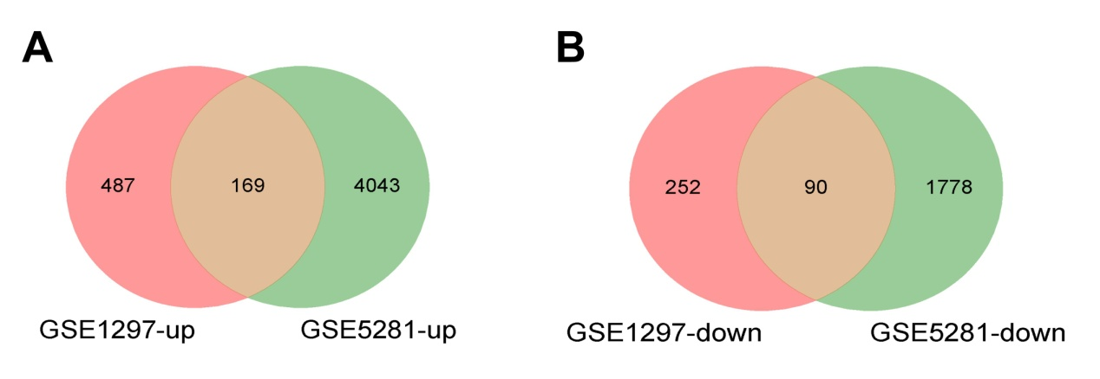

Figure S2 Protein-protein interaction network (PPI) of DEGs. 