Supporting Information for
Unveiling the Hidden Role of SNRPB2 in HCC: A Promising Target for Therapy

Jiaxing Guo¹, Lingshu Li¹, Haiyan Wang², Zhenqin Gao³, Chanjuan Shen¹*, Bokang Yan³*

*Correspondence: Bokang Yan (bokangyan2022@163.com) or Chanjuan Shen (chanjuanshenzch@163.com)

This file includes:

Table S1 to S3
Figure S1 to S4

Table S1 Demographics of 76 patients with HCC.
Chrematistics | No. of patients (%)
Gender  Male  Female  Age  ＞65  ≤65  Pathologic stage  I  II  III  IV  Level of differentiation  Well  Middle  Poor  AFP (ng/ml)  <= 400  > 400  SNRPB2 expression  0~3  4~6  7~9  10~12 | 47(61.8%)  29(38.2%)  28(36.8%)  48(63.2%)  24(31.6%)  26(34.2%)  19(25%)  7(9.2%)  33(43.4%)  27(35.5%)  16(21.1%)  49(64.5%)  27(35.5%)  9(11.8%)  16(21.1%)  26(34.2%)  25(32.9%)

Table S2 LncRNAs might interact with miR-204-5p.
miRNAname | geneID | geneName | geneType
hsa-miR-204-5p | ENSG00000288670 | AL592295.6 | lncRNA
hsa-miR-204-5p | ENSG00000203709 | MIR29B2CHG | lncRNA
hsa-miR-204-5p | ENSG00000223960 | CHROMR | lncRNA
hsa-miR-204-5p | ENSG00000279348 | AC012513.3 | TEC
hsa-miR-204-5p | ENSG00000260804 | LINC01963 | lncRNA
hsa-miR-204-5p | ENSG00000279809 | AC005538.2 | TEC
hsa-miR-204-5p | ENSG00000249413 | AC116049.1 | lncRNA
hsa-miR-204-5p | ENSG00000251095 | AC093866.1 | lncRNA
hsa-miR-204-5p | ENSG00000272335 | AC093297.2 | lncRNA
hsa-miR-204-5p | ENSG00000281398 | SNHG4 | lncRNA
hsa-miR-204-5p | ENSG00000281649 | EBLN3P | lncRNA
hsa-miR-204-5p | ENSG00000236901 | MIR600HG | lncRNA
hsa-miR-204-5p | ENSG00000269821 | KCNQ1OT1 | lncRNA
hsa-miR-204-5p | ENSG00000255717 | SNHG1 | lncRNA
hsa-miR-204-5p | ENSG00000245532 | NEAT1 | lncRNA
hsa-miR-204-5p | ENSG00000251562 | MALAT1 | lncRNA
hsa-miR-204-5p | ENSG00000279117 | AP001972.5 | TEC
hsa-miR-204-5p | ENSG00000261578 | AP003119.3 | lncRNA
hsa-miR-204-5p | ENSG00000284697 | AC006511.5 | lncRNA
hsa-miR-204-5p | ENSG00000258441 | LINC00641 | lncRNA
hsa-miR-204-5p | ENSG00000214548 | MEG3 | lncRNA
hsa-miR-204-5p | ENSG00000247556 | OIP5-AS1 | lncRNA
hsa-miR-204-5p | ENSG00000261771 | DNAAF4-CCPG1 | lncRNA
hsa-miR-204-5p | ENSG00000260417 | AC092127.1 | lncRNA
hsa-miR-204-5p | ENSG00000278876 | AC145207.9 | TEC
hsa-miR-204-5p | ENSG00000260032 | NORAD | lncRNA
hsa-miR-204-5p | ENSG00000215424 | MCM3AP-AS1 | lncRNA
hsa-miR-204-5p | ENSG00000229807 | XIST | lncRNA
hsa-miR-204-5p | ENSG00000271533 | Z83843.1 | lncRNA

Table S3 The sequences of the primers for RT-qPCR included in this manuscript.
Name | Forward premier (5’-3’) | Reverse premier (5’-3’)
SNRPB2 | CTGTGGAACAGACTGCAACAACC | ACCTGAGGATTTGGTGTTGAATTTC
SNHG4 | GCAGGTGACAGTCTGCATGT | TTTTAAGTCCCCTACCCCCATC
MiR-204-5p | TTCCCTTTGTCATCCTATGCCT
β-actin | CACCATTGGCAATGAGCGGTTC | AGGTCTTTGCGGATGTCCACGT

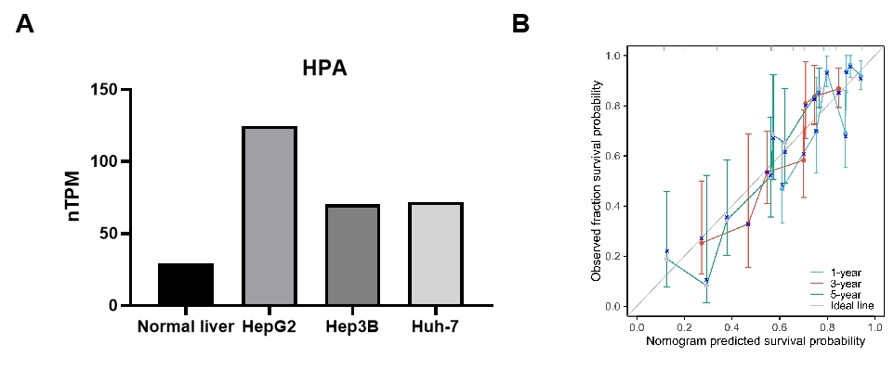
Figure S1. SNRPB2 is overexpressed and associated with poor prognosis in HCC. (A) SNRPB2 mRNA expression level in normal liver cell and HCC cell lines from HPA database. (B) Calibration curves for predicting OS of HCC patients.

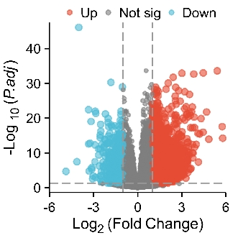
Figure S2. DEGs between high- and low-SNRPB2 expressing HCC patients.

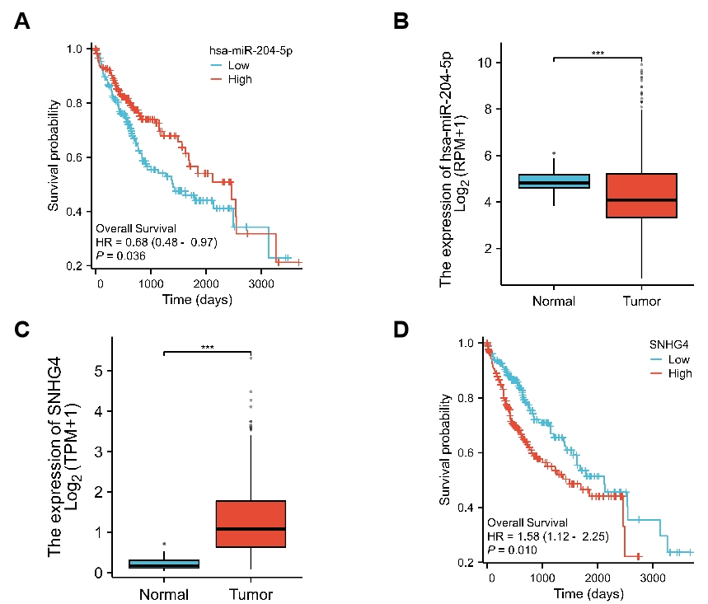
Figure S3. Expression and prognostic values of miR-204-5p and SNHG4 in HCC. (A) Correlation between miR-204-5p expression and the prognosis of HCC patients. (B) The mRNA expression level of miR-204-5p in HCC. (C) The mRNA expression level of SNHG4 in HCC. (D) Correlation between SNHG4 expression and the prognosis of HCC patients.

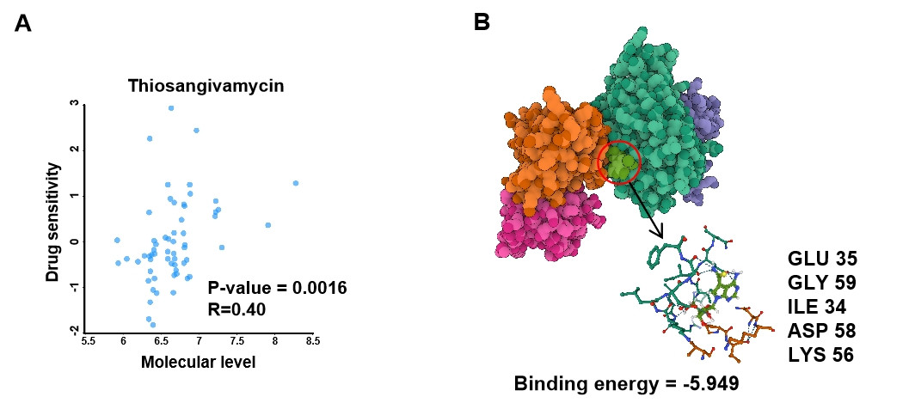
Figure S4. Prediction binding model of thiosangivamycin and SNRPB2. (A) Correlation analysis between drug sensitivity of thiosangivamycin and mRNA expression of SNRPB2 based on RNAactDrug database. (B) Prediction binding model of thiosangivamycin and SNRPB2 via dockeasy web tool.

