Supplementary Materials of
A Branched Convolutional Neural Network for Forecasting the Occurrence of Hazes in Paris using Meteorological Maps with Different Characteristic Scales

Chien Wang
Laboratoire d’Aerologie, CNRS and University of Paul Sabatier, Toulouse, France
chien.wang@aero.obs-mip.fr or wangc@mit.edu

Additional Figures and Tables.

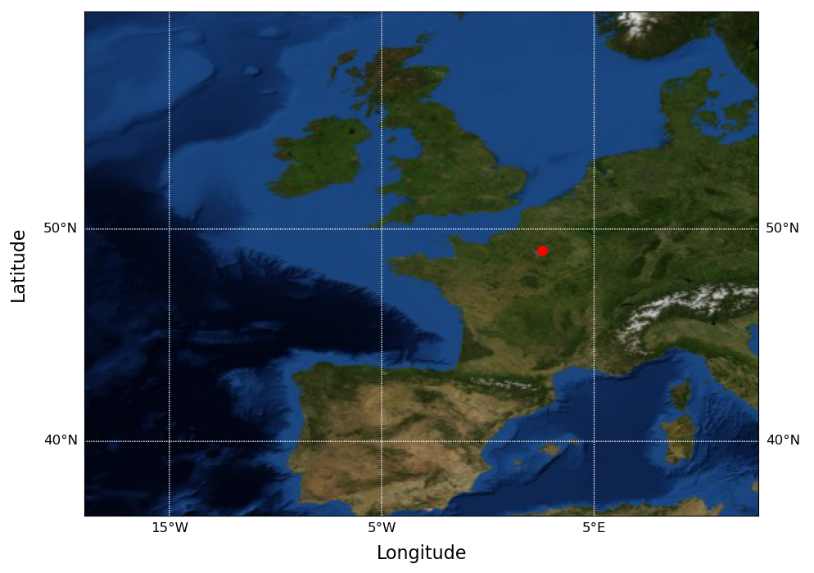
Figure. S1 The data domain of meteorological and hydrological input features, consisting of 96 latitudinal and 128 longitudinal grids with an increment of 0.25 degree. The red dot marks the location of Charles de Galle Airport.

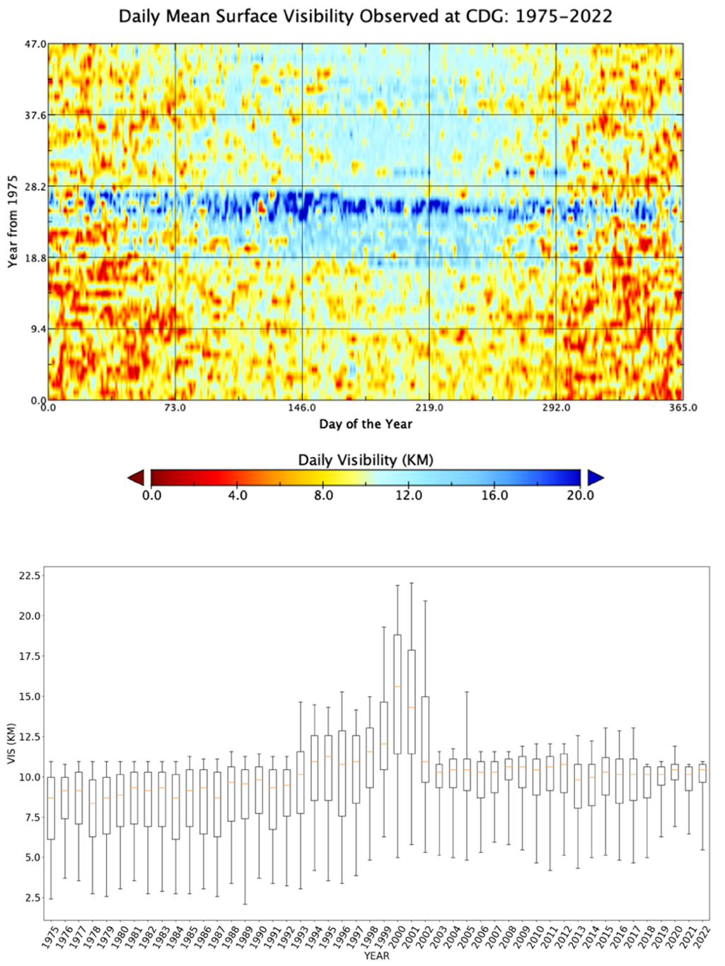
Figure S2 (a) Daily average surface visibility in km observed at Paris Charles de Gaulle Airport (CDG) since 1975. (b) Whisker plot of annual statistics of daily visibility observed at CDG, the boxes are bunded by the 25th and 75th percentile, extending respectively to the 5th and 95th percentile. The red line marks the annual mean. An unknown systematic switch in statistics during 2000-2002 affects mostly on the clear (high percentile) than haze (low such as the 25th percentile) days.

Table S1. Input features, all from ERA5 reanalysis data; here branch 1 is the branch with small kernel and branch 2 with large kernel in HazeNetb2 shown in Fig. 3.
Short Name | Long Name | Branch
REL | Surface relative humidity | 1
U10 | 10-meter wind, zonal component | 1
V10 | 10-meter wind, meridional component | 1
TCW | Total column water | 1
TCV | Total column water vapor | 1
DTCV | Diurnal change of TCV | 1
SW1 | Volumetric soli water, layer 1 | 1
SW2 | Volumetric soil water, layer 2 | 1
LCC | Low cloud cover | 1
Z500 | Geopotential height at 500 hPa level | 2
D850 | Diurnal change of Z850 | 2

Table S2. Certain statistics of the 5th, 10th, 15th, 20th, and 25th percentile (denoted as P5, P10, P15, P20, and P25, respectively) in surface daily visibility (vis.) of Charles de Gaulle Airport of Paris during 1975 and 2019, 16,436 samples in total.
 | P5 | P10 | P15 | P20 | P25
vis. (KM) | 3.70 | 5.15 | 6.44 | 7.24 | 7.89
Events without fog label | 251 | 665 | 1241 | 1788 | 2374
All events | 878 | 1670 | 2579 | 3359 | 4110

