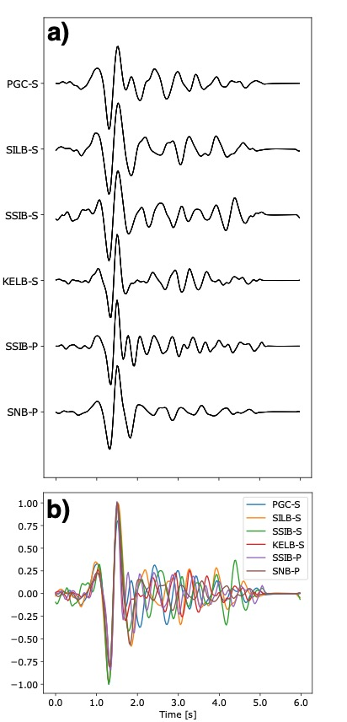
Supplementary Figure 1. a) S and P waveforms for template 053 used to locate 4 s tremor windows. S-waves have been corrected for splitting and P-waves for polarity. Note prominence and similarity of direct arrival across channels. b) Same waveforms superposed and aligned according to optimal delays Only stations PGC, KELB, SSIB, and SILB are used for S-wave detection and only SSIB or SNB are used for P-wave detection.

Supplementary Figure 2. Best-fit planes to the north and south clusters (clusters 1,2, and 3,4, respectively) exhibiting the steeper dip of tremor in the northern clusters (about 10 degrees). Northern plane is orange and southern plane is blue.

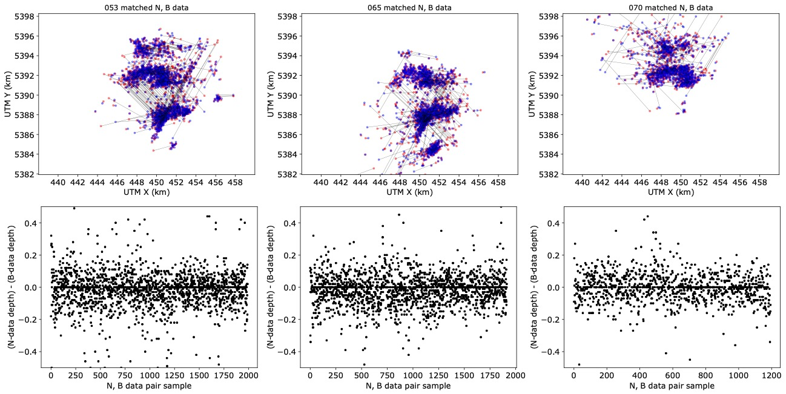
Supplementary Figure 3. Top row: Comparison of locations from common time detection windows between the narrow and broad band data for each template. Bottom row: Depth discrepancies for each matched detection do not show a significant shallowing or deepening bias.

Supplementary Figure 4. North (a) and south (b) patch data colored by direction from the best-fit PCA plane. c) and d) show distributions of distances from the PCA plane for the north (c) and south (d) patches, along with the number of events, standard deviation, skew, and kurtosis.

Supplementary Figure 5. Comparison of 4S detections for each ETS episode in 2003, 2004, and 2005. To varying extents, each tremor patch is activated in each year.

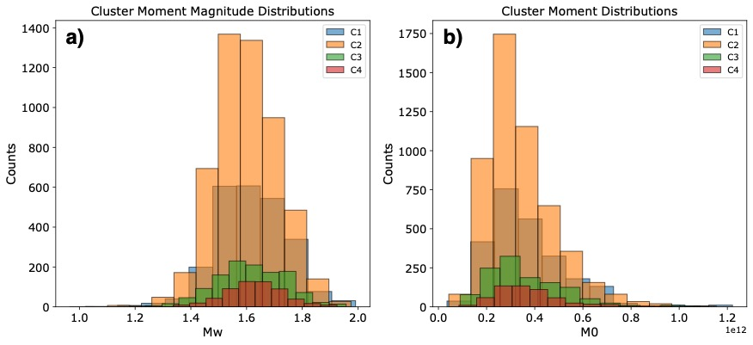
Supplementary Figure 6. Histogram distributions of a) moment magnitude, Mw, and b) scalar moment, M₀, for each cluster.

Supplementary Figure 7. Log-log plot of gouge thickness H as a function of total slip D redrawn from [1]. Point SAF was estimated by Scholz for the San Andreas fault in central California. The line $D={10}^{-3}H$ is extended to the slip and E-layer thickness appropriate for subduction beneath Vancouver Island (Figure 4; [2]).

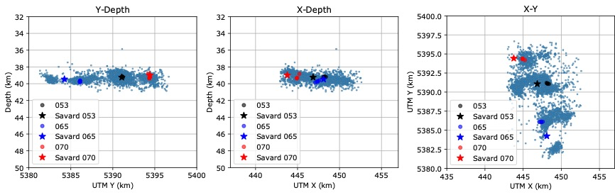
Supplementary Figure 8. Comparison relocations between LFE template waveforms using the method presented in this study (black, blue, red circles), and the LFE template locations of [3] (black, blue, red stars) superposed on the full tremor catalog (blue dots) of this study.

Supplementary Figure 9. Comparison of 339 detection time windows that yielded tremor locations for all six possible datasets, that is, the broad- (1-8 Hz) and narrow- (1.5-6 Hz) band data for each of the three templates (053, 065, 070) used for detection. Average epicentral discrepancy is about 250 m.

Supplementary Figure 10. Comparison of a high- and low Gini index (1-8 Hz) detections (Gini=89, left; Gini=61, right; respectively). Gini index is a measure of waveform impulsiveness. Top panel shows the S-waveforms aligned according to template, middle panel includes S-waveforms after fine-scale alignment and includes their first principal component (black dashed line), and bottom panel compares the fine-scale aligned P-waveform with the first S-wave principal component.

Supplementary Figure 11. The slight difference in dense cluster areas for the 4S1P (blue lines) and 4S (red lines) data sets. Cluster outlines are overlain on the 4S1P data to highlight the varying area extent of the dense clusters for the 4S and 4S+1P data.
Cluster  /Patch | Dataset | Number of events | Area (km²) | 2003 total moment | 2004 total moment | 2005 total moment | 2003-2005 cumulative moment | Azimuth  (deg.) | Dip  (deg.) | Std. Dev.  (m)
1 | 4S | 2468 | 10.23 | 3.74e14 | 3.16e14 | 2.23e14 | 9.13e14 | N/A | N/A | N/A
2 | 4S | 5234 | 16.83 | 5.73e14 | 6.19e14 | 6.03e14 | 1.79e15 | N/A | N/A | N/A
3 | 4S | 1219 | 8.34 | 8.35e13 | 1.47e14 | 2.15e14 | 4.45e14 | N/A | N/A | N/A
4 | 4S | 571 | 2.92 | 5.46e13 | 6.51e13 | 9.24e13 | 2.12e14 | N/A | N/A | N/A
1 | 4S+1P | 567 | 4.55 | N/A | N/A | N/A | N/A | 46.5 | 10.5 | 306
2 | 4S+1P | 2236 | 11.99 | N/A | N/A | N/A | N/A | 69.6 | 10.5 | 251
3 | 4S+1P | 1005 | 7.50 | N/A | N/A | N/A | N/A | 156.0 | 6.8 | 202
4 | 4S+1P | 215 | 1.73 | N/A | N/A | N/A | N/A | 40.0 | 333.9 | 145
North (1&2) | 4S+1P | 3231 | N/A | N/A | N/A | N/A | N/A | 65.6 | 10.5 | 294
South (3&4) | 4S+1P | 1442 | N/A | N/A | N/A | N/A | N/A | 120.6 | 0.5 | 265
Supplementary Table 1. Parameters for each cluster (1, 2, 3, 4) or patch (north, south) for each dataset (4S or 4S+1P). Moment calculations are carried out with 4S data only; cluster/patch dip orientations are only determined for 4S+1P data which have depth resolution. 4S data exhibit a slight spread in cluster areas when compared to the more confined 4S+1P detections. This results in the slightly different cluster areas in the table and is shown in Supplementary Figure 11.

Supplementary Figure 11. Average kurtosis versus width/standard deviation for events with randomly assigned initial depths between -w/2 and +w/2 that are moved randomly based on a normal distribution defined by a standard deviation that varies from std=w to std=w/10. The average kurtosis and its standard deviation calculated over 1000 test cases for each std assignment.

Supplementary Note 1: Positive tremor detection criteria

We cull detections using four criteria: 1) four S delay-time circuits meeting the threshold ≤ 0.0375 s, 2) mean S-wave cross-correlation coefficient > 0.60 for the broad band data, 3) S-P cross-correlation coefficient > 0.45 for all data, and 4) require the Gini coefficient of the detection window to be > 60 for all data. The Gini coefficient was originally used in social science research to measure wealth inequality, but in more recent applications it has been used as a measure of sparsity [4]. Detection windows with more impulsive wave arrivals are more ``sparse" and yield a higher Gini coefficient (Supplementary Figure 10). These metrics were determined heuristically to emphasize hypocentral patterns but reduce the scatter resulting from false detections or real detections emanating from regions of low tremor density.

The detection and initial location procedure is applied to each template 053, 065, and 070 using both the narrow and broad band data. We merge the narrow and broad band datasets by by assigning the narrow-band data detection for all common times. Common detections between templates are determined as those with common detection window timestamps and hypocentral locations within 200m. The selected location is chosen as the contributing detection from the template the matched pair is closest to.

Supplementary Note 2: Width of Seismogenic Shear Layer

In Fig. 1 of the main text, the seismogenic layers are about 500 m thick. We take this figure as an upper limit, yet uncertainty in depth determination implies that the actual thickness must be less. Comparison of locations of common events between narrow and broad-band data in three different templates yields an absolute depth uncertainty of about 300 m (Supplementary Figure 3). The layer width can be better estimated from the distribution of events about the best fitting planes for one set of stations shown in Supplementary Figure 4. The standard deviations are 243 m and 219 m for the north and south patch respectively. The kurtoses of 5.3 and 4.2 indicate broader tails than a normal distribution which has a kurtosis of 3.0.

If the events are uniformly distributed in a zone of width w, the kurtosis is always less than 3 and depends on the ratio w/std where std is the standard deviation of the measurement error. To quantify this relation, we initially place 2000 points at random depths between -w/2 and w/2. We then move each point by a random distance taken from a normal distribution with zero mean and an assigned standard deviation that varies from std=w to std=w/10. For each normal distribution, we run 1000 test cases (moving the points differently 1000 times), and calculate the kurtosis of the moved data points each time. The average kurtosis and its standard deviation over 1000 runs are shown as a function of w/std in Supplementary Figure 11. Note that the kurtosis = 3 for w/std. = 1 and that a kurtosis of 3 is possible at the one std level for 1<std<2. Thus, based on the kurtosis values > 3 for the north and south clusters (Supplementary Figure 3), the width of the seismogenic layer must not be much larger than the standard deviation (243 and 219 m for the north and south, respectively).

Bibliography

[1] | C. Scholz, "Wear and gouge formation in brittle faulting," Geology, vol. 15, no. 6, pp. 493-495, 1987.
[2] | A. J. Calvert, M. G. Bostock, G. Savard and M. J. Unsworth, "Cascadia low frequency earthquakes at the base of an overpressured subduction zone," Nature Communications, vol. 11, no. 3874, 2020.
[3] | G. Savard, M. G. Bostock and N. I. Christensen, "Seismicity, Metamorphism, and Fluid Evolution Across the Northern Cascadia Forearc," Geochemistry, Geophysics, Geosystems, vol. 19, no. 6, pp. 1881-1887, 2018.
[4] | N. Hurley and S. Rickard, "Comparing Measures of Sparsity," IEEE Transactions on Information Theory, vol. 55, no. 10, pp. 4723-4741, 2009.

