Appendix A: Debt
This section presents debt-to-GDP series for EU, US and China regions. Moreover, it investigates the heterogeneity of debt among all three regions. Eventually it presents the impact of the inflation on debt-to-GDP.
Debt-to-GDP time series
Right at the beginning of our time series the quantitative differences among the three regions are evident: from the start of 1997, both the US and EU public debt-GDP ratios float way higher than China.
The US and the EU start diverging from one another after the 2008 financial crash, when the US debt-to-GDP ratio rises to the top, leaving both China and Europe far behind.
Interestingly, after the Financial Crisis the US ratio keeps on growing steadily but slowly due to the monetary and fiscal policies adopted by the country to balance the debt and the GDP. The steadiness is kept until 2020 when the US experience the highest percentage increase in the debt ratio. This increase might be due to the poor regulamentation concerning employment, which consequently lowers the GDP of the nation entailing a rise in public debt-GDP ratio (Reinhart, Rogoff, 2010).
On the other hand, when the time series starts China is still a developing economy, and due to this, the GDP grows slowly. Therefore, the debt-to-GDP ratio of China cannot be compared to the powerhouses that are the European Union and the United States to this day (Barth et al., 2009).
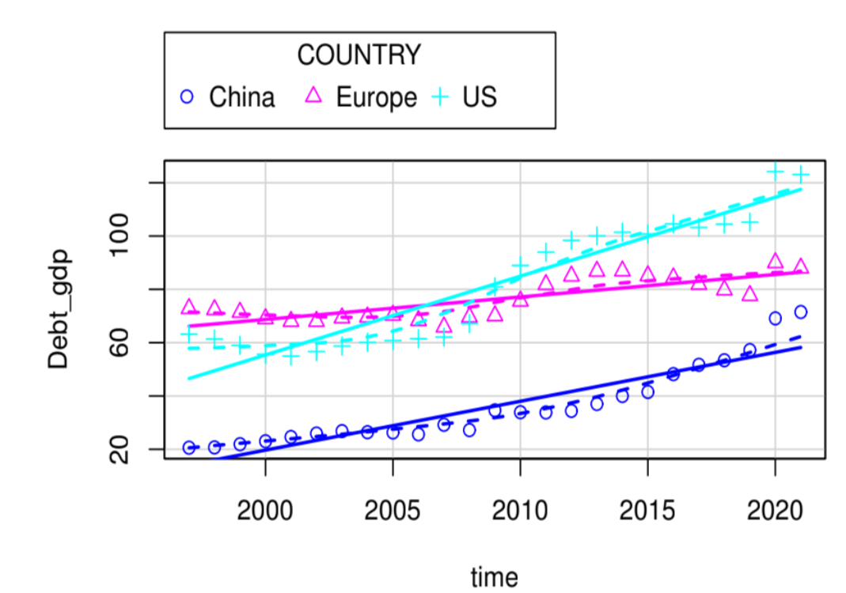
Figure 4 -Public debt over GDP ratio throughout the years in the three Countries

Regions’ Debt-GDP heterogeneity
Figure 5 shows the heterogeneity among the three regions. The public debt-to-GDP ratio has high heterogeneity among them, in particular between China and the two developed economies of US and EU. Moreover, a high heterogeneity can be observed within the US.
In line with Eberhardt and Presbitero (2015), our results show the differences among the regions. China trying to catch-up with well-established economies, that on the other hand float way higher in regards of debt-to-GDP ratio. Looking, instead, at the within hetero geneity the biggest gap is in the US. This is due to the difficulties the country experienced in the journey to recovery from the 2008 crisis before running into a new one.
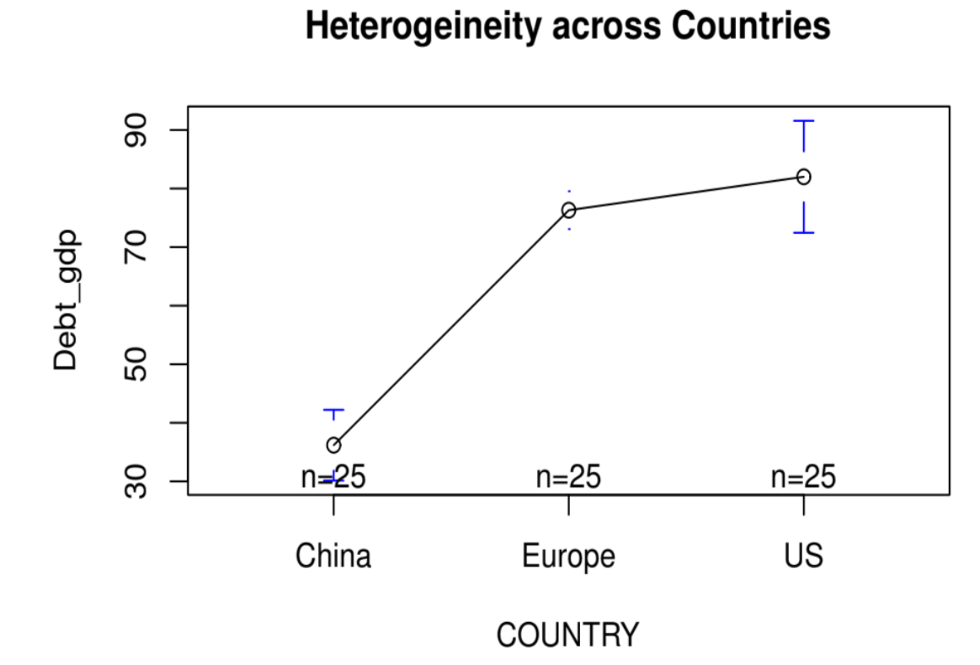
Figure 5 -Heterogeneity across Countries

Impact of inflation on debt-to-GDP
The regression below shows only the effect of a change in inflation for the EU and US. The main regression graph would not allow for all the results to show due to China high variability in inflation.
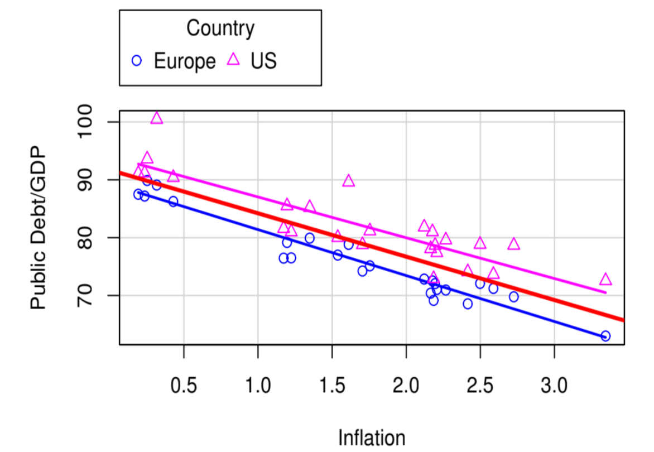
Figure 6 - Regression of Inflation over Public Debt to GDP Ratio for the US and
For both the EU and US an increase in inflation helps the economy deflate the debt-to-GDP. In line with the literature only developed economies benefit of an increase in inflation while emerging markets “prefer” traditional deflator instruments.

Appendix B: Model’s Checks
Appendix B presents first the correlation matrix, following the results of the Hausmann test and eventually, the VIF analysis.

 | Debt_GDP | CPI | Tax_revenues | Spending | Interest_rate | Gross_Cap_Form
Debt_GDP | 1
CPI | 0.152926 | 1
Tax_revenues | 0.315479 | 0.086628 | 1
Spending | 0.262154 | 0.094814 | 0.88808 | 1
Interest_rate | -0.2714 | -0.05632 | -0.0363 | -0.18967 | 1
Gross_Cap_Form | -0.74288 | -0.19204 | -0.50809 | -0.35239 | -0.05354 | 1
Table 4- Correlation matrix
The strongest correlation is between tax revenue and government expenditure (both independent variables), reaching the value of 0.8888.
The relationship between government expenditure and government tax revenue is important for fiscal policymaking and macroeconomic management. The nature and composition of government expenditure influence economic growth and social welfare. Therefore, government expenditure, influences government tax revenues as well.

For the sake of completeness and to check robustness we carry out the Hausmnn test (see Table 5 ). This test is used to decide which of the two models is statistically valid.
The null hypothesis is that the preferred model is the random effects model, whereas the alternative hypothesis is that the preferred model is the fixed effects model.

 | Fixed | Random | Var (Diff) | Prob.
π | 0.001440 | 0.001692 | 0.0 | 0.000
e | 0.001681 | 0.002872 | 0.0 | 0.000
t | 0.003713 | 0.001499 | 0.0 | 0.00034
Table 5 - The Hausmann Test Results.
Note: Chi-sq 48.148 (2); Test Summary Prob 0.000
As probability is .000 we reject the Null Hypothesis (where the Null Hypothesis is that the preferred model is the Random Effects one). This confirms that the Fixed Effects method is the right one to use in this case (Green, 2008).
No correlation occurs between the unique errors and the regressors in the model are detected.
Variance Inflation Factor (VIF)
Eventually, we check for multicollinearity for a given predictor, by computing a score called the variance inflation factor (VIF) which measures how much the variance of a regression coefficient is inflated due to multicollinearity in the model. Table 6 presents the results of the VIF analysis.
CPI | Spending | Tax_revenues | Interest_rate | Gross_Cap_Form
1.048201 | 3.749126 | 4.485482 | 1.137553 | 1.491945
Table 6 - VIF
The smallest possible value of VIF is one (absence of multicollinearity). As a rule of thumb, a VIF value that exceeds 5 or 10 indicates a problematic amount of collinearity (Yoo et al. 2014). We can therefore conclude that there is no multicollinearity among the variables in our model.

