Supplementary Data for: COMPARING CB1 RECEPTOR GIRK CHANNEL RESPONSES TO RECEPTOR INTERNALIZATION USING A KINETIC IMAGING ASSAY
Supplementary Figure 1: GIRK channel responses in AtT20 cells following cannabinoid treatment. AtT20 cells stably-expressing SEP-CB1R were treated with 10 fM – 10 μM of cannabinoids as indicated and GIRK channel response was measured continuously for 6 min (i.e., 240 s). The rate of response (k, in units s⁻¹⁾ was estimated by fitting data from individual experiments to a one-phase exponential decay curve in GraphPad Prism (v. 9.0). a) (±)CP55,940 (10 fM – 10 μM) n=5-13. b) WIN55,212-2 (0.5 nM - 10 μM) n=4-5. c) Δ⁹-THC (0.5 nM - 10 μM) n=4-18. d) AEA (0.5 nM – 20 μM) n=3-10. e) A comparison of the rate of GIRK channel maximal responses for each cannabinoid from panels a-d. [(±)CP55,940 10 μM n=13, WIN55,212-2 5 μM n=5, Δ⁹-THC 10 μM n=10, AEA 10 μM n=8]. These data correspond to data presented in Figure 2 and Table 1. All data are presented as mean ± S.E.M. ****p<0.0001, *p<0.05 compared to CP55,940; ^p<0.05 compared to WIN55,212-2 as determined by one-way ANOVA followed by Tukey’s post-hoc test.

Haley K. Andersen¹, Duncan G.Vardakas¹, Julie A. Lamothe¹, Tannis E.A. Perault¹, Kenneth B. Walsh², Robert B. Laprairie^{1,3}*
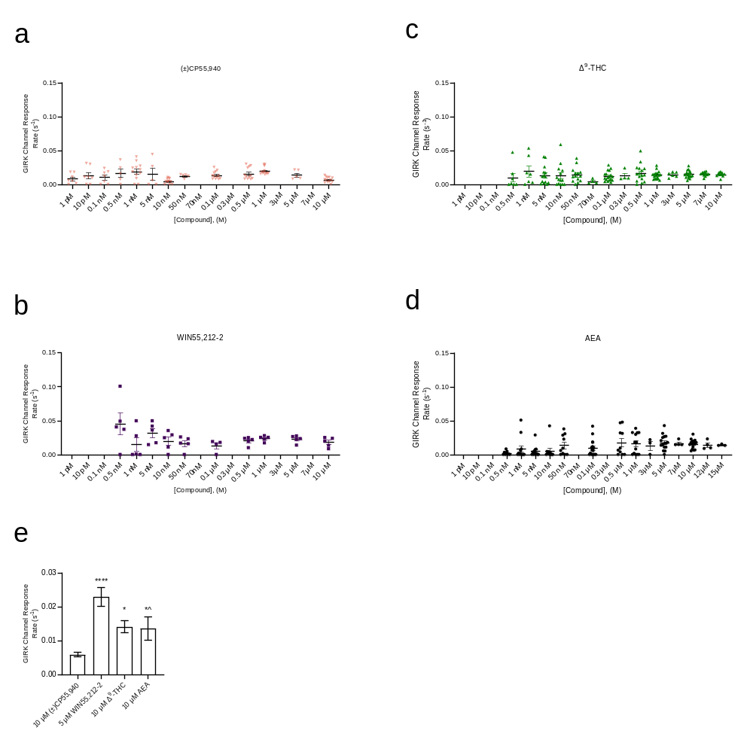
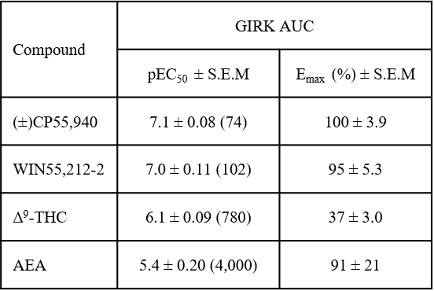
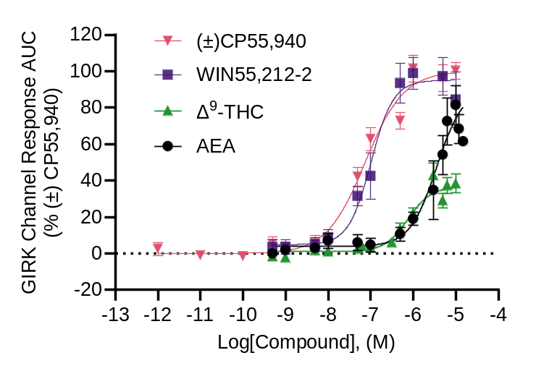
Supplementary Figure 2: GIRK channel responses in AtT20 cells following cannabinoid treatment. AtT20 cells stably-expressing SEP-CB1R were treated with 1 pM – 15 μM of cannabinoids as indicated and GIRK channel response was measured continuously for 6 min (i.e., 240 s) with corresponding data presented in Figure 2 [(±)CP55,940 10μM n=13, WIN55,212-2 5μM n=5, Δ⁹-THC 10 μM n=10, AEA 10 μM n=8]. a) Total AUC from curves presented in Fig. 2a-d was calculated and plotted here against log[Compound], (M) and normalized to the maximal (±)CP55,940 response (i.e., 100%). Data were fit to a four-parameter non-linear regression. Potency and efficacy data are presented in b. All data are presented as mean ± S.E.M
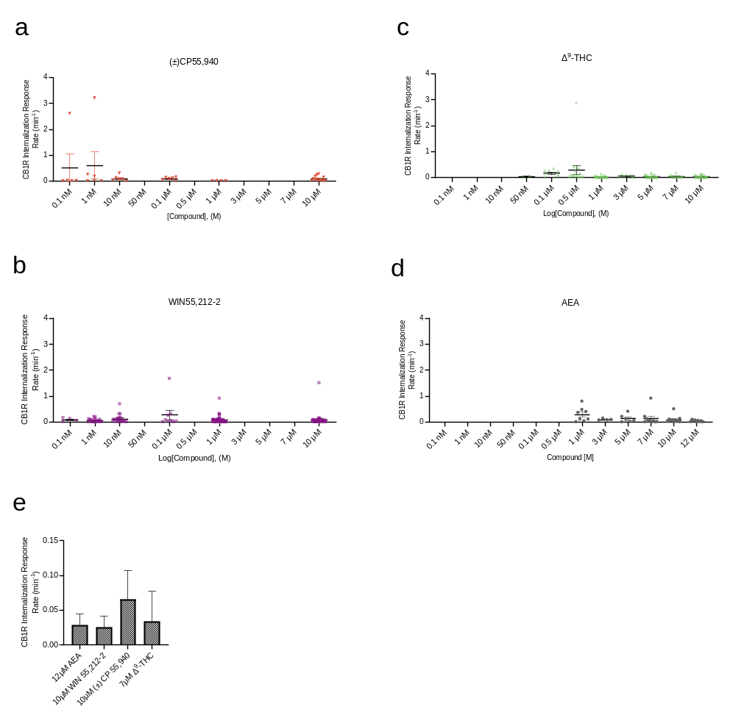
Supplementary Figure 3: CB1R internalization in AtT20 cells following cannabinoid treatment. AtT20 cells stably-expressing SEP-CB1R were treated with 0.1 nM – 10 μM of cannabinoids as indicated and CB1R internalization was measured at 5 min intervals for 30 min. The rate of response (k, in units min⁻¹) was estimated by fitting data from individual experiments to a one-phase exponential decay curve in GraphPad Prism (v. 9.0). a) (±)CP55,940 (0.1 nM – 10 μM) n=2-7. b) WIN55,212-2 (0.1 nM - 10 μM) n=4-35. c) Δ9-THC (50 nM - 10 μM) n=2-25. d) AEA (1 μ M – 12 μM) n=4. e) A comparison of the rate of CB1R internalization maximal responses for each cannabinoid from panels a-d. [(±)CP55,940 10μM n=7, WIN55,212-2 1 μM n=17, Δ⁹-THC 10 μ M n=25, AEA 12 μM n=4]. These data correspond to data presented in Figure 4 and Table 1. All data are presented as mean ± S.E.M.
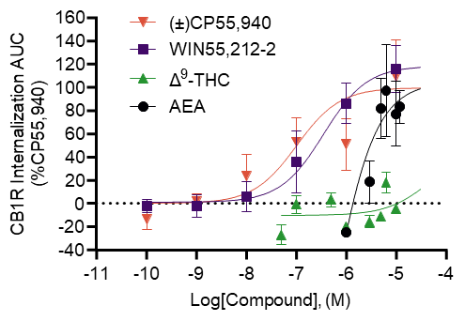
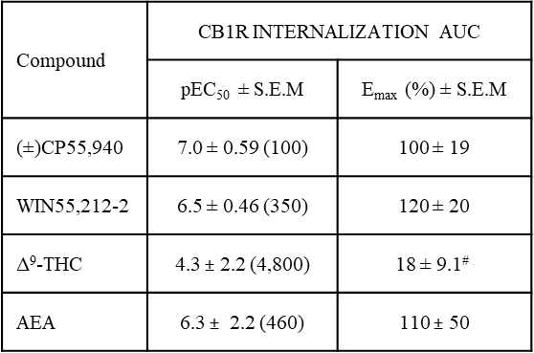
Supplementary Figure 4: CB1R internalization in AtT20 cells following cannabinoid treatment. AtT20 cells stably-expressing SEP-CB1R were treated with 0.1 nM – 12 μM of cannabinoids as indicated and CB1R internalization was measured at 5 min intervals over 30 min with corresponding data presented in Figure 4 ) (±)CP55,940 (0.1 nM – 10 μM) n=2-7, WIN55,212-2 (0.1 nM - 10 μM) n=4-35, Δ⁹-THC (50 nM - 10 μM) n=2-25, AEA (1 μ M – 12 μM) n=4]. a) Total AUC from curves presented in Fig. 4a-d was calculated and plotted here against log[Compound], (M) and normalized to the maximal (±)CP55,940 response (i.e., 100%). Data were fit to a four-parameter non-linear regression. Potency and efficacy data are presented in b. All data are presented as mean ± S.E.M. #: Δ⁹-THC is presented as highest observed value ± S.E.M. due to poor curve fit *p<0.05 compared to CP55,940 as determined by one-way ANOVA followed by Dunnett’s post-hoc test.

