Tailoring glioblastoma treatment based on longitudinal analysis of post-surgical tumor microenvironment
Chiara Bastiancich^{1,2*}, Emmanuel Snacel-Fazy¹, Samantha Fernandez³, Stéphane Robert⁴, Roberta Stacchini¹, Léa Plantureux⁴, Sébastien Boissonneau^{5,6}, Benoit Testud^{7,8,9}, Benjamin Guillet^{3,4,10}, Franck Debarbieux^{11,3,12}, Hervé Luche¹³, Dominique Figarella-Branger¹, Marie-Anne Estève^{1,14}, Emeline Tabouret^{1,15,16}, Aurélie Tchoghandjian^{1,17 *}

Supplementary material
Table S1. Flow cytometry panel for blood immunophenotyping
Antibody  – conjugated fluorophore | Concentration used | Provider | Reference number
Viakrome viability dye – 808 | 2.5 µL per tube | Beckman Coulter | C36628
CD45 – BB700 | 2.5 µg/mL | BD | 566440
CD11b – BV421 | 0.625 µg/mL | Biolegend | 101235
CD11c – BUV496 | 0.625 µg/mL | BD | 750450
CD8a – BV650 | 0.625 µg/mL | Biolegend | 100741
CD161 – PE/Cy5 | 2.5 µg/mL | Biolegend | 108715
CD357 (GITR) – APC | 0.156 µg/mL | Biolegend | 126311
Ly6G – FITC | 3.125 µg/mL | BD | 561105
SiglecF – BV605 | 0.625 µg/mL | BD | 740388

Table S2. Antibodies used for brain clearing and immunostaining
Antibody |  | Dilution used | Provider | Reference number
Primary | α-SMA | 1/500 | Abcam | ab21027
 | CD31 | 1/500 | R&D systems | AF3628
 | CD45 | 1/200 | Santa Cruz | sc-53665
 | GFAP-VioR667 | 1/50 | Miltenyi Biotec | 130-131-151
 | Podocalyxin | 1/500 | R&D systems | AF1556
 | TMEM119 | 1/700 | Abcam | Ab209064
Secondary | Anti-rabbit AF488 | 1/600 | Invitrogen | A11055
 | Anti-goat AF647 | 1/600 | Invitrogen | A21447
 | Anti-rabbit AF488 | 1/600 | Molecular Probes | A11008
 | Anti-rat AF647 | 1/600 | Jackson ImmunoResearch | 712-605-150
 | Anti-rabbit AF555 | 1/600 | Invitrogen | A31572

Table S3. Flow cytometry panel for brain immunophenotyping
Antibody  – conjugated fluorophore | Concentration used | Provider | Reference number
Viakrome viability dye – 808 | 2.5 µl per tube | Beckman Coulter | C36628
CD45 – BB700 | 2.5 µg/mL | BD | 566440
CD11b – BV421 | 0.625 µg/mL | Biolegend | 101235
CD11c – BUV496 | 0.625 µg/mL | BD | 750450
Ly6C – PE/Cy7 | 0.3 µg/mL | Biolegend | 128017
CD8a – BV650 | 0.625 µg/mL | Biolegend | 100741
MHCII – APC/Cy7 | 0.3125 µg/mL | Biolegend | 107627
CD161 – PE/Cy5 | 2.5 µg/mL | Biolegend | 108715
CCR2 –AF594 | 0.25 µg/mL | R&D systems | FAB5538T
CD357 (GITR) – APC | 0.156 µg/mL | Biolegend | 126311
CD317 – AF700 | 2.5 µg/mL | Biolegend | 127037
Ly6G – FITC | 3.125 µg/mL | BD | 561105
SiglecF – BV605 | 0.625 µg/mL | BD | 740388
XCR1 – BV650 | 1.25 µg/mL | Biolegend | 148220
CD38 – BUV737 | 5 µg/mL | BD | 741748
CD44 – BV510 | 5 µg/mL | Biolegend | 103043
CD3 – FITC | 3.125 µg/mL | Biolegend | 100203
CD64 – BV786 | 10 µg/mL | BD | 741024
CD26 – PE | 0.625 µg/mL | Biolegend | 137803
CD25 – BUV395 | 10 µg/mL | BD | 564022

Supplementary figures
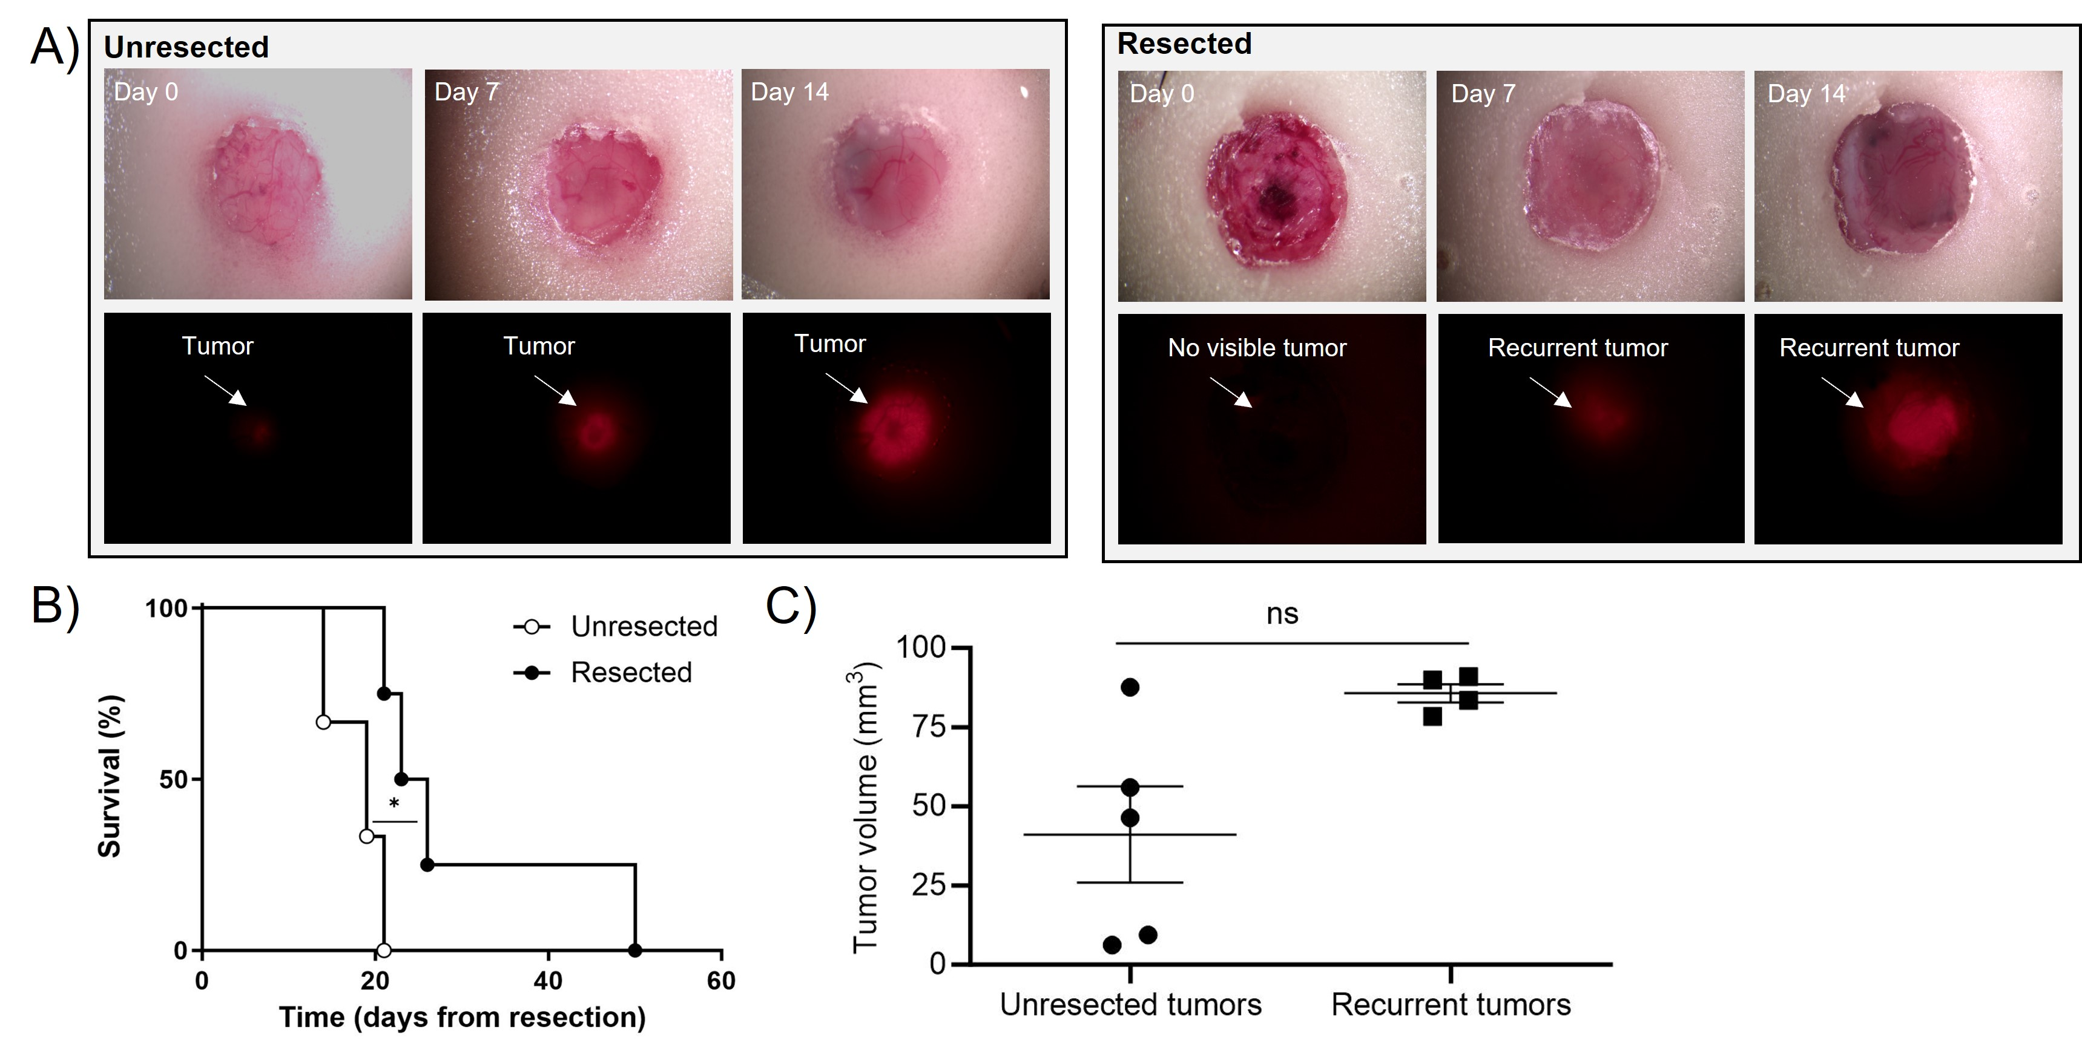
Figure S1. Imaging of the brain microenvironment from surgery to recurrence (A) Bright microscope (upper panel) and fluorescent microscope (lower panel) images of transgenic mice bearing GL261-DsRed tumors and the cranial window in unresected (left panel) and resected animals (right panel). Images were taken at day 0 (immediately after the surgery and/or establishment of a cranial window) and day 7 and 14 post-surgery and/or cranial window implantation; (B) Kaplan-Meier survival curves of the unresected and resected transgenic mice bearing GL261-DsRed tumors (n=3-4; *p < 0.05); (C) Quantification of the tumor volume of 3D light-sheet microscopy images of C57BL/6 mouse brains bearing GBM tumors 14 days post-surgery and/or cranial window implantation (mean ± SEM, n=4-5; not significant, unpaired Mann Whitney nonparametric test).
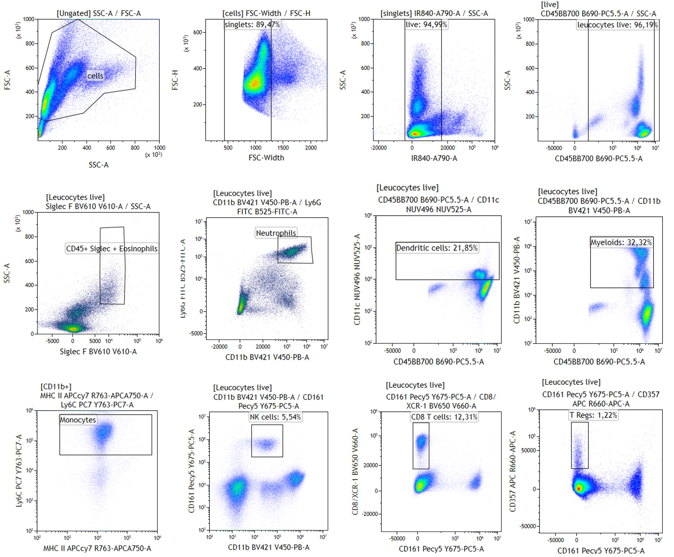
Figure S2. Flow cytometry gating strategy for blood samples analysis presented in Figure 1
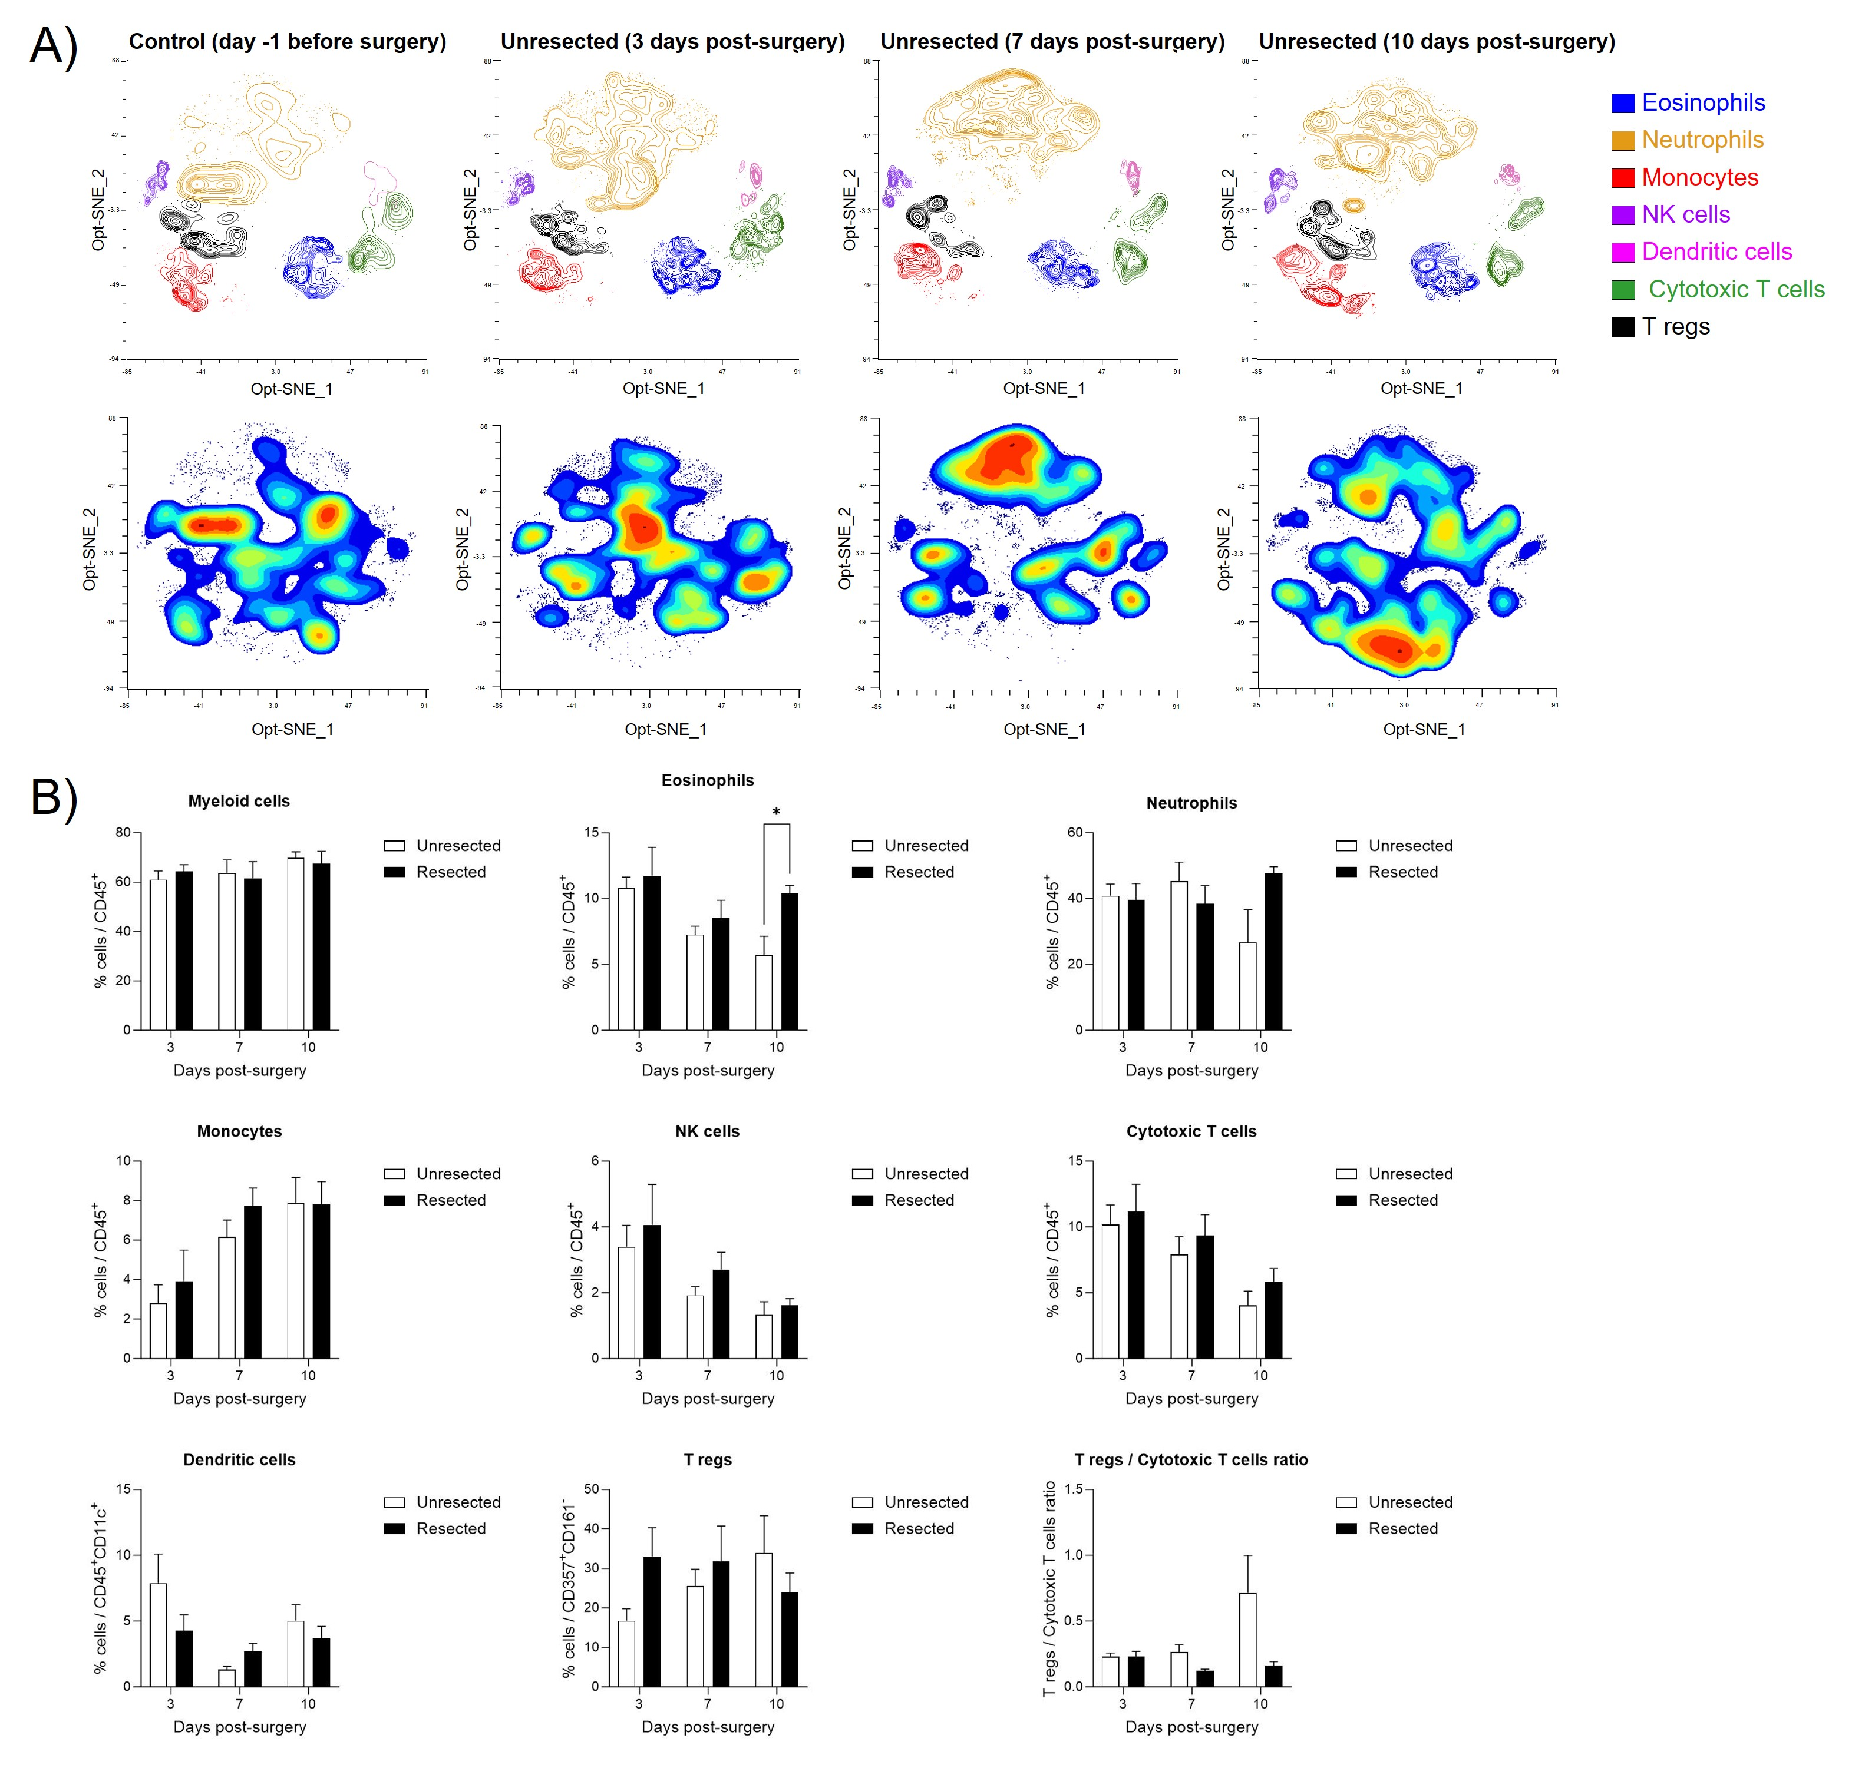
Figure S3. Longitudinal characterization of the impact of surgery on tumor recurrence: mouse model and systemic immune modifications. (A) Identification of immune cell population in mice blood using flow cytometry. The upper panels show Opt-SNE of manually selected cell cluster validated by FlowSOM analysis for control and unresected animals at day 3, 7 and 10 post-surgery. The lower panel represents, for the same groups of animals, the density contour plot of the different immune cell clusters in mice blood projected onto an Opt-SNE map; (B) Frequency of repartition of blood immune cell clusters for unresected and resected animals at day 3, 7 and 10 post-surgery. Numbers are expressed as percentage of cells related to CD45⁺ cells (for myeloid cells CD11b⁺, eosinophils, neutrophils, NK cells, Cytotoxic T cells), CD45⁺CD11c⁺ cells (for dendritic cells), CD357⁺CD161⁻ (for Tregs). The lowest right panel represents the ratio between Tregs and Cytotoxic T cells. (average ± SEM, n=5-9; Unpaired t test with Welch correction, *p<0.05).

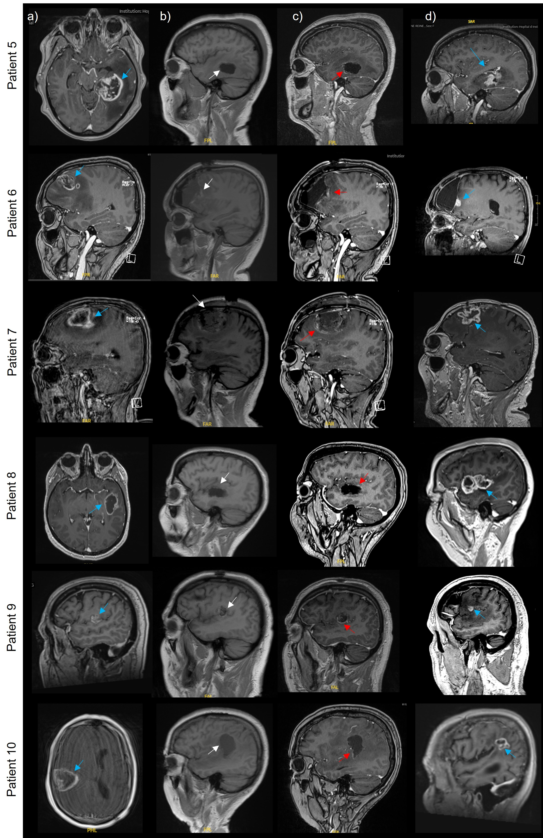
Figure S4. Illustrative brain MRI imaging of the remaining seven patients included in the study. The images show a T1 sequence with (a, c, d) or without (b) contrast enhancement, before (a) or after gross total resection (b and c) and at relapse (d). The blue arrows show the initial and recurrent tumor location, the white arrows show the tumor cavity location (b) and the red arrows show contrast enhancement associated with post-surgery BBB opening (c).

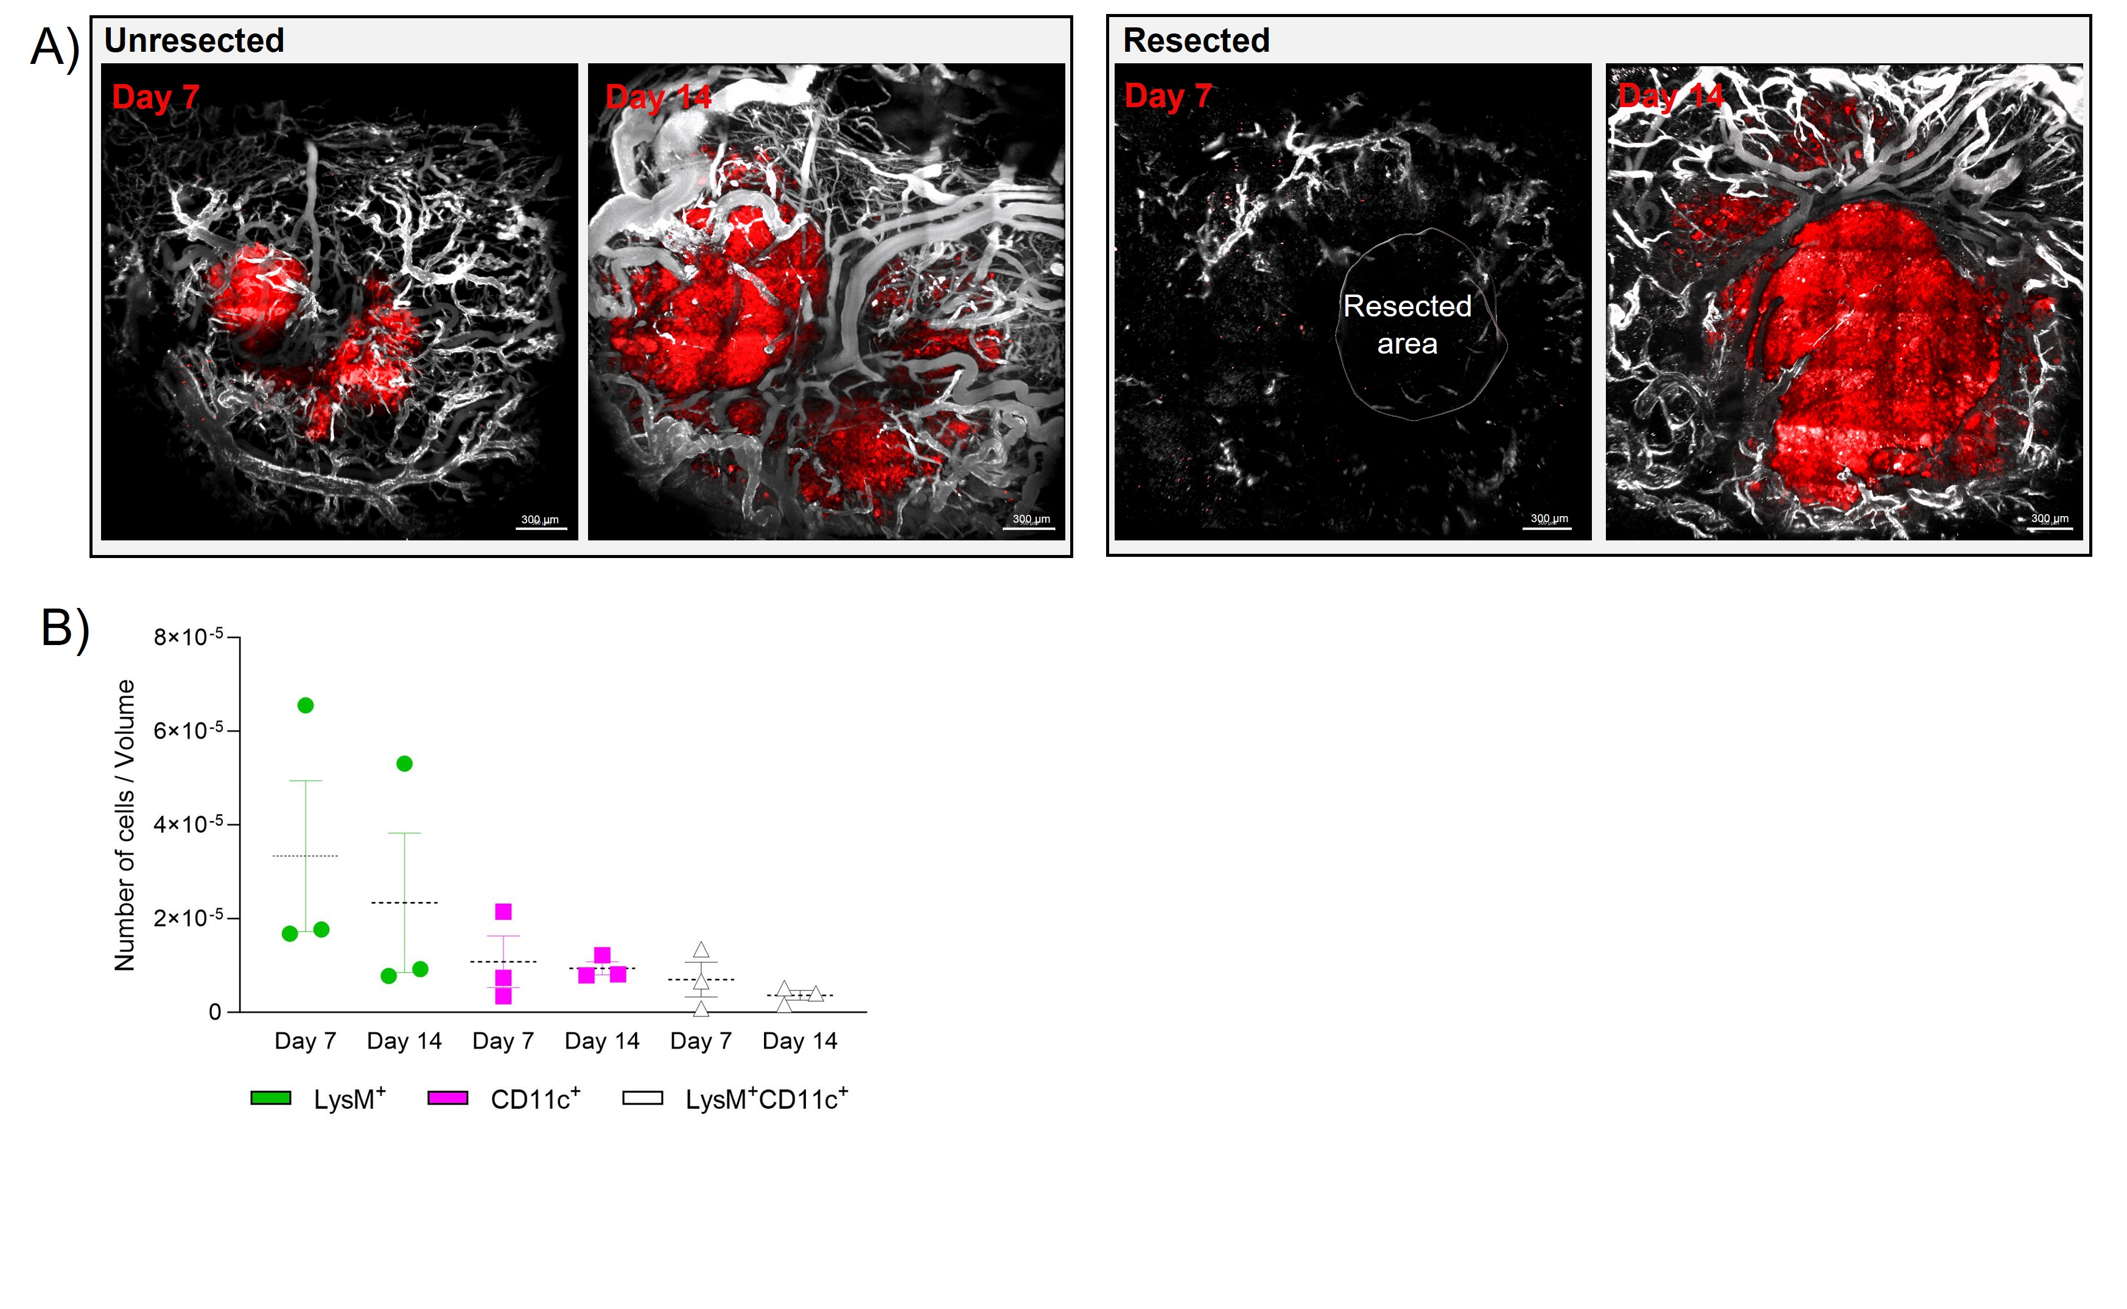
Figure S5. (A) Two-photon images at day 7 (left panels) and 14 post-implantation (right panels) of the cranial window (unresected) or resective surgery and cranial window implantation (resected). Tumors are represented in red, blood vessels in white (scale bar = 300 µm). In the left panel of the resected images, the resected area is represented as 3D reconstruction in white; (B) Quantification of the number of cells per volume of LysM⁺, CD11c⁺ and LysM⁺CD11c⁺ cells at day 7 and 14 in the resected animals. The bar graphs represent mean ± SEM (paired nonparametric Wilcoxon test, not significant difference between day 7 and 14).
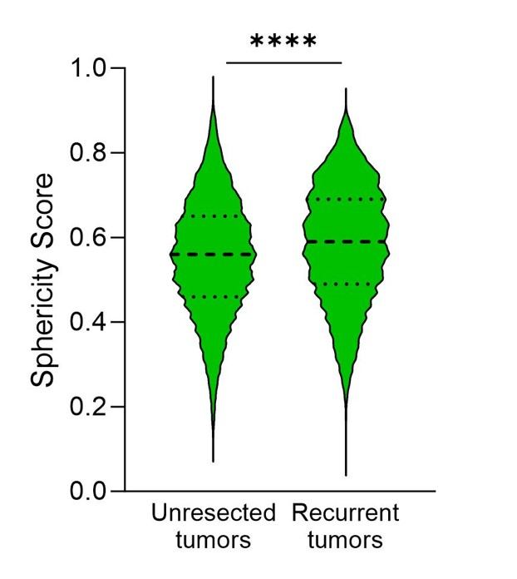
Figure S6. Sphericity score of TMEM119⁺ cells in 3D light-sheet microscopy images of brains of C57BL/6 mice bearing GBM tumors 14 days post-surgery and/or cranial window implantation (mean ± SEM, n=4-5; unpaired Mann Whitney nonparametric test, ****p<0.0001).

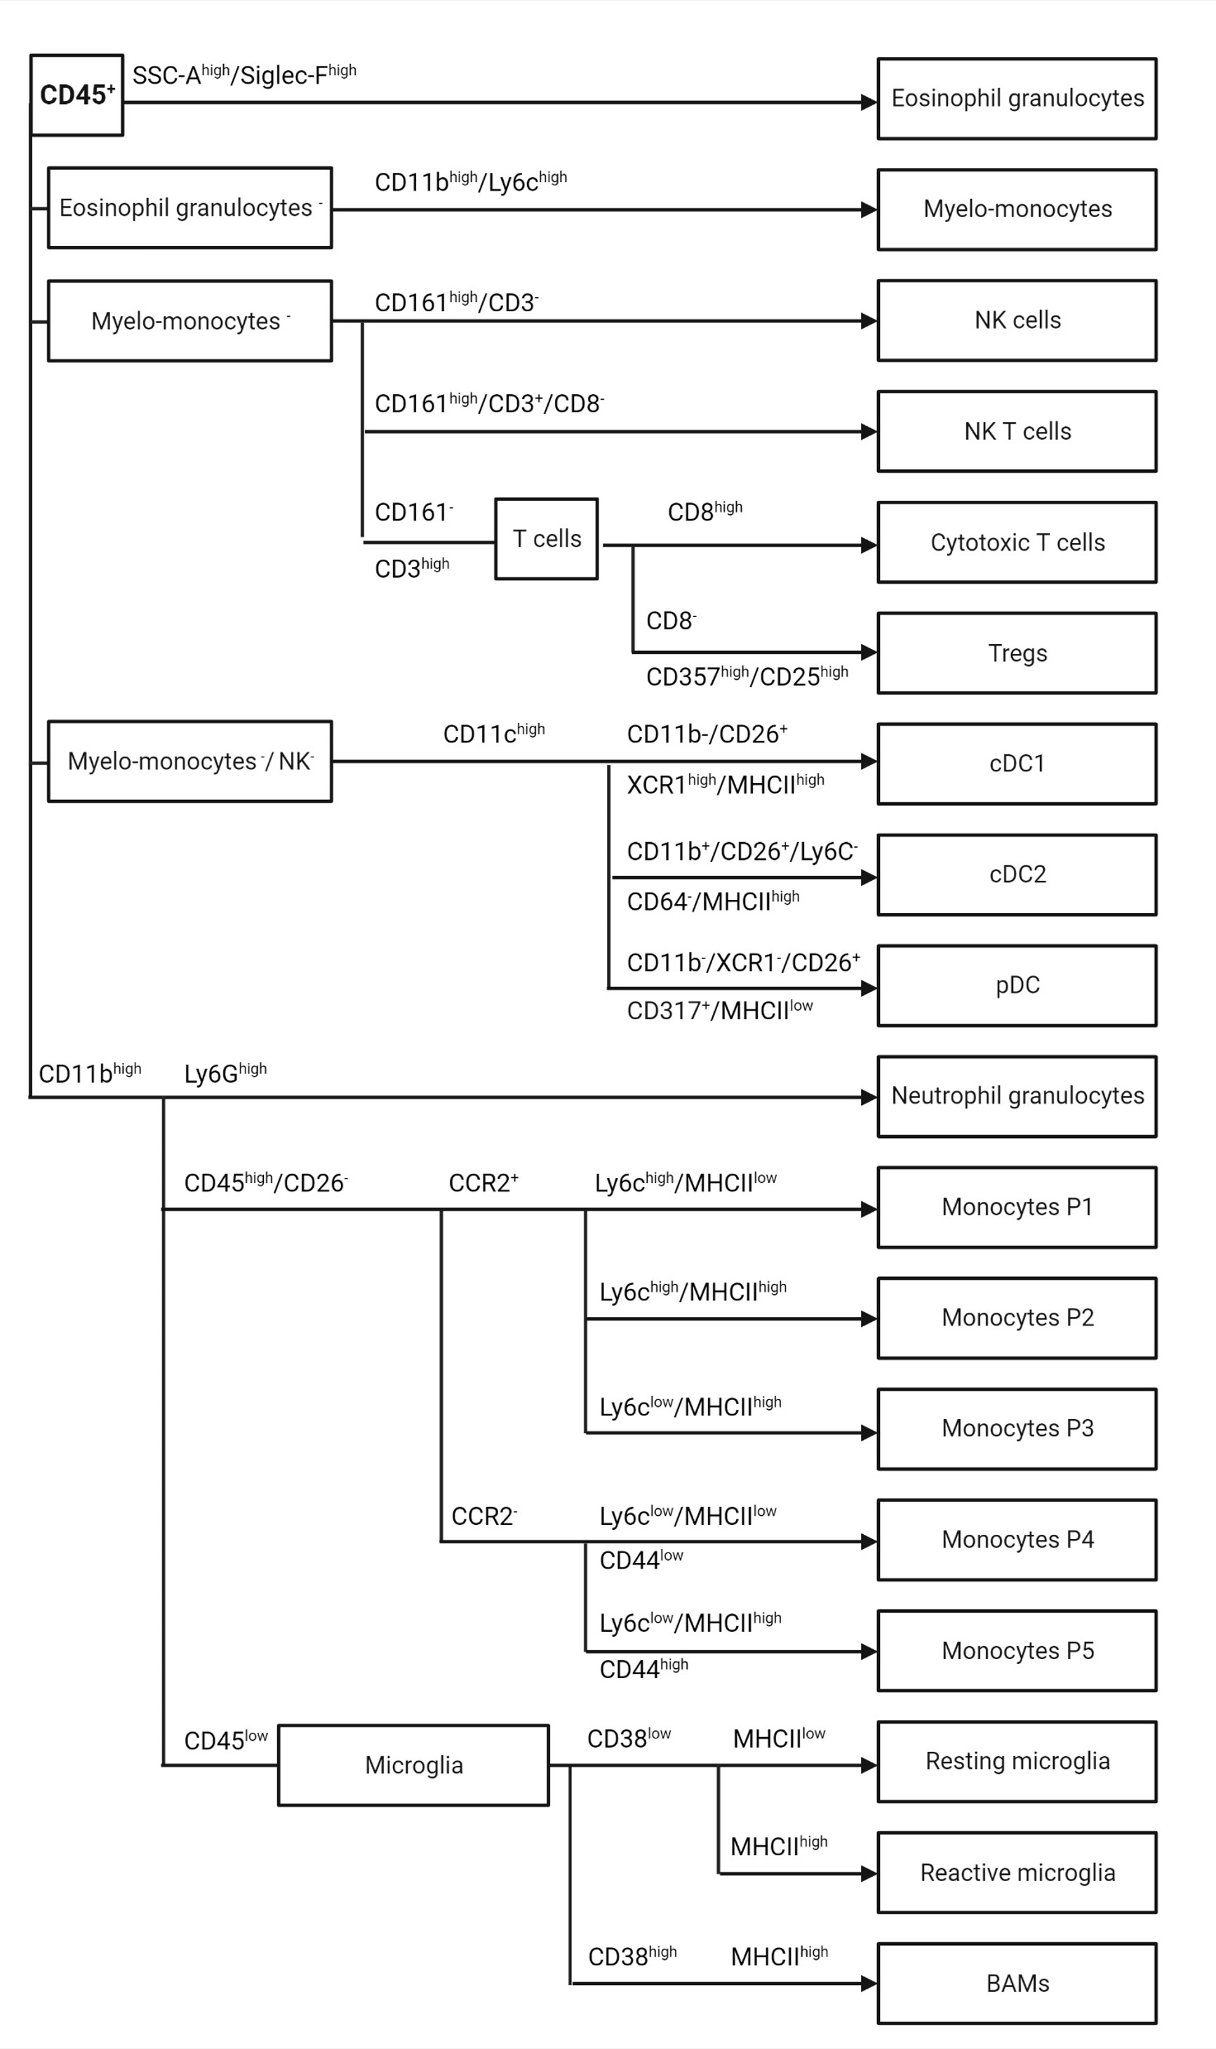
Figure S7. Scheme of the gating strategy used to analyze the tumor microenvironment in unresected and recurrent tumors by flow cytometry (DC: dendritic cells; BAM: border-associated macrophages).
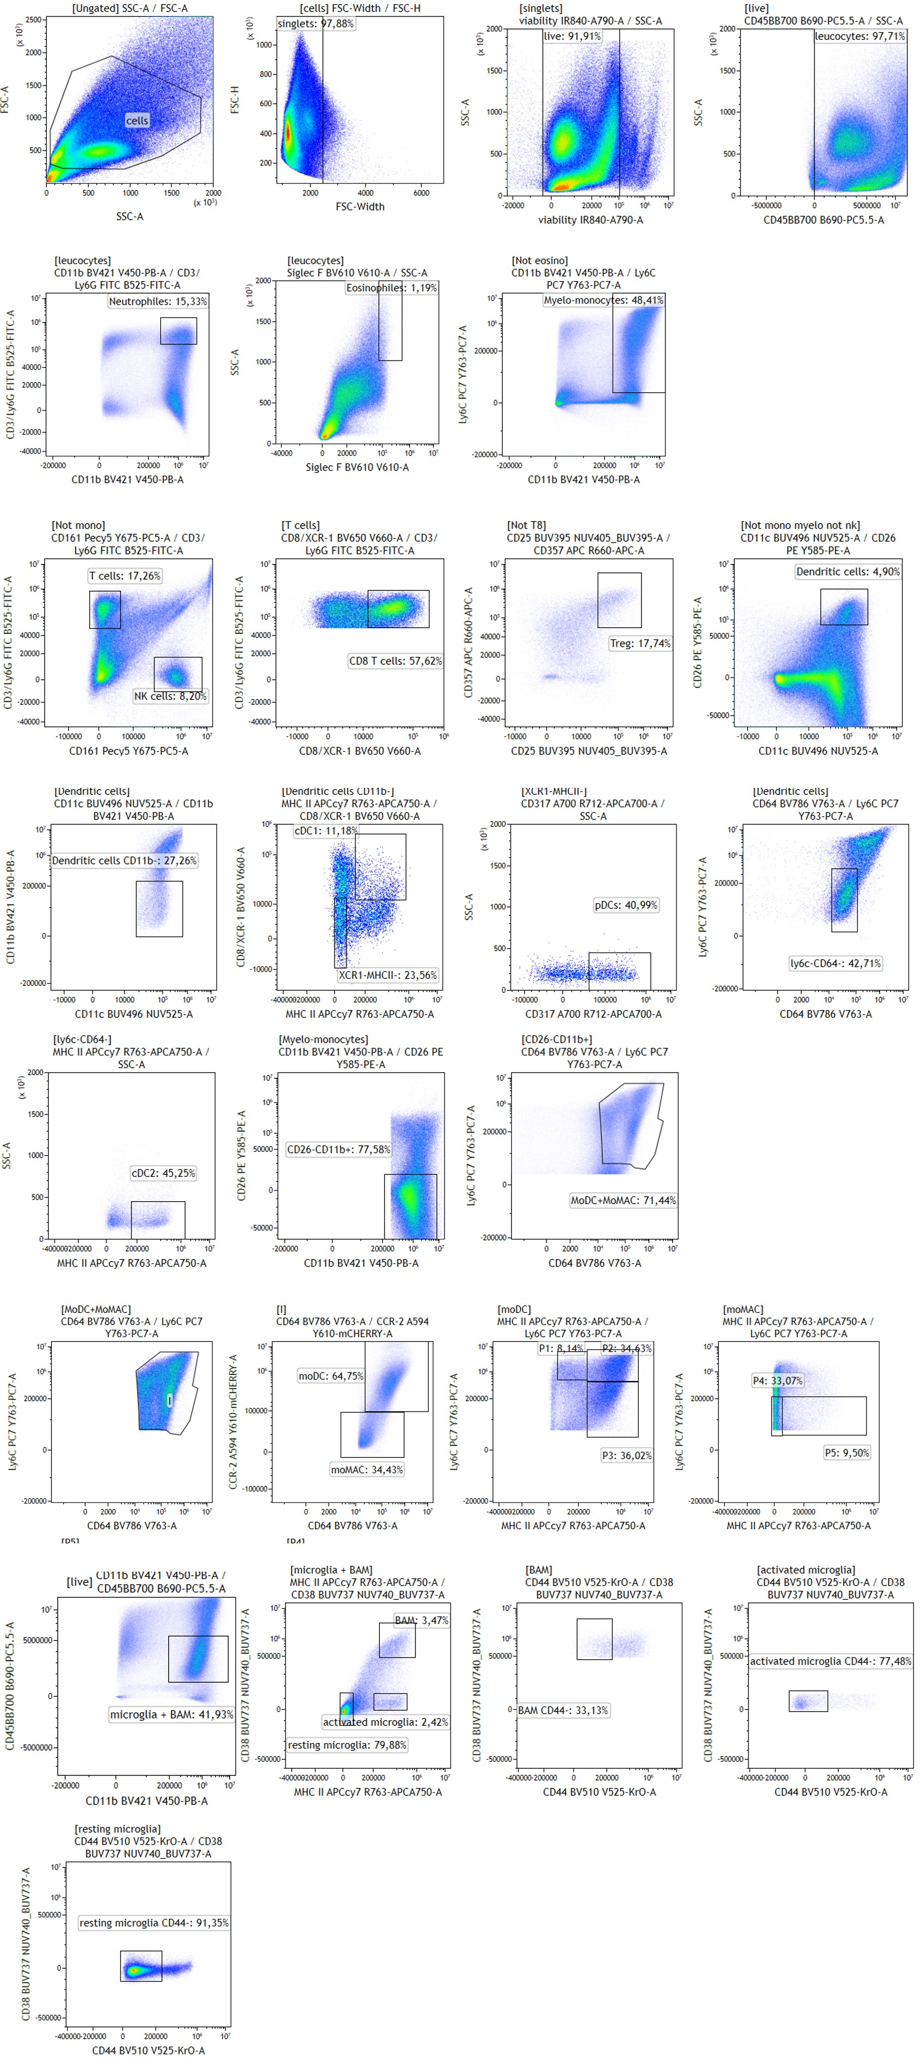
Figure S8. Flow cytometry gating strategy for brain tumor samples analysis.

