Sensitivity analysis for HCQ with or without AZT in addition to SOC compared with SOC alone
Figure 1. Using inverse RRs with random effect of selected studies HCQ with or without AZT in addition to SOC effectiveness compared with SOC alone
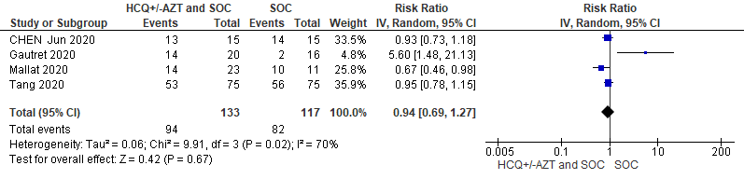
Figure 2. Excluding Tang et al. due to it’s the substantial relative weight on the meta-analysis
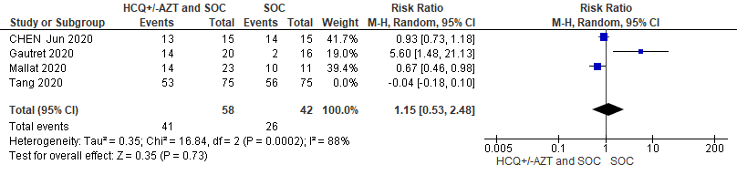
Figure 3. Using inverse RRs with random effect of selected studies on mortality
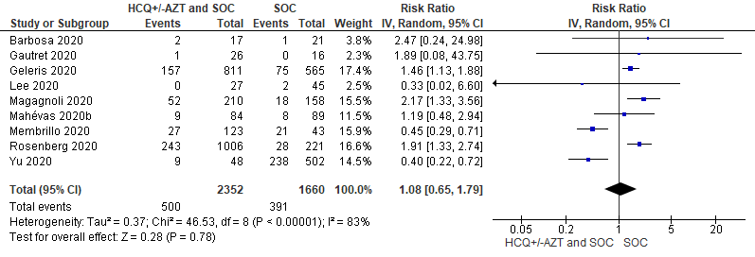
Figure 4. Excluding four studies (Barbosa 2020, Gautret 2020, Lee 2020, Yu 2020) with substantial low relative weight (<50 participants in Treatment group) on the meta-analysis
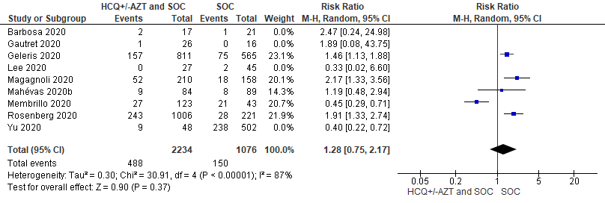
Figure 5. Excluding four studies (Barbosa 2020, Gautret 2020, Lee 2020, Yu 2020) with substantial low relative weight (<50 participants in Treatment group) and swapping events showed significance on the meta-analysis
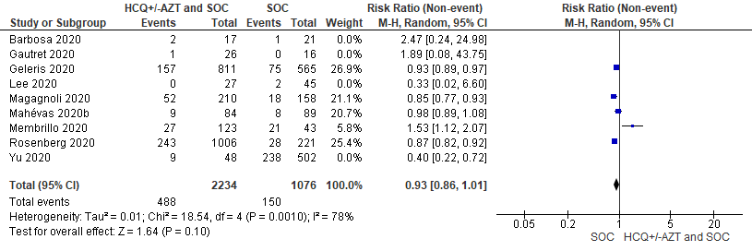
Figure 6. Forest plot for pooling mortality rates among treatment group HCQ with or without AZT in addition to SOC: Overall prevalence of mortality is 11.0% (11.0, 95% CI 9.60 to 12.7)

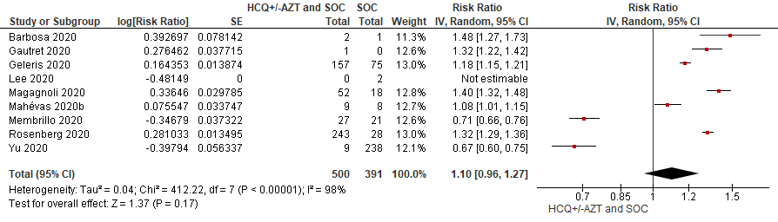
Figure 7. Excluding four studies (Barbosa 2020, Lee 2020, Yu 2020) with substantial low relative weight (<50 participants in Treatment group) showed no significance intubation during/after beginning of treatment among HCQ with or without AZT regimen and SOC on the meta-analysis
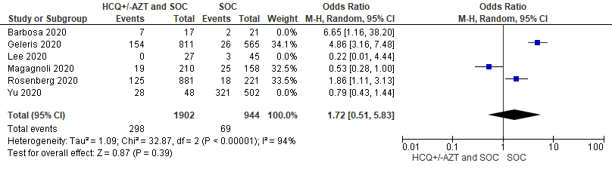
Figure 8. Excluding Rosenberg 2020 with substantial high relative weight ($>$500 participants in events) for odds of having Overall Adverse effects among HCQ with or without AZT regimen and SOC on the meta-analysis
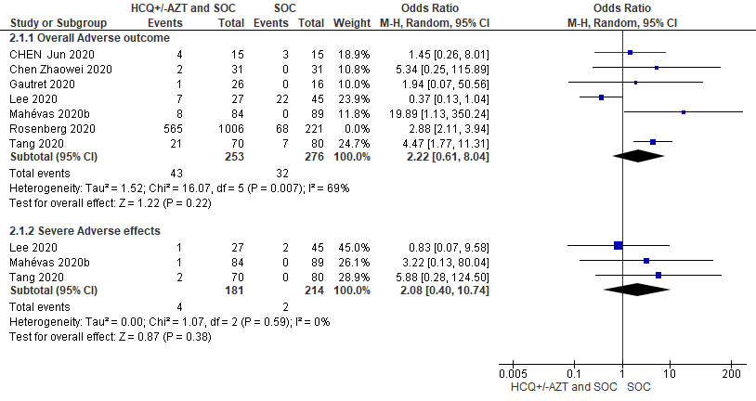
Figure 9. Forest plot for odds ratios (RE) and IV odds ratios regarding HCQ with or without AZT in addition to SOC on severe arrhythmias and QT changes
