Supplementary Material.

Title: Accessible Machine Learning and Deep Learning Models Predict Response and Survival in Early Stage Hormone Receptor-Positive/HER2-Negative Breast Cancer Receiving Neoadjuvant Chemotherapy

Authors:
Luca Mastrantoni, Giovanna Garufi, Giulia Giordano, Noemi Maliziola, Elena Di Monte, Giorgia Arcuri, Valentina Frescura, Angelachiara Rotondi, Armando Orlandi, Luisa Carbognin, Antonella Palazzo, Federica Miglietta, Letizia Pontolillo, Alessandra Fabi, Lorenzo Gerratana, Sergio Pannunzio, Ida Paris, Sara Pilotto, Fabio Marazzi, Antonio Franco, Gianluca Franceschini, Maria Vittoria Dieci, Roberta Mazzeo, Fabio Puglisi, Valentina Guarneri, Michele Milella, Giovanni Scambia, Diana Giannarelli, Giampaolo Tortora, Emilio Bria.

Other Sources:
GitHub repository: https://github.com/LucaMastrantoni/CORALAINE.
Interactive WebApp: https://coralaine-whxxbg8wwtwnntoxbxqjhu.streamlit.app.

Summary
Supplementary Table 1. Patients’ characteristics between the training and internal validation cohorts. 4
Supplementary Table 2. Patients’ characteristics between the internal and the external validation cohort. 5
Supplementary Table 3. Patients’ characteristics among the three cohorts. 6
Supplementary Table 4. Exploratory univariable analysis for pCR in the train cohort. 7
Supplementary Table 5. Variance inflation factor (VIF). 8
Supplementary Table 6. TRIPOD Checklist. 9
Supplementary Fig. S1| Model comparison for the framework using different models, one-hot-encoding and all features. 10
Supplementary Fig. S2| Partial dependence plot for the framework using different models, one-hot-encoding and all features. 11
Supplementary Fig. S3| Model comparison for the framework using different models, one-hot-encoding and only the 7 selected features. 12
Supplementary Fig. S4| Partial dependence plot for the framework using different models, one-hot-encoding and only the 7 features. 13
Supplementary Fig. S5| Partial dependence plot for the framework using different models, ordinal encoding and all features. 14
Supplementary Fig. S6| Partial dependence plot comparison for different algorithms according to each feature. 15
Supplementary Fig. S7| model comparison for the framework using different models, ordinal encoding and only the 7 selected features. 16
Supplementary Fig. S8| Partial dependence plot for the framework using different models, ordinal encoding and only the 7 selected features. 17
Supplementary Fig. S9| Partial dependence plot for the best model (GLM) of the framework using different models, ordinal encoding and only the 7 selected features. 18
Supplementary Fig. S10| Performance of the best model (GLM) of the framework using different models, ordinal encoding and only the 7 selected features (AML1). 19
Supplementary Fig. S11| Hyperparameters optimization for the best GLM model (AML2). 20
Supplementary Fig. S12| Learning curve, variable importance and partial dependence plot for the best GLM model (AML2). 21
Supplementary Fig. S13| Individual conditional expectations plot for the best GLM model (AML2). 22
Supplementary Fig. S14| Performance of the best GLM model (AML2). 23
Supplementary Fig. S15| Hyperparameters optimization for the best GLM model trained with SGD (SGD Elastic Net). 24
Supplementary Fig. S16| Partial dependence plots comparison for the SGD Elastic Net model. 25
Supplementary Fig. S17| Performance of the best GLM model trained with SGD (SGD Elastic Net). 27
Supplementary Fig. S19| Performance of the TabPFN with one-hot encoding. 30
Supplementary Fig. S20| Performance of the TabPFN model with ordinal encoding. 31
Supplementary Fig. S21| Permutation importance and partial dependence plot for the TabPFN model with ordinal encoding. 32
Supplementary Fig. S22| Performance of the best models in the external validation dataset. 33
Supplementary Fig. S23| Patient levels predictions of the SGD Elastic Net model. 34
Supplementary Fig. S24| Diagnostics for the association between pCR and disease-free survival in the whole internal cohort and in the internal validation cohort. 35
Supplementary Fig. S25| Diagnostics for the association between pCR and overall survival in the whole internal cohort and in the internal validation cohort. 36
Supplementary Fig. S26| Association between pCR and disease-free survival in the internal validation cohort. 38
Supplementary Fig. S27| Association between pCR and overall survival in the internal validation cohort. 40
Supplementary Fig. S28| Feature selection for disease-free survival and overall survival. 41
Supplementary Fig. S29| Parallel coordinate plot for machine learning models 42
Supplementary Fig. S30| Performance of the ML models for DFS in the internal validation cohort. 43
Supplementary Fig. S31| Performance of the ML models for OS in the internal validation cohort. 44
Supplementary Fig. S32| Parallel coordinate plot for machine learning models 45
Supplementary Fig. S33| Performance of the DL models for DFS in the internal validation cohort. 46
Supplementary Fig. S34| Performance of the DL models for OS in the internal validation cohort. 47
Sample size considerations. 48

 |  | Train | Internal Validation | P-Value
n |  | 463 | 109
Menopausal_Status, n (%) | Postmenopausal | 191 (41.3) | 48 (44.0) | 0.673*
Menopausal_Status, n (%) | Premenopausal | 272 (58.7) | 61 (56.0)
Age, mean (SD) |  | 49.8 (10.3) | 49.6 (11.4) | 0.821**
cT, n (%) | T1 | 44 (9.5) | 7 (6.4) | 0.021*
cT, n (%) | T2 | 279 (60.3) | 54 (49.5)
cT, n (%) | T3 | 90 (19.4) | 26 (23.9)
cT, n (%) | T4 | 50 (10.8) | 22 (20.2)
cN, n (%) | N0 | 73 (15.8) | 22 (20.2) | 0.404*
cN, n (%) | N1 | 229 (49.5) | 46 (42.2)
cN, n (%) | N2 | 131 (28.3) | 31 (28.4)
cN, n (%) | N3 | 30 (6.5) | 10 (9.2)
Histology, n (%) | Ductal | 356 (76.9) | 83 (76.1) | 0.625*
Histology, n (%) | Lobular | 59 (12.7) | 17 (15.6)
Histology, n (%) | Other | 48 (10.4) | 9 (8.3)
G, n (%) | G1_2 | 217 (46.9) | 46 (42.2) | 0.440*
G, n (%) | G3 | 246 (53.1) | 63 (57.8)
ER, mean (SD) |  | 78.7 (27.2) | 79.9 (25.2) | 0.654**
PR, mean (SD) |  | 47.8 (37.1) | 48.2 (37.2) | 0.918**
Ki67, mean (SD) |  | 41.1 (21.8) | 42.4 (20.2) | 0.571**
HER2, n (%) | Low | 284 (61.3) | 58 (53.2) | 0.147*
HER2, n (%) | Zero | 179 (38.7) | 51 (46.8)
pCR, n (%) | No | 391 (84.4) | 94 (86.2) | 0.749*
pCR, n (%) | Yes | 72 (15.6) | 15 (13.8)
ypT, n (%) | T0 | 97 (21.0) | 19 (17.4) | 0.882*
ypT, n (%) | T1 | 229 (49.5) | 56 (51.4)
ypT, n (%) | T2 | 100 (21.6) | 24 (22.0)
ypT, n (%) | T3 | 26 (5.6) | 6 (5.5)
ypT, n (%) | T4 | 11 (2.4) | 4 (3.7)
ypN, n (%) | N0 | 160 (34.6) | 39 (35.8) | 0.761*
ypN, n (%) | N1 | 192 (41.5) | 43 (39.4)
ypN, n (%) | N2 | 80 (17.3) | 22 (20.2)
ypN, n (%) | N3 | 31 (6.7) | 5 (4.6)

Supplementary Table 1. Patients’ characteristics between the training and internal validation cohorts.
An anthracycline and taxane-based regimen was used in nearly all patients (99%), mainly using a sequential schedule (76%).
* Chi-squared test. ** Two sample t-test.

 |  | Internal | External  Validation | P-Value
n |  | 572 | 151
Menopausal_Status, n (%) | Postmenopausal | 239 (41.8) | 48 (31.8) | 0.032*
Menopausal_Status, n (%) | Premenopausal | 333 (58.2) | 103 (68.2)
Age, mean (SD) |  | 49.8 (10.5) | 48.7 (9.1) | 0.231**
cT, n (%) | T1 | 51 (8.9) | 8 (5.3) | 0.380*
cT, n (%) | T2 | 333 (58.2) | 86 (57.0)
cT, n (%) | T3 | 116 (20.3) | 33 (21.9)
cT, n (%) | T4 | 72 (12.6) | 24 (15.9)
cN, n (%) | N0 | 95 (16.6) | 21 (13.9) | <0.001*
cN, n (%) | N1 | 275 (48.1) | 112 (74.2)
cN, n (%) | N2 | 162 (28.3) | 13 (8.6)
cN, n (%) | N3 | 40 (7.0) | 5 (3.3)
Histology, n (%) | Ductal | 439 (76.7) | 77 (51.0) | <0.001*
Histology, n (%) | Lobular | 76 (13.3) | 53 (35.1)
Histology, n (%) | Other | 57 (10.0) | 21 (13.9)
G, n (%) | G1_2 | 263 (46.0) | 81 (53.6) | 0.113*
G, n (%) | G3 | 309 (54.0) | 70 (46.4)
ER, mean (SD) |  | 78.9 (26.8) | 86.7 (8.9) | <0.001**
PR, mean (SD) |  | 47.9 (37.1) | 59.7 (33.1) | <0.001**
Ki67, mean (SD) |  | 41.4 (21.5) | 28.2 (15.1) | <0.001**
HER2, n (%) | Low | 342 (59.8) | 102 (67.5) | 0.099*
HER2, n (%) | Zero | 230 (40.2) | 49 (32.5)
pCR, n (%) | No | 485 (84.8) | 138 (91.4) | 0.050*
pCR, n (%) | Yes | 87 (15.2) | 13 (8.6)

Supplementary Table 2. Patients’ characteristics between the internal and the external validation cohort.
Chemotherapy administration was similar: in the external validation set 97% of patients received an anthracycline and taxane-based regimen and a sequential schedule was used in 76% of patients.
* Chi-squared test. ** Two sample t-test.

 |  | Train | Internal Validation | External Validation | P-Value | Mapping
n |  | 463 | 109 | 151
Menopausal_Status, n (%) | Postmenopausal | 191 (41.3) | 48 (44.0) | 48 (31.8) | 0.072* | 0
Menopausal_Status, n (%) | Premenopausal | 272 (58.7) | 61 (56.0) | 103 (68.2) |  | 1
Age, mean (SD) |  | 49.8 (10.3) | 49.6 (11.4) | 48.7 (9.1) | 0.527**
cT, n (%) | T1 | 44 (9.5) | 7 (6.4) | 8 (5.3) | 0.051* | 0
cT, n (%) | T2 | 279 (60.3) | 54 (49.5) | 86 (57.0) |  | 1
cT, n (%) | T3 | 90 (19.4) | 26 (23.9) | 33 (21.9) |  | 2
cT, n (%) | T4 | 50 (10.8) | 22 (20.2) | 24 (15.9) |  | 3
cN, n (%) | N0 | 73 (15.8) | 22 (20.2) | 21 (13.9) | <0.001* | 0
cN, n (%) | N1 | 229 (49.5) | 46 (42.2) | 112 (74.2) |  | 1
cN, n (%) | N2 | 131 (28.3) | 31 (28.4) | 13 (8.6) |  | 2
cN, n (%) | N3 | 30 (6.5) | 10 (9.2) | 5 (3.3) |  | 3
Histology, n (%) | Ductal | 356 (76.9) | 83 (76.1) | 77 (51.0) | <0.001* | 0
Histology, n (%) | Lobular | 59 (12.7) | 17 (15.6) | 53 (35.1) |  | 1
Histology, n (%) | Other | 48 (10.4) | 9 (8.3) | 21 (13.9) |  | 2
G, n (%) | G1_2 | 217 (46.9) | 46 (42.2) | 81 (53.6) | 0.167* | 0
G, n (%) | G3 | 246 (53.1) | 63 (57.8) | 70 (46.4) |  | 1
ER, mean (SD) |  | 78.7 (27.2) | 79.9 (25.2) | 86.7 (8.9) | 0.002**
PR, mean (SD) |  | 47.8 (37.1) | 48.2 (37.2) | 59.7 (33.1) | 0.002**
Ki67, mean (SD) |  | 41.1 (21.8) | 42.4 (20.2) | 28.2 (15.1) | <0.001**
HER2, n (%) | Low | 284 (61.3) | 58 (53.2) | 102 (67.5) | 0.064* | 0
HER2, n (%) | Zero | 179 (38.7) | 51 (46.8) | 49 (32.5) |  | 1
pCR, n (%) | No | 391 (84.4) | 94 (86.2) | 138 (91.4) | 0.100* | 0
pCR, n (%) | Yes | 72 (15.6) | 15 (13.8) | 13 (8.6) |  | 1
ypT, n (%) | T0 | 97 (21.0) | 19 (17.4) |  | 0.882 | 0
ypT, n (%) | T1 | 229 (49.5) | 56 (51.4) |  |  | 1
ypT, n (%) | T2 | 100 (21.6) | 24 (22.0) |  |  | 2
ypT, n (%) | T3 | 26 (5.6) | 6 (5.5) |  |  | 3
ypT, n (%) | T4 | 11 (2.4) | 4 (3.7) |  |  | 4
ypN, n (%) | N0 | 160 (34.6) | 39 (35.8) |  | 0.761 | 0
ypN, n (%) | N1 | 192 (41.5) | 43 (39.4) |  |  | 1
ypN, n (%) | N2 | 80 (17.3) | 22 (20.2) |  |  | 2
ypN, n (%) | N3 | 31 (6.7) | 5 (4.6) |  |  | 3

Supplementary Table 3. Patients’ characteristics among the three cohorts.
The mapping for ordinal encoding is shown in the column “mapping”. Patients’ characteristics are also available as interactive dashboards at the link https://github.com/LucaMastrantoni/CORALAINE/tree/main/Dashboards.
* Chi-squared test. ** One-way ANOVA

 |  | pCR No | pCR Yes | P-Value
n |  | 391 | 72
Menopausal_Status, n (%) | Postmenopausal | 164 (41.9) | 27 (37.5) | 0.566*
Menopausal_Status, n (%) | Premenopausal | 227 (58.1) | 45 (62.5)
Age, mean (SD) |  | 50.2 (10.3) | 47.7 (10.5) | 0.067**
cT, n (%) | T1 | 29 (7.4) | 15 (20.8) | <0.001*
cT, n (%) | T2 | 229 (58.6) | 50 (69.4)
cT, n (%) | T3 | 85 (21.7) | 5 (6.9)
cT, n (%) | T4 | 48 (12.3) | 2 (2.8)
cN, n (%) | N0 | 53 (13.6) | 20 (27.8) | 0.001*
cN, n (%) | N1 | 190 (48.6) | 39 (54.2)
cN, n (%) | N2 | 118 (30.2) | 13 (18.1)
cN, n (%) | N3 | 30 (7.7)
Histology, n (%) | Ductal | 298 (76.2) | 58 (80.6) | 0.250*
Histology, n (%) | Lobular | 54 (13.8) | 5 (6.9)
Histology, n (%) | Other | 39 (10.0) | 9 (12.5)
G, n (%) | G1_2 | 197 (50.4) | 20 (27.8) | 0.001*
G, n (%) | G3 | 194 (49.6) | 52 (72.2)
ER, mean (SD) |  | 81.5 (23.7) | 63.5 (37.9) | <0.001**
PR, mean (SD) |  | 51.0 (36.9) | 30.5 (33.5) | <0.001**
Ki67, mean (SD) |  | 38.5 (20.5) | 55.5 (23.0) | <0.001**
HER2, n (%) | Low | 244 (62.4) | 40 (55.6) | 0.335**
HER2, n (%) | Zero | 147 (37.6) | 32 (44.4)

Supplementary Table 4. Exploratory univariable analysis for pCR in the train cohort.
Significant values are reported in bold.
* Chi-squared test. ** One-way ANOVA.

a |  |  | b
Feature | VIF |  | Feature | VIF
Age | 2.94 |  | Age | 1.05
ER | 1.36 |  | ER | 1.36
PR | 1.33 |  | PR | 1.30
Ki67 | 1.34 |  | Ki67 | 1.33
cT | 1.07 |  | cT | 1.07
cN | 1.04 |  | cN | 1.04
Menopausal Status | 2.31 |  | G | 1.23
Histology | 1.02
G | 1.24
HER2 | 1.03

Supplementary Table 5. Variance inflation factor (VIF).
- VIF including all features. The highest multicollinearity was observed for age and menopausal status.
- VIF after feature selection. A reduction in the VIF was observed, with all features having a VIF lower than one.
Section/Topic | Item |  | Checklist Item | Page
Title and abstract
Title | 1 | D;V | Identify the study as developing and/or validating a multivariable prediction model, the target population, and the outcome to be predicted. | 1
Abstract | 2 | D;V | Provide a summary of objectives, study design, setting, participants, sample size, predictors, outcome, statistical analysis, results, and conclusions. | 2
Introduction
Background and objectives | 3a | D;V | Explain the medical context (including whether diagnostic or prognostic) and rationale for developing or validating the multivariable prediction model, including references to existing models. | 3
Background and objectives | 3b | D;V | Specify the objectives, including whether the study describes the development or validation of the model or both. | 3
Methods
Source of data | 4a | D;V | Describe the study design or source of data (e.g., randomized trial, cohort, or registry data), separately for the development and validation data sets, if applicable. | 15
Source of data | 4b | D;V | Specify the key study dates, including start of accrual; end of accrual; and, if applicable, end of follow-up. | 15
Participants | 5a | D;V | Specify key elements of the study setting (e.g., primary care, secondary care, general population) including number and location of centres. | 15
Participants | 5b | D;V | Describe eligibility criteria for participants. | 15
Participants | 5c | D;V | Give details of treatments received, if relevant. | 15
Outcome | 6a | D;V | Clearly define the outcome that is predicted by the prediction model, including how and when assessed. | 16
Outcome | 6b | D;V | Report any actions to blind assessment of the outcome to be predicted. | NA
Predictors | 7a | D;V | Clearly define all predictors used in developing or validating the multivariable prediction model, including how and when they were measured. | 15-16
Predictors | 7b | D;V | Report any actions to blind assessment of predictors for the outcome and other predictors. | NA
Sample size | 8 | D;V | Explain how the study size was arrived at. | 16-17  Suppl.
Missing data | 9 | D;V | Describe how missing data were handled (e.g., complete-case analysis, single imputation, multiple imputation) with details of any imputation method. | 18-20
Statistical analysis methods | 10a | D | Describe how predictors were handled in the analyses. | 17
Statistical analysis methods | 10b | D | Specify type of model, all model-building procedures (including any predictor selection), and method for internal validation. | 18-19-20-21
Statistical analysis methods | 10c | V | For validation, describe how the predictions were calculated. | 17
Statistical analysis methods | 10d | D;V | Specify all measures used to assess model performance and, if relevant, to compare multiple models. | 19-21
Statistical analysis methods | 10e | V | Describe any model updating (e.g., recalibration) arising from the validation, if done. | NA
Risk groups | 11 | D;V | Provide details on how risk groups were created, if done. | NA
Development vs. validation | 12 | V | For validation, identify any differences from the development data in setting, eligibility criteria, outcome, and predictors. | 4
Results
Participants | 13a | D;V | Describe the flow of participants through the study, including the number of participants with and without the outcome and, if applicable, a summary of the follow-up time. A diagram may be helpful. | 4
Participants | 13b | D;V | Describe the characteristics of the participants (basic demographics, clinical features, available predictors), including the number of participants with missing data for predictors and outcome. | 4  Suppl.  GitHub
Participants | 13c | V | For validation, show a comparison with the development data of the distribution of important variables (demographics, predictors and outcome). | 4  Suppl.  GitHub
Model development | 14a | D | Specify the number of participants and outcome events in each analysis. | 4-7
Model development | 14b | D | If done, report the unadjusted association between each candidate predictor and outcome. | Suppl.
Model specification | 15a | D | Present the full prediction model to allow predictions for individuals (i.e., all regression coefficients, and model intercept or baseline survival at a given time point). | 6-7  WebApp
Model specification | 15b | D | Explain how to the use the prediction model. | 6-7
Model performance | 16 | D;V | Report performance measures (with CIs) for the prediction model. | 6-7
Model-updating | 17 | V | If done, report the results from any model updating (i.e., model specification, model performance). | NA
Discussion
Limitations | 18 | D;V | Discuss any limitations of the study (such as nonrepresentative sample, few events per predictor, missing data). | 13-14
Interpretation | 19a | V | For validation, discuss the results with reference to performance in the development data, and any other validation data. | 10-11-12
Interpretation | 19b | D;V | Give an overall interpretation of the results, considering objectives, limitations, results from similar studies, and other relevant evidence. | 10-11-12-13-14
Implications | 20 | D;V | Discuss the potential clinical use of the model and implications for future research. | 12-13-14
Other information
Supplementary information | 21 | D;V | Provide information about the availability of supplementary resources, such as study protocol, Web calculator, and data sets. | 22
Funding | 22 | D;V | Give the source of funding and the role of the funders for the present study. | 26

Supplementary Table 6. TRIPOD Checklist.
Suppl. indicates the information is available in the supplementary material. Patients' characteristics and distributions of variables are available in tabular form in the supplementary material and as interactive dashboards in the GithHub repository of the study. Individual model predictions can be accessed through the WebApp.
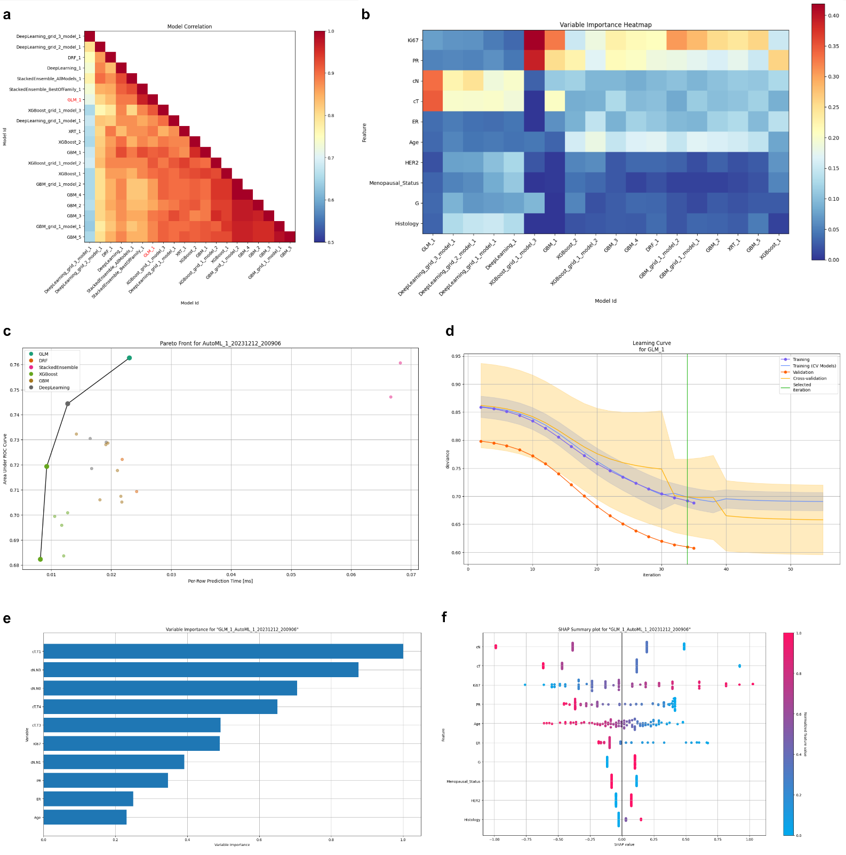

Supplementary Fig. S1| Model comparison for the framework using different models, one-hot-encoding and all features.
- Model correlation heatmap.
- Variable importance heatmap.
- Pareto chart, evaluating model performance and training time-
- Learning curve for the best model (GLM).
- Variable importance for the best model (GLM).
- SHAP value for the best model (GLM).

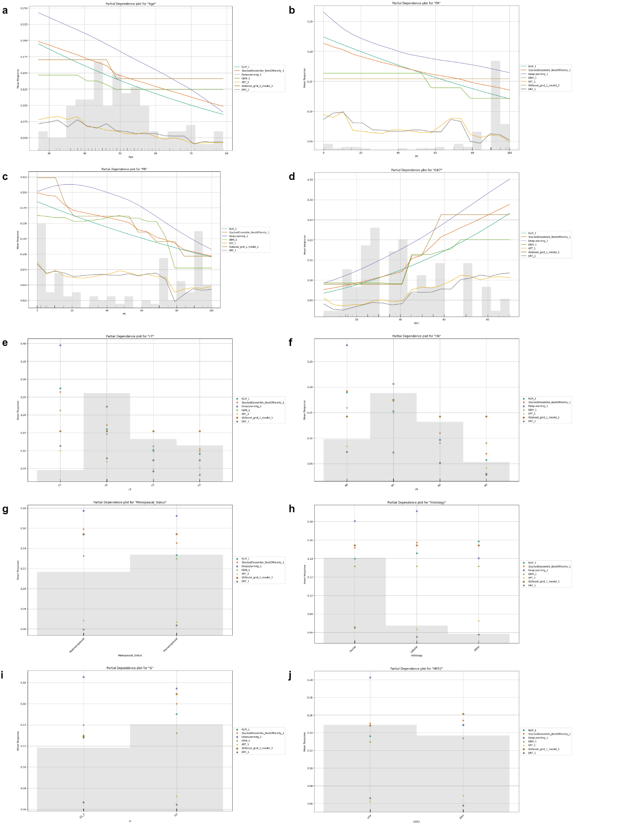

Supplementary Fig. S2| Partial dependence plot for the framework using different models, one-hot-encoding and all features.
a-f. From left to right and from upper to lower: Age, ER, PR, Ki67, cT, cN, Menopausal Status, Histology, G and HER2.
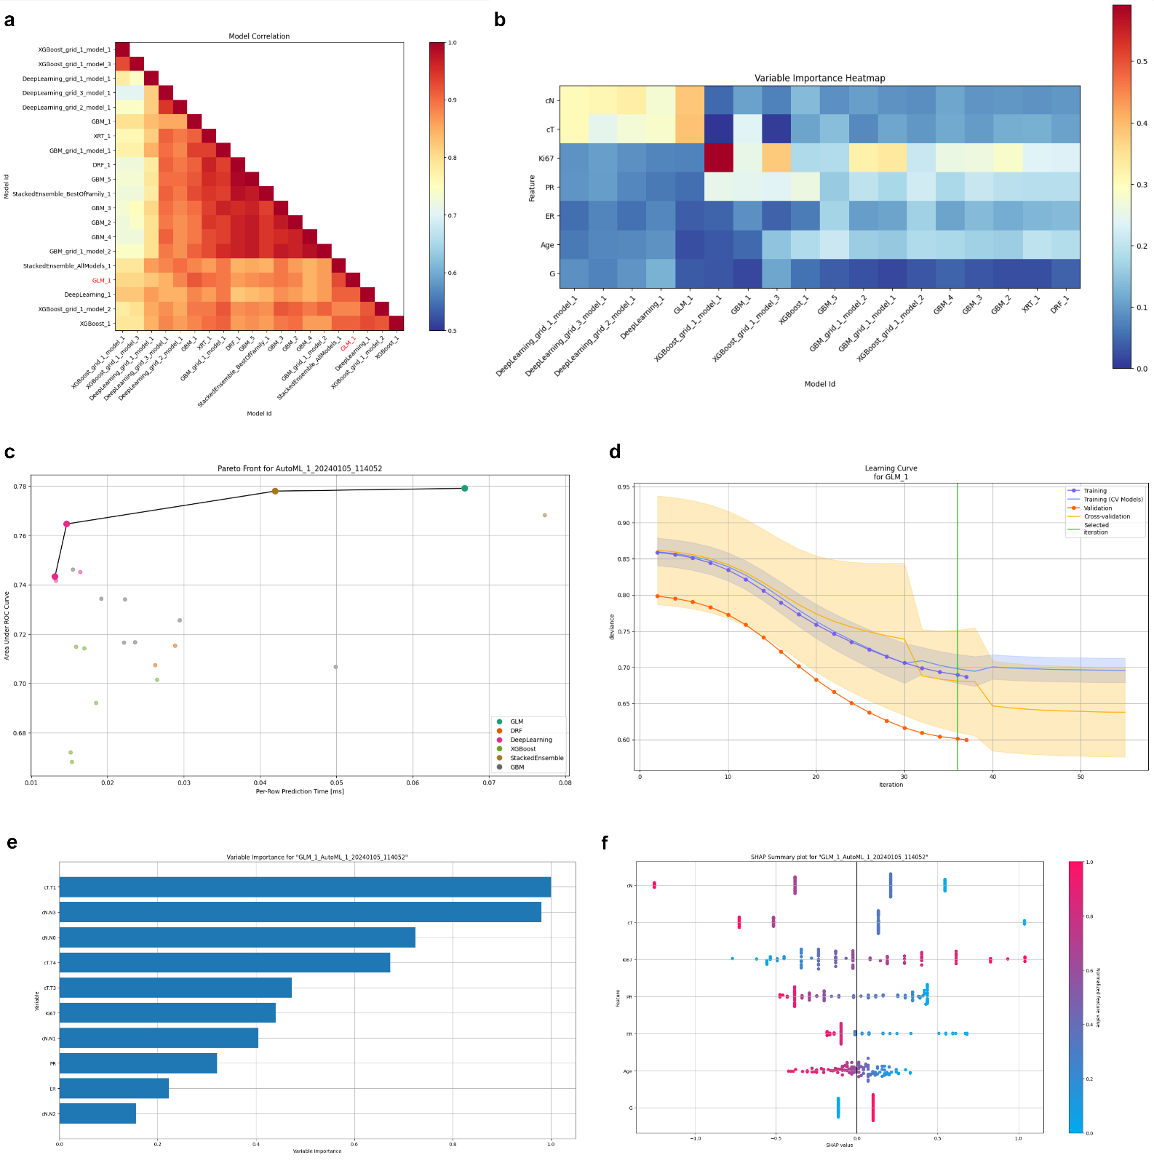

Supplementary Fig. S3| Model comparison for the framework using different models, one-hot-encoding and only the 7 selected features.
- Model correlation heatmap.
- Variable importance heatmap.
- Pareto chart.
- Learning curve for the best model (GLM).
- Variable importance for the best model (GLM).
- SHAP value for the best model (GLM).

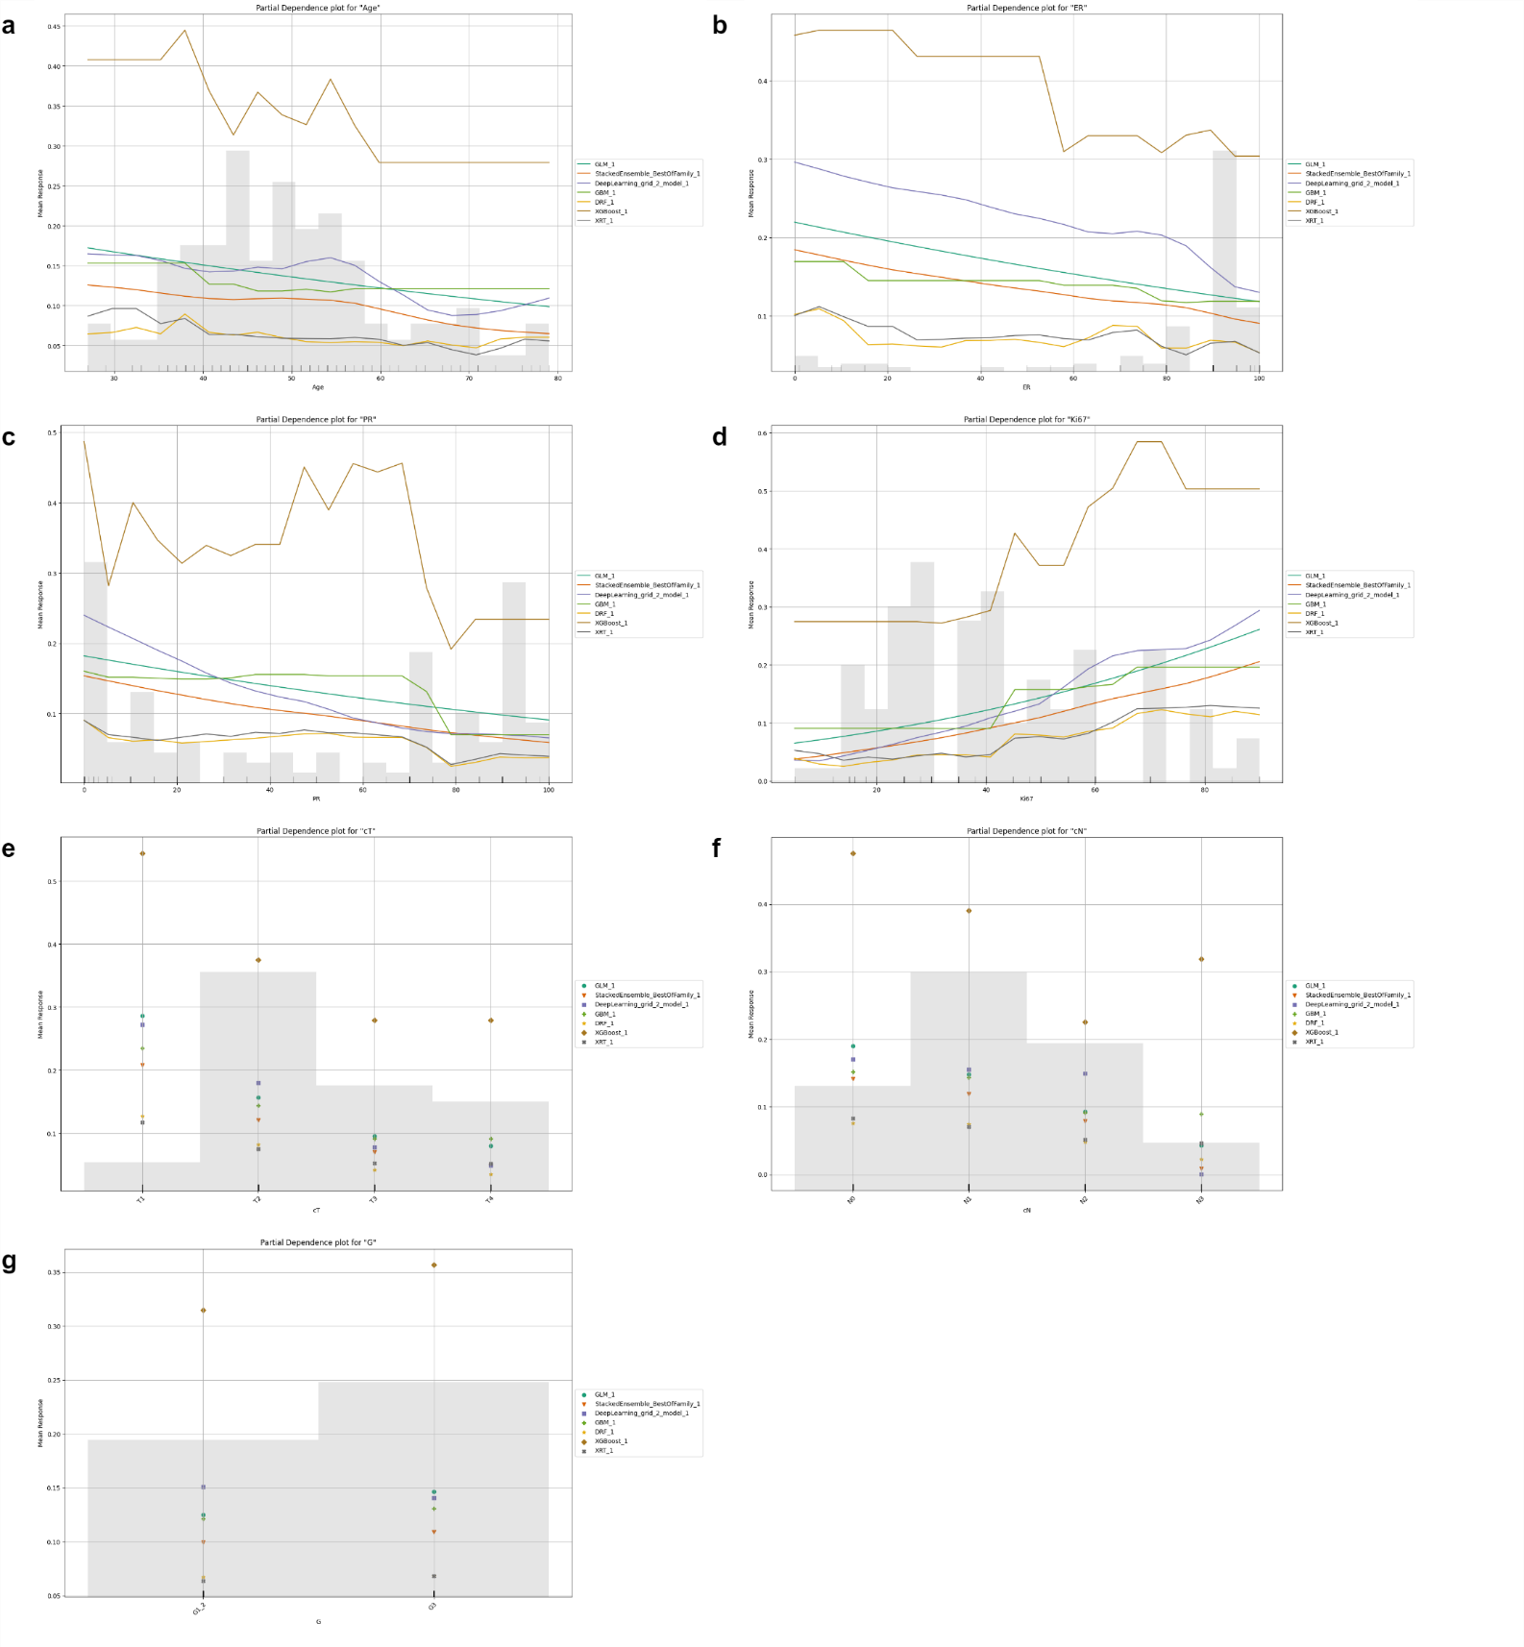

Supplementary Fig. S4| Partial dependence plot for the framework using different models, one-hot-encoding and only the 7 features.
a-g. From left to right and from upper to lower: Age, ER, PR, Ki67, cT, cN and G.

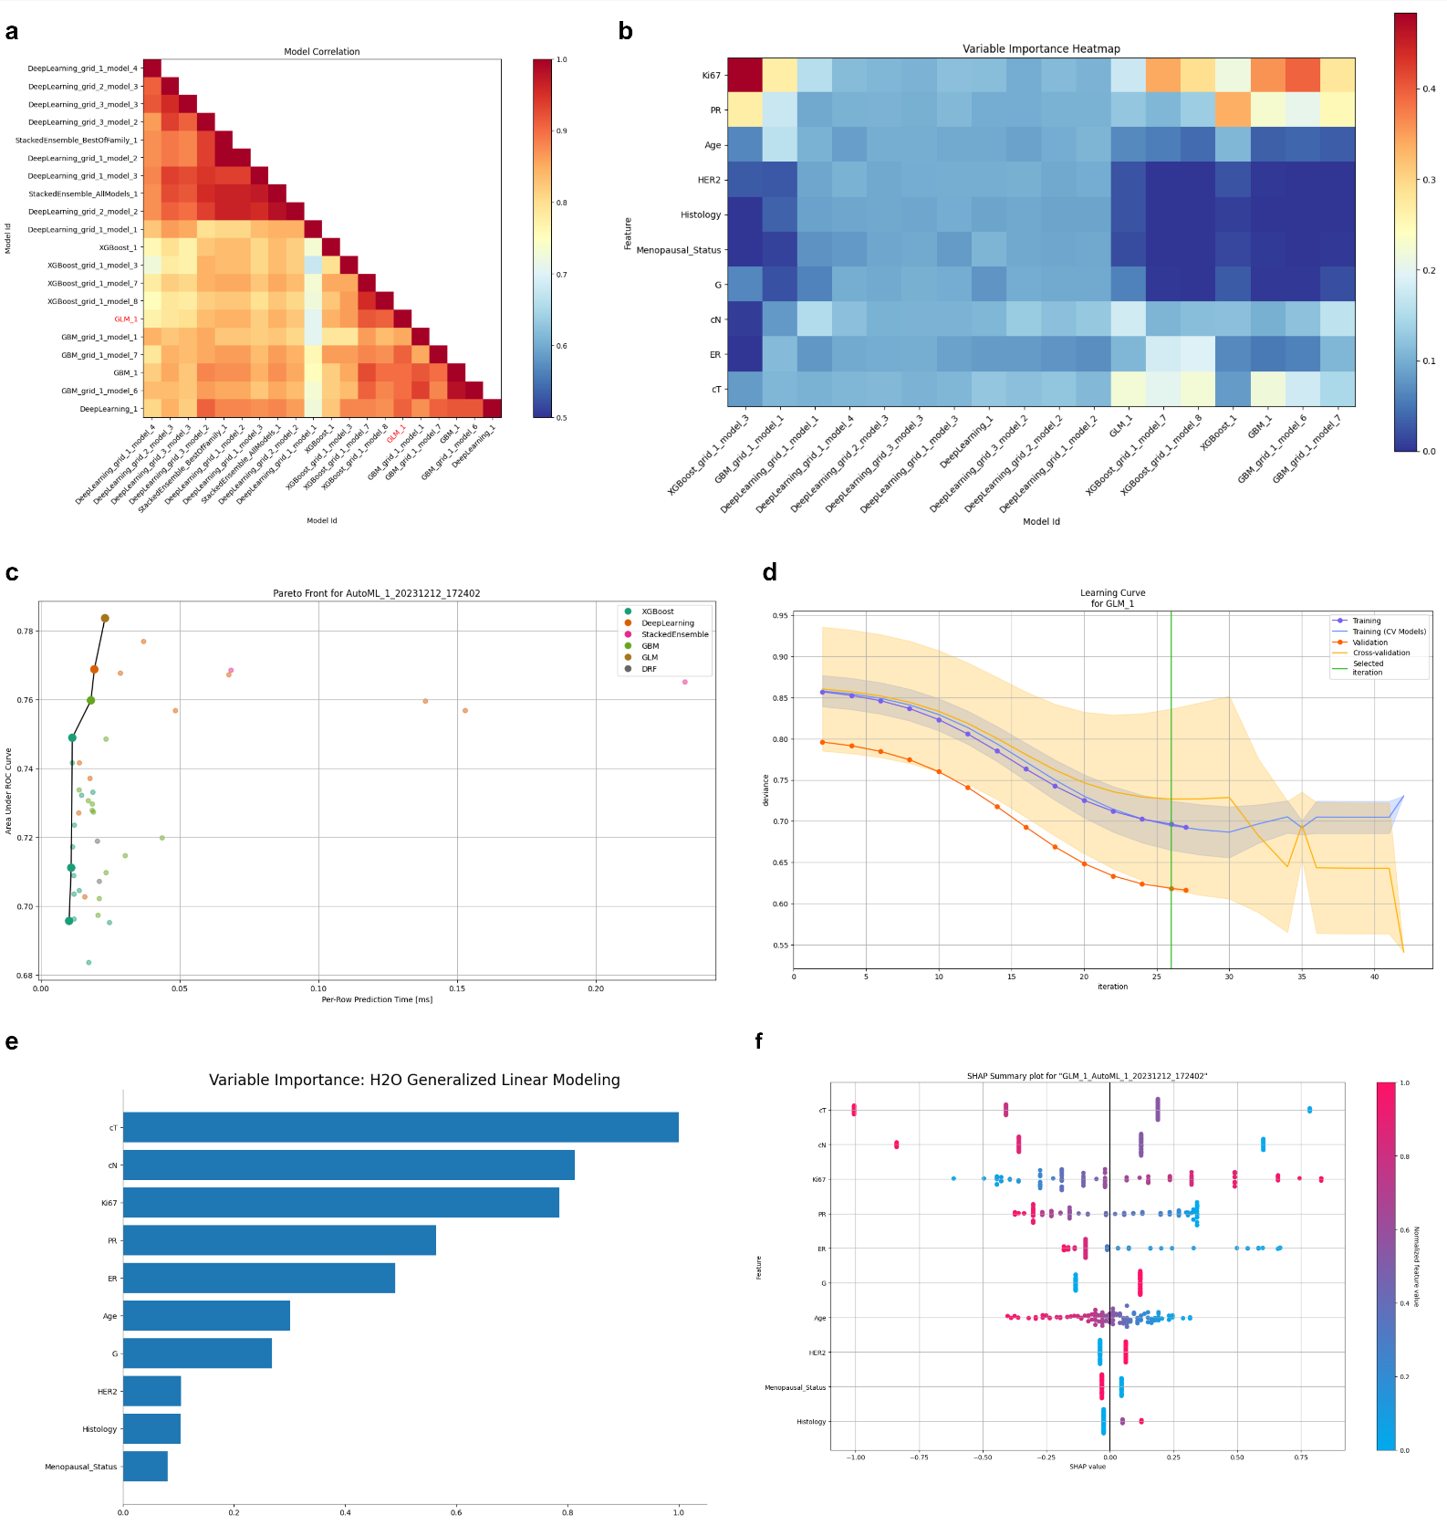

Supplementary Fig. S5| Partial dependence plot for the framework using different models, ordinal encoding and all features.
- Model correlation heatmap.
- Variable importance heatmap.
- Pareto chart.
- Learning curve for the best model (GLM).
- Variable importance for the best model (GLM).

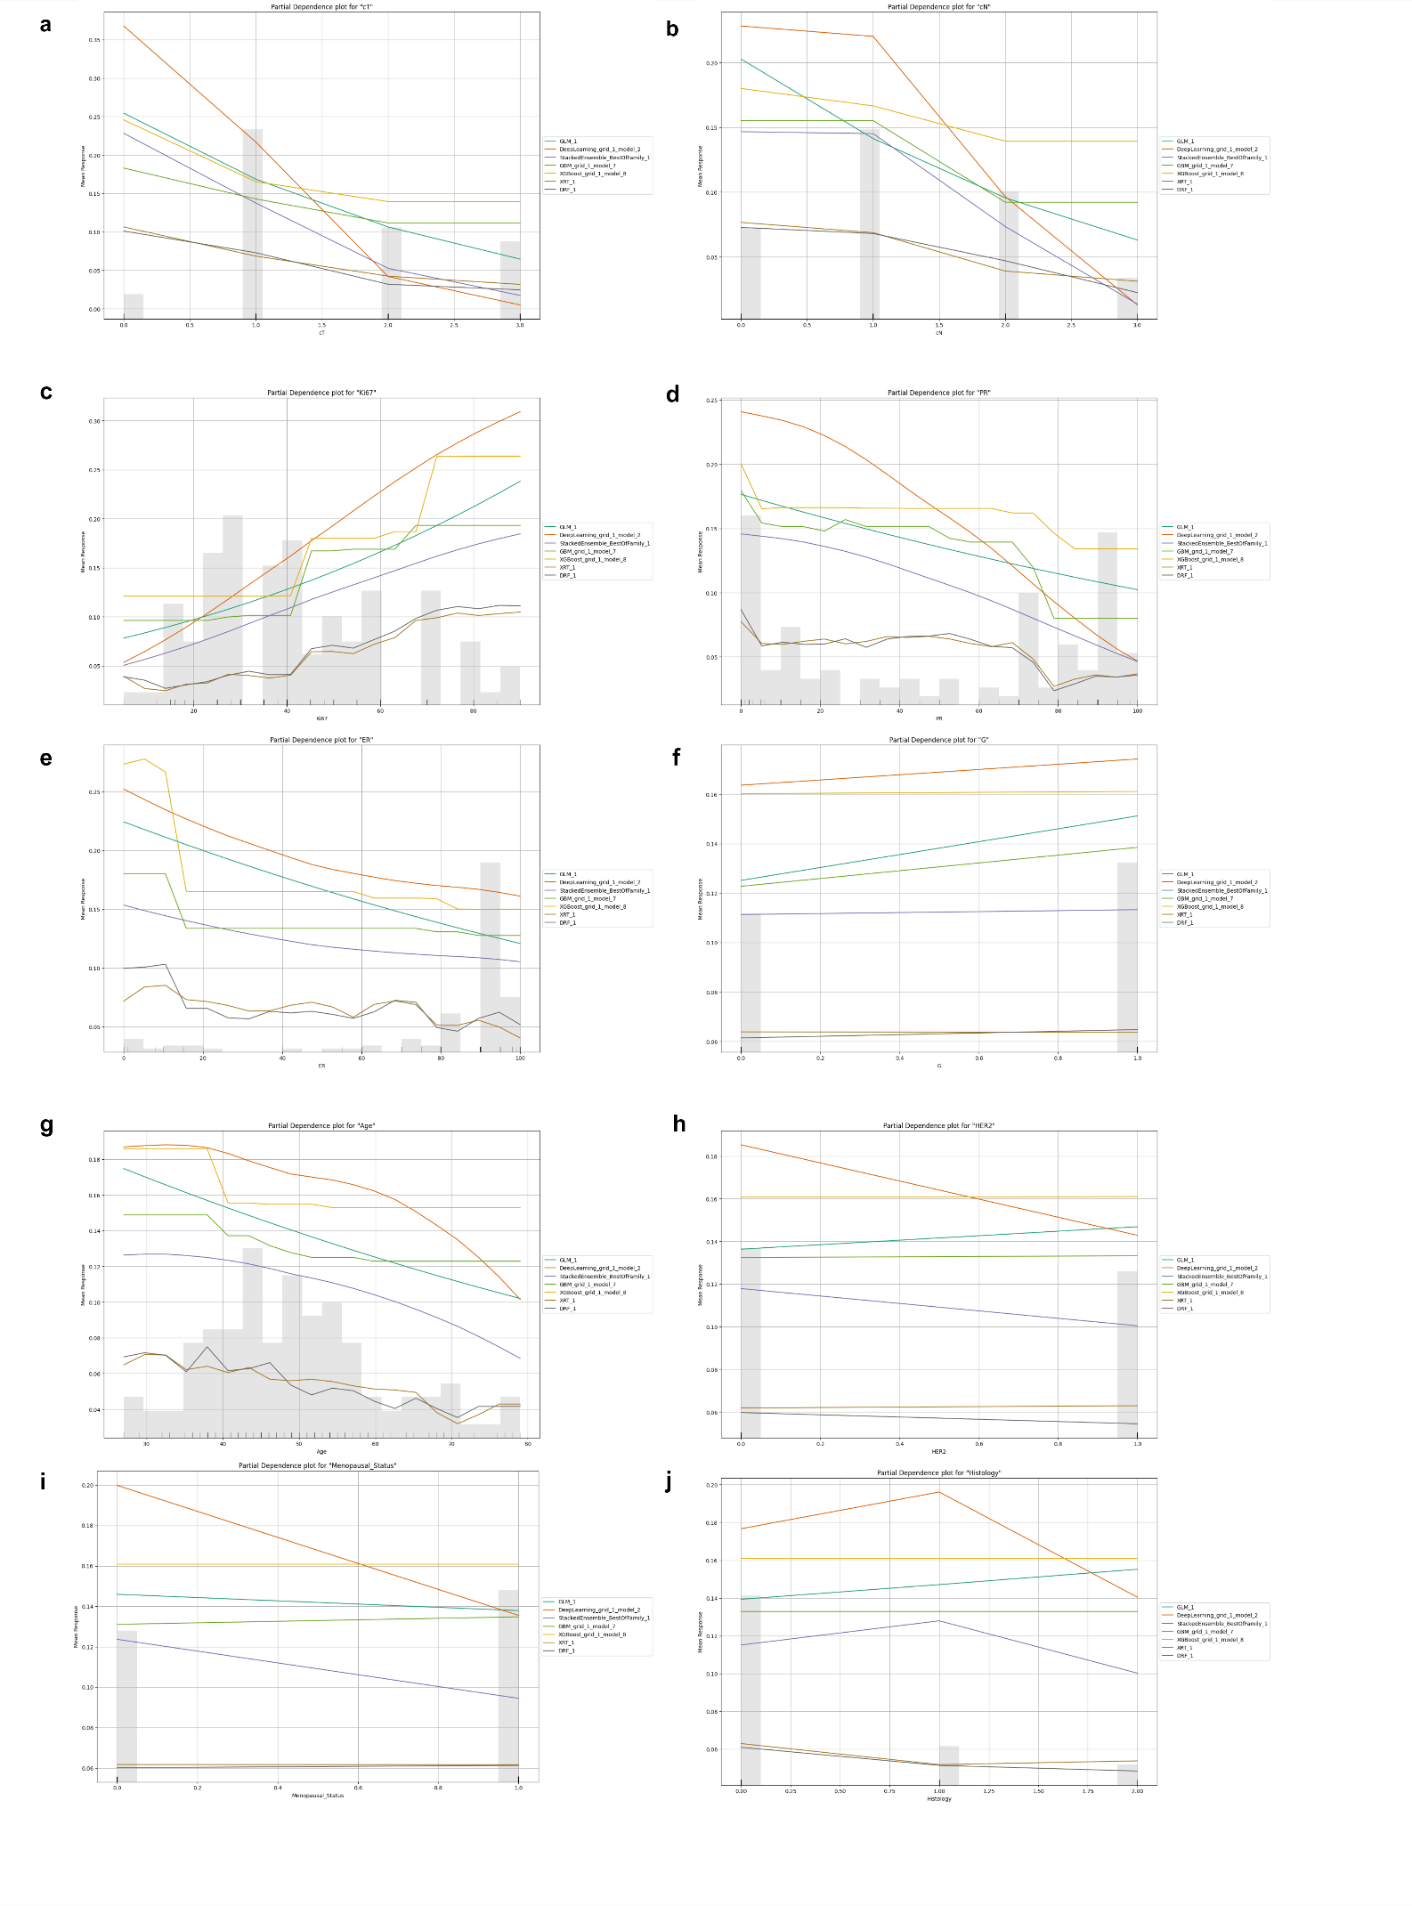

Supplementary Fig. S6| Partial dependence plot comparison for different algorithms according to each feature.
The framework using ordinal encoding and different ML models including all features was considered.
a-j. PDP for different variables in order of their SHAP value. From left to right and from upper to lower: cT, cN, Ki67, PR, ER, G, Age, HER2, Menopausal Status and Histology.
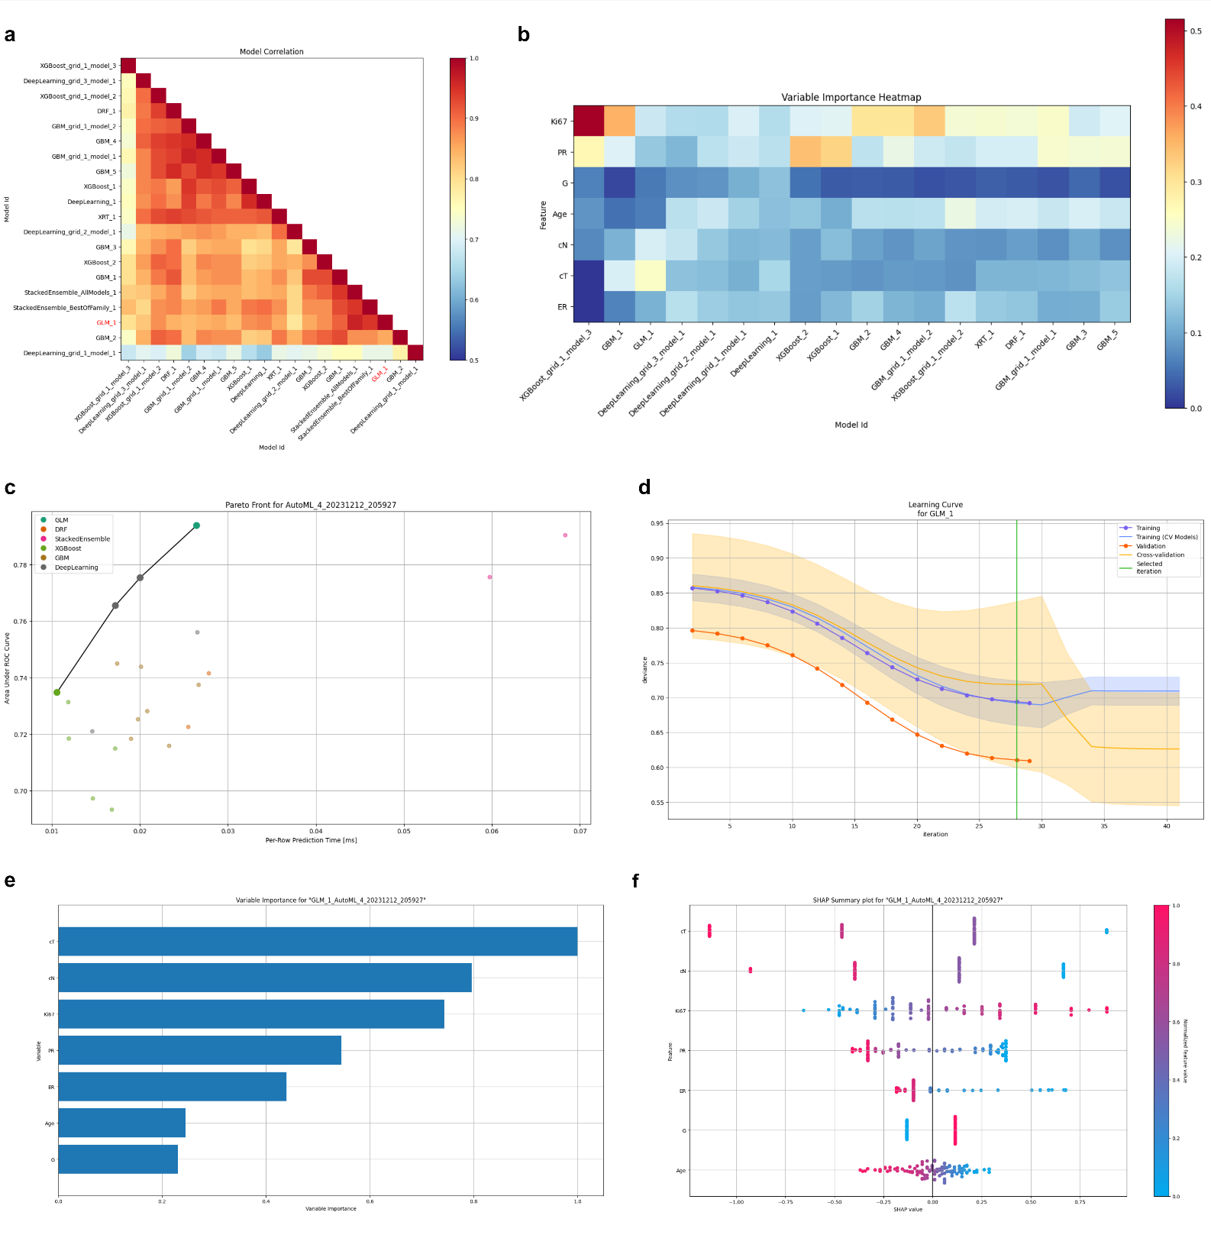

Supplementary Fig. S7| model comparison for the framework using different models, ordinal encoding and only the 7 selected features.
- Model correlation heatmap.
- Variable importance heatmap.
- Pareto chart.
- Learning curve for the best model (GLM).
- Variable importance for the best model (GLM).
- SHAP value for the best model (GLM).

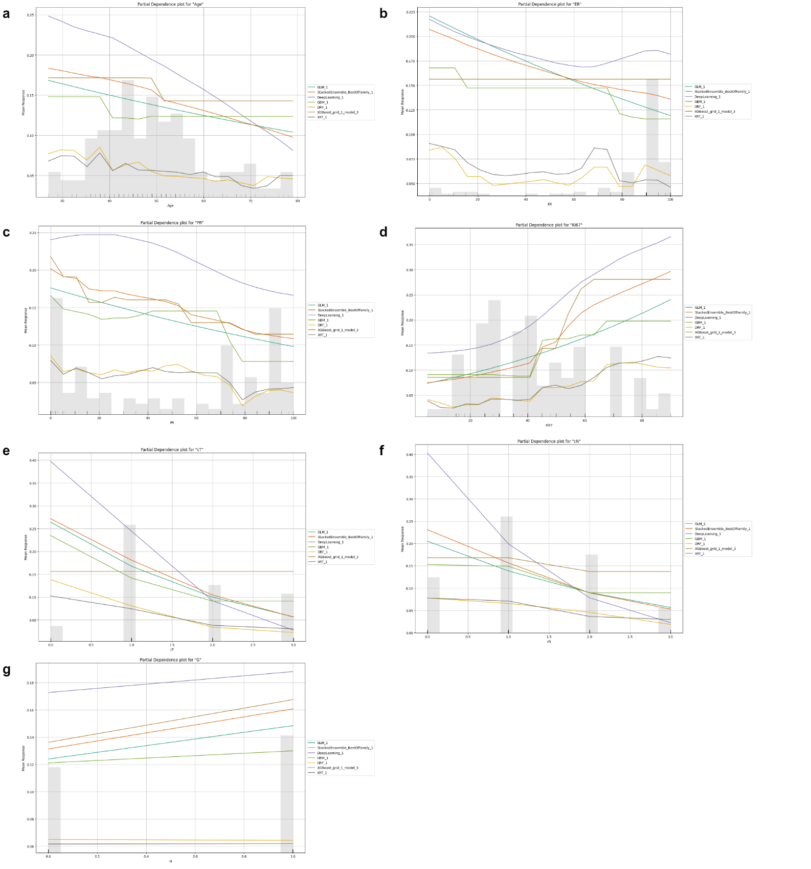

Supplementary Fig. S8| Partial dependence plot for the framework using different models, ordinal encoding and only the 7 selected features.
a-g. From left to right and from upper to lower: Age, ER, PR, Ki67, cT, cN and G.

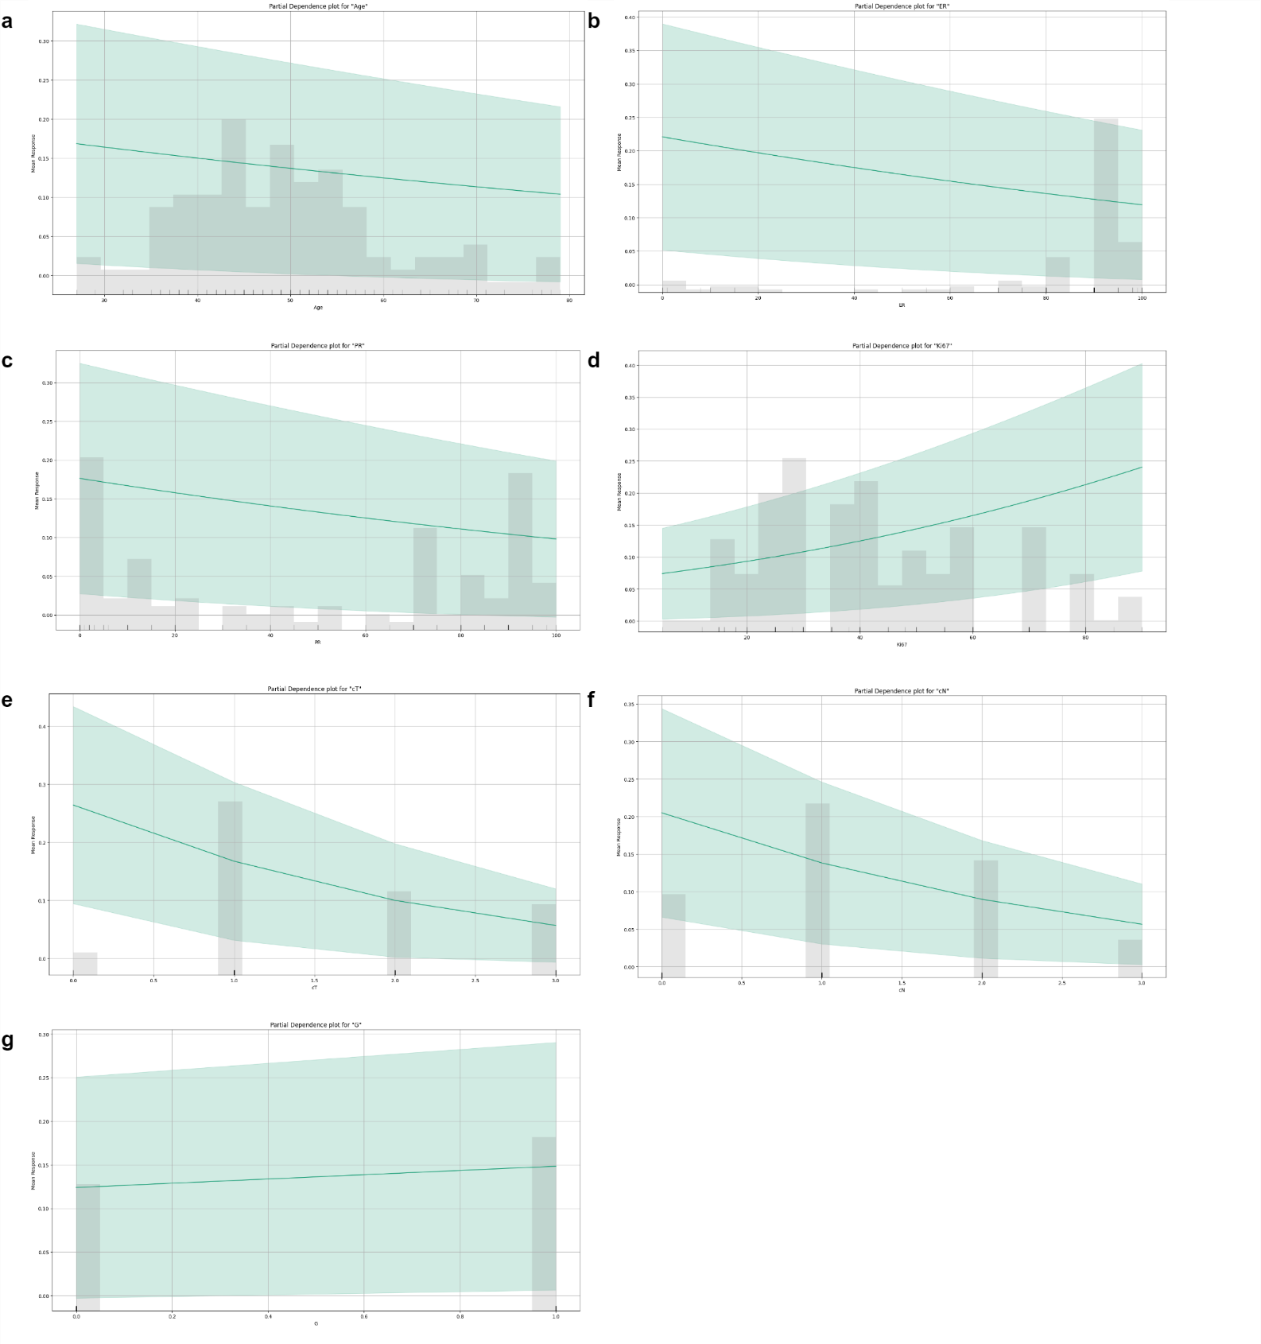

Supplementary Fig. S9| Partial dependence plot for the best model (GLM) of the framework using different models, ordinal encoding and only the 7 selected features.
a-g. From left to right and from upper to lower: Age, ER, PR, Ki67, cT, cN and G.

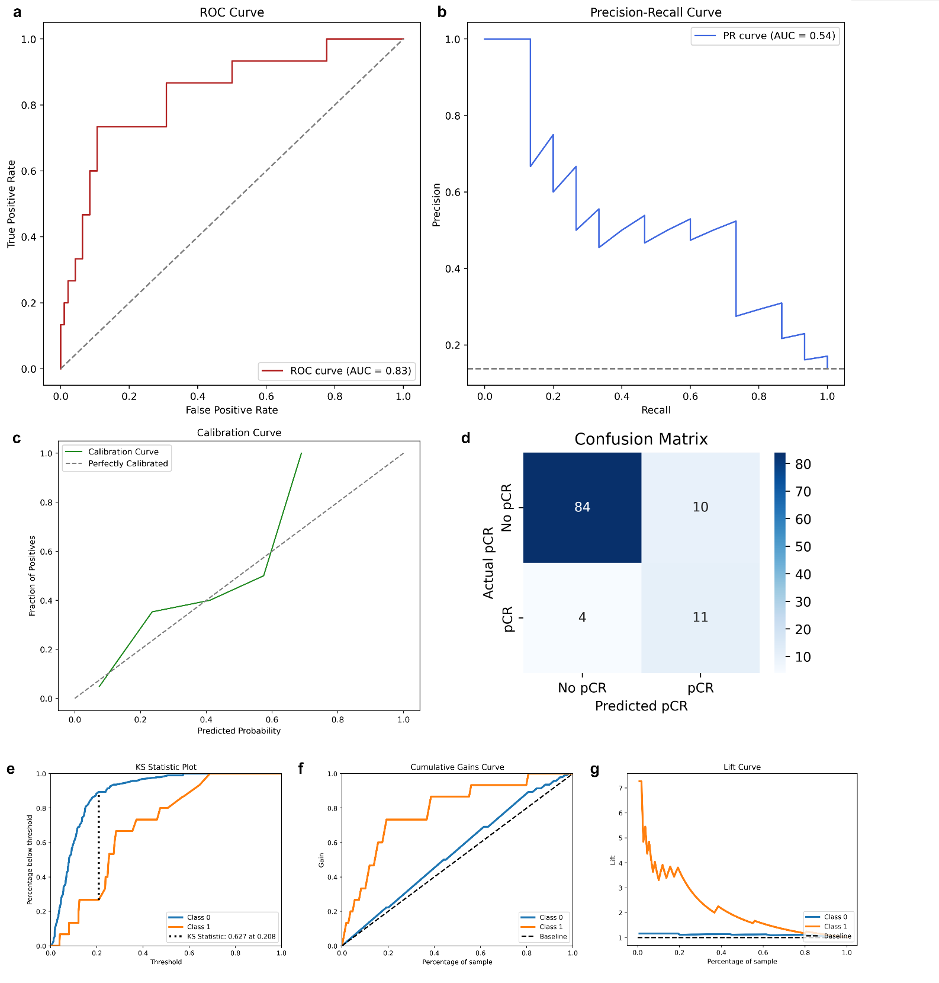

Supplementary Fig. S10| Performance of the best model (GLM) of the framework using different models, ordinal encoding and only the 7 selected features (AML1).
- ROC curve.
- Precision-Recall Curve.
- Calibration Curve.
- Confusion Matrix (Max F1).
- Kolmogorov-Smirnov plot.
- Cumulative gains curve.
- Lift curve.

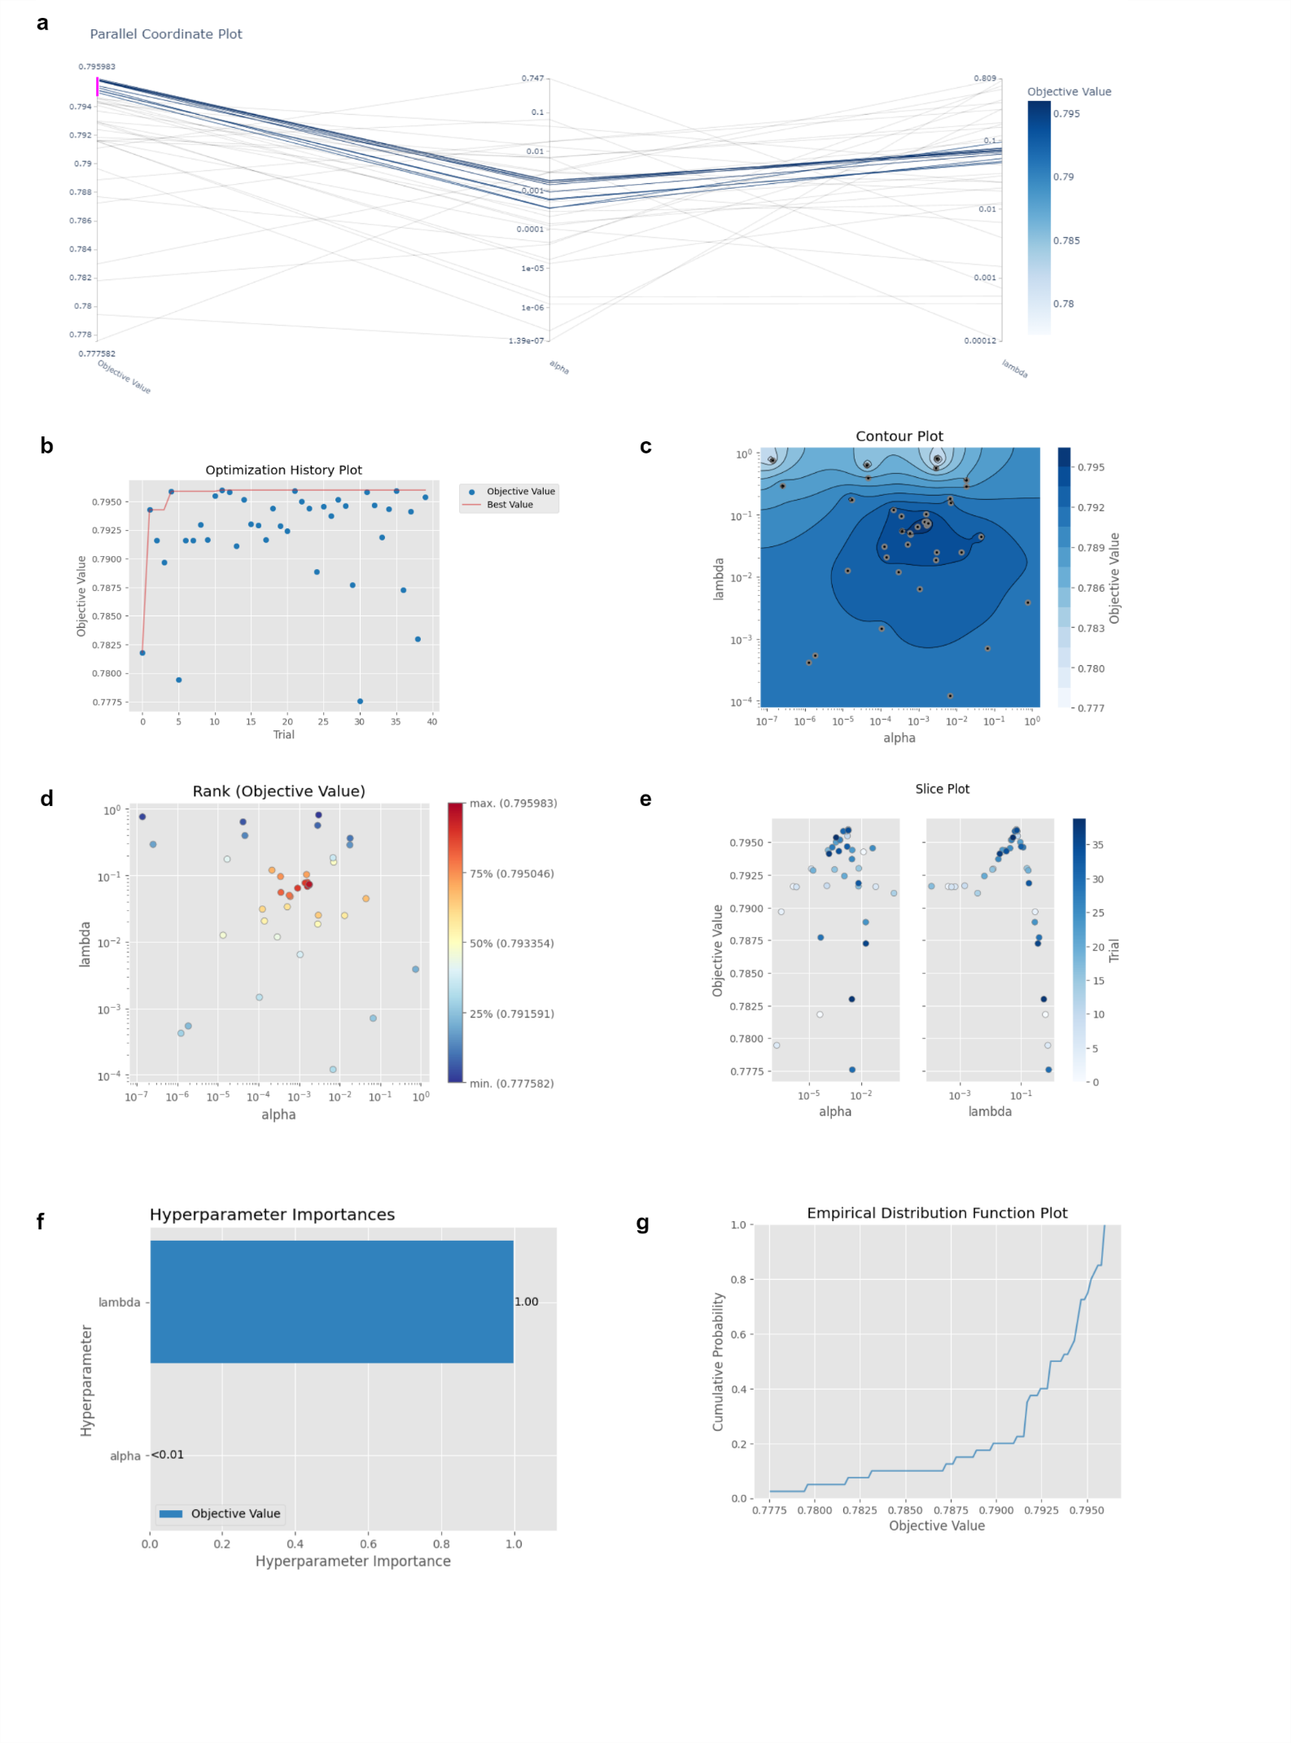

Supplementary Fig. S11| Hyperparameters optimization for the best GLM model (AML2).
- Parallel coordinates plot.
- Optimization history plot.
- Contour plot.
- Rank plot.
- Slice plot.
- Hyperparameter importance.
- Empirical distribution function plot.
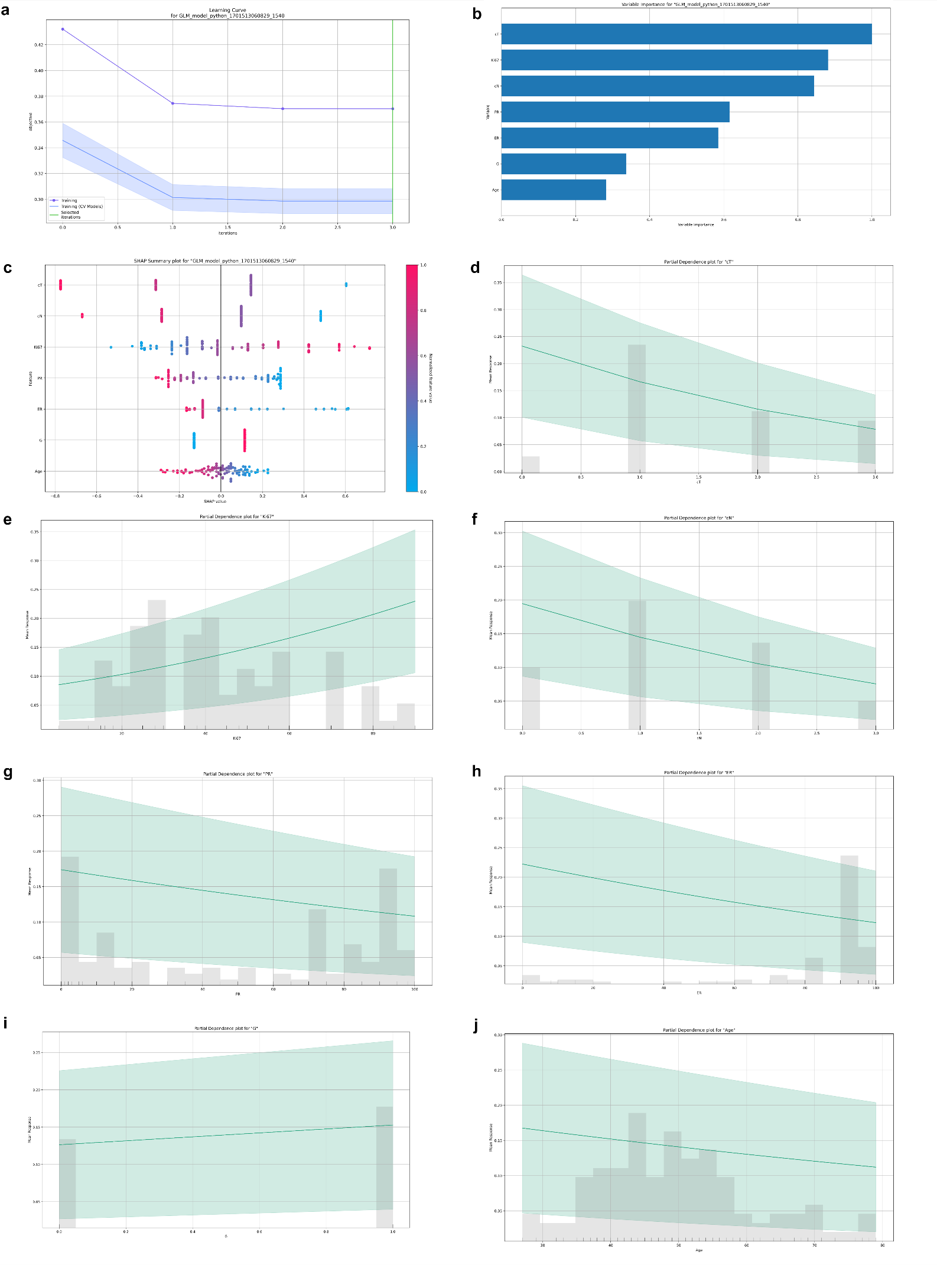

Supplementary Fig. S12| Learning curve, variable importance and partial dependence plot for the best GLM model (AML2).
a. Learning curve. b. Variable importance. c-i. From left to right and from upper to lower: Age, ER, PR, Ki67, cT, cN and G.
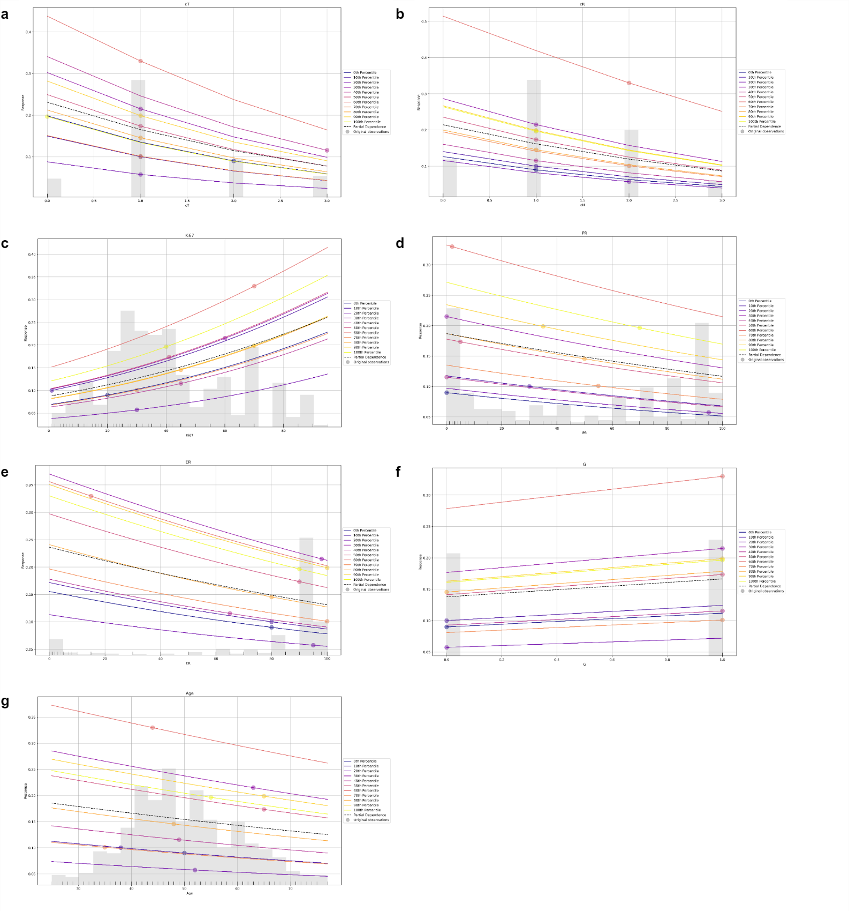

Supplementary Fig. S13| Individual conditional expectations plot for the best GLM model (AML2).
a-g. From left to right and from upper to lower: Age, ER, PR, Ki67, cT, cN and G.

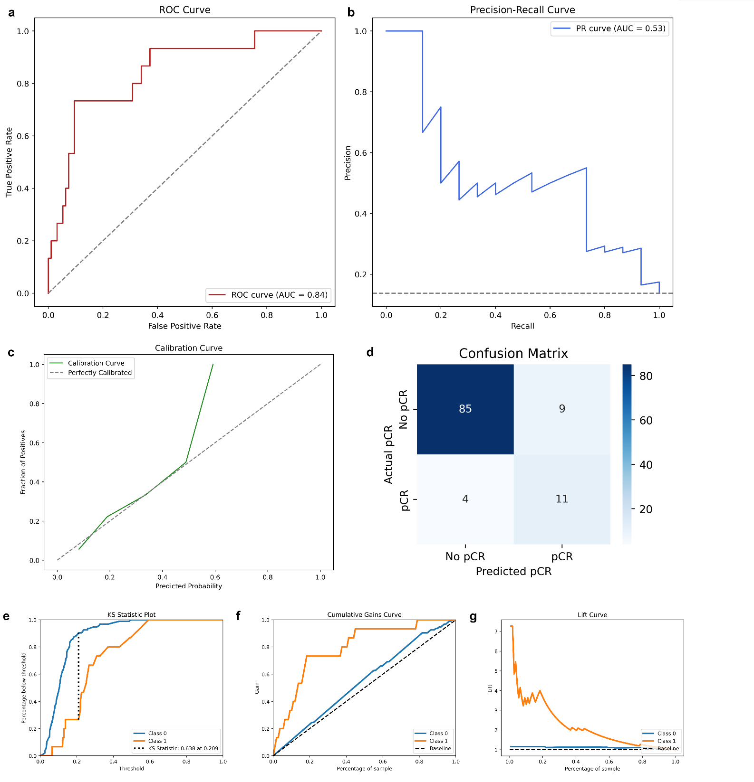

Supplementary Fig. S14| Performance of the best GLM model (AML2).
- ROC curve.
- Precision-Recall Curve.
- Calibration Curve.
- Confusion Matrix (Max F1).
- Kolmogorov-Smirnov plot.
- Cumulative gains curve.
- Lift curve.

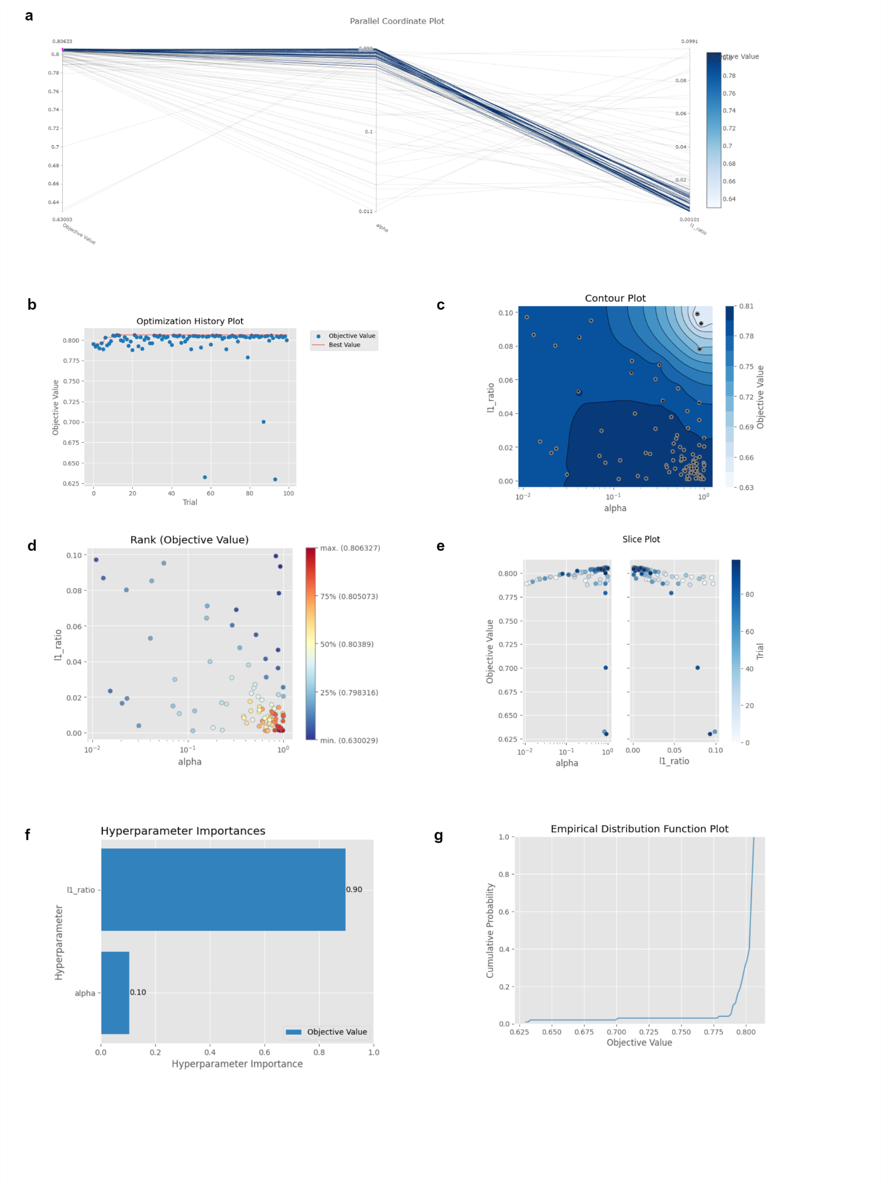

Supplementary Fig. S15| Hyperparameters optimization for the best GLM model trained with SGD (SGD Elastic Net).
- Parallel coordinates plot.
- Optimization history plot.
- Contour plot.
- Rank plot.
- Slice plot.
- Hyperparameter importance.
- Empirical distribution function plot.
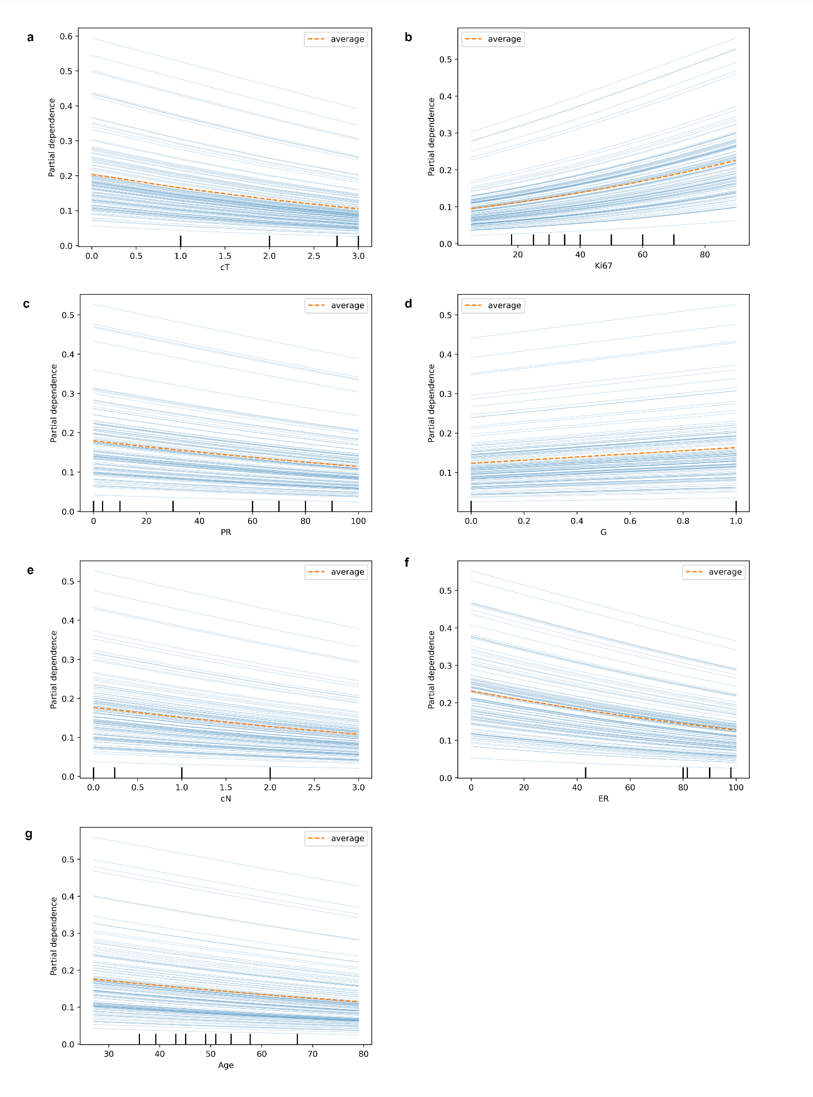

Supplementary Fig. S16| Partial dependence plots comparison for the SGD Elastic Net model.
The framework using ordinal encoding and SGD Elastic Net including the 7 selected features was considered. Ordinal encoding for categorical features was applied in alphabetical order with the following mapping. a-g.PDP for different variables in order of their SHAP value. From left to right and from upper to lower: cT, Ki67, PR, G, cN, ER and Age.
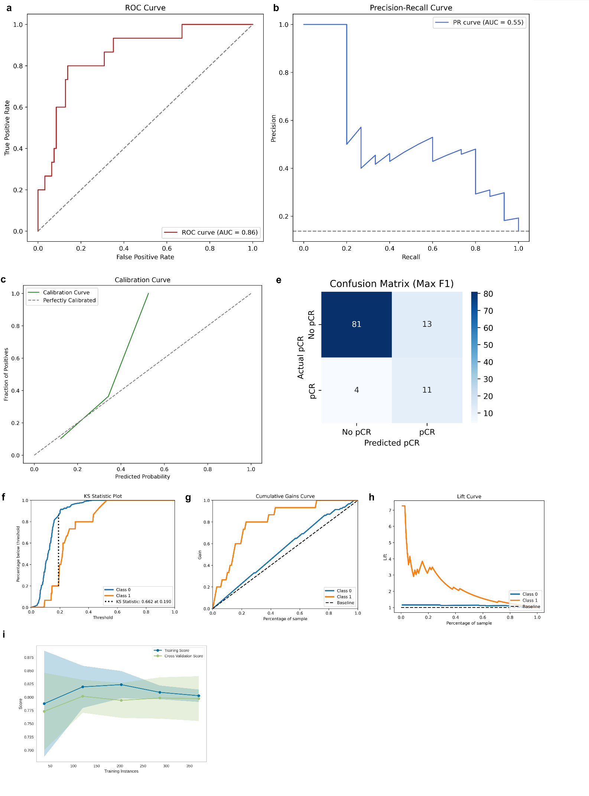

Supplementary Fig. S17| Performance of the best GLM model trained with SGD (SGD Elastic Net).
- ROC curve.
- Precision-Recall Curve.
- Calibration curve. The model showed a fair calibration between 0.1 and 0.4, but systematically tended to underestimate pCR probabilities after 0.4.
- Confusion Matrix.
- Kolmogorov-Smirnov plot.
- Cumulative gains curve.
- Lift curve.
- Model learning curve. Training and calibration curves are reported. While the training error seems to continue decreasing, the cross-validation error reached a plateau, confirming the number of instances on which the model was trained was enough.

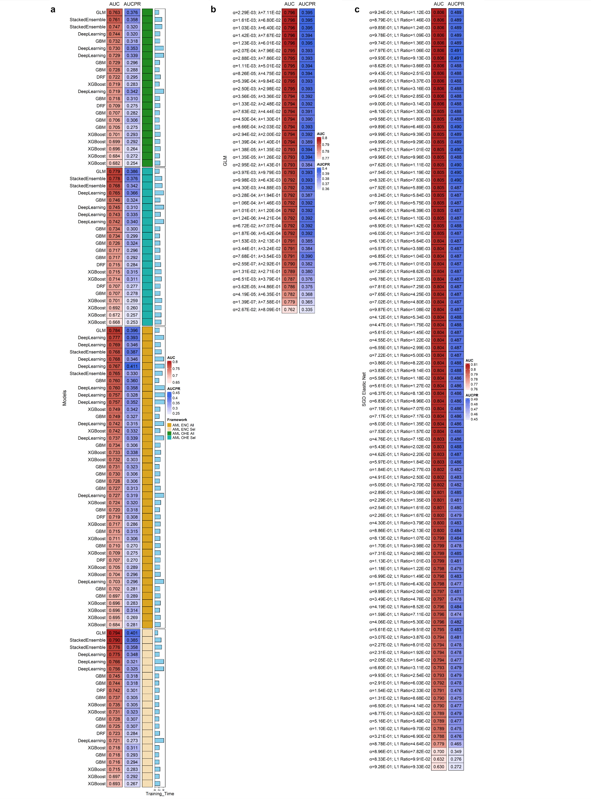

Supplementary Fig. S18| Model performance comparison.
All models were compared using 5-fold cross-validation, storing the AUROC and the AUC-PR for each set of hyperparameters tested.
- H2O AutoML algorithms. From upper to lower: OHE with all features, OHE with the 7 selected features, ordinal encoding with all features and ordinal encoding with the 7 selected features. The training time is expressed as base 10 logarithm of the total training time.
- H2O GLM algorithms with respective alphas and lambdas.
- SGD Elastic Net with Platt’s calibration. Since the calibration step was included in the pipeline for the optimization process, the train set was further splitted in a test dataset and a calibration dataset. Therefore, this model was indeed trained on less patients compared to the others model, without a loss in performance

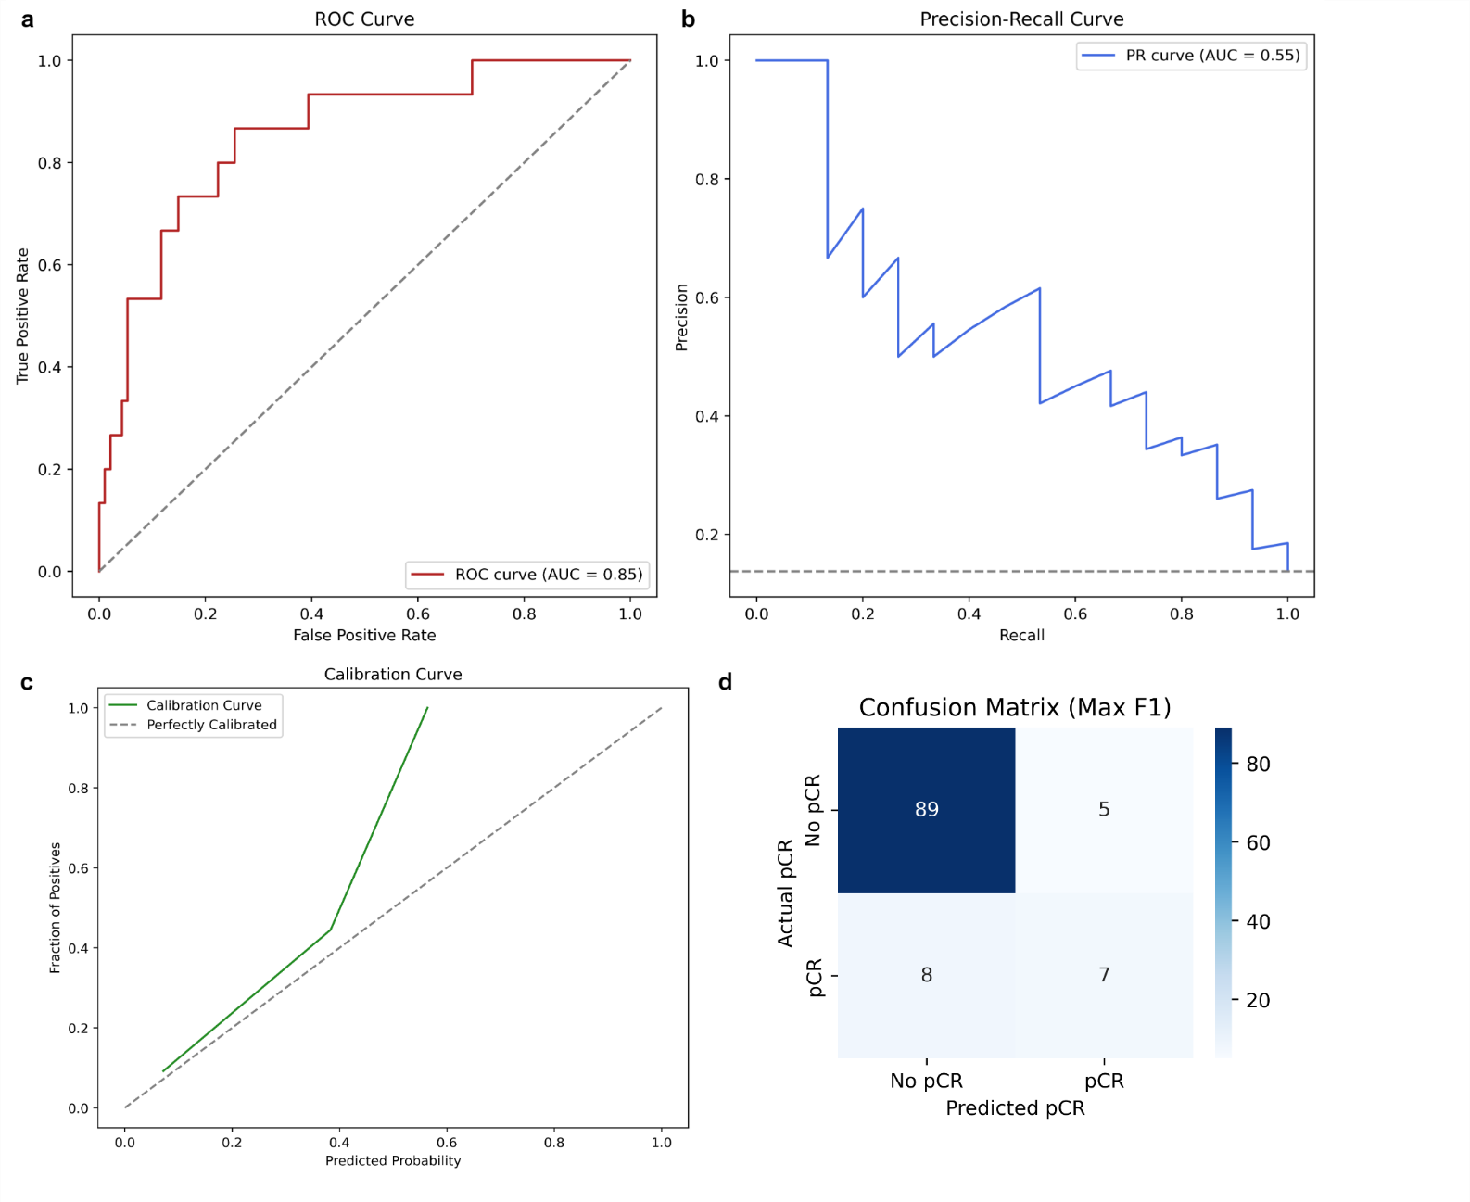

Supplementary Fig. S19| Performance of the TabPFN with one-hot encoding.
- ROC curve.
- Precision-Recall Curve.
- Calibration Curve.
- Confusion Matrix (Max F1).

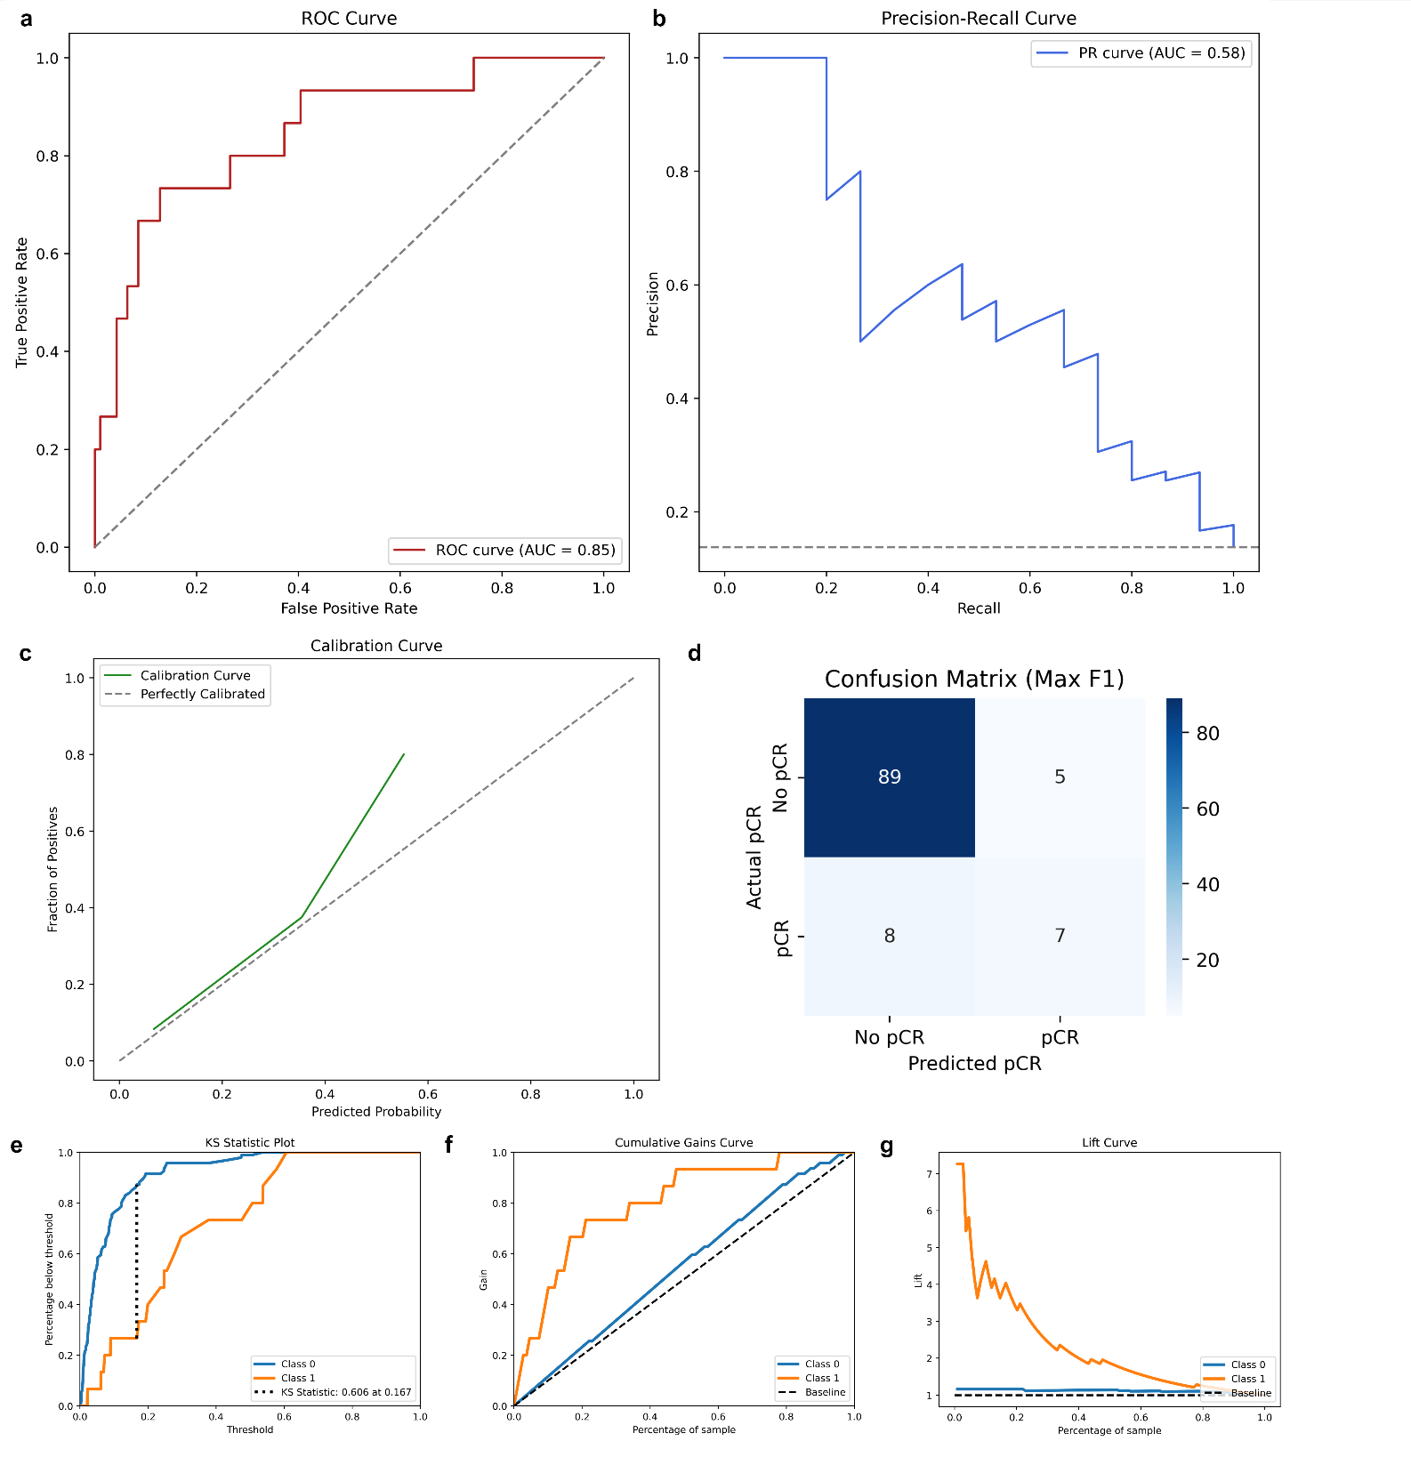

Supplementary Fig. S20| Performance of the TabPFN model with ordinal encoding.
- ROC curve.
- Precision-Recall Curve.
- Calibration Curve.
- Confusion Matrix (Max F1).
- Kolmogorov-Smirnov plot.
- Cumulative gains curve.
- Lift curve.

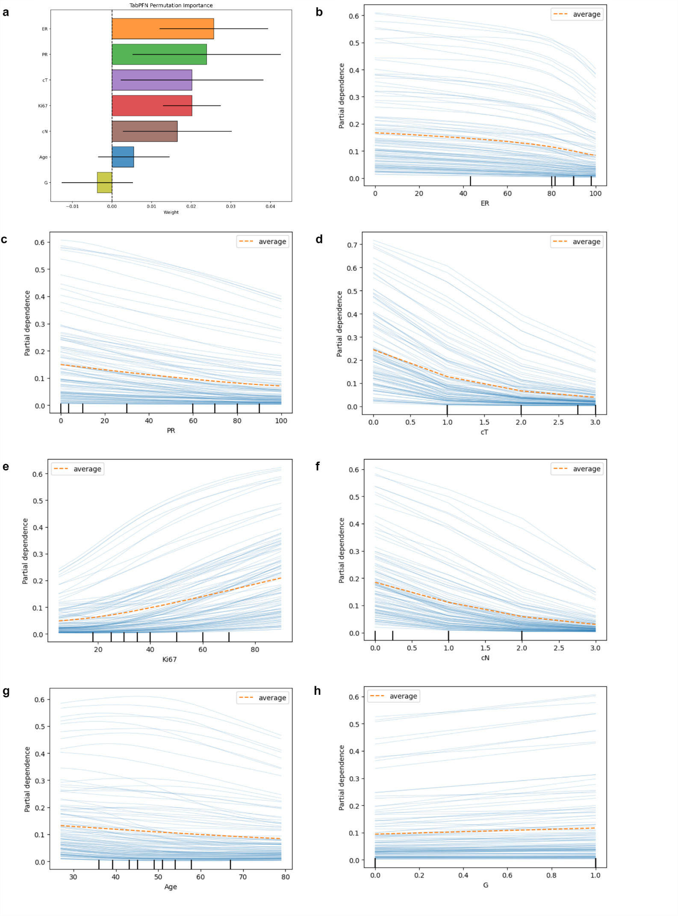

Supplementary Fig. S21| Permutation importance and partial dependence plot for the TabPFN model with ordinal encoding.
a. Permutation importance. b-h. From left to right and from upper to lower: ER, PR, cT, Ki67, cN Age and G.
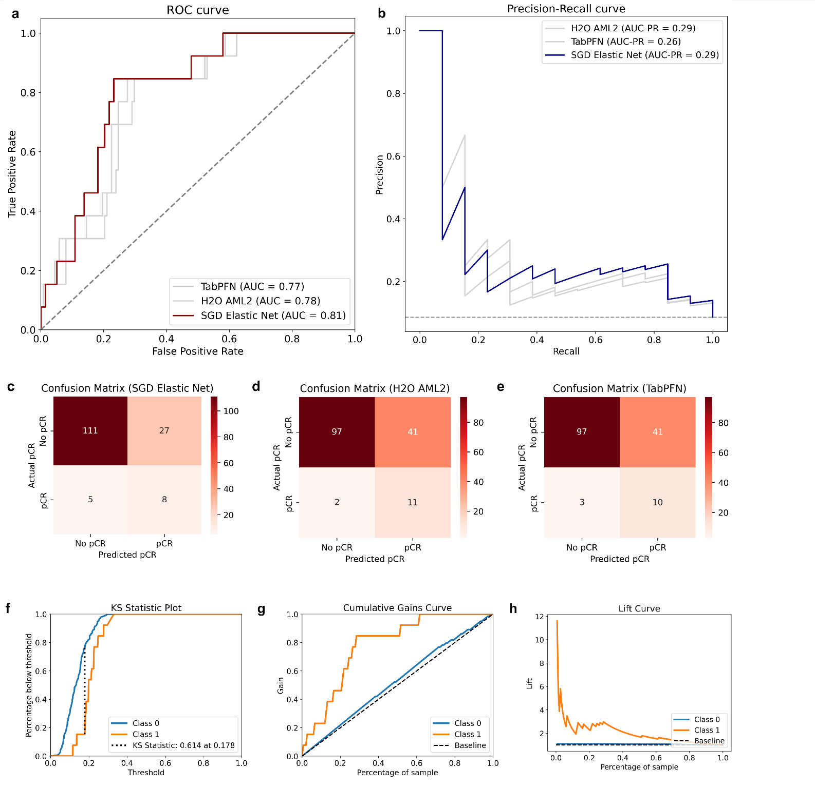

Supplementary Fig. S22| Performance of the best models in the external validation dataset.
The external validation dataset was used only to validate the performance of the best model (SGD Elastic Net), which was selection on the internal validation set. Therefore, the following comparisons on the external validation set should be considerate exploratory. The three best models are reported: H2O AML2, SGD Elastic Net and TabPFN.
- ROC curve.
- Precision-Recall Curve.
- Confusion Matrix (Max F1) for SGD Elastic Net.
- Confusion Matrix (Max F1) for H2O AML2.
- Confusion Matrix (Max F1) for TabPFN.
- Kolmogorov-Smirnov plot for the SGD Elastic Net model.
- Cumulative gains curve for the SGD Elastic Net model.
- Lift curve for the SGD Elastic Net model.

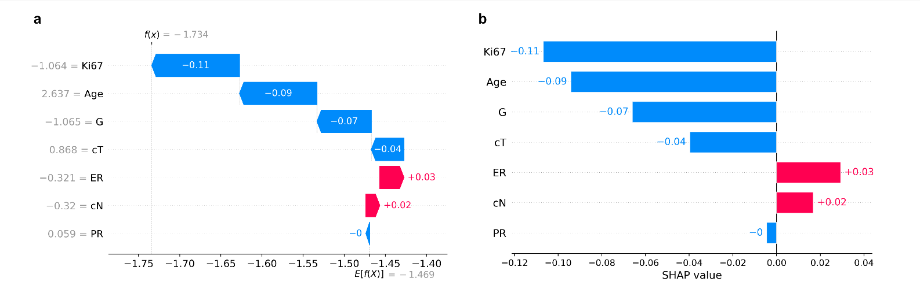

Supplementary Fig. S23| Patient levels predictions of the SGD Elastic Net model.
- Waterfall plot of SHAP predictions for patient #1 in the internal validation dataset. Patient’s characteristics were: Premenopausal, Age 77, cT3, cN1, Histology Ductal, G1 or 2, ER 70, PR 50, Ki67 18. The final prediction of the model was pCR No with f(x) = -1.743, which was actually correct.
- SHAP barplot for patient #1 in the internal validation dataset. For each feature, the corresponding SHAP value is reported.
- The force plot is available as an interactive html file at link: https://github.com/LucaMastrantoni/CORALAINE/tree/main/SHAP
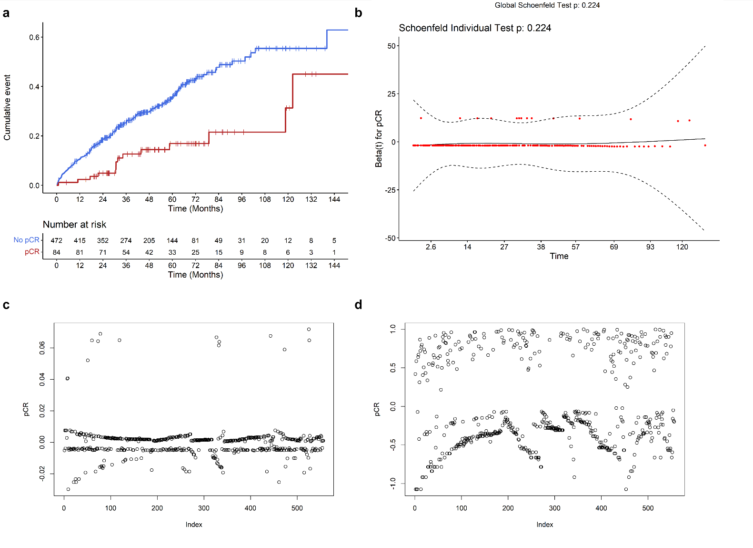

Supplementary Fig. S24| Diagnostics for the association between pCR and disease-free survival in the whole internal cohort and in the internal validation cohort.
- KM curve for cumulative DFS events according to pCR status in the whole internal cohort.
- Schoenfeld plot and test according to pCR status in the whole internal cohort.
- Beta residual according to pCR status in the whole internal cohort.
- Martingale residuals according to pCR status in the whole internal cohort.

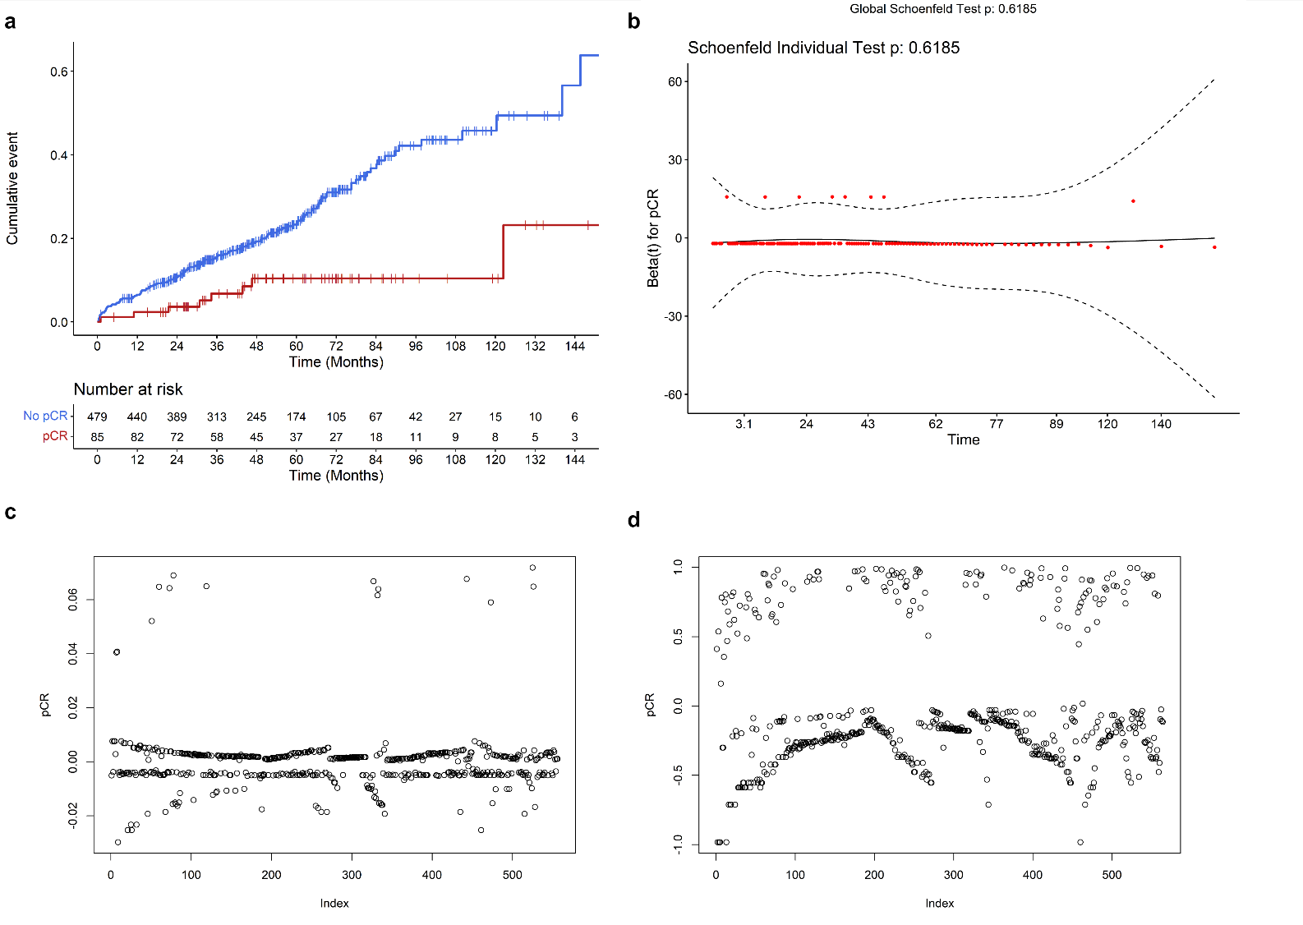

Supplementary Fig. S25| Diagnostics for the association between pCR and overall survival in the whole internal cohort and in the internal validation cohort.
- KM curve for cumulative DFS events according to pCR status in the whole internal cohort.
- Schoenfeld plot and test according to pCR status in the whole internal cohort.
- Beta residual according to pCR status in the whole internal cohort.
- Martingale residuals according to pCR status in the whole internal cohort.

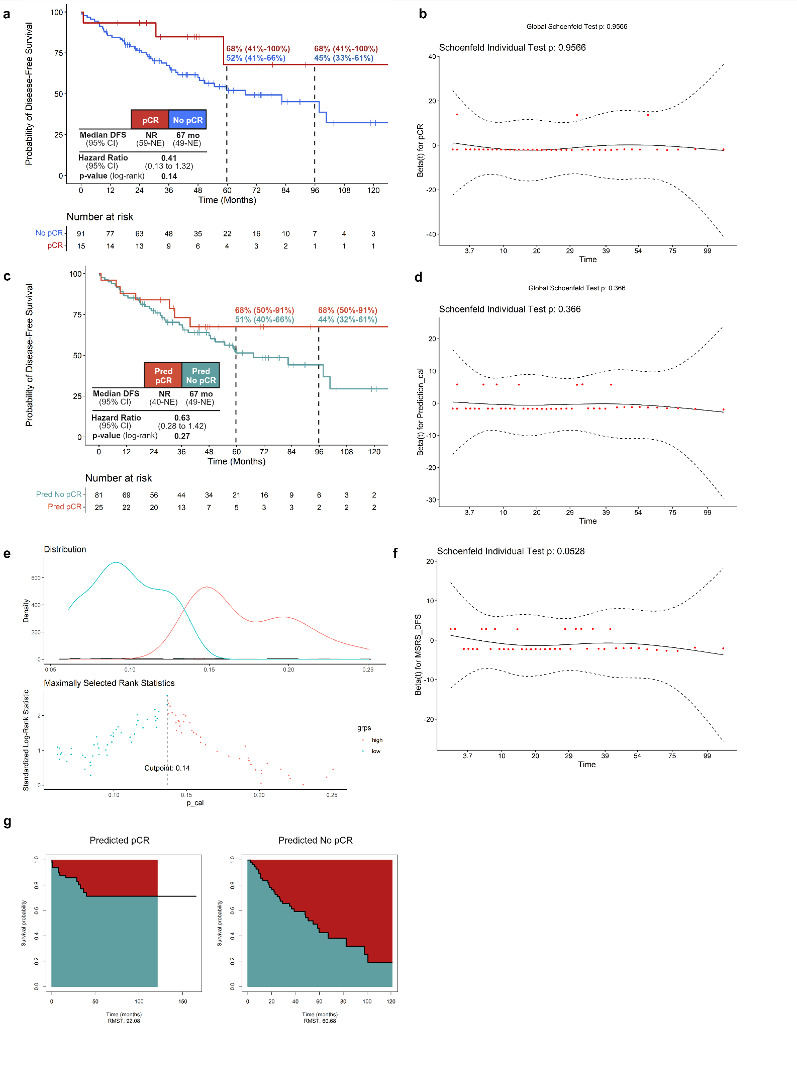

Supplementary Fig. S26| Association between pCR and disease-free survival in the internal validation cohort.
- Kaplan-Meier curves of DFS according to pCR in the internal validation cohort (log-rank test: p=0.14).
- Schoenfeld plot and test according to pCR status in the internal validation cohort.
- Kaplan-Meier curves of DFS according to pCR prediction in the internal validation cohort. Predictions were based on the maximum threshold for F1 score (log-rank test: p=0.27).
- Schoenfeld plot and test according to pCR prediction in the internal validation cohort (F1 score).
- Maximally selected rank statistics (MSRS) analysis. MSRS was conducted to identify the best pCR probability to maximize log-rank DFS differences between predicted pCR and predicted no-pCR patients in the internal validation cohort. The cut-off was 0.14.
- Schoenfeld residuals and test for proportional hazards assumption. The test is referred to pCR prediction based on MSRS cut-off and DFS. A violation of proportional hazard was graphically suspected and confirmed with the test.
- Exploratory analysis restricted mean survival (RMST). A significant difference in mean DFS between predicted pCR and predicted no-pCR patients was reported.

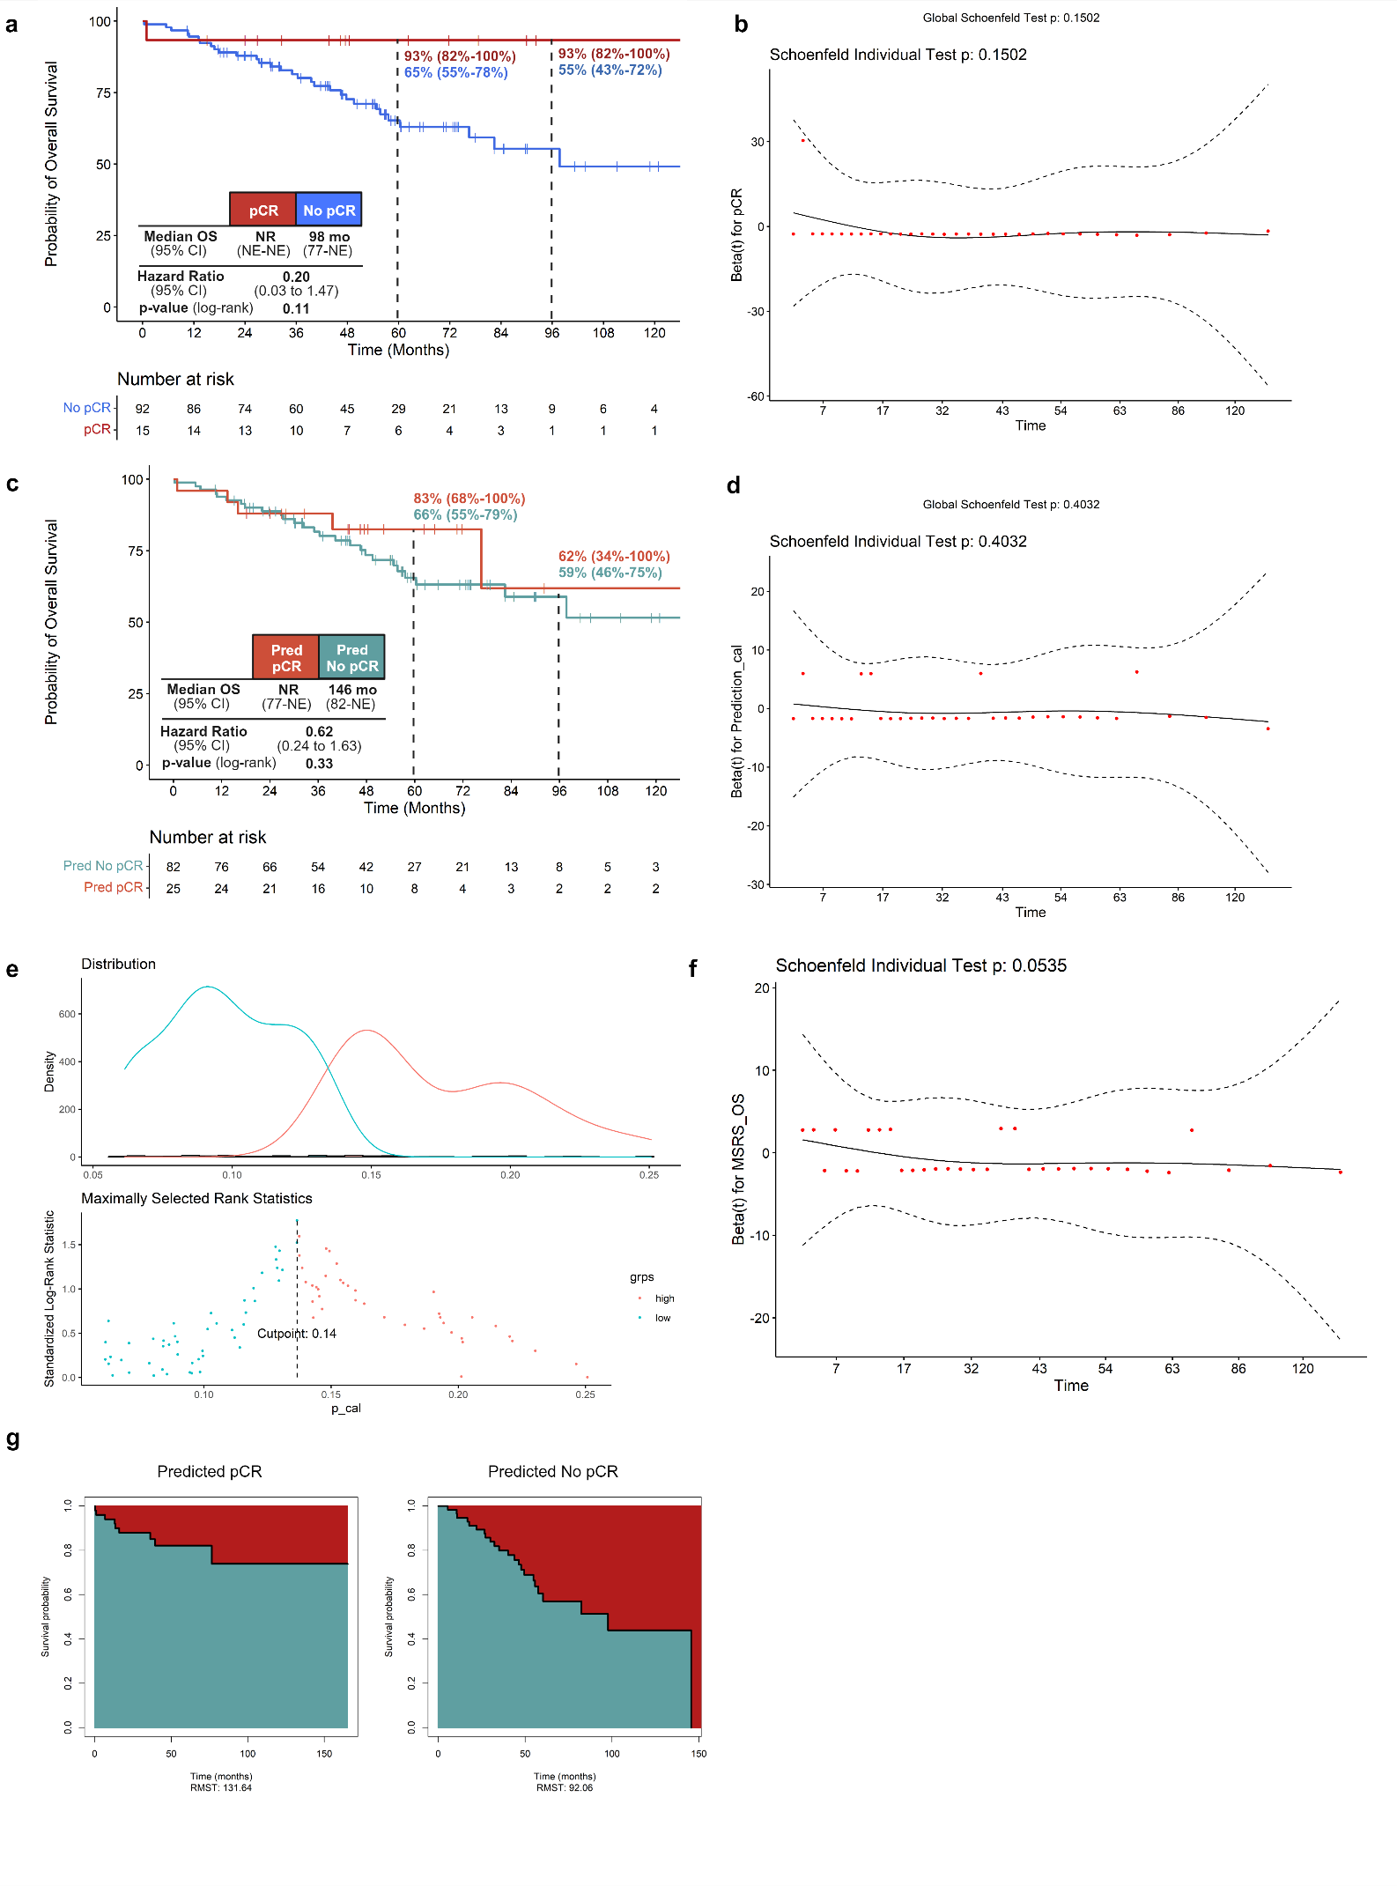

Supplementary Fig. S27| Association between pCR and overall survival in the internal validation cohort.
- Kaplan-Meier curves of OS according to pCR in the internal validation cohort (log-rank test: p=0.11).
- Schoenfeld plot and test according to pCR status in the internal validation cohort.
- Kaplan-Meier curves of OS according to pCR prediction in the internal validation cohort). Predictions were based on the maximum threshold for F1 score (log-rank test: p=0.27).
- Schoenfeld plot and test according to pCR prediction in the internal validation cohort (F1 score).
- Maximally selected rank statistics (MSRS) analysis. MSRS was conducted to identify the best pCR probability to maximize log-rank OS differences between predicted pCR and predicted no-pCR patients in the internal validation cohort. The cut-off was 0.14.
- Schoenfeld residuals and test for proportional hazards assumption. The test is referred to pCR prediction based on MSRS cut-off and OS. A violation of proportional hazard was graphically suspected and confirmed with the test.
- Exploratory analysis restricted mean survival (RMST). A significant difference in mean OS between predicted pCR and predicted no-pCR patients was reported.

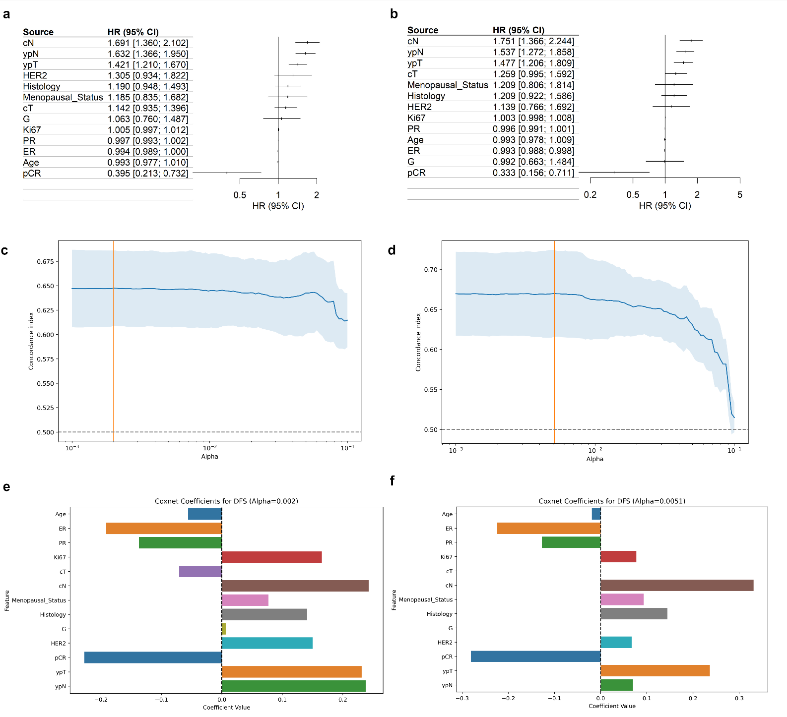

Supplementary Fig. S28| Feature selection for disease-free survival and overall survival.
- Univariate Cox Regression for DFS.
- Univariate Cox Regression for OS
- Selection of the best alpha corresponding to the maximum Harrell C in LASSO COX regression for DFS.
- Selection of the best alpha corresponding to the maximum Harrell C in LASSO COX regression for OS.
- COX LASSO Regression coefficients for the best alpha for DFS.
- COX LASSO Regression coefficients for the best alpha for OS.

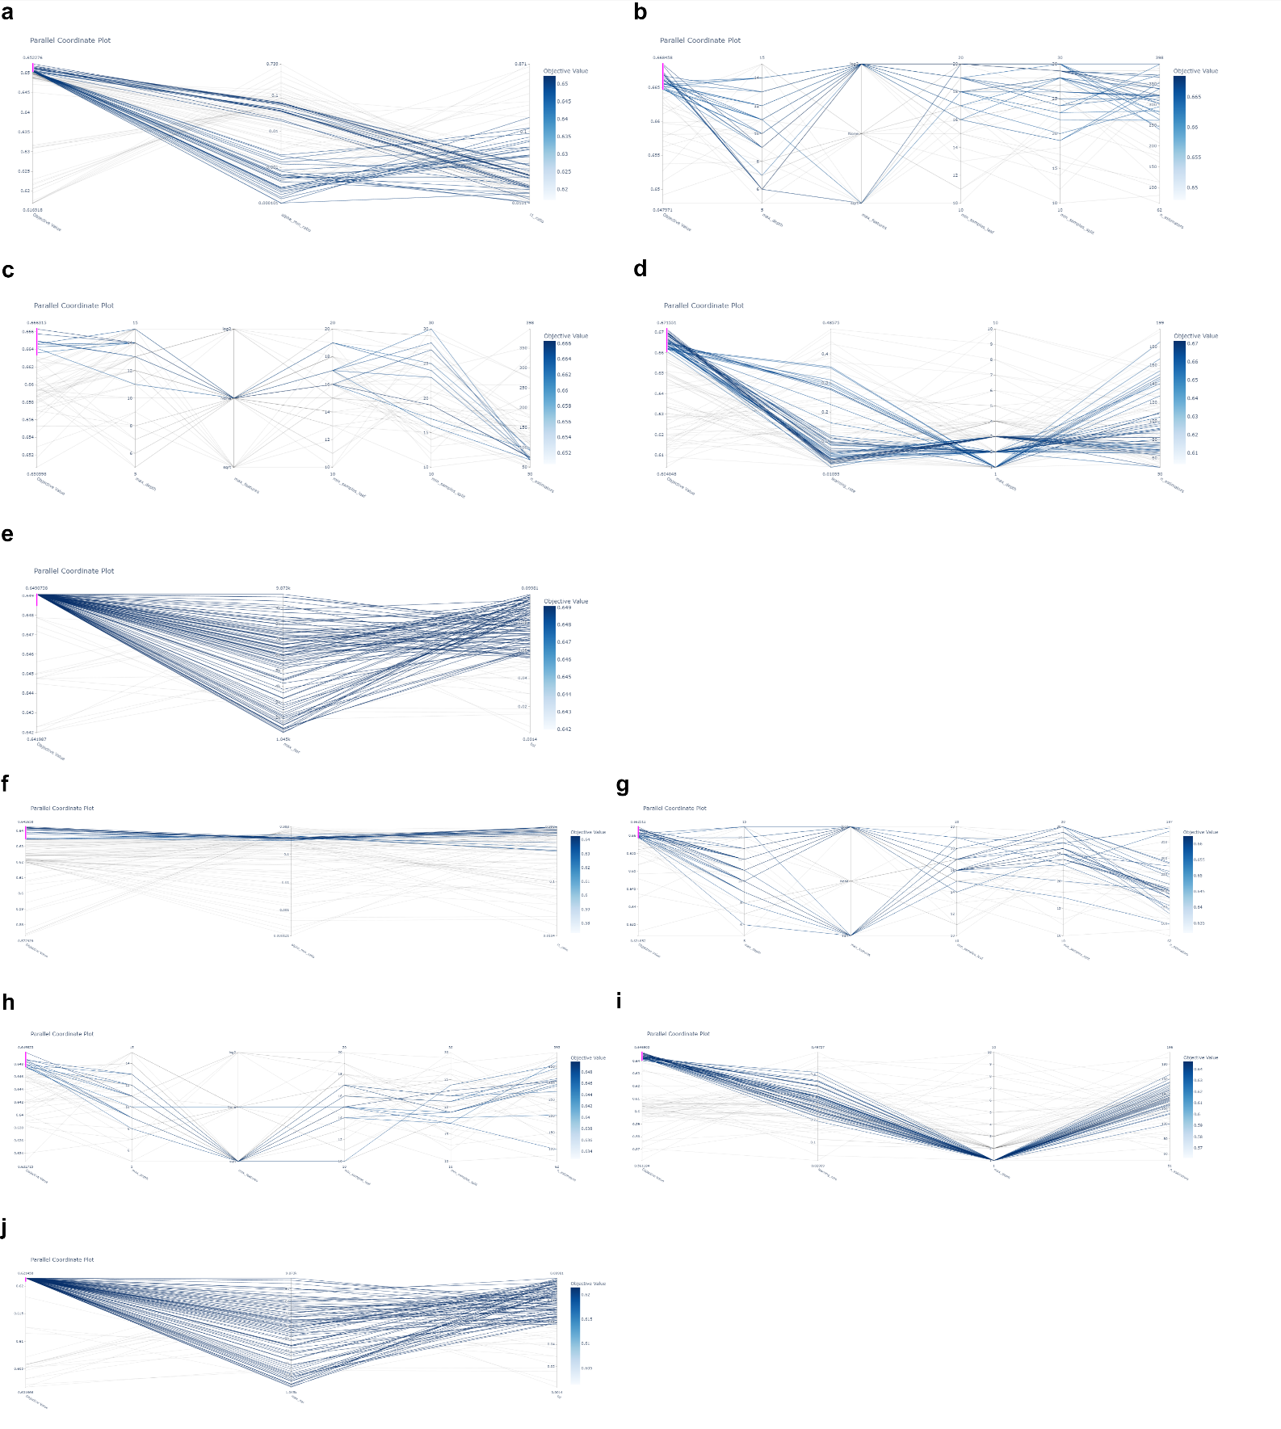

Supplementary Fig. S29| Parallel coordinate plot for machine learning models
a-e. Machine learning models for DFS. a: Cox Elastic Net (COX); b: Random Survival Forest (RSF); c: Extra Survival Trees (EST); d: Gradient Boosting (GB); e: Support Vector Machine (SVM).
f-i. Machine learning models for OS. f: Cox Elastic Net (COX); g: Random Survival Forest (RSF); h: Extra Survival Trees (EST); i: Gradient Boosting (GB); j: Support Vector Machine (SVM).

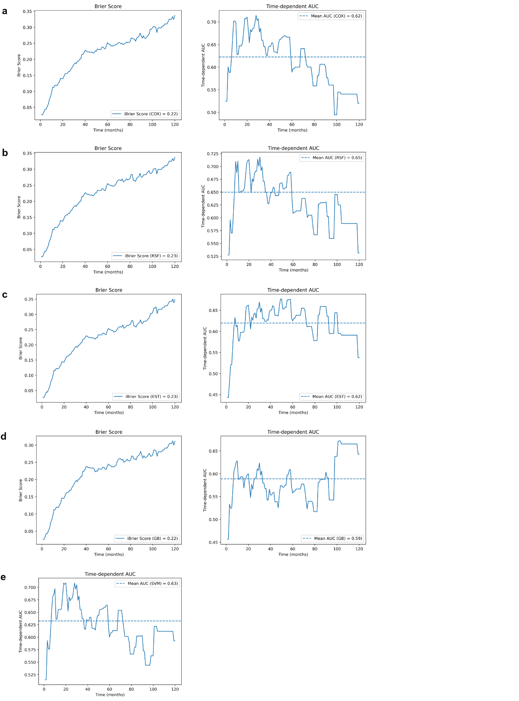

Supplementary Fig. S30| Performance of the ML models for DFS in the internal validation cohort.
For each model, Brier score is presented on left and time-dependent AUC on the right. SVM doesn’t generate a survival function and therefore Brier score can’t be evaluated. a-e. From upper to lower: COX, RSF, EST, GB and SVM.
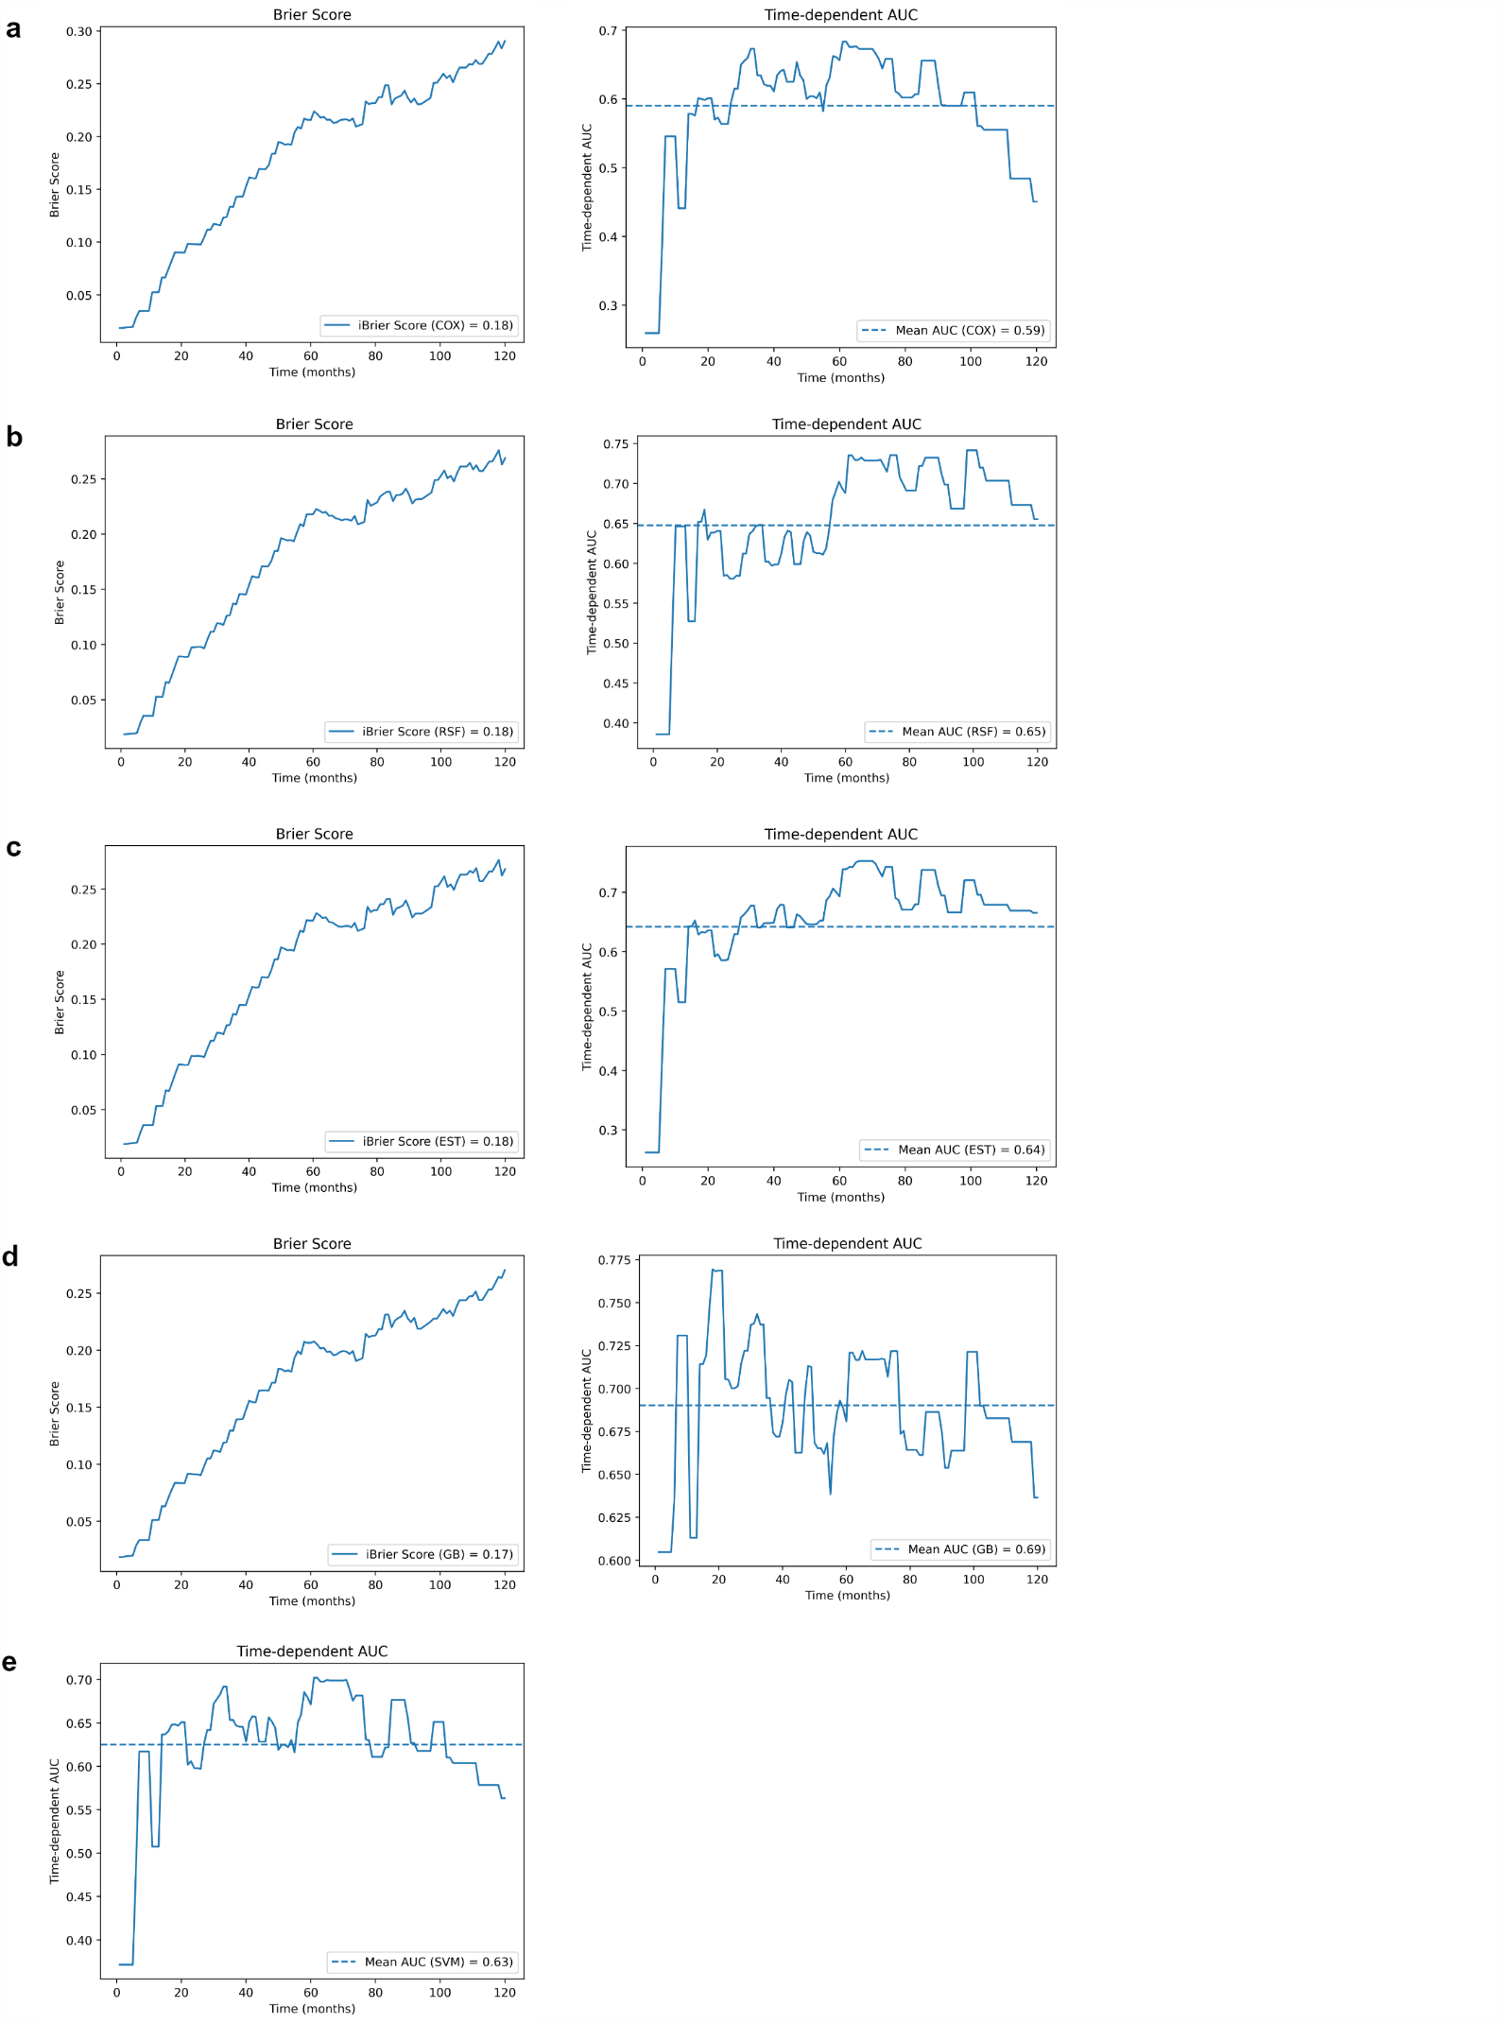

Supplementary Fig. S31| Performance of the ML models for OS in the internal validation cohort.
For each model, Brier score is presented on left and time-dependent AUC on the right. SVM doesn’t generate a survival function and therefore Brier score can’t be evaluated. a-e. From upper to lower: COX, RSF, EST, GB and SVM.
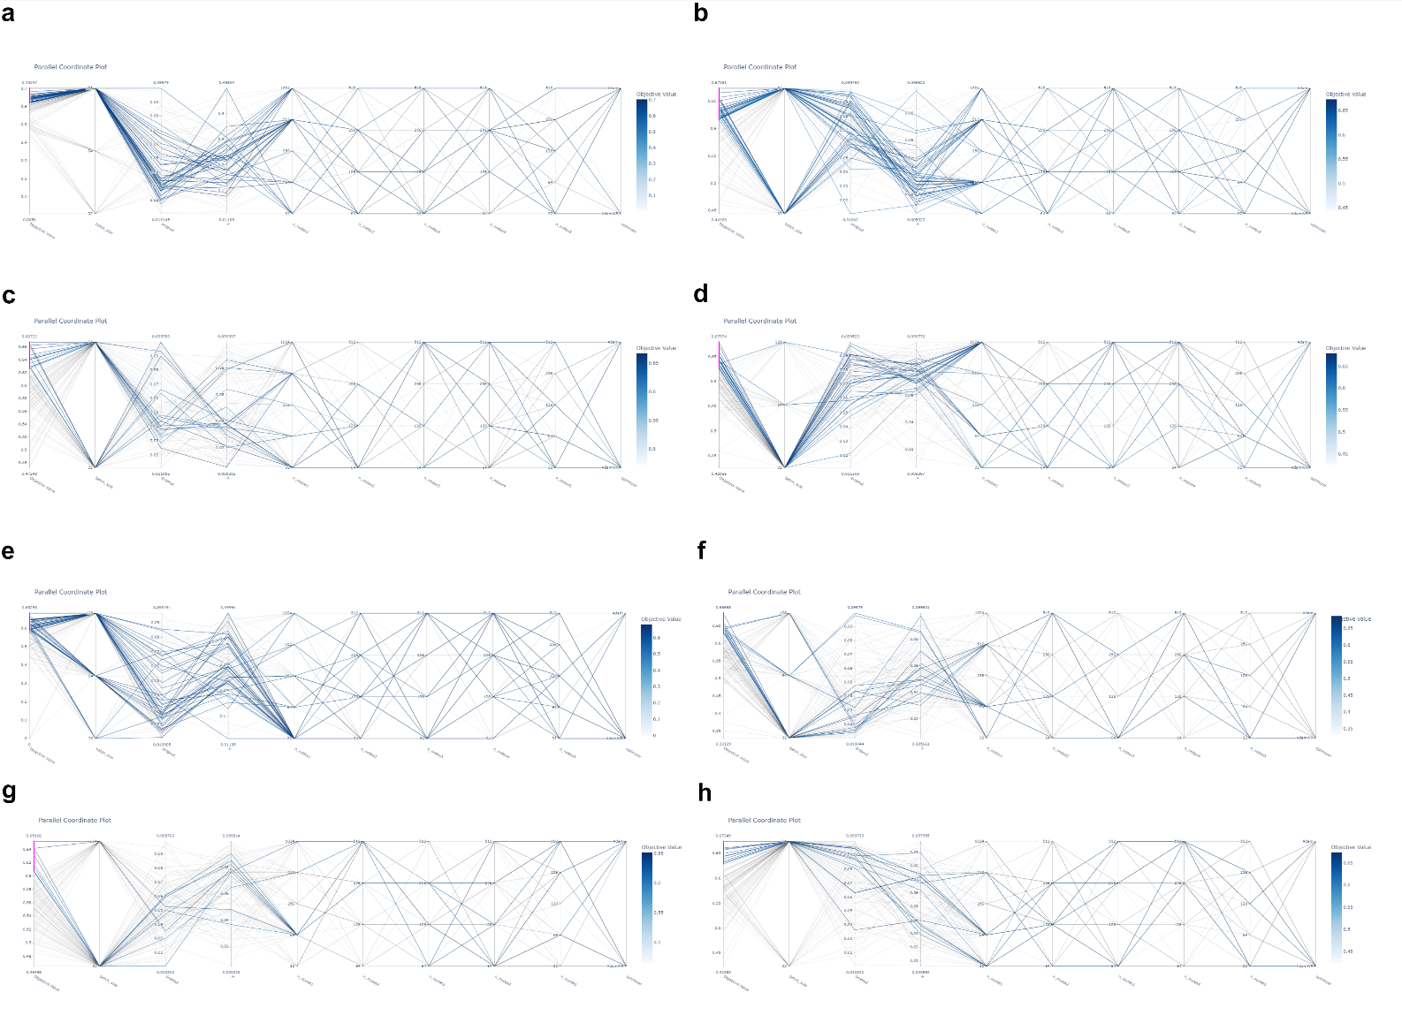

Supplementary Fig. S32| Parallel coordinate plot for machine learning models
a-d. Deep learning models for DFS. a: DeepSurv (DS); b: DeepHit (DH); c: Logisitc Hazard (LH); d: Multi-Task Logistic Regression (MTLR).
e-h. Deep learning models for OS. e: DS; f: DH; g: LH; h: MTLR.
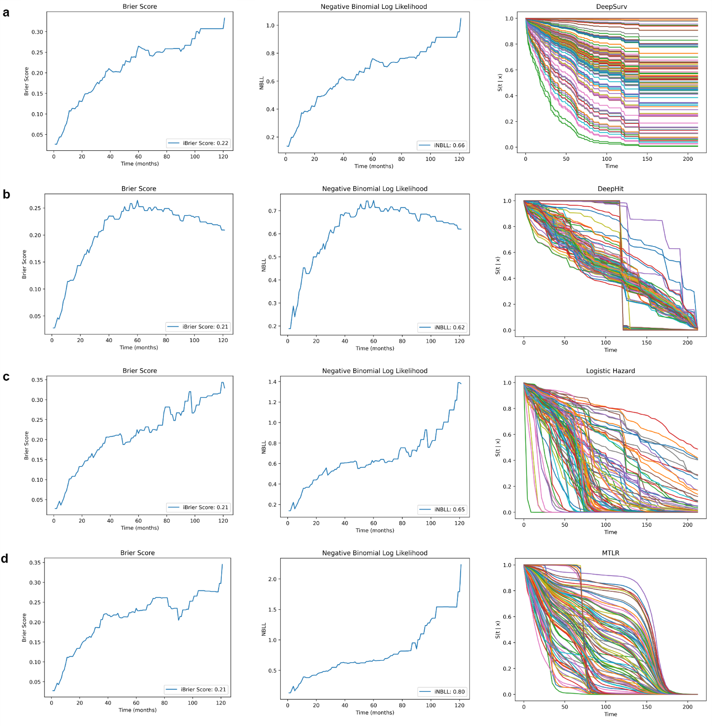

Supplementary Fig. S33| Performance of the DL models for DFS in the internal validation cohort.
For each model, Brier score is presented on left, negative binomial loglikelihood in the center and the estimated survival probabilities on the right.
a-d. From upper to lower: DeepSurv, DeepHit, LH and MTLR.

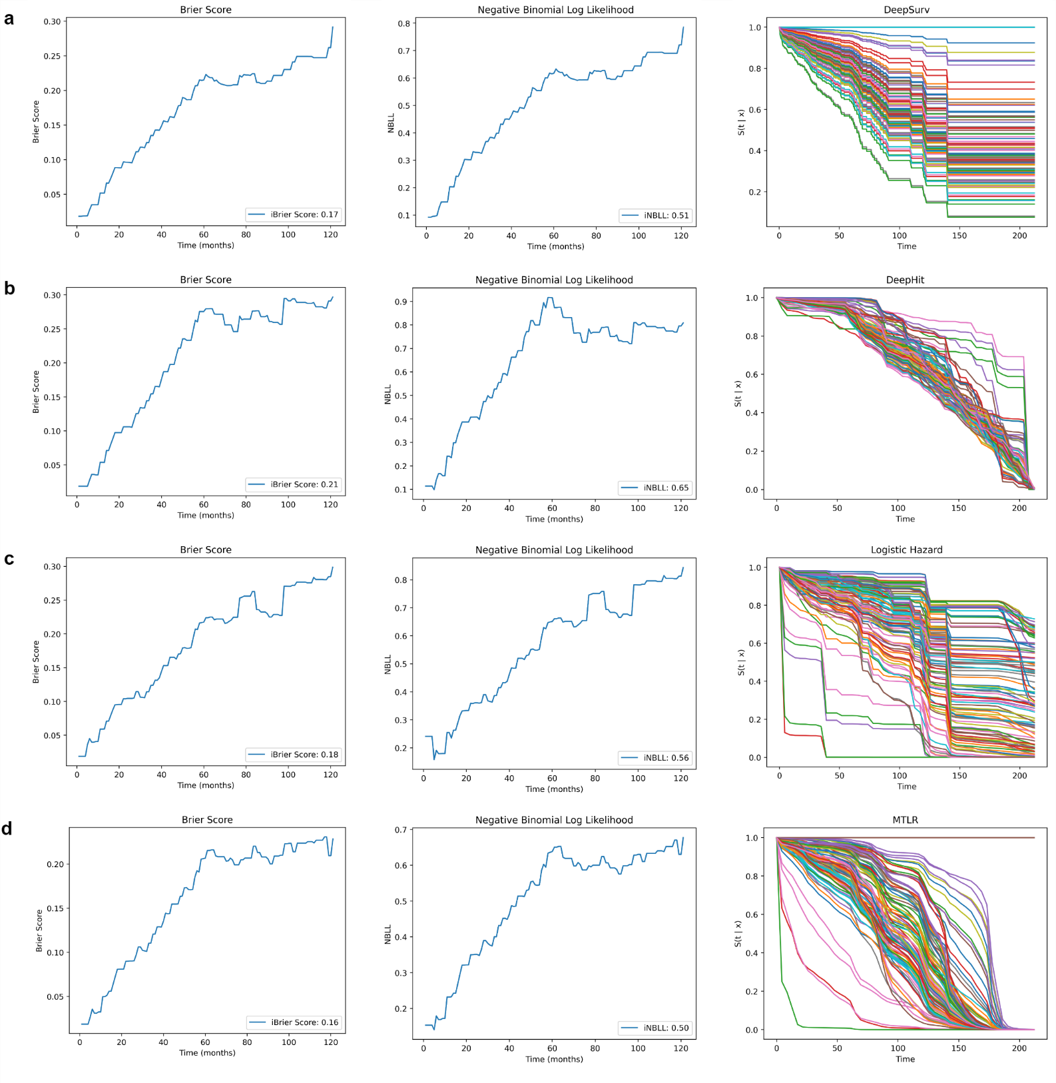

Supplementary Fig. S34| Performance of the DL models for OS in the internal validation cohort.
For each model, Brier score is presented on left, negative binomial loglikelihood in the center and the estimated survival probabilities on the right.
a-d. From upper to lower: DeepSurv, DeepHit, LH and MTLR.

Sample size considerations.

- Minimal sample size to achieve an outcome proportion with sufficient precision (σ=0.05) was
  - n =${ (\frac{1.96}{σ})}^{2}* φ*(1-φ)$ = ${ (\frac{1.96}{0.05})}^{2}* 0.15*(1-0.15)$ = 196.
- Minimal sample size to achieve a shrinkage factor of 0.9 with a estimated R² of 0.2 was
  - n = $\frac{P}{\left(S-1\right)*ln⁡(1- -\frac{R^{2}}{S})}$ = $\frac{10}{\left(0.9-1\right)*ln⁡(1-\frac{0.2}{0.9})}$ = 403.
- Sample size for survival
  - For DFS, the number of candidate predictors was set to 10 and the median DFS to 120 months (corresponding to an event rate of 0.0058). Considering 60 months as mean follow-up and 120 months as the timepoint, the minimum sample size required was 398 corresponding to 13.79 events per predictors and 138 outcome events.
  - Similar assumptions were made for OS: the number of candidate predictors was set to 10 and the median OS to 168 months (corresponding to an event rate of 0.0041). Considering 60 months as mean follow-up and 168 months as the timepoint, the minimum sample size was 398, corresponding to 9.85 events per variable and 99 outcome events.

References.
Riley RD, Snell KI, Ensor J, et al. Minimum sample size for developing a multivariable prediction model: PART II - binary and time-to-event outcomes. Stat Med. 2019;38(7):1276-1296. doi:10.1002/sim.7992.
Riley RD, Ensor J, Snell KIE, et al. Calculating the sample size required for developing a clinical prediction model. BMJ. Published online March 18, 2020:m441. doi:10.1136/bmj.m441.

