Supporting Information

Ultrasound Powered Wetting and Filling of Liquid Metal into Ultrafine Channels for Flexible Electronics

Zirong Xu^{1, 2, 3}, Dongdong Jin^{2*}, Sanhu Liu^{1, 3}, Guoqiang Li^{1, 2, 4}, Zichang Guo^{1, 2}, Zhengwei Li^{1, 3}, Chengqian Xiong^{1, 2}, Zhiwu Xu^{1, 3*}, Xing Ma^{1, 2*}

- State Key Laboratory of Advanced Welding and Joining, Harbin Institute of Technology, Harbin150001, China
- School of Integrated Circuits, Harbin Institute of Technology (Shenzhen), Shenzhen, Guangdong518055, China
- School of Materials Science and Engineering, Harbin Institute of Technology, Harbin150001, China
- Advanced Medical Research Institute, Cheeloo College of Medicine, Shandong University, Jinan, China.
*Corresponding authors: jindongdong@hit.edu.cn (D. Jin); xuzw@hit.edu.cn (Z. Xu); maxing@hit.edu.cn (X. Ma)

The PDF file includes
Supplementary Notes
Figs. S1 to S14

Other supplementary materials for this manuscript
Movie S1. Ultrasound powered filling of LM into straight microchannel with a minimum characteristic dimension of 100 μm
Movie S2. Filling results of microchannels with various sizes captured by micro-computed tomography
Movie S3. The wetting behavior of LM droplet without oxide film on PDMS substrate regulated by ultrasound
Movie S4. High-speed camera captured the LM filling process in microchannel (×0.0015 speed)
Movie S5. Ultrasound powered filling of LM into multiple microchannels to lighten LED array
Movie S6. Ultrasound powered filling of LM into multiple channels to connect a 32-pin microcontroller
Movie S7. Ultrasound powered filling of LM into a spiderman pattern with interlaced channels
Movie S8. Ultrasound powered filling of LM into a snowflake pattern with blind holes

Supplementary Note 1

Finite element analysis of ultrasound stimulated LM droplet spreading process
The finite element simulations for LM droplet spreading process stimulated by ultrasound were performed using COMSOL Multiphysics 6.1 software. We employed a two-dimensional axisymmetric model to research this issue and reduce the computational complexity. The entire model was divided into three regions: a square air region with a side length of 3 mm, a liquid metal (LM) droplet region with a radius of 1.5 mm, and a substrate region with dimensions of 3 mm in length and 1 mm in height. The materials for the air, liquid metal droplet, and substrate regions were selected as Air, Gallium [liquid] and Titanium [solid, annealed], respectively. These materials were selected from the COMSOL library to accurately represent the physical properties. It was worth noting that the density, dynamic viscosity, and speed of sound for Gallium [liquid] and EGaIn were nearly identical. Consequently, these minor differences did not significantly affect the finite element simulation results. Therefore, we used the material Gallium [liquid] from the COMSOL library to substitute for EGaIn in our analytical simulations.

We selected the physics interfaces for Laminar Flow (spf) and Phase Field (pf) in fluid dynamics, and utilized the Solid Mechanics (solid) interface to simulate ultrasound conduction. When investigating the flow field distribution within the liquid droplet, the ultrasound loading was applied by specifying displacement boundary conditions in the Solid Mechanics (solid) interface, employing a sinusoidal function with a frequency of 20 kHz. The amplitude was determined based on experimental parameters of the ultrasound device. According to the equipment manual for this experiment, the ultrasound probe exhibited a vibration amplitude of 6 μm when subjected to 600 W. When studying the distribution of acoustic pressure, it was necessary to introduce the Pressure Acoustics, Transient (actd) interface. The ultrasonic loading was introduced into this interface in a pressure-based manner. The governing equations and the conversion of power to pressure were specifically discussed in Supplementary Note 2.

Supplementary Note 2

Finite element analysis for ultrasound powered filling of LM into microchannel
The finite element simulations were performed using COMSOL Multiphysics 6.1 software. The dynamics of this unsteady laminar flow problem were governed by the continuity and Navier-Stokes equations, which described the conservation of mass and momentum, respectively. To account for the fluid being powered effects, the acoustic force density (f_{ac}) ¹ was introduced as a body force term on the right-hand side of the Navier-Stokes equation. The governing equations could be expressed as follows:
$\frac{∂ρ}{∂t}+ ∇·\left(ρu\right)=0$ (1)
$ρ\left(\frac{∂u}{∂t}\right)+ ρ·\left(u·∇\right)u= ∇·\left[-p+∇·μ\left(∇u+{\left(∇u\right)}^{T}\right)- \frac{2}{3}μ\left(∇·u\right)I_{m}\right]+ f_{ac}$ (2)
where u was the fluid velocity field, p was the fluid pressure, ρ was the fluid density, μ was the fluid viscosity, and I_{m} was the identity matrix. To simplify our theoretical model, the fluid flow in microchannel was assumed to be laminar, isothermal, isotropic and Newtonian. No-slip boundary condition for velocity field (u = 0) was imposed on microchannel boundary and the initial velocity (u_{t=0} = 0) of LM was taken as zero.

The acoustic power (W) and pressure (P) were related by the following relation²:
$W= \frac{P^{2}*S}{ρc}\cos{θ}$ (3)
where S, ρ, c and θ represented the contact area of surface, the mass density, sound velocity and the angle between the direction of propagation of sound and normal to surface, respectively. Unless otherwise specified, the applied ultrasound power in the following experiments and simulations was 600 W. The amplitude of the acoustic pressure could be determined by applying equation (3), while the simulated vibration mode of the clamp was illustrated in Fig.S2.

Supplementary Note 3

Discussion about the factors that influenced LM wetting speed powered by ultrasound
There were two main factors that influenced the velocity of filling process, one was the pressure drop due to viscosity of the fluid, the other was acoustic pressure which served as the powered source. According to the Hagen-Poiseuille equation³, the pressure drop could be calculated by:
$∆P= \frac{8πμLQ}{A^{2}}$ (4)
where, ∆P was the pressure difference between the two ends, L was the length of channel, μ was the dynamic viscosity, Q was the volumetric flow rate and A was the cross-sectional area of channel. According to the equation, the pressure difference between the two ends of a channel was inversely proportional to the square of the channel’s area. It elucidated the exceptionally high filling velocity observed in the 100 μm channel.

As far as the acoustic pressure was concerned, when LM filling into microchannel from chamber, it essentially flowed from a thicker diameter pipe to a finer diameter pipe⁴. We could analyze acoustic behavior using the concept of plane waves and coordinate the interface between the two pipes as x = 0. The acoustic pressure of incident wave (p_{i}), reflected wave (p_{r}), transmitted wave (p_{t}) could be described using the principles of acoustics⁵:
$\left\{\begin{aligned}p_{i}= p_{ai}e^{j(ωt-kx)} \\ p_{r}=p_{ar}e^{j(ωt-kx)} \\ p_{t}=p_{at}e^{j(ωt-kx)}\end{aligned}\right.$ (5)
Here, j represented the imaginary unit, ω was the angular frequency, and k was the spring constant. The corresponding particle velocities defined as $v_{i}$, $v_{r}$ and $v_{t}$, respectively. In order to conserve acoustic pressure and volume velocity, they should satisfy the following equations:
$p_{ai}+ p_{ar}= p_{at}$ (6)
$S_{1 }\left( v_{i}+ v_{r }\right)= S_{2}v_{t}$ (7)
where S₁ and S₂ were the cross-sectional area of thicker and thinner pipes, respectively. At the interface, equation (7) could be written as:
$S_{1 }\left( p_{ai}- p_{ar }\right)= S_{2}p_{at}$ (8)
By simultaneously solving equations (6) and (8), we could determine the acoustic pressure ratio ($r_{p}$):
$r_{p}= \frac{p_{ar}}{p_{ai}} = \frac{S_{21} - 1}{S_{21}+ 1}$ (9)
where $S_{21}= \frac{S_{1}}{S_{2}}$. From this, we could obtain the acoustic intensity transmission coefficient (t_{I}):
$t_{I}= \frac{I_{t}}{I_{i}}= \frac{4}{{(S_{12}+1)}^{2}}$ (10)
where $S_{12}= \frac{S_{2}}{S_{1}}$. The derived equations suggested that a finer microchannel exhibited a higher acoustic intensity transmission coefficient, implying a stronger acoustic pressure gradient that facilitated the filling of LM, which explained the remarkably rapid filling velocity in the 25 μm channel. We also utilized COMSOL simulation software to model the stable peak average acoustic pressure within channels of different characteristic sizes (ranging from 10 μm to 100 μm), as illustrated in Fig. S5. From the data, it was evident that with a decrease in channel characteristic size, the stable peak average acoustic pressure continued to increase, with an accelerated rate observed for channels finer than 40 μm (indicated by a steeper slope). The inset in the figure depicted the acoustic pressure variation within a channel with a characteristic size of 40 μm over the period from 0 to 0.02 s. The graph showed that the acoustic pressure stabilized after ~0.015 s, with a stable peak average acoustic pressure of ~4 × 10⁵ Pa. The simulation results aligned with theoretical derivations. However, it was important to note that when channel's characteristic size was reduced to 10 μm, the filling process became prolonged. This delay could be attributed to the impact of the parameter $S_{12}$ on the acoustic intensity transmission coefficient became less significant as channel size decreased and the higher-pressure drop compared to channels of different sizes, despite the presence of an enhanced acoustic pressure gradient.

Fig. S1 Process flow diagram of ultrasound powered filling of LM into microchannels diagram.

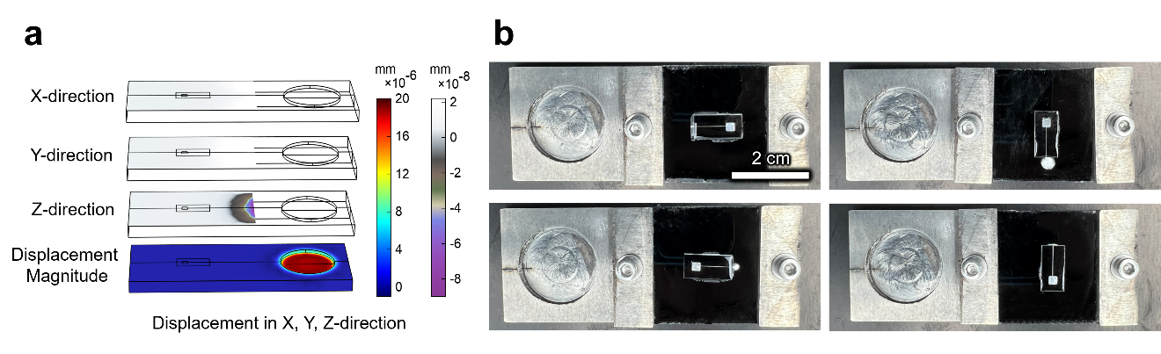
Fig. S2 Displacement analysis of the clamp surface and the filling results of devices with various orientations powered by ultrasound. a) Simulation of clamp surface displacement along the X, Y and Z directions, respectively. b) Experimental filling results of devices with different orientations powered by ultrasound.

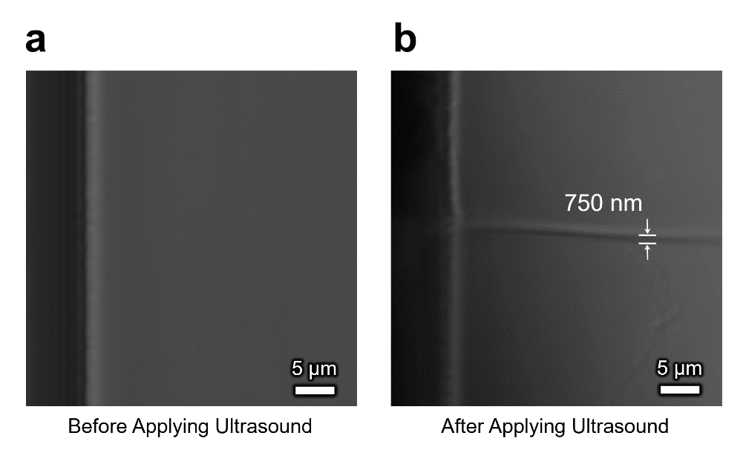
Fig. S3 Ultrasound powered filling of LM into the ultrafine channel recorded by CLSM. a) The empty ultrafine channel (~750 nm). b) The ultrafine channel filled with LM after applying ultrasound.

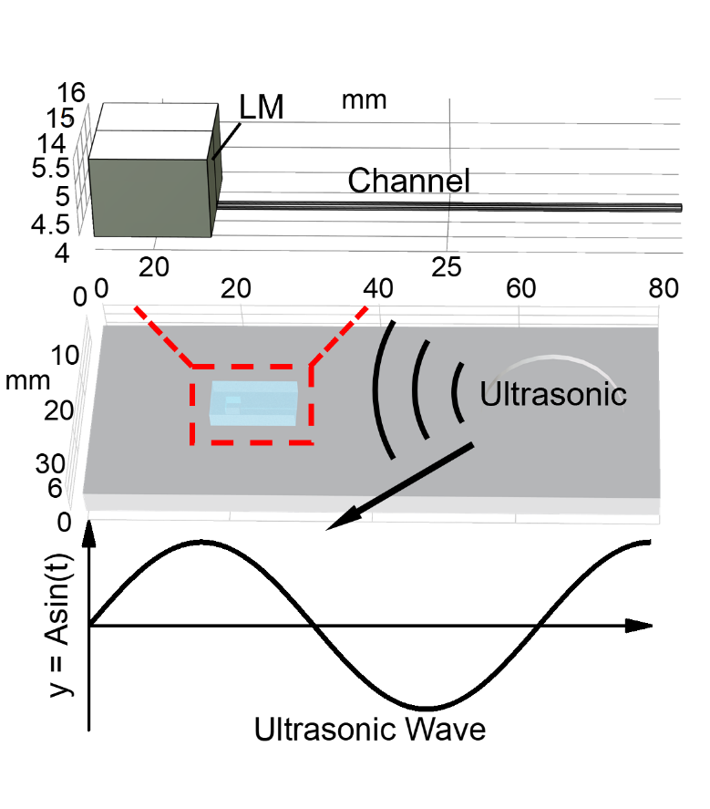
Fig. S4 3D mold structured in COMSOL Multiphysics 6.1 software including a TC4 clamp and PDMS sample with all dimensions consistent with the experiment.

Fig. S5 The stable peak average acoustic pressure within channels of different characteristic sizes (ranging from 10 μm to 100 μm).

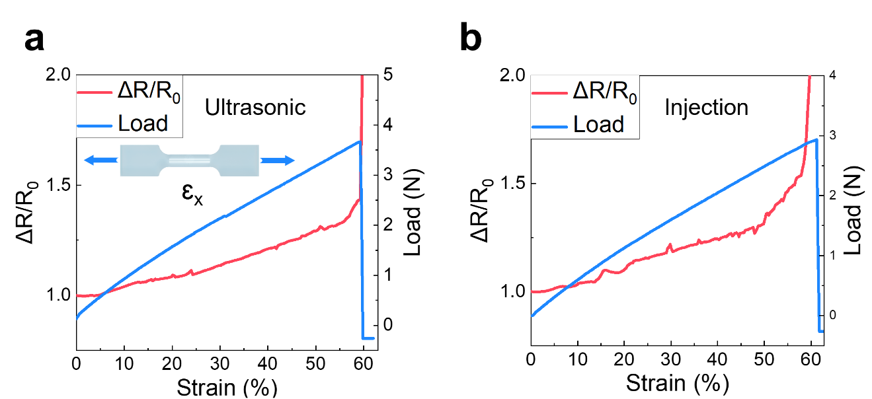
Fig. S6 Electromechanical performance of strain sensors. a) Electromechanical performance of the strain sensor made by ultrasonic method. b) Electromechanical performance of the strain sensor made by injection method.

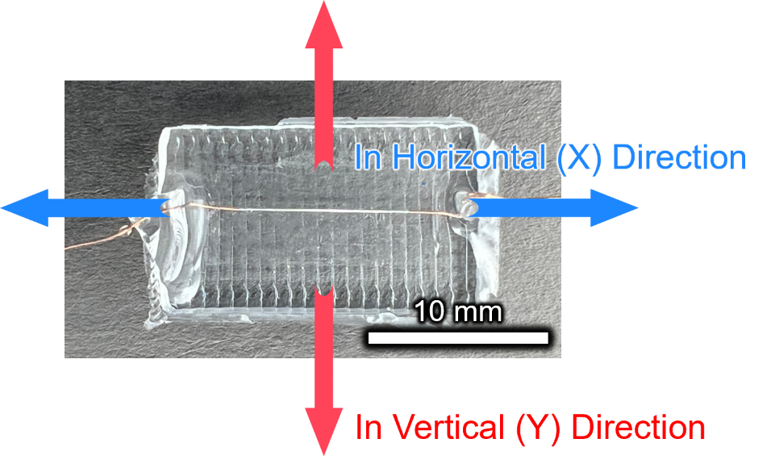
Fig. S7 Physical appearance of a LM strain sensor encapsulated in rectangular PDMS and the stretching direction of cyclic tests.

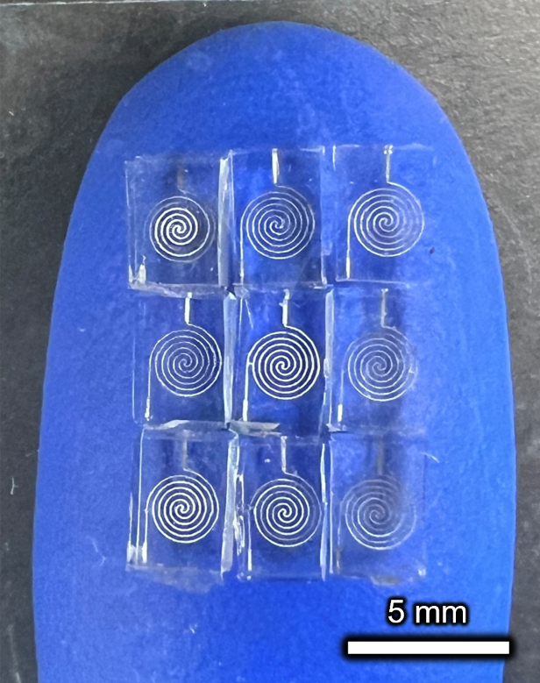
Fig. S8 Physical appearance of a stress sensor array with a minimum characteristic dimension (CD_{m}) of 25 μm placed on a fingertip.

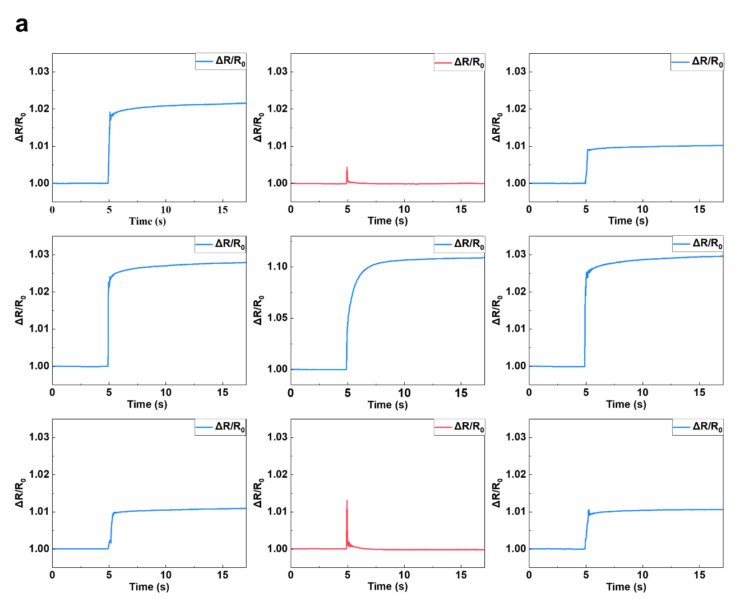
Fig. S9 Relative resistance change of different channels when applying compression plate with the letter shape of H. Blue data in figure represented the presence of load above sensor, while red data indicate the absence of load above sensor.

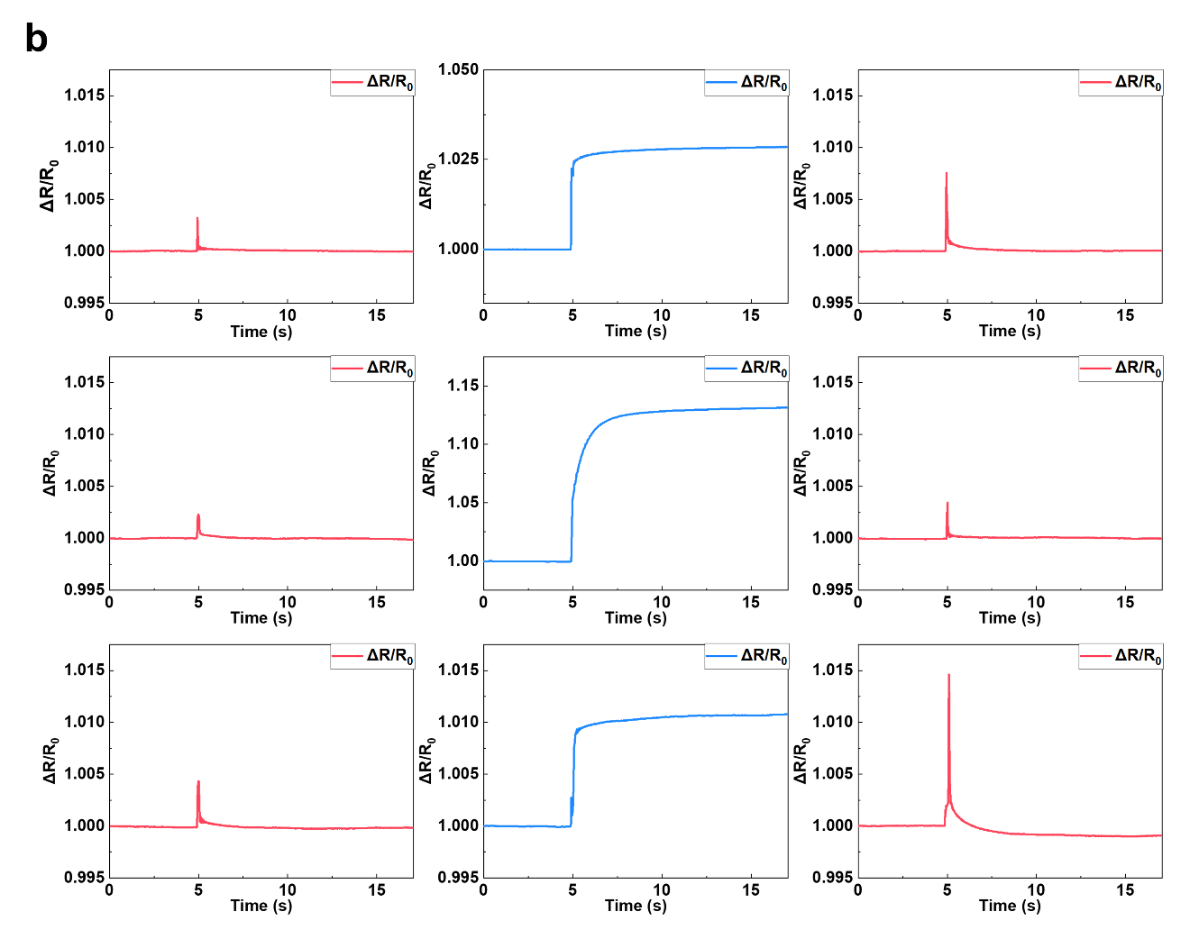
Fig. S10 Relative resistance change of different channels when applying compression plate with the letter shape of I. Blue data in figure represented the presence of load above sensor, while red data indicate the absence of load above sensor.

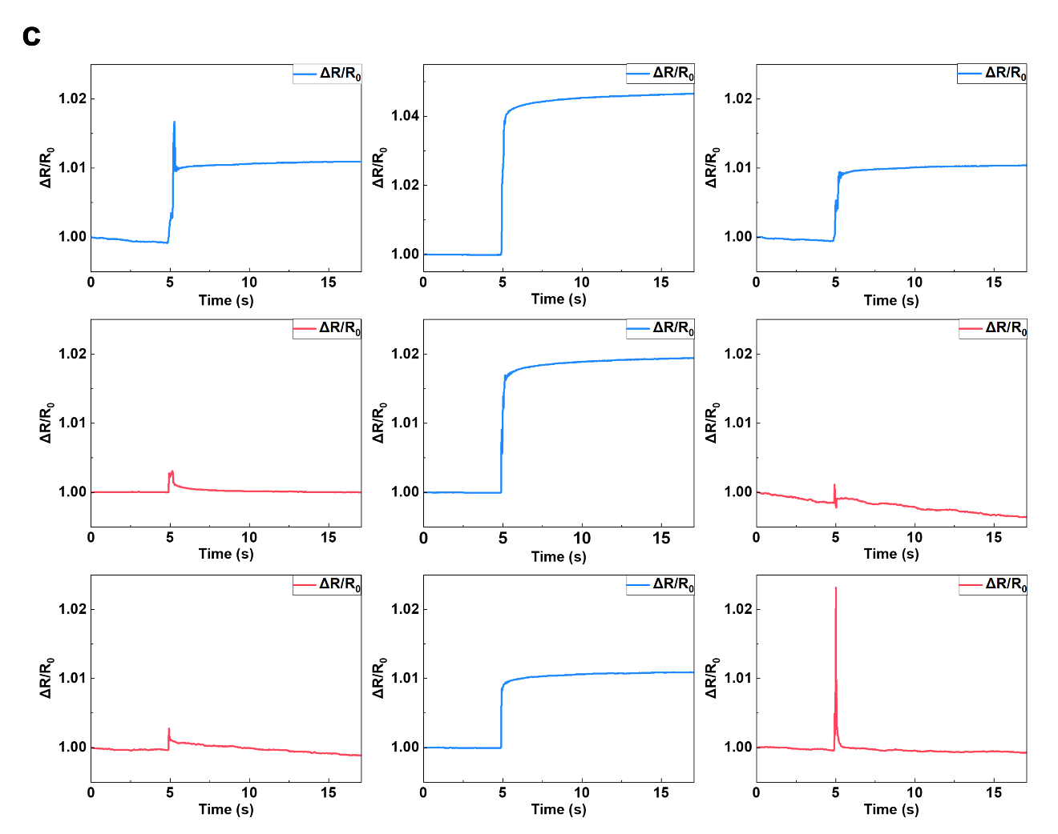
Fig. S11 Relative resistance change of different channels when applying compression plate with the letter shape of T. Blue data in figure represented the presence of load above sensor, while red data indicate the absence of load above sensor.

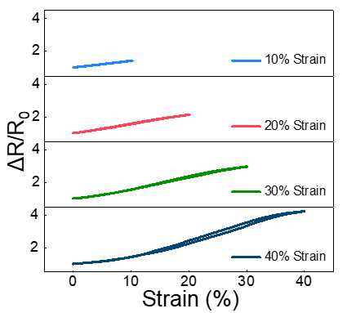
Fig. S12 Relative resistance change of strain sensor with five prismatic microstructures at various strain.

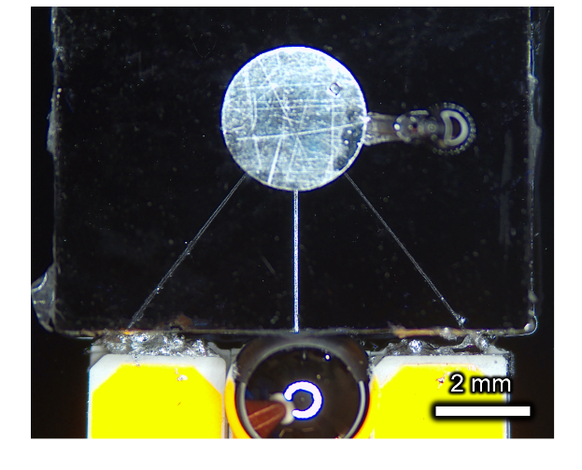
Fig. S13 Physical appearance of multichannel LED array filled with LM using manual injection method.

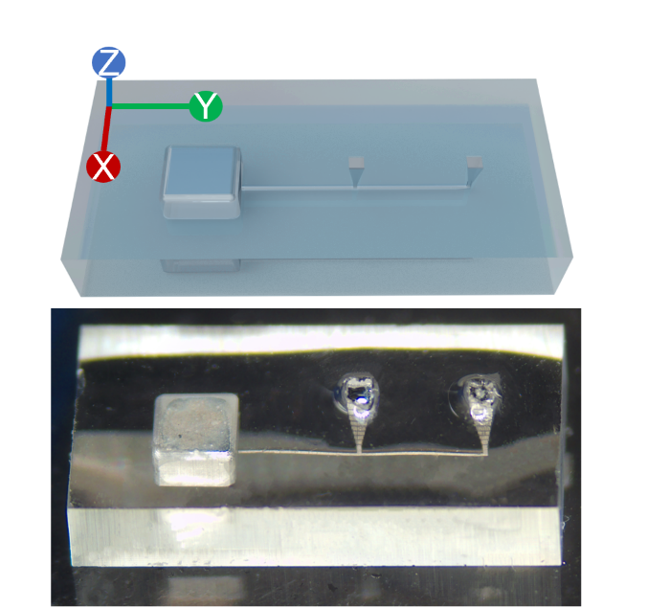
Fig. S14 Schematic diagram and physical image depicting the filling result of LM in the comb-like channel with two vertical outlets powered by ultrasound.

References
1 Pothuri, C., Azharudeen, M. & Subramani, K. Rapid mixing in microchannel using standing bulk acoustic waves. Phys. Fluids 31, 122001 (2019).
2 Landau, L. D. Fluid mechanics, course of theoretical physics, vol. 6. Addison-Wesley Publishing Co. (1959).
3 Kirby, B. J. Micro-and nanoscale fluid mechanics: transport in microfluidic devices. (Cambridge university press, 2010).
4 Kinsler, L. E., Frey, A. R., Coppens, A. B. & Sanders, J. V. Fundamentals of acoustics. (John wiley & sons, 2000).
5 Randall, R. H. An introduction to acoustics. (Courier Corporation, 2012).

