Extended data
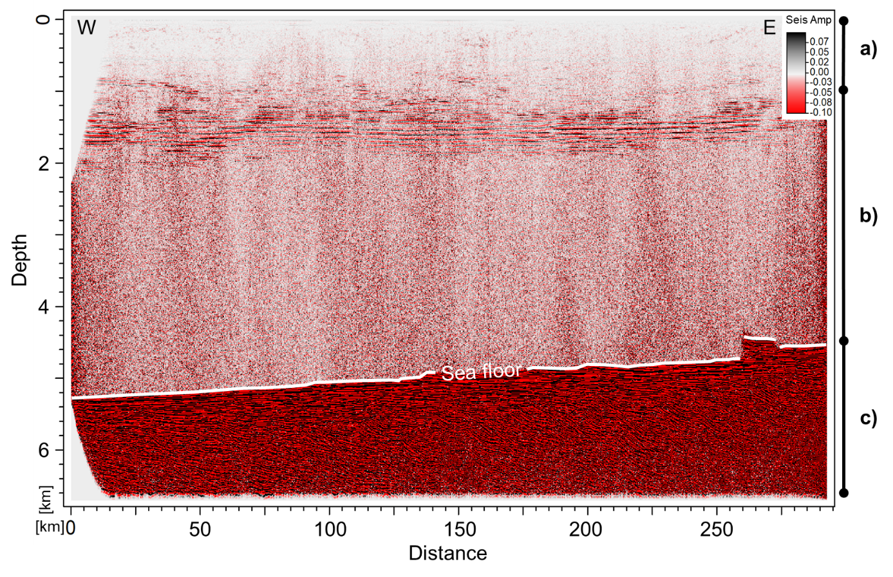
Fig. S1: Final processed seismic section (MAD-01-003) cropped at 9 seconds TWT. Top (a) (until 3 km depth) comprises reflections from the water column; middle (b) (up to seafloor) is reflection free; bottom (c), encompasses the seafloor and subsurface sediment bellow.

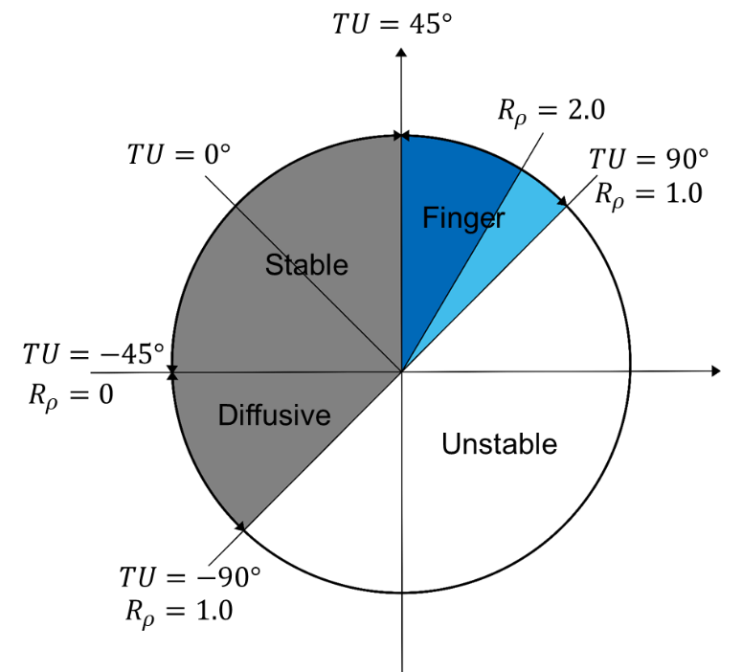
Fig. S2: Schematic representation of the definition of the Turner angle (°), and regions of instability due to double-diffusion (modified from You⁶).

